Multiple Salivary Gland Neoplasms: Adenocarcinoma of Palate and Pleomorphic Adenoma of the Parotid Gland
Sleem H¹, Sharabasy I² and Foad R³.
1-Associate professor of oral and maxillofacial surgery, faculty of dentistry Ain shams university
2_Researcher oral and maxillofacial surgery, faculty of dentistry Ain shams university
3- Lecturer of oral pathology faculty of dentistry Ain shams university

Corresponding Author: Sleem, Heba Abdulwahed, Department of Oral and Maxillofacial Surgery Ain Shams University, Cairo, Egypt, E-mail: drsleemh@gmail.com

Abstract:
Introduction: Salivary gland tumors account for fewer than 3% of the head and neck tumors. Typically salivary gland neoplasm presented as a single swelling localized to one salivary gland. A more unusual event is the development of multiple neoplasms (synchronously or metachronusly) , located either in different glands or in one gland.
Presentation of the case:
This manuscript present a case of palatal swelling diagnosed by incisional biopsy as polymorphous low-grade adenocarcinoma (PLGA), surprisingly another parotid lesion was accidentally discovered during MRI examination which was done to exclude lymphatic spread of palatal tumor. Palatal mass was resected with safety margin then immediate opturator inserted; superficial parotidectomy was also done for parotid lesion sparing facial nerve. Post-operative radiotherapy was recommended by pathologist due to evident perineural spread. The patient is tumor free after one year follow-up.
Discussion:
Clinical reports about synchronous multiple salivary tumors are very rare, consequently there is little known about its management and clinical presentation. Presence of one or more risk factor should favor expectation of multiple tumors and mandate examination of all salivary tissues. Each tumor should be diagnosed and treated separately according to its nature and extension.
Conclusions:
Although similar reports of multiple synchronous salivary tumors in one individual is sporadic, MRI scanning of all salivary tissues could be mandatory especially in presence of one or more risk factor such as smoking or radiation exposure.

Key words:
Salivary gland, tumors, parotid, palate
Introduction:
Salivary gland tumors account for fewer than 3% of the head and neck tumors¹. Very few case reports describes presence of more than one salivary gland tumor either synchronously or metachronusly^{2;3}. There is a great conflict in terminology used to describe multiple salivary gland neoplasms. Multiple salivary tumors may be considered from three standpoints: according to incidence time (synchronous or metachronous ) and anatomical (unilateral or bilateral), histology (identical or different). Multiple malignant salivary tumors of identical pathology are much more common, which proposes the possibility of genetic risk factor, rather than only accidental event⁴. Up to our knowledge this is the only case report of multiple synchronous ipsilateral benign and malignant salivary tumor involving both minor and major salivary glands.
Polymorphous low-grade adenocarcinoma (PLGA) was first described in 1984, diagnoses is usually made based on the hematoxylin and eosin morphology. . Solid nests of monotonous epithelial cells arranged in cribriform and trabecular masses as well as focal papillary cystic areas can typically be present within the same lesion. The epithelial cells are usually cuboidal, columnar or spindle with eosinophilic cytoplasm. The nuclei are uniform, round or ovoid, with a characteristic “washed out” appearance. Mucous cells, clear cells or oncocytic cells may also be seen. Mitotic figures are rare⁵. Minor salivary glands of the palate are its favorable site .PLGA tends to have lower local recurrence rates and have lower metastatic potential. Long-term follow-up surveillance is necessary because recurrences have been reported to occur more than 10 years after initial treatment⁶.
Among all salivary gland tumors, pleomorphic adenoma (PA) is the most commonly encountered tumor, it accounts for about 60% of all salivary gland neoplasms. Pleomorphic adenoma mostly occurs in the parotid gland specifically superficial lobe⁷. Histologically, it is characterized by a great variability in its morphology, being formed of neoplastic epithelial cells as well as modified myoepithelial cells. The epithelial cells are usually cuboidal or columnar with deeply eosinophilic cytoplasm and round nucleus, arranged in nests or more commonly duct like structures formed of a double layer of cells⁸. On clinical examination, PA is usually a painless mass with slow rate of growth . Combination of PLGA and PA at the same time is very uncommon presentation with accidental detection during radiographic examination. Perhaps radiographic assessment for both minor and major salivary tissues is mandatory to avoid miss management of such cases. This work has been reported in line with SCARE 2018 ⁹

Case Report:
A 52-year-old male patient, heavy smoker, free from other systemic disease, presented Outpatient clinic with chief complain of large painless 3x2x2.5cm mass progressively growing over a period of two months on the left side of the roof of the mouth at the junction of hard and soft palate. The mass was firm, non-tender, and rubbery with small surface ulceration 1x1cm fig (1). Oral examination was unremarkable. Assessment of lymph nodes and other salivary glands fail to discover any positive finding. At this point minor salivary gland neoplasm was the preliminary diagnosis and patient scheduled for diagnostic incisional biopsy. Meanwhile MRI examination of the head and neck was requested, the imaging showed 3x3x2 cm heterogeneous soft tissue mass occupying the left maxilla crossing the midline with resorption of underlying bone fig(2). Another well-defined homogenous circular mass 2x2 cm in superficial lobe of ipsilateral parotid gland was accidentally discovered, however no positive lymph nodes detected fig (3).
Incisional biopsy under local anesthesia was done for palatal swelling and diagnosed as “polymorphous low-grade adenocarcinoma” (PLGA). Ultra sound (US) guided fine-needle aspiration cytology (FNAC) of parotid mass was done showing a histopathological picture suggestive of pleomorphic adenoma fig (4). Work up was done to exclude other primary or synchronous tumors including chest CT and abdominal ultrasound.
The decision was made to surgically resect the palatal tumor (PLGA) with one centimeter safety margin including the underlying palatine bone and insertion of immediate opturator fig (5). For synchronously discovered parotid tumor superficial parotidectomy with facial nerve preservation was done through modified Blair incision followed by primary closure fig (6). Treatment plane was explained to the patient to ensure his acceptance before obtaining informed consent. Resected palatal mass showed perineural invasion accordingly the patient was scheduled for postoperative radiation. Patient was free from recurrence after follow up for one year with intact facial nerve function. However, patient was complaining from limited mouth opening secondary to radiotherapy.
Discussion:
The etiology of salivary gland tumors is unknown. There are many risk factors reported in literature including radiation, genetic predilection, excessive smoking, certain oncogenic viral infections and exposure to certain chemicals. Excessive exposure to diagnostic or therapeutic radiation has considerable increased risk of salivary gland neoplasia. There is also significant risk for carcinoma of other organs secondary to primary benign or malignant salivary tumors, especially breast, thyroid, bronchus and ovary¹⁰⁻¹².
In cases of multiple salivary tumors pathology of each lesion should be determined separately. If histopathology is similar the possibility of there being one primary tumor with metastasis should be considered³. In case of different pathology each one treated independently according to location, size of tumor, anatomical extension as well as histological phenotype⁴.
Radiological examination is mandatory in salivary tumors workup. Although ultra sound is useful in imaging of superficial masses it neither detects malignant features nor invasion of surrounding tissues¹³. In the present case it was used to guide fine needle aspiration cytology (FNAC) to overcome sampling error in diagnosis of parotid mass¹⁴. MRI was preferred in diagnosis of minor salivary gland tumor (palatal mass), since it has superior sensitivity over CT in malignancy prediction, lymph node involvement, detection of underlying bone marrow infiltration as well as perineural spread anticipation¹⁵.
In the present case both lesions were surgically managed in the same operation. Minor salivary tumor PLGA was resected with one cm safety margin including underlying palatal bone with proved tumor free margins, which is the most recommended by literature¹³. Superficial parotidectomy with facial nerve dissection and preservation was the treatment of choice for benign PA⁶. Unfortunately histopathological evidence of perineural spread mandate radiation therapy which add to patient disability due to marked limitation in mouth opening.
The aim of this manuscript is to present the rare incidence of multiple primary synchronous salivary tumors. One is malignant minor salivary gland neoplasms and the other is benign major salivary gland neoplasm in one individual. In fact parotid tumor has been discovered accidentally through MRI (magnetic resonance imaging) examination and missed by clinical assessment. Although similar reports of multiple salivary tumors in one individual is sporadic, MRI scanning of all salivary tissues could be mandatory especially in presence of one or more risk factor such as smoking or radiation exposure.
"Written informed consent was obtained for publication of this case report and accompanying images, a copy of the written consent is available for review by Editor-in-Chief of this journal on request"
Ethical approval
Ethical approval has been exempted by faculty ethical committee based on absence of any risk or violation of applied guidelines in such cases
Guarantor of the study:
The guarantor for this study is the head of oral and maxillofacial surgery department.
Funding:
This research did not receive any specific grant from funding agencies in the public, commercial, or not-for-profit sectors.
REFRENCES:
1_Licitra L, Grandi C, Prott FJ, Schornagel JH, Bruzzi P, Molinari R. Major and minor salivary glands tumours. Critical Reviews in Oncology/Hematology. 2003;45(2):215–225
2_Clayton JR, Pogrel MA, Regezi JA. Simultaneous multifocal polymorphous low-grade adenocarcinoma. Report of two cases. Oral Surg Oral Med Oral Pathol Oral Radiol Endod. 1995;80:71–7.
3_L. M. Ruíz-Godoy R., A. Mosqueda-Taylor, L. Suárez-Roa, A. Poitevin, E. Bandala-Sánchez, and A. Meneses-García, “Hybrid tumours of the salivary glands. A report of two cases involving the palate and a review of the literature,” European Archives of Oto-Rhino-Laryngology, vol. 260, no. 6, pp. 312–315, 2003
4_G. Seifert and K. Donath, “Multiple tumours of the salivary glands—terminology and nomenclature,” European Journal of Cancer Part B: Oral Oncology, vol. 32, no. 1, pp. 3–7, 1996.
5_ Paleri V, Robinson M and Bradley P.: Polymorphous low-grade adenocarcinoma of the head and neck. Curr Opin Otolaryngol Head Neck Surg. 2008; 16:163–169.
6-Vincent, S. D., H. L. Hammond , and M. W. Finkelstein . Clinical and therapeutic features of polymorphous low-grade adenocarcinoma. Oral Surg Oral Med Oral Pathol 1994. 77 3:41–47.
7_ 23. Johnson JT, Ferlito A, Fagan JJ, Bradley PJ, Rinaldo A. Role of limited parotidectomy in management of pleomorphic adenoma. Journal of Laryngology and Otology. 2007;121(12):1126–1128
8_ Ito FA, Jorge J, Vargas PA, Lopes MA: Histopathological findings of pleomorphic adenomas of the salivary glands. Med Oral Patol Oral Cir Bucal. 2009, 14(2): 57–61.
9_Agha RA, Borrelli MR, Farwana R, Koshy K, Fowler A, Orgill DP, For the SCARE Group. The SCARE 2018 Statement: Updating Consensus Surgical CAse REport (SCARE) Guidelines, International Journal of Surgery 2018;60:132-136.
10_Auclair PL, Eillis GL, Gnepp DR, et al. Salivary gland neoplasms: General considerations. In: Ellis GL, Auclair PL, editors. Surgical pathology of the salivary glands, 1st ed. Philadelphia, PA: Saunders; 1991. p. 135–164.
11_Schneider AB, Favus MJ, Stachura ME, et al. Salivary gland neoplasms as a late consequence of head and neck irradiation. Ann Intern Med. 1977;87:160–4.
12_ Horn-Ross PL, Ljung BM, Morrow M. Environmental factors and the risk of salivary gland cancer. Epidemiology. 1997;8(4):414–419.
13_Agulnik M, McGann C, Mittal B, Gordon S, Epstein J. Management of salivary gland malignancies: current and developing therapies. Oncology Reviews. 2008;2(2):86–94.
14_Orell SR. Diagnostic difficulties in the interpretation of fine needle aspirates of salivary gland lesions: the problem revisited. Cytopathology. 1995;6(5):285–300.
15_Lee YYP, Wong KT, King AD, Ahuja AT. Imaging of salivary gland tumours. European Journal of Radiology. 2008;66(3):419–436
13_Guzzo M, Locati LD, Prott FJ, Gatta G, McGurk M, Licitra L. Major and minor salivary gland tumors. Critical Reviews in Oncology/Hematology. 2010;74(2):134–148.

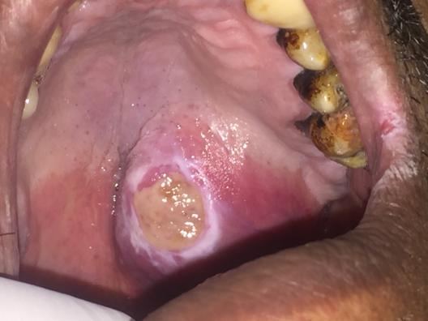
Fig 1:(A) intra oral clinical photograph showing 3x3 cm tumor mass on the left side at the junction of hard and soft palate with central superficial ulceration.

A
B
Fig 1:(A) axial and coronal MRI of palatal mass showing well defined homogenous mass with marked palatal bone resorption. (B) Coronal MRI of parotid gland showing well circumscribed 2x2 cm mass in superficial lobe accidentally discovered.

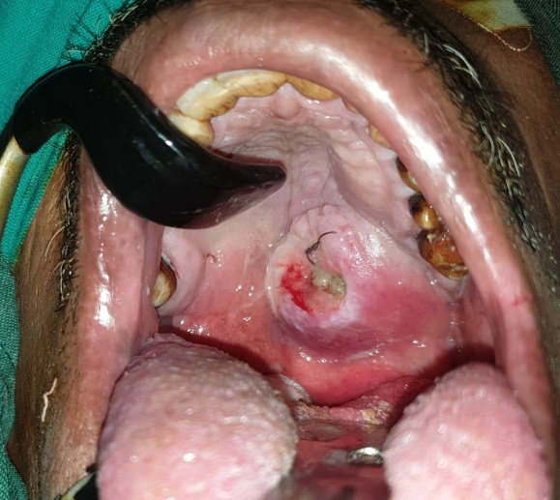
B
A
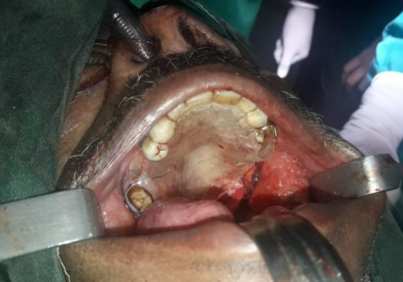
D
C
Fig 2:(A) intra oral clinical photograph showing 3x3 tumor mass diagnosed as (PLGA). (B) Resection of the tumor with one cm safety margin. (C) Intra-operative clinical photograph showing placement of immediate opturator after resection of palatal lesion (D). Tumor mass resected with safety margin.

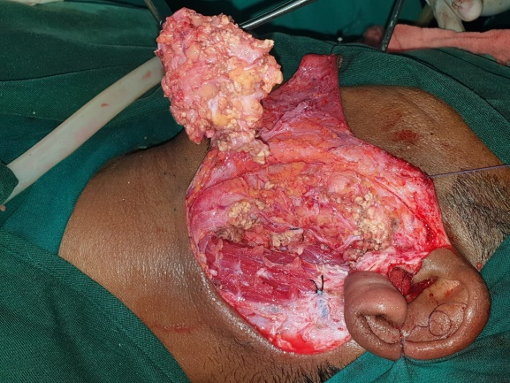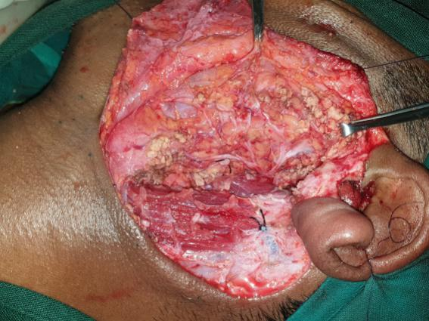
B
A
Fig 3: (A) intra-operative clinical photograph showing exposure and dissection of (PA) polymorphic adenoma using a modified Blair's incision (B): with preservation of facial nerve.
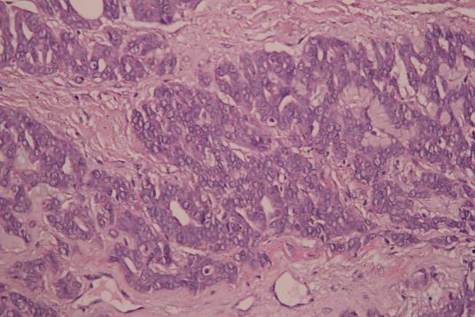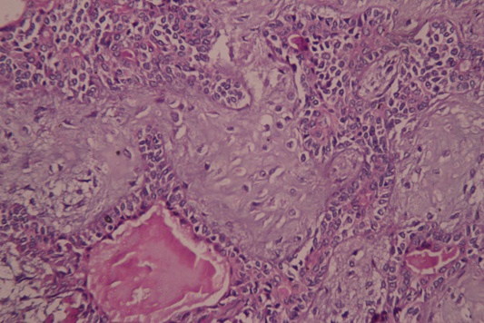
B
A
Fig 4: A. “polymorphous low-grade adenocarcinoma with showing cellular structure eosinophilic cytoplasm and finely dispersed nuclear chromatin. (Hematoxylin and eosinoPhil; original magnification 40X.)
B. Benign pleomorphic adenoma (PA): showing tubular and cribiform growth patterns. No mitoses or necrosis is seen. (Hematoxylin and eosino; original magnification 40X.)

