MESH REPAIRR OF INGUINAL HERNIA- A NOVEL APPROACH THROUGH SUPERFICAL INGUINAL RING

INTRODUCTION:
Repair of inguinal hernia is one of the most common surgical procedures performed all over the world[1].The aim of the repair of surgery is not only to fix the current hernia defect, but also to reduce the risk of recurrence. A mesh repair involves covering the defect by placing the mesh in one of the layers of the abdominal wall using either an open approach or minimal access laparoscopic technique. Open techniques of inguinal hernia repair include tension- free mesh repair such as the Lichenstein and kugel (preperitoneal )repairs or plug and patch[2] .In the tension free mesh repair, the mesh is placed in front of the transversalis fascia ,such as Lechienstein tension free hernioplasty, or behind the transversalis fascia in the preperitoneal space as in Kugel procedure.The two main laparoscopic groin hernia repairs are the totally extra peritoneal(TEP)and transabdomianal peritoneal patch (Tapp) repairs, both requiring the use of a mesh.Surgical treatment is successful in the majority of cases. The advantages of mesh repair were its association with less pain, rapid postoperative recovery, early return to normal activity and very low recurrence rate. Tension-free mesh repair is nevertheless associated with complications such as foreign body reaction, infection, fistula formation, migration, shrinkage, and recurrence. Other complications include skin anaesthesia, bruising and haematoma formation, seroma formation, orchitis and testicular atrophy[3].
In spite of all advances , over all, 11% of all patients suffer from a recurrence and 10-12% from chronic pain lasting more than 3 months following primary inguinal hernia repair. Approximately 1-3% of patients have severe chronic pain with long-term disability, thus requiring treatment .From a total of more than 100 different repair techniques for inguinal and femoral hernias, classified as tissue repair, open mesh repair, and laparo-endoscopic mesh repair, the new International Guidelines of the Hernia-Surgery Group only recommend the totally extraperitoneal patch plasty (TEP), transabdominal preperitoneal patch plasty (TAPP), and Lichtenstein techniques[4].
The open mesh repair is usually performed through an oblique inguinal incision of 5-6cm. starting from pubic tubercle towards the anterior superior iliac spine.This involves dividing the external oblique aponeurosis, in the direction of its fibres and identifying the indirect sac in the inguinal canal, followed by mesh repair. Thus. opening the inguinal canal,ligating the sac and repair of hernia by placement of mesh is the practice. Approaching the sac and mesh repair of inguinal hernia through superficial inguinal ring as a possibility, prompted us to try this approach of inguinal hernia repair as the superficial inguinal ring is easily approachable through a small transverse incision over it .
Patients and methods:
86 patients with inguinal hernia treated at Kamineni Institute of Medical sciences Hospital, Narketpally,Inidia, during the period 2012- 2016 formed the material for the study. Data regarding patient demographics, indications for surgery, type of anesthesia given, operation performed, complications were recorded. The exclusion criteria for this procedure were irreducible or partially irreducible hernia and recurrent hernia. Institute ethical committee have approved the study and informed consent has been taken from the patients.
The operative procedure was done under, spinal or epidural anesthesia. In supine position, the part was prepared and draped.
Before the incision, a bolus dose of a second-generation cephalosporin was given intravenously. The external inguinal ring was palpated and a transverse incision was made over the ring measuring 1 - 1.5cm.[Fig.1}.After incising the skin, subcutaneous tissue, the external inguinal ring was visualized,.
Retractors were placed to trtraact the edge of the ring upwards. This gave a good space to introduce the finger on either side of the spermatic cord and separated from all sides. the spermatic cord was elevated from the posterior wall of the inguinal canal [Fig. 2]. A finger was introduced underneath the external oblique aponeurosis. The cord was identified separated and lifted up. In cases of indirect hernias, the hernial sac was identified, dissected up to the internal ring and opened to allow examination of its contents. The sac was excised following high ligation and its distal portion was excised (Fig. 3 and 4 shows the separation of cord structures, and isolation of the sac).
However, in large indirect inguinal hernias, where the sac descents down to the scrotum, the distal part of the sac was left open to prevent the formation of a hydrocele, thus allowing spontaneous obliteration. In direct hernia, the sac was not opened, and was inverted with non-absorbable sutures (silk 2–0).
For both types of hernia, a polypropylene mesh (Proline, Ethicon Inc, 3 × 5 inch) was trimmed to fit the floor of the inguinal canal, and its apex was first sutured to the public tubercle using no 3–0 Proline sutures. The lower border of the mesh was sutured to the free edge of the inguinal ligament, after an opening was made into its lower edge to accommodate the spermatic cord. In majority of repairs 3-4 interrupted sutures could be applied after retraction (Fig. 5) and sutures extended up just medial to the anterior superior iliac spine. Interrupted Proline sutures were used to suture the two cute edges of the mesh together around the spermatic cord above the internal inguinal ring. The inferio-medial corner of the mesh is then attached well overlapping the pubic tubercle. The mesh was spread evenly without folding, and was then anchored to the conjoined tendon by interrupted sutures (Proline 3–0) after retracting the external aponeurosis,. After meticulous haemostasis, the subcutaneous tissue was closed with 3-0 absorbable suture material(vicryl) and the skin was closed with non absorbable interrupted sutures( Fig.6 shows skin sutures with a measuring tape to show the size of the incision after closure).
Regarding peri-operative care of the patient, prophylactic antibiosis was usually given for 48 – 72 hours postoperatively. The patient was mobilized about six hours after surgery. Pain was measured as per visual analogue scale (0-10, 0 being nil and 10 maximum as per the patient). Postoperative analgesia was maintained with the administration of paracetamol or NSAIDS or a combination of these two analgesics. The duration of the hospitalization was recorded. Sutures were removed on 8th post-operative day and the wound was observed for any evidence of infection or other complications. The patients were followed up to look for pain, recurrence and other complications.
3.Results

There were 86 men with age range of 22- 65 years ( mean 38.5). On examination,65 patients had indirecet hernia and 20 had direct inguinal hernia. (Table 1) They were operated under spinal anesthesia and 11 under epidural anesthesia. None of the patients were operated under general, local or regional anesthesia. The incision size at superficial ring and measured at the end of the operation was1.4cm, (range1.2 -2cm). By retracting the margins of the external ring upwards by retractors the spermatic cord could be lifted up easily after lifting up from floor of inguinal canal, the indirect sac could be identified, transfixation, ligation and excision of sac was done without difficulty. In direct inguinal hernia, the sac was not opened and was inverted with non absorbable suture (3-0 silk.). The mesh could be easily passed underneath the external oblique, spread and sutured. 3- sutures could be applied by retracting the external oblique . . The mean operation time was 42 miminutes (range40-52 minutes).There was no post-operative hematoma or scrotal edema in any of the patients. One patient had wound infection, which was treated by dressings. The mean hospital stay was 4.4 days(range 4-6.5 days).Pain in the post-operative period was 1-2 as per visual analogue scale... There was no hematoma or scrotal edema in any of the patients. One patient had wound infection which was treated by local dressings.
During a mean follow-up period of 46 months (range 12-58months), there was no recurrence and one patient had chronic pain, which after treatment with analgesics, was relieved.
Table 1
Distribution of inguinal hernias as per side and type in 86 patients
Type of hernia NO.of patients side
Right left
Indirect inguinal hernia 65 36 29
Direct inguinal hernia 20 11 9
Fig. 1 TO 6 show athe operative procedure..

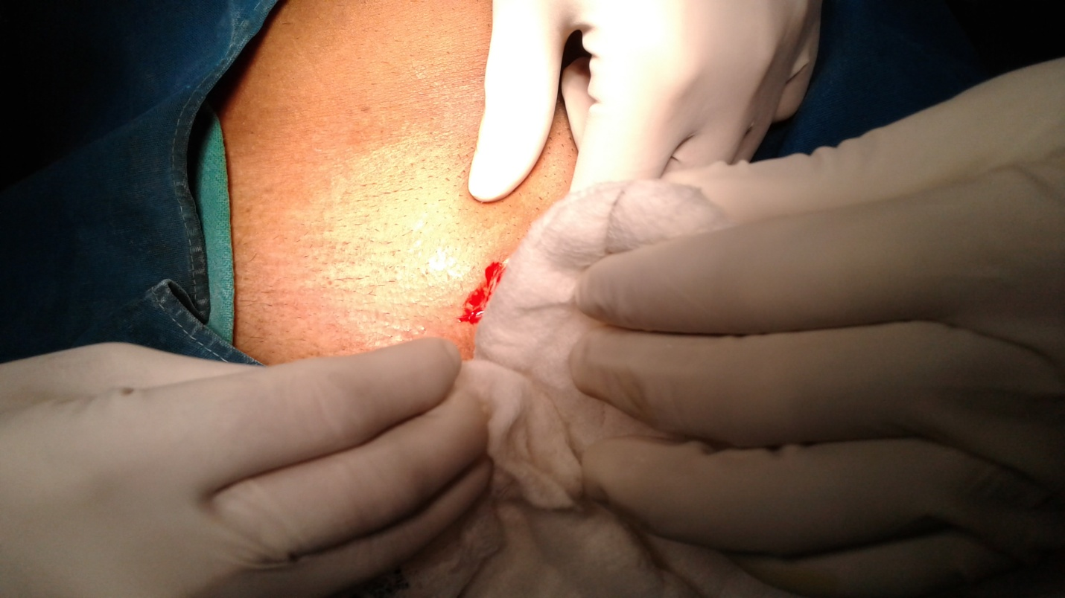

Fig.1. shows the incision just over superficial inguinal ring

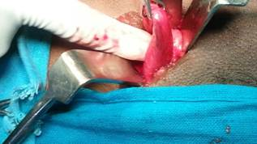
Fig.2. lifting up the cord , retractors in position at superficial inguinal ring.
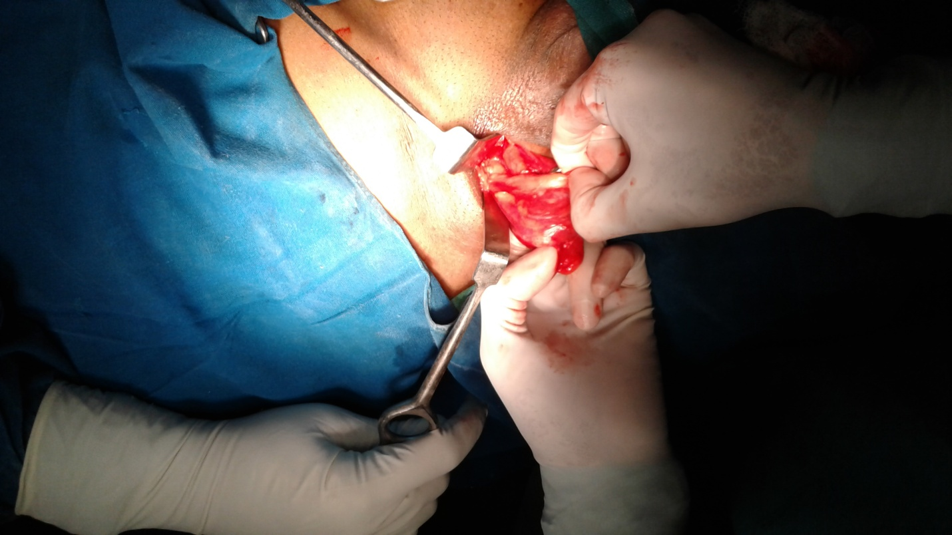
Fig,3. Separating the sac
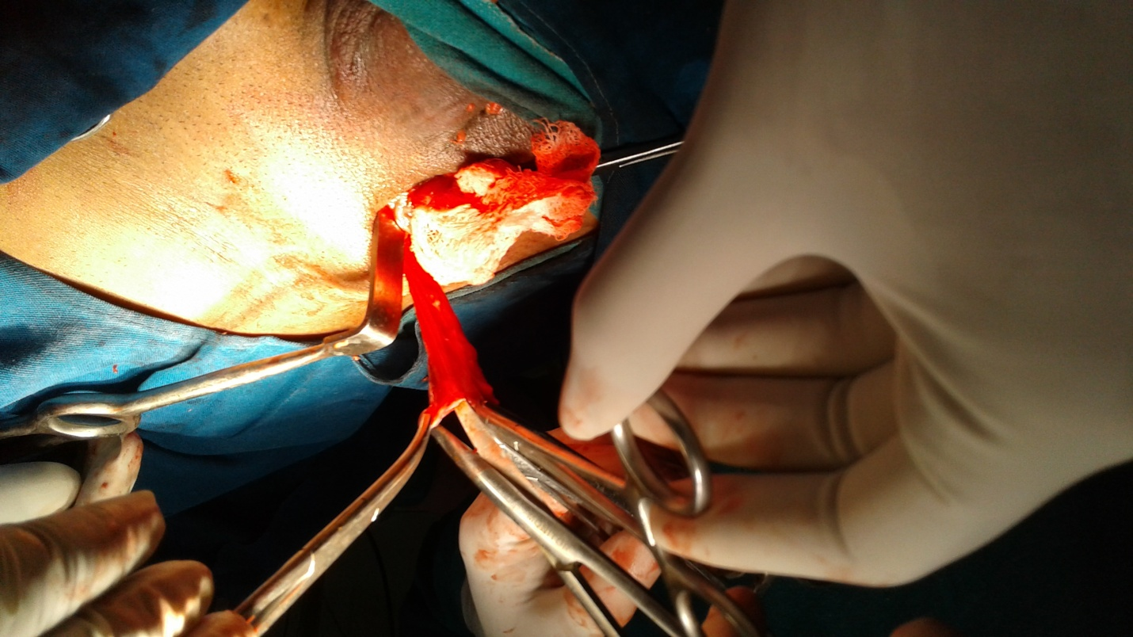
Fig.4. sac separated , ready for ligation and excision
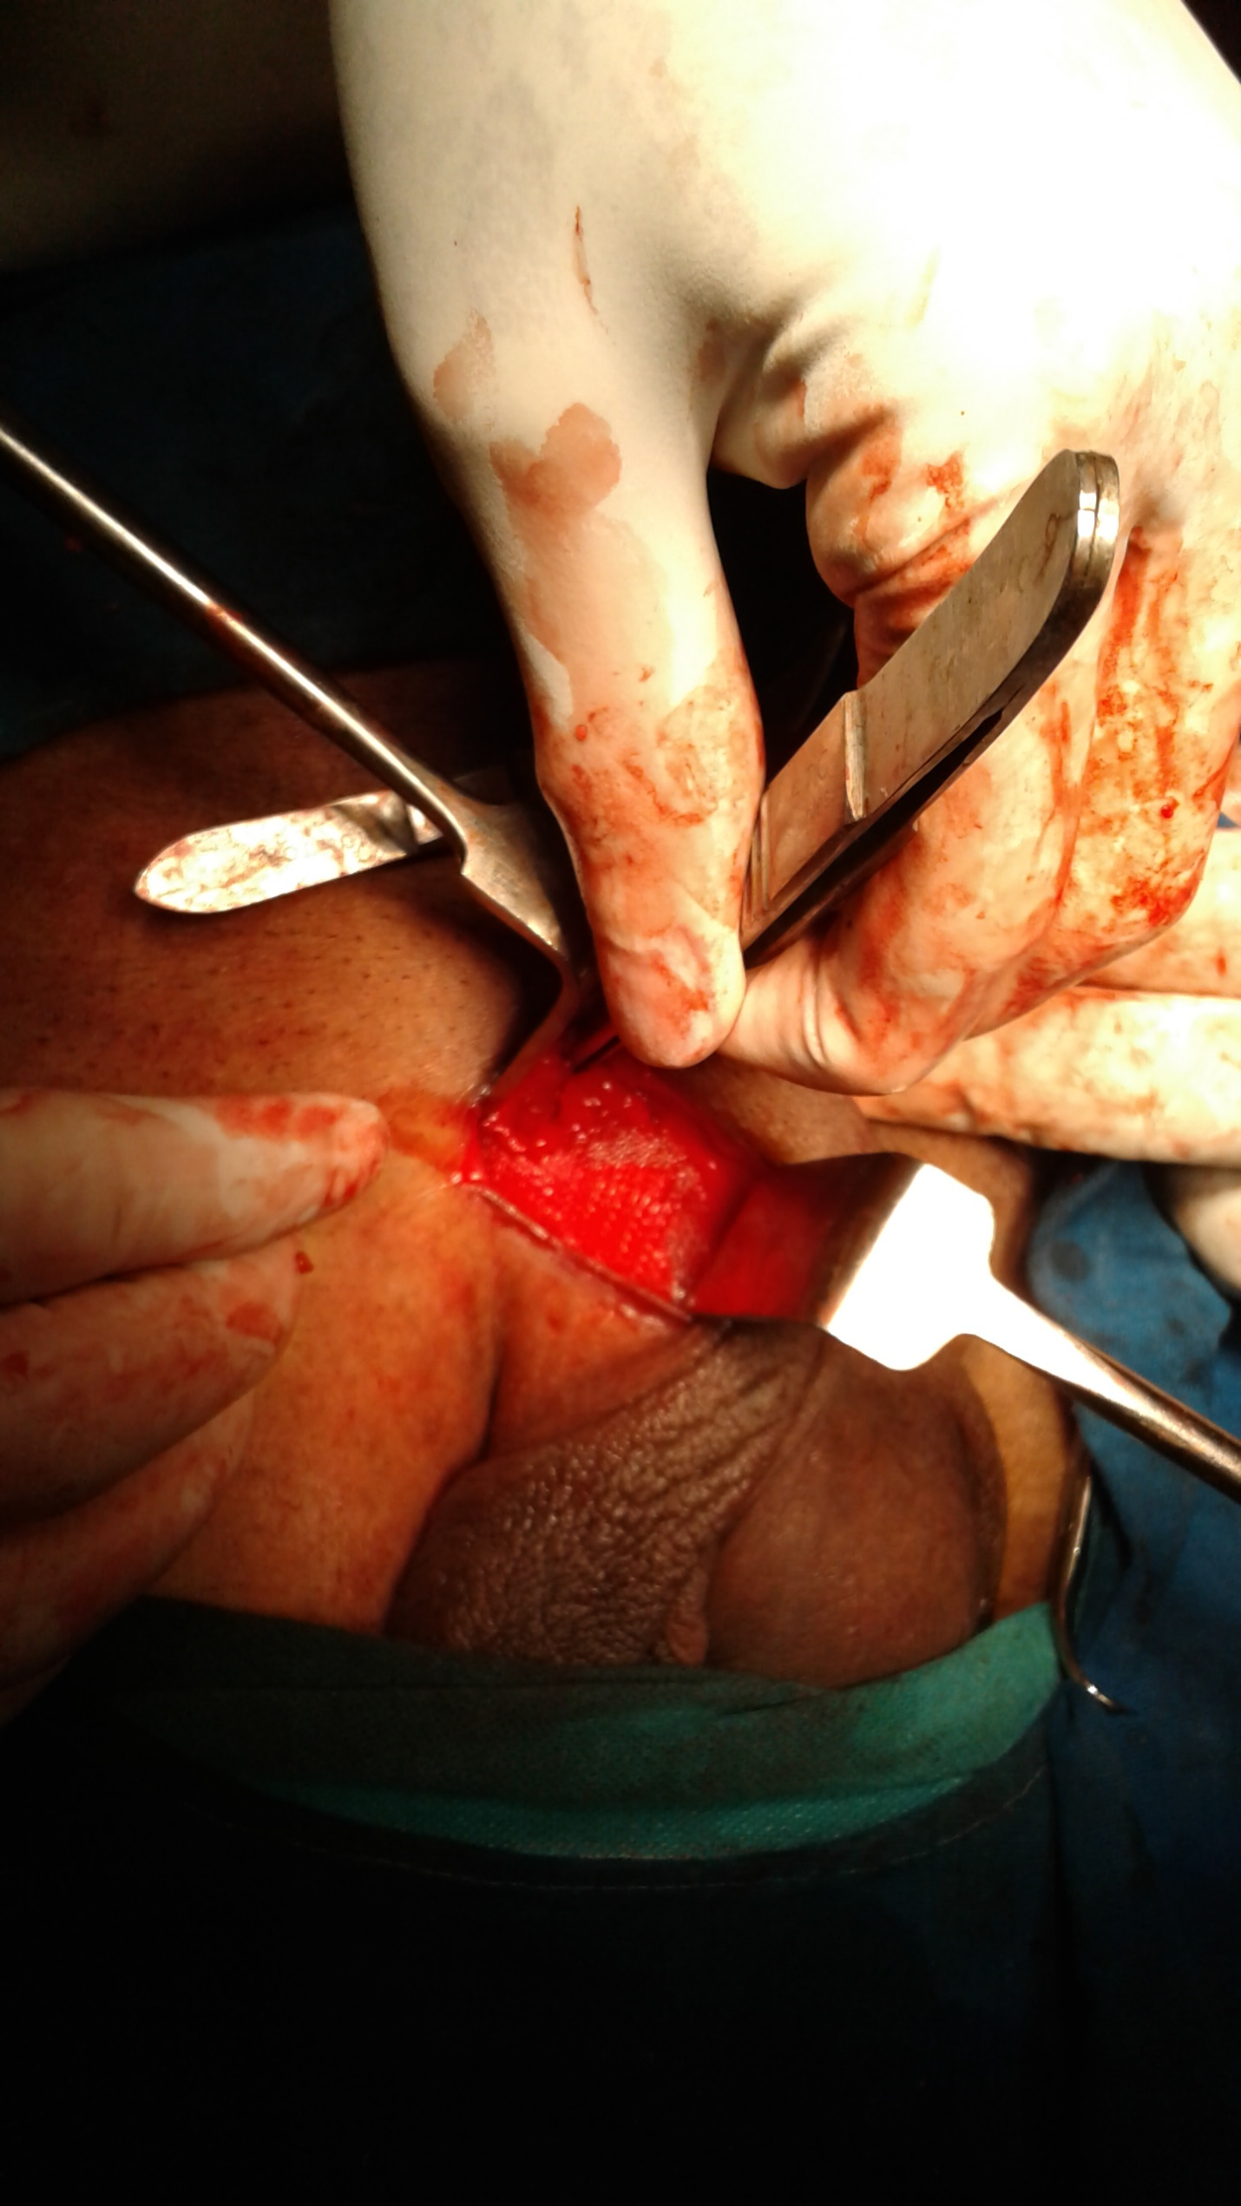
Fig.5, Mesh in position, being fixe
Fig.6.. Skin incision after closure with inch tape in position.
Discussion:

Approximately 75% of abdominal wall hernias occur in the groin. The lifetime risk of inguinal hernia is 27% in men and 3% in women. Of inguinal hernia repairs, 90% are performed in men and 10% in women. The Lichtenstein tension-free repair has become the dominant method of inguinal hernia repair. Recognizing that tension in a repair is the principal cause of recurrence, current practices in hernia management use a synthetic mesh prosthesis to bridge the defect, a concept popularized by Lichtenstein. The advantages of this repair were its association with less pain, rapid postoperative recovery, early return to normal activity and very low recurrence rate. Tension-free mesh repair is nevertheless associated with complications such as foreign body reaction, infection, fistula formation, migration, shrinkage, and recurrence. Other complications include skin anaesthesia, bruising and haematoma formation, seroma formation, orchitis and testicular atrophy [5].
. With the advent of the Lichenstein, or tension-free, repair, which utilizes a biologically inert mesh to bolster the body’s soft tissues rather than through rearrangement of the soft tissue itself, recurrence rates dropped even further. However, even with the advance associated with a tension-free repair, the recovery associated with the anterior approach has typically been long and uncomfortable, traditionally incapacitating the patient for several weeks. More recently, a posterior approach, first described by Stoppa has also been used. In the posterior approach, the repair takes place in the preperitoneal space, above the internal inguinal ring, with the mesh material placed entirely within the space. A laparoscopic approach to hernia repair has been developed, modeled on the posterior approach; however, due to high reported rates of recurrence associated with this approach, as compared to traditional anterior approaches, it is usually reserved for treatment of recurrent hernias after an anterior repair[6-10]. Nevertheless, there is evidence to show that in experienced hands, posterior repairs of primary inguinal hernias have success rates approaching that of the anterior approach, with vastly improved postoperative recovery [11-12]. However, the anterior approach method is simple, effective and is associated with a very low recurrence rates (ranging from0 to 2%) and can be performed under local or regional anesthesia. With these important advantages, it is currently the method for the plastic reconstruction of inguinal hernia for the majority of the surgeons around the world. In the anterior approach, the inguinal canal is opened by an oblique inguinal incision of 4-6 cm, starting from pubc tubercle towards the anterior iliac spine. This has remained same for all repairs. To maintain the integrity of external oblique and to prevent injury to nerves ,
A variety of prosthetic mesh is available to the surgeon. The ideal mesh properties are inertness, resistance to infection, molecular permeability, pliability, transparency, mechanical integrity, and biocompatibility. Absorbable mesh does not remain in the wound long enough for adequate collagen to be deposited, while multi-filament mesh can harbor bacteria. Monofilament mesh is the most popular presently in use with the various types of polypropylene having different characteristic advantages [11]. Use of porous mesh (polypropylene) allows a large surface area for in-growth of connective tissue leading to permanent fixation of the prosthesis within the abdominal wall. Intraparietal placement of the prosthesis allows well vascularized, tissue coverage of all aspects of the prosthesis. Fears of complications related to mesh implantation have proved to be without foundation. The use of vacuum drains is indicated in large inguinal hernias in order to minimize hematoma or seroma formation. However, duration of antibiotic use or indication for suction drainage differ among investigators [13-14]. In the present study, polypropylene mesh (monofilament) was used.
To reduce the chance of recurrence, the mesh should extent 2 – 4 cm beyond the boundary of Hesselbach's triangle [10]. The position of the mesh beneath the aponeurosis of the external oblique results in the intra abdominal pressure working in favor of the repair, since the external oblique aponeurosis keeps the mesh tightly in place by acting as an external support when intra abdominal pressure rises. In this procedure, the external oblique aponeurosis was not incised, it was only retracted and thus the the integrity was not disturbed. The mesh was fixed carefully, by the use of Prolene sutures and spread carefully to prevent folding, wrinkling. or curling of the mesh around the cord.
The method is simple, and has many advantages, such as effectiveness, safety, comfortable postoperative course with easily controlled pain, rapid return to unrestricted activities, an impressively low recurrence rate and high patient satisfaction. We have been encouraged by these good results of this procedure in, this study.
The proline mesh used to repair inguinal hernia in the present study is made of a monofilament poly-propylene that does not shrivel in the body due to its double knot structure. Moreover, it does not unravel when cut to fit a particular shape. It increases the strength of the inguinal canal, as a very strong fibrosis reaction occurs along and around the mesh when it is placed in the inguinal region. It has also been observed that in adults with indirect inguinal hernia, the use of mesh prevents the formation of a direct hernia later in life. Rejection of mesh, infection, seroma formation, edema of scrotum, orchitis are other complications. In our study infection occurred in 1 patient and no case of rejection or recurrence was noted during follow-up.
Inguinodynia or chronic postoperative groin pain following mesh repair is due to compression of the ilioinguinal or iliohypogastric nerve or genital branch of genitofemoral nerve between the sutures of the mesh. The pain may last more than 30 days after surgery and interfering with the patients activities of daily living or work activities. The incidence varies from 6-9%. [12-16]. In the present study, only 1 patient, (<1%) had chronic pain. It may be because of less tissue dissection and a few sutures used to fix the mesh.
Although numerous surgical approaches have been developed to treat inguinal hernias, the Lichtenstein tension-free mesh-based repair remains the criterion standard [14-17]. Neverthless transabdominal preperitoneal (TAPP) or totally extraperitoneal (TEP) laparoscopic inguinal hernioplasty may offer specific benefits for some patients, such as those with recurrent hernia after conventional anterior open hernioplasty, those with bilateral hernias, and those undergoing laparoscopy for other clean operative procedures. [18-20]. In view of so many options with varying results, we have tried this mini-incision approach. The main advantages are less dissection, keeping intact the external oblique aponeurosis, and less chances of inguinodynia. However, the incision and approach to open mesh repair of hernia has not changed much. W e tried to approach the hernia through a mini-incision over the superficial inguinal ring , retracted the edges of the ring upward and entered the inguinal canal. There was no difficulty to separate anteriorly and posteriorly from the inguinal canal. When once it is lifted the fingers are passed below the external oblique aponeurosis, the sac is identified in the indirect hernia. It was ligated and excised.. There was no difficulty in dissection, no bleeding . By retracting the superficial ring, the mesh could be easily pushed behind the cord and in front of transversalis fascia, . spread over and sutured. No nerve was in the field of operation and hence inguino dynia or chronic pain does not occur. The mean operation time was 42 minutes. Pain during the post-operative period was of mild nature. Wounds have healed. Only one case of infection was noticd. Therefore, we feel it is feasible for mesh repair to be done withy a mini-incision of 1.5 cm. over the superficial inguinal ring with good recovery.
5.Conclusion
Inguinal hernia mesh repair with a small incision of 1.5 cm. over the external inguinal ring and retracting the edges of the ring give adequate exposure to place the mesh and repair the hernia. Follow- up did not show any recurrence or significant chronic pain.

