GIANT ANGIOMA OF THE PAROTID AREA WITH TEMPORAL AND JUGAL EXTENSION: SURGICAL APPROACH TO A PEDIATRIC CASE.

Mabika Bredel Djeri Djor¹*, Ngoua Lysette¹, Garango Allaye^{1,} N’Guessan N’dia Dominique², Aboulaidad Salma¹, Laarach Mohammed¹, Mansouri Nadia Hattab¹
¹Department of Maxillofacial Surgery, Cadi Ayyad University, Marrakech, Morocco
²Department of Maxillofacial Surgery, Felix Houphouet Boigny University, Abidjan, Ivory Coast
*Corresponding author: Mabika Bredel Djeri Djor, Oral and Maxillofacial Surgery Department, Faculty of Medicine and Pharmacy, Cadi Ayyad University, Marrakech, City Postcode 40000, Morocco. Email address:bredmabika@gmail.com

ABSTRACT.
The management of vascular mass localized in the parotid area with temporal and jugal extension is delicate especially for children. The dissection of the facial or its avoidance and especially the total excision (to avoid the risk of recurrence) may be technically difficult and requires management of an experienced surgeon.
The purpose of this study is to illustrate this through a pediatric clinical case, presenting an original technique by an approach that using an expanded pre-auricular pathway of a cystic lymphangioma localized in the left parotid area with temporal and jugal extension.
Keywords: Cystic lymphangioma, vascular malformation, parotid area, facial nerve, expanded pre-auricular pathway.
INTRODUCTION
Cystic lymphangia, an entity of angiomas, are vascular malformations, congenital abnormalities, resulting from a sequestration of the embryonic lymphatic bag that would gradually fill with lymphatic fluid.
Somatic mutations of stem cells or endothelial cells of placental origin [1-3] could cause them. Skeletal muscular localization account for less than 1% of cases [1]. Those of simultaneous localization of the parotid area with temporal and jugal extension have the particularity of being in direct contact with the facial nerve. The diagnosis is evoked in front of the clinical and radiological arguments and confirmed by the histopathological examination. Its unsightly and functional appearance (pain, dysphagia) must require surgical management, which often poses the problem of risk of haemorrhage and dissection of the parotid.
We illustrate this through this a pediatric clinical case, presenting an original pathway to excision of a cystic lymphangioma localized in the left parotid area with temporal and jugal extension.

CASE REPORT
Observation
A 2-year-old patient, without pathological history or facial trauma in the area concerned, was referred to us for left parotid area tumor evolving since the age of 3months, slow growth, marked by a recent increase in the volume of the tumor with progressive onset of aesthetic discomfort and pain of variable intensity. The patient was in good general condition.
On examination, left parotid area tumor with temporal and jugal extension, covered with apparently healthy skin without collateral venous circulation or cutaneous fistula. It measured 10 cm by 5cm. The mass was bumpy (Figure 1).
The mass was regular, painless, causing significant facial deformity. Its consistency was sometimes hard and sometimes renovating, mobile in relation to the superficial plane. There was no increase in local heat, no facial paralysis, no cervical lymphadenopathy or trismus. She was not swinging nor pulsating. She was not influenced by the subject's effort or position (negative Wattle sign). There was no visual disturbance. Oral examination was normal.
On ultrasound had shown a multilocular image with partitions of varying thickness, with anechoic content (Figure 2.). The CT scan performed one month after panning confirmed the lesions, but more extensive, like homogeneous hyperdense images, occupying the parotid area with temporal and jugal extension without bone erosion or necrotic reworking, with repression of the para-pharyngeal cells and the infra-temporal lodge. CT also excluded the existence of subclinical cervical lymphadenopathy (Figure 3.). At the MRI, tissue injury, parotid, temporal, jugal and para-pharyngeal space, in T2 hyper signal with regular contour (Figure 4.). Faced with these clinical and radiological arguments, the diagnosis of cystic lymphangioma was suspected.
In view a facial dysmorphism, surgical management was indicated. The pre-atrial approach with temporal extension without dissection of the facial, without embolization prior to the excision nor association with another therapeutic modality was of choice.
Surgical technique
The procedure was conducted under general anesthesia with nasotracheal intubation; the patient was placed in a dorsal position with the head resting on a headrest and in external rotation exposing the affected side. The hair was gladly shaved, making sure to clear a hairless area up to 5cm above and in front of the auricle. A wick soaked with Vaseline was placed in the external auditory canal to prevent blood flow. Brushing with povidone iodine. The operative field was extended, leaving the ear free, the temporal fossa above, the forehead, the cheek, the external canthus, and the labial commissure forward and finally the mandibular angle below. The landmarks of the first pathway were the zygomatic arch, temporal vessels, and the mandibular angle.
The incision traces could be drawn at the junction between the skin of the face and the skin of the helix behind a natural fold: it extends from 2 mm below the lower edge of the lobule to 5cm above the root of the helix. From the end of the vertical incision, an incision is deported at 85 ° up and forward in the shaved area for about 5 cm.
Supplementary local anesthesia with 2% lidocaine is infiltrated into the subcutaneous plane to achieve a bloodless dissection field. Before the incision is made, 10 minutes are allowed to elapse after injection of the local anesthesia. The skin is incised by means of an N°15 scalpel blade according to the pre-established design (Figure 5). The subcutaneous plane is then incised, as is the temporo-parietal fascia in the direction of the incision, the hemostasis being ensure by means of a bipolar forceps.
The dissection is performed on a 5cm radius atraumatically using a pair of foamed scissors, and a stripper above the plane of the superficial temporal fascia. This dissection is first conducted above the zygomatic arch, progressing forward to take off a flap that is reclined on 5cm. Then the portion under the zygomatic arch is dissected, in an avascular plane located between the superficial wall of the mass and the fasciocutaneous flap. A flap encompassing the superficial temporal fascia, periosteum, and SMAS is then retracted forward. This flap contains the branches of the facial nerve, which are thus protected. Once the fasciocutaneous flap is correctly retracted forward, the encapsulated mass is exposed (Figure 6). The superficial temporal fascia is incised along a 45 ° oblique line with respect to the zygomatic arch from the upper pole to the root of the zygomatic arch stopping about 4 cm above and in front. A stripper was then introduced under the superficial temporal fascia separating this fascia from the fatty lodge usually present in its splitting around the arch, plunges on the posterior surface of the mass, creating a cleavage plane with the aid of a sharp stripper between the mass at the top and the parotid parenchyma at the bottom. The encapsulated dissection of the mass up to the jugal region carrying some fibers of the masseter muscle continues. Intraoral pressure was used to elevate the lower pole, facilitating dissection and total and almost encapsulated ablation of the bulk mass. Haemostasis of the perforator was progressively ensured on the basis of a bipolar (Figure 7). The parotid fascia and the flap of the superficial temporal fascia provided depression coverage. Adaptive skin resection was performed. Closure was finally made end to end in two planes after hemostasis was assured under drainage (Figure 8).
Result
Postoperative care was simple. The slight edema of the jugal area resolved over time, with preservation of facial symmetry and good mimicry without a facial paralysis and salivary effusion. Postoperative medical treatment consisted of analgesia (paracetamol 60 mg/kg/day for 5 days and then as required), intravenous prophylactic antibiotics for 24 h and then orally for 7 days total (amoxicillin + clavulanic acid 50 mg/kg/day).
A temporal depression was still perceptible. Histopathological examination favoured cystic lymphangioma. No signs of recurrence found at one year.
DISCUSSION
Cystic lymphangioma is an angiomatous malformative entity. Angioma is still used as a generic and non-discriminatory term to describe tumors and vascular malformations. Reference should be made to the classification of the International Society of Study of Vascular Anomaly (ISSVA), Tenth Workshop, Rome 1996. This classification is based on clinical, evolutionary, histological and hemodynamic data [1, 4]. The diagnosis is retained before the evolutionary mode, the clinical radiological and histological characteristics. The treatment is mainly surgical because it makes it possible to acquire a diagnostic certainty thanks to the histological examination, but the injection of ethanol is a good alternative to the surgery of the lymphatic and venous malformations [3]. Several other nonsurgical therapeutic methods have been proposed: cryotherapy, injection of corticosteroids or sclerosing agents, embolization alone, arterial ligation or radiotherapy with controversial results [ 5]. These methods are currently proposed only in case of contraindications to surgery, or refusal of surgery [6]. We have not used these alternatives.
Complete surgical resection, enlarged to adjacent healthy tissue, allows healing. The indication arises in the presence of a large tumor volume, aesthetic and / or functional discomfort, cutaneous necrosis or haemorrhage [4]. For very large lesions (requiring dilapidated surgery) ethanol remains an interesting alternative to surgery, or even in combination with it [7, 8].
The choice of technique was made to avoid the inconveniences of skin incision, parotidectomy and dissection of the facial nerve. Surgical treatment of a vascular mass with facial localization is mutilating and carries risks: major bleeding, especially in very young children, nerve damage, functional involvement by lesion of the facial and stenon [4, 6].
The dissection of vascular malformations and their excision do not present any particular technical difficulties compared to other tumors.
However, when they are much evolved in this parotid area with temporal and jugal extension localization in a child; the dissection of the facial or its avoidance and especially the total excision (to avoid the risk of recurrence) may be technically difficult and requires management by an experienced surgeon.
Several pathways for technique of surgical excision have been described (Figure 9): [11]
-The most used is the external temporo-auricular or temporo-auricular and cervical way. It allows a better surgical exposure, but has several drawbacks: it imposes a parotidectomy with dissection of the branches of the facial nerve [6], exposing to possible postoperative paresis that can last several months; the cicatricial ransom is not negligible.
-Redon classic way but could not meet these requirements view the volume and the extension of the mass
-The endaural route that avoids visible scars in the region of the tragus; however, it carries the risk of stenosis of the external auditory meatus;
- The pre-auricular way: [10]
The pre-tragical incision of the modified Dufourmentel type: it is retro-vascular, traced on the border of the anterior insertion of the auricle, ranging from the lobule of the ear to the root of the helix, following lines of cutaneous tension reproducing in a limited way the approach used in facial lifting [11 ]
- Ginestet type pathway or in a limited lift route (modified Dufourmentel) with the disadvantage of limited exposure: [12]
-The first intraoral approach gives a good cicatricial ransom but to the disadvantage of bad exposure
We use the pre-auricular lift pathway associated with temporal extension slightly modified from the type Obwegeser and meeting two essential criteria:
- Easy access to the parotid area with good exposure of the operating field thus allowing a good exposure of the mass, a bloodless dissection, without lesions of noble elements.
- Minimize morpho-functional sequelae including scar and postoperative cutaneous depression [13, 14].
The excision of giant cystic lymphangioma of the parotid area with temporal and jugal extension by pre-auricular lift associated with temporal extension without facial dissection is possible and does not seem to give more complications than other conventional pathways. The masseterine dissection in front is done avoiding the channel of Stenon. It allows a direct approach with a good individualization of the lesion, a local control of the bleeding and a direct encapsulated excision of the lymphangioma. There is no dissection of the branches of the facial nerve, the scarring ransom less visible. The major risk of this pathway is the injury of the superficial temporal artery or the auriculotemporal nerve, prevented by careful dissection.
This technique was performed in the patient of age 2 years. We have not found age limit in the literature to perform this surgical technique. At the time of drafting this report, the patients have been followed up for an average of 1year, with no relapses or complications.
Postoperative physiotherapy avoids or limits the muscle retractions responsible for limiting mouth opening. Recurrence may occur in cases of incomplete resection [15, 6].
CONCLUSION
This approach, which meets aesthetic and operational safety requirements, allowed us to have a good working day and a comfort for a monobloc excision of the tumor mass avoiding parotid and facial dissection. The treatment of reference obviously remains the surgery because a histological certainty is necessary. Other options therapeutic may be associated with surgery or non-therapeutic such as surveillance (if the clinic and imaging match).
DECLARATIONS
Acknowledgments
No person
Authors’ contributions
All authors made substantial contributions to conception and design of the study and performed data analysis and interpretation
Conflicts of Interest
All authors declared that there are no conflicts of interest.
Financial support and sponsorship
None.
Ethical approval and consent to participate
“Not applicable.”
Consent for publication
“Not applicable.”
REFERENCES
1. Mandel L, Surattanont F. Clinical and imaging diagnoses of intramuscular hemangiomas: the Wattle sign and case reports Oral Maxillofacial Surg 2004; 62:754–8.
2. Herbreteau D, Robier A, Disant F. Hémangiomes et malformations vasculaires superficielles de la tête et du cou. Pathologie vasculaire en ORL. Rapport de la Société française d’ORL et de chirurgie de la face et du cou 2000:405—25.
3. M. Achache, N. Fakhry, A. Varoquaux, B. Coulibaly, J. Michel, A. Lagier, F. Antonini, F. Turner, P. Dessi, A. Giovanni Management of vascular malformations of the parotid area European Annals of Otorhinolaryngology, Head and Neck Diseases, Volume 130, Issue 2, April 2013, Pages 55-60
4. Kanaya H, Saito Y, Gama N, Konno W, Hirabayashi H, Haruna S.Intramuscular hemangioma of masseter muscle with prominent formation of phleboliths: a case report. Auris Nasus Larynx 2008 ; 35:587–91.
5. Su L, Fan X, Zheng L, et al. Absolute ethanol sclerotherapy for venous malformations in the face and neck. J Oral Maxillofacial-Surg 2010; 68:1622—7.
6. Capote A, Acero J, Garcı´a-Recuero I, Rey J, Guerra B, Paz V. Infratemporal-preauricular-cervical approach for resection of a cavernous intramasseteric hemangioma : a case report. J Oral Maxillo-facial Surg 2008 ; 66:2393–7.
7. Collin AC, Viremouneix L, Guibaud L, Breton P. Malformations artérioveineuses intra-osseuses. Rev Stomatol Chir Maxillofacial 2010; 111:11–8.
8. Kang GC, Song C. Forty-one cervicofacial vascular anomalies and their surgical treatment: retrospection and review. Ann Acad Med Singapore 2008 ; 37:165—79.
9. JF.Chassagne, S.Chassagne, JE Bussienne, F.Gimel, E.Simon, JP Fyad, C. Stricker
Chirurgie et rééducation de l’articulation temporo-mandibulaire (en dehors de l’ankylose).
Encyclopédie médico-chirurgicale 22-056-T-15
10. H.Boukari Kit d’auto-apprentissage des voies d’abord latéro-faciale : à propos de 20 cas. Thèse n°78-15, Université Cadi-Aayad, Faculté de médecine et de pharmacie de Marrakech
11. L. Dufourmentel Chirurgie de l’articulation temporomandibulaire Masson, Paris, 1929
12. G. Ginestet Chirurgie stomatologique et maxillo-faciale. Paris: Flammarion, 1963.
13. V. Obwegeser C. Temporal approach to the TMJ, the orbit, and the retromaxillary-infracranial region. Head Neck Surg 1985; 7:185-9.
14. Al-Kayat A, A modified pre-auricular approach to the temporomandibular joint and malar arch. Br J Oral Surg.Bramley P 1979 Nov; 17(2):91-103.
15. Byars LT, Ackerman LV, Peacock E. Tumors of salivary gland origin in children: a clinical pathologic appraisal of 24 cases. Ann Surg 1957; 146:40—51.

Figure Legend
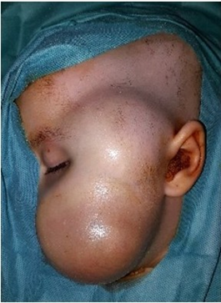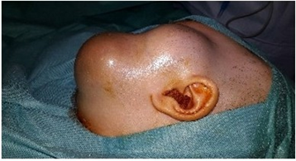
Figure 1. Left parotid area with temporal and jugal mass of bumpy appearance (on operating table).

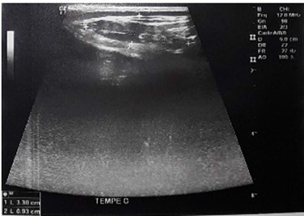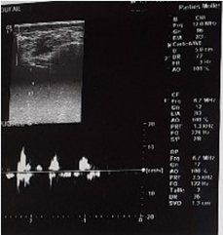
Figure 2. Echography, image multilocular by the partitions of the variable, in contrast to the eyes.

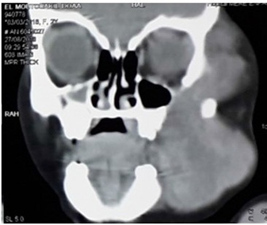
Figure 3. CT in coronal cut, hyperdense tumoral process of vascular appearance prevailing on the parotid area with temporal and jugal extension, and with regular edge.

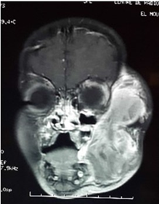
Figure 4. MRI in coronal section, tissue lesion, parotid, temporal, jugal and para-pharyngeal space, in hyper signal in T2 with regular contour.

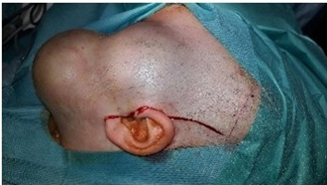
Figure 5. Pre-auricular and temporal skin incision, inspired by the Obwegeser pathway.

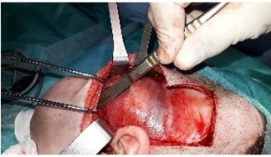
Figure 6. Exposure of the upper lobe of the mass.

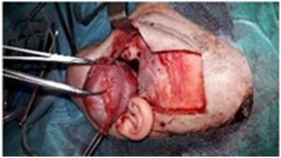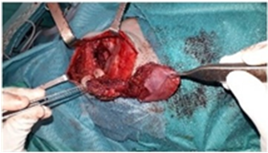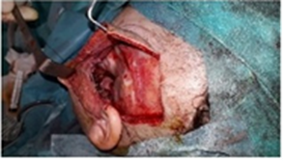
Figure 7. Release of the mass, mass removal of the mass and empty tumor site.

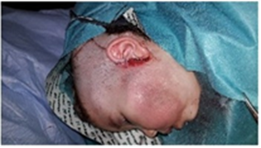
Figure 8. Appearance on operating table after closure under drainage.

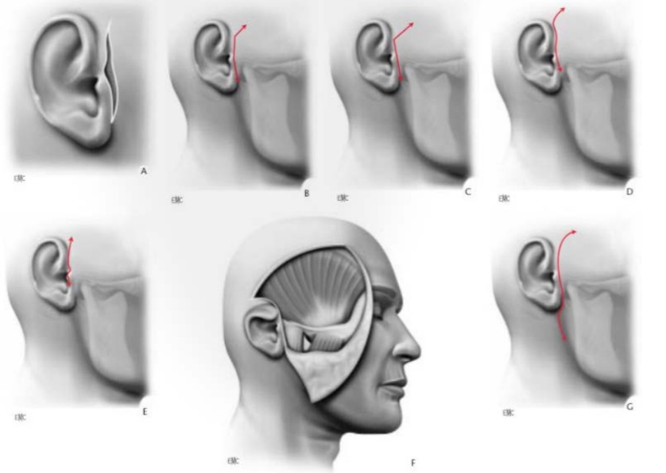

Figure 9: Cutaneous course of the various pre-auricular ways: A: pre-tragic way, B-C-D-E: variants of Dufourmentel-Dingman; F: Obwegeser incision; G: redon incision [9].

