An uncommon cause of intestinal obstruction: Paraduodenal Hernia

ABSTRACT:
Paradudenal hernias are rare causes of small bowel obstruction that constitutes approximately half of the internal hernias. Paradudenal hernias are seen more commonly on the left side when compared to the right side. Computed tomography is an important diagnostic tool in the preoperative evaluation of these patients. We presented a case of a patient who was admitted to the emergency department with the complaints of ileus and diagnosed as paradudenal hernia.
Keywords:İnternal hernia, Paraduodenal hernia

INTRODUCTION:
Paradudenal hernias are rare causes of small bowel obstruction that constitutes approximately half of the internal hernias. Left paradudenal hernias are three times more common than the right ones (1). Computed tomography (CT) is an important diagnostic tool in the preoperative evaluation of patients. Although it is difficult to consider paraduodenal hernias among the differential diagnosis, it is an important clinical presenation that may eventually lead to necrosis of the intestines. Contrasted abdominal tomography is highly effective in aiding the diagnosis. In this article, we present case of a 52-year-old male patient who was admitted to the emergency department with the complaints of ileus and diagnosed as left paradudenal hernia.

CASE REPORT:
A 52-year-old male patient with abdominal pain, dyspepsia and vomiting symptoms exists for the last two days was admitted to the emergency service. He had previously undergone laparoscopic cholecystectomy and had long-term complaints of bloating and vomiting. On physical examination, there was minimal distension in the abdomen, without any muscular defense or rebound. In the laboratory tests white blood cell count was 7000 / μL hemoglobin 15 g / dL., routine biochemistry and bleeding time values ​​were within normal limits. Direct abdominal x-ray showed small bowel-type air-fluid levels. Contrast abdomen tomography showed that the small intestine was leveled and collected in an area such as in a sac (Figure 1a).Vascular structures in hernia sac extends to the hernia neck(Figure 1b)..
Figure 1a Figure 1b.
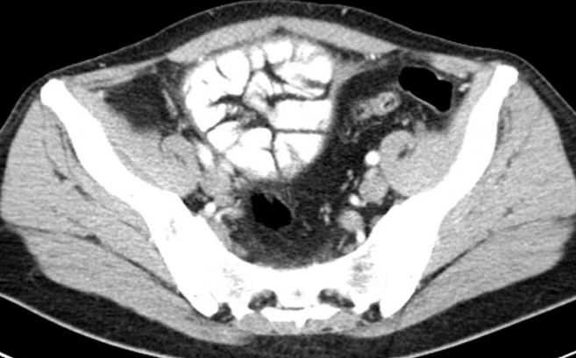
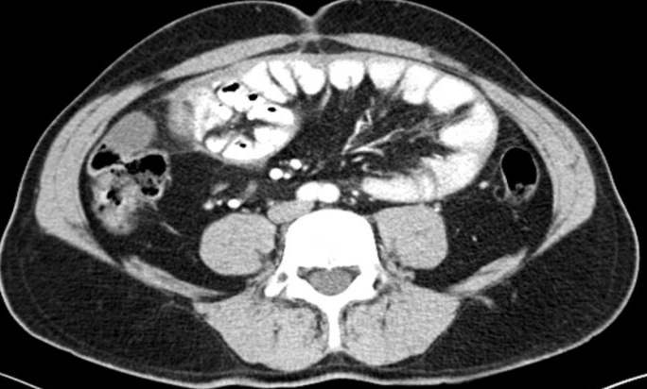
F

Figure 1: Contrast abdomen tomography showing (a) leveling, enlargement of the small intestine and collection of the intestines in an area such as in the sac.,(b) vascular structures extending to hernia neck.

The patient was hospitalized with the diagnosis of intestinal obstruction. During follow-up, his complaints did not regress and he was taken to the operation. The operation revealed that all small intestines were covered with a peritoneal membrane and herniated into the left paraduodenal space (Figure 2). The hernia sac was opened and intestines were mobilized. The blood supply to the intestines was normal.Peritoneal gap was closed(Fig. 3). The patient was discharged on the postoperative 4th day.

Figure 2: Figure 3:
İntestines are covered with hernia sac After the hernia sac opened and
intestines mobilized.

DISCUSSION:
Internal hernias are defined as the herniation of the internal organ from a congenital or acquired cavity in the abdominal cavity. According to Hansmann and Morton’s study on 967 cases, the internal hernias are divided into 7 main types by its location: paraduodenal, foramen of Winslow, pericecal, intersigmoid, transmesenteric, transomental and retroanastomotic (2). In addition, Liew and colleagues identified 25 different internal hernias according to their anatomical location (3).
Paraduodenal hernias are a subgroup of internal hernias, constitute 50% of internal hernias and 1% of small bowel obstruction. Firstly Andrews pointed out the congenital malrotation occurred in paraduodenal hernias (4). Paraduodenal hernias are divided to two groups as right and left. In paraduodenal hernias, herniated abdominal content in retrocolic area named as fossa of Waldeyer at right , fossa of Landzert at left. Paraduodenal hernias are generally seen in the 4th and 5th decades of life, more frequent in males and occurs three times more commonly on the left side (5)..
Clinical manifestationsinclude cramp-style pain, nausea, vomiting, distension, and clinical conditions ranging from ileus to shock due to herniated bowel segment. Until 50% of the patients are diagnosed, there is a history of intermediate ileus and the other 50% group is diagnosed incidentally (6).
Radiological evaluation is very important in the diagnosis. Air-fluid levels can be seen at direct X-ray. In the barium examinations, dilated loops of small intestine at the proximal of the obstruction can be seen and slowed barium passage in the obstructed area can be noted. Arteriographs can show left deviation of jejunal or splenic artery. Ultrasonography may show an increase in thickness in small bowel walls or intraabdominal fluid. On computed tomography, the findings can be detected such as collecting the intestines form as mass without capsule and the right or left deviation of the veins at the level of the hernia neck(7). Although the imaging modalities are helpful, the findings of paradudenal hernia were shaped within the framework of the ’Classic Empty Abdomen Sign’ which was defined by Kummer in 1921 as the well-defined mass formed small intestines without passage of intestines to the real pelvis standing at upright position (8).
As surgical approach, open surgery technique is mostly used, but there are studies about laparoscopic approach (9). In operation, dilatation of the hernia neck or emptying of the content within the hernia sac with closure of the hernia neck can be applied. Additional surgical procedures may be required depending on the condition of the hernia. Since the hernia neck may be adjacent to right / left colic arteries, celiac artery and celiac vein, attention should be paid to the vascular structures mentioned above during the surgery (9).
Left paraduodenal hernias should be treated surgically as soon as they are diagnosed since they have the risk of intestinal ischemia associated with obstruction and strangulation(10).

COMPLIANCE WITH ETHICAL STANDARDS

The authors declare that they have no conflict of interest.

REFERENCES:
- Atasoy G,Temiz A, Albayrak Y, Yalcin A (2017) A rare case of left paraduodenal hernia: A case report. Arch Clin Exp Med 2(2):55-57.
- Hansmann GH, Morton SA (1939) Intraabdominal hernia: report of a case and review of the literature. Arch Surg 3:973-86
- Liew KL, Choong CS, Shiau GF, Yang WC, Su CM (1999) Descending mesocolon defect herniation: case report. Changgeng Yi Xue Za Zhi 22:133-7
- Andrews E (1923) Duodenal Hernia, a Misnomer. Surg Gynec Obstet 37:740
- Manji R, Warnock GL (2001) Left paraduodenal hernia: an unusual cause of small-bowel obstruction. Can J Surg 44:455-7
- Huang YM, Chou AS, Wu YK, Wu CC, Lee MC, Chen HT, Chang YJ (2005) Left paraduodenal hernia presenting as recurrent small bowel obstruction. World J Gastroenterol 11:6557-9
- Blachar A, Federle MP, Dodson SF (2001) Internal hernia: clinical and imaging findings in 17 patients with emphasis on CT criteria. Radiology 218:68–74
- Kummer E (1921) Signes radiologiques de la hernie interne duodenojejunale. J Radiol Electrol 5:362–8
- Parmar BPS, Parmar RS (2010) Laparoscopic management of left paraduodenal hernia. Journal of Minimal Access Surgery 6(4):122-124
- Al-khyatt W, Aggarwal S, Birchall J, Rowlands TE (2013) Acute intestinal obstruction secondary to left paraduodenal hernia: a case report and literature review. World J Emerg Surg 8:5

