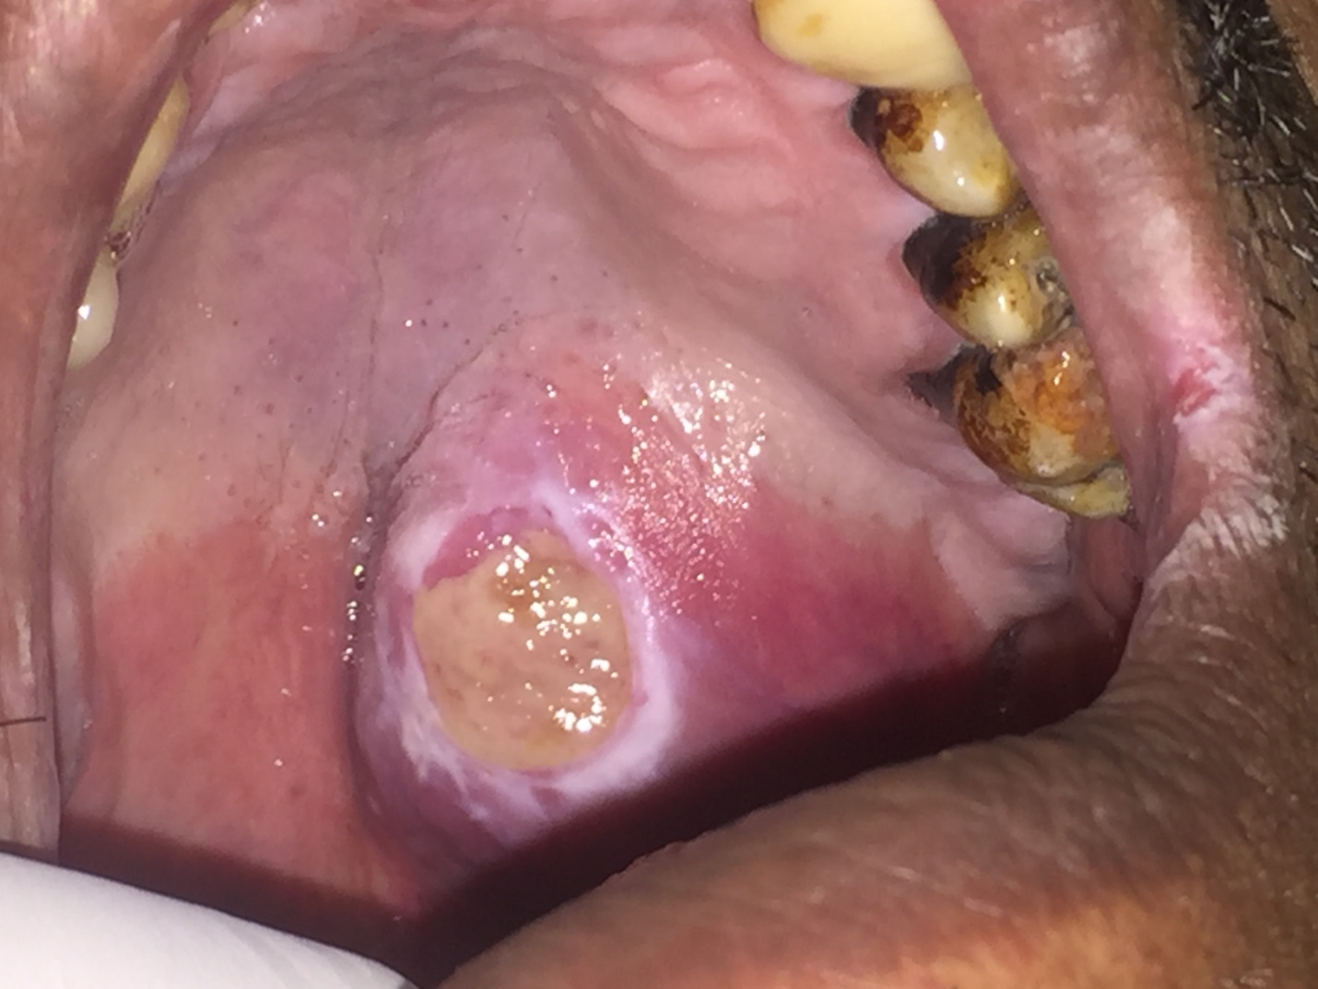
Fig 1:(A) intra oral clinical photograph showing 3x3 cm tumor mass on the left side at the junction of hard and soft palate with central superficial ulceration.

A
B
Fig 1:(A) axial and coronal MRI of palatal mass showing well defined homogenous mass with marked palatal bone resorption. (B) Coronal MRI of parotid gland showing well circumscribed 2x2 cm mass in superficial lobe accidentally discovered.

