Efficacy of pedicle fixation and debridement and inter body fusion performed for lumbar spine bone tuberculosis
Dipendra Gurung (orthopaedic/MS), She Yuan ju (Head of the department of orthopeadic/Spine)
(Jingzhou Central Hospital, Orthopedics Department, Jingzhou, Hubei 434000,
PR China)

ABSTRACT
OBJECTIVE: To determine the efficacy of surgical approach of Tb spine with posterior pedicle fixation along with debridement and Allograft.
MATERIALS AND METHOD: -
This is a retrospective based on the study of total 38 patients with Lumbar TB spine conducted in Central Hospital of Jingzhou, orthopaedic unit from January 1 (2013 ) to January 11 (2014) . We performed a surgery of posterior pedicle fixation , radical inter body fusion, along with debridement and posterior strut grafting Patients were postoperatively followed for 6-18 months in our outpatient department.
RESULTS:
All the patients with sign and symptoms of tuberculosis was cured and significantly showed the improvement of the neurological functions and spinal stability by posterior pedical screw instrumentation and one staged radical interbody fusion along with debridement and strut grafting. The allograft material was preserved without being insignificantly damaged. The bony fusion showed average five month to fuse and there was no any loosening of internal fixation and no breakage of internal fixations .There was no loss of vertebral height and spinal deformity, the average correction the cobb angle was around 12° postoperatively.

CONCLUSION:
Posterior pedicle fixation and debridement of tuberculosis spine surgery is safe and effective, the surgical method of choice should be based on segmental lesions, abscesses in front of a comprehensive range of other factors to judge.
Keywords: spinal tuberculosis; debridement; posterior fixation; bony fusion

INTRODUCTION
- In recent years, the incidence of spinal tuberculosis is becoming higher, and drug-resistant TB is growing [1], today on the basis of combination chemotherapy, the treatment of spinal tuberculosis has been as a boon for surgical treatment, which includes debridement for abscess and segmental lesions and reconstruction of spinal stability. In 1782, sir cercival Pott described spinal TB and surgical treatment of paravertebral abscess. Hence, spinal TB was called 'Pott's Disease. According to WHO (2006), about one third of the worlds population is infected by Mycobacterium TB, and 9 million indviduals develop TB each year. (1) Spinal TB accounts for 50% of the cases of skeletal TB, 15% of the case of extrapulmonary TB and 2% of all cases of TB. (2). Spinal tubercular infection is the most common and dangerous form of skeletal tuberculosis . It constitutes to 1/2 of all bone and joint tuberculosis. It is a result of hematogenous dissemination from primary focus in the lungs, lymph nodes, etc. (3). Thoracic and lumbar spine are commonly affected area. 10-40% of patients with thoracic spine tuberculosis may get neurological deficit. Urgent measures are needed to halt progression of destruction and deformity and especially to prevent and overcome paraplegia. Proper selection of drug therapy and operative modalities, however, is needed to optimize functional outcome for each individual case of Pott’s disease (3) . Tubererculosis of the spine, if not treated adequately, may cause serious sequelae. These include the importance of early diagnosis in order to prevent and, if necessary to treat kyphotic deformity, the principles of treating non-complicated and complicated cases, the diagnosis and management of atypical presentations ,the management of the sequelae of severe kyphotic deformity and the emergence of multidrug resistance. (4) Granulomatous infections of the spine, tuberculosis being the most common, readily infect the vertebral bodies and discs, with more than 50% of tuberculosis infections of bone occurring in the spine. The onset is insidious, with destruction of the vertebral bodies, discs, and ligaments if the disease progresses unchecked by medical and surgical treatment. As structural stability is destroyed, kyphosis combined with inflammatory debris and necrotic material can cause progressive paraplegia. Therefore, in the treatment of spinal infections, it is critical to make the diagnosis early so that antibiotic therapy or surgical debridement and fusion can be done before bony collapse and neurologic compromise occur. .

- There are different following techniques that are used for the treatment of TB spine surgery
1)Posterior decompression,debridement and fusion with bone autografts,
- 2) Anterior debridement/ decompression and fusion with bone autografts,
- 3) Anterior debridement/decompression and fusion, followed by simul taneous or sequential posterior fusion with instrumentation,
- 4) posterior fusion with instrumentation, followed by simultaneous or sequential anterior debridement/decompression and fusion.
- The combination of both posterior and anterior instrumentation has been reported for better outcome.so this study was conducted to find the benefit of posterior pedicle screw fixations and one staged radical interbody fusion along with debridement and bone strut grafting method for lumbar spinal TB.

MATERIALS AND METHODS:
Data collection:
Data were collected for all the patients with lumbar spinal TB who admitted in our jingzhou central hospital orthopedics department from January1 2013-january 11 2015 .There was total 38 patient admitted with lumbar spinal TB.There was total 4 cases of single vertebral tuberculosis at L3 ,11 cases of single vertebral tuberculosis at L4, 12 cases of single vertebral tuberculosis at L5 and 11 cases with psoas abscess and presacral abscess. The Kyphotic angle(cobb angle ) measured in all 38 patients was of 10 ° ~ 32 °, 20 °We did posterior pedicle screw fixation ,debridement and one staged radical interbody bony fusion. The bony strut graft materials were used and an internal fixations Beijing Fuller's pedicle screws and along with titanium mesh cage.

1.2 Preoperative preparation-
All total 38 Patients were admitted to our jingzhou central hospital ,orthopedic department and was kept on strict bed rest, with continuation of regular nutrition, regular quadriple antituberculosis therapy (isoniazid, rifampicin, streptomycin, ethambutol) for more than 4 weeks. Chest X-ray, ,erythrocyte sedimention rate ,C-reactive protein was done to exclude active tuberculosis and acute miliary tuberculosis. Magnetic resonance image inspection was done to evaluate the degree of spinal compressions .Routine Preoperation investigation including complete blood count ,liver function test, renal function test, electrocardiogram was done and all were within the normal range.

1.3 Surgical method
The lumbar spine TB operation was performed under General Anesthesia. The Foleys cathether was kept in advance to empty the bladder. The patients were kept in Prone position with bolster keeping longitudinally under it and keeping the shoulder abduction and little forward to keep the brachial plexus free and keeping the eyes safe and the abdominal muscles letting free to avoid the venous return to the spinal cord,with the knee and elbow padded to prevent from median nerve and common fibuar nerve injury.Painting done with betadine and draping was done under aseptic condition . The image intensifier C-arm positioning were fixed to see the appropriate level for the pedicle screw fixations- We performed with the dorsal longitudinal midline incisions around 6-10 cm to expose the bony verterbral aspects by separating the periosteal muscles primarily lattisimus dorsi, and subperiosteal muscles secondarily. The pedicle screw we choose the bejing fullers pedicle screws was 6.5*45mm in diameter.
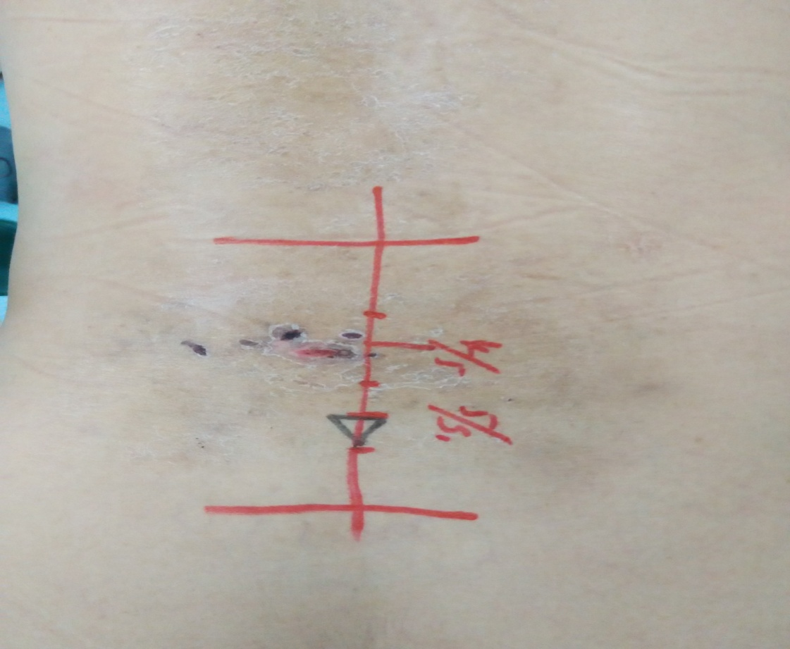
Picture A-Landmarking done for the mid longitudinal line incision lumbar aspects-
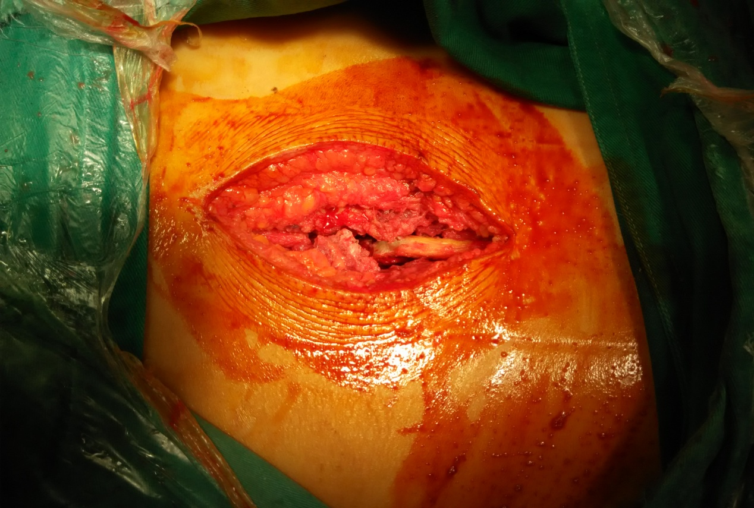
Picture B-Midline incision around 7-10 cm for the posterior approach

-Screw Insertion done -
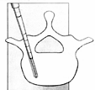
.
Step 1: Entry site is decorticated using a burr and a high-speed drill or a rongeur.
Step 2: Burr or awl is used to penetrate the dorsal cortex of the pedicle.
Step 3: Curved or straight pedicle probe is used to develop a path for the screw through the cancellous bone of the pedicle into the vertebral body.
Step 4: After cannulation, the pedicle sounding probe is placed into the pedicle that is then palpated from within to make sure there is not a medial, lateral, rostral or caudal disruption in the cortex of the pedicles.
* sound is also used to determine that there is bone at the bottom of the pilot
hole verifying that penetration of the ventral cortex of the vertebral body has
not occurred.
Step 5: After pedicles have been probed,:
a. Steinman pins or K-wires bilaterally or unilaterally into the pedicles to confirm the the trajectory and entry site was kept and then
b. tap the pedicle screw path if non-self tapping screws are used; then
c. place the permanent screws with the longest diameter that will not fracture the pedicle.
* length of the screw can be determined by measuring the length of t he Steinman pin/
K-wire/pedicle probe from the pedicle entry site to a depth of 50-80% of the
vertebral body.
* the screws in the lumbar spine usually have a 4.5 to 7 mm diameter and a 35-50 mm
length.
Step 6: After pedicle screw placement, the transverse process and the lateral aspects of the facet joint are decorticated, screws are connected to a longitudinal constructions
After than we connected the rods between the Beijing fullers pedicle screws within the appropriate arcs bringing into moderate distraction, correcting kyphotic angle , restoring vertebral height and laminectomy was performed to expose the spinal canal, protecting bilateral nerve root and dural sac through bilateral spondylolysis root resection of the front side and the upper and lower vertebral disc tissue, bleeding was arrested with cotton patties dissolved in thrombin gel, irrigation and debridement was done to clear the front of the segmental abscess, with isoniazid and hydrogen peroxide repeatedly within the segmental lesion site. We also prepared for the interbody fusion with bone graft material. After the measurement of vertebral lesions and down the pitch, the accurate length of titanium mesh cage, was made and was fused between the two adjacent vertebrae. Streptomycin powder was used to irrigate the wound. After the operation Indwelling drainage tube was used and the wounds was closed with sutured materials and was closed in layers.

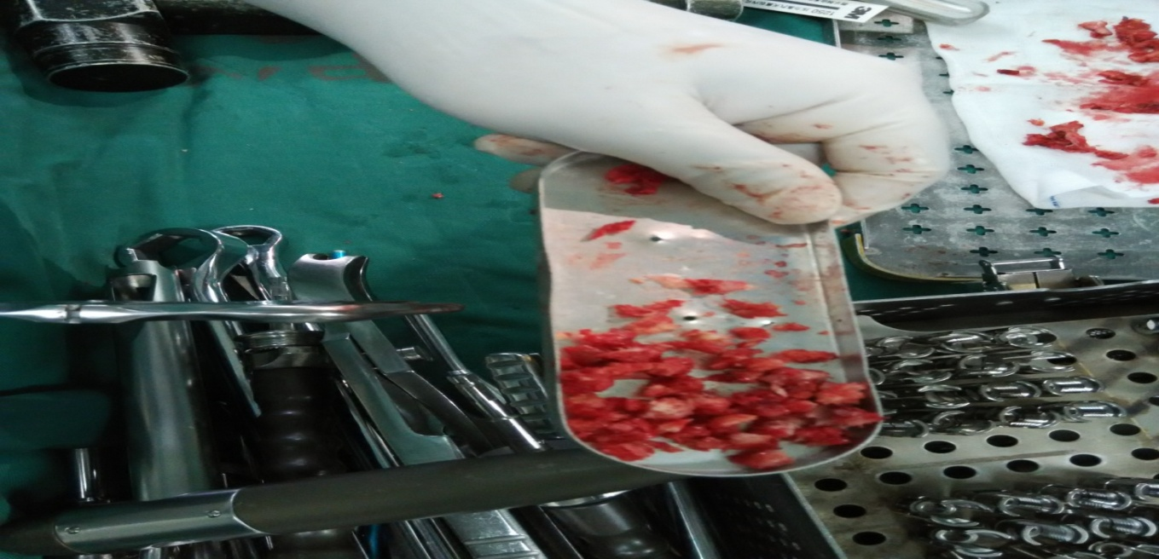
Picture C-Allograft bone graft material taken for bone fusion.

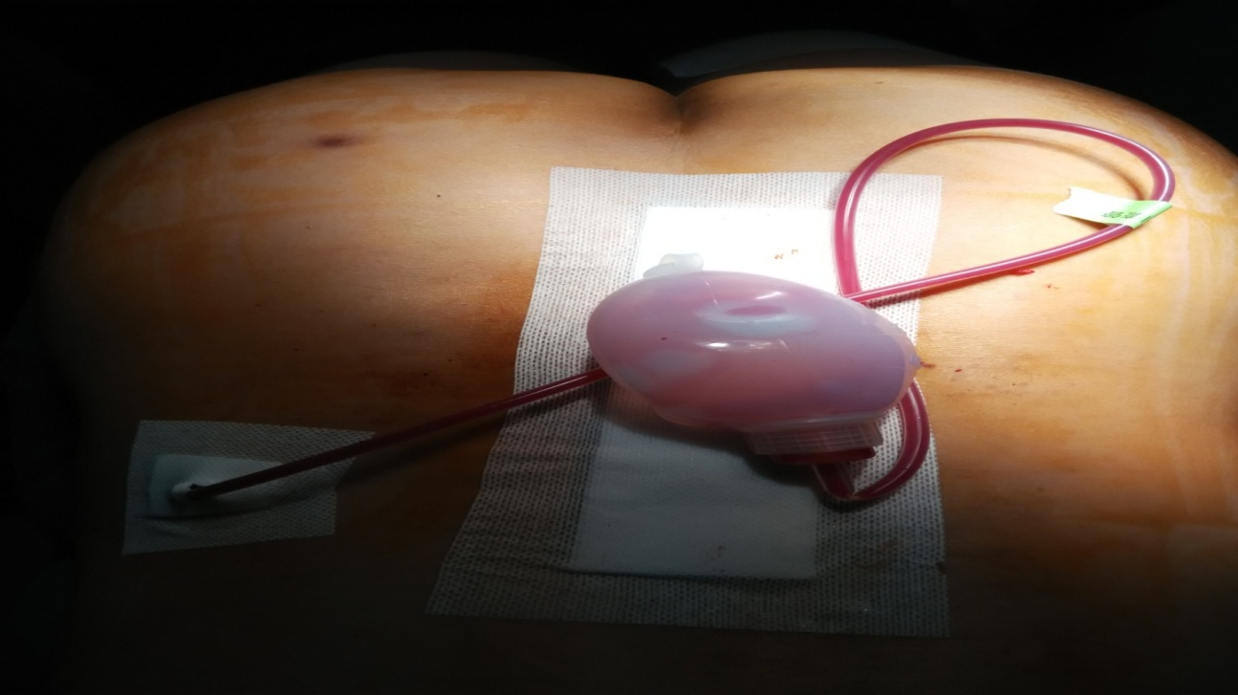
Picture C- After one staged radical debridement and posterior instrumentation ,indwelling drainage tube kept and wound closed in layers with non absorbable suture.

Diagnosis criteria
A history of tuberculosis, a positive skin test, and an elevated erythrocyte sedimentation rate (ESR) is useful in the diagnosis of spinal TB. Biopsy plays a valuable role in the diagnosis of spinal TB infection. The use of DNA amplification techniques (polymerase chain reaction or PCR) may facilitate rapid and accurate diagnosis of the disease . Culturing the organisms is slow and may be inaccurate. Mycobacterial infection as well as fungal involvement should be considered in these cases. Computed tomography (CT) provides bony detail, while MRI evaluates the involvement of soft tissue and abscess formation. The relative preservation of the disc, rarefaction of the vertebral endplates, anterior wedging, the presence of separate pre- and paravertebral or intra-osseous abscesses with a subligamentous extension and breaching of the epidural space, concentric collapse of vertebral body, ivory vertebra which is seen at conventional radiographs and refers to an increase in opacity of a vertebral body while preserving its size and contours (with no change in the opacity and size of adjacent intervertebral discs), neural arch tuberculosis, circumferential or pan vertebral involvement, extradural tuberculoma, subdural granuloma, intramedullary tuberculoma, and multilevel spinal TB are considered as the diagnostic clues for this disease in various imaging modalities. Significant bone destruction can be detected on plain radiographs or CT scan. Among the various types of imaging modalities, MRI has the ability to diagnose the disease earlier and more accurately than plain radiographs . Although not specific to spinal TB, there is a decrease in signal intensity of the involved bone and soft tissues on T2-weighted images and the increase in intensity of a uniform thin rim enhancement is a pathogenomic finding suggesting either caseation necrosis or a cold abscess in tuberculosis . In the evaluation of spinal TB with isolated involvement of the posterior elements, MRI is also useful in diagnosis and assessment of the treatment response .

Exlcusion criteria-
Patients with major cardio vascular ,respiratory and renal problems were excluded along with decreased bone densitometry ,inflammatory arthritis for pedicle screw fixation and one staged radical interbody fusion along with debridement.

Evaluation criteria:
Standard cure for spinal tuberculosis [2] :
( 1)There was no fever ,no local pain ,appetite normal ,and range of motion of spine was normal after the antitubercular drugs for six months..
(2) The Erythro sedimentation rate reviewed several times was within the normal range.
(3) x-ray showed fusion of the two adjacent vertebral body, the implant bone grow well. Lesions outline was all clear, no abnormal shadows was seen.
(4) The normal activities was all resumed and mild activites could be performed within 3 to 6 months .

RESULTS:
There was total 38 patient admitted with lumbar spinal TB. Among them there were 9 male patients and 18 female patients. The both sexes of patients aged ranged from aged 22 to 55 years and their mean aged was around 36.5 years. 27 cases(71.05%) had good surgical incision healing, there were no local sinus formation; followed for 6 to 18 months, an average of 10 months without recurrence of symptoms of tuberculosis, erythrocyte sedimentation rate in the normal range, x-ray showed the fusion of the adjacent vertebral body. The radiologic observation: for titanium mesh cage plant showed no change in bone mineral density within the location, the integration of trabecular bone callus area or adjacent vertebral bone healing was significant. The average healing time was 5 months, there was no loosening of pedicle screw and rods ( internal fixation loosening) and breakage of internal fixations. There was no loss of vertebral body height, normal physiological curvature of the spine was observed ; spinal deformity varying degrees of improvement was observed,the average correction kyphotic angle was 12 °; According to standard postoperative neurological Frankel I grading all the deformity was within the level of improvement and within a fixed set of CT proved complete decompression, spinal fully restored patency.

RADIOGRAPHIC EVIDENCES
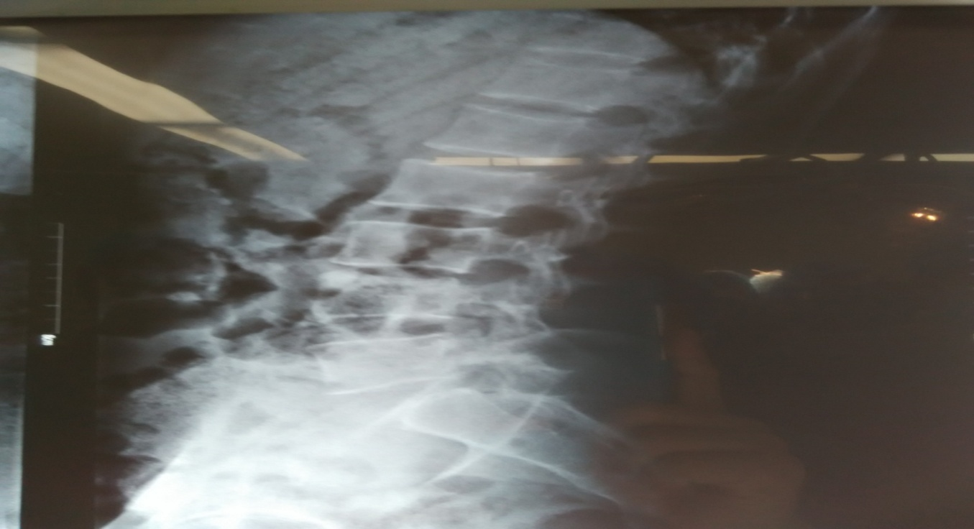
(Figure A)-Preoprative image - X-ray lateral view lumbar spine.The Lumbar L3—L4 verterbral body has loss of superior and inferior height with the osteoporotic changes and loss of concavity structure is lost in L-5 vertebrae.

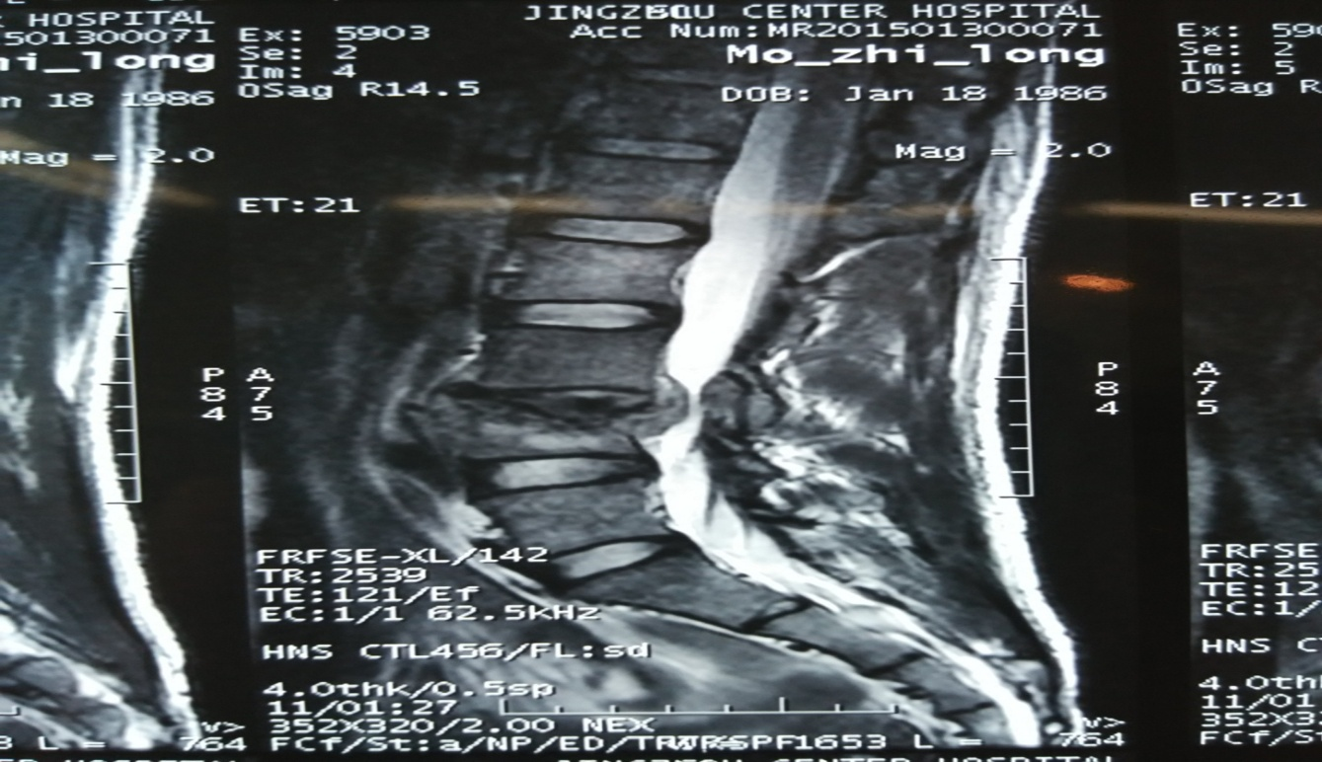
Figure B( preoperative image)-Magenetic resonance image-The T2 wieghted image of lumbar spine MRI(magnetic resonance image) shows the vertebral body destruction L 4 with the bony spur impinging on the nerve root canal and compressing the nerve root.
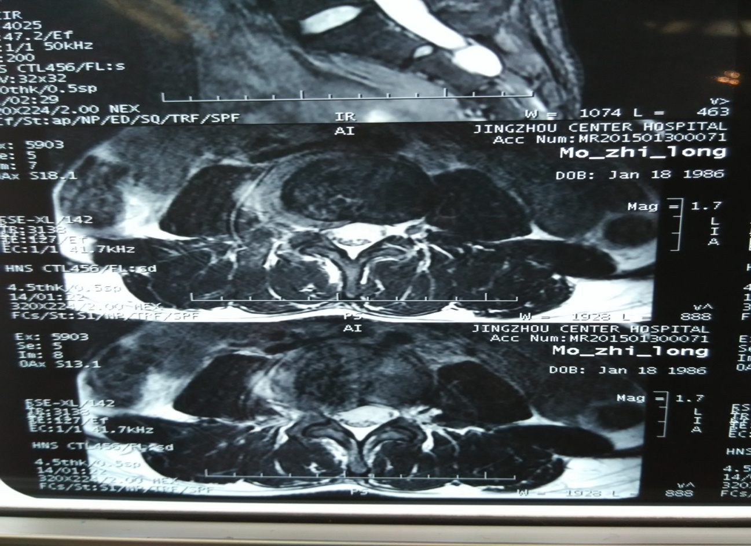
Figure C-Preoperative Image (MRI)-axial view of lumbar spine ,the bony spurs at the posterior side is compressing the dural sac at the right side of the posterolateral zone.

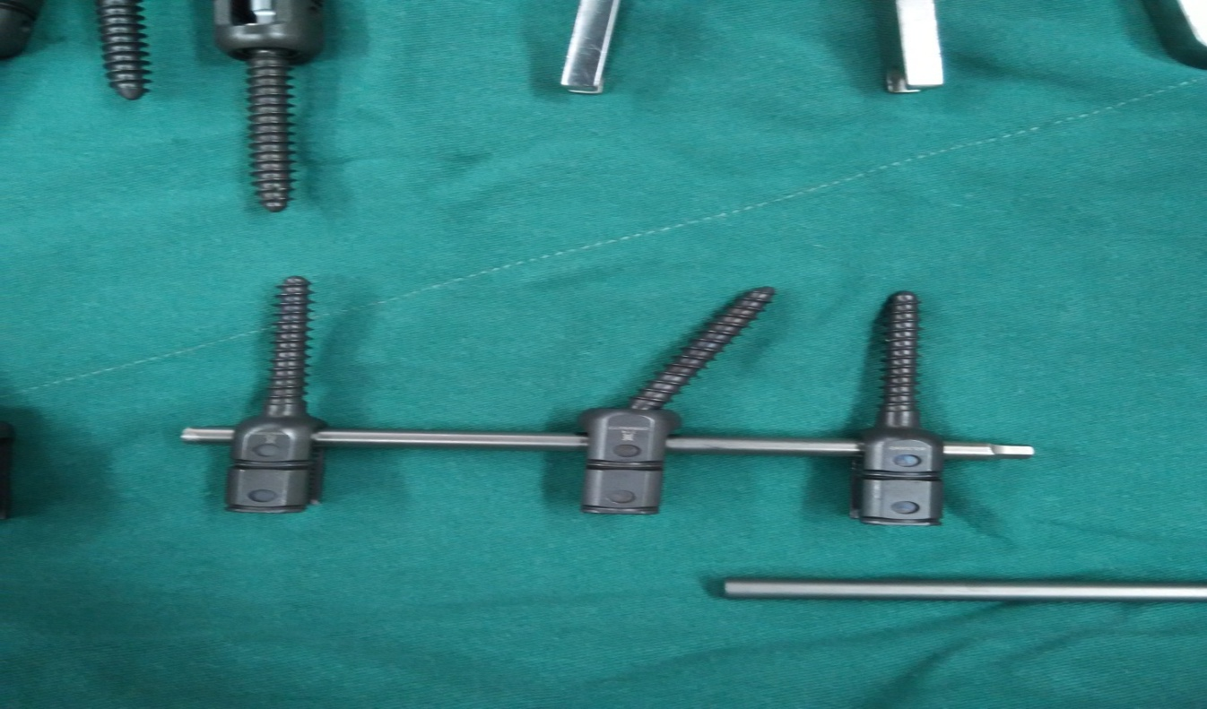
Figure D- pedicle screw (6.5*45mm) was used for posterior instrumentation in lumbar TB

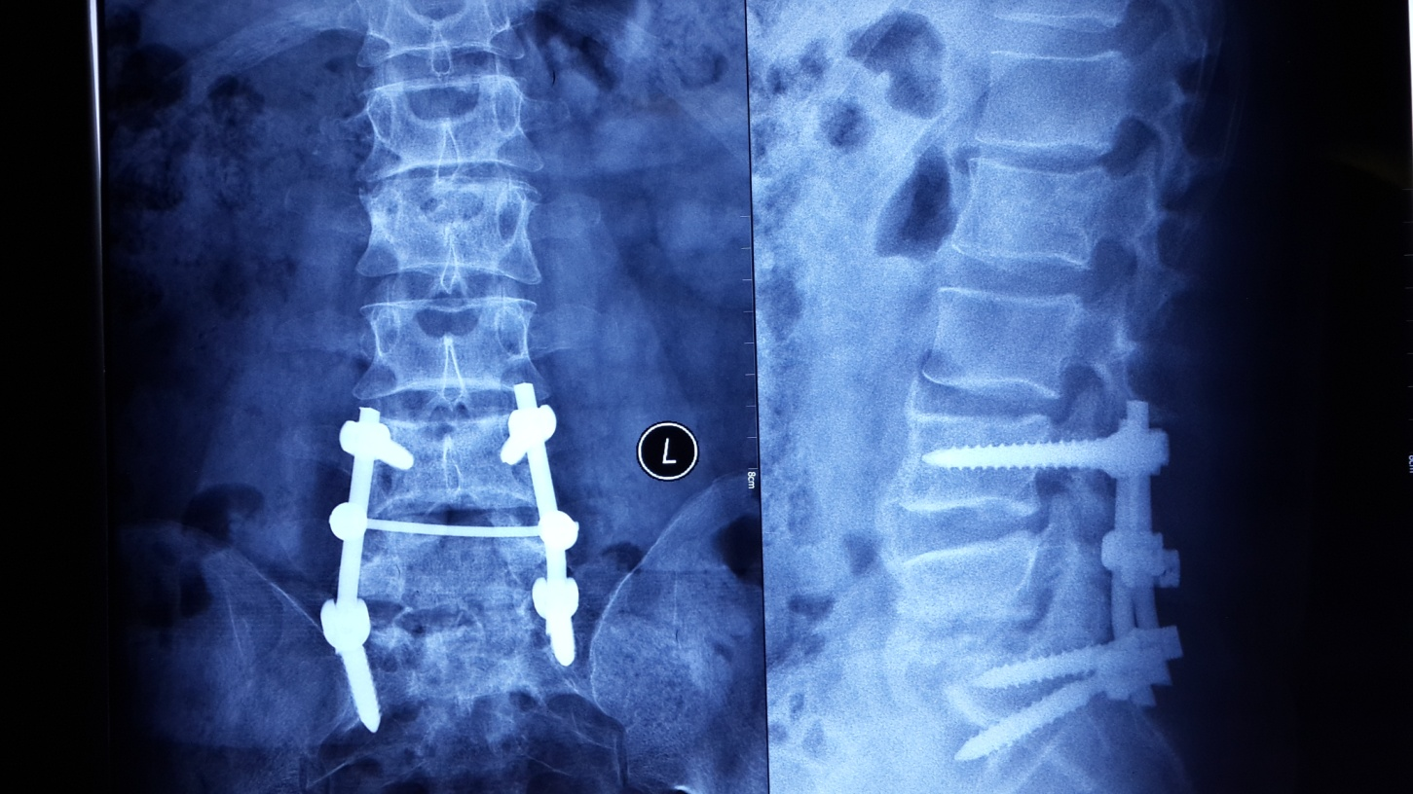
Postoperative image(Xray AP lumbar and lateral view)-Beijing fullers pedicle screw fixation kept between L4 –S1 connected with rods maintaing the arc, maintaing the normal kyphotic angle .

- 3. Discussion
.
Some reported series of the patients that underwent anterior instrumentation in the presence of active disease can be dangerous and may fail or be associated with additional complications. (5) Following with the anterior instrumentation it is reported the fusion was late using autografts. (5)From a biomechanical point of view neither anterior instrumentation nor posterior instrumentation can stabilizes the spinal column. (5).So this study was conducted to find the benefit of posterior pedicle screw fixations and one staged radical interbody fusion along with debridement and bone strut grafting method for lumbar spinal TB. So the benefit using the posterior pedicle screw fixation along with titanium mesh cage maintained the spinal stability, kyphotic angle with less than 12 °,no neurological dysfunction observed ,bony fusion with graft materials healed within five months ,proper wound healing ,no loosening of pedicle screw fixation and no breakage of internal fixation was observed .
.However the operative procedure was long with more time consuming, viability for more blood loss ,high cost to the patients and patients had to deal with high amount of stress and pain. The group of 38 cases of patients postoperative results strongly demonstrated the effectiveness of the surgical approach after 6-18 months of follow up.

CONLUSIONS- Posterior pedicle fixation ,one staged radical debridement of tuberculosis spine surgery is safe and effective, the surgical method of choice should be based on segmental lesions, abscesses in front of a comprehensive range of other factors to judge. Therefore, I believe that the method can be promoted and can be further revised

[References]
[1] Rosenthal DI, Treat ME, Mankin HJ, et a1. Treatment of epithelioid he-
mangioendothelioma of bone using a novel combined approach [J]. Skeletal Radiol, 2001,30 (4): 219-222.
[2] Hao, Wen Shiming, He Simin. An anterior debridement and internal fixation of thoracolumbar tuberculosis efficacy [J]. Chinese Journal of Spine and Spinal Cord, 2003,13 (11): 652-655.
[3] Xu Song, Xie Jing Ming Wang Yingsong, . Surgical treatment of spinal tuberculosis [J]. Spine Surgery, 2006,4 (1): 8-l1.
[4] Lianshun. Status and Problems of surgical treatment of spinal tuberculosis [J]. Chinese Orthopaedic Surgery, 2007.15: 516-518.
[5] HOU Shu-xun, QIU Gui-xing, Golden Land, etc. spine surgery [M]. Beijing: People's Medical Publishing House, 2005:
1151-1182.
[6] Tang Huamin, Xiao Zengming, Li Jian. Clinical analysis of 79 cases of surgical treatment of thoracolumbar spinal tuberculosis [J]. Journal of Practical, 2012, 18 (5): 398--401.
[7] Wukun Fang, et al. Anterior debridement and bone graft fixation for the treatment of thoracic tuberculosis [J]. Journal of Practical, 2009, 15 (12): 921--922.
[8] Li Tao-hua, Liu Guohui, such as titanium mesh cage in the front side of the road and pedicle screw fixation for the treatment of spinal tuberculosis with paraplegia [J] Chinese Journal of Orthopaedic Surgery, 2007, 3 (5): 274-276.
[9] Liu, Xing Weiping. An anterior debridement and internal fixation of thoracolumbar tuberculosis 27 cases [J]. Guizhou Medicine, 2011,35 (2): 134-137.
[10] Zhao Bin, Huang Yuanxia, Liu Shenpeng so on. Spinal tuberculosis debridement and bone graft fixation of efficacy [J]. Medical Informatics Operative Surgery, 2007,20 (12): 1080-1082.
11. Tuberculosis of the spine (Pott's disease) presenting as. B Dass*TA Puet2 and C Watanakunakorn1,. Belmont Avenue, Youngstown, OH,usa : B Dass et al.

