A New Treatment/Technique Hydrostatic Distension of Shoulder For Frozen Shoulder (One day Relief)
Dipendra Gurung ( MBBS,MS/ Orthopaedics)
Annapurna Children and Women Hospital, Pokhara/Lamjung model Hospital

Abstract

Objective-
A case study done for frozen shoulder treated with the technique of Hydrostatic distension of shoulder for frozen shoulder (one day relief).

Introduction-
It is a common problem suffered by approximately 2-5% of the population. It is however known that diabetic patients and patients who have suffered a stroke resulting in a loss of movement of the arm are more likely to be effected.
The pathologic anatomy was described in 1945 by Neviaser.(3) The synovium and capsule of the shoulder develop adhesions in response to a primary inflammatory response to a yet unknown etiology. The adhesions characteristically are found in the axillary fold and in the attachment of the capsule at the anatomic neck of the humerus (4).

Hydrostatic distension of the shoulder was first described in 1965 and since then many studies of the procedure have been undertaken(3). The procedure is also referred to as hydrodilatation, distension arthrography or hydrodistension and is considered a therapeutic intervention for a frozen shoulder.(2)(6).
Frozen shoulder syndrome has been an enigma to orthopaedic surgeons. The current treatment ranges from observation of this condition described as self-limiting, to manipulation under anaesthesia, to surgical release and in the last years arthroscopy treatment has been recommended . . The exact reason for this is still not fully understood . During the past one and half years, we have observed that hydraulic distension of gleno humeral joint have been a successful alternative for the management of this condition .(7)

Hydraulic distension is a safe, reliable, cost effective procedure without requiring specialized equipments in the management of frozen shoulder.

Method-

The hydrostatic distension of shoulder for frozen shoulder one day relief technique for acute and chronic cases, we distend the capsule and break the capsule after being distended and performing under under dissociative aanesthesia.. 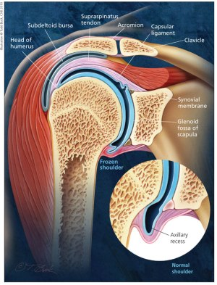
Patient kept in Npo for 4 hrs atleast and checking all preoperative basic investigation. Patient kept in supine position .
Anatomical landmarks identified -site is Anterior lateral aspect of coracoid process of glenohumeral crease into gleniodal fossa. It can be done under c- arm or experienced do just by marking and I do just by labeling only.
50 ml of Syringe required ,we need 3o ml of distilled water .Distilled water makes the capsule distended , bupivacaine 3 ml as muscle relxant and triamcinolone 1ml is diluted together in 50 ml syringe .we inject in the anatomical site as mentioned above.
How to check it going into correct site or not by puting the large gauge just into the site and make a flow into the needle gauge if it is in the proper place the diluted fluid will reverse back like fountain the efflux noted...be aware it is going to be very difficult to inject due to distended capsule though.
One theory as to how it decreases the pain is by stretching pain receptors in the shoulder rendering them less sensitive to pain⁹. A further theory is that the capsule is ruptures allowing better movement of the previously restricted joint . After this manipulation is done into external rotation and abduction during manipulation cracking noise is audible .we need to be aware sometimes if the bone is osteoporotic Patient may have fracture or dislocation.patient can be discharged home after 4-5 hours of rest.

-Preoperative preperations Images-
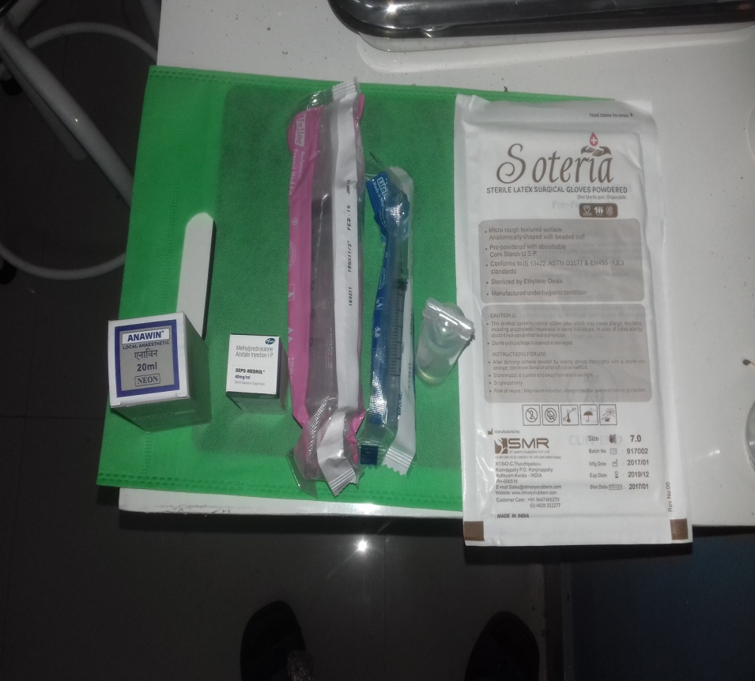
- 50 cc syringe
- 10 cc syringe
- 1ml of triamcinolone
- 3ml of bupivacaine
- 30 ml distilled water
- Surgical gloves

Patient presentation preoperative restriction of Right shoulder in image A and B
A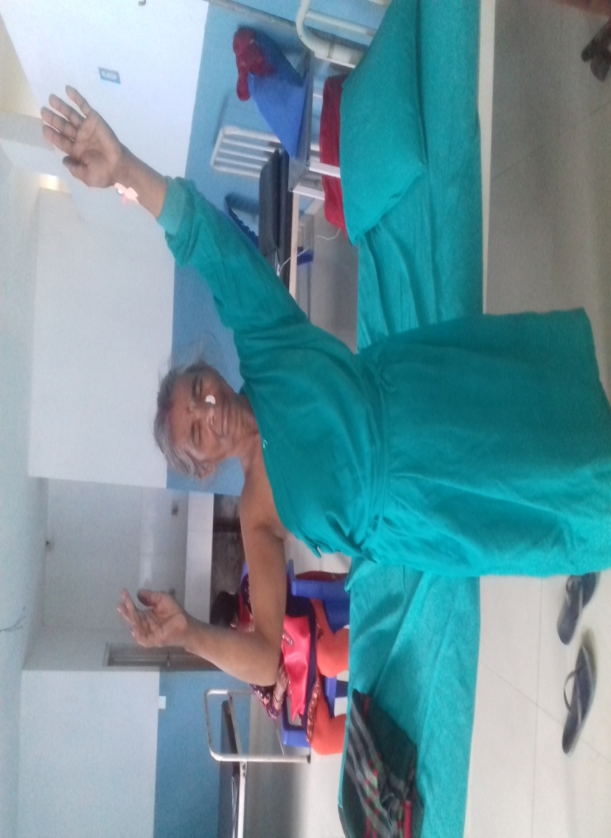B

Landmarks( anterolateral aspect of coracoid process)as marked in image B
.⁸ 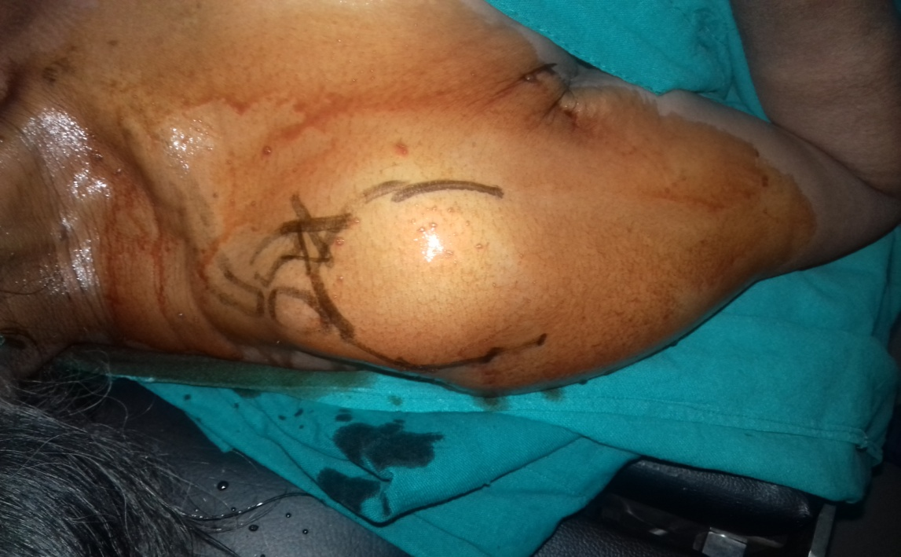A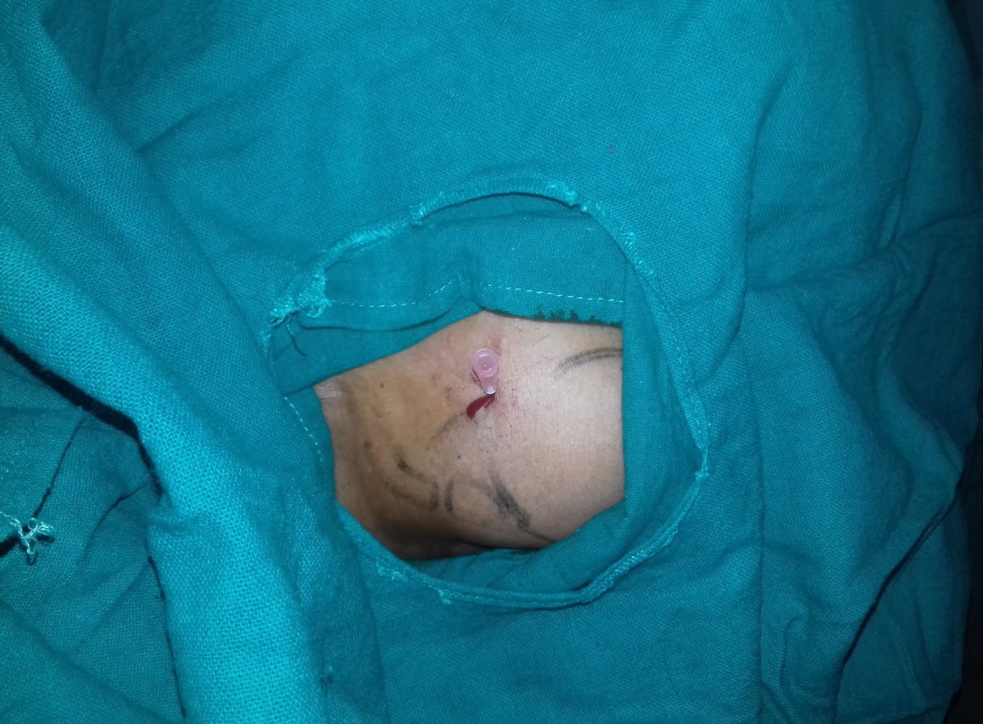B

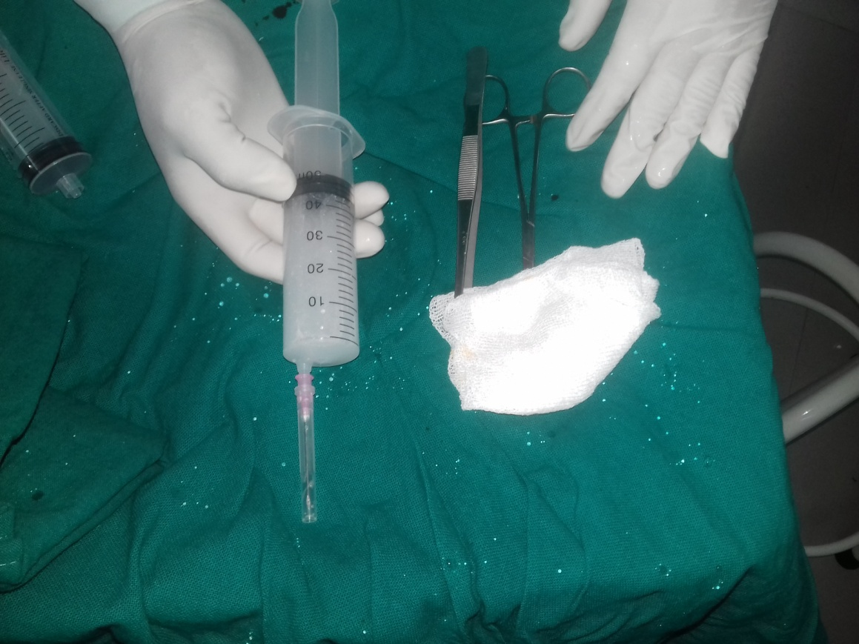 A

Medications preparations done under sterile conditions and air is created before ingestion.
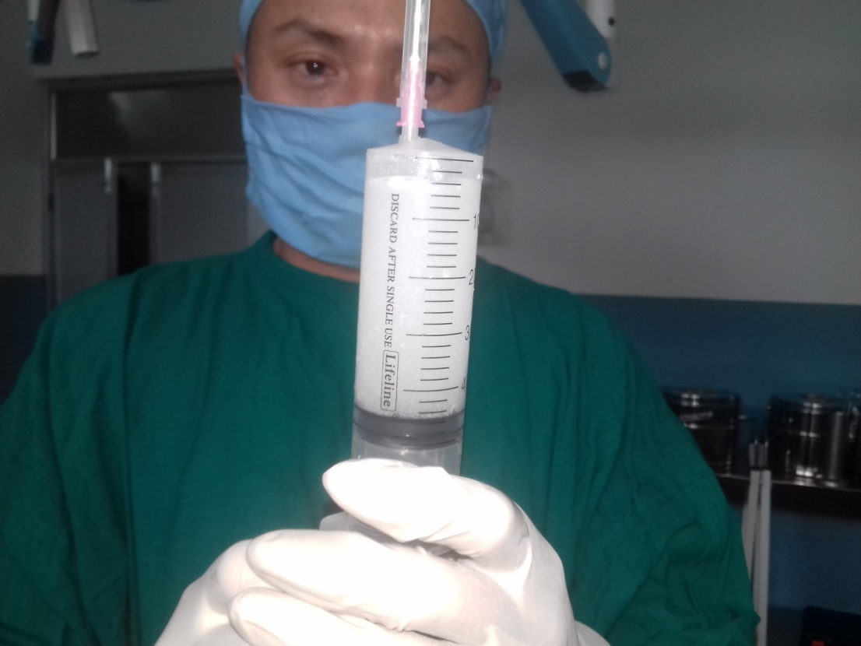 B

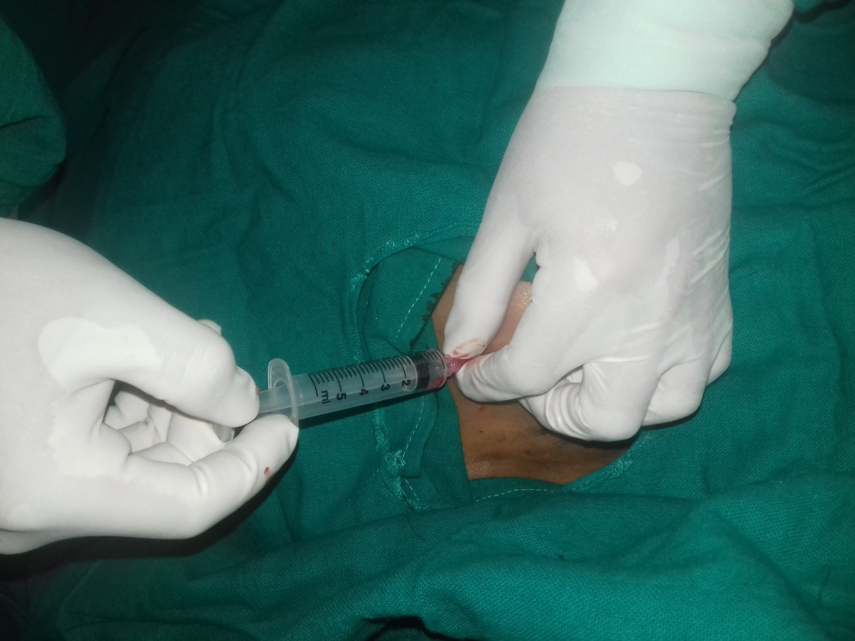 A
Synovial fluid withdrawn and reverse flow of fluid is seen as to ensure it is in the appropriate place or not. A and B
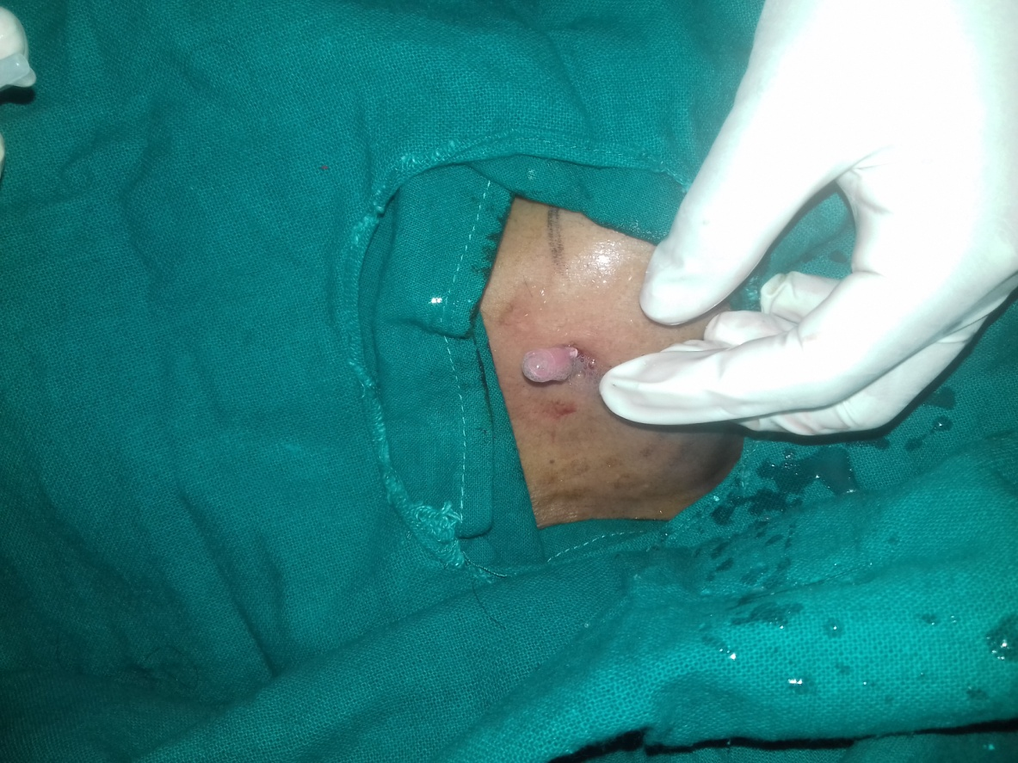 B

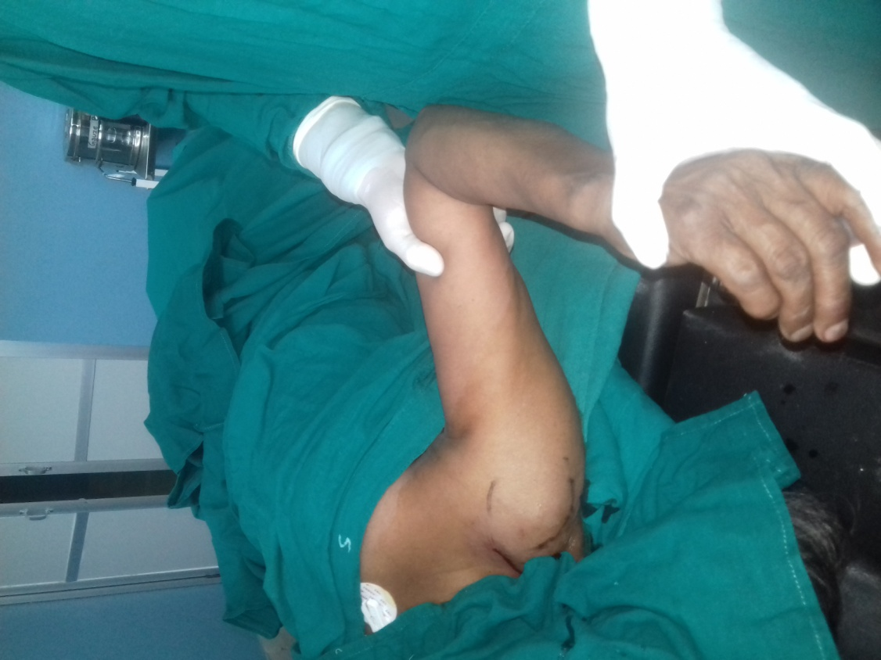 A
Manipulation is done after ingestion of medication into external rotation and abduction( ImageA and B)
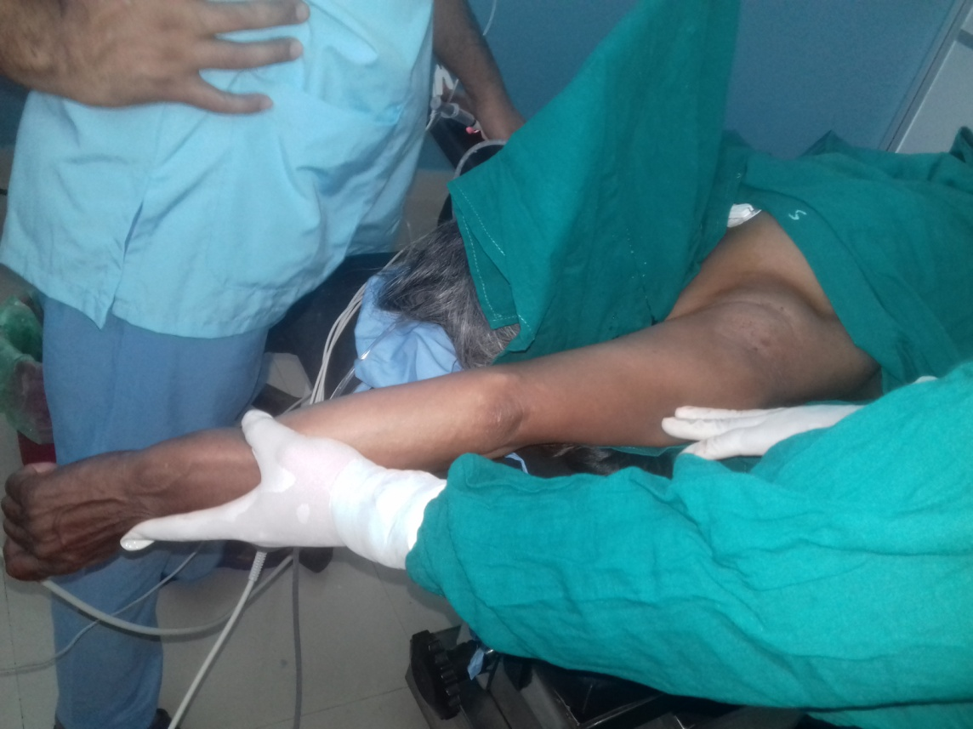 B

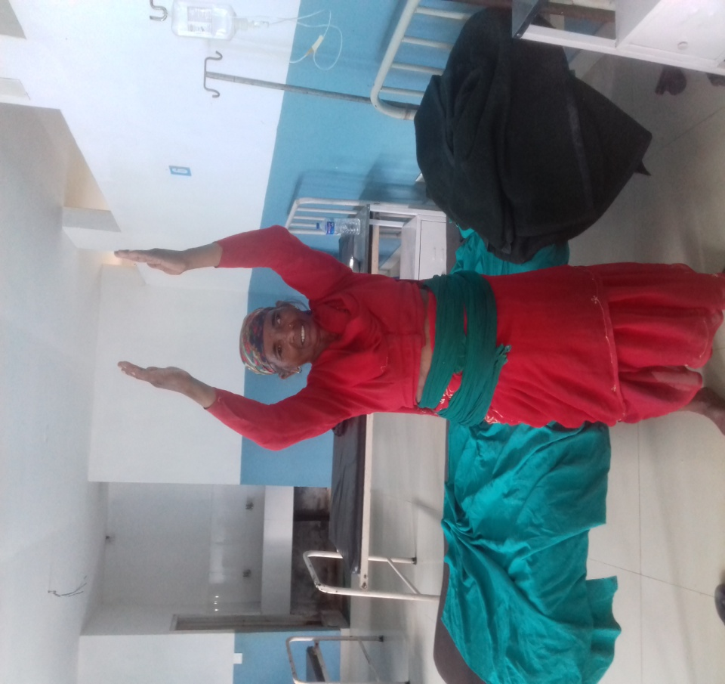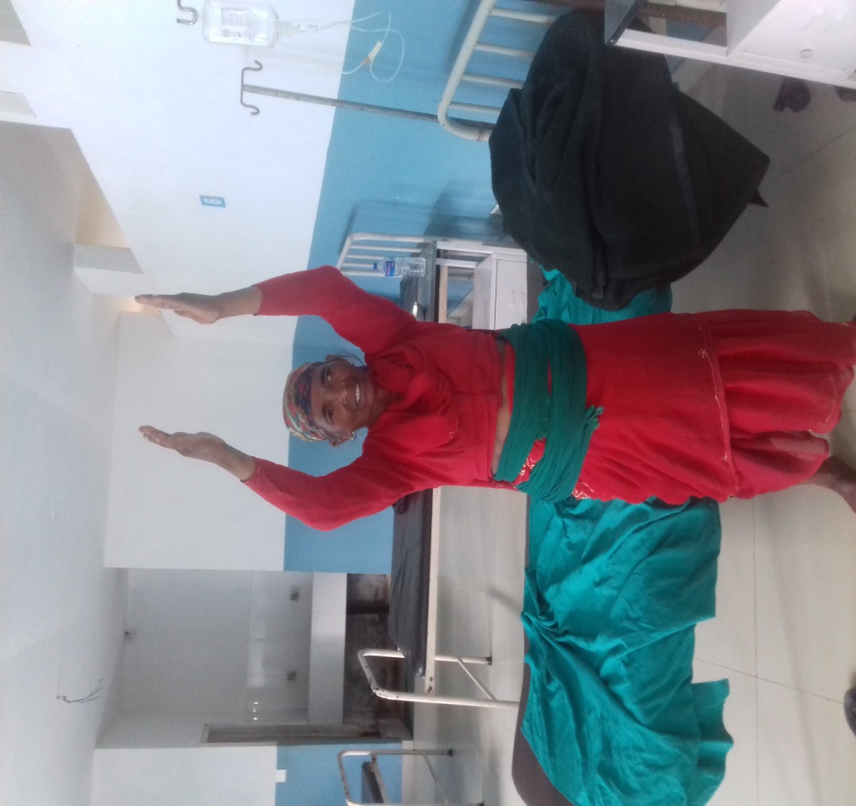
Post operative image gaining full Range of motion of Right shouder .

RESULT-
- 80% of patients are pain-free after a month – avoiding 18-24 months of stiffness!
Relief is felt almost instantaneously, after the first injection It’s quick (10 minute) and a straight ford procedure. There’s only minor discomfort during injections.
It’s cost effective (less physio sessions to attend) and thus we avoid surgery or any arthroscopic intervention.

DISCUSSION-

Hydraulic distension is a safe, reliable, cost effective modality in treating the chronically distressing painful condition of frozen shoulder. When performed with a right technique under aseptic precautions, it has absolutely no side effects. Hence, we conclude that hydraulic distension under local anesthesia with steroid can be considered as a first line management option in patients with frozen shoulder.

Key words( hydrostatic distension,arthrography,hydraulic distension

References
- Favejee MM, Huisstede BM, Koes BW. Frozen shoulder: the effectiveness of conservative and surgical interventions–systematic review. Br J Sports Med 2011;45(1):49-56.
- Bell S, Coghlan J, Richardson M. Hydrodilatation in the management of shoulder capsulitis. Australas Radiol 2003;47(3):247-51.
- Reeves B. The natural history of the frozen shoulder syndrome. Scand J Rheumatol 1975;4(4):193-6.
- Hannafin JA, Chiaia TA. Adhesive capsulitis. A treatment approach. Clin Orthop Relat Res2000(372):95-109.
- Hand C, Clipsham K, Rees JL, Carr AJ. Long-term outcome of frozen shoulder. J Shoulder Elbow Surg2008;17(2):231-6.
- Watson L, Bialocerkowski A, Dalziel R, Balster S, Burke F, Finch C. Hydrodilatation (distension arthrography): a long-term clinical outcome series. Br J Sports Med 2007;41(3):167-73.
- Andren L, Lundberg BJ. Treatment of Rigid Shoulders by Joint Distension during Arthrography. Acta Orthop Scand 1965;36:45-5
.

