Role of Silk Fibroin in Chronic Wound Management- Case Series

Abstract
Objective: To collate clinical evidence on the use of Silk fibroin, in patients with a variety of chronic wounds.
Method: Patients whose wounds had not improved in the eight weeks before the beginning of the evaluation were recruited. All participants had their dressings changed thrice weekly and received standard adjunctive wound care as part of their treatment. Data, collected over a 4-week
period, included: patient demographics, wound surface area measurements, Bates-Jensen score, level of wound pain and photographic imaging of patients’ wounds.
Results: We recruited 16 patients with 20 wounds and a mean wound duration of 5 months (range: 2–12 months). There was a mean decrease in wound surface area of 36% (median reduction: 47%). A reduction in the Bates-Jensen score was demonstrated in 87.5% of cases. Wound pain reduced by 66.66%.There was two cases of complete healing. No adverse events arose.
Conclusion: This case series provides clinical evidence on the use of silk fibroin in the management of hard-to-heal wounds that have previously received local standard therapy. The decrease in wound surface area together with other data indicating improved wound status suggests that a silk fibroin supports healing and improves quality of life through reduction in wound pain.
Declaration of interest: A Vijayakumar received supplies of Fibroheal Ointment and Fibroheal Dusting Powder from Fibroheal Woundcare Pvt Ltd for usage in patients. No Financial Interests to Disclose.

Introduction
Chronic ulcers or non-healing ulcers are defined as spontaneous or traumatic lesions, typically in lower extremities that are unresponsive to initial therapy or that persist despite appropriate care and do not proceed towards healing in a defined time period with an underlying etiology that may be related to systemic disease or local disorders.[1] There are many types of non-healing ulcers that may include venous, arterial, diabetic, pressure and traumatic ulcers. The normal wound healing process is dynamic and complex having three phases: inflammation, tissue formation and tissue remodeling. However, if the normal healing process is interrupted, an ulcer can become chronic in nature due to lack of growth factors and cytokines which delay the healing process.[2] These types of ulcers not only affect the quality of life and productivity of the patient but also become a substantial financial burden for the patient and the healthcare system.
Silk is a natural protein polymer which has been approved for medical use by the U.S. Food and Drug Administration (FDA).Silk fibroin is processed from mulberry silk after removal of the outer silk sericin which may potentially elicit an immunological response when it is associated with fibroin.[3]. Silk fibroin processes excellent biocompatibility, controllable biodegradability, remarkable mechanical strength, and low immunogenicity. Therefore, it has been widely used in tissue engineering and regenerative medicine applications such as bone, cartilage, and cornea repair.
It has been reported that the silk fibroin nanofibers promote the adhesion of human keratinocytes and fibroblasts as well as enhance the deposition of type I collagen in vitro In vivo studies have further shown that silk fibroin film dressing or spongy dressing promotes faster wound healing and better
skin regeneration, compared to the hydrocolloid dressing or porcine dermis/dermal matrix in small animal models.[4] Moreover, silk protein was found to be safe under acute dermal toxicity, acute dermal irritation, and skin sensitization. Here, we report on the performance of Silk Fibroin in 20 hard-to-heal wounds of varying aetiologies.
Method
Patients were included in the study if ≥18 years of age, with a clean wound between the epidermis and fascia, immune competent status, life expectancy >1 year and patient adherance with evaluation visits. Patients were excluded if the wound was grossly infected or nectrotic, was >100cm2, extended to the bone, were pregnant or had a life expectancy of under a year.
Following application of the inclusion/exclusion criteria and upon receipt of informed consent, patients
with wounds that had not improved following eight weeks of standard care in accordance with wound bed preparation guidelines were recruited.
Before being enrolled into the case series, subjects’ wounds were dressed with a variety of dressings that were consistent with the concept of moist wound healing. In addition, all DFUs had received ofﬂoading and patients with venous leg ulcers (VLUs) received compression bandaging therapy. All patients were treated according to local guidelines consistent with aetiology and the general condition of the wound. The topical silk Fibroin dusting powder or ointment was applied with a secondary dressing of non-adherent gauze. Dressings were changed thrice a week.
Data was collected on patient demographics, wound surface area measurements, Bates-Jensen score, level of wound pain using a visual numerical scale (1–10), wound infection status, wound depth imaging of patients’ wounds and the occurrence of any adverse reactions. The observation period was four weeks and data were collected on days 0, 14, and 28 (baseline T0, T14 and T28).
Wound surface area was calculated using acetate film. Wounds that decreased in surface area by at least 30% within the four-week assessment period were deemed to be on a healing trajectory and therefore improved. Those wounds that changed in size by 1–29% were defined as unchanged and an increase in surface area within the four-week period was recorded as deterioration.
The Bates-Jensen Wound Assessment Tool (BWAT) was used to assess and monitor healing in chronic
wounds. It uses a numerical scale to ascribe a score to 13 wound characteristics:
- Size
- Depth
- Edges
- Undermining or pockets
- Necrotic tissue type
- Necrotic tissue amount
- Exudate type
- Exudate amount
- Surrounding skin colour
- Peripheral tissue oedema
- Peripheral tissue induration
- Granulation tissue
- Epithelialisation.
Each characteristic has a range of descriptors rated on a scale from 1 to 5, ‘1’ indicating the best and ‘5’ the worst. There are two non-scored components that relate to wound location and shape. On completion of the assessment the sum of the 13 items scored provides a total score for the wound. This total is then plotted on the wound continuum found at the end of the BWAT and provides a visual indication of wound healing or degeneration. A score of nine indicates wound closure, and a score of 65 defines extreme tissue degeneration. Wound pain was recorded using a locally developed visual numerical scale where ‘1’ represented no pain and ‘10’ represented worst imaginable pain.
Results
A total of 16 patients with 20 wounds were recruited over a four-month period. There were 10 male patients and six female patients with a mean age of 44.8 years (range: 32–78 years). The mean duration of the wounds was 5months (range: 2–12 months). All 20 wounds were considered ‘hard–to–heal’ as there was no improvement in wound status in the eight weeks before inclusion despite targeted treatment according to wound aetiology and consistent with established guidelines. The patients and their individual severity indices may be seen in Table 1.
Table 1 : Table of wound etiology, duration and reduction in size.
Patient | Duration of wound Months | Etiology | Percentage Size change in 28 days
1 | 2 | Trauma | -35
2 | 7 | Pressure Ulcer | +25
3 | 5 | Arterial | -45
4 | 6 | Mixed | +35
5 | 5 | Mixed | -58
6 | 3 | Venous | -100
7 | 4 | Diabetic Ulcer | -28
8 | 5 | Mixed | -35
9 | 9 | Venous | -24
10 | 8 | Pressure ulcer | -26
11 | 3 | Diabetic ulcer | -50
12 | 12 | Venous | -15
13 | 2 | Burns | -100
14 | 4 | Mixed | -31
15 | 6 | Post trauma | -75
16 | 7 | Venous | -14

The total wound surface area as measured by acetate paper at T0 was 143.5cm2 reducing at T28 to 92.5cm2. A mean wound surface area reduction of 36% and a median reduction of 47% (range: -100 to +35) was achieved within 4 weeks of treatment with the silk fibroin dressing. Of the 16 patients enrolled, Two wound healed completely (patient 6, 13), 12 patients (1, 3, 5, 7, 8, 10, 11, 15) showed a healing trajectory and two patients (2,4) wounds deteriorated
Fig 1: Showing change in mean Bates Jensen scores in wound over the study period.

The sum of the 13 scored items in the BWAT provides a visual indication of wound healing or degeneration at the chosen time points. A reduction in the BWAT score from T0–T28 was demonstrated in 87.5% of cases. The downward trend in respect of mean scores may be seen in Fig 1. Only two patients’ wounds (patients 2 and 4) showed a slight increase in the BWAT scores, 2 and 3 points respectively. Wound pain measured on a numerical scale of 1–10 showed an overall decrease of 35% over the 28 days evaluation period. The level of patients’ wound pain decreased in 8 patients by 50%. The mean wound pain decreased over the 4-week evaluation period from 3.2 to 2.4. The decrease in pain including the decrease in median wound pain score over the 4 weeks from 3.0 to 2.0 is presented in Fig 2. Some patients received oral analgesia at T0. However, this number reduced during the treatment period.
Fig 2: Showing change in Pain score of wounds over the study period.

Fig 3 : 28 Yr old Female with post traumatic infected wound of 2 months duration at day 28 there is no signs of necrotic material and infection and wound has reduced in size by 75%.
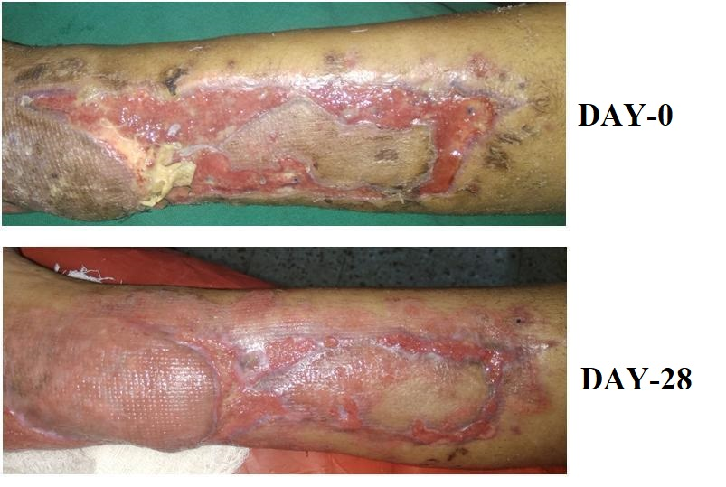

Fig 4 : 32 year old female with thermal burns of 2 months duration had biofilm formation over the wound and moderate exudates. With treatment with Silk fibroin dusting powder the infection and exudates reduced in 7 days and end of 28 days the wound is completely reepithelized.
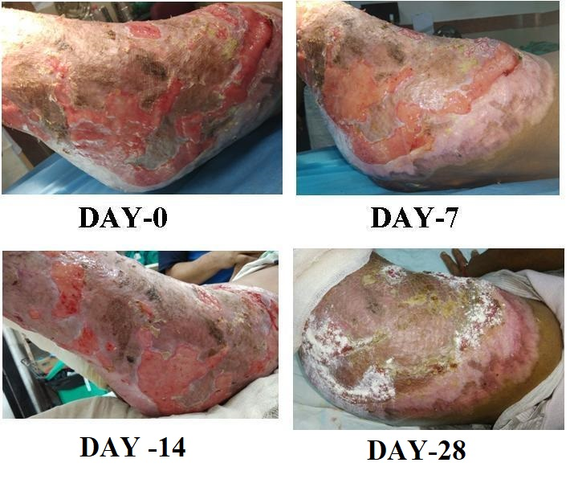
Fig 5: 42 year old male with venous ulcer of 3 months duration had moderate necrosis and high exudative ulcer. Post treatment with silk fibroin dusting powder and 4 layer compression dressing shows complete wound closure at 28 days.
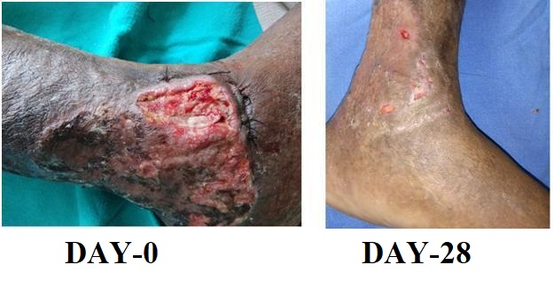
Fig 6: A 52 yr old diabetic patient with wound over the dorsum and medial side of foot of 3 months duration, the infection was controlled with regular dressing but showed no signs of wound size reduction. Edge debridement and dressing with silk fibroin powder on alternate day. Wound size reduction by over 50 % in 28 days.
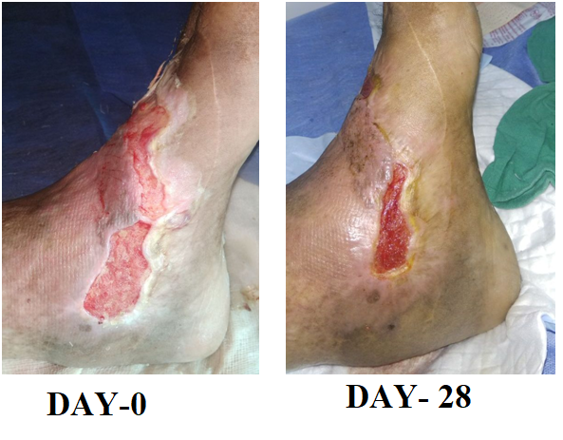

Discussion
Wound healing is a natural response to tissue damage. The healing process includes cellular activity that forms a complex cascade. The basic aim in wound healing is the restoration of the connective tissue and fast wound closure. The desired outcomes in this process are minimal pain, minimal discomfort, and minimal scar formation.
This evaluation has reported the improvements found in reduction in wound surface area (median 47%), the BWAT scores (reduction in 87.5% of cases) together with the overall decrease in wound depth as noted by visible tissue type. These findings support the ability of a silk fibroin based creams and dusting powder to provide a functional surrogate (extracellular matrix) ECM. Although follow-up of all 16 patients was not within the scope of the study, 7 patients’ wounds healed with continued use of silk fibroin ointment. As the majority of wounds in this study reduced in size by ≥30% we demonstrated progression to healing, as a number of studies indicate that wounds that reduce in size between 30–50% in a 2 to 4-week period are more likely to heal than ulcers that do not reduce in size by these amounts.[5] Pain is a key quality-of-life indicator for many patients and is often poorly controlled in those with chronic wounds. It is accepted that pain is a factor that may adversely affect healing and that pain mediators are pro-inﬂammatory.[6] Clinical signs of inﬂammation can be associated with high wound protease activity and application of a topical protease modulating dressing may reduce this.
A recent study determined that silver sulfadiazine preparations containing sericin increased the collagen production in burn patients and decreased the pain [7]. Aramwith et al. investigated the use of 8% sericin formulation in empirical incisional wound models with a diﬀerent empirical method and reported decreased inﬂammation in the wound area and reduced wound size [8]. The molecular mechanisms involved in wound healing with Silk Fibroin are gradually being characterized. Proliferation and matrix deposition of keratinocytes and fibroblasts increased after seeding with Silk fibroin(SF) on wound dressings [9]. SF controls the expression level of proinflammatory cytokines (IL-1a and IL-6) and anti-inflammatory cytokines (IL-10) after skin injury, where the overexpression of proinflammatory cytokines interrupts normal wound healing via expansion of skin damage, especially in burn injuries [10]. SF dressings also promoted wound healing by controlling the expression of vimentin, cyclin D1, VEGF, and fibronectin in NIH3T3 cells and skin injuries in a rat model by provoking the canonical NF-kB signaling pathway [11]. NF-kB signaling modulates cell growth and attachment, preventing the production of reactive oxygen species, and promoting the healing of corneal epithelial [12] and cutaneous wounds [13]. SF also increases the expression of c-Jun and c-Jun protein phosphorylation as key factors in wound healing. Moreover, SF promotes the phosphorylation of ERK 1/2 and JNK 1/2 kinases and stimulates cellular migration through activation of MEK, JNK, and PI3K kinases; inhibiting these signaling pathways prevents the upregulation and phosphorylation of c-Jun. [14]
Recently, the antimicrobial effect of silver nanoparticles (AgNPs) coated with electrospun Silk Fibroin nanofibers as a wound dressing showed that this structure inhibited the growth of Staphylococcus aureus and Pseudomonas aeruginosa [15]. Additionally, the AgNPs diffused to the bacterial cell membrane and disrupted the organelle function by binding to the proteins and organelles [16,17]. Upon AgNP binding to bacterial cell walls, the membranes changed their morphology, leading to bacterial cell death [16] The Ointment and Dusting powder have oxidized silver in addition to silk fibroin to control infection.
The results of this study show good healing of chronic wounds with minimal infection or inflammation .
These results indicate the capability of silk fibroin dressing materials to promote wound healing. Powdered dressing material can absorb the fluid easily from the wound during the initial healing period. This provides a more appropriate environment for wounds healing, and the powdered dressing detached from the wound spontaneously with the re-epithelization process. Therefore, there was little secondary trauma on the wounds. Based on our data, the powdered Silk Fibroin is a promising candidate in wound healing.
Conclusion
This case series provides clinical evidence on the use of silk fibroin in the management of hard-to-heal wounds that have previously received local standard therapy. The decrease in wound surface area together with other data indicating improved wound status suggests that a silk fibroin supports healing and improves quality of life through reduction in wound pain.
Acknowledgements
Would like to thank Dr Mukesh Sharma RML hospital, Dr Parul Sharma Swami Dayananda Hospital , Dr Sujatha and Dr Shardendu Sharma Safdarjung Hospital, Dr Sushma Sagar AIIMS trauma Center for providing study patients and clinical photographs. Would like to thank Fibroheal Woundcare Pvt Ltd for providing products for clinical study.

References
- Sebastian KMS, Lobato I, Hernandez I, et al. Efficacy and safety of autologous platelet rich plasma for the treatment of vascular ulcers in primary care: phase III study. BMC Fam Pract. 2014;15:211.
- Martinez-Zapata MJ, Martí-Carvajal AJ, Solà I, et al. Autologous platelet rich plasma for treating chronic wounds. Cochrane Database Syst Rev. 2012;Issue 10:Art. No.: CD006899.
- G. H. Altman, F. Diaz, C. Jakuba, T. Calabro, R. L. Horan, J. Chen, H. Lu, J. Richmond, D. L. Kaplan, Biomaterials 2003, 24, 401.
- A. Sugihara, K. Sugiura, H. Morita, T. Ninagawa, K. Tubouchi, R. Tobe, M. Izumiya, T. Horio, N. G. Abraham, S. Ikehara, Proc. Soc.Exp. Biol. Med. 2000, 225, 58.
- van Rijswijk, L. Fullthickness leg ulcers: patient demographics and predictors of healing. J Fam Pract 1993; 36: 6, 625–632.
- Clay, C.S., Chen, W.Y.J. Wound pain: the need for a more understanding approach. J Wound Care 2005;14: 4, 181–184.
- Aramwit P, Palapinyo S, Srichana T et al: Silk sericin ameliorates wound healing and its clinical efcacy in burn wounds. Arch Dermatol Res, 2013; 305: 585–94.
- Aramwit P, Sangcakul A. The effects of sericin cream on wound healing in rats. Biosci Biotechnol Biochem. 2007;71:2473–77.
- Roh, D.-H. et al. (2006) Wound healing effect of silk fibroin/alginate-blended sponge in full thickness skin defect of rat. J.Mater. Sci. Mater. Med. 17, 547–552.
- Ju, H.W. et al. (2016) Wound healing effect of electrospun silk fibroin nanomatrix in burn-model. Int. J. Biol. Macromol. 85, 29– 39.
- Park, Y.R. et al. (2017) NF-kB signaling is key in the wound healing processes of silk fibroin. Acta Biomater. 67, 183–195.
- Wang, L. et al. (2013) Epidermal growth factor (EGF)-induced corneal epithelial wound healing through nuclear factor kB subtype-regulated CCCTC binding factor (CTCF) activation. J. Biol. Chem. 288, 24363–24371.
- Chen, J. et al. (2016) Epidermal CFTR suppresses MAPK/NFkB to promote cutaneous wound healing. Cell. Physiol. Biochem. 39, 2262–2274.
- Martínez-Mora, C. et al. (2012) Fibroin and sericin from Bombyx mori silk stimulate cell migration through upregulation and phosphorylation of c-Jun. PLoS One 7, e42271
- Uttayarat, P. et al. (2012) Antimicrobial electrospun silk fibroin mats with silver nanoparticles for wound dressing application. Fiber. Polym. 13, 999–1006.
- Sondi, I. and Salopek-Sondi, B. (2004) Silver nanoparticles as antimicrobial agent: a case study on E.coli as a model for Gramnegative bacteria. J. Colloid Interface Sci. 275, 177–182.
- Suresh, A.K. et al. (2010) Silver nanocrystallites: biofabrication using Shewanella oneidensis, and an evaluation of their comparative toxicity on gram-negative and gram-positive bacteria.
Environ. Sci. Technol. 44, 5210–5215.

