Case Report
Endometriosis of Appendix presenting as appendicitis - Case Report and Review of Literature
Basim Al Khafaji¹, Muhammad Umar Younis², Yousif Al Khafaji³
¹Department of General Surgery, Canadian Specialist Hospital, Dubai, UAE.
²Department of General Surgery, Mediclinic City Hospital, Dubai, UAE.
Correspondence to: Dr. Muhammad Umar Younis, Department of General Surgery, Mediclinic City Hospital, Dubai, UAE. E-mail: umar000@hotmail.com ORCID: 0000-0001-6366-6991.

Abstract
Endometriosis is the appearance of functioning endometrial tissue which is responsive to hormonal changes, in a location outside of the uterine cavity. It is most commonly observed in the adnexa and pelvic peritoneum but may be seen in the gastrointestinal system in 3-37% of cases with less than 1% involving the appendix.
Case Presentation: We present here a 33 year old lady who was a known case of endometriosis and presented to the emergency with signs of acute appendicitis and underwent laparoscopic appendectomy.
Conclusion: Our case report illustrates the fact that the general surgeon may be confronted with rarer causes of acute appendicitis and a thorough history should be elicited in women having chronic pelvic pain, menstrual disorders and infertility and a gynecological assessment should be sought if possible.
Keywords: Endometriosis – Abdomen, acute –Appendicitis – Abdominal Pain – Appendectomy – Gynecology

INTRODUCTION
Endometriosis is the appearance of functioning endometrial tissue which is responsive to hormonal changes, in a location outside the uterine cavity¹. It is reported to affect up to 10% of women of childbearing age, 70% of women with complaints of chronic pelvic pain and up to 50% of women being investigated for infertility². It is most commonly observed in the adnexa and pelvic peritoneum but may also be seen in the gastrointestinal system in 3-37% of all endometriosis cases with less than 1% involving the appendix³. Clinical presentation of appendiceal endometriosis may be confused with acute appendicitis and is usually confirmed on histopathology reports after an appendectomy.

CASE REPORT
A 33 year old lady presented to the emergency department with complaints of severe right lower abdominal pain for 3 days duration associated with nausea, vomiting and low grade fever. She also complained of passing loose, watery stool upto 4 episodes a day for the last 2 weeks. On examination, she demonstrated tenderness and guarding at the right iliac fossa with positive rebound tenderness. She was being seen in the gynecology clinic for the past 4 years due to infertility and her past history was significant for laparoscopic right ovarian cystectomy which was done for endometriosis 3 years back.
Her vital signs on presentation were showing a temperature of 38 degrees Celsius, heart rate of 89 per min and a blood pressure reading of 131/76 mmHg. Laboratory investigations showed high inflammatory markers (White Cell Count = 13,100 /mm³ with predominant neutrophilia). Urinalysis was normal and pregnancy test was negative. An ultrasound was ordered which revealed a right ovarian cyst enlarged with signs of endometriosis with reactive acute appendicitis/appendicular mass formation (Fig.1&2). Consent was taken for surgical exploration. Intraoperative findings included a hard appendicular mass extending to the base of the appendix with subphrenic 50ml collection of blood. Further findings confirmed presence of right ovarian cyst filled with blood and subserosal fibroid. Laparoscopic appendectomy was performed without any complications and the gynecologist was called in who went on to perform right ovarian cystectomy during the same procedure. The specimen was sent for histopathological correlation and confirmed presence of endometrial tissue and stroma in the appendix. The patient fared well post surgery and was routinely discharged the next day with minimal residual pain. She remained well on immediate follow up but presented with vague lower abdominal pain after 6 weeks. An ultrasound was done at the time of follow up showing no further development of cyst and patient was duly discharged under gynecology care.

DISCUSSION
Acute appendicitis is one of the most common emergent clinical presentations in general surgery requiring surgical intervention. Although inflammation attributed to luminal obstruction secondary to fecoliths or lymphoid hyperplasia is the most common histopathological correlation, several unusual factors are also described that may result in its pathogenesis out of which endometriosis is also discussed in literature but is uncommon⁴. Endometriosis is the growth of endometrial tissue outside the uterus. Although it is widely found in the adnexa and pelvic organs, extragenital sites like the gastrointestinal system, kidneys and lungs may also be involved. Appendiceal endometriosis is rare and is not usually diagnosed preoperatively; it may present as a case of acute appendiceal inflammation likely due to partial or complete obstruction of the lumen due to the endometrioma⁵. The clinical spectrum may be discussed as four subsets: (1) patients presenting with typical signs and symptoms of acute appendicitis; (2) patients with nonconforming symptoms like vague abdominal pain, melena and nausea; (3) asymptomatic patients; and (4) patients with appendiceal invagination and intussusception^{6,7,10}.
Appendiceal endometriosis is frequently observed in cases presenting with ovarian endometriosis which has sparked a debate regarding routine elective appendectomies to be offered to patients undergoing gynecological surgery for endometriosis⁸. A recent large retrospective cohort carried out by Mabrouk et al also evaluates the question of performing appendectomy when there is clear involvement of the appendix in cases of endometriosis¹¹ renewing the idea of “elective incidental appendectomy” although there are no guidelines to promote the idea. Histopathology results describe one half of the specimens involving the body and the other half involving the tip of the appendix. Mucosa is usually spared while endometrial glandular tissue and stroma are observed in the muscular and seromuscular layers in two thirds of patients and exclusively in serosa in one third of patients^{6,8}. Treatment depends upon the level of involvement of the appendix and may range from laparoscopic appendectomy to ileocecetomy and right hemicolectomy. Acute symptoms mostly resolve with surgical intervention and gynecological assessment should also be done on table to evaluate the extent of disease and follow it up postoperatively⁹.
CONCLUSION:
Our case report illustrates the fact that the general surgeon may be confronted with rarer causes of acute appendicitis and a thorough history should be elicited in women having chronic pelvic pain, menstrual disorders and infertility and a gynecological assessment should be sought if possible. Although surgery is curative for the emergency presentation, the patient should be guided to follow up with gynecologist as good practice.

DECLARATIONS
Authors’ contributions
MU Younis wrote the manuscript and assisted in surgery, B Alkhafaji was the operating surgeon and present with study concept and design, Y Alkhafaji reviewed the manuscript for critical content. All the authors read and approved the final manuscript.
Availability of Data and Materials
Not applicable.
Financial support and sponsorship
None.
Conflicts of interest
All authors declared that there are no conflicts of interest.
Ethical approval and consent to participate
Not applicable.

Consent for publication
Written informed consent was obtained from the patient for the publication of this case report and the accompanying image.

REFERENCES
- Olive DL, Schwartz LB: Endometriosis. N Engl J Med 1993, 328:1759-1769.
- Hwang BJ, Jafferjee N, Paniz-Mon dolfi A, Baer J, Cooke K, Frager D. Nongynecological endometriosis presenting as an acute abdomen. Emerg Radiol 2012; 19:463-71.
- Gon S, Barui GN, Majumdar B, Baig SJ. Endometriosis of the appendix: a diagnostic dilemma. Indian Journal of Surgery 2010;72(1):315.
- Akbulut S, Tas M, Sogutcu N, Arikanoglu Z, Basbug M, Ulku A, et al. Unusual histopathological ﬁndings in appendectomy specimens: a retrospective analysis and literature review. World Journal Of Gastroenterology 2011;17(15):1961–70.
- Ijaz S, Lidder S, Mohamid W, Carter M, Thompson H: Intussusception of the appendix secondary to endometriosis: a case report. J Med Case Reports 2008, 2:12.
- Laskou S, Papavramidis T, Cheva A, Michalopoulos N, Koulouris C, Kesisoglou I, Papavramidis S et al. Acute appendicitis caused by endometriosis: a case report. J Med Case Rep 2011;5:144.
- Emre A, Akbulut S, Yilmaz M, Bozdag Z. An unusual cause of acute appendicitis: Appendiceal endometriosis. Int J. Surg Case Rep 2013; 4: 54-57.
- Uncu H, Taner D: Appendiceal endometriosis: two case reports. Arch Gynecol Obstet 2008, 278:273-275.
- Douglas C, Rotimi O. Extragenital endometriosis: a clinicopathological review of a Glasgow hospital experience with case illustrations. J Obstet Gynaecol 2004;24:804-8.
- Rao S, et al. Appendiceal Endometriosis: A Rare Cause of Pain and Tenderness in Mc Burney’s Point. Ann Med Health Sci Res. 2018; 8: 89-92.
- Mabrouk et al. Endometriosis of the Appendix: When to Predict and How to Manage; A Multivariate Analysis of 1935 Endometriosis Cases. Journal of Minimally Invasive Gynecology 2019; 1553-4650:doi:10.1016/j.jmig.2019.02.015.

Figure Legend
Fig.1 Sonogram of appendix showing enlarged appendix diameter.
Fig.2 Right iliac fossa indicating the dilated appendix.

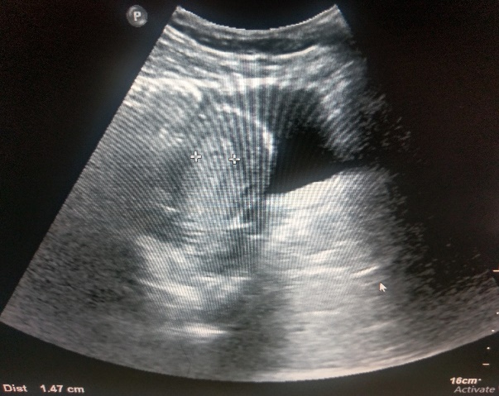
Fig 1

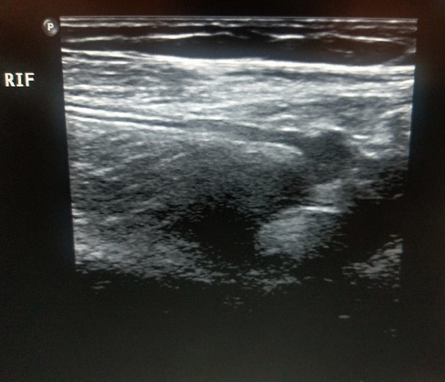
Fig 2

