Summary
This study was conducted to compare histologically between autogenous bone graft and the composite of bone marrow concentrate and Nano-hydroxyapatite granules in the repair of calvarial bony defects in white New Zealand rabbits.
The study was conducted on 14 standardized surgically created defects in seven white New Zealand rabbits with weights ranging from three to four kilograms. Each rabbit was submitted to two standardized surgical defects at the parietal bone. The defects were randomly allocated into two groups according to defect filling as follows: Group A (n=7), the defects were grafted using a composite of bone marrow concentrate (BMC) and Nano-hydroxyapatite granules; Group B (n=7), the defects were grafted using autologous bone graft. Animals were sacrificed eight weeks post-operative and Histo-morphometric assessment was done to calculate the percentage of newly formed bone with regard to the defect size.
There was no statistically significant difference (p>0.05) between the two groups regarding the percentage of newly formed bone.
It could be demonstrated that the use of bone marrow concentrate and Nano-hydroxyapatite granules to reconstruct surgical defects is a reliable alternative to autogenous bone graft.
Key words: Bone marrow concentrate, Autogenous bone graft, Nano-hydroxyapatite, Surgical defects.

Introduction
The structural and functional reconstruction of defects in the oral and maxillofacial region resulting from malformation, infection, trauma and resection may represent the most difficult problem in contemporary reconstructive surgery (Cutting et al., 1984) (Schmitz et al., 1990). Autogenous bone is considered the most effective bone graft material available for the use in the surgical reconstruction of the maxillofacial region because of its osteogenic potential, which has led it to be regarded as the “gold standard” (Sailer and Weber, 2000) (Gamradt and lieberman, 2003). However, many patients are unwilling to accept the need for surgery in the donor site in addition to the recipient area.
Regenerative medicine is an emerging field of biotechnology that combines various aspects of medicine, cell and molecular biology, materials science and bio-engineering in order to regenerate, repair or replace tissues. The frontier of regenerative medicine nowadays is represented by the stem cells. Maksimov in 1908 was the first scientist to introduce the term stem cells. Becker et al. in 1963 were the first to prove the existence of self-reproducible cells in bone marrow of rats (Becker and McCulloch, 1963) (Evans and Kaufman, 1983) (Egusa, 2012).
Bone marrow produces the red blood cells during haematopoiesis and is a major component of the immune system by producing lymphocytes. The bone marrow also contains hematopoietic cells and mesenchymal stem cells (MSCs) (Kasten and Beyen, 2008).
Mesenchymal stem cells were first isolated and characterized from bone marrow (BMSCs) by Friedenstein et al. (Friedenstein et al., 1974). Subsequently, different studies have shown that MSCs can be isolated from other tissues, such as peripheral blood, umbilical cord blood, Amniotic membrane, adult connective, adipose and dental tissues (Zhang and Huang, 2012) (Zarrabi et al., 2014). Recently, orofacial and dental tissues have acquired interest as a further accessible source of mesenchymal stem cells due to the fact that the oral area is rich in MSCs (Mao and Prockop, 2012).
Several uses for mesenchymal stem cells were made in all fields of medicine mainly to promote healing quality and time. Stem cells are used in tissues repair as in management of neural damage post brain stroke infarctions, spine injuries through regeneration of neural tissue, muscle repair as post myocardial infarction, bone repair in orthopaedics and maxillofacial region (Avasthi et al., 2008).
The concept of concentrating bone marrow to produce bone marrow concentrate (BMC) allows increasing not only the numbers of MSCs but also platelets containing growth factors and hematopoietic stem cells (HSCs) per sample volume (Chahla et al., 2017).
The use of BMC has become an increasingly popular alternative and adjunct in the treatment of cartilaginous lesions, bony defects, and tendinous injuries. Despite both basic science and clinical evidence of its efficacy, recent literature suggests that BMC has different functions and roles in each biologic environment (Kennedy and Murawski, 2011).
Generally, the use of BMC carries great hope in enhancing the healing and regenerative power of newly formed tissues in maxillofacial field. However, the use of this method remains a controversial issue as the available literature regarding its use in different tissue repair is highly heterogeneous with regards to indications, concentrations and overall functional outcomes (Arianna et al., 2017). This study aimed to compare histologically between autogenous bone graft and the composite of bone marrow concentrate and alloplast in the repair of calvarial bony defects in white New Zealand rabbits.

Methodology
Animals
All animal procedures were conducted after receiving an ethical clearance from the Research Ethics Committee of Ain Shams University, Faculty of Dentistry; that the study follows the guidelines of research ethical committee code of practice for animal care and housing. The study took place in the animal house of the Medical Research Centre (Bilharzia Research Unit), Faculty of Medicine, Ain Shams University. The study was conducted on 14 standardized surgically created defects in seven white New Zealand rabbits with weights ranging from three to four kilograms. Animals were housed under standard conditions for a week prior to use. They were kept in individual cages under the same environmental conditions before surgery and during the evaluation period.
Preparation of bone marrow concentrate (BMC)
Eight white New Zealand rabbits with weights ranging from three to four kilograms were sacrificed humanely by intravenous administration of anaesthetic overdose of sodium thiopental (Sodium Pentothal. Abbott, USA). After animal sacrifice, soft tissues were carefully dissected from both the tibia and femur bones of each rabbit and bone marrow tissues were then collected in a heparinized container (Fig: 1). The harvested bone marrow was then diluted by Dulbecco’s modified eagle’s medium (DMEM) (Biowhittaker® Lonza, Switzerland) in ratio 4:1. Collagenase type I (Sigma-Aldrich, Egypt) enzyme was then added to the previous mixture and left for 7 minutes in a water bath shaker in order to extract the cells from the tissues. Bone marrow tissues treated with collagenase were then filtered and centrifuged at 2000 rpm for 20 minutes at 20˚C in a swinging-bucket rotor without brake. Aspiration of the mononuclear cells rich layer using micro-pipette was done to be re-diluted by DMEM and centrifuged again at 1200 rpm for 10 minutes at 20˚C and this was repeated twice to ensure high concentration of mononuclear mesenchymal stem cells. Foetal bovine serum and streptomycin were then added to the prepared bone marrow aspirate concentrate for nutrition of the cells and prophylaxis against infection. The BMC was then gradually frozen to -30˚c then -70˚c before it was stored at -200˚c using liquid nitrogen.
Surgical procedure
Animals were anesthetized by intravenous injection of Sodium Thiopental (Sodium Pentothal. Abbott, USA) 25 mg /Kg body weight and maintained by ketamine hydrochloride (Ketalar, Pfizer pharmaceuticals, USA) 10 mg/ml with dose 1 –3mg/min. A sagittal incision was made approximately 10 cm in the midline of the skull, primarily in the skin, followed by the periosteum to expose the parietal bones. Two standardized surgical defects were made, one on each side, using sterile 10 mm trephine cutter drills (Fig: 2).
The cortico-cancellous blocks resulting from trephine drilling were crushed to be used as an autologous bone graft. The defects were then randomly allocated into two groups according to defect filling (Fig: 3, 4) as follows:
Group A (n=7), the defects were grafted using a composite of bone marrow concentrate (BMC) and Nano-hydroxyapatite granules (Nano Bone®, ARTOSS GmbH, Germany) 1 mm particle size.
Group B (n=7), the defects were grafted using autologous bone graft.
The incision line was then repositioned using 4-0 braided resorbable sutures (Vicryl 4.0; Ethicon GmbH & Co. KG, Norderstedt, Germany). After suturing, the surgical sites were washed using betadine solution then application of a suitable dressing. Upon completion of the surgical procedure, each animal received a single intramuscular injection of antibiotic (Cephotaxime 50 mg/Kg). Animals were sacrificed eight weeks postoperative by intra-venous administration of anaesthetic overdose of sodium thiopental.
Histological examination
After animal sacrifice, soft tissues were dissected then the specimens were fixed in 10% buffered formaldehyde for five days. The specimens were then decalcified using a solution containing 12% Ethylene diamine tetra-acetic acid (EDTA) buffered in pH7.2 phosphate buffer saline (PBS) for three weeks at 4ºC.After complete decalcification, specimens were assigned for histological staining. Specimens were stained by haematoxylin and eosin (H&E) stain for routine histological examination by one calibrated examiner using a polarized light microscope. Goldner’s trichrome (GT) special stain was used to detect areas of newly formed osteoid. For each GT-stained section, three microscopic fields showing the most abundant red/orange staining (characteristic of the newly formed osteoid) were selected and photomicrographs were captured at original magnification of 20X. All images were captured using digital camera (EOS206, Cannon, Japan) which was mounted on a light microscope (BX60, Olympus, Japan). Images were then transferred to the computer system to calculate percentage of the newly formed osteoid to the total area of the microscopic field (mean area fraction). This was performed in the Precision Measurement Unit, Oral Pathology Department, Faculty of Dentistry, Ain Shams University. All the steps of histochemical assessment were carried out using Image J, 1.41a, (NIH, USA) image analysis software.
Statistical analysis
Statistical analysis was performed using Statistical package for Social Science (IBM Corp. Released 2013. IBM SPSS Statistics for Windows, Version 22. Armonk, NY: IBM Corp). The Independent-Samples T Test was used to assess the statistical significance of the difference between the mean area fractions in group A compared to that of group B, with a level of p < 0.05 considered to be statistically significant.

Results
All but one of the animals completed the course of the study successfully. This case was excluded from the study due to premature sacrifice for reasons unrelated to the surgery. None of the cases developed infection, the animals did not show signs of pain and their welfare did not appear to be compromised. All cases returned to normal eating within 3 to 4 days after surgery.
Histological analysis
In both groups, after eight weeks, routine histological examination of sections stained by (H&E) showed the presence of newly formed highly cellular osteoid in the form of interconnecting bone trabeculae, bridging the defect and surrounding a highly vascular and cellular bone marrow spaces with no evidence of inflammatory reaction in relation to any of the grafting materials. In group A, the residues of the graft material around which formation of newly formed osteoid commences was evident (Fig: 5). However, in group B remaining autogenous bone graft was still evident infusing with highly vascular marrow spaces.
Morphometric analysis
Morphometric analysis of sections stained by (GT) showed that in group A, the mean area fraction (MAF) of newly formed osteoid was (30.03 ± 6.29) while in group B, the mean area fraction (MAF) of newly formed osteoid was (25.79 ± 4.44). Comparing these results revealed that there was no statistically significant difference (p>0.05) between the two groups regarding the percentage of newly formed bone (Fig: 6) (Tab: 1).

Discussion
Surgical reconstruction of bony defects is a routine procedure for rehabilitation of patients with severe bone deformities to restore continuity, shape and strength of the jaw for achieving better patient’s quality of life. Autogenous bone grafts have long been considered as the gold standard for reconstruction of residual surgical defects as it possesses the three classic qualities of the ideal graft, including osteo-induction, osteo-conduction, and osteogenesis. They have complete histocompatibility, thus generating a minimum immunological reaction. However, their harvesting is associated with donor site morbidity and they have a restricted availability. Therefore, the search for an alternative with an osteogeneic potential equivalent to autogenous bone grafts is mandatory. At an increasing rate cell therapeutics, such as mesenchymal stem cells from bone marrow in combination with osteoconductive bone substitutes are being used today (Kitoh et al., 2007) (Jager et al., 2011). One possible application method of cell therapeutics is the use of bone marrow concentrate (BMC), which is obtained by density gradient centrifugation (Rosset et al., 2014). So the aim of this animal study was to find out whether this modality could possibly be a substitute for autogenous bone graft or not.
In order to ensure the validity of the results of this study for human beings, rabbits were chosen as test animals. The rabbit is a mammal that is similar biologically to the human and has been recognized as an appropriate model to study bone bioengineering in the craniofacial region. The calvarial defect model is appropriate for the following reasons: the calvarial bone is a plate which allows creation of a uniform circular defect that enables convenient histological analysis, the calvarial bone has a good size for easier surgical procedures and specimen handling, no fixation is required because of the support of the dura and overlying skin, the model has been well studied and is reproducible which permits precise comparison of a variety of graft substances, finally the membranous origin of the calvarial bone closely resembles the maxillofacial bones (Lu and Rabie, 2002) .
Different studies have considered rabbit’s calvarial critical size defects in the range of 10-15 mm to be suitable (Shand et al., 2002) (Nagata et al., 2009). In this study, bilateral 10 mm calvarial defects without involving the sagittal suture were done as it is an accepted alternative to creating one 15-mm defect and allowed for the experimental testing of all materials under investigation in single animal thereby avoid individual variation. Animals were sacrificed eight weeks postoperative which is an appropriate healing period for assessing late healing, such as bone incorporation, resorption of materials, bone remodelling, or the amount of bone regeneration (Sohn et al., 2010).
The three key elements in the field of tissue engineering are stem cells, scaffolds and growth factors (Rodriguez-Lozano, 2012). In this study, the concentrated form of bone marrow was used instead of the unprocessed form as concentration of bone marrow allows increasing not only the numbers of MSCs but also platelets containing growth factors and hematopoietic stem cells (HSCs) per sample volume (Chahla et al., 2017). Nano-hydroxyapatite was used as a scaffold in this study as it fulfills the ideal requirements being, biocompatible, biodegradable, have optimal physical features and mechanical properties (Boos et al., 2014).
Goldner’s trichrome (GT) special stain was used to detect areas of newly formed osteoid as it is an excellent bone stain because it not only provides good distinction of osteoid from mature bone matrix but also provides good staining of osteoblasts and osteoclasts from the haematoxylin ferric chloride component of the stain (Gruber, 1992).
In this study, morphometric analysis revealed that the application of bone marrow concentrate and Nano-hydroxyapatite granules had a positive effect on bone defect healing manifested by abundant formation of osteoid bridge with focal areas exhibiting remodelling into mature bone. Comparing the composite of bone marrow concentrate and Nano-hydroxyapatite granules to the autogenous graft group revealed that the mean area fraction (MAF) of newly formed osteoid was higher in group (A) treated with BMC and Nano-hydroxyapatite than that in the autogenous graft group and this may be attributed to the longer time needed for the autograft to be replaced by newly formed osteoid. However, statistical analysis showed no significant difference between these two groups. Thus, within the limitations of our study the application of the composite of BMC and Nano-hydroxyapatite granules represents a comparable alternative to autologous bone. These results are in accordance with previous studies that investigated the efficacy of bone marrow concentrate as a substitute to autogenous bone however, further researches are recommended to identify the ideal scaffold (Hakimi et al., 2014).
Conclusion
Within the framework of this animal study, it could be demonstrated that the use of the composite of bone marrow concentrate and Nano-hydroxyapatite to reconstruct surgical defects is a reliable alternative to autogenous bone graft.
Funding
Authors’ own fund
Conflicts of interest
The authors declare that they have no competing interests
Acknowledgements
Not applicable

Table 1:Comparison between group A and group B regarding mean area fraction
Group | N | Mean | SD | t stat | p value | significance
A | 7 | 30.03 | 6.29 | -1.35 | 0.1 | NS
B | 7 | 25.79 | 4.44

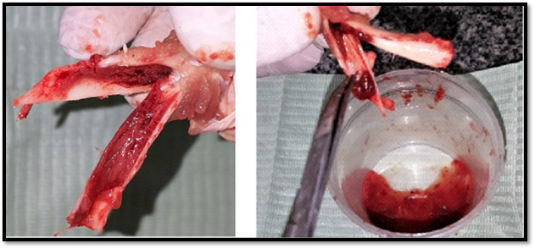
Figure 1: Harvesting bone marrow tissue from tibia and femur bones of the rabbits
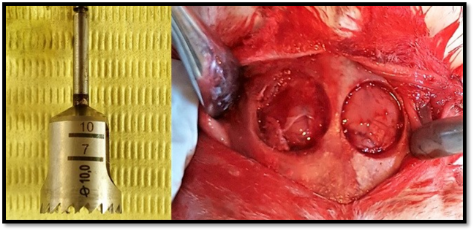
Figure 2: Bilateral surgically created 10 mm defects in the parietal bones using 10 mm trephine drill
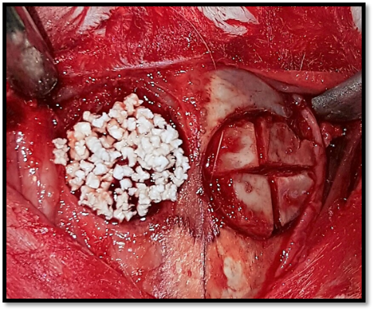
Figure 3: Grafting of surgically created defects with Nano-hydroxyapatite granules and autogenous bone in the right and left sides respectively
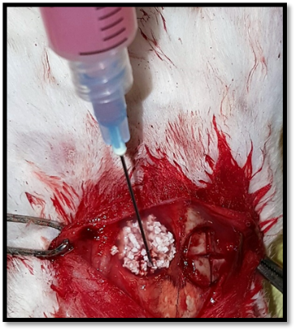
Figure 4: Adding bone marrow concentrate to the surgically created defect grafted with Nano-hydroxyapatite granules

Figure 5: A photomicrograph of a surgical defect reconstructed by BMC and Nano-hydroxyapatite granules, stained with H&E, showing a very vascular and cellular bone marrow stroma rich in mesenchymal cells differentiating into osteoblasts (orange arrow) forming and lining the newly formed osteoid trabeculae (green arrows). Note the residues of graft material (yellow arrow) around which the newly formed osteoid formation usually commences (red arrows) (Original magnification X40).

Figure 6: A photomicrograph of a surgical defect reconstructed by BMC and alloplast, stained with GT showing abundant formation of osteoid bridge (red-stained) with focal areas exhibiting some remodelling into mature bone, stained with reddish green colour (yellow arrows)(Original magnification X20).

References
- Arianna L Gianakos, Li Sun, Jay N Patel, Donald M Adams, Frank A Liporace. Clinical application of concentrated bone marrow aspirate in orthopaedics: A systematic review. World J Orthop : 8:491-506, 2017
- Avasthi S, Srivastava R.N, Singh A. Stem Cell: Past, Present and Future- A Review Article. Internet Journal of Medical Update. : 3:22-30, 2008
- Becker A.J, McCulloch E.A. Cytological demonstration of the clonal nature of spleen colonies derived from transplanted mouse marrow cells. Nature. : 197:452-4, 1963
- Boos AM, Weigand A, Deschler G, Gerber T, Arkudas A, Kneser U, Horch RE, Beier JP. Autologous serum improves bone formation in a primary stable silica-embedded nanohydroxyapatite bone substitute in combination with mesenchymal stem cells and rhBMP-2 in the sheep model. Int J Nanomedicine. : 19:5317-39, 2014
- Chahla J, Mannava S, Cinque ME, Geeslin AG, Codina D, LaPrade RF. Bone Marrow Aspirate Concentrate Harvesting and Processing Technique. Arthrosc Tech. : 6:441-45, 2017
- Cutting CB, Mccarthy JG, Berenstein A. Blood supply of the upper craniofacial skeleton: The search for composite calvarial blood flaps. Plast. Reconstr. Surg : 74: 603-610, 1984
- Egusa H. iPS cells in dentistry. Clin Calcium. : 22:67-73, 2012
- Evans M.J, Kaufman M.H. Establishment in culture of pluripotential cells from mouse embryos. Nature.: 292:154-6, 1981
- Friedenstein AJ, Chailakhyan RK, Latsinik NV, Panasyuk AF, Keiliss-Borok IV. Stromal cells responsible for transferring the microenvironment of the hemopoietic tissues. Cloning in vitro and retransplantation in vivo. Transplantation : 17: 331-340, 1974
- Gamradt SC, Lieberman JR. Bone graft for revision hip arthroplasty: Biology and future applications. Clin Orthop Relat Res : 417: 183-194, 2003
- Gruber HE. Adaptations of Goldner's Masson trichrome stain for the study of undecalcified plastic embedded bone. Biotech Histochem. : 67:30-4, 1992
- Hakimi M, Grassmann JP, Betsch M, Schneppendahl J, Gehrmann S, Hakimi AR, Kröpil P, Sager M, Herten M, Wild M, Windolf J, Jungbluth P. The composite of bone marrow concentrate and PRP as an alternative to autologous bone grafting. PLoS One. : 9:e100143, 2014
- Jager M, Herten M, Fochtmann U, Fischer J, Hernigou P. Bridging the gap: bone marrow aspiration concentrate reduces autologous bone grafting in osseous defects. J Orthop Res : 29: 173–180, 2011
- Kasten P., Beyen I. Instant stem cell therapy: characterization and concentration of human mesenchymal stem cells in vitro. European Cells & Materials, vol. 16. : 47–55, 2008
- Kennedy JG, Murawski CD. The Treatment of Osteochondral Lesions of the Talus with Autologous Osteochondral Transplantation and Bone Marrow Aspirate Concentrate: Surgical Technique. Cartilage : 2:327-336, 2011
- Kitoh H, Kitakoji T, Tsuchiya H, Katoh M, Ishiguro N Transplantation of culture expanded bone marrow cells and platelet rich plasma in distraction osteogenesis of the long bones. Bone: 40: 522–528, 2007
- Lu M, Rabie AB: The effect of demineralized intramembranous bone matrix and basic fibroblast growth factor on the healing of allogeneic intramembranous bone grafts in the rabbit. Arch oral Biol : 47:831- 841, 2002
- Mao JJ, Prockop DJ. Stem cells in the face: Tooth regeneration and beyond. Cell stem cell : 11: 291-301, 2012
- Nagata MJ, Melo LG, Messora MR, Bomfim SR, Fucini SE, Garcia VG, et al. Effect of platelet-rich plasma on bone healing of autogenous bone grafts in critical-size defects. J Clin Periodontol : 36:775-83, 2009
- Rodriguez-Lozano FJ, Insausti CL, Iniesta F, Blanquer M, Ramirez MD, Meseguer L, Meseguer-Henarejos AB, Marin N, Martinez S, Moraleda JM. Mesenchymal dental stem cells in regenerative dentistry. Medicina oral, patologia oral y cirugia bucal .: 17: 1062-1067, 2012
- Rosset P, Deschaseaux F, Layrolle P. Cell therapy for bone repair Orthopaedics & traumatology, surgery & research: OTSR : 100: S107–S112, 2014
- Sailer HF, Weber FE. Bone substitutes. Mund Kiefer Gesichtschir : 4(Suppl 1): 384-391, 2000
- Schmitz JP, Schwartz Z, Hollinger JO, Boyan BD. Characterization of rat calvarial nonunion defects. Acta Anat: 138: 185-192, 1990
- Shand JM, Heggie AA, Holmes AD, Holmes W. Allogeneic bone grafting of calvarial defects: an experimental study in the rabbit. Int J Oral Maxillofac Surg:31:525-31, 2002
- Sohn JY, Park JC, Um YJ, Jung UW, Kim CS, Cho KS, Choi SH. Spontaneous healing capacity of rabbit cranial defects of various sizes. J Periodontal Implant Sci.: 40:180-7, 2010
- Zarrabi M, Mousavi SH, Abroun S, Sadeghi B. Potential uses for cord blood mesenchymal stem cells. Cell journal:15: 274-281, 2014
- Zhang Y, Huang B. Peripheral blood stem cells: Phenotypic diversity and potential clinical applications. Stem cell reviews: 8: 917-925, 2012

