A Case Report on Inverted Papilloma of the Urinary Bladder
Dr. Alemayehu T. Tefera ( MD , Consultant general and minimal access Urologic surgeon, St. Paul Hospital millennium medical college, Addis Ababa, Ethiopia.)
Dr. Habtemariam Demoz (MD, MPH, St. Paul Hospital millennium medical college, Addis Ababa, Ethiopia)
ABSTRACT
Inverted urothelial papilloma is a rare non-invasive endophytic urothelial tumor of the urinary bladder accounting for less than 1% of urothelial neoplasm. The clinical and endoscopic features of inverted urothelial papilloma of the bladder are not specific, and the definitive diagnosis is based on the histopathological examination. We report a case with “inverted papilloma with cystitis glandular pattern” in a 45 years old man after he presented with LUTS of six month duration.

Key Words: Inverted Papilloma; cystitis glandularis, Urinary Bladder.

INTRODUCTION

A number of well-recognized urothelial lesions with inverted morphology occur in the urinary tract. Among them inverted papilloma is a rare tumor accounting for less than 1% of all urothelial neoplasms [1-2]. Its recognition is important because of similarities to inverted urothelial carcinoma, especially in small biopsy specimens. The age range of affected patients is broad, but most are in their sixth or seventh decade of life. Inverted papilloma is far more common in men than in women (7.3:1 ratio). Most patients present with hematuria and/or irritative voiding symptoms [3]. Rarely, patients might present with obstructive voiding symptoms.

CASE PRESENTATION
A 45 years old male patient presented to our outpatient urologic clinic with a compliant of LUTS more on voiding symptoms of six month duration. For this compliant he was visited different health service and took different PO medications but not improved. He had also history of STI for which he was treated IV and PO medications and got improvement.
On examination, there was no pertinent positive finding. Routine examination of urine detected 1-2 RBCs and 3-4WBC and other investigations like CBC and RFT were within normal range. With an impression of Urethral stricture CUG (Voiding and retrograde) was ordered and the result reveled a short segment bulbar urethral stricture.
Direct vision internal uretherotomy (DVIU) was done and the finding was narrowing of the urethral lumen at the site of mid bulbar urethra with minimal fibrosis in the spongy tissue. After DVIU being successful the urinary bladder examined systematically and found papillary mass in posterior wall of the bladder near the trigon area.
As a clinical impression of Urinary bladder cancer, patient was admitted in urology ward, prepared and TURBT was done with complete removal of the mass. The tissue sent for histopathology test and the result revealed “Inverted papilloma with cystitis glandularis”. (See image 1-3) Post procedure the patient is in smooth post op course and he is on follow-up.
After a month checkup cystoscopy examination done and there was no mass found in the bladder.

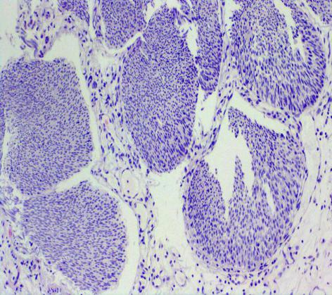
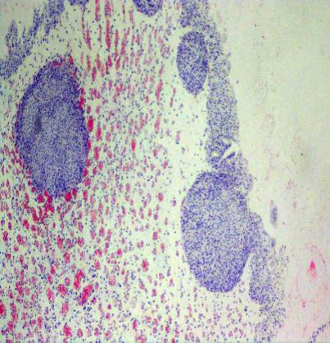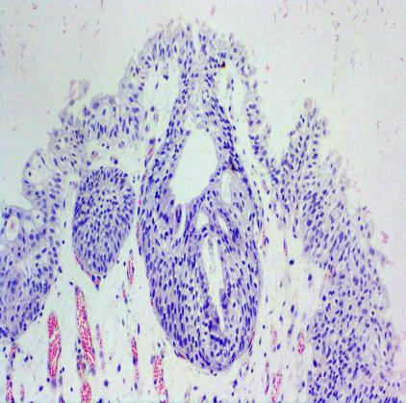
Image 1 Image 2 Image 3

DISCUSSION
Inverted papilloma of the urinary tract is a rare benign tumor most commonly diagnosed in older men presenting with hematuria or symptoms of lower urinary tract obstruction [4]. It is most frequently identified in the bladder neck or trigon as a polypoid growth with a smooth surface. These lesions are usually small (<3 cm) but can be large. Most are solitary although 1% - 4% may be multifocal.
Histologically there are two main subtypes of inverted papilloma; trabecular and glandular [1]. The former is characterized by widely branched, anastomosing cords of urothelial cells originating directly from the overlying transitional epithelium. The latter is characterized by multiple rounds to oval islands of proliferating urothelial cells together with pseudo glandular and true glandular structures, which are often connected with the surface urothelium. The glandular subtype has morphological overlap with cystitis glandularis.

Inverted papilloma is associated with a low risk of recurrence (5%), in marked contrast to the high recurrence rates of papillary urothelial carcinoma [5]. Sung et al. reported only one recurrence among 75 patients with inverted papilloma (1.3%) during a mean follow-up of 68 months after treatment. The authors recommend that complete transurethral resection appears to be adequate surgical therapy for inverted papilloma [2].

CONCLUSION
Physicians should do bladder examination systematically after doing Direct Vision Internal Urethrotomy (DVIU) to detect any pathology in the urinary bladder as early as possible which is happened in this case presentation.
INFORMED CONSENT
Written informed consent was obtained from the patient who participated in this study.
CONFLICT OF INTEREST
No conflict of interest was declared by the authors.
FINANCIAL DISCLOSURE
The authors declared that this study has received no financial support.

REFERENCES
- E. Kunze, A. Schauer and M. Schmitt, “Histology and Histogenesis of Two Different Types of Inverted Uro- thelial Papillomas,” Cancer, Vol. 51, 1983, pp. 348-358.
- M. T. Sung, G. T. MacLennan, A. Lopez-Beltran, R. Montironi and L. Cheng, “Natural History of Urothelial Inverted Papilloma,” Cancer, Vol. 107, No. 11, 2006, pp. 2622-2627.
- Sung MT, MacLennan GT, Lopez- Beltran A, Montironi R, Cheng L. Natural history of urothelial inverted papilloma. Cancer 2006; 107: 2622
- K. B. Hodges, A. Lopez-Beltran, G. T. MacLennan, R. Montironi and L. Cheng, “Urothelial Lesions with Inverted Growth Patterns: Histogenesis, Molecular Genetic Findings, Differential Diagnosis and Clinical Management,” BJU International, Vol. 107, No. 4, 2010, pp. 532-537.
- T. D. Jones, S. Zhang, A. Lopez-Beltran, J. N. Eble, M.-T., Sung, G. T. MacLennan, R. Montironi, P.-H. Tan, S. Zheng, L. A. Baldridge and L. Cheng, “Urothelial Car- cinoma with an Invereted Growth Pattern Can Be Dis- tinguished from Inverted Papilloma by Fluorescence in Situ Hybridization, Immunohistochemistry, and Mor- phologic Analysis,” American Journal of Surgical Patho- logy, Vol. 31, No. 12, 2007, pp. 1861-1867

