Research article
A Clinicopathological Classification of Perianal Paget’s Disease
Elroy Patrick Weledji
Department of Surgery, Faculty of Health Sciences, University of Buea, Cameroon
Correspondence: PO Box 126, Limbe, S,W, Region, Cameroon. E-mail: elroypat@yahoo.co.uk Tel: 237699922144
Abstract
Background: Perianal Paget’s disease is exceedingly rare and a heterogenous entity. The current staging system does not take into account the paraneoplastic aspect of the disease. The author attempted to simplify the conundrum by proposing a clinicopathological classification system of perianal Paget’s disease (Weledji’s classification).
Methods: The texts on the staging and treatment of perianal Paget’s disease have been reviewed . The clinicopathological classification has been developed from the cases reported in the literature and texts on perianal Paget’s disease.
Results: The presenting author classified perianal Paget’s disease into four clinicopathological groups. In the first group (Type1), there is a high frequency of an associated distant malignancy with similar immunoprofile requiring an aggressive search for the primary. This is akin to a paraneoplastic syndrome and has the worse prognosis. In the second group (Type 2) which is the commonest presentation, perianal Paget’s disease represents a cutaneous manifestation through the intraepithelial spread of an underlying anorectal or vulvar adenocarcinoma (i.e. secondary). The third group (Type 3) represents true primary intraepithelial cutaneous apocrine adenocarcinoma. The fourth group (Type 4) represents a primary perianal Paget’s disease with an associated malignancy but with discordant immunoprofile.
Conclusions: Preoperative staging of perianal Paget’s disease should include the Weledji’s clinicopathological classification before deciding treatment.
Keywords: Perianal, Paget’s disease, staging, classification. clinicopathological

Background
Perianal Paget’s disease is extremely rare. First discovered by Paget in 1874 (figure 1) as a breast lesion (figure 2) [1], similar findings in the perianal area were reported 20 years later by Darier (figures 3, 4) [2]. Sir James Paget, who is the father of British pathology stressed the importance of bringing science into medical practice with the success base on his knowledge of pathology and physiology. These are seen in his descriptions of Paget’s disease of bone, Paget’s abscess and Paget’s disease of the nipple etc. Paget reported in 1874 a chronic eczematous disease on the skin of the nipple and the areola with associated intraductal carcinoma in 15 women [1]. The ductal carcinoma-in-situ extended along major ducts into the skin around the nipple. Paget’s disease of the nipple is thus a secondary disease.

Figure 1: Sir James Paget (1870)
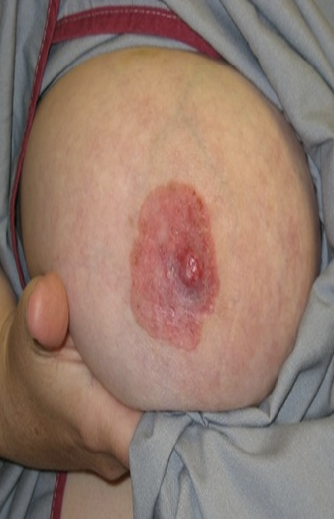
Figure 2: Paget’s disease of the breast
The French dermatologist, Ferdinand-Jean Darier (figure 3), a father of modern dermatology demonstrated in 1893 similar findings of perianal Paget’s disease as a cutaneous paraneoplastic syndrome (figure 4) [2]. He had demonstrated papulosquamous disorders such as acanthosis nigricans associated with gastric cancer and other cutaneous manifestations of distant malignancies such as tripe palms, palmar hyperkeratosis, acquired ichthyosis, erythema annularis, dermatofribrosarcoma etc,.
Figure 3: Ferdinand-Jean Darier (1856-1938)
Figure 4: Perianal Paget’s disease
A paraneoplastic syndrome is non-metastatic systemic effects that accompany malignant disease. It may consist of a set of signs and symptoms that is a consequence of cancer, but not necessarily due to local presence of cancer cells [3]. It may present as dermatoses which may precede, coincide with or follow the diagnosis of cancer. It may also be evidence of local recurrence of cancer. Generally, a paraneoplastic syndrome is often associated with a poor prognosis. The mechanism may entail humoral factors (hormones/ cytokines) excreted by tumour cells or immune response against tumour [3]. Therefore, perianal Paget’s disease is an heterogenous entity. It can present in isolation as a primary lesion of the apocrine glands, may be associated with underlying malignancy by intraepithelial spread of carcinoma of the sweat glands in vulva, perianal region, rectum, i.e. secondary as in the breast or may manifest as a cutaneous paraneoplastic syndrome [4]. ‘True’ Paget’s disease (a primary lesion of the apocrine glands) is usually a low-grade neoplastic lesion and can be distinguished from the Pagetoid spread of signet ring cells from a nearby carcinoma ( a secondary lesion) by immunohistochemical studies CK7+/ CK20+/ GCDFP-15-/ lysozyme-/Leu- M1- immunophenotype [5]. CK20 and GCDFP-15 are particularly useful adjuncts in distinguishing primary and secondary perianal Paget’s disease. If apocrine markers are absent in the staining pattern of perianal Paget’s, it is more likely that the lesion is associated with an underlying adenocarcinoma [5-8]. As perianal Paget’s disease is a heterogenous entity, the author proposed a clinicopathological classification system. The current staging system utilizes a tumour progression (TNM) histopathological approach which does not take into account the paraneoplastic aspect of the disease.
Methods: The texts on the staging and treatment of perianal Paget’s disease have been reviewed . The clinicopathological classification has been developed from the cases reported in the literature and texts on perianal Paget’s disease.
Results
100 cases were reported between 1893 -1990, 193 cases between 1990-2008 and 10 cases between 2009-2017. It is more common in white- skinned races, women greater than men and in the 50-80 years range [6]. The staging and treatment of perianal Paget’s disease (1990) is illustrated in table 1 [9]. Stage 1 is Paget’s cells found in peranal epidermis and adnexa without primary carcinoma ( in situ). This will require wide local excision. Stage IIA is cutaneous Paget’s disease without adnexal carcinoma (primary) and a wide local excision with flap reconstruction will suffice. Stage IIB is cutaneous Paget’s disease with associated anorectal carcinoma. This would require an abdominoperineal resection, Stage III is peranal Paget’s disease in which the associated anorectal carcinoma has spread to the regional inguinal nodes. This would require abdominoperineal resection with inguinal node dissection. Stage IV is distant metastastes with distant metastases of associated carcinoma. This would require chemotherapy, radiotherapy and local palliative treatment. The presenting author classifies perianal Paget’s disease into four clinicopathological groups. In the first group (Type1), there is a high frequency of an associated distant malignancy with similar immunoprofile ( lysozyme /leu₁-M1) requiring an aggressive search for the primary. This is akin to a paraneoplastic syndrome and has the worse prognosis [ 8, 10-12]. Regression of perianal Paget’s disease (type 1) has been observed following removal of an associated sigmoid colon carcinoma [13]. In the second group (Type 2) which is the commonest presentation, perianal Paget’s disease represents a cutaneous manifestation through the intraepithelial spread of an underlying anorectal or vulvar adenocarcinoma (i.e. secondary just like Paget’s of the breast) [4, 13-17]. This type may be made latent by neoadjuvant and adjuvant chemotherapy to slowly re-emerge as the evidence of local recurrenceafter anterior resection (figure 1) [4] The third group (Type 3) represents true primary intraepithelial cutaneous apocrine adenocarcinoma which is usually a low –grade neoplastic lesion [ 7, 18-20]. The fourth group (Type 4) represents a primary perianal Paget’s disease with an associated malignancy but with discordant immunoprofile [21, 22].

Table 1: Staging and treatment of perianal Paget’s disease [9]
STAGE | THERAPY
I.Paget’s cells found in perianal epidermis and adnexa without primary carcinoma (in situ | Wide local excision  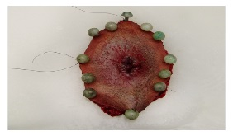
IIA. Cutaneous Paget’s disease without associated adnexal carcinoma (primary) | Wide local excision (Flap reconstruction)  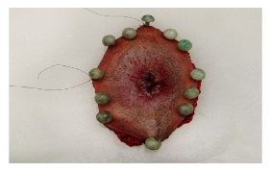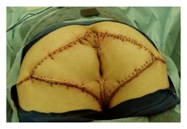
IIB. Cutaneous Paget’s disease with associated anorectal carcinoma (secondary)  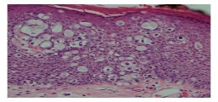 | Abdominoperineal excision  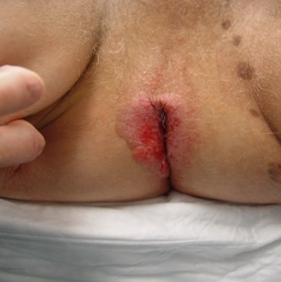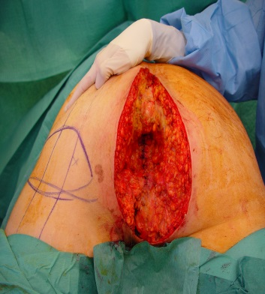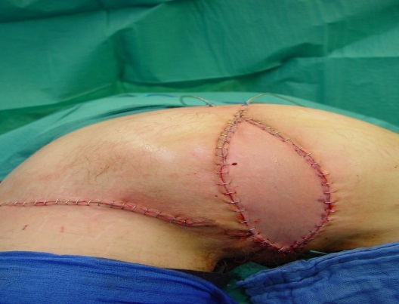
III. . Paget’s disease in which associated anorectal carcinoma has spread to regional nodes (secondary with locoregional spread)  IV. Paget’s disease with distant metastases of associated carcinoma | Inguinal node dissection  Abdominoperineal excision  Chemotherapy, radiotherapy  Local palliative treatment

Table 2: Weledji’s Clinicopathological Classification of Perianal Paget’s disease.

Type 1 | Cutaneous paraneoplastic syndrome -underlying adenocarcinoma may be in a distant organ, with similar immunoprofile (lysozyme/leu1-M1)  aggressive search for the distant primary, poor prognosis
Type 2 | 50-80%  cutaneous manifestation via intraepithelial spread of an underlying anorectal or vulva adenocarcinoma (i.e. secondary –just like Paget’s of the breast)  necessitating an abdomino-perineal excision
Type 3 | - True’ perianal Paget’s disease affecting the apocrine glands only i.e. primary  - Rare, indolent but often recurs  - low- grade neoplasia when unassociated with adenocarcinoma elsewhere , 50-70yrs, M=F
Type 4 | - Primary perianal Paget’s disease with an associated malignancy but with discordant immunoprophile ( indicating different origin)

Discussion
It is important to compare Paget’s disease of the breast with perianal paget’s disease histopathologically. Paget’s disease of the breast is always accompanied by intraduct carcinoma, and direct continuity at the nipple can usually be demonstrated [1]. The affected skin shows reactive changes in the dermis, with exudation, formation of vascular fibrous tissue, and infiltration with lymphocytes and plasma cells, These changes produce a characteristic eczematous condition of the nipple and areola named Paget’s disease of the breast (Figure 2). The cancer cells are larger than those of the epidermis, with pale cytoplasm and a large vesicular, hyperchromatic nucleus and prominent nucleolus (pagetoid cells). In some patients, intraduct cancer has already invaded the breast stroma but in others, it is still contained within the duct system.
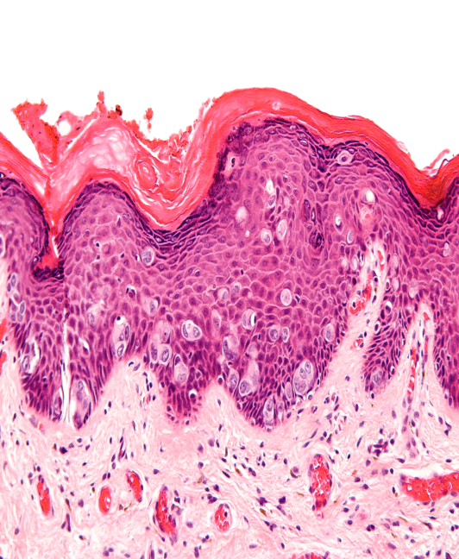

Figure 5: ‘True’ Paget’s disease (a primary lesion of the apocrine glands)

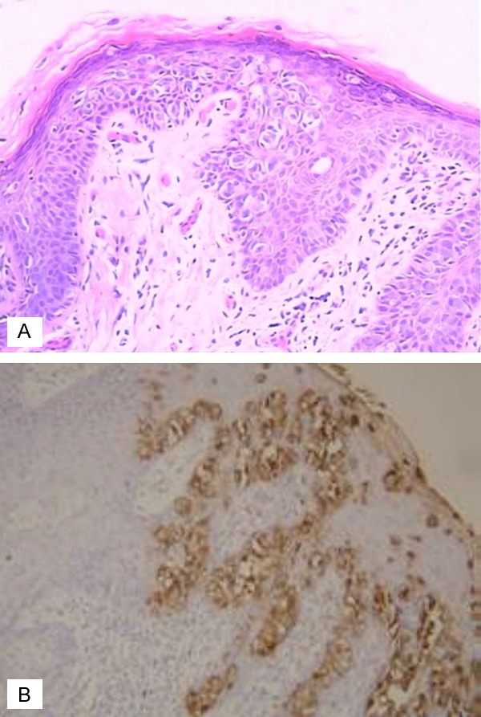
Figure 6: Pagetoid spread of signet ring cells from a nearby carcinoma (a secondary lesion) by immunohistochemical studies (CK7+/CK20+/GCDFP-15-/lysozyme-/Leu-M1-immunophenotype)

In either case, mastectomy is essential. Similarly, extramammary Paget’s disease of the skin may occur at the vulva, parianal region, axilla, etc., by intraepithelial spread of carcinoma of the sweat glands in theses sites [20, 23]. As Paget’s cells are probably of apocrine origin, corroborated by the breast itself being a modified sweat gland, these are ‘true’ Paget’s disease (figure 5) with usually low-grade neoplasia when unassociated with adenocarcinoma elsewhere (Type 3)[7]. The immunophenotype is favourable with an excellent prognosis if adequately resected [5] In most cases of perianal Paget’s disease (50-80%), there is an underlying adenocarcinoma usually of the rectum or vulva (figure 6) (Type 2) although the lesion may rarely be a distant organ (Type 1)[8, 13-17, 23]. Clinically occult Paget’s disease may be found on histologically examination following rectal excision for carcinoma (Type 2) [13, 14, 17]. Perianal Paget’s disease have occurred 4 years after anterior resection of rectal carcinoma associated with local recurrence of rectal carcinoma, necessitating an abdominoperineal excision (Type 2)[4]. Latent perianal Paget’s disease from contiguous spread have appeared several years following excision of rectal carcinoma (Type 2) [24]. Conversely, Paget’s disease with no apparent associated malignancy may be followed several years later by the development of an adenocarcinoma (Type 2) [13, 14, 17]. Type 4 consists of primary perianal Paget’s disease with an associated malignancy but with discordant immunoprofile which may indicate a different origin [12, 21, 22]. Although a typical macroscopic appearance of perianal paget’s disease shows a variegated darkly reddened skin and distorsion of the anus, the differential diagnosis of perianal Paget’s disease is wide. It includes intraepithelial squamous cell carcinoma (Bowen’s disease), squamous cell carcinoma, dermatitis, lichen planus, melanoma, psoriasis, hidradenitis suppurativa, and eczema [25]. Thus, the diagnosis must be confirmed from several full-thickness biopsies around the periphery of the lesion under general anaesthesia(figure 7) [26, 27].
Figure 7: Perianal mapping of the lesion under general anaesthesia
The staging system is the basis for deciding appropriate treatment of perianal Paget’s disease as shown in table [9]. However, there are limitations of the current staging system because it is based simply on tumour progression (TNM) and not on the clinicopathological aspect of the disease. For example the stage I in the current staging system with apparently no associated primary carcinoma histopathologically may clinicopathologically be a type 1 where a distant primary should be sought, and, it is indeed most sinister as being part of a paraneoplastic syndrome. It also excluded concomitant cancers with discordant immunoprofile (type 4).
Conclusions
Clinicians and pathologists should carefully examine the perianal epidermis in anorectal carcinoma and vice versa if the anorectal tumour shows intraepithelioid pagetoid (signet ring) cells. Preoperative staging of perianal Paget’s disease should include the Weledji’s clinicopathological classification before deciding treatment. Long-term follow-up after definitive treatment is required as local recurrence may occur many years later with the risk of metastatic spread.

Acknowledgement: The author would like to acknowledge his clinical fellowship award on pelvic floor surgery granted by the European Society of Coloproctology to Kantonsspital St Gallen, Switzerland, where my study on perianal Paget's disease evolved. I acknowledge Dr. Lukas Marti and Dr. Walter Brunner of the coloproctology unit at Kantonsspital St Gallen.
Conflict of interest: None
References

- Paget J. On disease of the mammary areola preceding cancer of the mammary gland St Bartholomew Hosp Res Lond. 1874;10:87–9
- Darier J, Couillard P. On a case of Paget's disease of the perineo-anal scrotal region Soc Franc Dermatol Syph. 1893;4:25–31
- Anderson JR. Tumours: 1. General features, types and examples. In: Muir’s Textbook of Pathology; Ed J.R. Anderson 12th Ed; Taylor and Francis publisher 2005
- Weledji EP, Hummel B, Marti L, Gruenert J, Malkert E, Brunner W. Perianal Paget's disease: Is it a primary or secondary disease? World J Colorectal Dis. 2016;6:1
- Nowak MA. Guerriiere- Kovach P, Pathan A, Campbell TE, Deppisch LM. Perianal Paget’s disease: distinguishing primary and secondary lesions using immunohistochemical studies including gross cystic disease fluid protein-15 and cytokeratin 20 expression. Arch Pathol lab Med 1998; 122(12):1077-81
- Carbotta G, Sallustio P, Prestera A, Laforgia R, Lobascio P, Palasciano N. Perineal Paget's disease: A rare disorder and review of literature Ann Med Surg (Lond). 2016;9:50–2
- Merot Y, Mazoujian G, Pinkus G, Momtaz-T K, Murphy GF. Extramammary Paget's disease of the perianal and perineal regions.Evidence of apocrine derivation Arch Dermatol. 1985;121:750–2
- Le Fur R, Mears L, Dannawi Z. A peri-anal extramammary Paget's disease associated with two well-differentiated invasive intramucosal sigmoid carcinomas, a very rare case: An immunohistochemical and clinical review of extramammary Paget's disease Ann R Coll Surg Engl. 2004;86:W26–31
- Shutze WP, Gleysteen JJ. Perianal Paget's disease. Classification and review of management: report of two cases. Dis. Colon. Rectum.1990 Jun;33(6):502-7.
- Shimizu S, Kobayashi H, Suchi et al. Extramammary Paget’s disease arising in mature cystic teratoma of the ovary. Am J Surg Pathol 1991:15:1002-6
- Stephenson TJ, Cotton DW. Paget’s disease in an epidermal cyst. Dermatologica 1987; 174:186-90
- Neumann R. Extramammary Paget’s disease associated with stomach cancer. Hautarzt1986; 37:566-570
- Lertprasertsuke N, Tsutsumi Y. Latent perianal Paget's disease associated with mucin-producing rectal adenocarcinoma.Report of two cases Acta Pathol Jpn. 1991;41:386–93
- Kubota K, Akasu T, Nakanishi Y, Sugihara K, Fujita S, Moriya Y. Perianal Paget's disease associated with rectal carcinoma: A case report Jpn J Clin Oncol. 1998;28:347–50
- Louis-Sylvestre C, Haddad B, Paniel BJ. Paget's disease of the vulva: Results of different conservative treatments Eur J Obstet Gynecol Reprod Biol. 2001;99:253–5
- Kim NR, Cho HY, Baek JH, Jeong J, Ha SY, Seok JY, et al Rare case of anal canal signet ring cell carcinoma associated with perianal and vulvar pagetoid spread J Pathol Transl Med. 2016;50:231–7
- Sasaki M, Terada T, Nakanuma Y, Kono N, Kasahara Y, Watanabe K. Anorectal mucinous adenocarcinoma associated with latent perianal Paget's disease Am J Gastroenterol. 1990;85:199–202
- Northover J. Malignant tumors: Anal and Perianal disease; In: Surgery of the Colon and Rectum. Eds: R John Nicholls, Roger R, Dozois Ist Edn 1997. Churchill Livingstone
- Clark ME, Schlussel AT, Gagliano RA Jr. Management of adenocarcinoma in the setting of recently operated perianal Paget's disease Case Rep Surg. 2013;2013:510813
- Goldblum JR, Hart WR. Perianal Paget's diseases: A histologic and immunohistochemical study of 11 cases with and without associated rectal adenocarcinoma Int J Surg Pathol. 2009;17:42–5
- Chanjuan S, Argani P. Synchronous primary perianal Paget's diseases and rectal adenocarcinoma: Report of a hitherto undescribed phenomenon Dis Colon Rectum. 2014;57:747–51
- Liao X, Mao W, Lin A. Perianal Paget's disease co-associated with anorectal adenocarcinoma: Primary or secondary disease? Case Rep Gastroenterol. 2014;8:186–92
- Armitage NC, Jass JR, Richman PI, Thomson JP, Phillips RK. Paget's disease of the anus: A clinicopathological study Br J Surg. 1989;76:60–3
- Koashi Y, Kitajima S, Schwartz RA, Tsuji T. Perianal Paget's disease years after rectal adenocarcinoma removal Dermatol Surg. 1997;23:1032–4
- Devine RM.Perianal dermatology; In: Surgery of the Colon and Rectum. Eds: R John Nicholls, Roger R, Dozois Ist Edn 1997. Churchill Livingstone
- Jabir S, Khatib M, Ali S, Niranjan N. Perianal Paget's disease: A diagnostic dilemma.BMJ Case Rep 2013;2013 pii: Bcr2013200504
- Wielfeldt ED, Thiele J. Malignancies of the anal margin and perianal skin. Clin Colon Rectal Surg 2009:22(2): 127-135

