Hip involvement negatively impacts postoperative radiographic outcomes after lumbar pedicle subtraction osteotomy in ankylosing spondylitis patients with thoracolumbar kyphosis—a retrospective study

Abstract
Background: Lumbar pedicle subtraction osteotomy (PSO) can significantly correct thoracolumbar kyphosis and relieve compensatory backward pelvic tilt (PT). However, hip involvement for some advanced ankylosing spondylitis (AS) patients can restrict the rotation of the pelvis around the femoral heads, which may affect the postoperative radiographic outcomes after lumbar PSO.
Objective: To identify whether hip involvement negatively impacts the postoperative radiographic outcomes after lumbar PSO in AS patients with thoracolumbar kyphosis.
Methods: Between March 2009 and June 2013, a total of 44 consecutive AS patients with thoracolumbar kyphosis who had undergone one-level lumbar PSO were retrospectively reviewed. All the patients had more than two years of follow-up. Hip involvement was evaluated based on the Bath Ankylosing Spondylitis Radiology Hip Index (BASRI-hip) and defined by a score of at least 2. All patients were divided into group A (patients without hip involvement) and group B (patients with hip involvement). Radiographical measurements included sagittal vertical axis (SVA), global kyphosis (GK), thoracic kyphosis (TK), local kyphosis (LK), lumbar lordosis (LL), pelvic incidence (PI), PT, and sacral slope (SS). The VAS scores for low back pain were also recorded.
Results: Preoperative SVA and PT were not significantly different between group A and group B (SVA: 14.0 ± 6.3 cm vs. 14.7 ± 6.0 cm, P > 0.05; PT: 36.8° ± 7.1° vs. 37.3° ± 7.7°, P > 0.05), and both groups had similar magnitudes of kyphosis corrections (LK correction: 44.9° ± 4.9° vs. 44.2° ± 8.3°, P > 0.05). However, group B had significantly larger SVA and PT than group A (SVA: 7.6 ± 4.5 cm vs 3.5 ± 3.4 cm, P < 0.05; PT: 28.1° ± 8.6° vs. 19.0° ± 8.0°, P < 0.05) at the last follow-up.
Conclusion: In AS patients with thoracolumbar kyphosis, hip involvement led to insufficient correction of SVA and PT after lumbar PSO, which negatively impacted postoperative radiographic outcomes. For these patients, additional osteotomies are recommended for satisfactory correction outcomes.
Keywords: ankylosing spondylitis, thoracolumbar kyphosis, pedicle subtraction osteotomy, hip involvement

INTRODUCTION
Ankylosing spondylitis (AS) is a chronic, progressive rheumatic disease that affects the sacroiliac joints, spine, and peripheral joints, causing characteristic inflammatory back pain, which can lead to structural and functional impairments and a decrease in quality of life. The prevalence of AS is 0.1–1.4% globally and 0.3% in China. In advanced stages, more than 30% of AS patients experience thoracolumbar kyphosis, resulting in sagittal imbalance and an inability to look straight ahead. In an attempt to compensate for sagittal imbalance, AS patients retrovert the pelvis to a more vertical position and tilt the trunk backwards. This position is biomechanically inefficient and can impair walking ability and interpersonal communication.⁶ Surgical intervention is usually required in AS patients with severe thoracolumbar kyphosis, sagittal imbalance, and low back pain.⁷
Lumbar pedicle subtraction osteotomy (PSO) is a vertebral wedge osteotomy for the correction of thoracolumbar kyphotic deformities in patients with AS and was first described by Thomasen in 1985.⁸ In PSO, both of the pedicles and a V-shaped bony wedge of the vertebral body are resected. The posterior column is shortened without lengthening the anterior column.⁹ Lumbar PSO can significantly correct thoracic kyphosis (TK), relieve compensatory backward pelvic tilt (PT), and reconstruct the sagittal spinopelvic alignment in AS patients. Ruf et al.¹⁰ asserted that the corrective surgery in AS patients with thoracolumbar kyphosis is performed to normalize PT and the gravity line and to restore the ergonomic upright position of the body. Debarge et al. ⁴ claimed that the reduction of PT is one of the most common surgical targets and that PT should be reduced to 20° to restore pelvic orientation.
According to reports, peripheral joint disease is frequently observed in AS patients and the incidence of hip involvement in AS patients is between 30% and 50%.¹¹⁻¹³ Li et al. ¹² found that AS patients with severe hip involvement had less range of motion during flexion-extension, abduction-adduction, and rotation. Hip involvement can result in decreased range of motion in the hips, which can in turn affect the rotation of the pelvis around the femoral heads and negatively impact postoperative radiographic outcomes. Thus, the current study aimed to investigate whether hip involvement can negatively impact radiographic outcomes after lumbar PSO in AS patients with thoracolumbar kyphosis.

SUBJECTS AND METHODS
Subjects
This study retrospectively reviewed a total of 92 consecutive AS patients who had undergone one-level lumbar PSO for the correction of thoracolumbar kyphosis between October 2009 and October 2013. Following this, 44 AS patients (40 males and 4 females) with a mean age of 34.8 years (range, 18–50 years) were selected according to the study’s inclusion and exclusion criteria. Hip involvement was assessed by the Bath Ankylosing Spondylitis Radiology Hip Index (BASRI-hip) scoring system and defined by a score of at least 2.¹⁴ The patients were divided into group A (patients without hip involvement) and group B (patients with hip involvement). This study was approved by the ethics committee of our hospital.
Inclusion criteria: The study included patients with ﬁxed thoracolumbar kyphosis of more than 40°,⁴ patients who had undergone one-level PSO at the lumbar spine, patients receiving preoperative and postoperative standing radiographs of the spine, and patients with a minimum of two years of follow-up.
Exclusion criteria: The study excluded patients with a preoperative coronal curve of more than 10°, patients who had undergone previous spinal surgery, patients who had undergone previous total hip replacement, and patients with spinal fractures or pathological pseudarthrosis. In total, 48 AS patients were excluded from this study (without two-year follow-up: 15 patients; coronal curve of > 10°: 13 patients; previous spinal or hip surgery: 8 patients; pathological spinal fractures or pseudarthrosis: 12 patients).
Operative Procedures
Under general anesthesia, patients were placed in a prone position on a bow-type frame with the abdomen free of pressure. A standard posterior approach was used to laterally expose the posterior elements to the transverse processes. Pedicle screws were inserted 4 levels above and 3 levels below the intended osteotomy level. Subsequently, the laminae and the articular processes of the planned osteotomy vertebra were resected and a partial laminectomy was performed at the adjacent level. Afterwards, the bilateral pedicles, dura, and bilateral nerve roots were exposed. To prevent translation and displacement, a unilateral, temporary short rod was fixed upon the pedicle screws opposite the osteotomy side. The dura and nerve root were retracted and protected with a nerve retractor. A hole was then drilled down through the pedicle into the vertebral body on the osteotomized side. The cancellous bone within the vertebral body was removed bilaterally with curettes and rongeurs. Subsequently, the posterior wall of the osteotomized vertebra was pushed down into the wedge-shaped cavity with a curette. Under direct vision of the dura and nerve roots, the osteotomy closure was carried out with the anterior cortex acting as a hinge. In the process of osteotomy closure, the bow-type frame was gradually straightened. Importantly, prior to closure of the osteotomy site, care was taken to ensure that the dural sac and nerve roots were not constricted. Finally, the temporary rod was replaced by a permanent long rod to fix the spine in the corrected position. Intraoperative neuromuscular monitoring for sensory-evoked potential and motor-evoked potential was continuously monitored during operation. All patients underwent the intraoperative wake-up test after completing instrumentation.
Radiographical Parameters
The following radiographical parameters were preoperatively and postoperatively measured on standard standing lateral radiographs of the entire spine using the Surgimap software (Spine Software, version 1.1.2, New York, NY, USA) (Figure 1, 2): (1) sagittal vertical axis (SVA),⁷ defined as the distance between a plumb line dropped from the center of the C7 body to the posterior-superior corner of S1 (the SVA was positive if the plumb line was anterior to the posterosuperior corner of S1 and negative if the plumb line was posterior to the posterosuperior corner of S1); (2) global kyphosis (GK),⁷ measured as the angle formed by the upper endplate of the most cranially-tilted vertebra and the lower endplate of the most caudally-tilted vertebra; (3) TK,¹⁶ calculated as the angle between the upper endplate of the T5 vertebra and the lower endplate of T12; (4) local kyphosis (LK),⁷ the angle between the upper endplate of the first cephalad vertebra to the osteotomy level and the lower endplate of the first caudal vertebra to the osteotomy level; (5) lumbar lordosis (LL),⁴ the angle between the superior endplate of T12 and the superior endplate of S1 (the angle was positive when the curve was kyphotic and negative when the curve was lordotic); (6) pelvic incidence (PI),¹⁷ assessed as the angle formed by the line perpendicular to the sacral plate at its midpoint and the line connecting the point to the middle axis of the femoral heads; (7) PT,¹⁷ computed as the angle formed by the vertical line and the line connecting the midpoint of the sacral plate to the middle axis of the femoral heads; and (8), sacral slope (SS),¹⁷ the angle between the sacral plate and the horizontal line. Whereas a postoperative SVA value of 5.0 cm or less was defined as a satisfactory correction outcome, a postoperative SVA value of more than 5.0 cm was considered to indicate residual sagittal imbalance. The age, sex, and duration of the disease were also recorded in this study. An independent observer performed the measurements of all parameters. Each parameter was measured three times, and the average values were calculated in both groups.
Evaluation of low back pain improvement
The VAS score was used to evaluate the low back pain of the patients before and two years after surgery. The lower the score, the better the low back pain.
Statistical analysis
Statistical analyses were performed using SPSS statistical software, version 16.0 (SPSS Inc., Chicago, IL, USA). The sagittal parameters after the operation and at the last follow-up were compared with those before the operation by the paired-samples t test. Student’s t tests were used to evaluate the differences in the sagittal parameters between the two groups before the surgery and at the last follow-up. Signiﬁcance was deﬁned as P < 0.05.
RESULTS
A total of 44 AS patients (40 males and 4 females) with a mean age of 34.8 ± 6.8 years (range, 18–50 years) met the aforementioned inclusion criteria. The average disease duration was 12.8 ± 6.3 years (range, 6–18 years), and the mean follow-up period was 32.4 moths (range, 24–60 moths). None of the participants had missing data for each variable of interest. According to the BASRI-hip scoring system, 21 AS patients without hip involvement were divided into group A and 23 AS patients with hip involvement were divided into group B. Group A was composed of 2 females and 21 males with an average age of 33.2 ± 6.5 years (range, 18–48 years), and group B consisted of 2 females and 19 males with a mean age of 36.4 ± 7.2 years (range, 20–50 years). The mean disease duration of AS was 12.3 ± 5.3 years (range, 6–16 years) in group A and 13.4 ± 6.4 years (range, 8–18 years) in group B. The VAS for low back pain was 6.8 in group A and 7.0 in group B. No significant differences were found between group A and group B for age, sex distribution, disease duration, and VAS for low back pain (P > 0.05).
The lumbar PSO procedure was performed at L1 in 14 patients, at L2 in 24 patients, and at L3 in 6 patients. No intraoperative or postoperative neurovascular complications were observed in all cases. Sagittal subluxation of osteotomized vertebra occurred in one patient without neurological deficits. Wound infection was found in two patients, and the wounds healed well when the patients were discharged. The infection rate for the current study was about 4.5%. Dural tear occurred in two patients when the ossified ligamentum flavum was dissected from the dura. With the prompt intraoperative management of the leaks with gel sponges, the patients recovered without adverse effects by the time of their final follow-ups.
The VAS scores for low back pain had significantly improved in both groups by the last follow-up period, and no significant differences were detected between group A (VAS: 2.3) and group B (VAS: 2.5). The sagittal parameters were measured preoperatively, postoperatively, and at the last follow-up (Table 1). There were no significant differences in terms of SVA, GK, TK, LK, LL, PI, PT, and SS before surgery (P > 0.05) between group A and group B (Table 1). SVA, GK, LK, LL, SS, and PT were significantly corrected after lumbar PSO in each group (P < 0.05) (Table 1). Both groups had similar magnitudes of kyphosis corrections (LK: 44.9° vs. 44.2°) (Table 2). However, SVA and PT were significantly larger in group B than in group A at the time of the last follow-up (SVA: 7.6 ± 4.5 cm vs. 3.5 ± 3.4 cm, P < 0.05; PT: 28.1° ± 8.6° vs. 19.0° ± 8.0°, P < 0.05) (Table 1).

DISCUSSION
During advanced stages, more than 30% of AS patients experience thoracolumbar kyphosis. With the progression of the disease, severe thoracolumbar kyphosis can lead to sagittal imbalance and the inability to look straight ahead. In order to maintain an erect posture, AS patients retrovert the pelvis to a more vertical position and tilt the entire rigid segment of the spine backwards.⁵ This posture does not completely compensate for their sagittal imbalance, which dramatically restricts their daily activities and decreases their quality of life.¹⁸ Therefore, reconstructive procedures are recommended to correct sagittal imbalance and to restore the ability for AS patients to look straight ahead.⁵
Lumbar PSO has been widely used to correct AS-related thoracolumbar kyphosis, restore backward PT, and reconstruct sagittal spinopelvic balance.¹⁶ Song et al.²⁰ studied 20 AS patients who had undergone spinal osteotomies to correct their kyphotic deformities. The study’s results showed that GK, PT, and SVA were significantly corrected from 53°, 30°, and 18 cm preoperatively to 3°, 11°, and 7 cm postoperatively. However, hip involvement was found in 30% to 50% of advanced AS patients, which can decrease the range of motion of the hips and affect the rotation of the pelvis around the femoral heads.¹¹ Until now, few studies have focused on whether hip involvement can negatively impact postoperative radiographic outcomes after lumbar PSO in AS patients.
Several previous studies have reported that highly-retroverted pelvises in AS patients can be corrected by lumbar PSO with the realignment of the spine. In Qian et al.’s ⁷ analyses of the sagittal spinopelvic parameters of 36 AS patients who had undergone lumbar PSO, they found that PT could be restored from 35.9° ± 7.3° preoperatively to 22.3° ± 7.9° postoperatively with the correction of GK from 73.7° ± 16.5° to 25.3° ± 11.7°. The results demonstrated that the PSO-induced correction of the TK relieved the compensatory backward PT. Chen et al.²² asserted that structural damage to the hips can contribute to mobility limitation, functional impairment, and the inability to exercise. Rousseau et al.²³ studied the spinal balance of 356 patients and determined that spondylarthritis cases showed less pelvic reorientation after lumbar PSO, probably due to limitations in hip mobility. In the present study, the correction of PT was smaller in group B than in group A (11.0° ± 6.2° vs. 19.3° ± 5.4°) and the postoperative PT was significantly larger in group B than in group A (26.2° ± 8.0° vs. 17.5° ± 7.7°, P < 0.05) (Figures 1 and 2). Thus, we deemed that hip involvement affected the rotation of the pelvis around the femoral heads, leading to the insufficient correction of PT after lumbar PSO. In addition, because the pelvis acts as an intercalary unit between the spine and the lower extremities, the position of the pelvis plays a critical role in maintaining standing postures. Lee et al.¹⁸ observed that PT was a significant parameter in determining sagittal balance in AS patients. Debarge et al.⁴ ascertained that sagittal balance cannot be sufficiently corrected with a high PT after lumbar PSO. Similarly, in the current study, the postoperative SVA was found to be significantly larger in group B than in group A (7.2 ± 4.2 cm vs. 3.1 ± 3.8 cm, P < 0.05) (Figures 1 and 2). Therefore, we concluded that hip involvement in AS patients limited the range of motion in hips, leading to the insufficient correction of PT and SVA and impacting postoperative radiographic outcomes after lumbar PSO.
This study contains two limitations that need to be addressed. First, because it did not perform assessments of hip range of motion, it was unable to establish a relationship between the correction of PT and hip range of motion. Second, as the study did not analyze the influence of osteotomy levels on the degree of PT correction in AS patients, this factor should be a point of focus in future research. In spite of these limiting factors, this study was the first of its kind to investigate how hip involvement negatively impacts postoperative radiographic outcomes after lumbar PSO in AS patients.
CONCLUSION
The results of this study demonstrate for the first time that hip involvement can lead to insufficient SVA and PT correction and negatively impact postoperative radiographic outcomes in AS patients with thoracolumbar kyphosis. Therefore, for AS patients with thoracolumbar kyphosis who require lumbar PSO surgery, the preoperative assessment of hip involvement plays a pivotal role. For AS patients with both spine and hip deformities, additional osteotomies may be recommended for satisfactory correction outcomes.

TABLE 1 Comparison of the Sagittal Parameters Before and After Lumbar PSO in AS Patients
 |  | Group A |  |  |  |  |  | Group B
 | Preoperative |  | Postoperative | Final Follow-up | Preoperative |  | Postoperative |  | Final Follow-up
SVA (cm) | 14.0 ± 6.3 |  | 3.1 ± 3.8* | 3.5 ± 3.4† | 14.7 ± 6.0 |  | 7.2 ± 4.2* |  | 7.6 ± 4.5†
GK (°) | 66.9 ± 12.3 |  | 18.0 ± 9.2* | 19.2 ± 7.6 | 67.2 ± 12.5 |  | 17.3 ± 10.4* |  | 21.4 ± 8.3
TK (°) | 42.7 ± 17.5 |  | 38.6 ± 9.2 | 40.5 ± 11.4 | 43.7 ± 15.3 |  | 37.9 ± 11.2 |  | 41.2 ± 13.3
LK (°) | 18.5 ± 8.6 |  | -26.4 ± 8.2* | -25.2 ± 9.2 | 17.1 ± 7.6 |  | -27.1 ± 9.1* |  | -26.6 ± 8.3
LL (°) | 5.7 ± 11.1 |  | -40.5 ± 7.4* | -39.9 ± 12.1 | 2.8 ± 16.7 |  | -39.3 ± 9.8* |  | -38.1 ± 9.2
PI (°) | 44.6 ± 8.4 |  | 44.9 ± 8.9 | 44.8 ± 8.3 | 45.5 ± 8.7 |  | 45.2 ± 8.5 |  | 45.4 ± 9.2
PT (°) | 36.8 ± 7.1 |  | 17.5 ± 7.7* | 19.0 ± 8.0† | 37.3 ± 7.7 |  | 26.2 ± 8.0* |  | 28.1 ± 8.6†
SS (°) | 7.8 ± 6.4 |  | 27.4 ± 9.1* | 25.8 ± 10.5† | 8.2 ± 7.0 |  | 18.9 ± 9.3* |  | 17.3 ± 9.8†
AS= ankylosing spondylitis, PSO= pedicle subtraction osteotomy, SVA= sagittal vertical axis, GK= global kyphosis, TK= thoracic kyphosis, LK= local kyphosis, LL= lumbar lordosis, SS= sacral slope, PT= pelvic tilt, and PI= pelvic incidence.
*P < 0.05 indicates statistically significant differences between the postoperative value and preoperative value.
†P < 0.05 indicates statistically significant differences between group A and group B at the final follow-up.

TABLE 2 Comparisons of the Changes in Sagittal Parameters Between AS Patients with and without Hip Involvement
 | Group A |  | Group B |  | P value
Correction of SVA (cm) | 11.0 ± 5.5 | 7.4 ± 5.6 |  | 0.003
Correction of GK (°) | 48.8 ± 11.9 | 49.7 ± 13.1 |  | 0.794
Correction of TK (°) | 4.0 ± 8.0 | 5.8 ± 9.2 |  | 0.501
Correction of LK (°) | 44.9 ± 4.9 | 44.2 ± 8.3 |  | 0.745
Correction of LL (°) | 46.3 ± 8.7 | 42.1 ± 13.9 |  | 0.249
Correction of PI (°) | 1.3 ± 2.9 | 1.5 ± 2.4 |  | 0.514
Correction of PT (°) | 19.3 ± 5.4 | 11.0 ± 6.2 |  | 0.001
Correction of SS (°) | 19.6 ± 4.9 | 10.7 ± 5.0 |  | 0.002
AS= ankylosing spondylitis, SVA= sagittal vertical axis, GK= global kyphosis, TK= thoracic kyphosis, LK= local kyphosis, LL= lumbar lordosis, SS= sacral slope, PT= pelvic tilt, and PI= pelvic incidence.

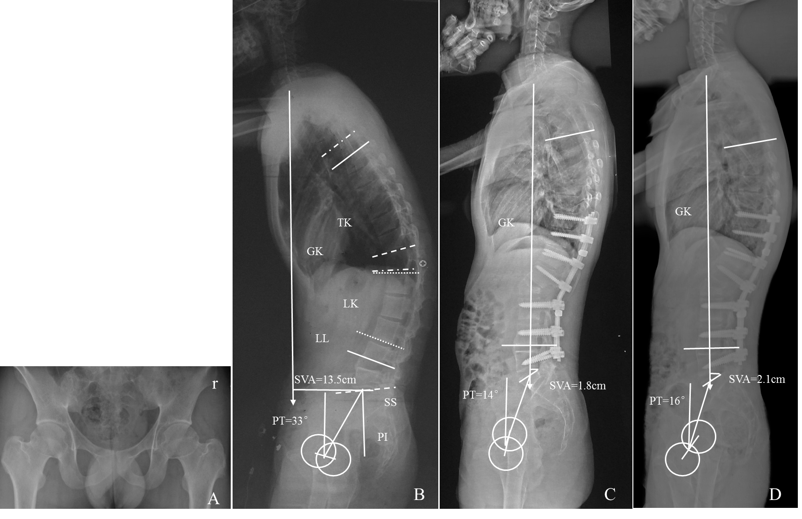
Figure 1. A 22-year-old male AS patient without hip involvement (the BASRI-hip scores were 0 at both sides of the hips) (A). The patient underwent PSO at the level of L2 with a good correction of PT (from 34º to 12º). The SVA, GK, LK, LL, and SS improved from 12.5 cm, 57º, 16º, 3º, and 8º preoperatively to 2 cm, 13º, -27º, -43º, and 12º postoperatively, respectively (B, C). This patient gained satisfactory postoperative sagittal balance (D).

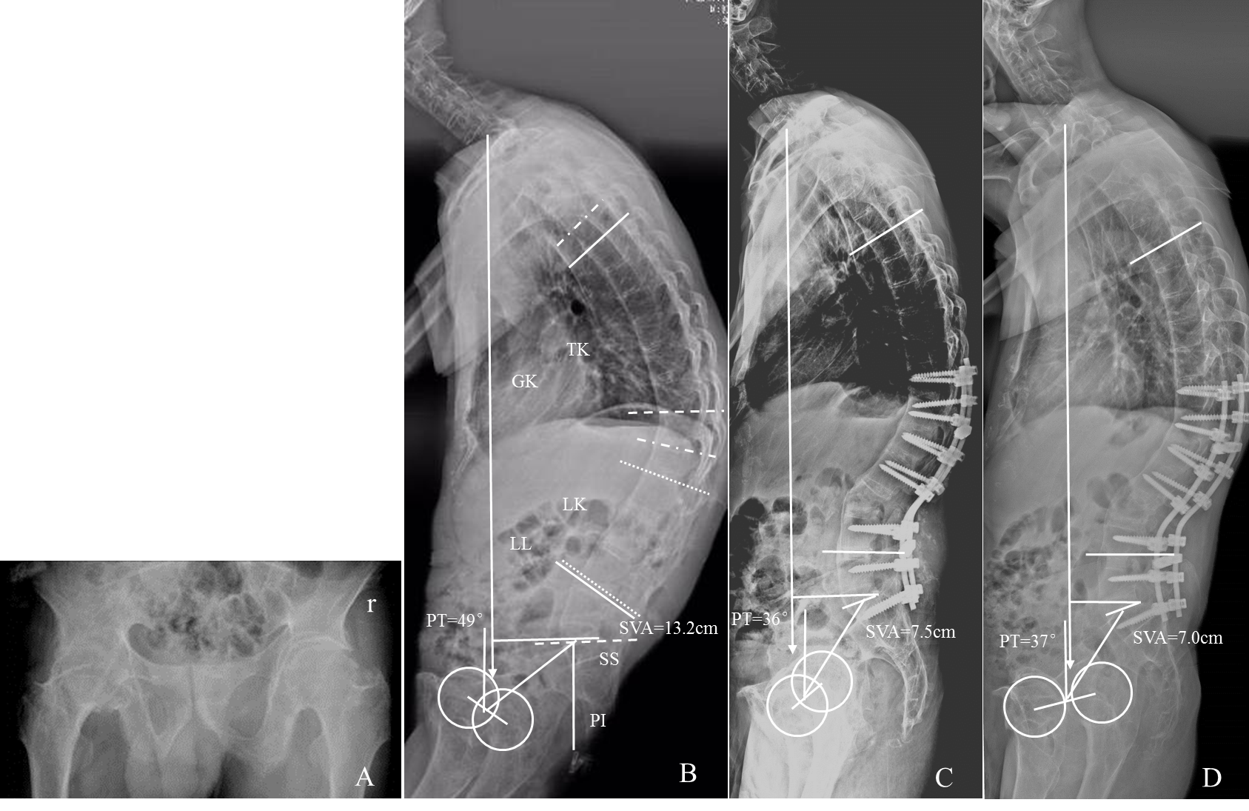

Figure 2. A 44-year-old male AS patient with hip involvement (the BASRI-hip scores were 4 at the left side and 3 at the right side of the hips) (A). The patient underwent PSO at the level of L3 with an insufficient correction of PT (from 50º to 38º). The SVA, GK, LK, LL, and SS improved from 10.2 cm, 78º, 12º, 9º, and 0º preoperatively to 6.4 cm, 32º, -31º, -39º, and 16º postoperatively, respectively (B, C). He had a residually positive postoperative sagittal imbalance (D).

