Hip involvement negatively impact the postoperative radiographic outcomes after lumbar pedicle subtraction osteotomy in ankylosing spondylitis patients with thoracolumbar kyphosis-a retrospective study

Jun Hu, Wenzhi Zhang*, Xu Li, Liqun Duan, Chang Ge

Spine Surgery, The First Affiliated Hospital of USTC, Division of Life Sciences and Medicine, University of Science and Technology of China, Hefei, Anhui, 230001, P.R. China

*To whom correspondence should be addressed. E-mail: zwzfp@163.com，Address: The First Affiliated Hospital of USTC, Division of Life Sciences and Medicine, University of Science and Technology of China, Hefei, Anhui, 230001, P.R. China

Abstract
Background: Lumbar pedicle subtraction osteotomy (PSO) can significantly correct thoracic kyphosis and relieve the compensatory pelvic backward tilt. However, hip involvement occurred in some advanced AS patients could restrict the rotation of the pelvis around the femoral heads, which may affect the postoperative radiographic outcomes after lumbar PSO. The aim of the study is to identify whether hip involvement will negatively impact the postoperative radiographic outcomes after lumbar PSO in AS patients with thoracolumbar kyphosis.
Methods: From March 2009 to June 2013, a total of 44 consecutive AS patients with thoracolumbar kyphosis undergoing one-level lumbar PSO were retrospectively reviewed. All the patients had more than 2-year follow-up. Hip involvement was evaluated based on the Bath ankylosing spondylitis radiology index-hip (BASRI-hip) and defined by a score of at least 2. All patients were divided into group A (patients without hip involvement) and group B (patients with hip involvement). Radiographical measurements included sagittal vertical axis (SVA), global kyphosis (GK), thoracic kyphosis (TK), local kyphosis (LK), lumbar lordosis (LL), pelvic incidence (PI), pelvic tilt (PT), and sacral slope (SS).
Results: The preoperative SVA and PT was not significantly different between group A and group B (SVA: 14.0 ± 6.3cm vs. 14.7 ± 6.0cm, P > 0.05; PT: 36.8° ± 7.1° vs. 37.3° ± 7.7°, P > 0.05), and both groups had similar magnitudes of kyphosis corrections (LK correction: 44.9° ± 4.9° vs. 44.2° ± 8.3°, P > 0.05). However, group B had significantly larger SVA and PT than group A (SVA: 7.6 ± 4.5cm vs 3.5 ± 3.4cm, P < 0.05; PT: 28.1° ± 8.6° vs. 19.0° ± 8.0°, P < 0.05) at the last follow-up.
Conclusion: In AS patients with thoracolumbar kyphosis, hip involvement lead to insufficient correction of SVA and PT after lumbar PSO, which negatively impact postoperative radiographic outcomes. For these patients, additional osteotomies may be recommended for satisfactory correction outcomes.
Key words: ankylosing spondylitis, thoracolumbar kyphosis, pedicle subtraction osteotomy, hip involvement

INTRODUCTION
Ankylosing spondylitis (AS) is a chronic progressive rheumatic disease that affects the sacroiliac joints, spine, and peripheral joints, causing characteristic inflammatory back pain, which can lead to structural and functional impairments and a decrease in quality of life. The prevalence of AS is 0.1-1.4% in global and 0.3% in China. In the advanced stages, more than 30% AS patients are often associated with thoracolumbar kyphosis resulting in sagittal imbalance and inability to look straight ahead. In an attempt to compensate for sagittal imbalance, AS patient retroverts the pelvis to a more vertical position and tilts the trunk backwards. This position is biomechanically inefficient, which impairs the ability of walking and interpersonal communication.⁶ Surgical intervention is usually required in the advanced stage of AS to restore the sagittal balance to achieve erect posture and the ability to see straight ahead.⁷
Lumbar pedicle subtraction osteotomy (PSO) is a vertebral wedge osteotomy for the correction of thoracolumbar kyphotic deformity in patients with AS was first described by Thomasen in 1985.⁸ In PSO, both of the pedicles and a V-shaped bony wedge of the vertebral body are resected. The posterior column is shortened without lengthening the anterior column.⁹ Lumbar PSO can significantly correct thoracic kyphosis, relieve the compensatory pelvic backward tilt, and reconstruct the sagittal spinopelvic alignment in AS patients. Ruf et al¹⁰ asserted that the correction surgery in AS patients with thoracolumbar kyphosis was to normalize pelvic tilt (PT) and the gravity line and to restore the ergonomic upright position of the body. Debarge et al⁴ claimed that the reduction of PT was one of the surgical targets and PT should be reduced to 20° to restore the pelvic orientation.
According to reports, peripheral joint disease is often observed in AS patients and the incidence of hip involvement in AS patients is between 30% and 50%.¹¹⁻¹³ Li et al¹² found that AS patients with severe hip involvement had less range of motion in flexion-extension, abduction-adduction, and rotation. Hip involvement could result in less range of motion of the hips, which might affect the rotation of the pelvis around femoral heads and negatively impact postoperative radiographic outcomes. Thus, our objective was investigated whether hip involvement can negatively impact the radiographic outcomes after lumbar PSO in AS patients with thoracolumbar kyphosis.

SUBJECTS AND METHODS
A total of 92 consecutive AS patients underwent one-level lumbar PSO for the correction of thoracolumbar kyphosis from October 2009 to October 2013 were retrospectively reviewed. The inclusion criteria were as follows: (1) the presence of ﬁxed thoracolumbar kyphosis of more than 40°;⁴ (2) undergoing one-level PSO at the lumbar spine; (3) availability of preoperative and postoperative standing anteroposterior and lateral radiographs of the spine; and (4) with a minimum of 2-year follow-up. Patients with a preoperative coronal curve of more than 10°, previous spinal surgery, previous total hip replacement, spinal fractures or pathological pseudarthrosis were excluded. 48 AS patients were excluded from this study (without 2-year follow-up: 15 patients; coronal curve of >10°: 13 patients; previous spinal or hip surgery: 8 patients; pathological spinal fractures or pseudarthrosis: 12 patients). Finally, 44 AS patients (40 males and 4 females), with a mean age of 34.8 years (range, 18-50 yrs) were recruited. Hip involvement was assessed by the Bath ankylosing spondylitis radiology index-hip (BASRI-hip) scoring system and defined by a score of at least 2.¹⁴ The patients were divided into group A (patients without hip involvement) and group B (patients with hip involvement).
Under general anesthesia, the patient was placed in a prone position on a bow-type frame with the abdomen free of pressure. A standard posterior approach was used to expose the posterior elements laterally to the transverse processes. Pedicle screws were inserted 4 levels above and 3 levels below the intended osteotomy level. Subsequently, the laminae and the articular processes of the planned osteotomy vertebra were resected and partial laminectomy was performed at the adjacent level. Afterwards, the bilateral pedicles, the dura, and bilateral nerve roots were exposed. A unilateral temporary short rod was fixed upon the pedicle screws opposite the osteotomy side to prevent translation and displacement. The dura and nerve root were retracted and protected with a nerve retractor. Then, a hole was drilled down through the pedicle into the vertebral body on the osteotomized side. The cancellous bone within the vertebral body was removed bilaterally with curettes and rongeurs. Subsequently, the posterior wall of the osteotomized vertebra was pushed down into the wedge-shaped cavity with curette. Under direct vision of the dura and nerve roots, the osteotomy closure was carried out with the anterior cortex acting as a hinge. In the process of osteotomy closure, the bow-type frame was gradually straightened. Importantly, prior to closure of the osteotomy site, care was taken to ensure that the dural sac and nerve roots were not constricted. Finally, the temporary rod was replaced by a permanent long rod to fix the spine in the corrected position. Sensory evoked potential and motor evoked potential were continuously monitored during operation. All patients underwent the intraoperative wake-up test after completing instrumentation.
The following radiographical parameters were measured on standard standing lateral radiographs of the entire spine preoperatively and postoperatively, using the Surgimap software (Spine Software, version 1.1.2, New York, NY, USA) (Figure 1, 2): (1) sagittal vertical axis (SVA),⁷ defined as the distance between a plumb line dropped from the center of the C7 body to the posterior-superior corner of S1 (the SVA was positive if the plumb line was anterior to the posterosuperior corner of S1 and negative if the plumb line was posterior to the posterosuperior corner of S1); (2) global kyphosis (GK),⁷ measured as the angle formed by the upper endplate of the most tilted vertebra cranially and the lower endplate of the most tilted vertebra caudally; (3) thoracic kyphosis (TK),¹⁶ calculated as the angle between the upper endplate of the T5 vertebra and the lower endplate of T12; (4) local kyphosis (LK),⁷ the angle between the upper endplate of the vertebra one cephalad to the osteotomy level and the lower endplate of the vertebra one caudal to the osteotomy level; (5) lumbar lordosis (LL),⁴ the angle between the superior endplate of T12 and the superior endplate of S1 (the angle was positive when the curve was kyphotic and negative when the curve was lordotic); (6) pelvic incidence (PI),¹⁷ assessed as the angle formed by the line perpendicular to the sacral plate at its midpoint and the line connecting the point to the middle axis of the femoral heads; (7) PT,¹⁷ computed as the angle formed by the vertical line and the line connecting the midpoint of the sacral plate to the middle axis of the femoral heads; and (8) sacral slope (SS),¹⁷ the angle between the sacral plate and the horizontal line. A postoperative SVA value of 5.0 cm or less was defined as satisfactory correction outcome, whereas a postoperative SVA value of more than 5.0 cm was considered as residual sagittal imbalance. The age, sex, and duration of disease were also recorded in this study. An independent observer performed the measurements of all parameters. Each parameter was measured 3 times and the average values were calculated in both groups.
Statistical analyses were performed using SPSS statistical software, version 16.0 (SPSS Inc., Chicago, IL, USA). The sagittal parameters after the operation and at the last follow-up were compared with those before the operation by the paired-samples t test. Student’s t tests were used to evaluate the differences of the sagittal parameters between the two groups before the surgery and at the last follow-up. Signiﬁcance was deﬁned as P < 0.05.

RESULTS
A total of 44 AS patients (40 males and 4 females) with a mean age of 34.8 ± 6.8 years (range, 18-50 yrs) met the aforementioned inclusion criteria. The average disease duration was 12.8 ± 6.3 years (range, 6-18 yrs) and the mean follow-up period was 32.4 moths (range, 24-60 moths). None of the participants had missing data for each variable of interest. According to BASRI-hip scoring system, 21 AS patients without hip involvement were divided into group A and 23 AS patients with hip involvement were divided into group B. Group A was composed of 2 females and 21 males with an average age of 33.2 ± 6.5 years (range, 18-48 yrs), and Group B consisted of 2 females and 19 males with a mean age of 36.4 ± 7.2 years (range, 20-50 yrs). The mean disease duration of AS was 12.3 ± 5.3 years (range, 6-16 yrs) in group A and 13.4 ± 6.4 years (range, 8-18 yrs) in group B. In terms of age, sex distribution and disease duration, no significant difference was found between group A and Group B (P > 0.05)
The lumbar PSO procedure was performed at L1 in 14 patients, at L2 in 24 patients, and at L3 in 6 patients. No intraoperative or postoperative neurovascular complications were observed in all cases. Sagittal subluxation of osteotomized vertebra occurred in 1 patient without neurological deficits. Dural tear occurred in 2 patients when the ossified ligamentum flavum was dissected from the dura. With a prompt management of the leak with gel sponge intraoperatively, the patients recovered without adverse effects at the final follow-up.
The sagittal parameters were measured preoperatively, postoperatively, and at the last follow-up (Table 1). There were no significant differences between group A and group B in terms of SVA, GK, TK, LK, LL, PI, PT, and SS before surgery (P > 0.05) (Table 1). SVA, GK, LK, LL, SS, and PT were significantly corrected after lumbar PSO in the 2 groups (P < 0.05) (Table 1). Both groups had similar magnitudes of kyphosis corrections (LK: 44.9° vs. 44.2°) (Table 2). However, SVA and PT were significantly larger in group B than in group A at the last follow-up (SVA: 7.6 ± 4.5 cm vs. 3.5 ± 3.4 cm, P < 0.05; PT: 28.1° ± 8.6° vs. 19.0° ± 8.0°, P < 0.05) (Table 1).

DISCUSSION
In advanced stages, more than 30% AS patients are often associated with thoracolumbar kyphosis. With the progressing of the disease, severe thoracolumbar kyphosis leads to sagittal imbalance and the inability to look straight ahead. In order to maintain an erect posture, AS patient retroverts the pelvis positioning the hips in extension, and tilts the entire rigid segment of the spine backwards.⁵ This posture is usually unable to completely compensate for sagittal imbalance, which dramatically restricts the daily activities and decreases the quality of life of AS patients.¹⁸ Therefore, reconstructive procedures are recommended to correct sagittal imbalance and to restore the ability to visualize the horizon.⁵
Lumbar PSO has been widely used to correct AS-related thoracolumbar kyphosis, restore the pelvic backward tilt, and reconstruct the sagittal spinopelvic balance.¹⁶ Song et al²⁰ studied twenty AS patients who underwent spinal osteotomy for correcting kyphotic deformity. Their results showed that GK, PT, and SVA were significantly corrected from 53°, 30° and 18cm preoperatively to 3°, 11°, and 7cm postoperatively. However, hip involvement was found in 30% to 50% advanced AS patients, which might decrease the range of motion of hips and affect the rotation of the pelvis around the femoral heads.¹¹ Until now, few studies have focus on whether hip involvement can negatively impact postoperative radiographic outcomes after lumbar PSO in AS patients.
Several previous studies reported that highly retroverted pelvis in AS patients could be corrected by lumbar PSO with the realignment of spine. Qian et al⁷ analyzed the sagittal spinopelvic parameters of 36 AS patients underwent lumbar PSO and they found PT could be restored from 35.9° ± 7.3° preoperatively to 22.3° ± 7.9° postoperatively with the correction of GK from 73.7° ± 16.5° to 25.3° ± 11.7°. The results demonstrated that PSO-induced correction of the thoracic kyphosis relieved the compensatory pelvic backward tilt. Chen et al²² claimed that the structural damage to the hips contributed to mobility limitation, functional impairment, and inability to exercise. Rousseau et al²³ studied the spinal balance of 356 patients and they found the spondylarthritis cases showed less pelvic reorientation after lumbar PSO, probably due to limitation of hip mobility. In the present study, the correction of PT was smaller in group B than group A (11.0° ± 6.2° vs. 19.3° ± 5.4°) and the postoperative PT was significantly larger in group B than in group A (26.2° ± 8.0° vs. 17.5° ± 7.7°, P < 0.05) (Figure 1, 2). Thus, we deemed that hip involvement affected the rotation of the pelvis around femoral heads, leading to insufficient correction of PT after lumbar PSO. Besides, the pelvis acts as an intercalary unit between the spine and the lower extremities; therefore, the position of the pelvis plays a critical role in maintaining standing postures. Lee et al¹⁸ found PT was a significant parameter in determination of sagittal balance in AS patient. Debarge et al⁴ found that the sagittal balance is not sufficiently corrected with a high PT after lumbar PSO. Similarly, in the current study, the postoperative SVA was found significantly larger in group B than in group A (7.2 ± 4.2 cm vs. 3.1 ± 3.8 cm, P < 0.05) (Figure 1, 2). Therefore, we considered that hip involvement of AS patients limited the range of motion of hips, leading to insufficient correction of PT and SVA and impacting postoperative radiographic outcomes after lumbar PSO.
Two limitations of this study need to be addressed. First, the assessments of range of motion of hips were not performed. Therefore, the relationship between the correction of PT and the range of motion of hips could not be established. Second, the influence of osteotomy level on the degree of PT correction in AS patient has not been analyzed, which should be a point of focus of our future study. Nevertheless, hip involvement negatively impacts the postoperative radiographic outcomes after lumbar PSO in AS patients was investigated by our study for the first time.
CONCLUSION
The results of this study for the first time demonstrated that hip involvement could lead to insufficient correction of SVA and PT and negatively impact postoperative radiographic outcomes in AS patients with thoracolumbar kyphosis. Therefore, for AS patients with thoracolumbar kyphosis who need lumbar PSO surgery, the preoperative assessment of hip involvement plays pivotal roles. For AS patients with both spine and hip deformities, additional osteotomies may be recommended for satisfactory correction outcomes.

Conflicts of interest and source of funding
The authors have no personal, financial, or institutional interest in any of the drugs, materials, or devices described in this article. This article is supported by the Fundamental Research Funds for the Central Universities (WK9110000083).

REFERENCES
1. Braun J, Sieper J. Ankylosing spondylitis. Lancet. 2007;369:1379-1390.
2. Qian BP, Jiang J, Qiu Y, et al. The presence of a negative sacral slope in patients with ankylosing spondylitis with severe thoracolumbar kyphosis. J Bone Joint Surg Am. 2014;96:e188.
3. Liu Y, Li L, Shi S, et al. Association study of ankylosing spondylitis and polymorphisms in ERAP1 gene in Zhejiang Han Chinese population. Rheumatol Int. 2016;36:243-248.
4. Debarge R, Demey G, Roussouly P. Radiological analysis of ankylosing spondylitis patients with severe kyphosis before and after pedicle subtraction osteotomy. Eur Spine J. 2010;19:65-70.
5. Kim KT, Lee SH, Suk KS, et al. Outcome of pedicle subtraction osteotomies for fixed sagittal imbalance of multiple etiologies: a retrospective review of 140 patients. Spine (Phila Pa 1976). 2012;37:1667-1675.
6. Shin JK, Lee JS, Goh TS, et al. Correlation between clinical outcome and spinopelvic parameters in ankylosing spondylitis. European Spine Journal. 2014;23:242-247.
7. Qian BP, Jiang J, Qiu Y, et al. Radiographical predictors for postoperative sagittal imbalance in patients with thoracolumbar kyphosis secondary to ankylosing spondylitis after lumbar pedicle subtraction osteotomy. Spine (Phila Pa 1976). 2013;38:E1669-1675.
8. Thomasen E. Vertebaral osteotomy for correction of kyphosis in ankylosing spondylitis. Clinical Orthopaedics and Related Research. 1985:142-152.
9. Qian BP, Qiu Y, Wang B, et al. Pedicle subtraction osteotomy through pseudarthrosis to correct thoracolumbar kyphotic deformity in advanced ankylosing spondylitis. Eur Spine J. 2012;21:711-718.
10. Ruf M, Wagner R, Merk H, et al. Preoperative planning and computer assisted surgery in ankylosing spondylitis. Zeitschrift Fur Orthopadie Und Ihre Grenzgebiete. 2006;144:52-57.
11. Joshi AB, Markovic L, Hardinge K, et al. Total hip arthroplasty in ankylosing spondylitis: an analysis of 181 hips. J Arthroplasty. 2002;17:427-433.
12. Li J, Xu W, Xu L, et al. Hip resurfacing arthroplasty for ankylosing spondylitis. J Arthroplasty. 2009;24:1285-1291.
13. Tang WM, Chiu KY. Primary total hip arthroplasty in patients with ankylosing spondylitis. J Arthroplasty. 2000;15:52-58.
14. MacKay K, Brophy S, Mack C, et al. The development and validation of a radiographic grading system for the hip in ankylosing spondylitis: the bath ankylosing spondylitis radiology hip index. J Rheumatol. 2000;27:2866-2872.
15. Chen IH, Chien JT, Yu TC. Transpedicular wedge osteotomy for correction of thoracolumbar kyphosis in ankylosing spondylitis: experience with 78 patients. Spine (Phila Pa 1976). 2001;26:E354-360.
16. Qian BP, Wang XH, Qiu Y, et al. The influence of closing-opening wedge osteotomy on sagittal balance in thoracolumbar kyphosis secondary to ankylosing spondylitis: a comparison with closing wedge osteotomy. Spine (Phila Pa 1976). 2012;37:1415-1423.
17. Le Huec JC, Aunoble S, Philippe L, et al. Pelvic parameters: origin and significance. Eur Spine J. 2011;20 Suppl 5:564-571.
18. Lee JS, Suh KT, Kim JI, et al. Analysis of sagittal balance of ankylosing spondylitis using spinopelvic parameters. J Spinal Disord Tech. 2014;27:E94-98.
19. Wang Y, Zhang Y, Mao K, et al. Transpedicular bivertebrae wedge osteotomy and discectomy in lumbar spine for severe ankylosing spondylitis. J Spinal Disord Tech. 2010;23:186-191.
20. Song K, Zheng G, Zhang Y, et al. A new method for calculating the exact angle required for spinal osteotomy. Spine (Phila Pa 1976). 2013;38:E616-620.
21. Kiaer T, Gehrchen M. Transpedicular closed wedge osteotomy in ankylosing spondylitis: results of surgical treatment and prospective outcome analysis. Eur Spine J. 2010;19:57-64.
22. Chen HA, Chen CH, Liao HT, et al. Factors associated with radiographic spinal involvement and hip involvement in ankylosing spondylitis. Semin Arthritis Rheum. 2011;40:552-558.
23. Rousseau MA, Lazennec JY, Tassin JL, et al. Sagittal rebalancing of the pelvis and the thoracic spine after pedicle subtraction osteotomy at the lumbar level. J Spinal Disord Tech. 2014;27:166-173.

TABLE 1 Comparison of the Sagittal Parameters Before and After Lumbar PSO in AS Patients
 |  | Group A |  |  |  |  |  | Group B
 | Preoperative |  | Postoperative | Final Follow-up | Preoperative |  | Postoperative |  | Final Follow-up
SVA (cm) | 14.0 ± 6.3 |  | 3.1 ± 3.8* | 3.5 ± 3.4† | 14.7 ± 6.0 |  | 7.2 ± 4.2* |  | 7.6 ± 4.5†
GK (°) | 66.9± 12.3 |  | 18.0 ± 9.2* | 19.2 ± 7.6 | 67.2 ± 12.5 |  | 17.3 ± 10.4* |  | 21.4 ± 8.3
TK (°) | 42.7 ± 17.5 |  | 38.6± 9.2 | 40.5 ± 11.4 | 43.7 ± 15.3 |  | 37.9 ± 11.2 |  | 41.2 ± 13.3
LK (°) | 18.5 ± 8.6 |  | -26.4 ± 8.2* | -25.2 ± 9.2 | 17.1 ± 7.6 |  | -27.1 ± 9.1* |  | -26.6 ± 8.3
LL (°) | 5.7 ± 11.1 |  | -40.5 ± 7.4* | -39.9 ± 12.1 | 2.8 ± 16.7 |  | -39.3 ± 9.8* |  | -38.1 ± 9.2
PI (°) | 44.6 ± 8.4 |  | 44.9 ± 8.9 | 44.8 ± 8.3 | 45.5 ± 8.7 |  | 45.2 ± 8.5 |  | 45.4 ± 9.2
PT (°) | 36.8 ± 7.1 |  | 17.5 ± 7.7* | 19.0 ± 8.0† | 37.3 ± 7.7 |  | 26.2 ± 8.0* |  | 28.1 ± 8.6†
SS (°) | 7.8 ± 6.4 |  | 27.4 ± 9.1* | 25.8 ± 10.5† | 8.2 ± 7.0 |  | 18.9 ± 9.3* |  | 17.3 ± 9.8†
AS = ankylosing spondylitis, PSO = pedicle subtraction osteotomy, SVA = sagittal vertical axis, GK = global kyphosis, TK = thoracic kyphosis, LK = local kyphosis, LL = lumbar lordosis, SS = sacral slope, PT = pelvic tilt, PI = pelvic incidence.
*P<0.05 indicates statistically significant difference in the postoperative value compared with preoperative value
†P<0.05 indicates statistically significant difference between group A and group B at the final follow-up

TABLE 2 Comparisons of the Changes in Sagittal Parameters Between AS Patients with and without Hip Involvement
 | Group A |  | Group B |  | P value
Correction of SVA (cm) | 11.0 ± 5.5 | 7.4 ± 5.6 |  | 0.003
Correction of GK (°) | 48.8 ± 11.9 | 49.7 ± 13.1 |  | 0.794
Correction of TK (°) | 4.0 ± 8.0 | 5.8 ± 9.2 |  | 0.501
Correction of LK (°) | 44.9 ± 4.9 | 44.2 ± 8.3 |  | 0.745
Correction of LL (°) | 46.3 ± 8.7 | 42.1 ± 13.9 |  | 0.249
Correction of PI (°) | 1.3 ± 2.9 | 1.5 ± 2.4 |  | 0.514
Correction of PT (°) | 19.3 ± 5.4 | 11.0 ± 6.2 |  | 0.001
Correction of SS (°) | 19.6 ± 4.9 | 10.7 ± 5.0 |  | 0.002
AS = ankylosing spondylitis, SVA = sagittal vertical axis, GK = global kyphosis, TK = thoracic kyphosis, LK = local kyphosis, LL = lumbar lordosis, SS = sacral slope, PT = pelvic tilt, PI = pelvic incidence.

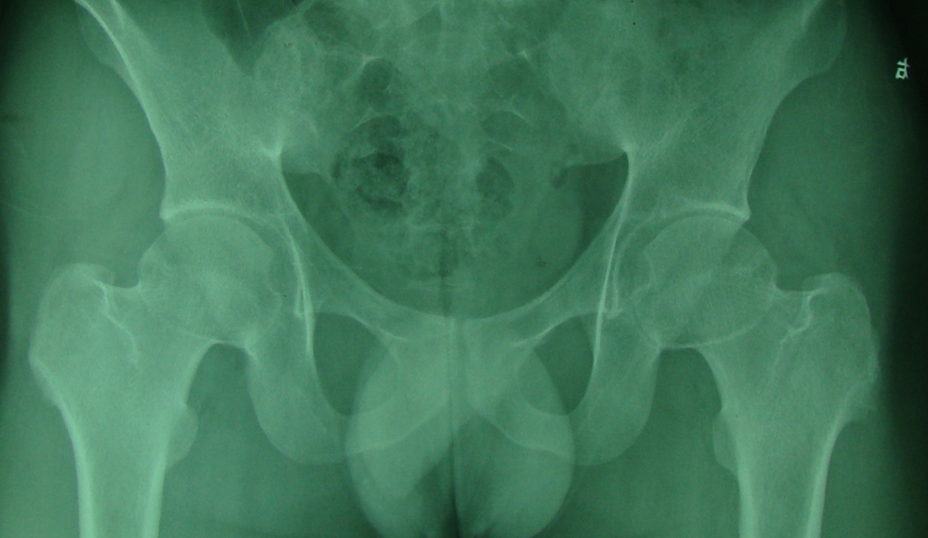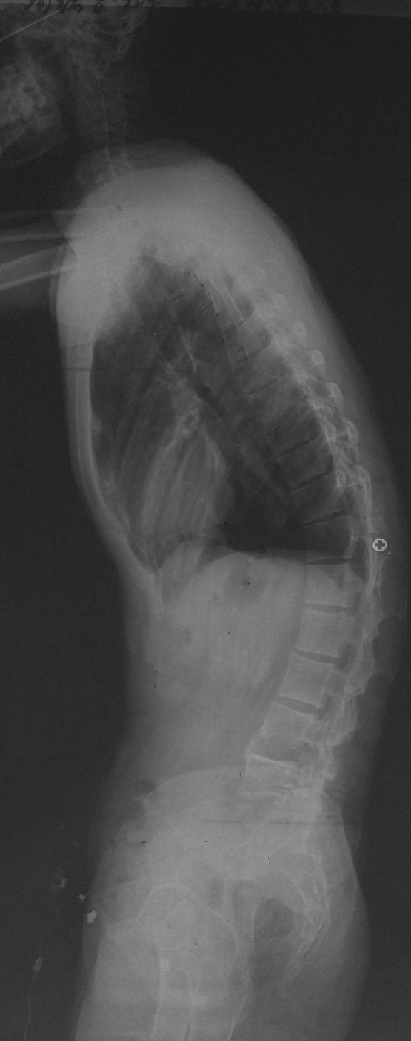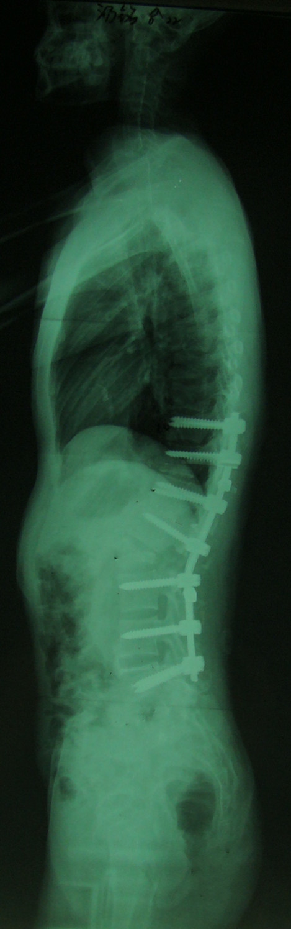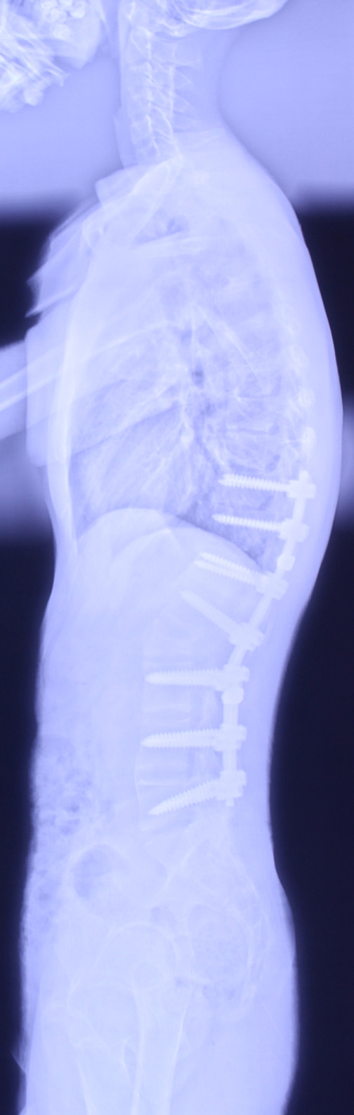
A
GK
LK
TK
LL
PI=42º
SVA=12.5cm
B
PT=34º
SS=8º
PT=12º
GK
SVA=2.0cm
C
PI
SS
D
GK
PT=14°
ss
PI
SVA=2.1cm

Figure 1. A 22-year-old male AS patient without hip involvement (the BASRI-hip scores were 0 at both sides of the hips) (A). The patient underwent PSO at the level of L2 with a good correction of PT (from 34º to 12º). The SVA, GK, LK, LL, and SS improved from 12.5 cm, 57º, 16º, 3º, and 8º preoperatively to 2 cm, 13º, -27º,-43º, and 12º postoperatively, respectively (B, C). This patient gained satisfactory postoperative sagittal balance (D).

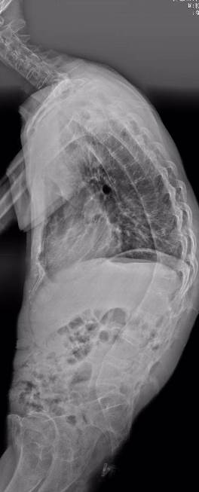
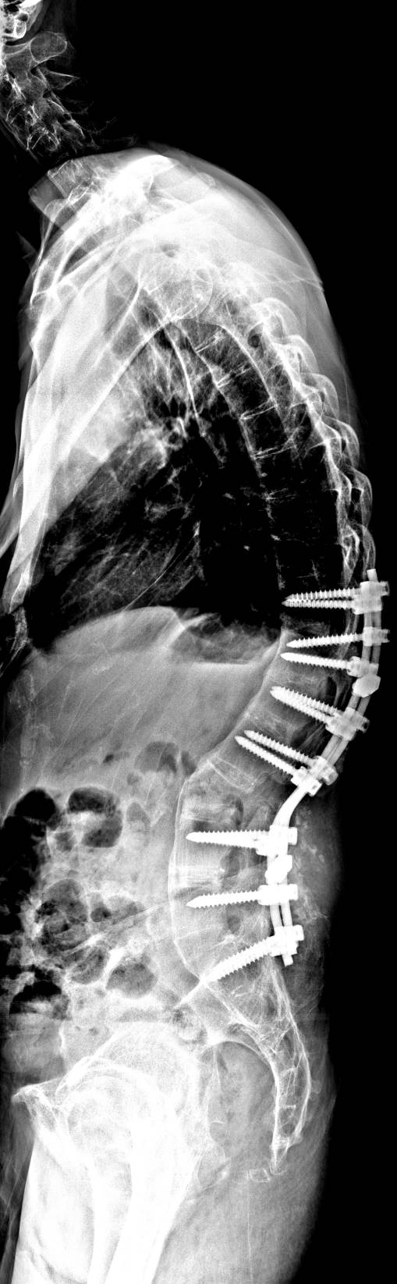
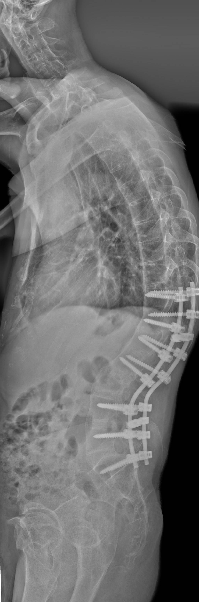

TK
GK
GK
GK
LL
LK
SVA
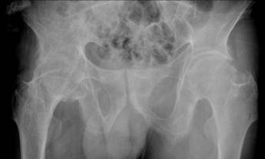
SVA
SS
SVA
PI
PT=50º
C
PT=38º
D
PT= 39°
B
A

Figure 2. A 44-year-old male AS patient with hip involvement (the BASRI-hip scores were 4 at the left side and 3 at the right side of the hips) (A). The patient underwent PSO at the level of L3 with an insufficient correction of PT (from 50º to 38º). The SVA, GK, LK, LL, and SS improved from 10.2 cm, 78º, 12º, 9º, and 0º preoperatively to 6.4 cm, 32º, -31º, -39º and 16º postoperatively, respectively (B, C). He had a residual positive postoperative sagittal imbalance (D).

