Role of Low-Level Laser Therapy in Z-plasty
Authors:
- Chirra Likhitha Reddy,
Senior Resident
Department of Plastic Surgery
Jawaharlal Institute of Postgraduate Medical Education and Research (JIPMER)
Pondicherry
India-605006
Email: drlikhithareddy@gmail.com

- Ravi Kumar Chittoria
Professor
Department of Plastic Surgery
Jawaharlal Institute of Postgraduate Medical Education and Research (JIPMER)
Pondicherry
India-605006
Email: drchittoria@yahoo.com

- Abhinav Aggarwal
Senior Resident
Department of Plastic Surgery
Jawaharlal Institute of Postgraduate Medical Education and Research (JIPMER)
Pondicherry
India-605006
Email: abhi2128@gmail.com
- Saurabh Gupta
Senior Resident
Department of Plastic Surgery
Jawaharlal Institute of Postgraduate Medical Education and Research (JIPMER)
Pondicherry
India-605006
Email: drsaurabh2007@gmail.com

- Padma Lakshmi Bharathi Mohan
Senior Resident
Department of Plastic Surgery
Jawaharlal Institute of Postgraduate Medical Education and Research (JIPMER)
Pondicherry
India-605006
Email: pebeyem@gmail.com

- Shijina K
Senior Resident
Department of Plastic Surgery
Jawaharlal Institute of Postgraduate Medical Education and Research (JIPMER)
Pondicherry
India-605006
Email: chinnuvmmc@gmail.com

- Imran Pathan
Senior Resident
Department of Plastic Surgery
Jawaharlal Institute of Postgraduate Medical Education and Research (JIPMER)
Pondicherry
India-605006
Email: pathan.drimran@gmail.com

Corresponding author:
Ravi Kumar Chittoria
Professor
Department of Plastic Surgery
Jawaharlal Institute of Postgraduate Medical Education and Research (JIPMER)
Pondicherry
India-605006
Email: drchittoria@yahoo.com
Phone no- 9442285670

Abstract
Z-plasty is a commonly performed procedure in plastic surgery. Flap necrosis is an important complication that may occur, and various precautions have been described to prevent it. Several studies have been conducted to establish the role of low-level laser therapy (LLLT) in local flap survival. We would like to discuss the role of LLLT in Z-plasty.
Key words
Low-level laser therapy (LLLT), Z-plasty

Introduction
Z-plasty, a procedure introduced by Denonvillers in 1856, is commonly performed by plastic and reconstructive surgeons [1]. It consists of the transposition of two interdigitating triangular flaps [1].
Tip necrosis is one of the most common complications in Z-plasty. It may occur due to an inappropriate angle, inadequate thickness of the flaps, the site of surgery, the handling of tissue by surgeon, and the laxity of the surrounding skin. Tension in the flaps can invariably lead to tip necrosis. Various modifications and precautions have been described to prevent this complication.
We used low-level laser therapy (LLLT) during a Z-plasty procedure on a patient to prevent tip necrosis. We report this case because we have found no similar reports in the literature.

Case Presentation
A 24-year-old female patient was admitted to the plastic surgery department of a tertiary care center. The patient had history of thermal burn, following which she developed a band contracture extending across the distal interphalangeal joint crease of the left ring finger with an apparent defect of 0.5 cm and a true defect of 0.75 cm. Two adjacent Z-plasty with two limbs of 1 cm each leading to four transposition flaps were performed, as a single Z-plasty would have required a greater limb length (figure 1). The little finger was treated by soft tissue distraction using a Joshi’s external stabilization system (JESS) fixator.
LLLT was applied to the flaps intraoperatively using a continuous gallium arsenide (GaAs) diode red laser beam with a frequency of 10 kHz, a wavelength of 650 nm, and output power of 100 mW. The energy density used was calculated as 2.5 J/cm². It’s a non-contact device that delivers a laser beam in scanning mode. The distance between the laser source and the wound is 60 cm. LLLT was applied to the Z-plasty flaps for 125 s each time (2). A regular dressing was applied to the suture line. LLLT was repeated five times, once every three days (Figure 2). The suture was removed on postoperative day 10. The flaps were rechecked three weeks later (Figure 3).

Results
All the flaps healed well. No complications were noted at three weeks.

Discussion
Z-Plasty is a surgical procedure whereby two interdigitating triangular flaps are transposed. Z-plasty produces change in the direction of the scar and also gives gain in length along the direction of the common limb of the ‘Z’ [3]. Various contractures, such as oral commissure contractures, cicatricial bands hindering joint mobility, and axillary burn synechiae, can be treated by Z-plasty. The flap angles can range from 30 to 90 degrees. With angles less than 30 degrees, tip necrosis may occur. Flaps with angles greater than 75 degrees are difficult to rotate and can result in increased tension and dog-ear formation. Certain defects require variations in traditional Z-Plasty with the use of unequal flap angles.
Tip necrosis is a known complication of Z-plasty. This leads to healing by secondary intention and further scarring. Methods of prevention include meticulous handling, proper planning, and surrounding tissue laxity.
Our patient had a scarred surrounding skin area due to burns. For this reason, we performed multiple Z-plasty as scar tissue might have limited the transposition of flaps and caused suture line tension. We decided to use LLLT as an adjunctive procedure to prevent flap tip necrosis.
LLLT, also known as phototherapy or photobiomodulation, refers to the use of photons at a non-thermal irradiance to alter biological activity [4]. The role of LLLT in wound healing has been established by various in vivo and in vitro studies. Its role in stimulating hair growth in alopecia has also been widely studied.
There are various mechanisms whereby the desired effects of LLLT are obtained. At low doses, LLLT has been shown to promote the proliferation of fibroblasts [5-8], keratinocytes [9], endothelial cells [10], and lymphocytes [11, 12]. The mechanism of proliferation is thought to be triggered by an increase in growth factors due to the upregulation of transcription factors and the activation of signaling pathways in the mitochondria by photostimulation [5, 13-16]. Moreover, LLLT enhances neovascularization, promotes angiogenesis, and increases collagen synthesis, contributing to acute [17] and chronic wound healing [18-20]. Due to its beneficial effects, it can be used for the prevention of local flap failure. Various animal studies on the role of LLLT in local flap survival have shown that it improves microcirculation, leading to good results [21].

Conclusion
We suggest that LLLT can be used in Z-plasty as an adjunctive therapy to improve microcirculation, thereby increasing the chances of flap survival. However, large randomized control trials are required to establish its exact role.
DECLARATIONS
Authors’ contributions
All authors made contributions to the article
Availability of data and materials
Not applicable.
Financial support and sponsorship
None.
Conflicts of interest
None.
Consent for publication
Not applicable.
Copyright
© The Author(s) 2019.

References
- Barreiros H, Goulao J. Z-Plasty: useful uses in dermatologic surgery. Anais brasileiros de dermatologia. 2014 Feb;89(1):187-8.

- Gaida K, Koller R, Isler C, Aytekin O, Al-Awami M, et al. Low level laser therapy--a conservative approach to the burn scar? Burns 2004;30:362-7.

- McGregor IA, McGregor AD. Fundamental techniques of plastic surgery: and their surgical applications. Churchill Livingstone; 2000.

- Avci P, Gupta A, Sadasivam M, Vecchio D, Pam Z, Pam N, Hamblin MR. Low-level laser (light) therapy (LLLT) in skin: stimulating, healing, restoring. InSeminars in cutaneous medicine and surgery 2013 Mar (Vol. 32, No. 1, p. 41). NIH Public Access.

- Lubart R, Wollman Y, Friedmann H, Rochkind S, Laulicht I. Effects of visible and near infrared lasers on cell cultures. J Photochem Photobiol B. 1992;12(3):305–310.

- Wu W, Naim JO, Lanzafame RJ. The effect of laser irrafiation on the release of bFGF from 3T3 fibroblasts. Photochem Photobiol. 1994;59(2):167–170.

- Vinck EM, Cagnie BJ, Cornelissen MJ, Declercq HA, Cambier DC. Increased fibroblast proliferation induced by light emitting diode and low power laser irradiation. Lasers Med Sci. 2003;18(2):95–99.

- Frigo L, Fávero GM, Lima HJ, Maria DA, Bjordal JM, et al. Low-level laser irradiation (InGaAlP-660 nm) increases fibroblast cell proliferation and reduces cell death in a dose-dependent manner. Photomed Laser Surg. 2010;28(Suppl 1):S151–S156.

- Basso FG, Oliveira CF, Kurachi C, Hebling J, Costa CA. Biostimulatory effect of low-level laser therapy on keratinocytes in vitro. Lasers Med Sci. 2013;28(2):367–374.

- Szymanska J, Goralczyk K, Klawe JJ, Lukowicz M, Michalska M, et al. Phototherapy with low-level laser influences the proliferation of endothelial cells and vascular endothelial growth factor and transforming growth factor-beta secretion. J Physiol Pharmacol. 2013;64(3):387–391.

- Moore P, Ridgway TD, Higbee RG, Howard EW, Lucroy MD. Effect of wavelength on low-intensity laser irradiation-stimulated cell proliferation in vitro. Lasers Surg Med. 2005;36(1):8–12.

- Agaiby AD, Ghali LR, Wilson R, Dyson M. Laser modulation of angiogenic factor production by T-lymphocytes. Lasers Surg Med. 2000;26(4):357–363.

- Stadler I, Evans R, Kolb B, Naim JO, Narayan V, et al. In vitro effects of low-level laser irradiation at 660 nm on peripheral blood lymphocytes. Lasers Surg Med. 2000;27(3):255–256.

- 40. Saygun I, Nizam N, Ural AU, Serdar MA, Avcu F, et al. Low-level laser irradiation affects the release of basic fibroblast growth factor (bFGF), insulin-like growth factor-I (IGF-I), and receptor of IGF-I (IGFBP3) from osteoblasts. Photomed Laser Surg. 2012;30(3):149–154.

- Esmaeelinejad M, Bayat M. Effect of low-level laser therapy on the release of interleukin-6 and basic fibroblast growth factor from cultured human skin fibroblasts in normal and high glucose mediums. J Cosmet Laser Ther. 2013;15(6):310–317.

- de Sousa AP, Paraguassú GM, Silveira NT, de Souza J, Cangussú MC, et al. Laser and LED phototherapies on angiogenesis. Lasers Med Sci. 2013;28(3):981–987.

- Chen CH, Tsai JL, Wang YH, Lee CL, Chen JK, et al. Low-level laser irradiation promotes cell proliferation and mRNA expression of type I collagen and decorin in porcine Achilles tendon fibroblasts in vitro. J Orthop Res. 2009;27(5):646–650.

- Usumez A, Cengiz B, Oztuzcu S, Demir T, Aras MH, et al. Effects of laser radiation at different wavelengths (660, 810, 980, and 1,064 nm) on mucositis in an animal model of wound healing. Lasers Med Sci. 2014;29(6):1807–1813.
- Yu W, Naim JO, Lanzafame RJ. Effects of photostimulation on wound healing in diabetic mice. Lasers Surg Med. 1997;20(1):56–63.

- Dadpay M, Sharifian Z, Bayat M, Bayat M, Dabbagh A. Effects of pulsed infra-red low level-laser irradiation on open skin wound healing of healthy and streptozotocin-induced diabetic rats by biomechanical evaluation. J Photochem Photobiol B. 2012;111:1–8

- Kubota J, Ohshiro T. The effects of diode laser LLLT on flap survival: measurement of flap microcirculation with laser speckle flowmetry. Laser Therapy. 1996;8(4):241-6.

Photos
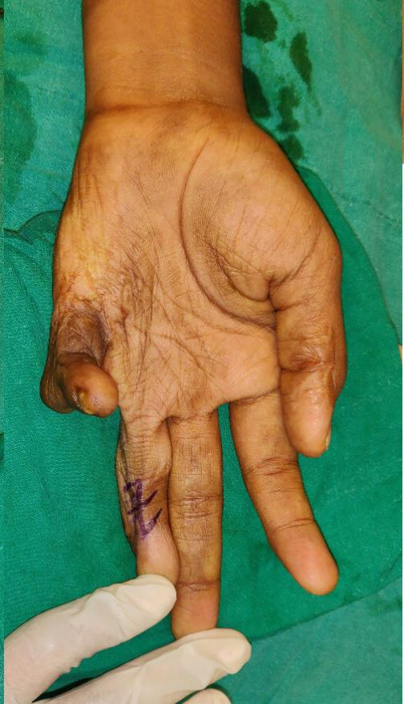
Figure 1 Pre op marking for Contracture release of left middle finger
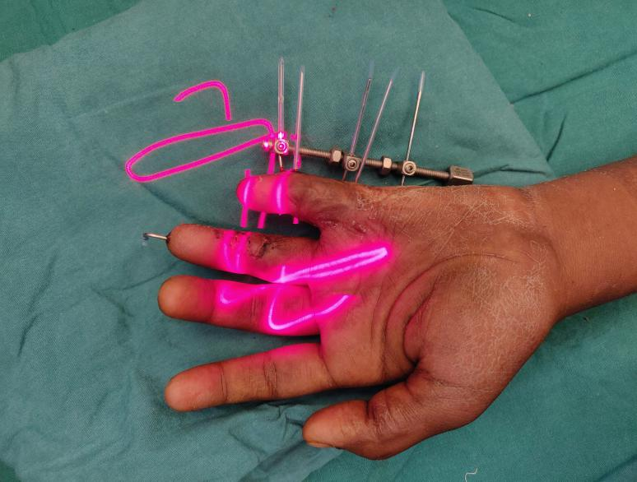
Figure 2 LLLT applied onto the transposed flaps

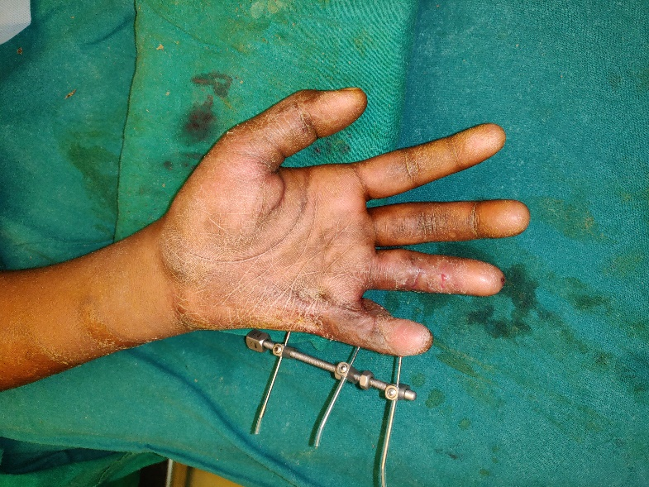
Figure 3 Post operatively at 3 weeks with well healed scar

