Role of Low-level LASER therapy in Z-plasty
Authors:
- Chirra Likhitha Reddy,
Senior Resident
Department of Plastic Surgery
Jawaharlal Institute of Postgraduate Medical Education and Research (JIPMER)
Pondicherry
India-605006
Email: drlikhithareddy@gmail.com

- Ravi Kumar Chittoria
Professor
Department of Plastic Surgery
Jawaharlal Institute of Postgraduate Medical Education and Research (JIPMER)
Pondicherry
India-605006
Email: drchittoria@yahoo.com

- Abhinav Aggarwal
Senior Resident
Department of Plastic Surgery
Jawaharlal Institute of Postgraduate Medical Education and Research (JIPMER)
Pondicherry
India-605006
Email: abhi2128@gmail.com
- Saurabh Gupta
Senior Resident
Department of Plastic Surgery
Jawaharlal Institute of Postgraduate Medical Education and Research (JIPMER)
Pondicherry
India-605006
Email: drsaurabh2007@gmail.com

- Padma Lakshmi Bharathi Mohan
Senior Resident
Department of Plastic Surgery
Jawaharlal Institute of Postgraduate Medical Education and Research (JIPMER)
Pondicherry
India-605006
Email: pebeyem@gmail.com

- Shijina K
Senior Resident
Department of Plastic Surgery
Jawaharlal Institute of Postgraduate Medical Education and Research (JIPMER)
Pondicherry
India-605006
Email: chinnuvmmc@gmail.com

- Imran Pathan
Senior Resident
Department of Plastic Surgery
Jawaharlal Institute of Postgraduate Medical Education and Research (JIPMER)
Pondicherry
India-605006
Email: pathan.drimran@gmail.com

Corresponding author:
Ravi Kumar Chittoria
Professor
Department of Plastic Surgery
Jawaharlal Institute of Postgraduate Medical Education and Research (JIPMER)
Pondicherry
India-605006
Email: drchittoria@yahoo.com
Phone no- 9442285670

Abstract
Z-plasty is a commonly done procedure in plastic surgery. One of the complications that the surgeon is worried about is flap necrosis. Various precautions have been described to prevent this complication. There have been various studies done to identify the role of LLLT in local flap survival. We would like to discuss the role of low-level LASER therapy (LLLT) in Z-plasty.

Key words
Low-level LASER therapy (LLLT), Z-plasty

Introduction
Z-plasty, a technique introduced by Denonvillers in 1856, is a common procedure done by plastic and reconstructive surgeons (1). It is the transposition of two inter digitating triangular flaps (1).
One of the most common complication is tip necrosis. This could be due to angle of flaps, the thickness of the flap, the location where it is being done, tissue handling and the surrounding skin laxity. Tension in the flaps can invariably lead to tip necrosis. There have been various modifications described and various precautions explained to prevent this complication.
We have used a low-level LASER therapy (LLLT) during the Z-plasty to prevent this complication. On literature review we have not found any similar reports and we wanted to share our experience.
Methodology
This study was conducted in department of plastic surgery in a tertiary care centre. Our patient was a 24 year female with post burn band contracture over the distal interphalangeal joint region of left ring finger with apparent defect of 0.5cms and true defect of 0.75cms. Multiple Z-plasty was planned as the limb length required would be less compared to a single Z-plasty [figure 1]. The little finger was treated by soft tissue distraction using JESS fixator.
Intra operatively, LLLT was given to the flaps. We used Gallium Arsenide (GaAs) diode red laser of wavelength 650 nm, frequency 10 kHz and output power 100 mW. It was a continuous beam laser with an energy density of 4 J/cm². Machine delivers laser in scanning mode (non-contact delivery) with 60 cm distance between laser source and wound. The zplasty flaps were given laser therapy for duration of 125 second every time [2]. Regular dressing of the suture line done. Regular LLLT was given once every three days [figure 2] for a total of 5 times. Suture removal done on POD-10. Flaps re-checked at 3 weeks [figure3].
Results
All the flaps healed well. No complications noted at 3 weeks.

Discussion
Z-Plasty is a procedure that involves the transposition of two interdigitating triangular flaps. Z-plasty leads to gain in length along the direction of the common limb of the Z and there is change in direction of scar [3]. It is used to correct contractures of the oral commissure, axillary burn synechiae, and in joint mobility hindered by cicatricial bands. The flaps are typically designed with angles ranging from 30 to 90 degrees. Angles of less than 30 degrees may incur tip necrosis, and angles of over 75 degrees create flaps that are difficult to rotate, creating dog-ears as well as increased tension. Variations in the traditional Z-Plasty that involve unequal flap angles may be needed in the reconstruction of certain defects.
One of the known complications of Z-plasty is tip necrosis. This leads to healing by secondary healing and further scarring. There are various methods of prevention including meticulous handling, proper planning and, surrounding tissue laxity.
Our patient has scarred skin surrounding area due to burns for which we planned multiple Z-plasty. As the scar tissue might cause reduced transposition of flaps and the suture line will be in tension and hence, we have decided to use LLLT as an adjunctive procedure to help prevent flap tip necrosis.
LLLT, phototherapy or photobiomodulation refers to the use of photons at a non-thermal irradiance to alter biological activity [4]. Various in vitro and in vivo studies have been done on the role of LLLT in wound healing. Its role in stimulating hair growth in alopecia has also been widely studied.
There are various mechanisms by which the desired effect is obtained with the use of LLLT. At low dose, it has been shown to enhance proliferation of fibroblasts [5-8], keratinocytes [9], endothelial cells [10] and lymphocytes [11, 12]. The mechanism of proliferation is thought to result from increase in growth factors due to the upregulation of transcription factors and activation of signalling pathways in mitochondria by photo-stimulation [5, 13–16]. LLLT can enhance neovascularization, promote angiogenesis and increase collagen synthesis to aid in the healing of acute [17] and chronic wounds [18-20]. All the properties of LLLT might be put to use in the prevention of complication of local flap failure.
There have been various animal studies done to identify the role of LLLT in local flap survival and it was proven to improve the microcirculation leading to good results [21].

Conclusion
We proposed that LLLT can be used in Z-plasty, as an adjunctive therapy to improve flap survival as it improves microcirculation . However large randomized control trials are required for establishing its role.

DECLARATIONS
Authors’ contributions
All authors made contributions to the article
Availability of data and materials
Not applicable.
Financial support and sponsorship
None.
Conflicts of interest
None.
Consent for publication
Not applicable.
Copyright
© The Author(s) 2019.

References
- Barreiros H, Goulao J. Z-Plasty: useful uses in dermatologic surgery. Anais brasileiros de dermatologia. 2014 Feb;89(1):187-8.

- Gaida K, Koller R, Isler C, Aytekin O, Al-Awami M, et al. Low level laser therapy--a conservative approach to the burn scar? Burns 2004;30:362-7.

- McGregor IA, McGregor AD. Fundamental techniques of plastic surgery: and their surgical applications. Churchill Livingstone; 2000.

- Avci P, Gupta A, Sadasivam M, Vecchio D, Pam Z, Pam N, Hamblin MR. Low-level laser (light) therapy (LLLT) in skin: stimulating, healing, restoring. InSeminars in cutaneous medicine and surgery 2013 Mar (Vol. 32, No. 1, p. 41). NIH Public Access.

- Lubart R, Wollman Y, Friedmann H, Rochkind S, Laulicht I. Effects of visible and near infrared lasers on cell cultures. J Photochem Photobiol B. 1992;12(3):305–310. [PubMed] [Google Scholar]

- Wu W, Naim JO, Lanzafame RJ. The effect of laser irrafiation on the release of bFGF from 3T3 fibroblasts. Photochem Photobiol. 1994;59(2):167–170. [PubMed] [Google Scholar]

- Vinck EM, Cagnie BJ, Cornelissen MJ, Declercq HA, Cambier DC. Increased fibroblast proliferation induced by light emitting diode and low power laser irradiation. Lasers Med Sci. 2003;18(2):95–99. [PubMed] [Google Scholar]

- Frigo L, Fávero GM, Lima HJ, Maria DA, Bjordal JM, et al. Low-level laser irradiation (InGaAlP-660 nm) increases fibroblast cell proliferation and reduces cell death in a dose-dependent manner. Photomed Laser Surg. 2010;28(Suppl 1):S151–S156. [PubMed] [Google Scholar]

- Basso FG, Oliveira CF, Kurachi C, Hebling J, Costa CA. Biostimulatory effect of low-level laser therapy on keratinocytes in vitro. Lasers Med Sci. 2013;28(2):367–374. [PubMed] [Google Scholar]

- Szymanska J, Goralczyk K, Klawe JJ, Lukowicz M, Michalska M, et al. Phototherapy with low-level laser influences the proliferation of endothelial cells and vascular endothelial growth factor and transforming growth factor-beta secretion. J Physiol Pharmacol. 2013;64(3):387–391. [PubMed] [Google Scholar]

- Moore P, Ridgway TD, Higbee RG, Howard EW, Lucroy MD. Effect of wavelength on low-intensity laser irradiation-stimulated cell proliferation in vitro. Lasers Surg Med. 2005;36(1):8–12. [PubMed] [Google Scholar]

- Agaiby AD, Ghali LR, Wilson R, Dyson M. Laser modulation of angiogenic factor production by T-lymphocytes. Lasers Surg Med. 2000;26(4):357–363. [PubMed] [Google Scholar]

- Stadler I, Evans R, Kolb B, Naim JO, Narayan V, et al. In vitro effects of low-level laser irradiation at 660 nm on peripheral blood lymphocytes. Lasers Surg Med. 2000;27(3):255–256. [PubMed] [Google Scholar]
- 40. Saygun I, Nizam N, Ural AU, Serdar MA, Avcu F, et al. Low-level laser irradiation affects the release of basic fibroblast growth factor (bFGF), insulin-like growth factor-I (IGF-I), and receptor of IGF-I (IGFBP3) from osteoblasts. Photomed Laser Surg. 2012;30(3):149–154. [PubMed] [Google Scholar]

- Esmaeelinejad M, Bayat M. Effect of low-level laser therapy on the release of interleukin-6 and basic fibroblast growth factor from cultured human skin fibroblasts in normal and high glucose mediums. J Cosmet Laser Ther. 2013;15(6):310–317. [PubMed] [Google Scholar]

- de Sousa AP, Paraguassú GM, Silveira NT, de Souza J, Cangussú MC, et al. Laser and LED phototherapies on angiogenesis. Lasers Med Sci. 2013;28(3):981–987. [PubMed] [Google Scholar]

- Chen CH, Tsai JL, Wang YH, Lee CL, Chen JK, et al. Low-level laser irradiation promotes cell proliferation and mRNA expression of type I collagen and decorin in porcine Achilles tendon fibroblasts in vitro. J Orthop Res. 2009;27(5):646–650. [PubMed] [Google Scholar]

- Usumez A, Cengiz B, Oztuzcu S, Demir T, Aras MH, et al. Effects of laser radiation at different wavelengths (660, 810, 980, and 1,064 nm) on mucositis in an animal model of wound healing. Lasers Med Sci. 2014;29(6):1807–1813. [PubMed] [Google Scholar]

- Yu W, Naim JO, Lanzafame RJ. Effects of photostimulation on wound healing in diabetic mice. Lasers Surg Med. 1997;20(1):56–63. [PubMed] [Google Scholar]

- Dadpay M, Sharifian Z, Bayat M, Bayat M, Dabbagh A. Effects of pulsed infra-red low level-laser irradiation on open skin wound healing of healthy and streptozotocin-induced diabetic rats by biomechanical evaluation. J Photochem Photobiol B. 2012;111:1–8. [PubMed] [Google Scholar]

- Kubota J, Ohshiro T. The effects of diode laser LLLT on flap survival: measurement of flap microcirculation with laser speckle flowmetry. Laser Therapy. 1996;8(4):241-6.

Photos
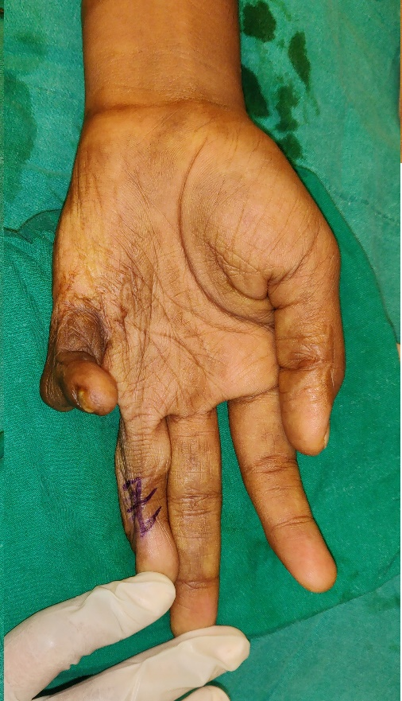
Figure 1 Pre op marking for Contracture release of left middle finger
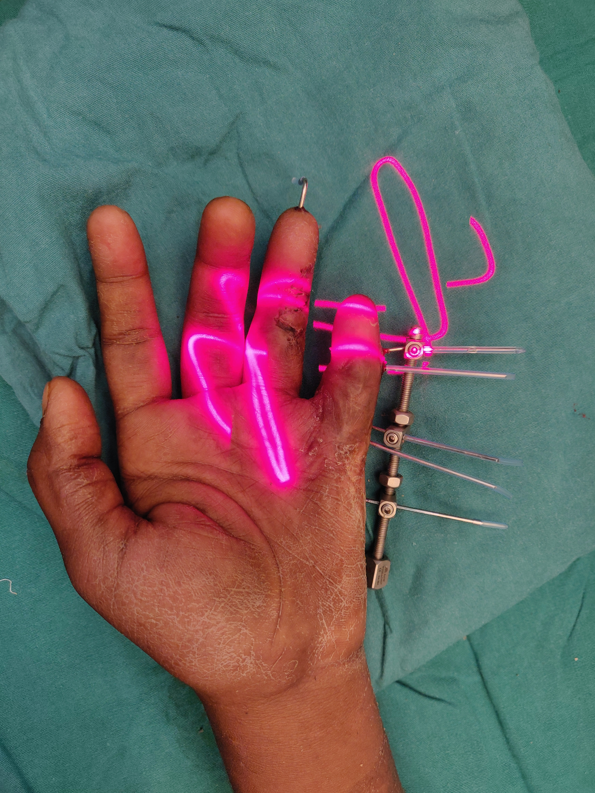
Figure 2 LLLT applied onto the transposed flaps

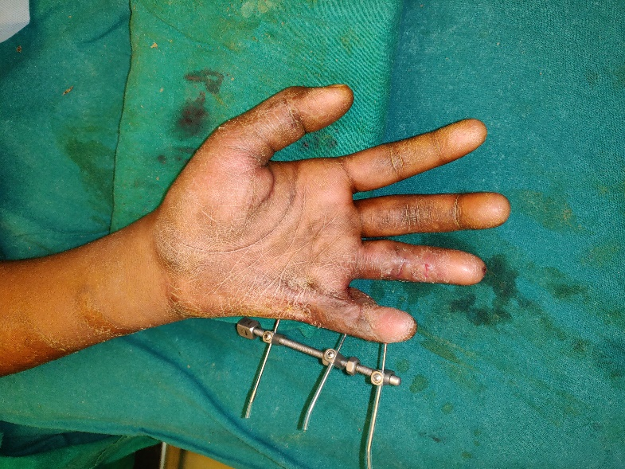
Figure 3 Post operatively at 3 weeks with well healed scar

