Case Report
Peritonitis due to Typhoid Perforation of Gall bladder in Young Male Child
Muhammad Jamaluddinª, Shameen Shoaib^{a*}, Sobia Majeedª, Muhammad Tahirª, Imran Ahmed Khanª, Sobia Naseem Siddiqui^{b}

ªDepartment of General Surgery, Abbasi Shaheed Hospital,

^{b}Department of Physiology, Dow University of Health Sciences

Corresponding Author: Shameen Shoaib
E-mail: shameenshoaib@yahoo.com
Department of General Surgery, Abbasi Shaheed Hospital, Karachi
Abstract
Acalculus cholecystitis is the acute inflammation of gall bladder in the absence of gall stones usually seen in critically ill patients like after major surgery, trauma, burns, patients with sepsis and infectious disease. It is one of the rare clinical manifestation in the setting of typhoid fever, leading to perforation. It usually involves the peyer’s patches of terminal ileum, so enteric perforation commonly ensue. The objective of this case report is to aware the clinicians to diagnose the extraintestinal complications in a patient suffering from typhoid fever, requiring surgical intervention. Diagnosis is usually made during surgery when the gall bladder is visualized and perforation is seen. Here we report a case of 12 year old boy presented to us in emergency department with high grade fever, loose stools and acute abdomen. Labs showed typhi dot was positive. We planned for exploratory laparotomy after initial resuscitation. On exploration of abdomen gangrenous gall bladder with single perforation in gallbladder was found. Patient recovered uneventfully. This is one of the serious condition, so a good clinician should keep a high index of suspicion in managing patient with salmonella infection.
Key words: peritonitis, typhoid, gall bladder, Acalculous cholecystitis.
Introduction:
Typhoid fever is a common bacteremic infection, seen in patients with poor sanitation and who drink contaminated unboiled water [1]. Gall bladder wall is being injured by salmonella, the causative agent of typhoid fever. This organism has the ability to attack on gallbladder epithelial cells and causes perforation in its wall [5]. The infection is transmitted by the faecooral route. The incubation period is 5–30 days.
Acute acalculous cholecystitis is an acute inflammation of the gallbladder in the absence of gallstones and accounts for 5% to 10% of all cases of acute cholecystitis [4]. Gall bladder perforation is one of the rare complication of enteric fever [2]. Pre-operative diagnosis is rare and mortality is high [3].
Case Presentation:
A 12 year male child with no known co-morbids, student of class V, resident of manghopir, came to emergency with complain of pain in abdomen, loose stools, fever and vomiting since 3 days. Abdominal pain was colicky in nature, sudden in onset, radiating to back and relieved only by taking medicine prescribed by General physician clinic located in his area. Loose stools were 2 to 3 episodes per day having semi solid particles not having blood or mucous in it. Fever was intermittent and documented upto 103F. Vomiting were 6 to 7 episodes per day, non-projectile, containing gastric contents and fowl smelling. On examination, patient was pale and dehydrated with dry tongue. Abdomen was soft but distended and tender all over the abdomen and gut sounds were sluggish. He was kept under observation and investigated. All investigations were within normal limit except IgM typhi dot was positive. After few hours of observation his condition did not improve and exploratory laparotomy was planned. On exploration through a mid-line incision, there were pus flakes in whole of the gut, bile stained fluid in sub hepatic area and a single perforation in the body of gall bladder. Therefore cholecystectomy was done and abdomen closed with a pelvic drain. Patient recovery was uneventful and he was discharged after few days. The histopathology of gall bladder showed acute necrotizing gall bladder with no evidence of granulomatous infection or carcinoma seen.
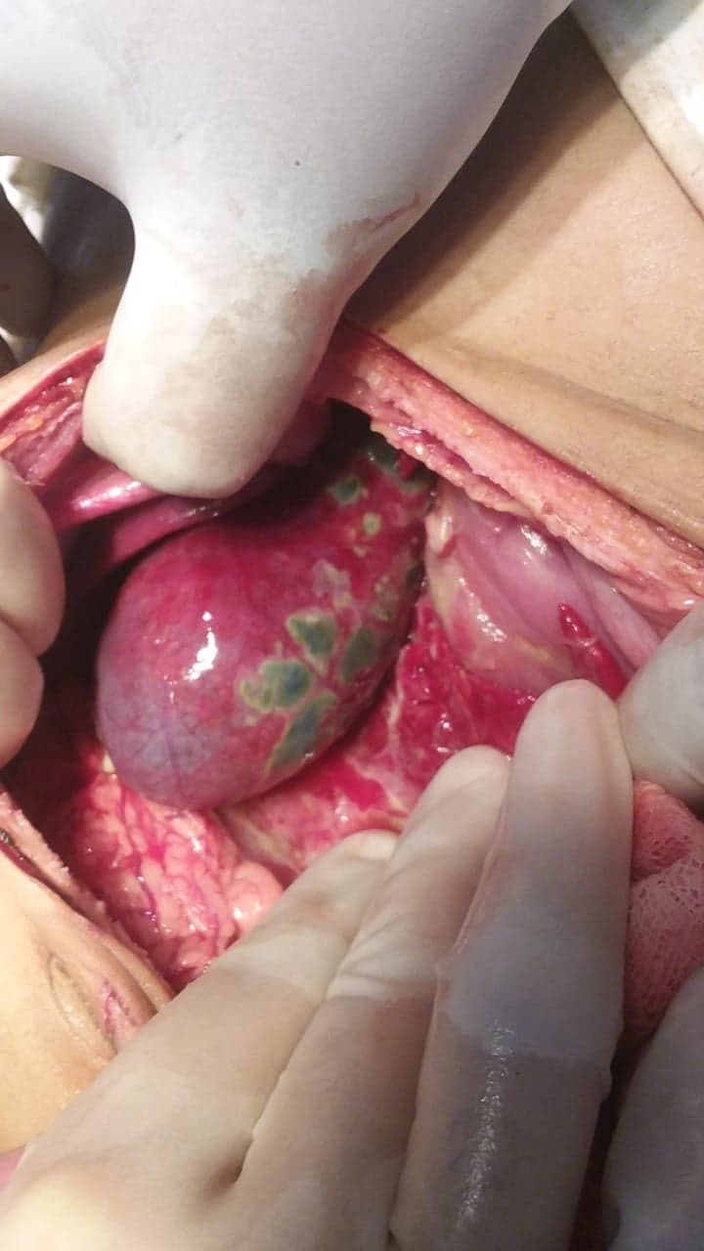

Figure 1: per-operative picture showing gangrenous Gall bladder

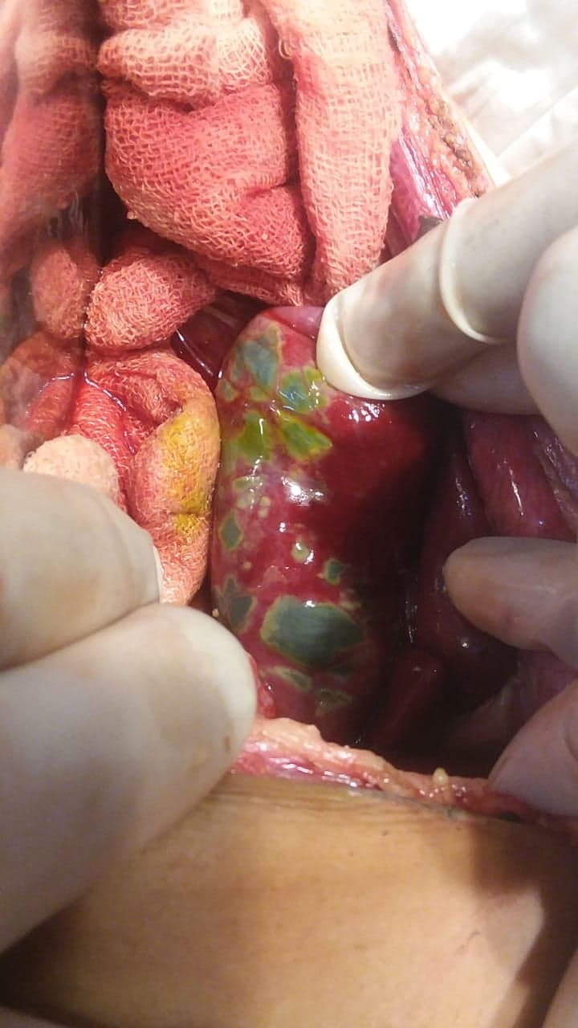

Figure 2: Per-operative picture showing necrosis in the wall of Gall Bladder with small perforation.

Discussion:
Gangrenous gall bladder perforation is a rare disease, it is a life-threatening emergency that is caused by S. Typhi and S. Paratyphi A infection. Distal part of gall bladder is the most common site of its perforation. Acute calculus cholecystitis is the most common cause of gall bladder perforation.
Acalculous cholecystitis, though rare, also causes gall bladder perforation [6]. Salmonella typhi and S. paratyphi is responsible for approx 200,000 deaths worldwide, and it is a cause of enteric fever [7]. The organism invades the reticuloendothelial system of the bone marrow, spleen and liver [7]. Salmonella infection spreads through blood stream resulting in invasive salmonellosis. Salmonella infection occurs via ingestion of contaminated food products like poultry, eggs and egg products. Patients at extremes of ages with immunocompromised conditions, such as human immunodeficiency virus infection, diabetes mellitus, underlying malignancy and use of immunosuppressive medications, are at risk of invasive salmonellosis and complications from Salmonella infection.(9) Salmonella has tendency to cause meningitis, endocarditis, mycotic aneurysm, pneumonia, empyema, abscess formation, osteomyelitis and septic arthritis by causing wide spread dissemination in the body.
The pathophysiology of acalculous cholecystitis complicating typhoid fever is incompletely defined. Endotoxin-mediated injury seen in gram-negative sepsis is one of the proposed mechanism. These mediators lead finally to biliary stasis that results in increased bile viscosity, sludge formation and increases the gallbladder mucosal damage [8].Terminal ileum is most commonly affected by typhoid fever, usually leads to the perforation, rarely it affects the jejunum or cecum. [10]. There is a high mortality rate in gallbladder perforation (around 12%-16%) as compared to the intestinal perforation in enteric fever [11].
Gali BM et al. reported two cases of gallbladder perforation complicating typhoid fever in boys aged 13 and 16 years [2]. In our case, it was a young child who presented with fever for 4 days and a rigid, board like abdomen along with leukopenia and positive Typhidot test, pointing towards a diagnosis of enteric fever with an acute abdomen. Gallbladder perforation usually occurs in elderly patients with acute cholecystitis [12]. In young patients, gallbladder perforation is rare and occurs as a result of intense inflammation [12]. This appears to have occurred most likely in our case, as the patient was young, with no clinical or radiographic evidence of cholecystitis.

References:

Pandove PK, Moudgil A, Pandove M, Aggarwal K, Sharda D, Sharda VK: Multiple ileal perforations and concomitant cholecystitis with gall bladder gangrene as complication of typhoid fever. J Surg Case Rep. 2014, 2014:rju070. 10.1093/jscr/rju070

Gali BM, Ali N, Agbese GO, Duna VD, Dawha SD, Ismai GI, Mohammed M: Gallbladder perforation complicating typhoid fever: report of two cases. Niger J Med. 2011, 20:181-183.

Singh M, Kumar L, Singh R, Jain AK, Karande SK, Saradna A, Prashanth U: Gallbladder perforation: a rare complication of enteric fever. Int J Surg Case Rep. 2014, 5:73-75. 10.1016/j.ijscr.2013.12.004

G. Inian, V. Kanagalakshmi, and P. J. Kuruvilla, “Acute acalculous cholecystitis: a rare complication of typhoid fever,” Singapore Medical Journal, vol. 47, no. 4, pp. 327–328, 2006. View at Google Scholar · View at Scopus

Menendez A, Arena ET, Guttman JA, Thorson L, Vallance BA, Vogl W, Finlay BB: Salmonella infection of gallbladder epithelial cells drives local inflammation and injury in a model of acute typhoid fever. J Infect Dis. 2009, 200:1703-1713. 10.1086/646608

Clinical predictors of severe gallbladder complications in acute acalculous cholecystitis. Wang A-J, Wang T-E, Lin C-C, Lin S-C, Shih S-C. https://www.ncbi.nlm.nih.gov/pubmed/14669342. World J Gastroenterol. 2003;9:2821–2823. [PMC free article] [PubMed] [Google Scholar]

Gallbladder perforation: a rare complication of enteric fever. Singh M, Kumar L, Singh R, Jain AK, Karande SK, Saradna A, Prashanth U. Int J Surg Case Rep. 2014;5:73–75. [PMC free article] [PubMed] [Google Scholar]

Dhanoa, A, Fatt, QK. Non-typhoidal Salmonella bacteraemia: epidemiology, clinical characteristics and its’ association with severe immunosuppression. Ann Clin Microbiol Antimicrob 2009; 188: 15.

Becker CG, Dubin T, Glenn F. Induction of acute cholecystitis by activation of factor XII, J Exp Med, 1980, vol. 151 (pg. 81 – 90)

Sümer A, Kemik Ö, Dülger AC, et al.: Outcome of surgical treatment of intestinal perforation in typhoid fever. World J Gastroenterol. 2010, 16:4164-4168. 10.3748/wjg.v16.i33.4164

Singh M, Kumar L, Singh R, Jain AK, Karande SK, Saradna A, Prashanth U: Gallbladder perforation: a rare complication of enteric fever. Int J Surg Case Rep. 2014, 5:73-75. 10.1016/j.ijscr.2013.12.004

Jansen S, Stodolski M, Zirngibl H, Godde D, Ambe PC: Advanced gallbladder inflammation is a risk factor for gallbladder perforation in patients with acute cholecystitis. World J Emerg Surg. 2018, 13:9. 10.1186/s13017-018-0169-2

