Revision

We thank the reviewers for their kind and beneficial comments about our case report. Here we present the revisions made to this report:

Reviewer 1:
- The title was changed as "Iatrogenic Pneumothorax During Parathyroid Gland Biopsy; A Case Report ".
- The sentence "It should always be kept in mind that peri-thoracic invasive procedures may cause iatrogenic pneumothorax." is changed as "It should always be kept in mind that peri-thoracic and cervical invasive procedures may cause iatrogenic pneumothorax. ".
- We added the method for calculating the amount of pneumothorax into the discussion section. We thank the reviewer for his/her beneficial suggestion. We did not add a table into the discussion section because the scope of this article is not wide such as a review of iatrogenic pneumothoraces.
- We did not add a figure for CT of the parathyroid gland and report the final result of the parathyroid pathology, because we do not keep patient’s identifiers such as name, patient number etc. after writing the case report in order to protect patient privacy thus, we could not look into the patient files again.
- We added some arrows to the chest x ray figures to show lung border.
- We added a paragraph about the surface anatomy of the apical parietal pleura to the discussion section.
- We added the phrase “fourth post-procedure day” to the legend of Figure 2.
Reviewer 2:
- The abstract section is revised according to the reviewer’s comments.
- The English language is revised.
- Additional information about pneumothorax is added into the discussion part. But we could not find any medical literature about iatrogenic pneumothorax occurred during parathyroid adenoma biopsy and thus, we could not add any.

Case Report

Iatrogenic Pneumothorax During Parathyroid Gland Biopsy; A Case Report

¹İsmail Ertuğrul GEDİK
¹ Erzurum Regional Education and Research Hospital Thoracic Surgery Department
Erzurum Regional Education and Research Hospital Thoracic Surgery Department, 25000, Erzurum/TURKEY

Correspondence to: İsmail Ertuğrul GEDİK
Erzurum Regional Education and Research Hospital Thoracic Surgery Department, 25000, Erzurum/TURKEY

ORCID: https://orcid.org/0000-0002-1667-4793
Phone: +90 442 232 5500
Mobile: +90 532 331 30 67
e-mail: ertugrulgedik@gmail.com

Running Title: Pneumothorax During Parathyroid Gland Biopsy.

Abstract
Iatrogenic pneumothorax is an important subgroup of traumatic pneumothoraces, which may occur during many invasive procedures including surgeries. We present a case of iatrogenic pneumothorax that occurred during parathyroid gland biopsy in this report. 54-year-old male patient was consulted to our clinics with the complaints of acute onset right-sided chest pain and dyspnea that occurred during parathyroid gland biopsy. Patient’s physical examination revealed diminished respiratory sounds on the right hemithorax. Pneumothorax on the right hemithorax was found on the posterior-anterior chest x-ray. Chest tube thoracostomy was immediately performed through right fifth intercostal space. Air drainage stopped on the second post-procedure day, but lung auscultation revealed diminished respiratory sounds on the right apical zone on the fourth post-procedure day. Chest x-ray was performed on the same day which revealed lung expansion defect. Chest tube was clamped. Chest x-ray was repeated 2 hours later, and it did not show any significant difference. Chest tube was removed. Control physical examination and chest x-ray did not reveal any significant abnormalities and the patient was discharged. It should always be kept in mind that peri-thoracic and cervical invasive procedures may cause iatrogenic pneumothorax.

Keywords
Pneumothorax, Thoracostomy, Biopsy, Fine-Needle, Iatrogenic Disease

Introduction
Pneumothorax is the pathological accumulation of air in the pleural cavity. Pneumothoraces can be spontaneous or traumatic. Iatrogenic pneumothorax (IPx) is an important subgroup of traumatic pneumothoraces. IPx’s may occur during many invasive procedures, including surgeries [1]. We present a case of iatrogenic pneumothorax that occurred during parathyroid gland biopsy in this report.

Case Report
54-year-old male patient was consulted to our clinics with the complaints of acute onset right-sided chest pain and dyspnea that occurred during parathyroid gland biopsy performed by the endocrinology clinics. Patient’s physical examination findings were blood pressure of 130/88 mm Hg, heart rate of 96/min, respiratory rate of 26/min. Lung auscultation revealed diminished respiratory sounds on the right hemithorax. Pneumothorax on the right hemithorax was found on the posterior-anterior (PA) chest x-ray (Figure 1). Chest tube thoracostomy using 28 French (Fr) drain was performed immediately through the intersection of right fifth intercostal space and mid-axillary line. Air drainage stopped on the second post-procedure day, but lung auscultation revealed diminished respiratory sounds on the right apical zone on the fourth post-procedure day. PA chest x-ray was performed on the same day, which revealed lung expansion defect (Figure 2). Chest tube was clamped. PA chest x-ray was repeated 2 hours later, and it did not show any significant difference. The chest tube was removed. Control physical examination and PA chest x-ray did not reveal any significant abnormalities. The patient was discharged and invited for a follow up outpatient clinics examination.

Discussion
Anatomy of the apical part of the parietal pleura is important in understanding the etio-pathophysiology of IPx. The upper part of the pleura and pulmonary apex occupy the thoracic inlet on both sides. Between the pleura and neck of the first rib are the superior intercostal artery, sympathetic trunk and ventral ramus of the first thoracic nerve. The internal thoracic artery enters the thorax between the first costal cartilage and the pleura [1].
The most common cause of IPx’s is subclavian catheter insertion. Transthoracic/transbronchial fine needle biopsy, positive pressure mechanical ventilation are also among the top etiological procedures for IPx [2]. It has also been reported that IPx has occurred during axillary lymph node biopsy, hypoglossal nerve stimulation, and acupuncture [3-5]. No case report of the occurrence of IPx during parathyroid gland biopsy was found.
IPx incidence is reported to be 1.36% and increase over the number of invasive interventions [6].
Pathophysiology of IPx is similar to non-iatrogenic traumatic pneumothoraces. In IPx, the visceral pleura is usually damaged, and this could even lead to potentially life-threatening tension pneumothorax. Thus, the symptoms and signs include decreased or absent breath sounds on the affected side, pleuritic pain and dyspnea, tachypnea, and tachycardia. If tension pneumothorax is present, hypotension, bradycardia, and cardiopulmonary arrest may occur [7].
The diagnosis of IPx is also similar to non-iatrogenic types. Radiological methods such as PA chest x-ray, thoracic computerized tomography and thoracic ultrasonography may help the physician in the establishment of the diagnosis of IPx in conjunction with physical examination findings [7].
There are several methods to calculate the amount of pneumothorax using radiological findings. We use Light index in our clinics for this calculation. In the Light index, the pneumothorax size is a function of the average diameter at the midpoint of the cranial half of the hemithorax (y) and the average diameter at the midpoint of the cranial half of the lung (x). Thus, the Light index is calculated as Light % = 100 – 100 x (x/y)³ [8].
Treatment of IPx is similar to any other type of pneumothorax, and it is dependent on the severity of the condition. Simple observation with oxygen insufflation can be curative in cases of mild pneumothoraces (<20%) as long as the patient is stable. Fine needle aspiration can also be considered as a treatment. Chest tube thoracostomy is the treatment of choice in large volume pneumothoraces and unstable cases [7].
As a conclusion it should always be kept in mind that peri-thoracic invasive procedures may cause IPx. In case of clinical suspicion for IPx thoracic surgery clinics should be consulted without delay and thus, potential morbidity and mortality attributable to pneumothorax can be prevented.
DECLARATIONS
Authors’ contributions
Made substantial contributions to conception and design of the study and performed data analysis and interpretation. Performed data acquisition, as well as provided administrative, technical, and material support: Gedik İ E.
Availability of Data and Materials
Not applicable.
Financial support and sponsorship
None.
Conflicts of interest
All authors declared that there are no conflicts of interest.
Ethical approval and consent to participate
Not applicable.
Consent for publication
Not applicable.

References
1. Charalampidis C, Youroukou A, Lazaridis G, Baka S, Mpoukovinas I, Karavasilis V, Kioumis I, Pitsiou G, Papaiwannou A, Karavergou A, Tsakiridis K, Katsikogiannis N, Sarika E, Kapanidis K, Sakkas L, Korantzis I, Lampaki S, Zarogoulidis K, Zarogoulidis P. Pleura space anatomy. J Thorac Dis. 2015;7(Suppl 1):S27-32.
2. Ojeda Rodriguez JA, Hipskind JE. Pneumothorax, Iatrogenic. Treasure Island (FL): StatPearls Publishing; 2018.
3. Stefani A, Ruggiero C, Aramini B, Scamporlino A. An unusual drain in the pleural cavity: iatrogenic pneumothorax due to pulmonary misplacement of a nasogastric tube. Intensive Care Med. 2018; 44: 2290-2291.
4. Arteaga AA, Pitts KD, Lewis AF. Iatrogenic pneumothorax during hypoglossal nerve stimulator implantation. Am J Otolaryngol. 2018; 39: 636-638.
5. Tagami R, Moriya T, Kinoshita K, Tanjoh K. Bilateral tension pneumothorax related to acupuncture. Acupunct Med. 2013; 31: 242-4.
6. Celik B, Sahin E, Nadir A, Kaptanoglu M. Iatrogenic pneumothorax: etiology, incidence and risk factors. Thorac Cardiovasc Surg. 2009;57:286-90.
7. Loiselle A, Parish JM, Wilkens JA, Jaroszewski DE. Managing iatrogenic pneumothorax and chest tubes. J Hosp Med. 2013;8:402-8.
8. Salazar AJ, Aguirre DA, Ocampo J, Camacho JC, Díaz XA. Evaluation of three pneumothorax size quantification methods on digitized chest X-ray films using medical-grade grayscale and consumer-grade color displays. J Digit Imaging. 2014;27:280-6.

Figure Legend

Figure 1. Right sided pneumothorax on PA chest x ray. 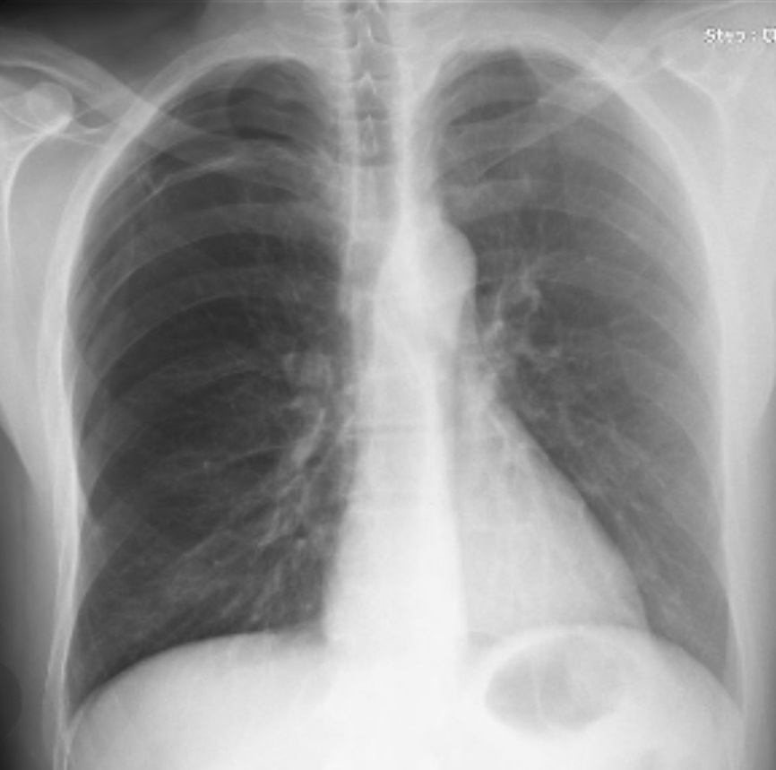

Figure 2. Right lung expansion defect seen on PA chest x ray at fourth post-procedure day.