Catheterizable bladder tube: A newly calculated formula for the optimum bladder capacity suitable for this technique

M. Moussa Dahab, Abdelhameed Elkassaby, Shady Sherin Shokry and Sameh Abdelhay
Department of pediatric surgery, Faculty of medicine, Ain Shams University
Cairo, Egypt

Objective
To share our experience and outcomes in using the bladder tube as a catheterizable channel in pediatric patients with intractable voiding dysfunction and to calculate the optimum bladder capacity suitable for the technique.

Patients and Methods
Eight patients underwent the procedure during the period from January 2014 to January 2018. A Pfannenstiel incision was done to avoid intraperitoneal dissection. After proper mobilization of the bladder, a 4 cm vertical flap with a base of 1.5-2 cm width was done at the dome of the bladder and tubularized over a 12 Fr or 14 Fr catheter. Then this flap was intussuscepted into the bladder (as an antireflux mechanism) and its other end tunneled and sutured to the umbilicus, followed by closure of the bladder in two layers.

Results
Out of the eight patients included in the study, five patients were successfully self-catheterizable. One patient had stenosis of the tube which was managed by dilatation. One patient had complete necrosis of the flap and required conversion to an alternative catheterizable channel. Another one had a refluxing bladder tube which improved by time.

Conclusion
Continent catheterizable bladder tube is an alternative technique for urinary drainage in patients with large bladder capacity that spares the use of appendix or ileum and avoids intraperitoneal dissection.
Introduction
Children with intractable voiding dysfunction as neurogenic bladder and fulgurated posterior urethral valve usually suffer from urinary incontinence all over the day, high pressure bladder and a certain degree of vesicoureteric reflux, unilaterally or bilaterally. In these patients, the upper urinary tract may be deteriorated if the condition is neglected. So the most important treatment goal in these patients is protection of the upper urinary tract by decreasing the bladder pressure and achievement of urinary dryness by timely bladder emptying ^{[1]}.
This could be achieved in early infancy by clean intermittent catheterization (CIC) which is easier in female patients than males. An alternative way to CIC is vesicostomy which is usually done in case of urethral obstruction or when the parents are not compliant. Both techniques are transient ways done only to protect the upper system and are not suitable as a long term management, especially in adult life, because dryness won’t be achieved in case of vesicostomy, and CIC could not be maintained, whether due to obstructive causes, false passages or in old age children where it is distressing.
Consequently a continent catheterizable channel (CCC) should be done, whether using the appendix (Mitrofanoff), the ileum (Monti) or a tubularized bladder flap (continent catheterizable bladder tube).
Although the use of appendix has become the CCC of choice for many surgeons, sometimes the appendix is not available or inappropriate because of its length, lumen or vascularity.
A simpler form of CCC is the tubularized bladder tube as it avoids intraperitoneal dissection and escape the problem of appendicular availability, but it is appropriate only in patients with large bladder capacity which is usually the limiting step in the procedure.

Patients and Methods
During the period from January 2014 to January 2018, 63 cases with voiding dysfunction were presented to our center. 28 of them had small bladder capacity and required bladder augmentation and catheterizable channel using the appendix. The remaining 35 cases had average bladder capacity to age and needed catheterizable channel only.
Out of those 35 patients, 27 patients had their bladder capacity around the suitable capacity for age and underwent appendicovesicostomy (Mitrofanoff). While the other 8 patients had considerably large bladder capacity and we decided to perform bladder tube as a catheterizable channel for them.
We used this equation to calculate the average bladder capacity suitable for age, Bladder capacity = (Age+2) x 30. ^{[2]}
The choice of the catheterizable channel was made depending on the bladder capacity which was measured preoperatively with voiding cystourethrogram VCUG (leaking point) and revised again intraoperatively before performing the procedure.
We followed up those eight patients who underwent tubularized bladder tube. Age of the patients ranged from 5 to 11 years old, they were 6 males and 2 females. The etiology of voiding dysfunction in our patients was neurogenic bladder due to spina bifida in 6 patients and post PUV in one patient and in last patient was secondary to multiple pelvic operations for HSD repair.
Surgical technique was done through Pfannenstiel incision to avoid intraperitoneal dissection (exception was done in one patient where the access to the bladder was done through an old lower midline vertical incision, as the patient had previous surgeries for HSD repair). After separation of recti, the bladder was filled (through a urethral catheter) with normal saline to be properly identified and to reassess the capacity intraoperatively. Then extraperitoneal mobilization of the bladder by blunt dissection was done. Two stay suture (4/0 silk suture) were taken on either sides of the midline followed by creation of a 3-4 cm vertical flap (with a base of 1.5-2 cm width). The size of the flap length and its base differs according to the bladder capacity and the age of the patient. This flap is then tubularized (in two layers) over a 12 Fr or 14 Fr urinary catheter using 4/0 vicryl or PDS continuous sutures (Fig. 1 a, b). The tube was intussuscepted into the bladder (1 to 1.5 cm into the bladder) as an antireflux maneuver and its other end was tunneled extraperitoneally (except for the patient with history of repaired HSD, intraperitoneally) and sutured to the umbilicus with interrupted 4/0 vicryl sutures, then closure of the bladder was done in 2 layers by 3/0 vicryl sutures (Fig. 1c). Then the bladder was filled again to check any leakage from the wall and to assess the continence of the tube, followed by closure of the abdomen in layers.
Postoperatively, the patients were given proper analgesia to control the pain with prophylactic dose of antibiotics. The urinary catheter was left in place for 1 week and the bladder tube catheter for 3 weeks. Then the patients were instructed how to use it properly, as a channel for CIC.
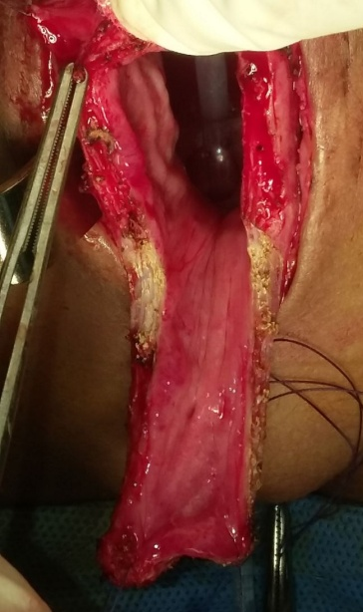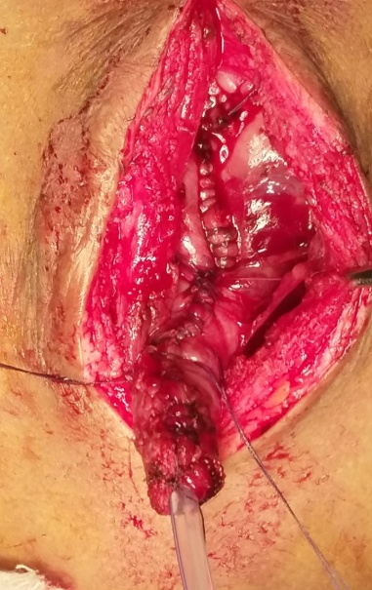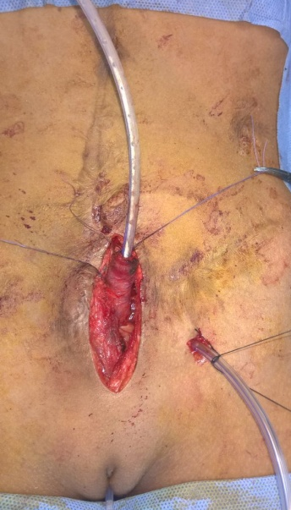
Fig.1a Fig. 1b Fig. 1c
Results
All surgeries passed uneventful with a median operative time of 117.2 minutes and median hospital stay of 4 days.
Out of the eight patients included in the study, five patients (62.5%) were successfully self-catheterizable with no detected intra or postoperative complications at the last follow-up visit. Median follow-up period was 8 months.
Patient NO | Gender | Age at operation | Etiology | Bladder capacity before the procedure (ml) | Bladder capacity after the procedure (ml) |  | Operative time (mins)
1 | Male | 10 yrs 6 ms | Spina bifida | 490 | 370 |  | 105
2 | Male | 5 yrs | PUV | 290 | 220 |  | 130
3 | Male | 7 yrs 4 ms | Spina bifida | 360 | 280 |  | 110
4 | Male | 11 yrs | Spina bifida | 510 | 380 |  | 100
5 | Female | 8 yrs 1 month | Spina bifida | 410 | 300 |  | 120
6 | Male | 5 yrs 8 ms | Spina bifida | 300 | 230 |  | 115
7 | Male | 6 yrs 5 ms | Spina bifida | 330 | 250 |  | 123
8 | Female | 9 yrs | Post HSD | 440 | 330 |  | 135

One patient (12.5%) had stenosis of the stoma which was managed by dilatation once. Stenosis was due to skin stricture and non-compliance of the patient (infrequent use of the catheterizable channel).
One patient (12.5%) had complete necrosis of the flap. He suffered from failure of passage of the catheter through the tube. The patient was explored 1 month postoperatively and the cause of necrosis was found to be due to bad proportion between the flap length and its base. Excision of the necrosed tube was done with conversion to an alternative catheterizable channel (appendicovesicostomy).
Another one (12.5%) had a refluxing bladder tube, which improved after 2 months without intervention by decreasing the catheterization timing from 6 to 5 hours.

Discussion
Children suffering from urinary incontinence due to neurogenic bladder or repaired obstructive urethral causes require a continent catheterizable channel (CCC) instead of clean intermittent urethral catheterization (CIC) which is quite distressing and painful, especially in older children. The use of tubularized bladder flap is a simple technique and good alternative to the appendicovesicostomy (Mitrofanoff) in case of absent appendix or inappropriate length or vascularity.
Appendicovesicostomy (Mitrofanoff) introduced in 1980, remains the preferred method for a bladder catheterizable channel. However, its limitation is availability of the appendix ^{[3]}. Monti ileovesicostomy, first described in 1997 represent a commonly used alternative when appendix is already used or not available but it requires bowel resection and its possible hazards ^{[4]}.

Only a few techniques have been reported describing the use of bladder tissue as a catheterizable channel. Cain et al. in 2002 described a continent vesicostomy with excellent continence rates but higher rates of stenosis requiring surgical intervention ^{[5]}.

Leslie et al. in 2016 described the continent catheterizable vesicostomy procedure as a catherizable channel in 6 cases with voiding dysfunction and large bladder capacity. There were no complications except stomal stenosis in one patient, continence was excellent and no reoperation was required ^{[6]}.

A retrospective study was published in 2017 comparing long term results of 117 children who had a CCC using appendicovesicostomy, tubularized bladder flap and Monti. Surgical revision was required in 52%, with no significant difference between the three techniques. Major revision was required in 27% of patients (more in Monti channels). Stenosis requiring surgical revision was seen in 33%. The study concluded that a TBF CCC is a good alternative for the APV if the appendix is not available and bladder volume is sufficient, a TBF channel is preferred to a Monti channel ^{[1]}
Proper choice the patient suitable for catheterizable bladder tube remains the cornerstone for the success of the technique. Few studies were published using this technique in pediatric age group. However, none of them precisely described the suitable bladder capacity for this technique, which can provide successful outcome without impairing the remaining bladder capacity.
In our study, we found that the bladder loses around one fourth of its original volume after performing the bladder tube. This was proved by measuring the actual volume intraoperatively after the procedure and comparing it to the original capacity measured in the beginning of the operation (Fig 2).
So we assume that the suitable bladder capacity for this technique should be at least 1/3 more than the optimum capacity for age in order not to compromise bladder capacity and thus this procedure should not be performed unless this criterion is fullfiled.
In this study 8 patients underwent a tubularized bladder flap over a period of 4 years, 5 of them were successfully self catheterizable, with a percentage of 62.5%.
We had one patient who suffered from stenosis due to skin stricture with a percentage of 12.5% and was managed by dilatation in comparison to 16.6% in Leslie et al. series ^{[6]}. Patient compliance is very important to minimize stomal stenosis.
Despite the relatively higher rate of stomal problems with continent catheterizable bladder tube in comparison to appendicovesicostomy, it remains a reasonable alternative in patients with large bladder capacity, requiring only a catheterizable channel without augmentation ^{[5]}.
Channel continence will remain a great concern of any catheterizable channel, with reported rates from 2% to 12% ^{[7]}. In our series we had a case of transient incontinence who improved with follow up. However, long term follow up is required to confirm the success of our antireflux technique as leakage can occur at any point in lifetime.

The present study revealed the need for conversion to another type of catheterizable channel in one patient (12.5% of cases). The patient suffered from complete necrosis of the flap due to inappropriate proportion between the flap length and the base, which should be at least 2:1 or 3:1 to preserve the vascularity. Another cause of necrosis is tight reconstruction of the flap over the catheter due to narrow flap which may also impair the blood supply of the flap.
We found that this procedure is safe, easy, feasible, and with good continence and less hospital stay compared to procedures where bowel resection is needed. The bladder capacity must be large enough to perform the procedure without compromising the remaining capacity. This technique is very beneficial for cases in which the appendix is unavailable or patients who suffer stool incontinence and require the use of appendix for a MACE as it avoids bowel resection (Monti procedure).

The study lacks long term follow up with median of 8 months. However, there are no publications on long term results with TBF channels

The limitations include the relatively small sample size, as this procedure was done only for patients with large bladder capacity. Other limitations include single center study and lack of comparison between different types of CCC and lack of long term follow up.

Conclusion
Continent catheterizable bladder tube is a good alternative technique for urinary drainage in patients with large bladder capacity that spares the use of appendix or ileum and avoids intraperitoneal dissection. This technique should be the first choice as a CCC for patients with large bladder capacity especially when appendix is not available.

References
1- Pepijn D.P., Laetitia M.O., Tom P.V.M. et al. Techniques Used to Create Continent Catheterizable Channels: A Comparison of Long-term Results in Children. Urology 2017; 110: 192-195.
2- Robert M.B., Max M., George C.M., et al. Bladder Capacity (Ounces) Equal Age (years) Plus 2 Predicts Normal Bladder Capacity and Aids in Diagnosis of Abnormal Voiding Patterns. Journal of Urology 1983; 129(2): 347-349.
3- Mitrofanoff P. Trans-appendicular continent cystostomy in the management of the neurogenic bladder. Chir Pediatr 1980; 21: 297-305.
4- Monti P.R., Lara R.C., Dutra M.A. et al. New techniques for construction of efferent conduits based on the Mitrofanoff principle. Urology 1997; 49: 112-115.
5- Cain M.P., Rink R.C., Yerkes E.B., et al. Long term follow up and outcome of continent catheterizable vesicostomy using the rink modification. Journal of Urology 2002; 168(6): 2583-2585.
6- Leslie P., Patrick J.F., William M.A. et al. Continent Catheterizable Vesicostomy: An Alternative Surgical Modality for Pediatric Patients with Large Bladder Capacity. Urology 2016; 93: 217-222.
7- Welk B.K., Afshar K., Rapoport D. et al. Complications of the catheterizable channel following continent urinary diversion: their nature and timing. Journal of Urology 2008; 180: 1856-1860.

