TITLE: Low Level Laser (LLL) as an adjuvant therapy for pruritis in post burn scars

AUTHORS:
- Dr Saurabh Gupta

Senior Resident,
Department of Plastic Surgery,
Jawaharlal Institute of Postgraduate Education and Research (JIPMER),
Puducherry, India.
Email: drsaurabh2007@gmail.com
Contact: +91-9981856366
ORCID: 0000-0003-1843-458X

- Dr Ravi Kumar Chittoria (corresponding author)

Professor,
Department of Plastic Surgery,
Jawaharlal Institute of Postgraduate Education and Research (JIPMER),
Puducherry, India.
Email: drchittoria@yahoo.com
Contact: +91-9442285670
ORCID: 0000-0002-4637-7503

- Dr Abhinav Aggarwal

Senior Resident,
Department of Plastic Surgery,
Jawaharlal Institute of Postgraduate Education and Research (JIPMER),
Puducherry, India.
Email: abhi2128@gmail.com
Contact: +91-9646496250

- Dr Chirra Likhitha Reddy

Senior Resident,
Department of Plastic Surgery,
Jawaharlal Institute of Postgraduate Education and Research (JIPMER),
Puducherry, India.
Email: drlikhithareddy@gmail.com
Contact: +91-9159180505

- Dr Padmalakshmi Bharathi Mohan

Senior Resident,
Department of Plastic Surgery,
Jawaharlal Institute of Postgraduate Education and Research (JIPMER),
Puducherry, India.
Email: pebeyem@gmail.com
Contact: +91-9443133845

- Dr Shijina K

Senior Resident,
Department of Plastic Surgery,
Jawaharlal Institute of Postgraduate Education and Research (JIPMER),
Puducherry, India.
Email: chinuvmmc@gmail.com
Contact: +91-98606725940

- Dr Imran Pathan

Senior Resident,
Department of Plastic Surgery,
Jawaharlal Institute of Postgraduate Education and Research (JIPMER),
Puducherry, India.
Email: pathan.drimran@gmail.com
Contact: +91-7015325799

- Dr Nishad K

Senior Resident,
Department of Plastic Surgery,
Jawaharlal Institute of Postgraduate Education and Research (JIPMER),
Puducherry, India.
Email: nishadtmc@gmail.com
Contact: +91-9895143199

ABSTRACT:
Background: Pruritis is presentr in 87% of post burn scars and a significant problem during rehabilitation phase. There are varied treatment of pruritis but none of them is completely effective. Low Level Laser Therapy (LLLT) is one of the adjuvant treatment of post burn scars. We have conducted a randomized control study to assess effect of LLLT over pruritis in post burn scars. Methods: This is a single institute prospective randomized control study. One scar of each subject was included in each group. 41 post burn scars are included in each group. Control group scars received pressure therapy alone and study group scars received LLLT along with pressure therapy, for 8 weeks. Subjects were asked for presence of itching in the scars before and after the study. Results: The mean age of patients was 24.1±16.9 years. There were 14 male and 27 female subjects. At the time of presentation 30 (73.2%) scars in both groups were having pruritis. Pruritis reduced from 30 (73.2%) to 16 (39%) scars in study group while same reduced from 30 (73.2%) to 25 (58.5%) scars in control group. Study group scars have significantly more reduction in itching during study period. Pruritis was present in 95.5% scars presenting before 1 year, while it is present in only 47.4% scars presenting after 1 year. Conclusion: Combining low level laser (LLL) as an adjuvant with conventional scar therapy has a positive role in reducing pruritis in these scars, especially during first post burn year.

Key Words: Low Level Laser Therapy; Post Burn Scar; Pruritis.

BACKGROUND:
Burn injury has an annual incidence of around 6-7 million per year in India.¹ Prolonged rehabilitation is required in burn survivors.¹ Post burn scars have significant physical, psychosocial and socioeconomic impact on a burn survivor.² Pruritis is one of the most common sequelae of burn injury. Pruritis is present in upto 87% of post burn scars.³ Pressure therapy is the conventional treatment of post burn scars.³⁻⁶ But pressure therapy is not completely effective in reducing post burn pruritis. Various pharmacological and physical modalities are available for treatment of post burn pruritis but very few real comparative studies have been done.
Low Level Laser Therapy (LLLT) is one of the proposed modalities to improve scar quality. LLLT is claimed to increase collagen synthesis, decrease inflammation and has positive impact on scar remodeling.⁷⁻¹⁴ LLLT can be utilized for treatment of post burn pruritis.¹⁴ In this article we present results of a prospective interventional study to assess effect of low level laser therapy (LLLT) on pruritis in post burn immature scars.

MATERIALS AND METHODS:
This study was performed at tertiary burn care centre of our institute in India between August 2018 to October 2019. Ethical clearance for the study was obtained from the institute ethics committee. Study design is single institute randomized control study. Sampling population was post burn patients coming to the plastic surgery outpatient department of our institute. Subjects with post burn scars were included. Exclusion criteria were following: (1) Subjects with acute burn wounds (<1month old), (2) subjects with age >65 years, (3) Subjects with diabetes/ radiation exposure, (4) Scars near eyes, (5) Scars >4 square feet area and (5) Subjects not willing to participate in the study.
Two groups were studied: (1) Group 1 (study group) was the scars treated with combination therapy (LLLT and conventional therapy); and (2) Group 2 (control group) was the scars treated with conventional therapy alone. After taking written informed consent, patient selection and scar selection for the study was done by the investigator based on inclusion and exclusion criteria. In every subject two discrete patches of post burn immature scar were selected. In each subject selected scars were similar in area and VSS score (± 1) at the time of presentation. One scar of each subject was included in study group and one in the control group. Thus each group was having same number of scars and same set of the subjects. Group was allotted to the scar using simple randomization technique. Total number of scars studied was 41 in each group.
Low level laser used was Gallium Arsenide (GaAs) diode red laser of wavelength 650 nm, output power 100 mW, frequency 10 kHz, continuous beam, scanning mode, non contact delivery (60cm distance between laser source and scar) with area of delivery adjustable according to the size of scar. Laser therapy was given for duration 125 sec every time. Therapy is given twice a week (not less than 3 days interval between two therapies) for 8 weeks. LLLT was given to the study scars on day care basis, with all laser safety precautions in dedicated laser room.
Conventional scar therapy (including scar massage, pressure garments, elastic bandages, low stretch exercises, or orthotics) were continued in all scars of the subjects equally during the study period.
All the subjects were asked for presence of itching (pruritis) in the scars at the time of presentation and after 8 weeks (i.e. after completion of the intervention). Observer who evaluates the VSS and itching was kept unaware of the fact that which scar has been treated with LLLT (single blind study). Figure-1 shows one of the scar included in the study.

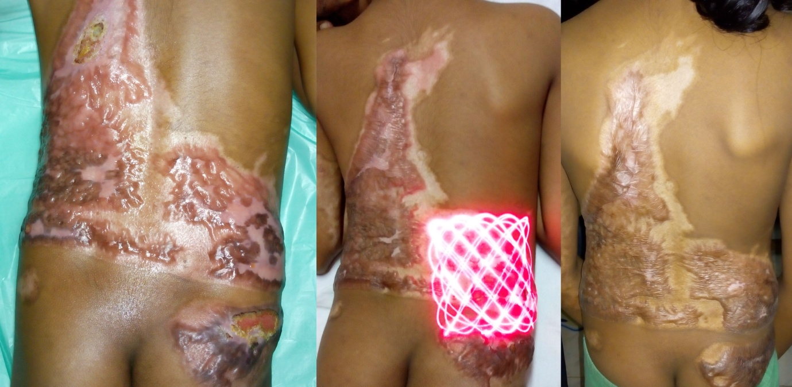
Figure 1: Clinical picture of a scar before, during and after the study (Right side scar is control scar and left side scar is study scar)

RESULTS:
The mean age of patients was 24.1±16.9 (range, 3-62 years). There were 14(34.1%) male and 27(65.9%) female subjects. At the time of presentation 30 (73.2%) scars in both groups were having pruritis. Pruritis reduced from 30 (73.2%) to 16 (39%) scars in study group while same reduced from 30 (73.2%) to 25 (58.5%) scars in control group. Study group scars have significantly more reduction in itching during study period. (Table-1) (Figure-1)
The correlation between time since burn and pruritis has showed that pruritis is present in 95.5% scars presenting before 1 year, while it is present in only 47.4% scars presenting after 1 year. (Table-2)

Table -1: Effect of LLLT on post burn pruritis
 | Pruritis | Pre-intervention | Post-intervention
Study group | Absent | 11 (26.8%) | 25 (61%)
 | Present | 30 (73.2%) | 16 (39%)
 | Total | 41 | 41
Control group | Absent | 11 (26.8%) | 17 (41.5%)
 | Present | 30 (73.2%) | 24 (58,5%)
 | Total | 41 | 41

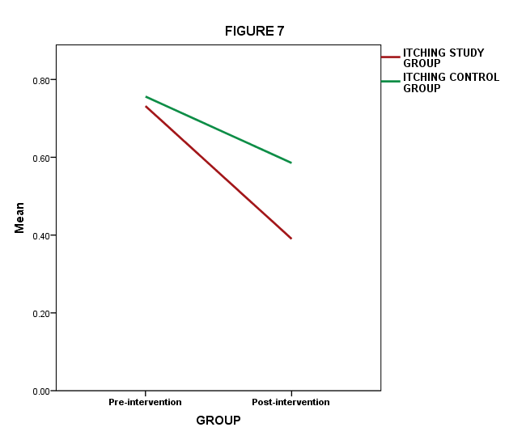
Figure 2: Comparison of change in pruritis (itching) in scars between study and control group
Table-2: Correlation between time since burn and pruritis in post burn scars
Time since burn | n | Pruritis
Less than 12 months | 22 | Present | 21 (95.5%)
 |  | Absent | 1 (4.5%)
More than 12 months | 19 | Present | 9 (47.4%)
 |  | Absent | 10 (52.6%)
Total | 41 |  | 41

DISCUSSION:
Pruritis can influence the quality of life and duration of rehabilitation required in burn survivors. It is very common for the patient to have a significant problem exercising or sleeping if the itching is intense. In addition scratching can lead to abrasions and graft ulcerations. First line of treatment for post burn pruritis is moisturizing lotions, topical anaesthetic, topical antihistaminics, topical steroids, topical tricyclic antidepressants. Scar massage seems to be very effective against pruritis. Other measures include Transcutaneous Electric Nerve stimulatiuon (TENS), Pulsed Dye Laser (PDL), Electroaccupuncture, LLLT and silicone gel sheets. Oral medications (antihistaminics, Gabapentin and Naltrexone) are reserved for intractable pruritis.³
Present study also shows that scar massage and pressure garments are effective in reducing pruritis of post burn immature scars. However combining LLLT as an adjuvant to pressure therapy significantly increase its effectiveness for the same. Present study shows that combination therapy improves scar pruritis better than conventional therapy alone. Its effects are evident in 8 weeks of therapy. Our findings are in accordance with a similar study done by Gaida et al in 2004.¹⁵ We also found that initially almost all of the post burn immature scars have itching, which decreases with time. Thus it can be said that combining LLLT with conventional therapy is expected to have better results if used during early phase (first year) of the post burn scar.
We did not find any local or systemic side effect of LLLT. None of the scar got worsened during study period. LLLT is a safe laser, considered to be a non heat producing laser. It is classified as laser safety class IIIb. For the scar treatment with LLLT patient has to come twice a week to OPD, which was found to be problematic for some patients. There is no standard set parameter of LLLT for post burn scar treatment. This makes comparison between studies difficult.
Shortcomings of present study are that we did not consider categorization of scars based on location of scar, extent of original burn injury, previous operative wound management, and presence of skin graft over the scars. These may be confounding factors contributing to errors. We used scanning mode laser machine, which has advantage of covering large surface area in one sweep. Problem with scanning mode is it decreases power density of the laser due to scattering effect. Also the power density is variable based on area covered. Present study is a short term study with 8 weeks of intervention period. Results may be different on long term follow up of the subjects. Pruritis is a subjective measure of scar quality, thus not an ideal outcome parameter.

CONCLUSION:
Combining low level laser (LLL) as an adjuvant with conventional scar therapy has a positive role in reducing pruritis in these scars, especially during first post burn year.

REFERENCES:
- Gupta JL, Makhija LK, Bajaj SP. National programme for prevention of burn injuries. Indian journal of plastic surgery. 2010 Sep;43(Suppl):S6.
- Misra, et al. Facial burn scars-psychology and quality of life. Indian Journal of Burns. 2012 Dec; 20(1):57-61.
- Meyer WJ, Martyn JA, Wiechman S, Thomas CR, Woodson L. Management of pain and other discomforts in burned patients. In: Herndon DN, editor. Total Burn Care. 5th ed. Edinburgh: Elsevier; 2018: 679-699.
- Serghiou MA, Ott S, Cowan A, Offenberg JK, Suman OE. Burn rehabilitation along the continuum of care. In: Herndon DN, editor. Total Burn Care. 5th ed. Edinburgh: Elsevier; 2018: 490-495.
- Sarabhai S, Tiwari VK, Goel A, Gupta LC. Wound Healing in Burns. In: Sarabhai S, editor. Principles and Practice of Burn Care. Delhi: Jaypee. 2010: 51-68.
- Kwan P, Desmouliere A, Tredget EE. Molecular and Cellular basis of Hypertrophic Scarring. In: Herndon DN, editor. Total Burn Care. 5th ed. Edinburgh: Elsevier; 2018: 455-465.
- McLaughlin, Branski LK, Norbury WB, Bache SE, et. al. Laser for Burn Scar Treatment. In: Herndon DN, editor. Total Burn Care. 5th ed. Edinburgh: Elsevier; 2018: 648-654.
- Parrett BM, Donelan MB. Pulsed dye laser in burn scars: current concepts and future directions. Burns. 2010;36:443-449.
- Chittoria R.K., Kumar S.H. (2018) Low-Level Laser Therapy (LLLT) in Wound Healing. In: . Recent Clinical Techniques, Results, and Research in Wounds. Springer; 2018, Cham.
- Mester E, Hazay L, Fenyo M, Kertész I, Toth N, Jàrànyi Z et al. The biostimulating effect of laser beam. In: Waidelich W, editor. Optoelectronics in Medicine. Berlin: Springer; 1982: 146-152.
- Posten W, Wrone DA, Dover JS, Arndt KA, Silapunt S, Alam M. Low-level laser therapy for wound healing: mechanism and efficacy. Dermatol Surg. 2005 Mar; 31 (3):334–40.
- Farivar S, Malekshahabi T, Shiari R. Biological Effects of Low Level Laser Therapy. J Lasers Med Sci. 2014 spring;5(2):58-62.
- Andrade F, Rosana C, Manoel F. Effects of low-level laser therapy on wound healing. Rev. Col. Bras. Cir. 2014 Apr; 41(2):129-133.
- Gaida K, Koller R, Isler C, Aytekin O, Awami MA, Meissl G, Frey M. Low Level Laser Therapy—a conservative approach to the burn scar? Burns. 2004 Jun; 30(4):362–367.

