Role of Fat Grafting in Scar Management

Authors

- Imran Pathan
Senior Resident
Department of Plastic Surgery
Jawaharlal Institute of Postgraduate Medical Education and Research (JIPMER)
Pondicherry
India-605006
Email: pathan.drimran@gmail.com

- Ravi Kumar Chittoria
Professor
Department of Plastic Surgery
Jawaharlal Institute of Postgraduate Medical Education and Research (JIPMER)
Pondicherry
India-605006
Email: drchittoria@yahoo.com

- Saurabh Gupta
Senior Resident
Department of Plastic Surgery
Jawaharlal Institute of Postgraduate Medical Education and Research (JIPMER)
Pondicherry
India-605006
Email: drsaurabh2007@gmail.com

- Chirra Likhitha Reddy,
Senior Resident
Department of Plastic Surgery
Jawaharlal Institute of Postgraduate Medical Education and Research (JIPMER)
Pondicherry
India-605006
Email: drlikhithareddy@gmail.com

- Padmalakshmi Bharathi Mohan
Senior Resident
Department of Plastic Surgery
Jawaharlal Institute of Postgraduate Medical Education and Research (JIPMER)
Pondicherry
India-605006
Email: pebeyem@gmail.com

- Shijina K
Senior Resident
Department of Plastic Surgery
Jawaharlal Institute of Postgraduate Medical Education and Research (JIPMER)
Pondicherry
India-605006
Email: chinnuvmmc@gmail.com

7. Nishad K.
Senior Resident
Department of Plastic Surgery
Jawaharlal Institute of Postgraduate Medical Education and Research (JIPMER)
Pondicherry
India-605006
Email: nishadtmc@gmail.com

8. Neljo Thomas
Senior Resident
Department of Plastic Surgery
Jawaharlal Institute of Postgraduate Medical Education and Research (JIPMER)
Pondicherry
India-605006
Email: neljothomas@gmail.com

Corresponding author:
Ravi Kumar Chittoria
Professor
Department of Plastic Surgery
Jawaharlal Institute of Postgraduate Medical Education and Research (JIPMER)
Pondicherry
India-605006
Email: drchittoria@yahoo.com
Phone no- 9442285670

Abstract
Scar is a common problem following burn, trauma or infection. There are various methods to improve the scar. But there is no well-established method to prevent or treat the scar. Stem cell therapy is most recent technique that is claimed to hasten the healing. Fat graft is a source of stem cells. This article highlights the role of fat graft in scar treatment.

Keywords
Fat, grafting, scar, management
Introduction
Scar is the end result of wound healing. It is a common problem following any injury, burn or surgical procedure. Various modalities have been described in literature for its management. Among these are - surgical excision with or without grafting (1), pressure therapy (3), intralesional interferon (4), intralesional corticosteroids (5), intralesional bleomycin (6), laser therapy (7), silicone gel sheeting (8), onion extract gel and other therapies directed at collagen synthesis (9). One of the newer modalities available is the fat grafting.
Adipose-derived stem cell-based therapy is one of the most recent therapeutic strategies for wound healing that affects all aspect of wound healing i.e. re-epithelization, angiogenesis, and immunomodulation. In review of literature we have seen very few Indian studies on fat grafting in scar management. We share our experience on fat grafting in scar management.

Methodology
This is case report of use of fat grafting in post burn scar area. This study was conducted in a tertiary care hospital in 2019. The patient was 20 year female with post thermal burn scar area on thigh and leg and abdomen. Fat grafting was planned for thigh scar. (Figure- 1)
Under anaesthesia tumescent was infiltrated in abdominal wall. A stab incision was given at umbilicus and 20 ml of lipospirate was harvested.(Figure- 2) It was centrifuged at 1500rpm. After centrifugation there were three layers. (Figure-3) Upper layer and lower layer were discarded. The middle portion containing adipose tissue fraction was taken for fat grafting. The fat was converted to nano-fat by moving it back and forth in two syringes connected with each other (Figure-4)
The adipose tissue fraction was inserted into the dermohypodermic junction in all cases. Through the same incision, many radiating passages are made in order to distribute fat in different directions. The amount of fat was - 1 mL of fat graft for an area of 2 cm² of scar surface. (Figure- 5)
Injection is performed with retrograde technique leaving a very small space between the injected tissue lines. The treated area is covered with sterile dressing for 1 week and the patient is told to avoid pressure and friction to limit the displacement of fat infiltration. The abdominal incision was closed by polypropylene suture, and compression dressing was applied to be kept in place for 5 days to prevent hematoma formation.
Scar was evaluated at 2 weeks and at 6th week. (Figure- 6) Clinical assessment of scars with the POSAS (Patient and Observer Scar Assessment Scale) was performed .Each patient scored the characteristics of scar color, pliability, thickness, relief, itching, and pain whereas the physician scored scar vascularization, pigmentation, pliability, thickness, and relief. The score is composed of a numerical scale (1–10) in which 10 corresponds to the worst possible scar characteristic while 1 corresponds to normal skin. The POSAS evaluation of the physician is not known to the patient.

Result
The quality improvement was shown both from an aesthetic and functional point of view; in particular, relief from pain, itching and increase in scar elasticity. POSAS score for pain was 7 that became 5 and for itching it was 7 and 2 weeks after fat grafting it became 5 and decresed further to 3 after 6 weeks. POSAS score for relief as assessed by physician, was 6 before fat grafting and became 5 after 6 weeks of the procedure.

Discussion
Historically, the use of fat was used to treat congenital deformities and complex traumatic wounds with soft-tissue loss after oncologic demolishing surgery. The first 'fat grafting' procedure dates 1893, when a German Plastic Surgeon, Gustav Neuber (1850-1932) transferred fat from the arm to the orbital (eye) region to correct scars formed from osteomyelitis (bone infection). The disadvantage of autologous fat graft was the unpredictable reabsorption rate of the volume grafted. In 1992, Coleman described a technique for increasing the survival of fat harvested by liposuction and transplanted by injection. Rigotti et al in 1997 first used fat injection for the management of radiodermatitis with successful outcomes.¹⁻⁶
The autologous fat grafts are made up of fat cells, extra cellular matrix (ECM), and adipose-derived stem cells (ADSCs). The clinical use of autologous adipose-derived stem cells (ADSCs) is rapidly expanding. Applications as diverse as myocardial infarction, cosmetic surgery, osteoarthritis, bone regeneration, inflammatory bowel disease and chronic wounds and recently in scar management. Since ADSCs have been shown to play a role in antiaging and skin regeneration, the scar-remodeling effect of fat grafts may be related to ADSCs. ADSCs demonstrably survive after transplantation, show pluripotential and exhibit anti-apoptotic, anti-inflammatory,and angiogenic effects. It promotes wound healing via epithelial differentiation that lead to accelerated epithelialization of the wound. These cells also have capacity of differentiation into endothelial cells and secretion of endogenic growth factor that contribute to increased neovascularization.⁷⁻¹⁰
Various techniques exist in literature for harvesting stems cell. The technique used in this article is easy to perform and has low co-morbidity and it does not requires special instruments.
Conclusion
In this study we found that fat grafting has role in remodeling of scar. The resultant scar was also of better quality. But since it is a single case study, definite conclusion cannot be made. Large randomized control trials are required to confirm the efficacy of fat grafting in scar management.
Conflicts of interest
None.
Bibliography
- Gu Z, Li Y, Li H. Use of Condensed Nanofat Combined With Fat Grafts to Treat Atrophic Scars. JAMA Facial Plast Surg. 2018;20(2):128–135
- Gir P, Brown SA, Oni G, Kashefi N, Mojallal A, Rohrich RJ. Fat grafting: Evidence-based review on autologous fat harvesting, processing, reinjection, and storage. Plast Reconstr Surg. 2012;130:249–258.
- Kling RE, Mehrara BJ, Pusic AL, et al. Trends in autologous fat grafting to the breast. Plast Reconstr Surg. 2013;132:35–46
- Coleman SR. Long-term survival of fat transplants: controlled demonstrations. Aesthetic Plast Surg 1995; 19: 421–425.
- Coleman SR. Facial augmentation with structural fat grafting. Clin Plast Surg 2006; 33: 567–577
- Rigotti G, Marchi A, Galiè M, et al. Clinical treatment of radiotherapy tissue damage by lipoaspirate transplant: a healing process mediated by adipose-derived adult stem cell. Plast Reconstr Surg 2007; 119: 1409–1422
- Klinger M, Marazzi M, Vigo D, et al. Fat injection for cases of severe burn outcomes: a new perspective of scar remodeling and reduction. Aesthetic Plast Surg 2008; 32: 465
- Caviggioli F, Klinger F, Forcellini D, et al. Scar treatment by lipostructure. Update Plast Surg 2009; 2: 51–53
- Caviggioli F, Klinger F, Villani F, et al. Correction of cicatricial ectropion by autologous fat graft. Aesthetic Plast Surg 2008; 32: 555
- Klinger M, Caviggioli F, Vinci V, et al. Treatment of chronic post-traumatic ulcers using autologous fat graft. Plast Reconstr Surg 2010; 126: 154e–155e
DECLARATIONS
Authors’ contributions
All authors made contributions to the article
Availability of data and materials
Not applicable.
Financial support and sponsorship
None.
Consent for publication
Not applicable.
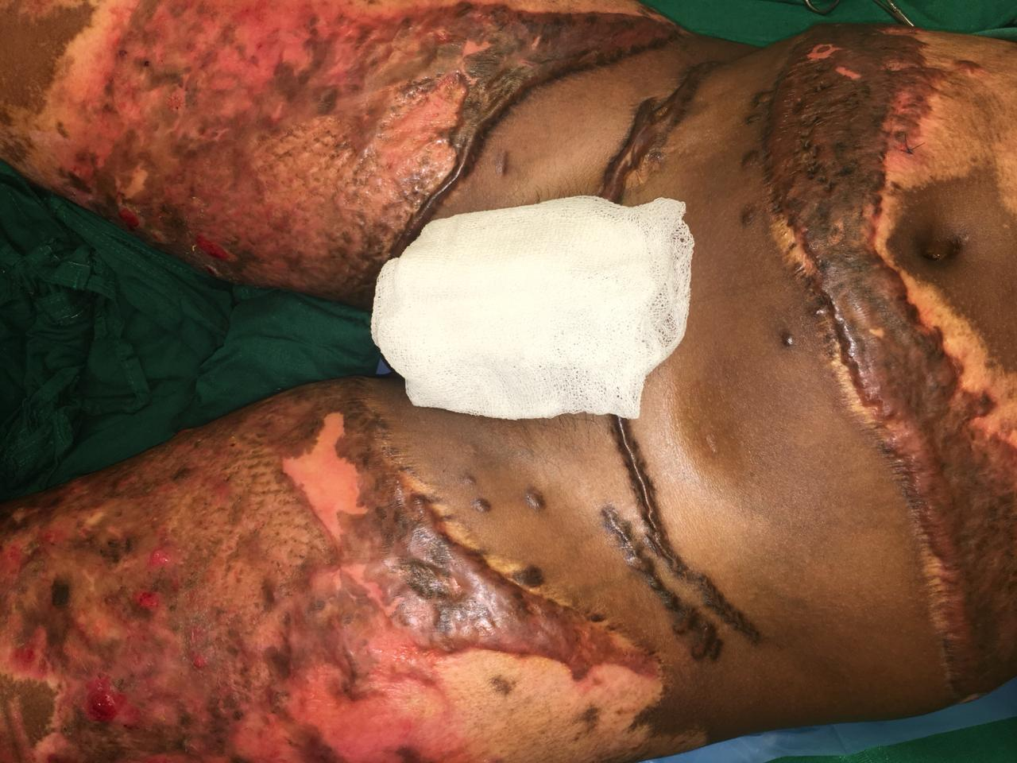
Figure-1 – Pre-operative scar

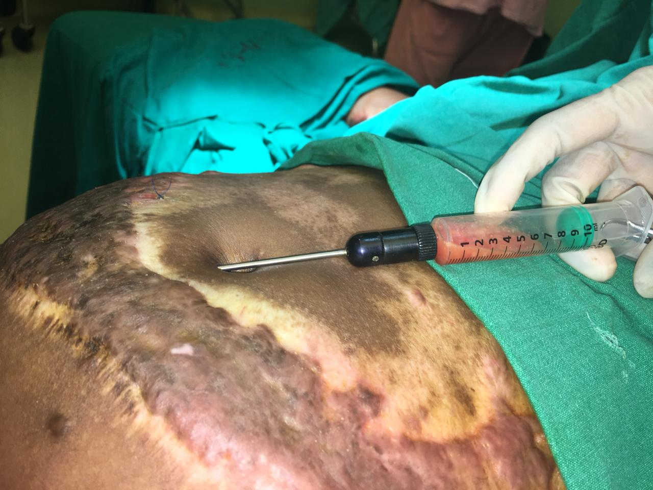
Figure-2 – Fat being harvested

Figure-3- Lipoaspirate after centrifugation showing three layers
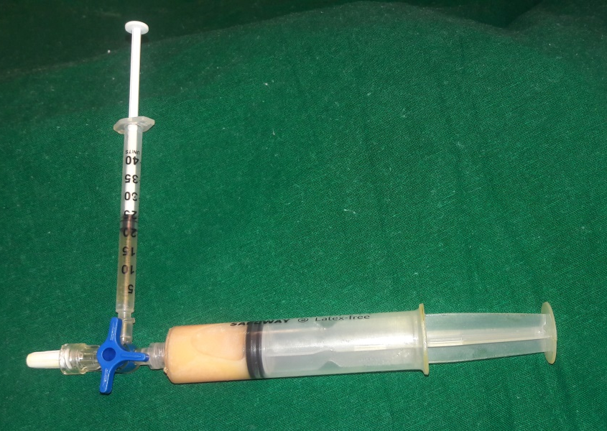
Figure-4- Converting fat to nano-fat by moving plunger back and froth

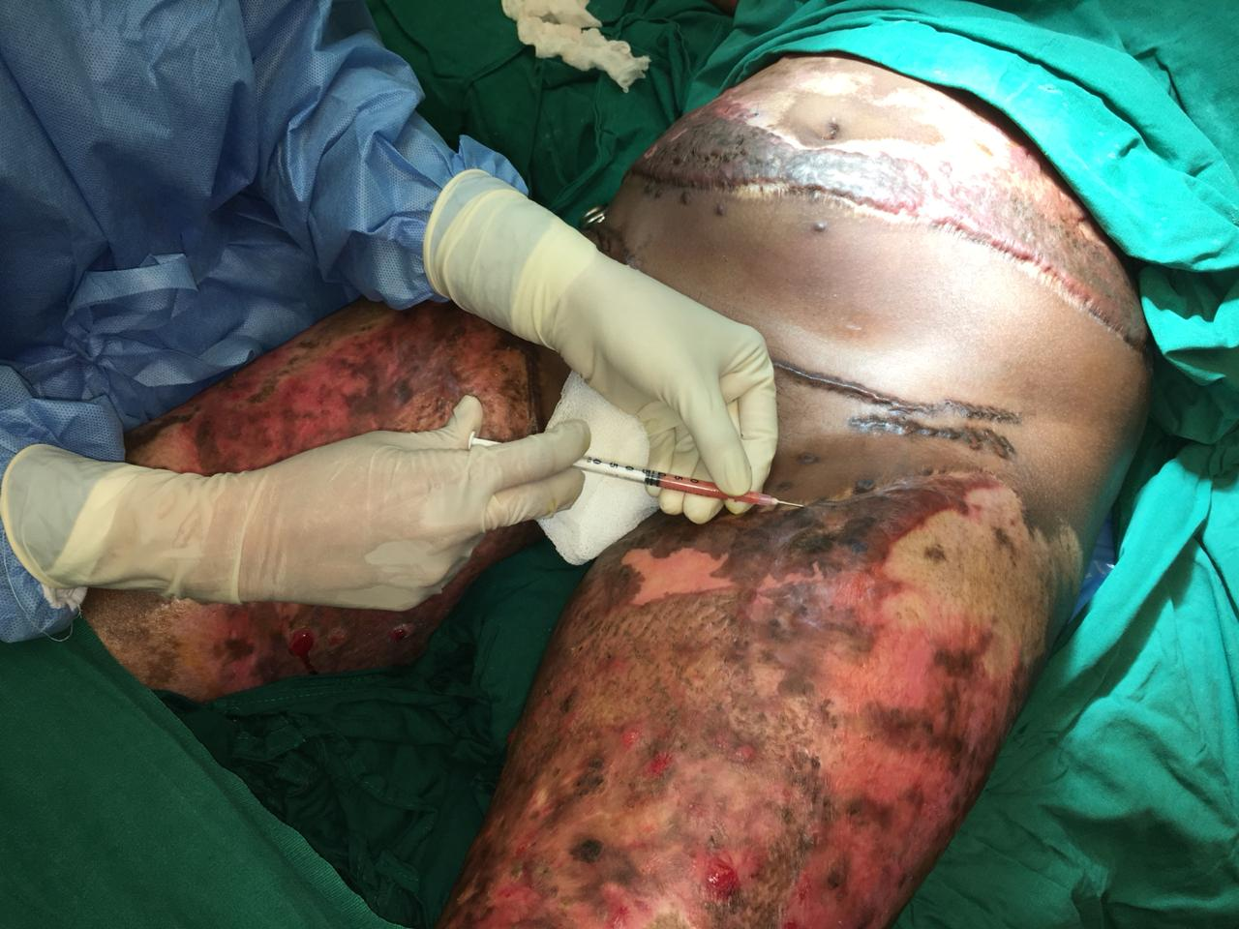
Figure-5- Fat graft being injected into scar area
Figure-6 Scar after 6 weeks

