Unusual method in tracheo-bronchial foreign body aspiration management
Running Title: Tracheo-bronchial foreign body aspiration
Ahmed Abdel-Aziz, Walid Abu Arab
Cardiothoracic Surgery Department, Faculty of Medicine, University of Alexandria

Corresponding author:
Prof. Walid Abu Arab
Cardiothoracic Surgery Department
Faculty of Medicine
University of Alexandria
Middan Al-Khartoum
Alexandria, Egypt
Tel: +2 01062335875
E-mail: walidabuarab@yahoo.com

Abstract:
Tracheo-bronchial foreign body aspiration could be a life-threatening condition that occurs mainly in children. Prompt diagnosis and intervention through foreign body retrieval are critical to prevent probable morbidity and mortality. The retrieval procedure could be difficult depending on the shape and consistency of the foreign body material. Surgeons can utilize special tools to help in the extraction of tracheo-bronchial foreign bodies. We present here a child patient who accidentally aspirated a plastic bead. He underwent successful retrieval of the foreign body using a Fogarty embolectomy catheter introduced through a rigid bronchoscope.
Key words: Foreign body, aspiration, tracheo-bronchial foreign body
Introduction:
Tracheo-bronchial foreign body aspiration could be a life-threatening event (1, 2). It occurs mainly in children (3). Early diagnosis and management are important to avoid complications (1-3). Endoscopic extraction could be difficult and may require the employment of special instruments (3). We present here a child patient who accidentally aspirated a plastic bead. He underwent successful retrieval of the foreign body using a rigid bronchoscope and a Fogarty embolectomy catheter.
Case presentation:
A nine-year-old male child was referred to the Cardiothoracic Surgery Department with a history of aspiration of a plastic bead into the trachea-bronchial tree. A previous trial of bronchoscopic extraction was done using a dormia basket at another center. The child was asymptomatic. However, examination revealed decreased air entry over the left lung base.
Plain chest x-ray showed a rounded smooth opacity related to the foreign body; it was located mostly in the left lower lobar bronchus (Figure 1). Routine laboratory investigations were performed. The findings were within the normal values for age and sex. Rigid bronchoscopy under general anesthesia was performed using the number 5 Karl Storz bronchoscope. A foreign body in the form of a white plastic bead with a central hole was visualized. Repeated attempts of extraction using conventional foreign body forceps were conducted with no success.
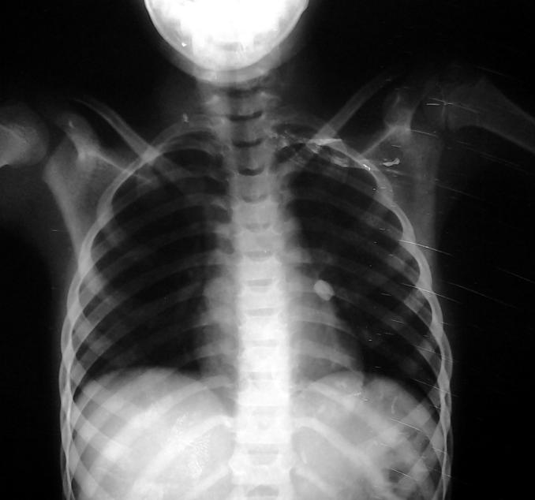
Figure 1: Plain postero-anterior chest x-ray showed a rounded smooth opacity of a foreign body located at the left lower lobar bronchus
A Fogarty embolectomy catheter was passed under vision through the central hole. The balloon was inflated. This was followed by the removal of the catheter holding the bead together with the bronchoscope as one unit (Figure 2).
Figure 2: A Fogarty embolectomy catheter was passed through the central hole of the foreign body with its inflated balloon holding the bead
Further examination of the tracheo-bronchial tree was conducted to exclude any traumatic injury or impacted secretions. No complications were encountered. The patient was discharged on the same day.
Discussion:
Foreign body aspiration occurs mainly in children (3). Foreign bodies could be organic in nature, such as nuts and seeds, or inorganic like pins, nails, and dental appliances (5). In this study, the child aspirated a bead, which is a rounded plastic piece with a smooth surface and a very small opening at its center. Usually, foreign bodies could be removed using extraction forceps (6). However, sometimes, special tools need to be used such as a magnet for metallic objects (7) or a Fogarty catheter (4). In the case at hand, the bead was rounded and smooth and impacted inside the lobar bronchus. It was difficult to grasp with forceps or to pass any tool like a Fogarty catheter between the bronchial wall and the bead. Surgery in the form of bronchotomy was an option. However, surgeons should exert their best efforts to avoid major procedures and the probable complications in such cases. Creativity and the ability to use available tools according to the type of the foreign body and its shape should be kept in mind. In our patient, a Fogarty catheter was used to pass through the central hole, followed by the inflation of its balloon. Then, the Fogarty catheter with its inflated balloon supporting the foreign body was removed with a rigid bronchoscope.
The procedure of foreign body extraction in infants and children requires the collaboration of the surgeon and the anesthetist. Both should be patient and communicate well to prevent intra-procedural complications.
Conclusion:
In conclusion, the management of aspirated foreign bodies could be difficult. It necessitates the use of available instruments depending on the shape and structure of the foreign body in order to extract it endoscopically and avoid bronchotomy.
Authors Contributions:
Abdel-Aziz A. and Abu Arab W.; have collected the data and wrote the manuscript. Abu Arab W. has revised and edited the manuscript.
Availability of Data and Materials: Not applicable.
Financial Support and Sponsorship: None.
Conflict of Interest: All authors declare that they are bound by confidentiality agreements that prevent them from disclosing their conflicts of interest in this work..
Ethical Approval and Informed consent: Not applicable."
Consent for Publication: Not applicable.

References:
1- Mahmoud M, Imam S, Patel H, King M. Foreign Body Aspiration of a Dental Bridge in the Left Main Stem Bronchus. Case Reports in Medicine.2012; 2012:798163.
2- Burton EM, Brick WG, Hall JD, Riggs JW, Houston CS. Tracheobronchial foreign body aspiration in children. Southern medical journal. 1996 Feb;89(2):195-8.
3- Midulla F, Guidi R, Barbato A, Capocaccia P, Forenza N, Marseglia G, Pifferi M, Moretti C, Bonci E, De Benedictis FM. Foreign body aspiration in children. Pediatrics international. 2005 Dec;47(6):663-8.
4. Ullyot DG, Norman JC. The Fogarty catheter: an aid to bronchoscopic removal of foreign bodies. The Annals of thoracic surgery. 1968;6(2):185.
5. Weber SM, Chesnutt MS, Barton R, Cohen JI. Extraction of dental crowns from the airway: a multidisciplinary approach. The Laryngoscope. 2005;115(4):687-9.
6. Wadhera R, Hernot S, Gulati SP, Kalra V, Kaintura M, Singla A. Combined use of a Fogarty Balloon Catheter, Bronchoscope, and Tracheostomy for the Controlled Retrieval of an Endobronchial Foreign Body: A. Head Neck Surg. 2000;123:311-6.
7. Mayr J, Dittrich S, Triebl K. A new method for removal of metallic-ferromagnetic foreign bodies from the tracheobronchial tree. Pediatric surgery international. 1997 Jul 1;12(5-6):461-2.

Figure legends:
Figure 1:
Plain Postero-anterior chest x-ray showed a rounded smooth opacity of a foreign body located at the left lower lobar bronchus
Figure 2:
A Fogarty embolectomy catheter is passing through the central hole of the foreign with its inflated balloon holding the bead

