Unusual method in the management of tracheo-bronchial foreign body aspiration
Running Title: Tracheo-bronchial foreign body aspiration
Ahmed Abdel-Aziz, Walid Abu Arab
Cardiothoracic Surgery Department, Faculty of Medicine, University of Alexandria

Corresponding author:
Prof. Walid Abu Arab
Cardiothoracic Surgery Department
Faculty of Medicine
University of Alexandria
Middan Al-Khartoum
Alexandria, Egypt
Tel: +2 01062335875
E-mail: walidabuarab@yahoo.com

Abstract: 91
Word count: 933
Key words: Foreign body, aspiration, Tracheo-broncheal foreign body

Abstract:
Tracheo-broncheal foreign body aspiration could be a life threatening condition. It occurs mainly in children. Prompt diagnosis and intervention through foreign body retrieval is critical to prevent probable morbidity and mortality. Retrieval procedure could be difficult depending on the shape and consistency of the foreign body material. Surgeon can use special tools to help in extraction of the trachea-bronchial foreign bodies. We present here a child patient who accidentally aspirated in a plastic bead. He underwent successful retrieval of foreign body using the fogarty embolecomy catheter introduced through the rigid bronchoscope.

Introduction:
Tracheo-bronchial foreign body aspiration could be a life threatening event (1, 2). It occurs mainly in children (3). Early diagnosis and management is important to avoid complications (1-3). Endoscopic extraction could be difficult and may need employment of special instruments (3). We present here a child patient who accidentally aspirated in a plastic bead. He underwent a successful retrieval of the foreign body using rigid bronchoscopy and fogarty embolecomy catheter.
Case presentation:
Nine years-old male child was referred to Cardiothoracic Surgery Department with a history of aspiration of a plastic bead into the trachea-bronchial tree.. A previous trail of bronchoscopic extraction was done using dormia basket at another center. The child was asymptomatic. However, examination revealed decreased air entry over the left lung base.
Plain chest x-ray showed a rounded smooth opacity; related to the foreign body; located mostly in the left lower lobar bronchus (Figure 1). Routine laboratory investigations were performed. They were within the normal values for age and sex. Rigid bronchoscopy under general anesthesia was performed using the number 5 Karl Storz bronchoscope. Foreign body; in the form of white plastic bead with a central hole; was visualized. Repeated attempts of extraction using the conventional foreign body forceps were done with no success.
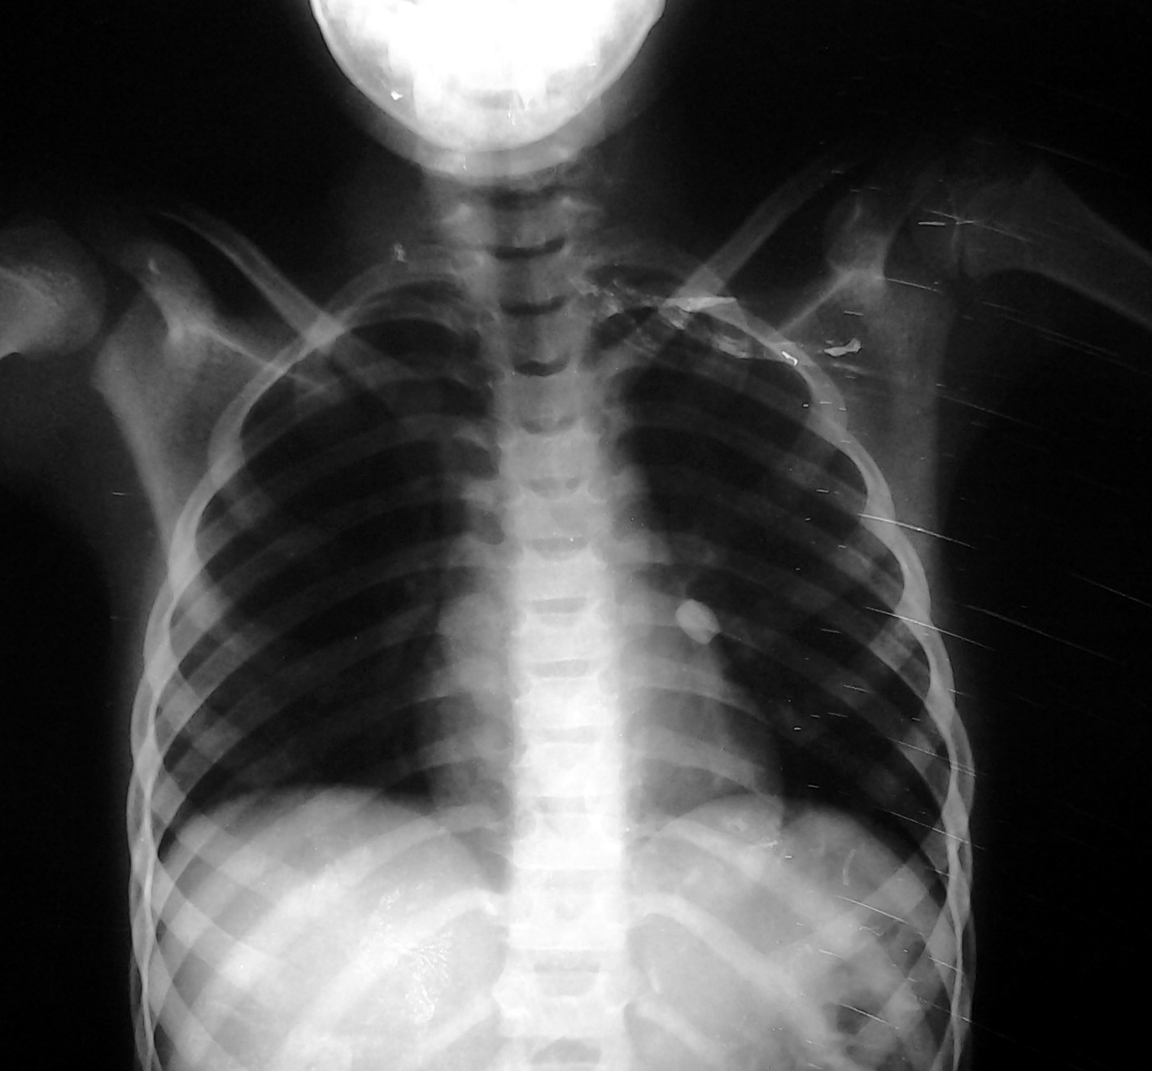
Figure 1: Plain Postero-anterior chest x-ray showed a rounded smooth opacity of a foreign body located at the left lower lobar bronchus
A Fogarty embolectomy catheter was passed under vision through the central hole. The balloon was inflated and followed by removing the catheter holding the bead together with the bronchoscope as one unit (Figure 2).
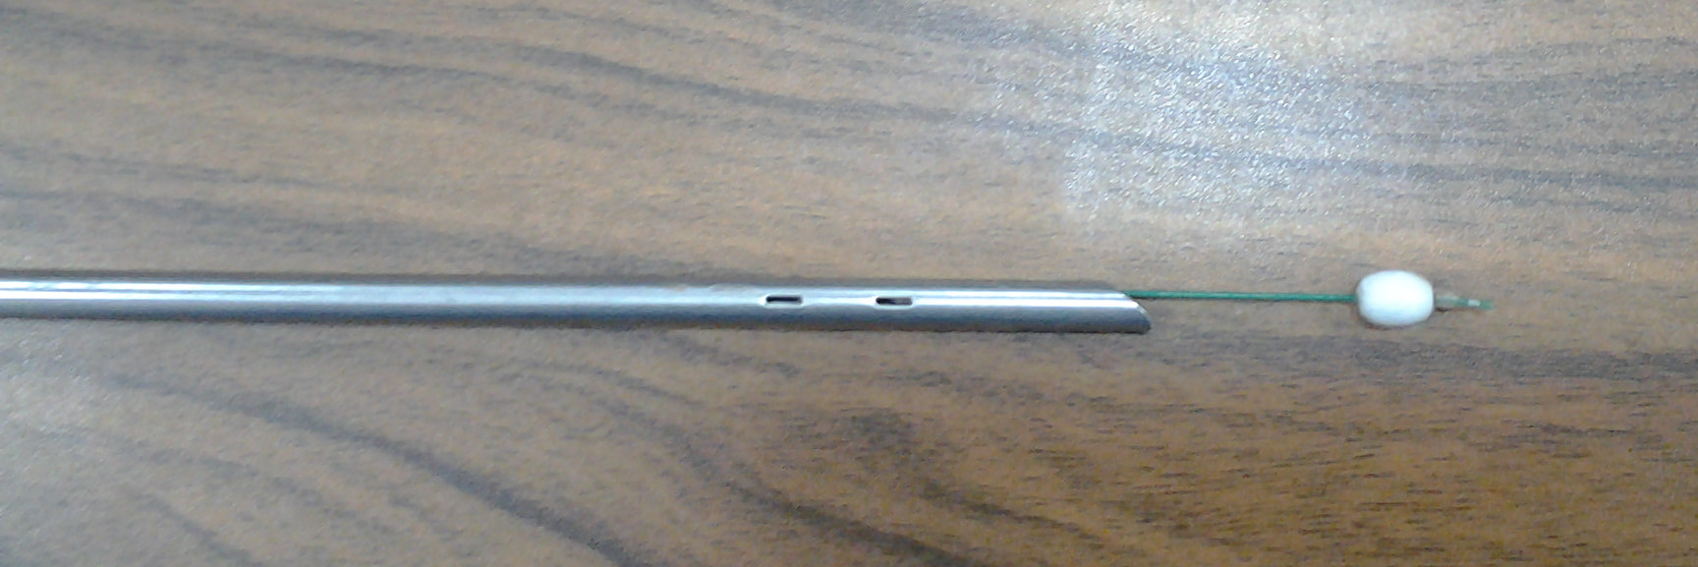
Figure 2: A Fogarty embolectomy catheter is passing through the central hole of the foreign with its inflated balloon holding the bead

Further examination of the trachea-bronchial tree was done to exclude any traumatic injury or impacted secretions. No complications were encountered. Patient was discharged home same day.
Discussion:
Foreign body aspiration occurs mainly in children (3). Foreign bodies could be organic in nature in the form of nuts and seeds, or could be inorganic like pins, nails, and dental appliances (5). In this study, the child was aspirated in a bead which is a rounded plastic peace with smooth surface and very small opening in its center. Usually, foreign bodies could be removed with extraction forceps (6). Sometimes, special tools should be used e.g. magnet for metallic object (7), or fogarty catheter (4). In our patient, the bead was rounded, smooth and impacted inside the lobar bronchus. It was difficult to grasp it with a forceps or to pass any tool like fogarty catheter between the bronchial wall and the bead. Surgery in the form of bronchotomy was an option. However, surgeon should do his effort to avoid major procedures and its probable complications in such cases. Creativity and ability to use available tools according to the type of the foreign body and its shape should be kept always in mind. In our patient, a fogarty catheter was used to pass through the central hole, followed by inflation of its balloon was done. Then, the fogarty catheter with its inflated balloon supporting the foreign body was removed with the rigid bronchoscope.
Moreover, the procedure of foreign body extraction in infants and children needs collaboration of the surgeon and the anesthetist. Both should keep patient and communicate in a good way to prevent intra-procedural complications.

Conclusion:
In conclusion, management of aspirated foreign bodies could be difficult. It needs the use all of the available instruments depending on the shape and the structure of the foreign body in order to extract it endoscopically and avoid the bronchotomy.
Authors Contributions:
Abdel-Aziz A. and Abu Arab W.; have collected the data and wrote the manuscript. Abu Arab W. has revised and edited the manuscript.
Availability of Data and Materials: Not applicable.
Financial Support and Sponsorship: None.
Conflict of Interest: All authors declare that they are bound by confidentiality agreements that prevent them from disclosing their conflicts of interest in this work..
Ethical Approval and Informed consent: Not applicable."
Consent for Publication: Not applicable.

References:
1- Mahmoud M, Imam S, Patel H, King M. Foreign Body Aspiration of a Dental Bridge in the Left Main Stem Bronchus. Case Reports in Medicine.2012; 2012:798163.

2- Burton EM, Brick WG, Hall JD, Riggs JW, Houston CS. Tracheobronchial foreign body aspiration in children. Southern medical journal. 1996 Feb;89(2):195-8.
3- Midulla F, Guidi R, Barbato A, Capocaccia P, Forenza N, Marseglia G, Pifferi M, Moretti C, Bonci E, De Benedictis FM. Foreign body aspiration in children. Pediatrics international. 2005 Dec;47(6):663-8.

4. Ullyot DG, Norman JC. The Fogarty catheter: an aid to bronchoscopic removal of foreign bodies. The Annals of thoracic surgery. 1968;6(2):185.
5. Weber SM, Chesnutt MS, Barton R, Cohen JI. Extraction of dental crowns from the airway: a multidisciplinary approach. The Laryngoscope. 2005;115(4):687-9.
6. Wadhera R, Hernot S, Gulati SP, Kalra V, Kaintura M, Singla A. Combined use of a Fogarty Balloon Catheter, Bronchoscope, and Tracheostomy for the Controlled Retrieval of an Endobronchial Foreign Body: A. Head Neck Surg. 2000;123:311-6.

7. Mayr J, Dittrich S, Triebl K. A new method for removal of metallic-ferromagnetic foreign bodies from the tracheobronchial tree. Pediatric surgery international. 1997 Jul 1;12(5-6):461-2.

Figure legends:
Figure 1:
Plain Postero-anterior chest x-ray showed a rounded smooth opacity of a foreign body located at the left lower lobar bronchus
Figure 2:
A Fogarty embolectomy catheter is passing through the central hole of the foreign with its inflated balloon holding the bead

