Onlay mesh repair versus sublay mesh repair in open ventral incisional hernia repair: Meta-analysis of randomized controlled trials

Authors: Mohamed Ali Chaouch¹, Mohamed Wejih Dougaz¹, Aziz Daghmouri², Hichem Jerraya¹, Mehdi Khalfallah¹, Ibtissem Bouasker¹, Ramzi Nouira¹, Chadli Dziri¹
Affiliations:
- Department B of surgery, Charles Nicolle Hospital, Tunis, Tunisia
- Department of intensive care, Charles Nicolle Hospital, Tunis, Tunisia

Corresponding Author:
Mohamed Ali Chaouch
Charles Nicolle Hospital
E-mail: Docmedalichaouch@gmail.com
Phone N°:+21626205105

Abstract:
Background: Treatment of incisional hernia remains a major issue of abdominal wall surgery. Open onlay mesh repair and open sublay mesh repair were the most frequently used procedures. This meta-analysis aimed to compare onlay mesh repair with sublay mesh repair both indicated for open ventral incisional hernias repair regarding wound infections, hematoma, seroma, operative time, and recurrence.
Methods: Literature searches of electronic databases and manual searches up to January 31, 2019, were performed. Review Manager Version 5.3 was used for pooled estimates. We included only randomized controlled trials (RCTs) in this meta-analysis. Random-effects meta-analysis model was used, and meta-regression was applied when appropriate.
Results:
Of 22 relevant articles, six RCTs met eligibility criteria involved 909 patients (465 onlay mesh repair versus 444 sublay mesh repairs). Sublay mesh repair improves results in terms of wound infection (OR = 2.33, 95%CI: 1.09 to 4.94, p=0.03), and seroma (OR = 3.71, 95%CI: 2.26 to 6.09, p<0.00001) with a longer operative time (MD = -24.68, 95%CI [-35.78 to -13.59], I²=61%; p<0.0001). As concerns recurrence, the forest plot did not show a statistical difference (OR = 1.75, 95%CI: 0.55 to 5.55, I²=54%; p=0.34), however heterogeneity is high (I² =54%) and the meta-regression showed a statistical significant difference in favour of sublay mesh repair. There was no significant difference between these two techniques regarding hematoma (OR = 2.53, 95%CI: 0.90 to 7.11, p=0.08).
Conclusions:
This meta-analysis of RCTs showed that sublay repair was superior to onlay mesh repair for open ventral incisional hernia repair. Sublay mesh repair should probably be the first choice in repair and onlay mash repair can be reserved only for more difficult situations where sublay is not possible.

Keywords: Incisional hernia; Onlay; Sublay; Recurrence; Surgical site infection; Wound complications
INTRODUCTION
An incisional hernia may occur during a follow up of two years after a midline incision, with a rate ranging between 10-20% (1,2). It is essentially due to a surgical error during the closure of the abdominal wall. This incidence is higher in patients with risk factors such as obesity and steroid-dependent patients (3). Incisional hernia can affect the quality of life with the risk of life-threatening in case of strangulation. Mesh repair ensures a decrease of incisional hernia recurrence (4,5). The two most frequently used procedures are the onlay mesh repair and sublay mesh repair (6). These procedures have advantages such as reducing the recurrence rate significantly and disadvantages such as chronic pain (6,7).
Some surgeons favoured the onlay mesh repair avoiding an advanced abdominal wall dissection while other surgeons insisted that the sublay mesh repair remain the best mesh placement even for incisional hernia. However, onlay repair is flawed by a slightly increased wound complication rate (8). Incisional hernia recurrence and postoperative wound complications depend on the abdominal wall mesh site that is still a debated question among surgeons (9–11). Onlay repair is known to be easier and faster and sublay repair is expected by many to reduce recurrence.
This meta-analysis aimed to compare open onlay mesh repair with open sublay mesh repair performed for ventral incisional hernias regarding wound infections, hematoma, seroma, operative time, and recurrence.
METHODS
Electronics searches:
An extensive electronic search of the relevant literature, with no language restrictions, was performed on January 15, 2020, using the following databases: “Cochrane Library’s Controlled Trials Registry and database of systematic review”, “United States National Library of Medicine”, “National Institutes of Health PubMed/MEDLINE”, “Excerpta Medica Database”, “Embase”, “Scopus”, and “Google Scholar”. Keywords used for the final search in all databases were “onlay”, “sublay”, “retromuscular”, “preperitoneal”, “open”, “surgery”, “incisional hernia”, “abdominal wall”, “repair”, “retrorectus”, “prefascial”, “retrofascial”, “Rives-Stoppa”, and “mesh placement”.
Criteria of eligibility
Included studies: All randomized controlled trials (RCTs) reporting a comparison between Onlay mesh repair and Sublay mesh repair to treat ventral incisional hernia, published in a peer-reviewed journal, were considered for analysis. Data from non-randomized trials, non-comparative studies, editorials, letters to editors, review articles, and case series (fewer than ten cases) were excluded from the analysis.
Participants: Adults (aged over 18 years) of either sex operated on for ventral incisional hernia and undergoing open onlay or sublay mesh repair were included.
Interventions: We studied two groups of surgical procedures:
1. Sublay mesh repair according to Rives-Stoppa (12) and Schumpelick (13) for treatment of incisional hernia. The mesh was placed in the retro-rectus muscles (prefascial space or in the preperitoneal and retrofascial space).
2. Onlay mesh repair according to Cheverel description (14). The mesh was placed in the anterior rectus fascial after dissection of the fascia from the subcutaneous plane.
This meta-analysis was in accordance with the 2010 Preferred Reporting Items for Systematic Review and Meta-analysis (PRISMA) guidelines (15).
Outcomes measures
Main outcome measure: recurrence
Secondary Outcome measures were wound infection, seroma, hematoma, and operative time.
Data collection and analysis
Study Selection: Two authors (MAC and MWD) independently reviewed all abstracts. All studies, accompanied by the full text that met the inclusion criteria were retained. Disagreements were resolved by discussion after consulting a third member of the review team (IB).
Assessment of studies quality: All studies that met the selection criteria were appraised independently by two authors (MAC and MAD) using the CONSORT statement for randomized controlled trials (RCTs) (16).
Data Extraction: Each author extracted the data independently from each study. Disparities were settled after discussion with the senior authors (MWD, CD).
Assessment of heterogeneity: We used the Cochrane Chi² test (Q-test) to assess heterogeneity and the I² statistic to estimate the degree of heterogeneity (17). I² between 0% and 50% was considered as a low level, between 51% and 100% as a high level of heterogeneity (18). Funnel plots identified studies responsible of heterogeneity.
Evaluation of effect size: We used the RevMan 5.3.5 statistical package from the Cochrane collaboration for meta-analysis (19). We selected the mean difference (MD) as an effective measure for continuous data. For dichotomous variables, odds ratios (OR) with 95% confidence intervals (95% CI) were calculated. Random effects model was used. The threshold of significance was fixed to 0.05. When I² was between 51% and 100%, we tested for the interaction between relevant factors and effect size estimates. We performed a meta-regression using the natural log (OR) as the dependent variable and the explored factor as the independent variable (17) as determined by Comprehensive Meta-Analysis Software. The meta-regression concerned the interaction between treatment effects and the main outcome measure “recurrence”. The covariate used was the global rate of recurrence.

RESULTS
Literature search results
We retrieved potentially relevant articles (Figure 1). Of these, seven studies published between 2010 and 2018 met eligibility criteria (8,20–25). Sixteen studies were excluded with reasons: one study (26) was a prospective non-randomized trial, two studies (27,28) were descriptive studies, one study was a meta-analysis of onlay versus sublay mesh repair in incisional ventral hernias (29), twelve studies concerned onlay and sublay mesh repair but concern abdominal ventral hernia or included abdominal ventral hernia and abdominal ventral incisional hernia without subgroup analysis (30–41). The seven identified studies were published as full papers and involved a total of 954 patients (487 onlay mesh repair versus 466 sublay mesh repairs). The quality assessment of the included studies was summarized in Table 1.
Studies and patients’ characteristics
Details of the included studies were reported in Table 1. Studies included were fully matched for year of publication, country, mean age, hernia size, mesh type, number of patients undergoing a sublay mesh repair or onlay mesh repair, prophylactic antibiotic use, and follow up duration. Five studies were published in English (8,20–23) and one study in Hungarian (24).
Wound infection
It was reported in six studies (8,20–23,25) (figure 2.A). These studies included 515 patients. Wound infection was reported in 27 out of 263 patients in onlay repair group versus 11 out of 252 patients in sublay repair group. There was a statistically significant low rate of wound infection in sublay repair group (OR = 2.33, 95%CI: 1.09 to 4.94, p=0.03).
Seroma
It was reported in five studies (8,21–23,25) (figure 2.B). These studies included 451 patients. Seroma was reported in 84 out of 231 patients in onlay repair group versus 29 out of 220 patients in sublay repair group. There was a lower seroma rate in sublay repair groups with a statistically significant difference between the groups (OR = 3.71, 95%CI: 2.26 to 6.09, p<0.00001).
Hematoma
This outcome was reported in four studies including 426 patients (20–23) (figure 2.C). Seroma was reported in 14 out of 217 patients in onlay repair group versus 6 out of 209 patients in sublay repair group. There was no difference between the two groups (OR = 2.53, 95%CI: 0.90 to 7.11, p=0.08).
Operative time
Operative time was reported, in minutes, in three studies including 362 patients (21–23) (figure 2.D). It was reported in 185 patients in the onlay repair group and 177 patients in sublay repair group. Operative time was longer in sublay repair group. This difference was statistically significant between the groups (MD = -24.68, 95%CI [-35.78 to -13.59], p<0.0001). There was a substantial heterogeneity level between the studies (I²=61%).
Recurrence
It was reported in seven studies including 852 patients (8,20–25) (figure 3.A). Recurrence was reported in 37 out of 431 patients in onlay repair group versus 42 out of 421 patients in sublay repair group. There was no statistically difference in term of recurrence rate between the two groups (OR = 1.75, 95%CI: 0.55 to 5.55, p=0.34). However, there was high heterogeneity between the studies (I²=54%). The random-effects meta-regression (Figure 3.B) was in favour of Sublay repair (p=0.007).
DISCUSSION
This meta-analysis of RCTs showed that sublay mesh repair improves results in terms of wound infections and seroma with a longer operative time. As concerns recurrence rate, meta-regression was in favour of Sublay repair (p=0.007). There was no significant difference between these two techniques regarding hematoma. Sublay mesh repair should probably be the first choice in repair and onlay mash repair can be reserved only for more difficult situations where sublay is not possible. This is the first meta-analysis of seven RCTs comparing onlay mesh repair and sublay mesh repair for incisional hernia repair.
Mesh placement has an impact on tissue incorporation, tissue reaction, and tensile strength of the abdominal wall (11,42–44). In the case of incisional hernia, mesh bedding dissection is challenging especially in cases of previous wound infection, hostile abdomen, multiply retromuscular repair and adhesions. However, a wide dissection with a large mesh overlap was favourable with regard to tissue incorporation. This imperative could be associated with increased postoperative wound complications and recurrence.
Wound complications present a problem following mesh repair of incisional hernia. They increase secondary recurrence (45). Many reports indicated sublay mesh repair for incisional hernias (44,46,47). The placement of the mesh on the posterior rectus fascia compared with onlay position would benefit from a more vascularized area (46). On the other side, it is widely recognized that dissection of the onlay mesh placement subcutaneous supra fascial space promotes wound infection and seroma (47).
As concerns the wound infection, the results in this meta-analysis were in favour of the sublay mesh repair. This outcome seems to be not related directly to the hernioplasty or mesh, but it is due to poor skin antisepstic. Then, an adequate clean of the skin before the procedure is mandatory. Some authors (29,48) explained the higher rate of mesh infection, in the group of onlay repair, by the more superficial position of onlay repair making it more accessible for bacterial colonization. On another hand, in case of sublay mesh repair, mesh positioning on the retro rectus prefascial space ensure a better body’s immune system infections fights (11,49). Mesh infection ranged from 5 to 10% of mesh repairs (50,51). The management of this complication is complex due to several factors predicting its occurrence: medical history, causal germ, type of the prosthesis and its location in the abdominal wall. Operative time was also incriminated in the increase in wound complications (52). In this meta-analysis, the operative time was longer in sublay mesh repair. In sublay repair, the hernia sac is introduced the hernia in the abdominal cavity. The wall defect is closed and the mesh prevents a new displacement. For this reason the treatment is more prolonged and hard. In onlay repair, the hernias defect is not closed and the mesh recovers the hernia. For this reason onlay repair is in fact faster, but it is only justified when the surgeon is not able to do a sublay repair or does not have an experienced surgeon to help. Seroma is related to a tight contact of any subcutaneous foreign body (mesh) much more than in deeper abdominal wall. Seroma was more frequent with onlay technique than the sublay one (53,54). A meta-analysis of Timmermans et al (29) did not find a statistical difference between onlay and sublay techniques concerning seroma while in our study, sublay mesh repair was associated with lesser seroma rate than onlay mesh repair. This complication could be reduced by wearing abdominal binders and the use of low-thrombin fibrin sealant (55,56). Postoperative complications rate (seroma, hematoma, and wound infection) were higher after onlay mesh repair (49,57).
As concerns recurrence, many factors could affect this outcome: wound complications, operative time, the tensile strength of the abdominal wall, and mesh shrinkage (43,45,58). Studies results were controversial (23,24,29,53,59,60). They reported a less frequency rate of recurrence after sublay technique (53,61) or a similar recurrence rate between the two surgical procedures (23,60). Weber et al (54) reported that recurrence is less frequent after onlay method compared to sublay mesh repair. Surgical care of patients with recurrent hernias may be best provided in referral centers with interest and expertise in the management of complex abdominal hernias (62). Additional variables are missed such as mesh overlap, mesh fixation, and surgeon’s learning curve. In addition, this high heterogeneity was explained in some degree by to the small number of patients with different follow-up.
All included studies had similar endpoints of comparable study populations and similar interventions. In this meta-analysis result, we must keep specific attention to the major outcome: Incisional hernia recurrence. This outcome was associated with a moderate level of heterogeneity. In the forest plot of this analysis, five studies (8,20–23) reported a lower incisional hernia recurrence rate after sublay mesh repair. The study of Weber et al (24) was a source of heterogeneity. RCT of Wéber et al could be a subject of a critical level of heterogeneity and bias. Regarding the substantial heterogeneity concerning outcomes of recurrence in our meta-analysis, we used meta-regression analysis which is an extension of subgroup analyses (Figure 3.B). This controversy regarding the recurrence evaluation make difficult to allow for solid conclusions and others multi-center RCTs with longer follow-up were recommended.
This meta-analysis of RCT has several limitations. We have not assessed the hospital stay, postoperative pain scores, time of return to activities, chronic pain, and long-term discomfort. The definition of these criteria was not clearly defined. In addition, we have no data as to the types of ventral incisional hernias and surgical wound classification entered in the reference articles as recurrent, infected, reoperated, previous mesh etc… Moreover, the study of Wéber et al (24), including half of the included participants: 459 out of 909 patients, was the only study to found a lower recurrence rate after onlay mesh repair. It was a source of asymmetry and heterogeneity. When it was removed, the heterogeneity was reduced to 0 and the results became statistically significant in favour of sublay repair. Furthermore, the trial of Weber et al (24) was judged by Timmermans et al (29) to be of mediocre quality and might be subject to location bias. Additionally, this study did differ somewhat compared with other studies. It included only larger hernias, which explain the heterogeneity.
In conclusion, based on the available literature, sublay technique is superior to the onlay technique in term of wound complications and recurrence rate for open ventral incisional hernia repair. Sublay mesh repair should probably be the first choice in open incisional hernia repair and onlay mesh repair can be reserved only for more difficult situations where sublay is not possible.

AUTHOR DISCLOSURES
The authors declare that they have no conflict of interest.

REFERENCES
1. Bosanquet DC, Ansell J, Abdelrahman T, Cornish J, Harries R, Stimpson A, et al. Systematic review and meta-regression of factors affecting midline incisional hernia rates: analysis of 14 618 patients. PLoS One. 2015;10(9):e0138745.
2. Paajanen H, Hermunen H. Long-term pain and recurrence after repair of ventral incisional hernias by open mesh: clinical and MRI study. Langenbeck’s Archives of Surgery. 2004 Oct;389(5):366–70.
3. Sugerman HJ, Kellum Jr JM, Reines HD, DeMaria EJ, Newsome HH, Lowry JW. Greater risk of incisional hernia with morbidly obese than steroid-dependent patients and low recurrence with prefascial polypropylene mesh. The American journal of surgery. 1996;171(1):80–84.
4. Burger JW, Luijendijk RW, Hop WC, Halm JA, Verdaasdonk EG, Jeekel J. Long-term follow-up of a randomized controlled trial of suture versus mesh repair of incisional hernia. Annals of surgery. 2004;240(4):578.
5. Kokotovic D, Bisgaard T, Helgstrand F. Long-term recurrence and complications associated with elective incisional hernia repair. Jama. 2016;316(15):1575–1582.
6. den Hartog D, Dur AH, Tuinebreijer WE, Kreis RW. Open surgical procedures for incisional hernias. Cochrane Colorectal Cancer Group, editor. Cochrane Database of Systematic Reviews [Internet]. 2008 Jul 16 [cited 2019 May 6]; Available from: http://doi.wiley.com/10.1002/14651858.CD006438.pub2
7. Mathes T, Walgenbach M, Siegel R. Suture versus mesh repair in primary and incisional ventral hernias: a systematic review and meta-analysis. World journal of surgery. 2016;40(4):826–835.
8. Natarajan S, Meenaa S, Thimmaiah KA. A Randomised Prospective Study to Evaluate Preperitoneal Mesh Repair Versus Onlay Mesh Repair and Laparoscopic IPOM in Incisional Hernia Surgery. Indian Journal of Surgery. 2017 Apr;79(2):96–100.
9. Korenkov M, Sauerland S, Arndt M, Bograd L, Neugebauer EAM, Troidl H. Randomized clinical trial of suture repair, polypropylene mesh or autodermal hernioplasty for incisional hernia. British Journal of Surgery. 2002;89(1):50–56.
10. Langer C, Schaper A, Liersch T, Kulle B, Flosman M, Füzesi L, et al. Prognosis factors in incisional hernia surgery: 25 years of experience. Hernia. 2005;9(1):16–21.
11. Dougaz MW, Chaouch MA, Cherni S, Khalfallah M, Jerraya H, Bouasker I, et al. Preperitoneal Versus Retromuscular Mesh Repair for Ventral Abdominal Hernias: A Propensity Matched Analysis. Indian J Surg [Internet]. 2020 Apr 5 [cited 2020 Apr 8]; Available from: http://link.springer.com/10.1007/s12262-020-02153-7
12. Stoppa RE. The treatment of complicated groin and incisional hernias. World journal of surgery. 1989;13(5):545–554.
13. Schumpelick V, Klinge U, Junge K, Stumpf M. Incisional abdominal hernia: the open mesh repair. Langenbecks Arch Surg. 2004 Feb 1;389(1):1–5.
14. Chevrel JP. Traitement des grandes éventrations médianes par plastie en paletot et prothèse. Nouv Presse Med. 1979;8(2):695–696.
15. Moher D, Liberati A, Tetzlaff J, Altman DG. Preferred reporting items for systematic reviews and meta-analyses: the PRISMA statement. International journal of surgery. 2010;8(5):336–341.
16. Begg C, Cho M, Eastwood S, Horton R, Moher D, Olkin I, et al. Improving the quality of reporting of randomized controlled trials: the CONSORT statement. Jama. 1996;276(8):637–639.
17. Higgins JP, Thompson SG, Deeks JJ, Altman DG. Measuring inconsistency in meta-analyses. Bmj. 2003;327(7414):557–560.
18. Higgins JP. Cochrane handbook for systematic reviews of interventions. Version 5.1. 0 [updated March 2011]. The Cochrane Collaboration. www cochrane-handbook org. 2011;
19. Higgins JP, Green S. Cochrane handbook for systematic reviews of interventions. 2008;
20. Gondal SH, Anjum IH. Sutureless Sublay verses Onlay Mesh Hernioplsty in Incisional Hernia Repair: A comparative study at Teaching Hospital, Lahore. :4.
21. Demetrashvili Z, Pipia I, Loladze D, Metreveli T, Ekaladze E, Kenchadze G, et al. Open retromuscular mesh repair versus onlay technique of incisional hernia: A randomized controlled trial. International Journal of Surgery. 2017 Jan;37:65–70.
22. Sevinç B, Okuş A, Ay S, Aksoy N, Karahan Ö. Randomized prospective comparison of long-term results of onlay and sublay mesh repair techniques for incisional hernia. Turkish journal of surgery. 2018;34(1):17.
23. Venclauskas L, Maleckas A, Kiudelis M. One-year follow-up after incisional hernia treatment: results of a prospective randomized study. Hernia. 2010 Dec;14(6):575–82.
24. Wéber G, Baracs J, Horváth ÖP. Kedvezőbb műtéti eredmények „onlay” hálóval, mint „sublay” helyzetben beültetettel: Varrattal, illetve hálóbeültetéssel történő hasfal-rekonstrukció prospektív, randomizált, multicentrikus vizsgálata – ötéves utánkövetés eredményei. Magyar Sebészet. 2010 Oct;63(5):302–11.
25. Ahmed M, Mehboob M. Comparisons of Onlay versus Sublay Mesh Fixation Technique in Ventral Abdominal Wall Incisional Hernia Repair. Journal of the College of Physicians and Surgeons Pakistan. 2019;29(9):819–822.
26. Leithy M, Loulah M, Greida HA, Baker FA, Hayes AM. Sublay hernioplasty versus onlay hernioplasty in incisional hernia in diabetic patients. Menoufia Medical Journal. 2014;27(2):353.
27. Cobb WS, Harris JB, Lokey JS, McGill ES, Klove KL. Incisional herniorrhaphy with intraperitoneal composite mesh: a report of 95 cases. American Surgeon. 2003;69(9):784–787.
28. Arer IM, Yabanoglu H, Aytac HO, Ezer A, Caliskan K. Long-term results of retromuscular hernia repair: a single center experience. Pan Afr Med J [Internet]. 2017 [cited 2019 May 6];27. Available from: http://www.panafrican-med-journal.com/content/article/27/132/full/
29. Timmermans L, de Goede B, van Dijk SM, Kleinrensink G-J, Jeekel J, Lange JF. Meta-analysis of sublay versus onlay mesh repair in incisional hernia surgery. The American Journal of Surgery. 2014 Jun;207(6):980–8.
30. Dhaigude BD, Sugunan A, Pancbhai SV, Francis M, Patel K, Metta V. Comparative evaluation of sublay versus onlay meshplasty in incisional and ventral hernias. Int Surg J. 2017 Dec 26;5(1):187.
31. Ali AymanMA, Khalil M. Ventral hernias meshplasty: does mesh-implantation site affect the outcome? The Egyptian Journal of Surgery. 2017;36(1):69.
32. Department of General Surgery, DVVPFS Medical College, Ahmednagar, Dhanbhar R. Comparative Study of Onlay and Pre-Peritoneal Mesh Repair in the Management of Ventral Hernias. jmscr [Internet]. 2018 Mar 12 [cited 2019 May 6];6(3). Available from: http://jmscr.igmpublication.org/v6-i3/65%20jmscr.pdf
33. Afridi SP, Siddiqui RA, Rajput A. Complications of Onlay and Sublay Mesh Plasty in Ventral Abdominal Hernia Repair. Journal of Surgery Pakistan. 2015;4.
34. Naz A, Abid K, Syed AA, Baig NN, Umer MF, Mehdi H. Comparative evaluation of sublay versus onlay mesh repair for ventral hernia. J Pak Med Assoc. 2018;68(5):4.
35. Shehryar HA, Shahka MA, Javed MU. Comparison of Sublay versus Onlay Mesh Technique of Ventral Hernia Repair. :3.
36. Saber A. Onlay versus Sublay Mesh Repair for Ventral Hernia. JS. 2016;4(1):1.
37. Bessa SS, El-Gendi AM, Ghazal A-HA, Al-Fayoumi TA. Comparison between the short-term results of onlay and sublay mesh placement in the management of uncomplicated para-umbilical hernia: a prospective randomized study. Hernia. 2015 Feb;19(1):141–6.
38. Abo-Ryia MH, El-Khadrawy OH, Moussa GI, Saleh AM. Prospective randomized evaluation of open preperitoneal versus preaponeurotic primary elective mesh repair for paraumbilical hernias. Surg Today. 2015 Apr;45(4):429–33.
39. Murad QAF, Awan TA, Khan A, Malik AZ. Onlay Versus Sublay Technique of Repairing Ventral Abdominal Hernia. :3.
40. Choudhry EA, Sheth JY, Darshan JR. A systemic analysis of patients undergoing open ventral hernia repair (2011-2017). International Surgery Journal. 2018 Jun 25;5(7):2567.
41. Weber G, Horvath OP. Results of ventral hernia repair: comparison of suture repair with mesh implantation (onlay vs sublay) using open and laparoscopic approach–prospective, randomized, multicenter study. Magyar sebeszet. 2002;55(5):285–289.
42. Johansson M, Gunnarsson U, Strig\a ard K. Different techniques for mesh application give the same abdominal muscle strength. Hernia. 2011;15(1):65–68.
43. Binnebösel M, Klink CD, Otto J, Conze J, Jansen PL, Anurov M, et al. Impact of mesh positioning on foreign body reaction and collagenous ingrowth in a rabbit model of open incisional hernia repair. Hernia. 2010;14(1):71–77.
44. Nacef K, Chaouch MA, Chaouch A, Khalifa MB, Ghannouchi M, Boudokhane M. Trocar site post incisional hernia: about 19 cases. The Pan African medical journal. 2018;29.
45. Basoglu M, Yildirgan MI, Yilmaz I, Balik A, Celebi F, Atamanalp SS, et al. Late complications of incisional hernias following prosthetic mesh repair. Acta Chirurgica Belgica. 2004;104(4):425–448.
46. Cobb WS, Warren JA, Ewing JA, Burnikel A, Merchant M, Carbonell AM. Open retromuscular mesh repair of complex incisional hernia: predictors of wound events and recurrence. J Am Coll Surg. 2015 Apr;220(4):606–13.
47. White TJ, Santos MC, Thompson JS. Factors affecting wound complications in repair of ventral hernias. The American Surgeon. 1998;64(3):276.
48. Deerenberg EB, Timmermans L, Hogerzeil DP, Slieker JC, Eilers PHC, Jeekel J, et al. A systematic review of the surgical treatment of large incisional hernia. Hernia. 2015 Feb;19(1):89–101.
49. Köckerling F. Onlay Technique in Incisional Hernia Repair—A Systematic Review. Front Surg. 2018 Nov 27;5:71.
50. Carlson MA, Frantzides CT, Shostrom VK, Laguna LE. Minimally invasive ventral herniorrhaphy: an analysis of 6,266 published cases. Hernia. 2008;12(1):9–22.
51. Sanchez VM, Abi-Haidar YE, Itani KM. Mesh infection in ventral incisional hernia repair: incidence, contributing factors, and treatment. Surgical infections. 2011;12(3):205–210.
52. Stremitzer S, Bachleitner-Hofmann T, Gradl B, Gruenbeck M, Bachleitner-Hofmann B, Mittlboeck M, et al. Mesh graft infection following abdominal hernia repair: risk factor evaluation and strategies of mesh graft preservation. A retrospective analysis of 476 operations. World journal of surgery. 2010;34(7):1702–1709.
53. Israelsson LA, Smedberg S, Montgomery A, Nordin P, Spangen L. Incisional hernia repair in Sweden 2002. Hernia. 2006 Jun;10(3):258–61.
54. Wéber G, Baracs J, Horváth OP. ["Onlay" mesh provides significantly better results than “sublay” reconstruction. Prospective randomized multicenter study of abdominal wall reconstruction with sutures only, or with surgical mesh--results of a five-years follow-up]. Magy Seb. 2010 Oct;63(5):302–11.
55. Rothman JP, Gunnarsson U, Bisgaard T. Abdominal binders may reduce pain and improve physical function after major abdominal surgery – a systematic review. 2014;6.
56. Köhler G, Koch OO, Antoniou SA, Lechner M, Mayer F, Emmanuel K. Prevention of Subcutaneous Seroma Formation in Open Ventral Hernia Repair Using a New Low-Thrombin Fibrin Sealant. World J Surg. 2014 Nov 1;38(11):2797–803.
57. Holihan JL, Nguyen DH, Nguyen MT, Mo J, Kao LS, Liang MK. Mesh location in open ventral hernia repair: a systematic review and network meta-analysis. World journal of surgery. 2016;40(1):89–99.
58. García-Ureña MÁ, Ruiz VV, Godoy AD, Perea JMB, Gómez LMM, Hernández FJC, et al. Differences in polypropylene shrinkage depending on mesh position in an experimental study. The American journal of surgery. 2007;193(4):538–542.
59. Gleysteen JJ. Mesh-Reinforced Ventral Hernia Repair: Preference for 2 Techniques. Archives of Surgery. 2009 Aug 14;144(8):740.
60. de Vries Reilingh TS, van Geldere D, Langenhorst B, de Jong D, van der Wilt GJ, van Goor H, et al. Repair of large midline incisional hernias with polypropylene mesh: comparison of three operative techniques. Hernia. 2004 Feb;8(1):56–9.
61. Gleysteen JJ. Mesh-reinforced ventral hernia repair: preference for 2 techniques. Arch Surg. 2009 Aug;144(8):740–5.
62. Novitsky Y, Porter J, Rucho Z, Getz S, Pratt B, Kercher K, et al. Open Preperitoneal Retrofascial Mesh Repair for Multiply Recurrent Ventral Incisional Hernias. Journal of the American College of Surgeons. 2006 Sep;203(3):283–9.
Figures list:
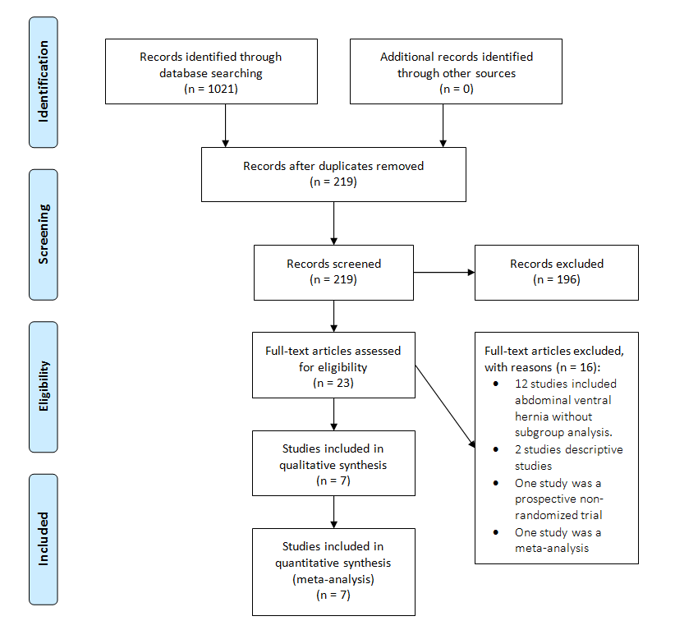
Figure 1: Flow diagram of included studies
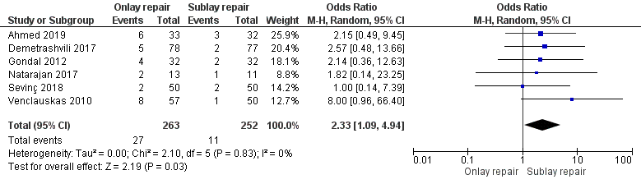

Figure 2.A: Meta-analysis of studies on wound infections
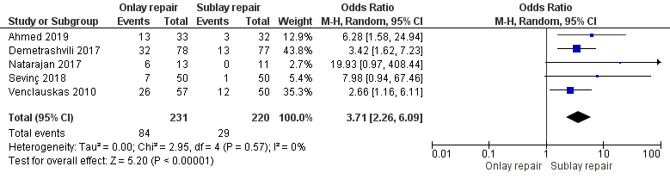

Figure 2.B: Meta-analysis of studies on seroma
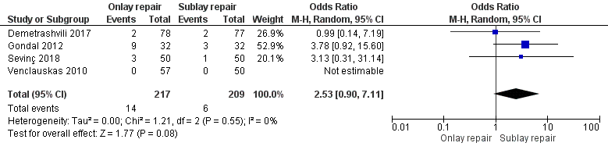

Figure 2.C: Meta-analysis of studies on hematoma
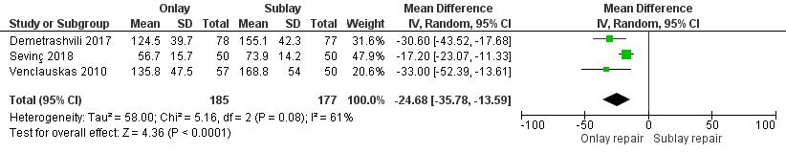
Figure 2.D: Meta-analysis of studies on operative time
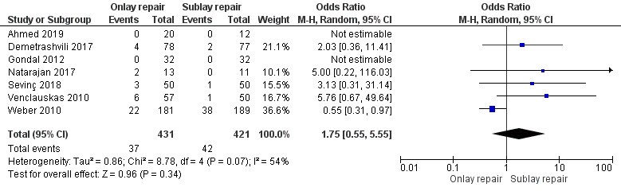
Figure 3.A: Meta-analysis of studies on recurrence
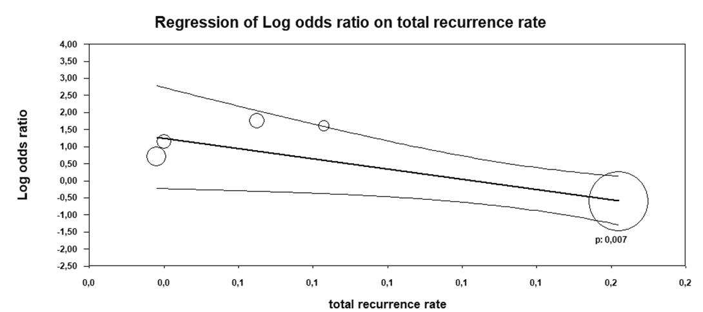
Figure 3.B: Meta-regression of studies on recurrence

Table 1: Details of the included studies

References | Year | Country | Mean age (years) | Nb of onlay repair | Nb of Sublay repair | Hernia size | Mesh type | Prophylactic antibiotics | Follow up (months) | Quality assessment
Gondal et al (20) | 2012 | Pakistan | 44.9 | 32 | 32 | NF | NF | NF | 6 | 10/25
Demetrashvili et al (21) | 2017 | Georgia | 60.4 | 78 | 77 | Onlay: 62.7 cm²  Sublay: 100.4 cm² | Polypropylene | Yes (Cefuroxime 1.5g) | 26 | 21/25
Sevinc et al (22) | 2018 | Turkey | 55.4 | 50 | 50 | 73.4 cm² | Polypropylene | No | 37 | 19/25
Venclauskas et al (23) | 2010 | Lithuania | 55 | 57 | 50 | Onlay: 114.5 cm²  Sublay: 110 cm² | Polypropylene | Yes (Oxacillin 1g) | 12 | 15/25
Natarajan et al (8) | 2017 | India | 56.3 | 13 | 11 | ≥ 4 cm | Polypropylene | NF | 6 | 16/25
Weber et al (24) | 2010 | Hungary | NF | 235 | 224 | > 25 cm² | Polypropylene | Yes (cephazolin) | 60 | 14/25
Ahmed et al (25) | 2019 | Pakistan | 39.13 | 23 | 22 | ≥ 3 cm | NF | Yes | 6 | 14/25

