Onlay versus sublay mesh repair of open ventral incisional hernia: A meta-analysis of randomized controlled trials
Authors: Mohamed Ali Chaouch¹, Mohamed Wejih Dougaz¹, Aziz Daghmouri², Hichem Jerraya¹, Mehdi Khalfallah¹, Ibtissem Bouasker¹, Ramzi Nouira¹, Chadli Dziri¹
Affiliations:
- Department B of surgery, Charles Nicolle Hospital, University Tunis El Manar, Tunis, Tunisia
- Department of intensive care, Charles Nicolle Hospital, University Tunis El Manar, Tunis, Tunisia

Corresponding Author:
Mohamed Ali Chaouch
Charles Nicolle Hospital
E-mail: Docmedalichaouch@gmail.com
Phone N°:+21626205105

Abstract
Background: Incisional hernia treatment remains a major issue in abdominal wall surgery. Open onlay and sublay mesh repair are the most frequently used procedures. This meta-analysis aimed to compare the two techniques for open ventral incisional hernia repair in terms of wound infection, hematoma, seroma, and recurrence.
Methods: A search in electronic databases for randomized controlled trials (RCTs) published up to September 30, 2019 was performed. Review Manager Version 5.3 was used for pooled estimates. The eligibility criteria were as follows: RCTs comparing onlay mesh repairs performed according to Cheverel with sublay mesh repairs performed according to Rives-Stoppa and Schumpelick and including patients aged 18 or older.
Results: Of 22 relevant articles, 7 RCTs involving a total of 954 patients (487 onlay and 466 sublay mesh repairs) met the eligibility criteria. Sublay mesh repairs were found to require better results in terms of wound infection (odds ratio [OR]: 2.33, 95% CI: 1.09–4.94, p = 0.03) and seroma (OR: 3.71, 95% CI: 2.26–6.09, p < 0.001). There was no significant difference between the two techniques in terms of hematoma (OR: 2.53, 95% CI: 0.90–7.11, p = 0.08). Regarding recurrence, the forest plot showed no statistical difference (OR: 1.75, 95% CI: 0.55–5.55, I² = 54%, p = 0.34); however, heterogeneity was high (I² = 54%), and meta-regression showed a statistically significant difference in favor of sublay mesh repair.
Conclusions: This meta-analysis of RCTs shows that sublay mesh repair of open ventral incisional hernias is superior to onlay repair. Sublay mesh repair should probably be the first choice, and onlay repair should be reserved for more difficult cases, where sublay repair is not possible.

Keywords: Incisional hernia; Onlay; Sublay; Recurrence; Surgical site infection; Wound complications

INTRODUCTION
An incisional hernia may occur within two years of a midline incision, with a rate ranging between 10% and 20% [1,2]. Incisional hernias are mainly caused by surgical errors during the closure of the abdominal wall. The incidence is higher in patients with risk factors such as obesity and steroid use [3]. Incisional hernias can impair patients’ quality of life and can be life-threatening in case of strangulation. Mesh repair reduces the likelihood of incisional hernia recurrence [4,5]. The two most frequently used procedures are onlay and sublay mesh repair [6]. These procedures have advantages such as significantly reducing the likelihood of recurrence but also disadvantages such as chronic pain [6,7].
Some surgeons prefer onlay mesh repair to avoid extensive abdominal wall dissection, while others insist that sublay repair remains the best mesh placement even for incisional hernias. Onlay repair is known to be easier and faster but has a slightly higher wound complication rate [8]. Sublay repair is believed by many to carry a lower recurrence risk. Incisional hernia recurrence and postoperative wound complications depend on the abdominal wall mesh site. Then, the best mesh location is still debated among surgeons [9–11].
This meta-analysis aimed to compare open onlay with sublay mesh repair of ventral incisional hernias in terms of wound infection, hematoma, seroma, and recurrence.
METHODS
Electronic database searches
An extensive electronic search of the relevant literature, with no language restrictions, was performed on September 30, 2019, using the following databases: the Cochrane Library’s Controlled Trials Registry and Database of Systematic Reviews, PubMed/MEDLINE of the United States National Library of Medicine, National Institutes of Health, Excerpta Medica Database (Embase), Scopus, and Google Scholar. The keywords used were “onlay,” “sublay,” “retromuscular,” “preperitoneal,” “open,” “surgery,” “incisional hernia,” “abdominal wall,” “repair,” “retrorectus,” “prefascial,” “retrofascial,” “Rives-Stoppa,” and “mesh placement.” This meta-analysis was performed in accordance with the 2010 Preferred Reporting Items for Systematic Review and Meta-analysis guidelines [12].

Eligibility criteria
Studies. All randomized controlled trials (RCTs) reporting comparisons between onlay and sublay mesh repairs of ventral incisional hernias published in peer-reviewed journals were considered for the analysis. Non-randomized trials, non-comparative studies, editorials, letters to editors, review articles and case series (fewer than ten cases) were excluded.
Participants. Adults (aged 18 or older) of either gender undergoing open onlay or sublay mesh repair of ventral incisional hernia were included.
Interventions. The following surgical procedures were included:
(1) Sublay mesh repair according to Rives-Stoppa [13] and Schumpelick [14], with the mesh placed in the retrorectus muscles (prefascial or preperitoneal and retrofascial space).
(2) Onlay mesh repair according to Cheverel [15], with the mesh placed in the anterior rectus fascial after dissection of the fascia from the subcutaneous plane.
Outcome measures
The main outcome measure was recurrence. Secondary outcome measures were wound infection, seroma, and hematoma.
Data collection and analysis
Study selection. Two authors (MAC and MWD) independently reviewed all abstracts. The full texts of all studies that met the inclusion criteria were retrieved. Disagreements were resolved by discussion after consulting a third member of the review team (IB).
Assessment of the studies’ quality. All studies that met the selection criteria were independently appraised by two authors (MAC and MAD) according to the CONSORT Statement [16].
Data extraction. Each author independently extracted the data from each study. Disparities were settled after discussion with two senior authors (MWD and CD).
Assessment of heterogeneity. We used Cochran’s Q test to assess heterogeneity and the I² statistic to estimate the degree of heterogeneity [17]. We used the Cochrane Chi² test (Q-test) to assess heterogeneity and we calculated the variance TAU², between studies and the I². An I² between 0% and 50% was considered a low level and between 51% and 100% a high level of heterogeneity [18]. Funnel plots were used to identify the studies responsible for heterogeneity.
Evaluation of effect size. For the meta-analysis, we used Cochrane’s Review Manager statistical package version 5.3.5 [19]. We selected the mean difference (MD) as an effective measure for continuous data. For dichotomous variables, we calculated odds ratios (OR) with 95% confidence intervals (CI). We used the random-effects model and set the threshold of statistical significance at 0.05. When I² was between 51% and 100%, we tested for interactions between relevant factors and effect size estimates. We performed meta-regression using the natural log (OR) as the dependent variable and the explored factor as the independent variable [17], as determined by the Comprehensive Meta-Analysis software. Meta-regression concerned interactions between treatment effects and the main outcome measure of recurrence. The covariate used was the global rate of recurrence.
RESULTS
Literature search results
We retrieved seven potentially relevant articles (Figure 1). They were published between 2010 and 2018 [8,20–25]. Sixteen studies were excluded for the following reasons: one study [26] was a prospective non-randomized trial, two [27,28] were descriptive studies, one was a meta-analysis [29], and twelve concerned onlay and sublay mesh repair of abdominal ventral hernias or included abdominal ventral hernias and abdominal ventral incisional hernias without subgroup analysis [30–41].
The seven identified studies involved a total of 954 patients (487 onlay and 466 sublay mesh repairs). They were fully matched in terms of year of publication, country, mean age, hernia size, mesh type, numbers of patients undergoing sublay and onlay mesh repairs, prophylactic antibiotic use, and follow-up duration. Six studies were published in English [8,20–23,25] and one in Hungarian [24]. The quality assessment and details of the included studies are summarized in Table 1.
Outcome measures
Wound infection. Wound infections were reported in six studies [8,20–23,25] (Figure 2.A), which included a total of 515 patients. They were detected in 27 of 263 patients undergoing onlay repair and 11 of 252 patients undergoing sublay repair. There was a significantly lower rate of wound infections in sublay repair patients (OR: 2.33, 95% CI: 1.09–4.94, p = 0.03] with no heterogeneity among the studies (Tau² =0 and I² = 0%).
Seroma. Seromas were reported in five studies [8,21–23,25] (Figure 2.B), which included a total of 451 patients. They were detected in 84 of 231 patients undergoing onlay repair and 29 of 220 patients undergoing sublay repair. There was a significantly lower seroma rate in sublay repair patients (OR: 3.71, 95% CI: 2.26–6.09, p < 0.00001) with no heterogeneity among the studies (Tau² =0 and I² = 0%).
Hematoma. Hematomas were reported in four studies [20–23], which included a total of 426 patients (Figure 2.C). They were detected in 14 of 217 patients undergoing onlay repair and 6 of 209 patients undergoing sublay repair. There was no statistical difference between the two techniques (OR: 2.53, 95% CI: 0.90–7.11, p = 0.08) with no heterogeneity among the studies (Tau² =0 and I² = 0%).
Recurrence. Recurrence was reported in seven studies [8,20–25]. After excluding patients lost of follow-up in these studies, we found a total of 852 patients (Figure 3.A). It was reported in 37 of 431 patients undergoing onlay repair and 42 of 421 patients undergoing sublay repair. There was no statistical difference between the two groups (OR: 1.75, 95% CI: 0.55–5.55, p = 0.34). There was a high level of heterogeneity between the studies (Tau² = 0.86 and I² = 54%). Random-effects meta-regression (Figure 3.B) favored sublay repair (p = 0.007).
DISCUSSION
This is the first meta-analysis of RCTs comparing onlay and sublay mesh repair of incisional hernias. Our results show that sublay mesh repair yields better results than onlay repair in terms of wound infection and seroma. We found no significant difference between the two techniques in terms of hematoma. Regarding the recurrence rate, meta-regression favored sublay repair. We conclude that sublay mesh repair should probably be the first choice, and onlay mesh repair should be reserved for more difficult cases, where sublay is not possible.
Mesh placement affects tissue incorporation, tissue reaction, and tensile strength of the abdominal wall [11,42–44]. In the case of incisional hernia, mesh bedding dissection is challenging, especially in cases of previous wound infection, hostile abdomen, multiple retromuscular repairs, and adhesions. A wide dissection with a large mesh overlap is preferable in terms of tissue incorporation. However, this could be associated with an increased risk of postoperative wound complications and recurrence.
Wound complications present a problem following mesh repair of incisional hernia and pose a higher risk of secondary recurrence [45]. Many studies have recommended sublay mesh repair for incisional hernias [44,46,47]. The placement of the mesh on the posterior rectus fascia benefits from a more vascularized area compared with the onlay position [46]. Moreover, it is widely recognized that dissection of subcutaneous suprafascial space for onlay mesh placement promotes wound infection and seroma [47].
Regarding wound infection, our results favor sublay mesh repair. This does not seem to be directly related to the mesh or to hernioplasty, but rather to poor skin antisepsis [46,47]. Adequate sterilization of the skin before the procedure is therefore essential. Some studies have attributed the higher rate of mesh infections in patients undergoing onlay repair to the more superficial position of the mesh, which leaves it more exposed to bacterial colonization [29,48]. In contrast, in sublay mesh repair, the placement of the mesh on the retrorectus prefascial space offers the body’s immune system a better chance of fighting infections [11,49]. Mesh infections occur in 5% to 10% of mesh repairs [50,51]. Their management is complicated due to several factors, such as medical history, causal germs, and type and location of the prosthesis in the abdominal wall [52].
Seroma is related to a tight contact of any subcutaneous foreign body (mesh). A meta-analysis of Timmermans et al. [29] found no statistical difference between the onlay and sublay techniques in terms of seroma frequency. Other studies have reported a higher frequency associated with the onlay technique [53,54]. Our results also show a higher seroma rate in onlay mesh repair. This complication could be reduced by using low-thrombin fibrin sealant, as well as by wearing an abdominal binder postoperatively [55,56]. Overall, the postoperative complication rate (seroma, hematoma, and wound infection) has been reported to be higher after onlay mesh repair [49,57].
Regarding recurrence, many factors, such as wound complications, tensile strength of the abdominal wall, and mesh shrinkage, can affect this outcome [43,45,58]. In sublay repair, the hernia sac is introduced to the abdominal cavity. The wall defect is closed, and the mesh prevents a new displacement. In onlay repair, the hernia defect is not closed, and the mesh recovers the hernia. Nevertheless, it is only justified when the surgeon lacks of skills or assistance from an experienced surgeon. Many studies have reported contradictory results [23,24,29,53,59,60]. Some have reported a lower recurrence rate after the sublay technique [53,61], whereas Wéber et al [54] found a lower rate after the onlay method. Other studies have reported similar rates associated with both procedures [23,60]. However, other factors were not taken into consideration in the included studies, such as mesh overlap, mesh fixation, and the surgeon’s experience are missed. Moreover, this high degree of heterogeneity can be explained to some extent by the small number of patients and the different follow-up periods included in these studies. Surgical care of patients with recurrent hernias may best be provided in referral centers with expertise in the management of complex abdominal hernias [62].
All the studies included in this meta-analysis had comparable study populations and similar interventions. Our main result concerning incisional hernia recurrence is worthy of special attention. This outcome is characterized by a high level of heterogeneity. In the forest plot, Wéber et al’s study [24], which included almost half of all patients (370 of 852), was the only study to report a lower recurrence rate after onlay mesh repair and was thus a source of asymmetry and heterogeneity. Furthermore, the study was judged as of mediocre quality and as potentially subject to location bias by Timmermans et al [29]. This study did differ somewhat from the other studies in that it only included larger hernias, which explains the heterogeneity. To compensate for heterogeneity, we used meta-regression, which is an extension of subgroup analysis (Figure 3.B). When this study was removed, the heterogeneity (I²) was reduced to 0%, and the results became statistically significant in favor of sublay repair. However, this uncertainty regarding the recurrence rates makes it difficult to draw solid conclusions. Therefore, more multi-center RCTs with longer follow-ups are recommended.
This meta-analysis has several limitations. We did not assess hospital stay durations, postoperative pain scores, chronic pain, long-term discomfort, and the time of returning to everyday activities. These criteria were not clearly defined in the included studies. Moreover, the reference articles provided no data as to the types of ventral incisional hernias and surgical wound characterizations, such as recurrent, infected, reoperated, and previous mesh. The heterogeneity caused by Wéber et al’s study [24] represents another limitation.
In summary, the available literature suggests that the sublay technique for open ventral incisional hernia repair is superior to the onlay technique in terms of wound complications and recurrence rate. Sublay mesh repair should probably be the first choice for open incisional hernia repair, and onlay repair should be reserved for more difficult cases, where sublay is not possible.

AUTHOR DISCLOSURES
The authors declare that they have no conflict of interest.

REFERENCES
1. Bosanquet DC, Ansell J, Abdelrahman T, Cornish J, Harries R, Stimpson A, et al. Systematic review and meta-regression of factors affecting midline incisional hernia rates: analysis of 14 618 patients. PLoS One. 2015;10(9):e0138745.
2. Paajanen H, Hermunen H. Long-term pain and recurrence after repair of ventral incisional hernias by open mesh: clinical and MRI study. Langenbeck’s Archives of Surgery. 2004 Oct;389(5):366–70.
3. Sugerman HJ, Kellum Jr JM, Reines HD, DeMaria EJ, Newsome HH, Lowry JW. Greater risk of incisional hernia with morbidly obese than steroid-dependent patients and low recurrence with prefascial polypropylene mesh. The American journal of surgery. 1996;171(1):80–84.
4. Burger JW, Luijendijk RW, Hop WC, Halm JA, Verdaasdonk EG, Jeekel J. Long-term follow-up of a randomized controlled trial of suture versus mesh repair of incisional hernia. Annals of surgery. 2004;240(4):578.
5. Kokotovic D, Bisgaard T, Helgstrand F. Long-term recurrence and complications associated with elective incisional hernia repair. Jama. 2016;316(15):1575–1582.
6. den Hartog D, Dur AH, Tuinebreijer WE, Kreis RW. Open surgical procedures for incisional hernias. Cochrane Colorectal Cancer Group, editor. Cochrane Database of Systematic Reviews [Internet]. 2008 Jul 16 [cited 2019 May 6]; Available from: http://doi.wiley.com/10.1002/14651858.CD006438.pub2
7. Mathes T, Walgenbach M, Siegel R. Suture versus mesh repair in primary and incisional ventral hernias: a systematic review and meta-analysis. World journal of surgery. 2016;40(4):826–835.
8. Natarajan S, Meenaa S, Thimmaiah KA. A Randomised Prospective Study to Evaluate Preperitoneal Mesh Repair Versus Onlay Mesh Repair and Laparoscopic IPOM in Incisional Hernia Surgery. Indian Journal of Surgery. 2017 Apr;79(2):96–100.
9. Korenkov M, Sauerland S, Arndt M, Bograd L, Neugebauer EAM, Troidl H. Randomized clinical trial of suture repair, polypropylene mesh or autodermal hernioplasty for incisional hernia. British Journal of Surgery. 2002;89(1):50–56.
10. Langer C, Schaper A, Liersch T, Kulle B, Flosman M, Füzesi L, et al. Prognosis factors in incisional hernia surgery: 25 years of experience. Hernia. 2005;9(1):16–21.
11. Dougaz MW, Chaouch MA, Cherni S, Khalfallah M, Jerraya H, Bouasker I, et al. Preperitoneal Versus Retromuscular Mesh Repair for Ventral Abdominal Hernias: A Propensity Matched Analysis. Indian J Surg [Internet]. 2020 Apr 5 [cited 2020 Apr 8]; Available from: http://link.springer.com/10.1007/s12262-020-02153-7
12. Moher D, Liberati A, Tetzlaff J, Altman DG. Preferred reporting items for systematic reviews and meta-analyses: the PRISMA statement. International journal of surgery. 2010;8(5):336–341.
13. Stoppa RE. The treatment of complicated groin and incisional hernias. World journal of surgery. 1989;13(5):545–554.
14. Schumpelick V, Klinge U, Junge K, Stumpf M. Incisional abdominal hernia: the open mesh repair. Langenbecks Arch Surg. 2004 Feb 1;389(1):1–5.
15. Chevrel JP. Traitement des grandes éventrations médianes par plastie en paletot et prothèse. Nouv Presse Med. 1979;8(2):695–696.
16. Begg C, Cho M, Eastwood S, Horton R, Moher D, Olkin I, et al. Improving the quality of reporting of randomized controlled trials: the CONSORT statement. Jama. 1996;276(8):637–639.
17. Higgins JP, Thompson SG, Deeks JJ, Altman DG. Measuring inconsistency in meta-analyses. Bmj. 2003;327(7414):557–560.
18. Higgins JP. Cochrane handbook for systematic reviews of interventions. Version 5.1. 0 [updated March 2011]. The Cochrane Collaboration. www cochrane-handbook org. 2011;
19. Higgins JP, Green S. Cochrane handbook for systematic reviews of interventions. 2008;
20. Gondal SH, Anjum IH. Sutureless Sublay verses Onlay Mesh Hernioplsty in Incisional Hernia Repair: A comparative study at Teaching Hospital, Lahore. :4.
21. Demetrashvili Z, Pipia I, Loladze D, Metreveli T, Ekaladze E, Kenchadze G, et al. Open retromuscular mesh repair versus onlay technique of incisional hernia: A randomized controlled trial. International Journal of Surgery. 2017 Jan;37:65–70.
22. Sevinç B, Okuş A, Ay S, Aksoy N, Karahan Ö. Randomized prospective comparison of long-term results of onlay and sublay mesh repair techniques for incisional hernia. Turkish journal of surgery. 2018;34(1):17.
23. Venclauskas L, Maleckas A, Kiudelis M. One-year follow-up after incisional hernia treatment: results of a prospective randomized study. Hernia. 2010 Dec;14(6):575–82.
24. Wéber G, Baracs J, Horváth ÖP. Kedvezőbb műtéti eredmények „onlay” hálóval, mint „sublay” helyzetben beültetettel: Varrattal, illetve hálóbeültetéssel történő hasfal-rekonstrukció prospektív, randomizált, multicentrikus vizsgálata – ötéves utánkövetés eredményei. Magyar Sebészet. 2010 Oct;63(5):302–11.
25. Ahmed M, Mehboob M. Comparisons of Onlay versus Sublay Mesh Fixation Technique in Ventral Abdominal Wall Incisional Hernia Repair. Journal of the College of Physicians and Surgeons Pakistan. 2019;29(9):819–822.
26. Leithy M, Loulah M, Greida HA, Baker FA, Hayes AM. Sublay hernioplasty versus onlay hernioplasty in incisional hernia in diabetic patients. Menoufia Medical Journal. 2014;27(2):353.
27. Cobb WS, Harris JB, Lokey JS, McGill ES, Klove KL. Incisional herniorrhaphy with intraperitoneal composite mesh: a report of 95 cases. American Surgeon. 2003;69(9):784–787.
28. Arer IM, Yabanoglu H, Aytac HO, Ezer A, Caliskan K. Long-term results of retromuscular hernia repair: a single center experience. Pan Afr Med J [Internet]. 2017 [cited 2019 May 6];27. Available from: http://www.panafrican-med-journal.com/content/article/27/132/full/
29. Timmermans L, de Goede B, van Dijk SM, Kleinrensink G-J, Jeekel J, Lange JF. Meta-analysis of sublay versus onlay mesh repair in incisional hernia surgery. The American Journal of Surgery. 2014 Jun;207(6):980–8.
30. Dhaigude BD, Sugunan A, Pancbhai SV, Francis M, Patel K, Metta V. Comparative evaluation of sublay versus onlay meshplasty in incisional and ventral hernias. Int Surg J. 2017 Dec 26;5(1):187.
31. Ali AymanMA, Khalil M. Ventral hernias meshplasty: does mesh-implantation site affect the outcome? The Egyptian Journal of Surgery. 2017;36(1):69.
32. Department of General Surgery, DVVPFS Medical College, Ahmednagar, Dhanbhar R. Comparative Study of Onlay and Pre-Peritoneal Mesh Repair in the Management of Ventral Hernias. jmscr [Internet]. 2018 Mar 12 [cited 2019 May 6];6(3). Available from: http://jmscr.igmpublication.org/v6-i3/65%20jmscr.pdf
33. Afridi SP, Siddiqui RA, Rajput A. Complications of Onlay and Sublay Mesh Plasty in Ventral Abdominal Hernia Repair. Journal of Surgery Pakistan. 2015;4.
34. Naz A, Abid K, Syed AA, Baig NN, Umer MF, Mehdi H. Comparative evaluation of sublay versus onlay mesh repair for ventral hernia. J Pak Med Assoc. 2018;68(5):4.
35. Shehryar HA, Shahka MA, Javed MU. Comparison of Sublay versus Onlay Mesh Technique of Ventral Hernia Repair. :3.
36. Saber A. Onlay versus Sublay Mesh Repair for Ventral Hernia. JS. 2016;4(1):1.
37. Bessa SS, El-Gendi AM, Ghazal A-HA, Al-Fayoumi TA. Comparison between the short-term results of onlay and sublay mesh placement in the management of uncomplicated para-umbilical hernia: a prospective randomized study. Hernia. 2015 Feb;19(1):141–6.
38. Abo-Ryia MH, El-Khadrawy OH, Moussa GI, Saleh AM. Prospective randomized evaluation of open preperitoneal versus preaponeurotic primary elective mesh repair for paraumbilical hernias. Surg Today. 2015 Apr;45(4):429–33.
39. Murad QAF, Awan TA, Khan A, Malik AZ. Onlay Versus Sublay Technique of Repairing Ventral Abdominal Hernia. :3.
40. Choudhry EA, Sheth JY, Darshan JR. A systemic analysis of patients undergoing open ventral hernia repair (2011-2017). International Surgery Journal. 2018 Jun 25;5(7):2567.
41. Weber G, Horvath OP. Results of ventral hernia repair: comparison of suture repair with mesh implantation (onlay vs sublay) using open and laparoscopic approach–prospective, randomized, multicenter study. Magyar sebeszet. 2002;55(5):285–289.
42. Johansson M, Gunnarsson U, Strig\a ard K. Different techniques for mesh application give the same abdominal muscle strength. Hernia. 2011;15(1):65–68.
43. Binnebösel M, Klink CD, Otto J, Conze J, Jansen PL, Anurov M, et al. Impact of mesh positioning on foreign body reaction and collagenous ingrowth in a rabbit model of open incisional hernia repair. Hernia. 2010;14(1):71–77.
44. Nacef K, Chaouch MA, Chaouch A, Khalifa MB, Ghannouchi M, Boudokhane M. Trocar site post incisional hernia: about 19 cases. The Pan African medical journal. 2018;29.
45. Basoglu M, Yildirgan MI, Yilmaz I, Balik A, Celebi F, Atamanalp SS, et al. Late complications of incisional hernias following prosthetic mesh repair. Acta Chirurgica Belgica. 2004;104(4):425–448.
46. Cobb WS, Warren JA, Ewing JA, Burnikel A, Merchant M, Carbonell AM. Open retromuscular mesh repair of complex incisional hernia: predictors of wound events and recurrence. J Am Coll Surg. 2015 Apr;220(4):606–13.
47. White TJ, Santos MC, Thompson JS. Factors affecting wound complications in repair of ventral hernias. The American Surgeon. 1998;64(3):276.
48. Deerenberg EB, Timmermans L, Hogerzeil DP, Slieker JC, Eilers PHC, Jeekel J, et al. A systematic review of the surgical treatment of large incisional hernia. Hernia. 2015 Feb;19(1):89–101.
49. Köckerling F. Onlay Technique in Incisional Hernia Repair—A Systematic Review. Front Surg. 2018 Nov 27;5:71.
50. Carlson MA, Frantzides CT, Shostrom VK, Laguna LE. Minimally invasive ventral herniorrhaphy: an analysis of 6,266 published cases. Hernia. 2008;12(1):9–22.
51. Sanchez VM, Abi-Haidar YE, Itani KM. Mesh infection in ventral incisional hernia repair: incidence, contributing factors, and treatment. Surgical infections. 2011;12(3):205–210.
52. Stremitzer S, Bachleitner-Hofmann T, Gradl B, Gruenbeck M, Bachleitner-Hofmann B, Mittlboeck M, et al. Mesh graft infection following abdominal hernia repair: risk factor evaluation and strategies of mesh graft preservation. A retrospective analysis of 476 operations. World journal of surgery. 2010;34(7):1702–1709.
53. Israelsson LA, Smedberg S, Montgomery A, Nordin P, Spangen L. Incisional hernia repair in Sweden 2002. Hernia. 2006 Jun;10(3):258–61.
54. Wéber G, Baracs J, Horváth OP. ["Onlay" mesh provides significantly better results than “sublay” reconstruction. Prospective randomized multicenter study of abdominal wall reconstruction with sutures only, or with surgical mesh--results of a five-years follow-up]. Magy Seb. 2010 Oct;63(5):302–11.
55. Rothman JP, Gunnarsson U, Bisgaard T. Abdominal binders may reduce pain and improve physical function after major abdominal surgery – a systematic review. 2014;6.
56. Köhler G, Koch OO, Antoniou SA, Lechner M, Mayer F, Emmanuel K. Prevention of Subcutaneous Seroma Formation in Open Ventral Hernia Repair Using a New Low-Thrombin Fibrin Sealant. World J Surg. 2014 Nov 1;38(11):2797–803.
57. Holihan JL, Nguyen DH, Nguyen MT, Mo J, Kao LS, Liang MK. Mesh location in open ventral hernia repair: a systematic review and network meta-analysis. World journal of surgery. 2016;40(1):89–99.
58. García-Ureña MÁ, Ruiz VV, Godoy AD, Perea JMB, Gómez LMM, Hernández FJC, et al. Differences in polypropylene shrinkage depending on mesh position in an experimental study. The American journal of surgery. 2007;193(4):538–542.
59. Gleysteen JJ. Mesh-Reinforced Ventral Hernia Repair: Preference for 2 Techniques. Archives of Surgery. 2009 Aug 14;144(8):740.
60. de Vries Reilingh TS, van Geldere D, Langenhorst B, de Jong D, van der Wilt GJ, van Goor H, et al. Repair of large midline incisional hernias with polypropylene mesh: comparison of three operative techniques. Hernia. 2004 Feb;8(1):56–9.
61. Gleysteen JJ. Mesh-reinforced ventral hernia repair: preference for 2 techniques. Arch Surg. 2009 Aug;144(8):740–5.
62. Novitsky Y, Porter J, Rucho Z, Getz S, Pratt B, Kercher K, et al. Open Preperitoneal Retrofascial Mesh Repair for Multiply Recurrent Ventral Incisional Hernias. Journal of the American College of Surgeons. 2006 Sep;203(3):283–9.
Figures list:
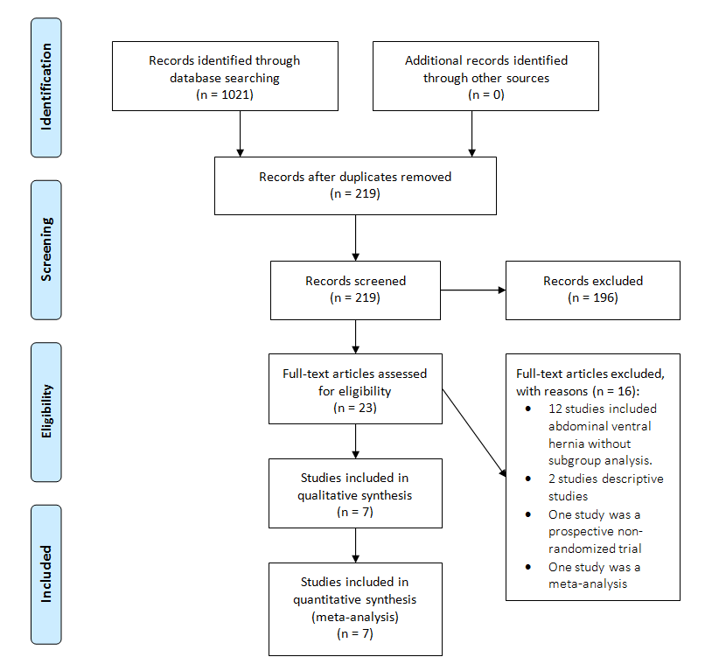

Figure 1: Flow diagram of included studies
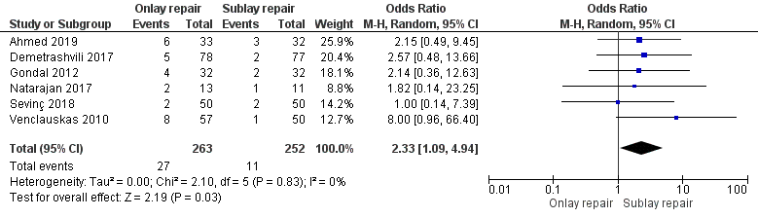

Figure 2.A: Meta-analysis of studies on wound infections
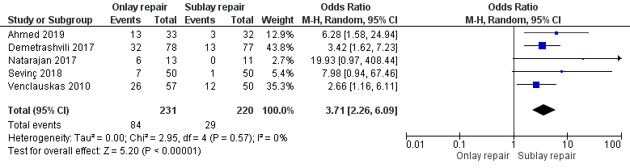
Figure 2.B: Meta-analysis of studies on seroma
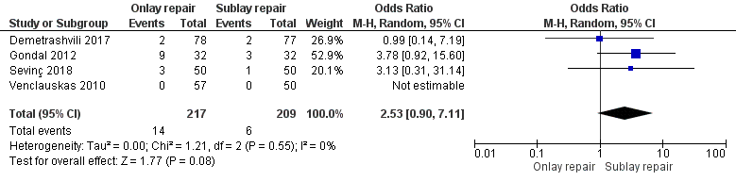
Figure 2.C: Meta-analysis of studies on hematoma
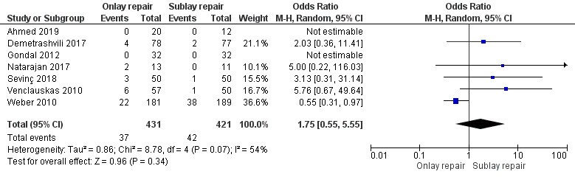
Figure 3.A: Meta-analysis of studies on recurrence
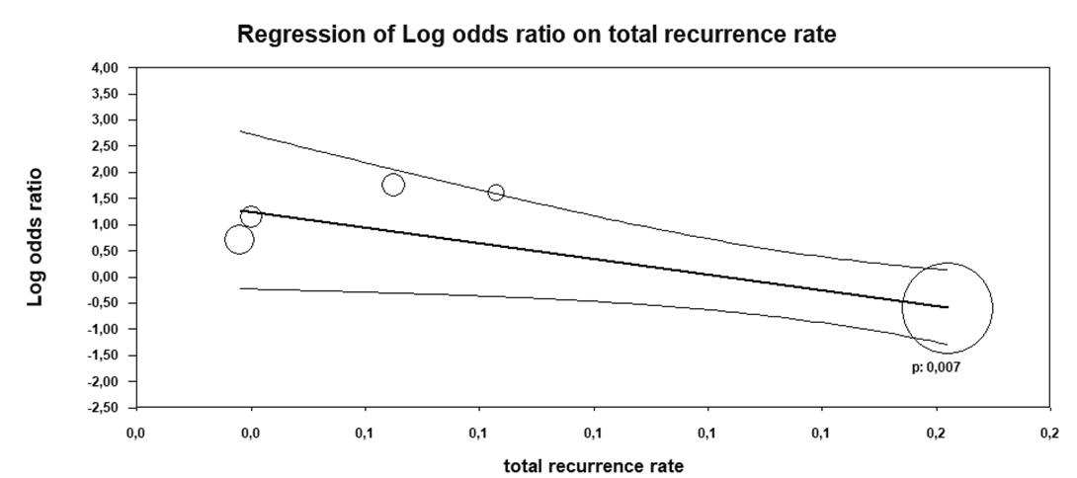
Figure 3.B: Meta-regression of studies on recurrence
References | Year | Country | Mean age (years) | Nb of onlay repair | Nb of Sublay repair | Hernia size | Mesh type | Prophylactic antibiotics | Follow up (months) | Quality assessment
Gondal et al [20] | 2012 | Pakistan | 44.9 | 32 | 32 | NF | NF | NF | 6 | 10/25
Demetrashvili et al [21] | 2017 | Georgia | 60.4 | 78 | 77 | Onlay: 62.7 cm²  Sublay: 100.4 cm² | Polypropylene | Yes (Cefuroxime 1.5g) | 26 | 21/25
Sevinc et al [22] | 2018 | Turkey | 55.4 | 50 | 50 | 73.4 cm² | Polypropylene | No | 37 | 19/25
Venclauskas et al [23] | 2010 | Lithuania | 55 | 57 | 50 | Onlay: 114.5 cm²  Sublay: 110 cm² | Polypropylene | Yes (Oxacillin 1g) | 12 | 15/25
Natarajan et al [8] | 2017 | India | 56.3 | 13 | 11 | ≥ 4 cm | Polypropylene | NF | 6 | 16/25
Wéber et al [24] | 2010 | Hungary | NF | 235 | 224 | > 25 cm² | Polypropylene | Yes (cephazolin) | 60 | 14/25
Ahmed et al [25] | 2019 | Pakistan | 39.13 | 23 | 22 | ≥ 3 cm | NF | Yes | 6 | 14/25

Nb: number, NF: Not Found

Table 1: Details of the included studies

