MALPOSITION OF LUMBAR TRANSPEDICULAR SCREWS; REVISION OF CURRENT TECHNIQUES: FREE HAND, FLUOROSCOPY, NAVIGATION

Dr. Iñaki Arrotegui*
Consultan Neurosurgeon. MD. Ph. D
Valencia General Hospital
Dept. of Neurosurgery
Avda Tres Cruces S/n .46014 – Valencia-Spain
e-mail: athbio@yahoo.es

Abstract
Background: Although pedicle screws were originally placed via the classic free-hand technique, which is based on vertebral bone landmarks for screw insertion, with the advances of technology and imaging, new techniques have been introduced, such assistive techniques include fluoroscopy guidance and navigation.
Fluoroscopy and plain serial radiography are still commonly used, nevertheless it has some inconveniences. Fluoroscopy only captures images in the lateral and AP planes and has been associated with increased radiation exposure.
Computer navigated surgery provides a simultaneous multiplanar visualization of spinal anatomy and allows virtually any surgical instrument to be tracked in relation to the displayed anatomy in real time. Navigation systems also have some drawback such as increased operating times and high cost associated with purchase and installation of an image-guided surgical suite.
Material & Methods: We present the results obtained in the 428 surgeries performed through the technique of free hand + the use of fluoroscopy, using only 2 projections throughout the surgery and only the lateral view. since 2016-2019 in degenerative lumbar pathology in which an arthrodesis was performed
Results: The total number of screws used was 2064, 1 level of arthrodesis in 283 patients, 2 levels in 118 patients, 3 levels in 23 patients and 4 levels in 4 patients. Of the total number of screws used, only 7 screws had to be removed in seven patients, due to the involvement of the root L4 ( 1 patient ) L5 ( 4 patients ) 2 patients at S1. what I mean; 0.33 of the implanted screws or 1.63 of the operated patients .
Conclusion : Valid techniques: The surgeon's experience is Fundamental in the Results
Free Hand In Favor: Zero Radiatiion ; Against: EL> Bad Position Index.
Fluoroscopy In Favor: Lower MISPLACEMENT , Against:> Radiation index.
Navigation In Favor : The Lowest Index of Bad Position and Radiation Against: Price of Navigation System , Longer surgical time
Key word: Lumbar degenerative pathology , free hand , fluoroscopy , misplacement pedicle screws, arthrodesis. Navegation system , O-arm

The number of patients with degenerative diseases of the spine has increased significantly in recent years, due to changes in the lifestyle and behavior patterns, as well as increasing in life expectancy.(1) It is estimated that between 70-90% of the general population suffers from back pain and that approximately 4% will require surgical treatment.(1 )estimates that 44 million people in the United States suffer degenerative diseases of the spine, osteoporosis being the main cause; you are expected to be figures increase 30% over the next 20 years, as well as the number of patients with vertebral pathology that will require surgical treatment.(2) In the same way, the amount of economic resources for prevention, diagnosis, treatment and rehabilitation of patients with these pathologies It has increased in recent years.(3)
One of the options available for surgical treatment of vertebral pathology is the instrumentation of the transpedicular column. Currently, surgery of transpedicular vertebral fusion represents the fixation technique most commonly used for treatment Surgical of vertebral diseases of a nature degenerative, vascular, infectious, metastatic, congenital and traumatic (4.5)
The procedure involves the introduction of screws transpedicular through a point located at the junction of the transverse apophysis with the superior articular apophysis, which crosses the pedicle on its way to reach the vertebral body, providing stability and fixation internal to the Among the advantages of this procedure are the stabilization of the affected vertebral segments, the reduction of postoperative complications and the short hospital stay time, as well as a good degree of clinical improvement. Among the postoperative complications the most frequent acute and chronic infections are found, stenosis of adjacent vertebral segments to fixation, transient or permanent neurological deficit affected vertebral segment Screw misplacement, fixing system failure, persistence or aggravation of pain, fracture of the pedicle and invasion of the medullary canal with rupture of the dura and cerebrospinal fluid leak .
The morphometric characteristics of the vertebrae and in special pedicle, determine the size of the implants pedicle in both width and length, as well as the ideal shape, direction and angulation of the screw at the moment of its introduction. It is important for the surgeon, knowledge of these characteristics to avoid injuries of the pedicle cortex, meninges, nerve roots, facets articular, viscera or adjacent vascular structures due to incorrect placement or orientation of the screws.

Material & Methods
404 surgically operated patients have been studied of Lumbar column of multiple etiologies between 2016 and 2019 in two hospitals. All surgical interventions were performed by the same surgeon with great surgical experience in spinal surgery.
Screw insertion was done all cases with “hands-free” technique. All patients were underwent an introperative radiological examination at the end of the surgery to confirm the correct position of the screws, In each surgery only 2 controls were performed, in lateral projection, so radiation was minimized on the patient and the surgical team. . The degenerative surgeries performed were in the lumbar region with the diagnoses of. canal stenosis, spondylolisthesis, scoliosis,
The total number of screws used was 2064, 1 level of arthrodesis in 283 patients, 2 levels in 118 patients, 3 levels in 23 patients and 4 levels in 4 patients.
Of the total number of screws used, only 7 screws had to be removed in seven patients, due to the involvement of the root L4 ( 1 patient ) L5 ( 4 patients ) 2 patients at S1. what I mean; 0.33 of the implanted screws or 1.63 of the operated patients (fig II; III; IV).
Surgical time
The median surgical time was 60 minutes with a minimum of 45 minutes( 0ne level ) and a maximum of 180 minutes in patients operated on 4 levels .
"Patients presented neurological focality with involvement of the L5 root the day after the intervention (Fig I grades II Gertzbein classification ) , within the first 4 hours the surgery and screw removal were performed. The patient improved pain but in both cases he continued with dorsi flexion paresia although this did not affect them to walk normally.After the rehabilitation period there has been improvement of the symptomatology but not his complete recovery.

Discussion
Since its introduction by Roy-Camille (6) and Louis (7) in the seventies, the use of screws pedicle has increased remarkably to the present day. The causes of its success against non-instrumented arthrodesis it based on better consolidation rates of vertebral fusions in lumbosacral spine ), especially in patients with and a more comfortable postoperative period for the patient( 8).
There are three types of techniques currently used by surgeons for the placement of transpedicular screws. These techniques can be classified as techniques based on anatomical references and image-assisted techniques, either by fluoroscopy or by computer.
The classic techniques were based on the recognition of normal and abnormal spinal anatomy, preoperative radiological imaging and intraoperative anatomical references. Later, technical advances regarding the image expanded the field of intraoperative assistance to the knee, hip and spine. Thus, conventional fluoroscopy guidance techniques included the x-ray arch for the insertion of transpedicular screws and for intraoperative evaluation of their position.
Computer-assisted techniques, also called navigation-assisted or stereotactic calls, began to be used in the field of spinal surgery in 1995, seeking to increase the precision in the placement of instrumentation material.8 Subsequently, new ones have been developed navigation assistance techniques, based on CT or fluoroscopy, that assess the placement of the screw in the pedicle in real time. These techniques are limited by the cost of surgical time and in the case of fluoroscopy, by considerable radiation exposure. Navigation-guided techniques offer the possibility of significantly improving placement accuracy, without requiring sequential use of fluoroscopy during the introduction of instruments and screw.
Regarding complications, neurological they are the most serious in complications usual and its incidence varies among authors and especially decreases with the experience of surgeon. These types of complications occur due to invasion of the channel when introducing an excessively screw medial, inferior or lateral and are associated occasionally to hard ruptures(9)., in a study conducted with the members of the American Back Society, collects the complications of 617 surgeries with pedicle instrumentation in 3,949 screws, appreciating 1.9% of ruptures durales, 2.4% transient root injury and 2.3% permanent root injury(10). Yahiro (11) analyzes 101 Articles reviewing results from 5,756 patients treated with pedicular instrumentation for different types of pathology appreciating 1.1% of ruptures hard and 1.7% neurological lesions.
Lumbar roots only occupy the upper third and previous of the foramen, so the site more dangerous of pedicle rupture is the inferior cortex and medial. Medial localization may cause a dural rupture and nerve root injury that comes out immediately below the pedicle instrumented . The bottom location can catch the root in its lowering at the bottom of the pedicle, in the foramen. Lateral location can injure the root of the level superior to the pedicle instrumented, such as a herniated disc extraforaminal The cephalic screw location in the vertebral body can cause rape of the disc space of a non-merged segment and has the potential risk of accelerating the disc degeneration In front of the vertebral body, in the lower back, we find vital structures like the aorta and vena cava, and in the sacral area the autonomous plexuses responsible for the correct sexual function, internal iliac veins and L5 roots in front of the lateral area of ​​the body vertebral of S1, so a screw that protrude excessively in front of the body vertebral could damage structures previously
Regarding the average time of scopia, few studies value it. Slomczykowski (12) uses 63 seconds of shot-by-screw. Steinman (13), in a study carried out with specimen vertebrae in the laboratory, the time of scooters invitroes of 1.6 minutes per intervention (ten screws) or 9.6 seconds per screw, but it is necessary to have Keep in mind that it is not a surgical intervention but a laboratory study.
In our series the average time per screw has been 40 seconds. When we have used the shotgun with memory, the time taken by screw has been less than half (24 seconds) than when we have used the shotgun without memory (58 seconds).
The annual exposure to 5 REM (5,000 milliREM) is currently allowed. An intervention of this type offers an exposure between 10 and 40 mREM. Radiation exposure may be reduced if the light emitter is under the table or if a leaded apron with thyroid protection and protective goggles is used, which decreases 90% of exposure or the use of radiation gloves that reduces exposure by 40%. (13).
Gertzbein classification(14)
The first and most used scale is known in general and in the literature as Gertzbein Scale. In it, cortical perforation is described by the extracortical extension of the screw violation. Grade 0 screws are those fully housed within the boundaries of the pedicle without evidence of cortical perforation, while the greater degrees are assigned at the distance of perforations multiples of 2 mm, while the distance is measured from the medial edge of the pedicle. This scale was initially used to assess screws placed from T8 to S1. During its initial application, the scale tried to assess only the invasion of the spinal canal, so that the lateral screws were excluded from the classification. More recent studies have expanded the original Gertzbein scale by applying it in each of the possible cortical perforation directions.(14) A subsequent study uses this scale for each of the six possible cortical perforation directions: anterior, lateral, medial, inferomedial, inferolateral and superior.(14)
Table I
Grade Drilling distance
0 Screw completely housed inside the pedicle
One Screw invades but does not pierce the cortex
2 Perforation <2 mm
3 Perforation 2-4 mm
4 Drilling> 4 mm
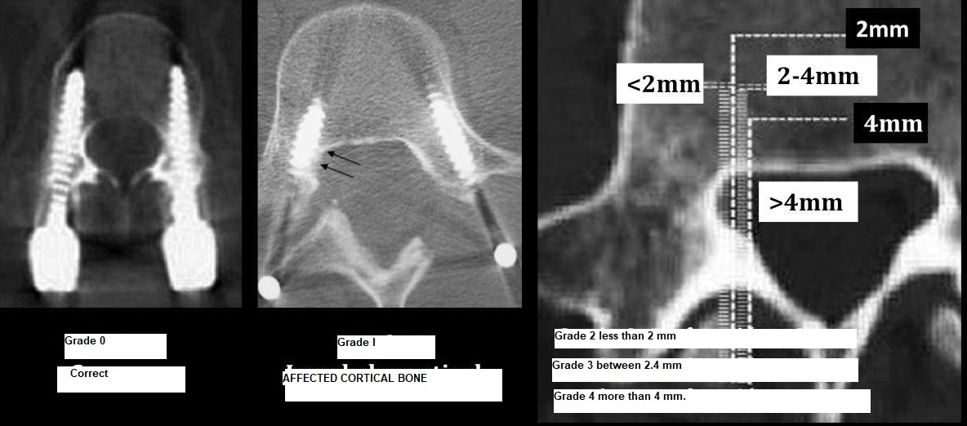
FIG I : Gertzbein classification images

Free Hand Technique,
Several studies investigate the accuracy of techniques based on anatomical references, or "free-hand technique", for the placement of transpedicular screws. We have selected the most significant studies in which the placement of the screws was carried out using exclusively the technique based on anatomical references. In them, the accuracy rates range between 71.9% and 93.3% (15 )
Free Hand technique + Fluoroscopy
The placement of screws with fluoroscopic control has a much smaller learning curve when compared to the classical technique. Theoretically, the perforation rates of the pedicle cortex should be lower, since image control provides the surgeon with the opportunity to correct errors. However, this added security mechanism comes at a price (15).
The use of intraoperative fluoroscopic control is associated with an increase in surgical times and radiation exposure. The increase in surgical time is mainly due to the introduction and removal of the fluoroscopy arch, previously prepared with a sterile sleeve. Each use of a C-arch requires the movement of the surgical work equipment, with the consequent increase in the procedure time. Apart from the fact that an increase in surgical time is related to a decrease in efficiency, the increase in surgical times has also been associated with an increase in the incidence of surgical wound infection. (16 )
The radiation risk associated with fluoroscopy during pedicle screw placement has been extensively studied in the literature. This risk exists for both the patient and the surgeon, being able to say that it is the surgeon who has a greater chance of developing long-term adverse effects. Some studies use anthropometric models to estimate radiation exposure in patients treated by placing transpedicular screws with intraoperative fluoroscopy guidance.(17)
Particularly interesting is the registry of postoperative complications they perform, describing 2% of patients who presented with radicular pain and neurological deficit due to malpositioned lumbar screws.(18) In our study, the number of patients was 1 with neurological defict. (0.23%).

Conclusions
- Free hand technique + fluoroscopy, small learning curve, need for an exaggerated knowledge of the anatomy of the spine. Need for a spatial vision.
- Surgical times, radioactive dose and complications well below average.
- Performing all types of lumbar degenerative pathology, leaving the use of navigation or eyes or the like for pathologies with Gr III spondylolisthesis or vertebral ptosis

- Acknowledgements : 'Not applicable' for that section
- Authors' contributions : 'Not applicable' for that section
- Financial support and sponsorship : 'Not applicable' for that section
- Conflicts of interest : 'Not applicable' for that section
- Ethics approval and consent to participate : 'Not applicable' for that section

Reference
1. Abumi, K., Panjabi, M.M., Kramer, K.M.: Biomechanical evaluation of lumbar spinal stability after graded facetectomies.Spine. 1990; 15: 1142-1147.
2. Akamaru, T., Kawahara, N., Tim Yoon, S.: Adjacent segment motion after a simulated lumbar fusion in different sagittal alignments: a biomechanical analysis. Spine. 2003; 28: 1560-1566.
3. Arnoldi, C.C., Brodsky, A.E., Cauchoix, J., et al.: Lumbar spinal stenosis and nerve root entrapment syndromes. Definition and classification. Clin Orthop Relat Res. 1976; 115: 4-5.
4. Booth, K.C., Bridwell, K.H., Eisenberg, B.A.: Minimum 5-year results of degenerative spondylolisthesis treated with decompression and instrumented posterior fusion. Spine. 1999; 24: 1721-1727.
5. Bridwell, K.H., Sedgewick, T.A., O'Brien, M.F.: The role of fusion and instrumentation in the treatment of degenerative spondylolisthesis with spinal stenosis. J Spinal Disord. 1993; 6: 461-472.
6. LOUIS R. Fusion of the lumbar and sacral spine by internal fixation with screw plates. Clin Orthop. 1986; 203: 18-33.
7. ROY-CAMILLE R, SAILLANT G, BERTEAUX D, SALGADO V. Osteosynthesis of thoracolumbar spine fractures with metal plates screwed through the vertebral pedicles. Reconstr Surg Traumatol. 1976; 15: 2.
8. AMUNDSEN G, EDWARDS C, GARFIN S. Spondylolisthesis. En: R H Rothman, F A Simeone (eds), The Spine. Philadelphia: W B Saunders, 1992; 913-970.
9. STAUFFER R, COVENTRY M. Posterolateral lumbar spine fusion: Analysis of Mayo Clinic series. J Bone Joint Surg. 1972; 54-A: 1195-1204.
10 . ESSES S I, SACHS B L, DREYZIN V. Complications associated with the technique of pedicle screw fixation. A selected survey of ABS members. Spine. 1993; 18: 2231-2239.
11. YAHIRO M A. Review of the «Historical cohort study of pedicular fixation of thoracic, lumbar and sacral spinal fusions » report. Spine. 1994; 19s: 2297s-2299s.
12.SLOMCZYKOWSKI M, ROBERTO M, SCHNEEBERGER P, OZDOBA C, VOCK P. Radiation dose for pedicle screw insertion. Fluoroscopic method versus computer-assisted surgery. Spine. 1999; 24: 975-983.
13. STEINMANN J C, HERKOWITZ H N, ELKOMMOS H, WESOLOWSKI D P. Spinal pedicle fixation. Confirmation of an image-based technique for screw placement. Spine. 1993; 18: 1856-1861
14.Gertzbein SD, Robbins SE. Accuracy of pedicular screw placement in vivo. Spine (Phila Pa 1976) 15: 11-14, 1990
15. Learch TJ, Massie JB, Pathria MN, Ahlgren BA, Garfin SR. Assessment of pedicle screw placement utilizing conventional radiography and computed tomography: a proposed systematic approach to improve accuracy of interpretation. Spine (Phila Pa 1976) 29:767-773, 2004
16.Heintel TM, Berglehner A, Meffert R. Accuracy of percutaneous pedicle screws for thoracic and lumbar spine fractures: a prospective trial. Eur Spine J 22: 495-502, 2013
17.Perisinakis K, Theocharopoulos N, Damilakis J, Katonis P, Papadokostakis G, Hadjipavlou A, et al. Estimation of patient dose and associated radiogenic risks from fluoroscopically guided pedicle screw insertion. Spine (Phila Pa 1976) 29: 1555-1560, 2004
18. Amato V, Giannachi L, Irace C, Corona C. Accuracy of pedicle screw placement in the lumbosacral spine using conventional technique: computed tomography postoperative assessment in 102 consecutive patients. J Neurosurg Spine 12: 306-313, 2010

Legend
Fig I : Gertzbein classification images
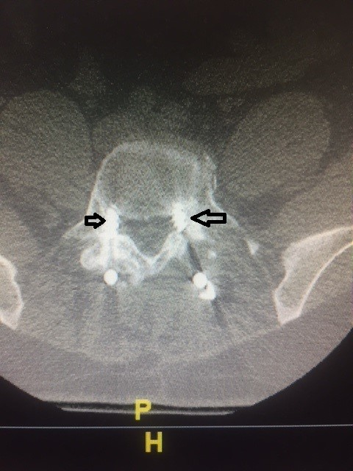
FIG II . Malposition left side Gertzbein Gr II
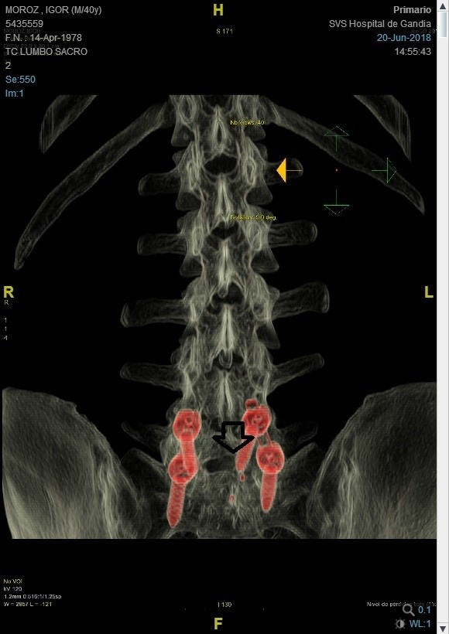
FiG III Malposition Grade I of Gertzbein
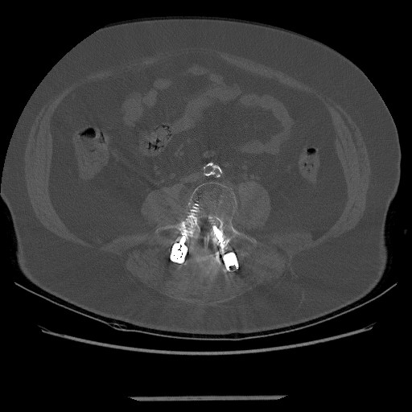
Fig IV Grade III of Gertzbein Classification

