Corona Virus Disease; A Public Health Emergency

Wajeeha Khalid, Muhammad Jamaluddin

Worldwide practicing physicians and hospitals are on alert, since most commonly called cornonavirus (2019- nCoV) has taken over the world and now considered as the foremost and most concerning public health emergency; nationally as well as internationally. According to recent articles the epidemic started from 12th December 2019 which has caused 2050 confirmed new cases out of which 56 were fatal cases by 26th January 2020 [1]. Since 8th December 2019, several cases of pneumonia of unknown etiology were reported in Wuhan, Hubei province, China. Most of the cases reported, majority of the patient worked or lived around the local Huanan seafood whole sale market, where live animals were also on sale [2]. Early stage of disease was characterized by the variety of upper respiratory tract symptoms including fever, chest pain, cough, and other non-specific symptoms, which later on leads to acute respiratory distress syndrome (ARDS) and consequently respiratory failure leading to death. On 7th January 2020 novel coronavirus was detected by Chinese Centre of disease control and prevention. It was identified from the throat swab sample of the patient, and was named as 2019-nCoV by WHO. [3]
As described earlier by many medical and pathological textbooks about Coronavirus that it is one of the most common pathogen of upper respiratory tract infections. Many variants of coronavirus have been discovered, of which highly pathogenic coronavirus includes SARS-CoV and MERS-CoV causing severe respiratory syndrome in humans and four other human coronavirus (HCoV-OC43HCoV-229E, HCoV-NL63, HCoV-HKU1) induce mild upper respiratory disease. However, sequence of recently discovered 2019-nCoV is different form six other variants and can be classified as betacoronavirus [1,2]. Highly pathogenic variants of coronavirus can be transmitted directly to humans from civets and dromedary camels, and both virus originates from bats, but the origin of 2019-nCoV is still unclear and needs further investigations [4].
Recently a cohort study was conducted [5] on the 41 patients which were hospitalized in one of the hospitals in Wuhan City, according to which clinical features and disease progression was determined by researchers. It turned out that many patients with active disease initially had fever along with fatigue, myalgia, progressing to dry cough, dyspnea, rhinorrhea, sneezing, or sore throat. Some patient also presented with GI symptoms like diarrhea. Subsequently, patient leads to acute respiratory distress syndrome (ARDS) and other complications leading to mortality. Patient with severe disease developed ARDS and required ICU admission and oxygen therapy. The time duration between hospital admission and ARDS was as short as 2 days. Study also showed 66% of the patient had direct exposure to seafood market Huanan, due to which China has shut down this seafood market. Laboratory test included complete blood count and CT chest which showed sever leukopenia and lymphopenia, with raised D-dimers in ICU patients and multilobular consolidations with ground glass appearance respectively.
According to WHO [3,5] early recognition, immediate isolation (separation), implementation of appropriate infection prevention and control (IPC) measures and provision of optimized supportive care. Early recognition includes screening of clinical signs and symptoms of pneumonia which are categorized as uncomplicated illness, mild pneumonia, severe pneumonia, and ARDS (complicated pneumonia). Suspected patient should be isolated into separate room and a medical mask should be provided to him and keeping at least 1 meter distance from him. Droplet precautionary measures should be applied by the help of wearing medical mask by the patients and the other people in the surrounding (e.g medical staff) along with this all the patients with the disease should be kept in an isolated ward. Contact measures should be taken, for example prevention from contaminated surfaces or equipment, use of PPE (medical mask, eye protection, gloves and gown) when entering room and remove PPE when leaving.
WHO guidelines [3,5] for the treatment includes supplemental oxygen therapy, use of conservative fluid management, giving empiric antimicrobials to treat all likely pathogen causing SARI, closely monitor patients with SARI for signs of clinical deterioration, such as rapidly progressive respiratory failure and sepsis,and apply supportive care interventions immediately, and understanding patient’s comorbid conditions.
According to surveillance, as effect of 28th January 2020 by WHO there were a total of 4593 cases reported globally majority in China some from other parts of the world as shown in Table No. 1. Number of new cases reported outside Wuhan and China are few and has been thought to occur due travelling to or from Wuhan City. However limited data is available on the mode of transmission of 2019-nCoV. Travelling history to Wuhan has been the cause of disease in the patients in some Chinese provinces which include large cities such as Beijing, Shanghai, and Shenzhen, as well as other countries including Thailand, Japan, South Korea, Taiwan, Hong Kong, Macau, and United states [6].
Since Wuhan city is the major domestic and international transport hub it is not unexpected to see more reported cases outside the premises; nationally as well as internationally. Many guidelines regarding screen of travelers has been proposed by WHO, which have been implemented and regulated very tightly at international airports and hubs to reduce the risk of transmission, as noted human-to-human contact transmission of this virus [3,7]. Advice for exit screening in countries or areas with ongoing transmission of the novel coronavirus 2019-nCoV (currently People’s Republic of China) include screening with aim of early detection in international travelers and checking of sign and symptoms through interview and clinical examination of travelers. Also encouraging screening at domestic airports, railway stations, and long-distance bus stations is necessary. Screening of disease at entry in countries without transmission is of utmost importance because exported confirmed cases were detected by entry screening.
No confirmed case has yet been reported in Pakistan, however due to demographical locations of Pakistan and China (since they share same borders), migration of Pakistani students and worker back to Pakistan from China, and travelling of Chinese population to Pakistan are contributing factors which increases the risk of exporting virus to Pakistan. Government officials in Pakistan and China are working to take preventive measure to minimize the risk of potential viral spread through proper screening and awareness programs at entry and exit. Though, limited data is available on the transmission to neighboring countries, since no confirmed case has been reported in South Asia as yet.
Table 1. Countries, territories or areas with reported confirmed cases of 2019-nCoV, 30 January 2020

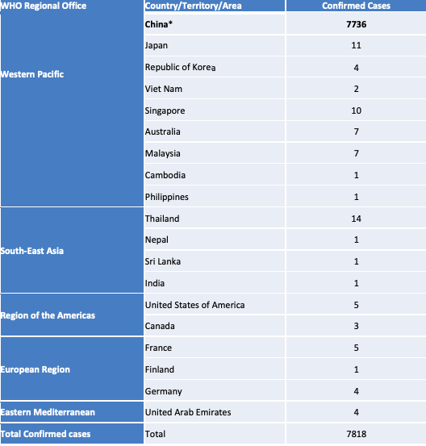

REFERENCES:
- Zhou P, Yang X, Wang X, et al. A pneumonia outbreak associated with a new coronavirus of probable bat origin. Nature (2020).
- Chen N, Zhou M, Dong X, et al. Epidemiological and clinical characteristics of 99 cases of 2019 novel coronavirus pneumonia in Wuhan, China: a descriptive study. Published:January 30, 2020DOI:https://doi.org/10.1016/S0140-6736(20)30211-7.
- WHO Clinical management of severe acute respiratory infection when Novel coronavirus (nCoV) infection is suspected: interim guidance.
https://www.who.int/internal-publications-detail/clinical-management-of-severe-acute-respiratory-infection-when-novel-coronavirus-(ncov)-infection-is-suspected
- Tao Y, Shi M, Chommanard C, et al. Surveillance of bat coronaviruses in Kenya identifies relatives of human coronaviruses NL63 and 229E and their recombination history. J Virol. 2017;91:e01953-e02016.
- Huang C, Wang Y, Li X, et al. Clinical features of patients infected with 2019 novel coronavirus in Wuhan, China. Lancet. 2020; (published online Jan 24) https://doi.org/10.1016/S0140–6736(20)30183–5
- JM et al. Novel coronavirus 2019-nCoV: early estimation of epidemiological parameters and epidemic predictions. Published online Jan. 24, 2020 ; doi: http://dx.doi.org/10.1101/2020.01.23.20018549
- Wu JT, Leung K, Leung GM. Nowcasting and forecasting the potential domestic and international spread of the 2019-nCoV outbreak originating in Wuhan, China: a modelling study. Published online January 31, 2020 https://doi.org/10.1016/S0140-6736(20)30260-9

