Impacted mandible second molars of two sisters
Peng Sunª, Hanglin Qinª, Shenghai Cui^{b}, Ning Li^{a*}
ªDepartment of Orthodontics,Stomatological Hospital of Yantai affiliated to Binzhou medical college, Yantai China;
^{b}Department of Oral Maxillofacial Surgery,Stomatological Hospital of Yantai affiliated to Binzhou medical college, Yantai China;

Corresponding author: Ning Li , Department of Orthodontics,Stomatological Hospital of Yantai affiliated to Binzhou medical college, Yantai China;
E-mail: best32@163.com

Abstract The most of impacted mandibular second molars are reported as individual cases, and it is rare to have twin children with impacted mandibular second molars at the same time. The purpose of this paper was to report a case of two sisters with impacted mandibular second molars.The elder sister had bilateral impacted mandibular second molars, while the younger sister had unilateral impacted mandibular second molar and impacted mandibular cusp, indicating that impacted teeth may be related to genetic inheritancem,but local factors could also affect the eruption.
Key words: Mandibular Second molar; Impaced teeth; Genetic

INTRODUCTION
The impacted tooth is one that is prevented from erupting into position because of malposition, lack of space, or other impediments. The incidence of impacted teeth in the general population is 0.8-3.6%^{[1, 2].}The most frequently impacted is the mandibular third molar, followed by the maxillary third molar ,the maxillary cuspids,mandibular premolars and maxillary central incisors^{[1, 3, 4]}.

The common reason of impacted Mandibular second molars are the blocking by adjacent first molars, third molars, mandibular ascending ramus, or the crowns are in normal position, but fail to erupt normally within the bone.The incidence of Impacted mandibular second molars is about 0.3%^{[5]}, the unilateral more common than the bilateral, and the right is more common than the left^{[6]}.At present, the most of impacted mandibular second molars are reported as individual cases, and it is rare to have twin children with impacted mandibular second molars at the same time. The purpose of this paper was to report a case of two sisters with impacted mandibular second molars.

CASE REPORT 1
The patient was a 19-year-old girl with the chief complaint of impacted mandibular second molars. Clinical and radiographic examinations (Figure 1) showed mandibular second molars and third molars were mesially impacted.The overbite and overjet were normal and there was mild crowding in the archs. The maxillary central incisors had been treated with unideal root canal therapy.The treatment plan is root canal retreatment of the maxillary central incisors,extracting the third molars,uprighting mandibular second molars with fixed orthodontic appliances. But the patient rejected the plan and orthodontic treatment was not performed.
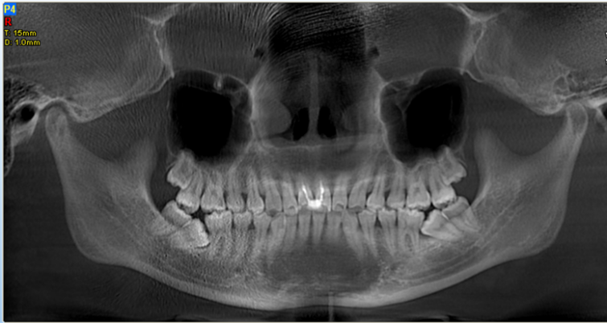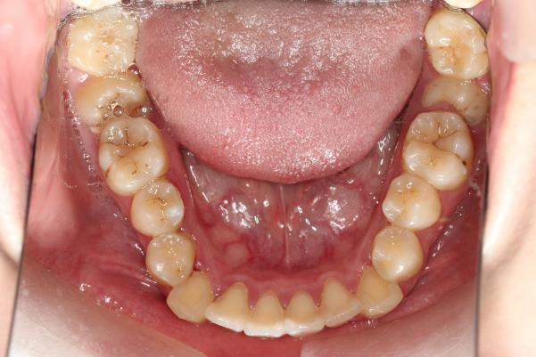
Figure 1：Panorama and Intraoral mandibular photograph
CASE REPORT 2
The patient who is the sisiter of the above patient was a 16-year-old girl with the chief complaint of the impacted right mandibular second molar. Clinical and radiographic examinations (Figure 2) showed that the right mandibular second molar and the mandibular third molars were mesially impacted.The right mandibular deciduous canine was retented and the canine was low horizontal impacted.The deep overbite was II°and the overjet was normal.There were mild crowding in the upper arch and moderate crowding in the lower arch. The right mandibular first molar had been treated with unideal resin filling.The treatment plan is retreatment of the maxillary central incisors,extracting the third molars,uprighting the right mandibular canine and second molar.But the patient also rejected the plan.

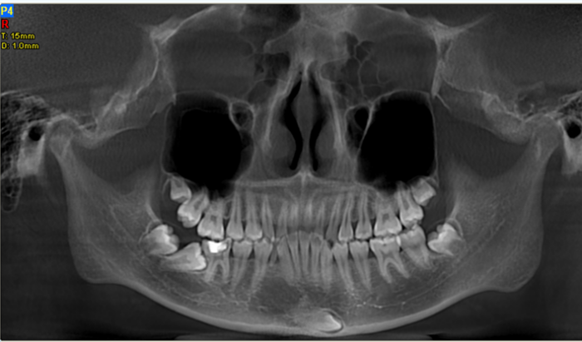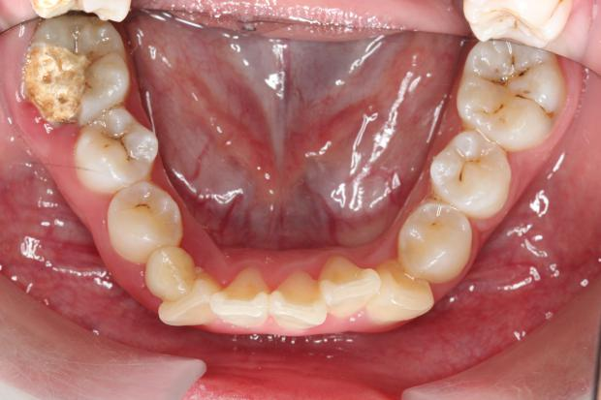
Figure 2：Panorama and Intraoral mandibular photograph
DISCUSSION
Impacted teeth were the result of many factors including systemic factors, local factors and genetic factors.Systemic factors include endocrine defects, radiotherapy, cranioclastic dysplasia,et. Local factors include root absorption , premature loss and retention of deciduous teeth.The significance of genetic factors in the diagnosis and treatment of dental patients have been indicated in previous investigations^{[7-11]}.Monozygotic twins have identical occlusions, as manifested by similar arch shapes and sizes, crowding, tooth size and Angle molar classifications , but they have individual overjet, overbite and rotations^{[10,11]}.The incidence of mesiodens in first-degree relatives is significantly higher than that in the general population,which suggesting that the genetic factor has influences on tooth development^{[12]}.

At present genetics researchs about impacked mandibular second molars are less.The comparative analysis of Israel and Chinese-America such as the genetic characteristics and remarkable characteristic showed that the prevalence of mandibular second molar impaction was almost 2-fold greater in the Chinese-Americans (2.3%) than in the Israelis (1.4%).The ratio of bilateral to unilateral mandibular second molar impaction was higher in the Chinese-Americans (45:55) than in the Israelis (27:73). Mandibular second molar impaction demonstrates a moderate genetic trait.A genetic penetrance of mandibular second molar impaction is related to the severity of the aberration. MM2 impaction appears to be an autosomal trait, rather than inherited via the sex chromosomes^{[13]}.

Some studies suggest that the development of tooth is stable but the eruption is greatly influenced by local factors by the genetic analysis of 82 pairs of twin’s teeth development and eruption^{[14]}.The elder sister had bilateral impacted mandibular second molars, while the younger sister had unilateral impacted mandibular second molar and impacted mandibular cusp, indicating that environmental factors could also affect the phenotype.

CONCLUSIONS
In this case, the sisters with impacted mandibular second molars suggest that impacted teeth may be related to genetic inheritancem,but local factors could also affect the eruption.It is hoped that this report will act as a stimulus to further objective and quantitative studies .

CONFLICTS OF INTEREST
All authors declared that there are no conflicts of interest.

REFERENCES
- Chu F C, Li T K, Lui V K, et al. Prevalence of impacted teeth and associated pathologies--a radiographic study of the Hong Kong Chinese population.[J]. Hong Kong Med J, 2003, 9(3):158-163.
- Hattab F N, Rawashdeh M A, Fahmy M S. Impaction status of third molars in Jordanian students[J]. Oral Surg Oral Med Oral Pathol Oral Radiol Endod, 1995, 79(1):24-29.
- Dachi S F, Howell F V. A survey of 3,874 routine full-mouth radiographs : II. A study of impacted teeth[J]. Oral Surgery Oral Medicine & Oral Pathology, 1961, 14(10):1165-1169.
- Grover P S, Lorton L. The incidence of unerupted permanent teeth and related clinical cases.[J]. Oral Surgery Oral Medicine Oral Pathology, 1985, 59(4):420.
- Varpio M, Wellfelt B. Disturbed eruption of the lower second molar: clinical appearance, prevalence, and etiology.[J]. Asdc Journal of Dentistry for Children, 1988, 55(2):114.
- Wellfelt B, Varpio M. Disturbed eruption of the permanent lower second molar: treatment and results.[J]. Asdc Journal of Dentistry for Children, 1988, 55(3):183.
- Kaczor-Urbanowicz K, Zadurska M, Czochrowska E. Impacted Teeth: An Interdisciplinary Perspective[J]. Advances in Clinical & Experimental Medicine Official Organ Wroclaw Medical University, 2016, 25(3):575.
- Harris JE, Kowalski CJ, Watnick SS. Genetic factors in the shape of craniofacial complex. Angle Orthod 1973; 43: 107-11.
- Harris JE, Kowalski CJ. All in the family: use of familial information in orthodontic diagnosis, case assessment and treatment planning. Am J Orthod 1976; 69: 493-510.
- Lobb WK. Craniofacial morphology and occlusal variation in monozygous and dizygous twins. Angle Orthod 1987;57: 219-33.
- Potter RHG, Nance WE. A twin study of dental dimension. 1. Discordance, assymmetry, and mirror imagery. Am J Phys Anthropol1976; 44:.391-6.
- Langowskaadamczyk H, Karmańska B. Similar locations of impacted and supernumerary teeth in monozygotic twins: a report of 2 cases.[J]. American Journal of Orthodontics & Dentofacial Orthopedics, 2001, 119(1):67-70.
- Shapira Y, Finkelstein T, Shpack N, et al. Mandibular second molar impaction. Part I: Genetic traits and characteristics.[J]. American Journal of Orthodontics & Dentofacial Orthopedics, 2011, 140(1):32-7.
- Liu He,DENG Hui,CAO Caifang.Genetic analysis of tooth development and eruption in 82 pairs of female-female twins[J]. Chin J Stomatol, 1999, 34(3):159-161.

