Dear Editors:

We would like to submit the enclosed manuscript entitled “Distal impaction of the upper left second molar and proximal impaction of the third molar:case report”, which we wish to be considered for publication in “Clinical Surgery Research Communications”. No conflict of interest exits in the submission of this manuscript, and manuscript is approved by all authors for publication. I would like to declare on behalf of my co-authors that the work described was original research that has not been published previously, and not under consideration for publication elsewhere, in whole or in part. All the authors listed have approved the manuscript that is enclosed.

In this work, we evaluated the case of two sisters of right impacted Mandibular second molars.I hope this paper is suitable for “Clinical Surgery Research Communications”.

We deeply appreciate a case of left distal maxillary second molar with mid-level impact, third molar with mid-level impact, and first molar root absorption. After the three molars are extracted, the first molar is implanted to restore posterior bite relationship.

Thank you and best regards.
Yours sincerely,
Corresponding author:
Name: Liangyu Wang
E-mail: best32@163.com

Distal impaction of the upper left second molar and proximal impaction of the third molar:case report
Peng Sunª, Meijuan Zhangª, Huijuan Xiao^{b}, Liangyu Wang^{a*}
ªDepartment of Orthodontics,Stomatological Hospital of Yantai affiliated to Binzhou medical college, Yantai China;
^{b}Department of Oral Plant ,Stomatological Hospital of Yantai affiliated to Binzhou medical college, Yantai China;
Corresponding author: Liangyu Wang , Department of Orthodontics,Stomatological Hospital of Yantai affiliated to Binzhou medical college, Yantai China;
E-mail: best32@163.com
Abstract :This article reports a case of left distal maxillary second molar with mid-level impact, third molar with mid-level impact, and first molar root absorption. After the three molars are extracted, the first molar is implanted to restore posterior bite relationship. Related literatures are introduced.
Key words: Impacted;Second molar ;Third molar

INTRODUCTION
Impaction of the third molar of the lower jaw is clinically common. Horizontal impact of the second and third molars of the maxilla is relatively rare. This case involves the impaction of the left upper maxillary second molar and the third molar, resulting in the absorption of the apex of the first molar, and finally all the three molars of the upper jaw were extracted and implanted for restoration.
CASE REPORT
General information: Male patient, 31 years old, found swollen upper left posterior tooth area about 10 years ago, repeated purulent fluid outflow, self-inflammation treatment was not effective, no other treatment. He visited a doctor in outpatient department of oral and maxillofacial surgery in January 2017.
Clinical examination: Tooth 18-26, 37-47 were seen in the mouth. Tooth 27, 28 were not seen. No obvious swelling on the buccal side, palpable ping-pong-like feeling, tenderness, a fistula opening on the surface buccal mucosa. Purulent fluid flowed out when squeezing vestibular groove. No obvious loosening was seen at 26, percussion (+).
Auxiliary examination: CBCT (cone beam CT, Cone Beam CT) (Figure 1) showed that tooth 27 was disto-impacted, tooth 28 was meso-impacted, and a round-like low-density shadow around 2.0cm × 2.1cm surrounds 27 , 28 teeth crown, clear boundary, the maxillary sinus bottom and lateral bone plate parts were squeezed into the maxillary sinus, and did not communicate with the maxillary sinus, tooth 26 distal buccal root was located in the lesion, part of the tooth root was absorbed. Tooth 18 erupted normally, 38 tongue tilted, and tooth 48 mesial tilted.
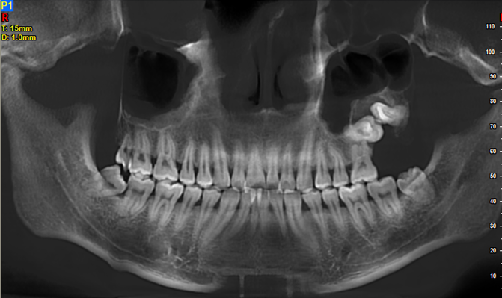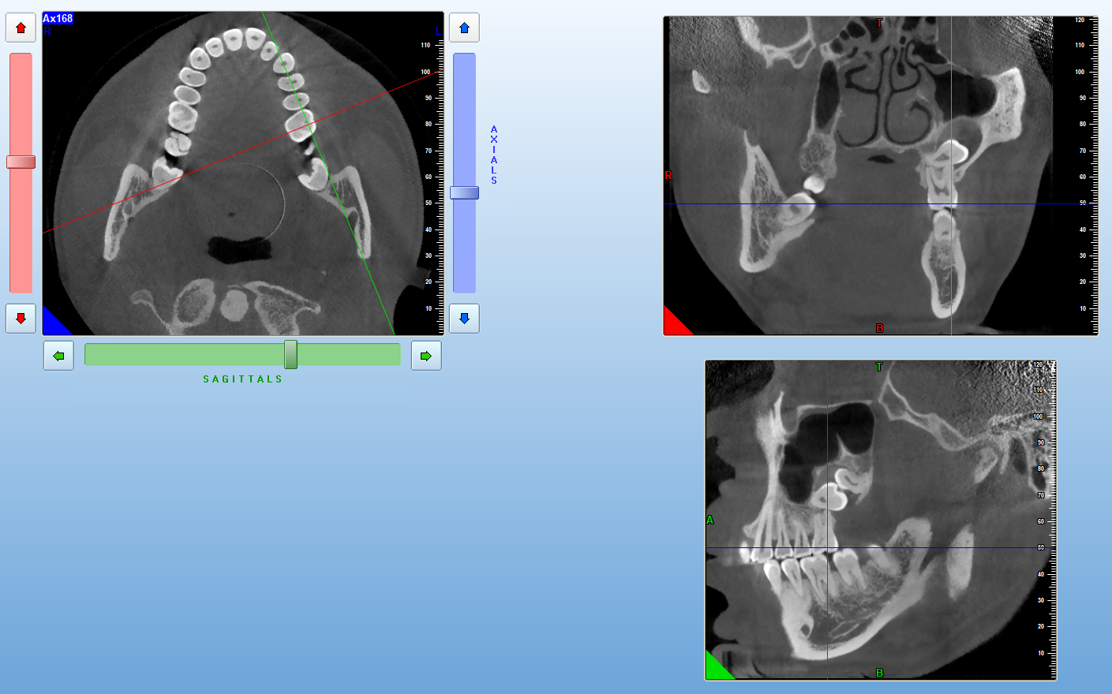
Figure 1: CBCT before surgery（2017.1.3）
Diagnosis and treatment: After comprehensive analysis and consideration of the wishes of the patient, a plan for inpatient surgery to remove impacted teeth was developed, and in January 2017 under general anesthesia, "Left maxillary cystectomy +27, 28, 18, 38, 48 impacted Tooth extraction +26 extraction. " Diagnosis on discharge: left maxillary cyst; tooth 27, 28, 18, 38, 48 impacted.
Implant prosthesis diagnosis and treatment: In January 2018, the patient went to the implantation department for 26 implant restorations. Intraoral examination of 26 and 27 was missing. Alveolar bone plumpness was average. Tooth 36 and 37 were not elongated, the height between the jaw was about 7mm, and there was no obvious tilt of the adjacent teeth. CBCT (Figure 2) showed that the bone height of area tooth 26 was about 10mm, the width was about 7mm. The bone density was low in area tooth 27, and the width of bone was about 4mm. Tooth 27 bone mass was insufficient. Considering all this above ,we suggested the patient to do 26 implant repair at first.
In February 2018, the patient underwent dental implant surgery in the Implant Department of our hospital (Figure 3). Postoperative CBCT (Figure 4) showed that tooth 26 implant is in good orientation. In July 2018, the patient was revisited for prosthetic treatment. The intraoral examination (Figure 5) showed no loosening of the implant, and the apical slice (Figure 6) showed that 26 implant healed well. The prosthesis was worn in August 2018. The prosthesis was in place (Figure 7), and the apical slice (Figure 8) showed the crown edges of 26 were well-closed.
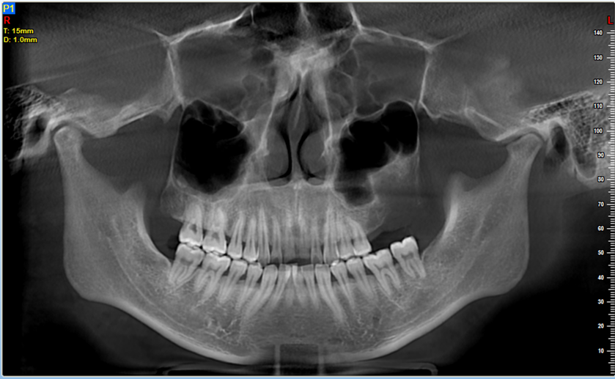
Figure 2: CBCT before implantation（2018.1.8）
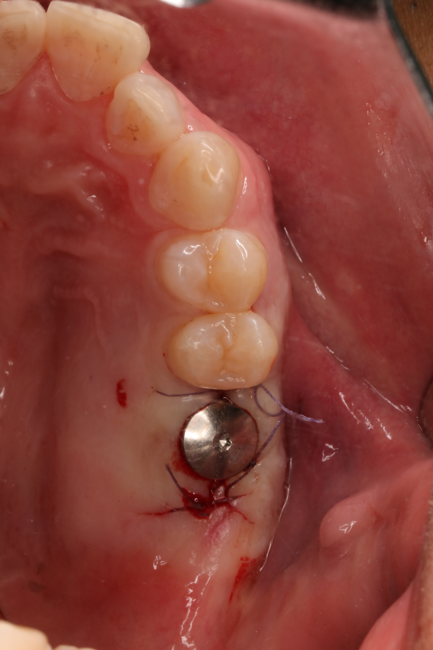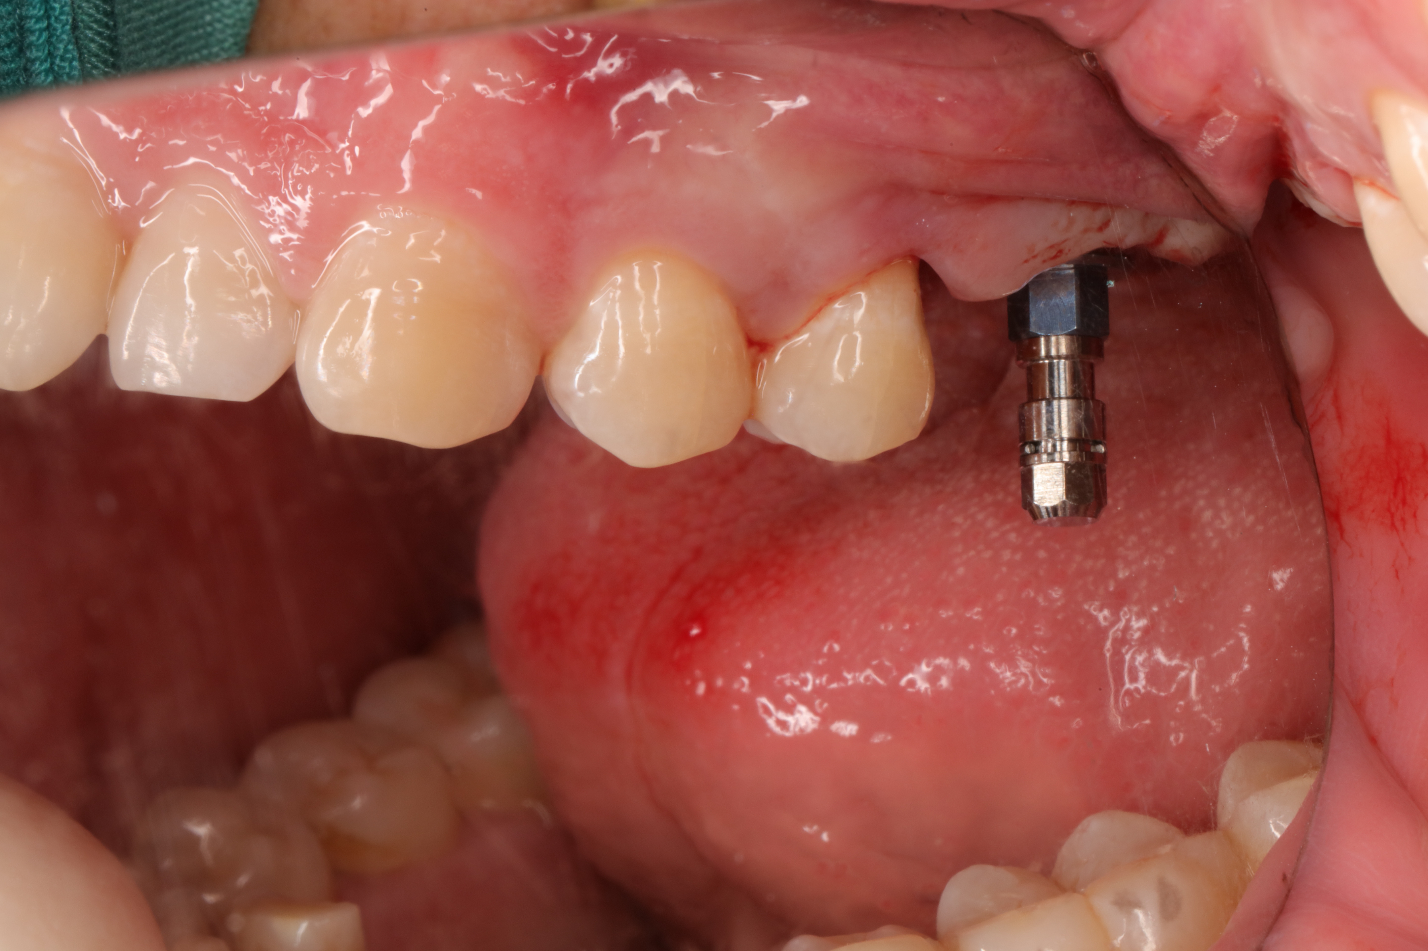
Figure 3: 26 intraoral images during implantation（2018.2.1）
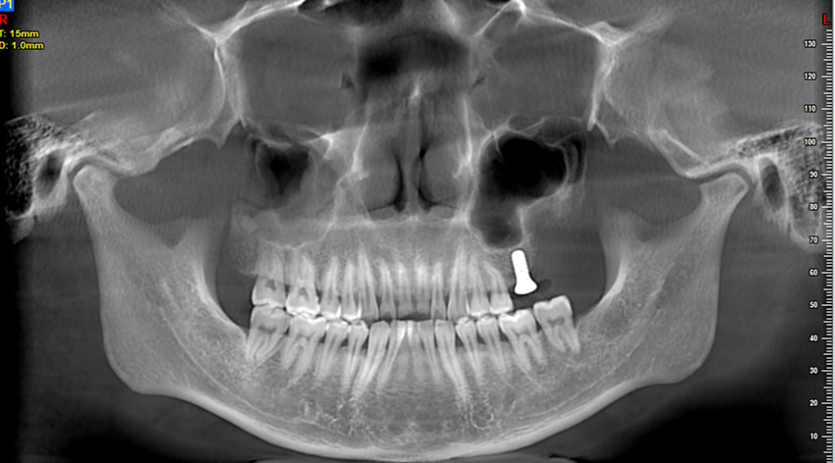
Figure 4: CBCT after implantation（2018.2.1）
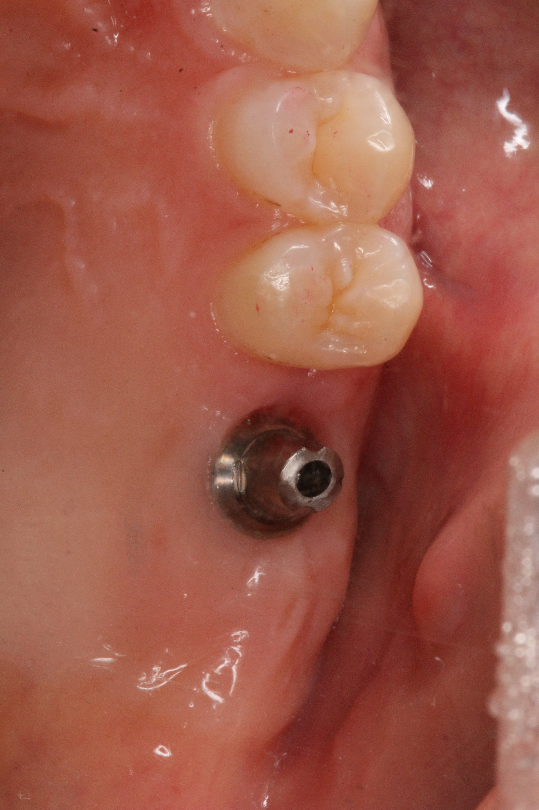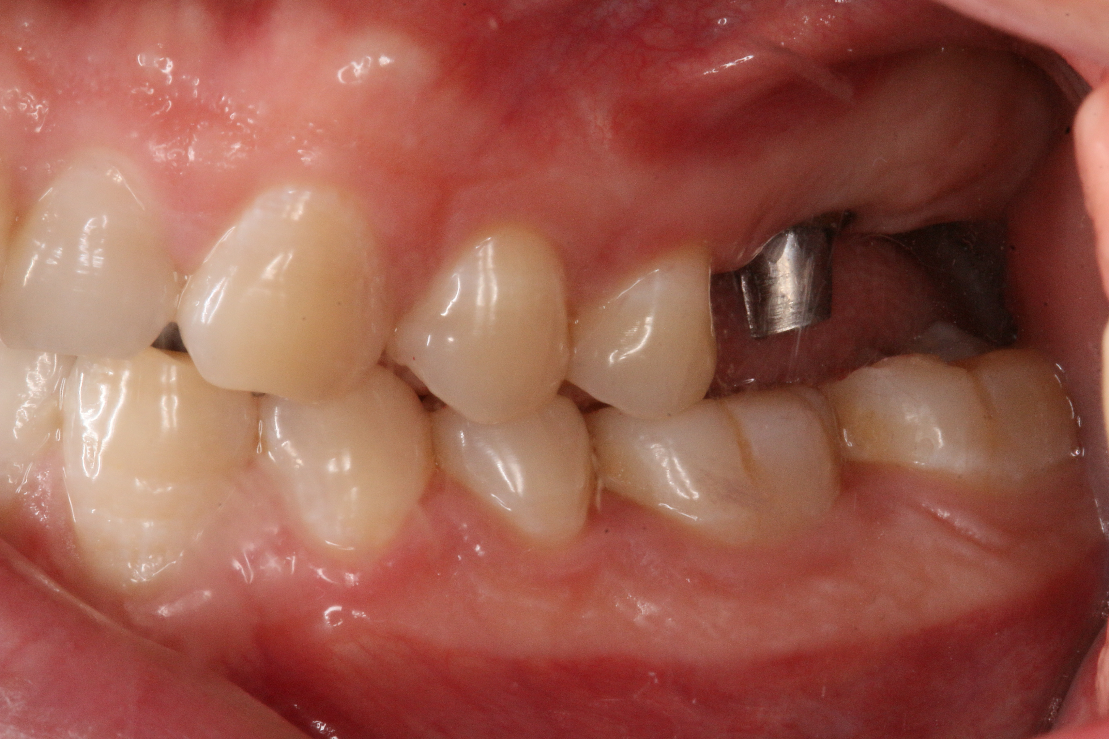
Figure 5: 26 intraoral images 6 months after planting（2018.7.31）
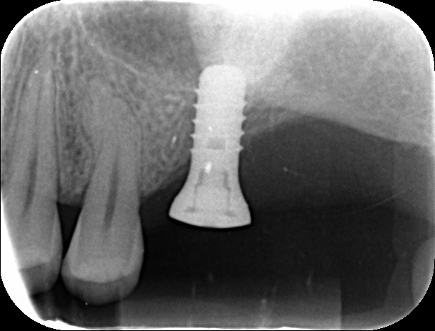
Figure 6: 26 Apical slices 6 months after planting（2018.7.31）
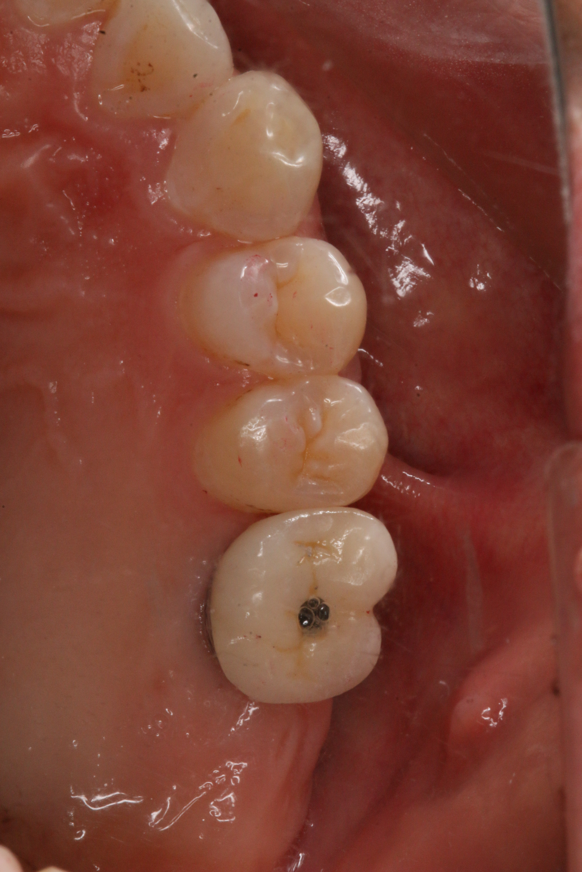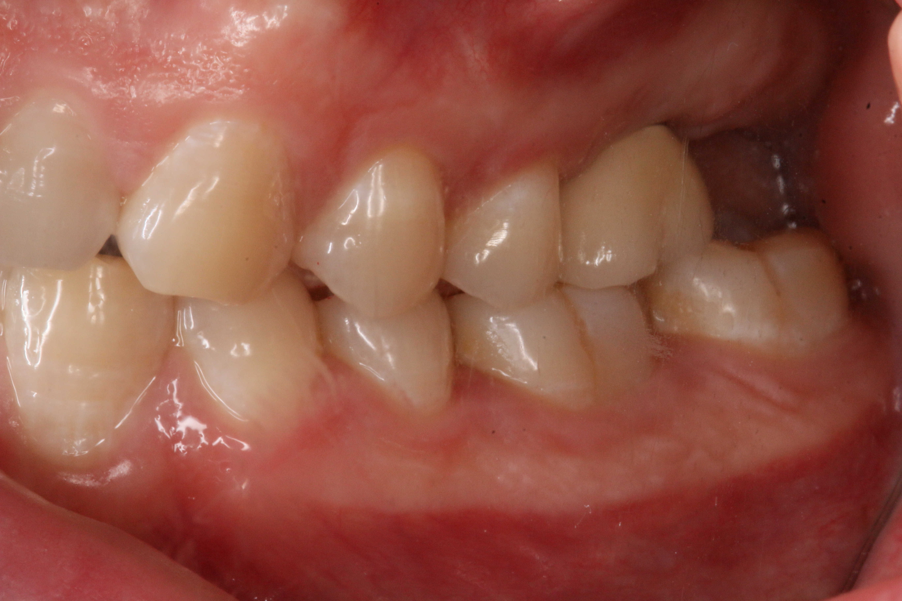
Figure 7: 26 Intraoral image after restoration（2018.8.16）
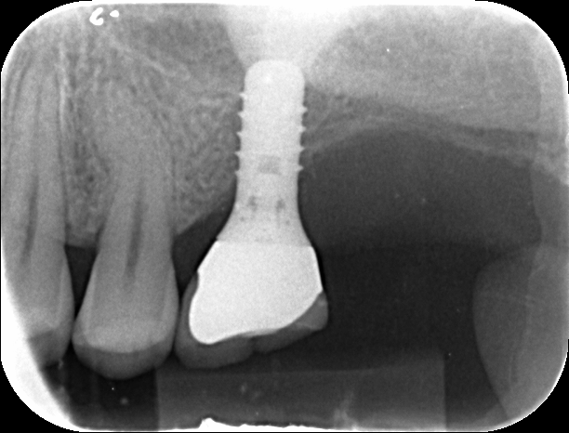
Figure 8: 26 apical slices after planting and restoration（2018.8.16）
DISCUSSION
An impacted tooth refers to a tooth that can only partially erupt or cannot erupt at all due to the obstruction of adjacent teeth, bone, or soft tissue, and cannot erupt in the future. Common impacted teeth are the third mandibular molar, the third maxillary molar and the maxillary canine ^{[1]} .
In this case, 26 had no obvious dental pulp disease, so it was speculated that it may be a para-dental cyst. Microscopically, the para-dental cyst behaved similarly to the apical cyst. Clinically, the affected tooth of the apical cyst was a dead pulp tooth, and the para-dental cyst accompanied by the tooth was with living pulp. Paradental cyst is a special type of inflammatory root cyst, which mostly occurs in the buccal or distal of the impacted mandibular third molar. Patients often have recurrent episodes of pericoronitis. The teeth are live pulp teeth. X-rays show that the partially impacted mandibular third molar has a clearly defined transmission zone in the distal.Sometimes, the lesion can extend to the apical region. Paradental cysts can also occur in positions other than the third molar of the mandible ^{[2,3]} ,such as the first permanent molar of the lower jaw and the second permanent molar of the lower jaw, but there is no report of the paradental cyst of the upper molar.
The reason for the second molar molar misalignment is the lack of posterior arch space (such as developmental or iatrogenic), the adjacent tooth factor (the developing second molar loses the close guidance of the distal root of the first molar and cannot normally erupt vertically. The third molar of the mandible is often impacted mesially, and the force of its crown may cause the impact of the second molar; when the developing third molar tooth sac is competing with the second molar over the gap, it often leads to the impaction of the second molar), Abnormal position of the second molar (tooth germ displacement; abnormal axis tilt), systemic factors, local factors, etc ^{[4,5]} . The impact of the second molar is a relatively rare condition during the eruption of teeth, and its incidence is about 0.03% -0.21%. The incidence of this condition is more unilateral than bilateral, and it is more common in the lower jaw than the upper jaw. There are slightly more males than females, and the incidence of mesial obesity is higher ^{[6]} .
The second molar impact treatment method: ① The most ideal treatment method refers to orthodontic treatment, which is believed to have the least impact on the tooth dentition, the best prognosis. Orthodontic treatment requires higher treatment timing and direction of tooth impact, and long traction time. ②Extract the second molar and observe the eruption of the third molar ^{[7]}. After the extraction of the second permanent molar of the upper jaw, the third molar moves mesially, which promotes eruption and reduces the impact; the axis of the upper third molar is clearly upright. The earlier the extraction time, the better it may be for the uprightness of the maxillary third molar, which is helpful for reducing impact. But this has higher requirements on the shape and eruption direction of the third molar^{[8]}③Surgical methods: (a)straight surgical procedure (b) extraction of the impacted second molar and replantation of the third molar at the second molar④Extraction of impacted molars, repair treatment.
CONFLICTS OF INTEREST
All authors declared that there are no conflicts of interest.
REFERENCES
- Zhang Zhiyuan. Oral and Maxillofacial Surgery: 7th Edition [M]. 2012.
- Friedrich R E , Scheuer H A , Zustin J . Inflammatory paradental cyst of the first molar (buccal bifurcation cyst) in a 6-year-old boy: case report with respect to immunohistochemical findings.[J]. Vivo, 2014, 28(3):333-339.
- Borgonovo A E, Grossi G B, Maridati P C, et al. Juvenile paradental cyst: presentation of a rare case involving second molar[J]. Minerva Stomatologica, 2013, 62(10):397.
- Bilodeau EA, Collins BM. Odontogenic Cysts and Neoplasms. Surg Pathol Clin. 2017;10(1):177‐222.
- Duan Yinzhong, Han Chun. Cause analysis and orthodontic treatment of second molar malocclusion [J]. Chinese Journal of Practical Stomatology, 2009, 2 (7): 404-408.
- He Xin, Zhang Dongliang. Treatment of impacted mandibular second molar [J]. Stomatology Research, 2014 (10): 1001-2003.DOI: 01-1003.DOI: 10.13701 / j.cnki.kqyxyj. 2014.10.025.
- Liu Yao, Duan Yinzhong, Jin Zuolin. A clinical study of the third molar's spontaneous migration after the second permanent molar is removed [J]. Journal of Practical Stomatology, 2004, 20 (4): 497-499.
- Baik U B , Kim M R , Yoon K H , et al. Orthodontic uprighting of a horizontally impacted third molar and protraction of mandibular second and third molars into the missing first molar space for a patient with posterior crossbites[J]. American Journal of Orthodontics & Dentofacial Orthopedics, 2017, 151(3):572-582.

