Paper Title Foramen magnum papilloma case report and review of the literature

Veranis Sotiris ¹, Karydakis Ploutarchos ¹, Tsantopoulos Margaritis^{2,} Spanou Kallirroi², Koutsoumpelis George¹

¹ 251 General Air Force and Reserve Hospital, Neurosurgical Department
² 251 General Air Force and Reserve Hospital, Neuropathology Department

Correspondence
Veranis Sotiris, 251 General Air Force and Reserve Hospital, 3-5 Kanellopoulou Street po box 11525,
Athens, Greece
Email address: veranissotiris@gmail.com

Abstract
Atypical choroid plexus papillomas are rare tumors in adults especially when there are located in an extraventricular location.
We present a case of a 42-year-old male patient suffering from a foramen magnum choroid plexus papilloma resembling meningioma in initial evaluation who developed dizziness, hearing loss and gait disturbances Patient was treated with suboccipital craniotomy and partial tumor removal. We describe technique and postoperative complications. We further review other published cases with atypical choroid plexus papillomas of the posterior fossa in adults.
Keywords Papilloma, foramen magnum, suboccipital craniotomy, posterior fossa

1.Introduction
Choroid plexus papilloma (CPP) is a rare tumor of neuroectodermal origin. Is more common in paediatric population than adults and it presents supratentorial in the former and subtentorial in the latter. According to the 2016 World Health Organization classification, choroid plexus tumors are classified as papillomas (grade I), atypical tumors (grade II) and carcinomas (grade III). Choroid plexus papillomas grade I have less than two mitotic figures per 10 high power fields, atypical grade II depict two to five per 10 high power fields, and carcinomas grade III have greater than five mitotic figures per 10 high power fields. Grossly, the tumors are soft, globular, friable pink masses with irregular projections and high vascularity.²
Choroid plexus papillomas of the posterior fossa cause symptoms of cranial nerves palsies, such as deafness or tinnitus, cerebellar dysfunction and raised intracranial pressure which can cause papilledema and blindness.^{1,5,6,7}
CPP in adults is located usually inside the fourth ventricle and extraventricular locations are rare. Although the most common anatomical site of involvement is the fourth ventricle, some may arise from the foramen of Luschka and extend to the extraventricular area ³. Furthermore, a rare case of multiple spinal drop metastases from CPP of the posterior fossa has been published.⁸
CT (computed tomography), MR (magnetic resonance) and rarely angiography are the initial diagnostic workup modalities. CPP in adults. They are weak enhancing tumors, entrapped cyst of CSF or peritumoral flow voids are occasionally seen and calcification as well in some cases.
Tumors are iso or hyperintense in T2 imaging compared to cerebellar gray matter. In head CT tumor mass is usually isodense in precontrast and hyperdense in postconstrast imaging compared to white matter.^{3,6}
Anterior or Posterior inferior cerebellar arteries are involved mainly in the blood supply of the tumor in angiographic images.³
Surgery with complete resection can be curative in papillomas, with 5-year survival rates close to 100% and occasional recurrences. Radical surgery in carcinomas is difficult and usually requires adjuvant therapy.
Article | Patient age /sex | Tumor Location | Pathology | Approach | Resection | Complication
Ignacio Jusué-Torres et al¹ | 38 male | 4th ventricle | Atypical choroid papilloma | Telovellar | Total | None
Lechanoine F et al ⁴ | 47 male | Cerebellomedullary cistern | Benign CPP | Midline suboccipital and c1 partial laminectomy | Total | None preoperative hydrocephalus and Rinorrhea
van Swieten JC et al ⁶ | 28 female | 4th ventricle - CPA | Benign CPP | Midline suboccipital sitting position | Subtotal | None
van Swieten JC et al ⁶ | 30 male | Cerebellomedullary cistern | Benign CPP | Midline suboccipital sitting position | Total | None
van Swieten JC et al ⁶ | 64 female | CPA angle | Benign CPP | Left suboccipital sitting position | Total | Meningitis
Matsushita S et al ⁷ | 42 female | Left foramen of Luschka | Benign CPP with focal ependymal differentiation | Preoperative emobilization Suboccipital approach park bench position | Total | Brain stem infraction
Symms NP et al ⁹ | 61 male | 4th ventricle and foramen magnum | Benign CPP | Midline suboccipital and c1 partial laminectomy | Total | None
Yu H et al ⁸ | 49 male | Conus medullaris, C3-4, T7 | Atypical CPP | Staged excision | Partial | None

Table 1 Case reports publication with relevant pathology and surgical results

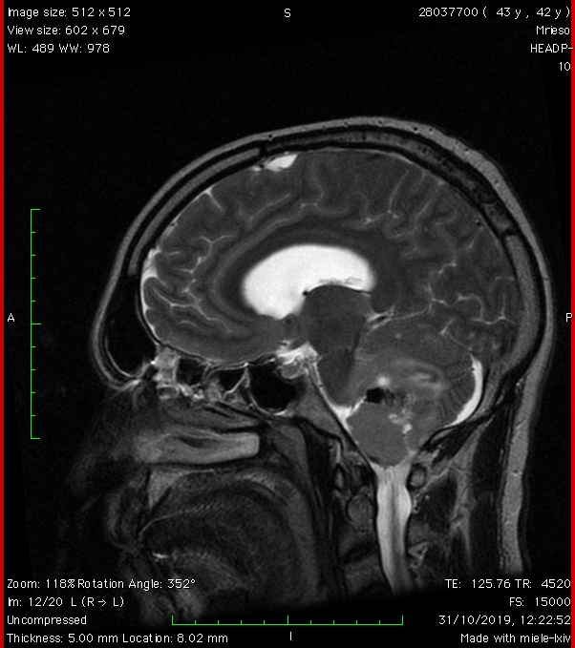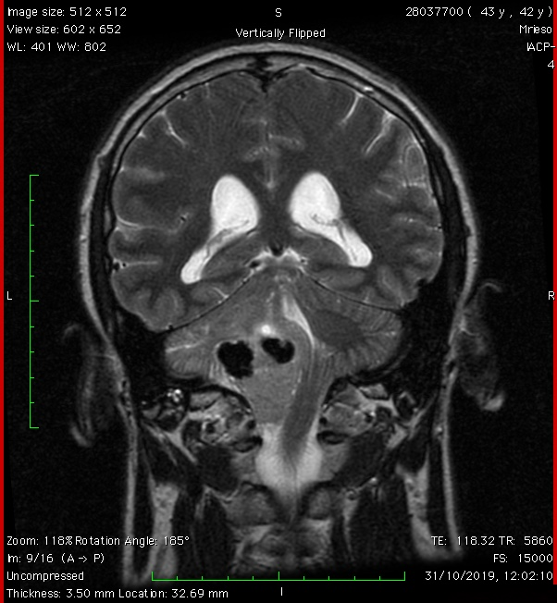
Figure 1 Preoperative sagittal and coronal T2 MR depicted a large mass at the level of the fourth ventricle and left lateral and anterior foramen magnum. Note calcification at the upper pole of the tumor

2. Method
We present a case of a 42 years old man who reported to our clinic with symptoms of progressive headache, left side deafness, diplopia and episodes of sudden loss of consciousness. Clinical examination revealed unsteady gait, left side nystagmus and deafness on the left side. On MRI and examination, a large mass at the left ant anterior foramen magnum has been diagnosed. (Fig 1) There were calcifications at the upper part of the tumor which was seated in the cerebellomedullary cistern. The tumor depicted mild enhancement after contrast administration. Differential diagnosis was between meningioma of the foramen magnum and choroid plexus papilloma.
Patient was operated under general anaesthesia and in the prone position, by a midline left suboccipital craniotomy and left C1 laminectomy. Microsurgical technique was applied for tumor removal and detachment from critical structures such as lower cranial nerves, vertebral artery and PICA. Vertebral artery and PICA (Posterior Inferior Cerebellar Artery) were detached from the lower pole of the tumor using an arachnoid plane. Central debulking was done with CUSA (Cavitronic Ultrasound Aspirator). On the anterior and lateral part of the tumor we recognized IX, X, XI and XII nerves. The upper part of the tumor was located inside the cerebellomedullary cistern and was heavily calcified and firmly attached to the dorsal aspect of the medulla and the distal PICA. This part was left intact to prevent neurological injury. (Fig2) Artificial dura and tissue glue were used to seal any dural defects Closure of the craniotomy was done by replacing the bone flap with titanium mini plates.
3. Results
Patient extubated immediately after surgery without neurological deficit. Postoperative course was complicated with mild voice hoarsens which gradually resolved. Fifteen days later patient was readmitted because of fever and nuchal rigidity. Meningitis by a MRSA strain was diagnosed and patient treated for 15 days with intravenous vancomycin 1gr twice per day. Meningitis resolved completely and patient discharged at home.
Histological findings consisted of well-differentiated papillary pattern composed of a single layer of monomorphic cells. Number of mitoses was two to five per 10 high power fields and therefore we diagnosed the tumor as grade II atypical choroid papilloma. Fig 3-5
In our patient, choroid papilloma cell were stained 100% for s100 which is a good prognostic feature.^{10,11}

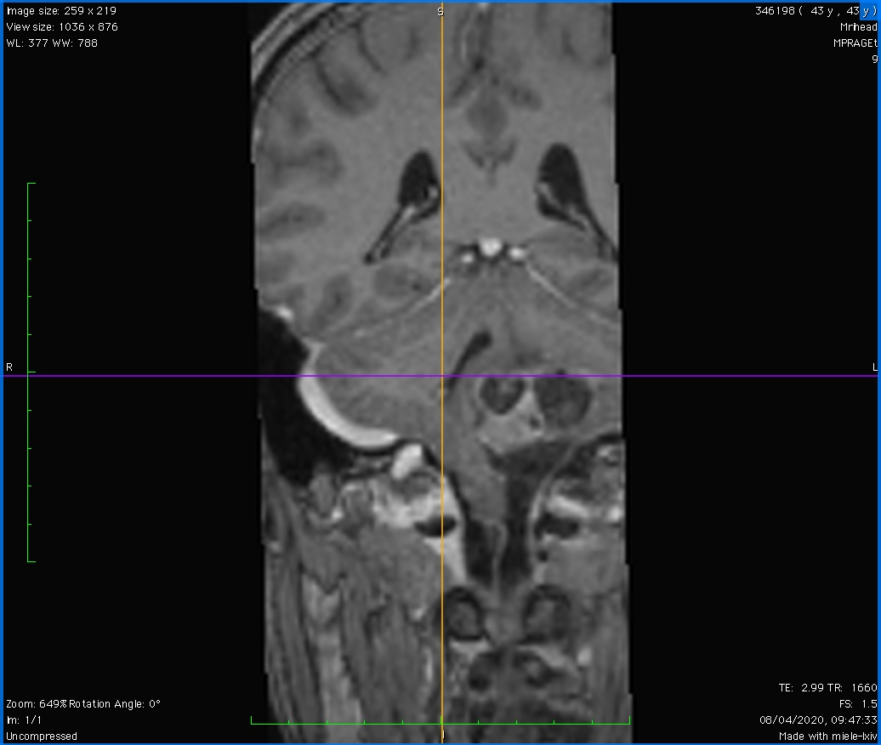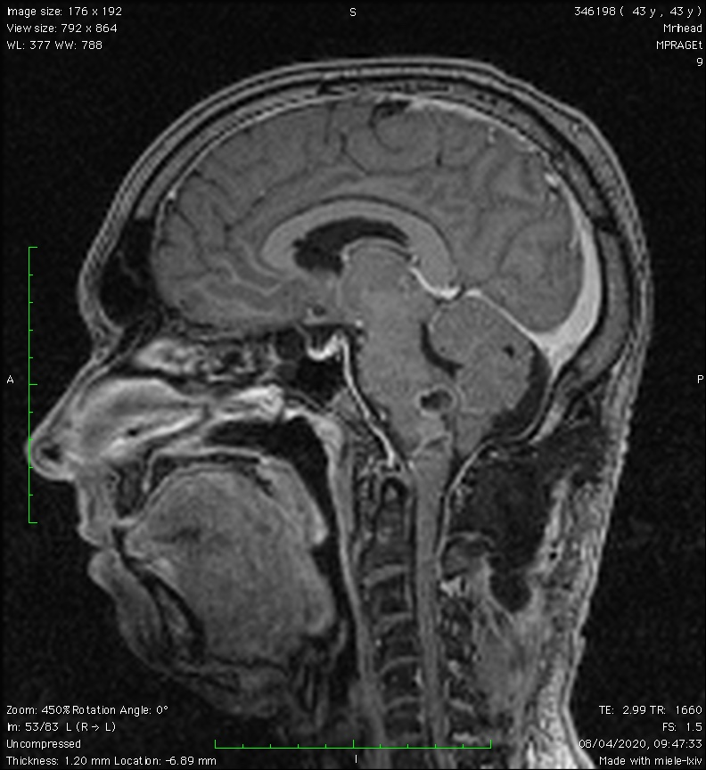
Figure 2 Postoperative coronal and sagittal T1 MRI depicts partial resection of the firmly adherent upper pole of the tumor to the brainstem and PICA

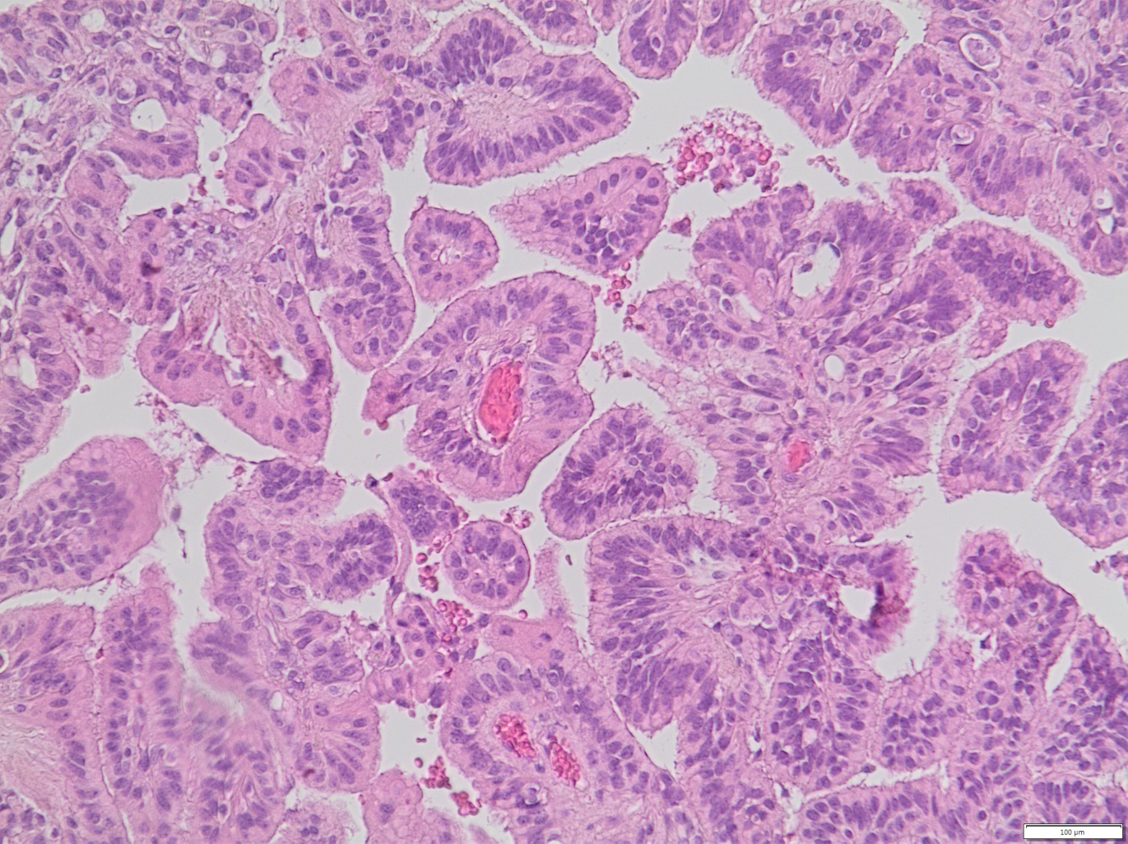
Figure 3 x20 Well-differentiated papillary pattern composed of a single layer of monomorphic cells

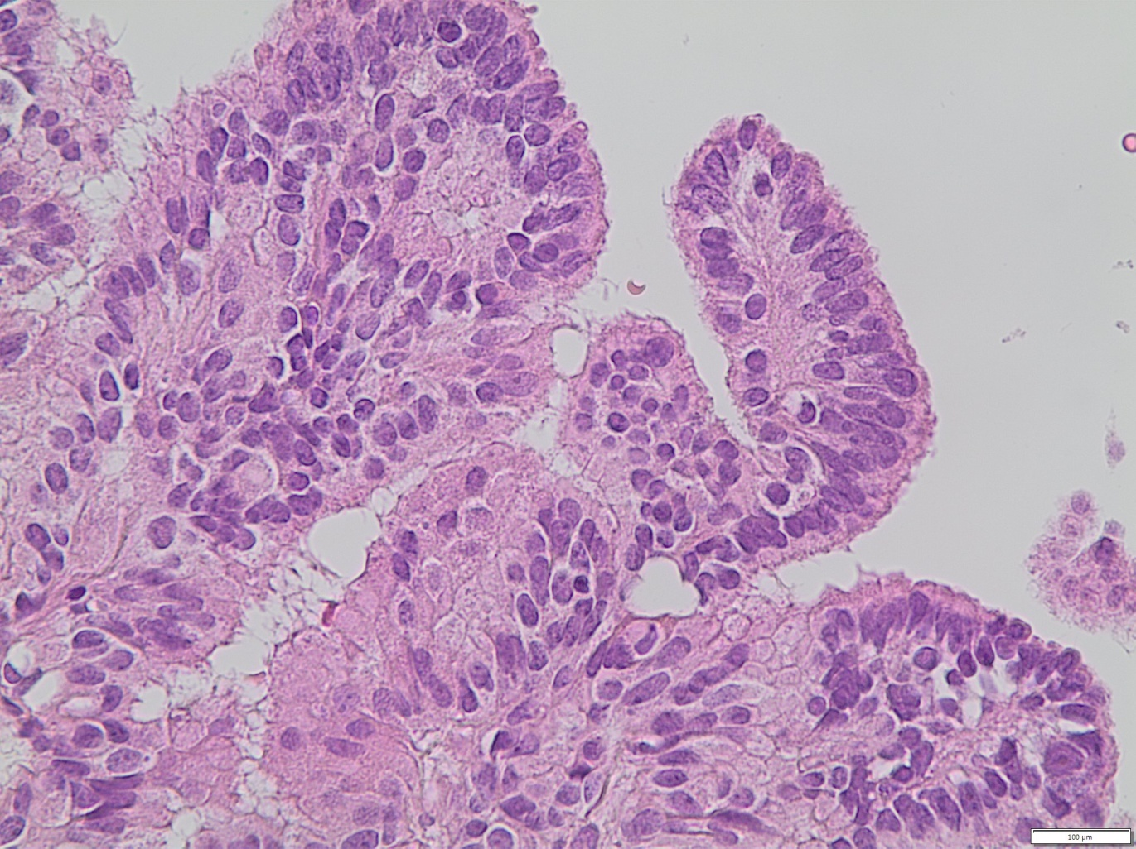
Figure 4 x40 focally the neoplastic cells are mild atypical and pseudostratified

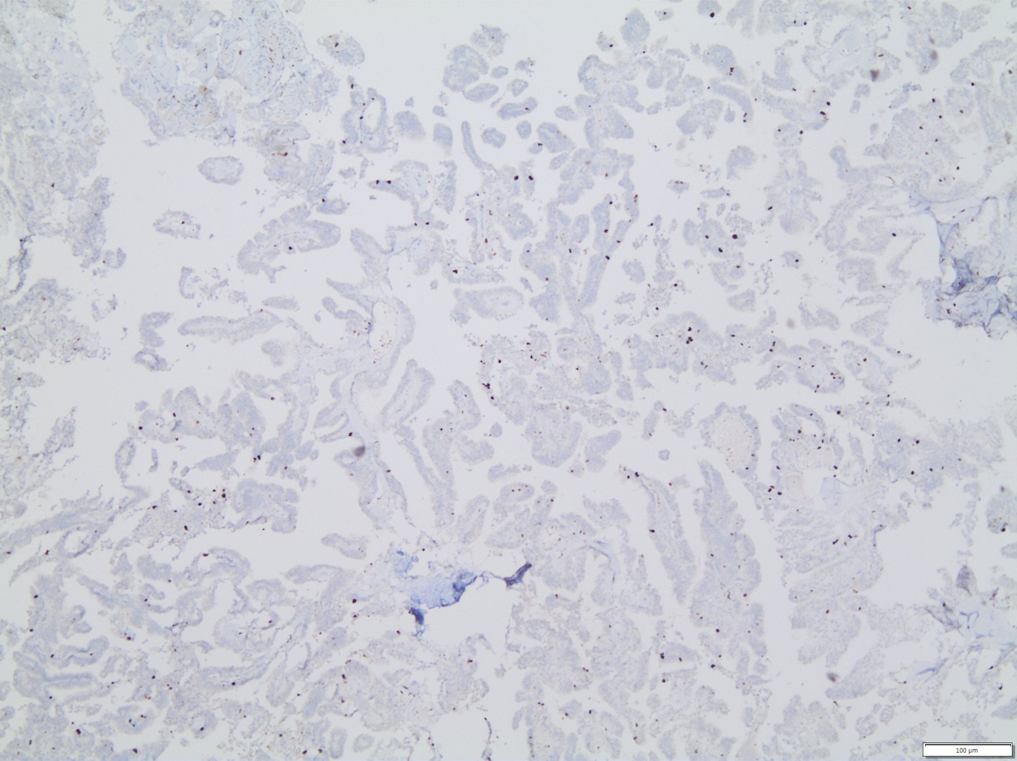
Figure 5 Focal increase of proliferation (ki-67 proliferation index)

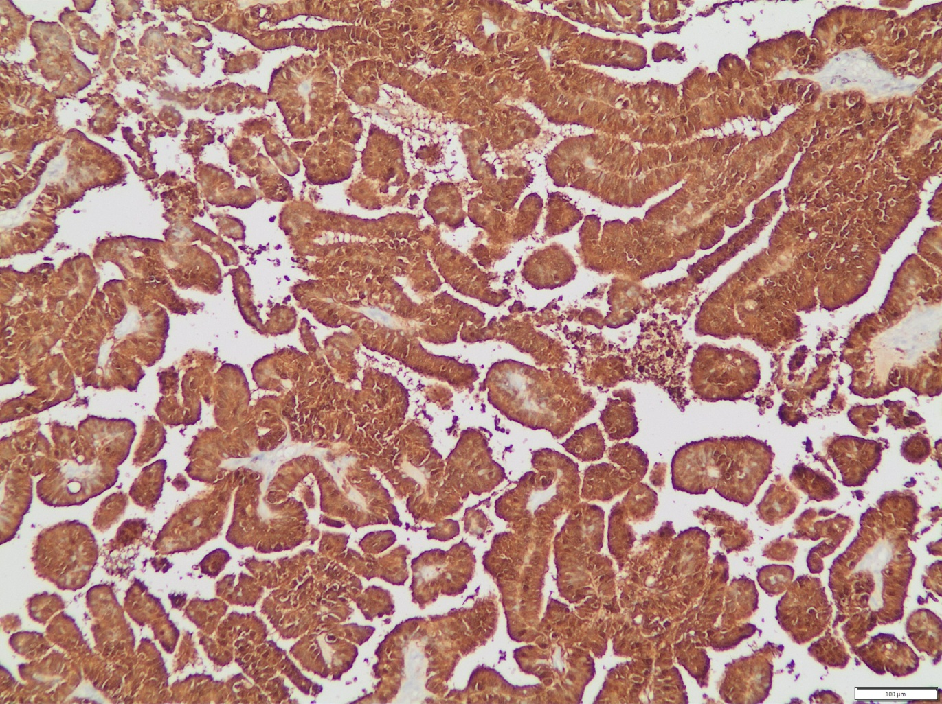
Figure 6 Diffuse S100 positive staining is related with older patient age and better prognosis ^{10,11}

4. Discussion

First line treatment of CPP in all studies were surgical excision, Adjuvant treatment has been suggested only for carcinoma and simple follow up for benign CPPs.⁵. Chemotherapy is suggested for choroid plexus carcinomas in infants and radiotherapy for choroid plexus carcinomas in adults.⁵Although it not clear what is the best strategy for atypical CPPs.
Prognosis of CPP depends mainly on histology. 10-year projected survival rate was 77% in benign CPP and 35% in choroid plexus carcinoma in a meta-analysis reported by Wolff et al ^{5.} Relapse after primary treatment is a poor prognostic factor for carcinoma only in respect to benign papilloma.

5.Conclusion

Atypical choroid plexus papillomas are associated with an increased risk of recurrence or malignant transformation when compared to “typical” papillomas. At present, complete surgical excision and close follow-up seems to be the most reliable treatment. Adjuvant chemotherapy or radiotherapy should be considered in cases of partial resection, recurrence or dissemination

References

- Jusué-Torres I, Ortega-Zufiría JM, Tamarit-Degenhardt M, Poveda-Núñez PD.
[Atypical choroid plexus papilloma in adults: case report and literature review]. Neurocirugia (Astur). 2012 May;23(3):116-21. doi: 10.1016/j.neucir.2011.02.001.
Epub 2012 May 8. Review. Spanish. PubMed PMID: 22575760.
- Joseph JJ, M Das J. Choroid Plexus Papilloma. [Updated 2019 Oct 21]. In: StatPearls [Internet]. Treasure Island (FL): StatPearls Publishing; 2020 Jan-. Available from: https://www.ncbi.nlm.nih.gov/books/NBK539749/
- Ji Hoon Shin, Ho Kyu Lee, Ae Kyung Jeong, Sung Hye Park, Choong Gon Choi, Dae Chul Suh Choroid plexus papilloma in the posterior cranial fossa MR, CT, and angiographic findings Journal of Clinical Imaging 25 (2001) 154–162
- Lechanoine F, Zemmoura I, Velut S. Treating Cerebrospinal Fluid Rhinorrhea without Dura Repair: A Case Report of Posterior Fossa Choroid Plexus Papilloma and Review of the Literature. World Neurosurg. 2017 Dec; 108:990. e1-990.e9. doi: 10.1016/j.wneu.2017.08.121. Epub 2017 Sep 1. Review. PubMed PMID: 28866068.
- JEA Wolff, M Sajedi, R Brant, MJ Coppes and RM Egeler Choroid plexus tumors British Journal of Cancer (2002) 87, 1086 – 1091
- van Swieten JC, Thomeer RT, Vielvoye GJ, Bots GT. Choroid plexus papilloma in the posterior fossa. Surg Neurol. 1987 Aug;28(2):129-34. PubMed PMID: 3496674.
- Matsushita S, Shimono T, Goto T, Doishita S, Kuwae Y, Miki Y. Posterior fossa choroid plexus papilloma with focal ependymal differentiation in an adult patient: A case report and literature review. Radiol Case Rep. 2018 Dec4;14(3):304-308. doi: 10.1016/j.radcr.2018.11.017. eCollection 2019 Mar. PubMed PMID: 30546813; PubMed Central PMCID: PMC6282631
- Yu H, Yao TL, Spooner J, Stumph JR, Hester R, Konrad PE. Delayed occurrence of multiple spinal drop metastases from a posterior fossa choroid plexus papilloma. Case report. J Neurosurg Spine. 2006 Jun;4(6):494-6. PubMed PMID
- Symss NP, Prasad AN, Vasudevan MC, Ramamurthi R. Exophytic choroid plexuspapilloma of the fourth ventricle presenting with cerebrospinal fluid rhinorrhea: a case report. Surg Neurol. 2009 Jun;71(6):705-8. doi: 10.1016/j.surneu.2007.11.019. Epub 2008 Mar 3. PubMed PMID: 18313738.
- Paulus W (1), Jänisch W Clinicopathologic correlations in epithelial choroid plexus neoplasms: a study of52 cases. Acta Neuropathol. 1990;80(6):635-41.
- Coffin CM, Wick MR, Braun JT, Dehner LP Choroid plexus neoplasms. Clinicopathologic and immunohistochemically studies. Am J Surg Pathol. 1986 Jun;10(6):394-404.

