Role of prolotherapy in electric burns management
1. Neljo Thomas
Senior Resident
Department of Plastic Surgery
Jawaharlal Institute of Postgraduate Medical Education and Research (JIPMER)
Pondicherry
India-605006
Email: neljothomas@gmail.com
2. Ravi Kumar Chittoria
Professor
Department of Plastic Surgery
Jawaharlal Institute of Postgraduate Medical Education and Research (JIPMER)
Pondicherry
India-605006
Email: drchittoria@yahoo.com
Phone no- 9442285670

3. Saurabh Gupta
Senior Resident
Department of Plastic Surgery
Jawaharlal Institute of Postgraduate Medical Education and Research (JIPMER)
Pondicherry
India-605006
Email: drsaurabh2007@gmail.com

4. Chirra Likhitha Reddy,
Senior Resident
Department of Plastic Surgery
Jawaharlal Institute of Postgraduate Medical Education and Research (JIPMER)
Pondicherry
India-605006
Email: drlikhithareddy@gmail.com

5. Padmalakshmi Bharathi Mohan
Senior Resident
Department of Plastic Surgery
Jawaharlal Institute of Postgraduate Medical Education and Research (JIPMER)
Pondicherry
India-605006
Email: pebeyem@gmail.com

6. Shijina K
Senior Resident
Department of Plastic Surgery
Jawaharlal Institute of Postgraduate Medical Education and Research (JIPMER)
Pondicherry
India-605006
Email: chinnuvmmc@gmail.com

7. Imran Pathan
Senior Resident
Department of Plastic Surgery
Jawaharlal Institute of Postgraduate Medical Education and Research (JIPMER)
Pondicherry
India-605006
Email: pathan.drimran@gmail.com

8 .Nishad K.
Senior Resident
Department of Plastic Surgery
Jawaharlal Institute of Postgraduate Medical Education and Research (JIPMER)
Pondicherry
India-605006
Email: nishadtmc@gmail.com
9.Daisy Loyola
Observer
Department of Plastic Surgery
Jawaharlal Institute of Postgraduate Medical Education and Research (JIPMER)
Pondicherry
India-605006
Email : drdaisyloyola@gmail.com

Corresponding author:
Ravi Kumar Chittoria
Professor
Department of Plastic Surgery
Jawaharlal Institute of Postgraduate Medical Education and Research (JIPMER)
Pondicherry
India-605006
Email: drchittoria@yahoo.com
Phone no- 9442285670
Abstract: Electric burns are known for difficulty in healing and wound management. There is a lack of growth factors in these chronic wounds and needs to be supplemented with adjuvant therapy that allows for the faster healing .This article highlights the role of prolotherapy in management of electric burns.

Key words prolotherapy, Electric burns
Introduction
Adult wound healing is divided into three stages: inflammatory phase, proliferative phase, and remodelling phase. The three stages have to occur in conjunction to result in wound healing. Wound bed preparation is a novel concept and can be summarized using T.I.M.E with T for tissue: non-viable or deficient. I for infection/inflammation, M for moisture balance. E for epidermis which was changed to E for edge. ¹Large wounds often require graft or flap for wound coverage, which require wound bed preparation. Prolotherapy is a procedure in which some irritant substance is injected into wound that initiate an inflammatory reaction that in turn promote healing of wound.². Recently in literature, we came across use of prolotherapy for use in wound bed preparation. .
Materials and methods: This study was conducted in the department of Plastic Surgery at tertiary care center after getting the departmental ethical committee approval. Informed written consent was taken from the patient. The details of the patient in study are as follows: 40 year old female without any known co morbidities with history of accidental electric burns from low voltage source and sustained circumferential 3rd to 4th degree burns over the left little finger with loss of vascularity of the distal area and 2nd degree burns over the medial aspect of the ring finger in the proximal phalanx (figure 1). Wound bed preparation was done for the patient with prolotherapy with 25% Dextrose (figure 2) as her ulcer did not show any evidence of healing (figure3). Patient underwent little finger disarticulation after 1 week when the line of demarcation was developed (figure 4). Following the procedure patient was dressed regularly. She developed a raw area over the medial aspect of the ring finger which failed to show any evidence of healing. Dextrose 25% solution was used as agent for prolotherapy. It was injected uniformly on to the wound (10ml) followed by gauze dressing. Repeated session of prolotherapy was given every three days. After 4 sessions of the treatment the wound was reassessed after 2weeks for evidence of wound healing.
Results: The wound bed showed good granulation tissue (figure 5). Prolotherapy is found feasible as adjuvant modality of wound bed preparation. Its role in wound bed preparation needs investigation by further studies.

Discussion

Burn injury is a major cause of trauma to the human body,with a long healing period. The mortality rate of burn injury has decreased with new treatment modalities, but secondary infections and prolonged healing periods still affect the mortality rates. Many therapeutic methods are available to effect the wound healing such as the topical application of insulin, growth factors, negative pressure assisted wound closure, oxidized regenerated cellulose/collagen, hyaluronic acid conjugated with glycidyl methacrylate or gelatin dressings.
The term prolotherapy was coined by Dr. George Hackett in 1956 derived from the Latin word proles meaning offspring or progeny and the English word- therapy. It involves injecting an irritant substance into a ligament or tendon to improve the growth of new tissue. Multiple agents are used in prolotherapy,such as irritants (phenol), chemo-attractants (sodium morrhuate), and osmotic agents(dextrose).
However the exact mechanism of prolotherapy is not clear, proponents of the technique believe that the application of hypertonic dextrose causes cell dehydration and osmotic rupture at the injection site that leads to local tissue injury that induces granulocyte and macrophage migration, with release of the growth factors and collagen deposition.³In vitro studies have shown that concentrations of 5% dextrose have resulted in production of a number of growth factors needed for tissue repair like PDGF, TGF-b, EGF, b-FGF, IGF-1, and CTGF.⁴
In vitro studies have shown that cultivation of cells in high glucose culture medium can increase the PDGF expression. PDGF has multiple reparative effects in wounds, including promotion of angiogenesis, fibroblast proliferation, and extra-cellular production. TGF-b expression is also increased by high glucose.^{5,6}TGF-b is involved in different steps of wound healing from inflammation to wound re-epithelialization. Other growth factors increased by high glucose include EGF,b-FGF, IGF and CTGF.
Studies on prolotherapy suggest that there are direct effects on collagen synthesis.⁷A few studies have demonstrated up-regulation of matrix in response to prolotherapy or in vitro cultivation with high concentrations of glucose. Collagen type-I synthesis is also increased in high-glucose cultivation of renal fibroblasts, in a TGF-b-mediatedpathway.⁸Cartilage matrix protein aggrecan is increased and reported in chondrocytes cultured in high glucose, and in patients who have received intra-articular injections of 12.5% dextrose.^{4-8.}There were no adverse effects for the prolotherapy with 25% dextrose solution .no local or systemic side effects were demonstrable.
Prolotherapy has been shown effective in treating many musculoskeletal conditions—such as tendinopathies, ligament sprains, back and neck pain, tennis/golfers elbow, ankle pain, joint laxity and instability, plantar fasciitis, shoulder, knee pain and other joint pain. Prolotherapy is useful in chronic wound and allows to hasten the healing time.Prolotherapy provides analgesia to the patient although the mechanism is not known.

Limitations: The study was done on a single patient and needs large population based study to apply in practice
DECLARATIONS
Acknowledgment
Authors’ contributions
All authors made contributions to the article
Availability of data and materials
Not applicable.
Financial support and sponsorship
None.
Conflicts of interest
None.
Consent for publication
Not applicable.

Copyright
© The Author(s) 2020.
References
- Frykberg RG, Banks J. Challenges in the treatment of chronic wounds. Adv Wound Care (New Rochelle) 2015; 4:560–582.
- Farpour HR, Fereydooni F. Comparative effectiveness of intra-articular prolotherapy versus periarticular prolotherapy on pain reduction and improving function in patients with knee osteoarthritis:a randomized clinical trial. Electron Physician 2017; 9:5663–5669.
- Barrientos S, Stojadinovic O, Golinko MS, Brem H,Tomic-Canic M. Growth factors and cytokines in wound healing. Wound Repair Regen 2008; 16:585–601.
- Oh JY, Choi GE, Lee HJ, et al. High glucose induced reactive oxygen species stimulates human mesenchymal stem cell migration through snail and EZH2-dependent E-cadherin repression. Cell Physiol Biochem 2018; 46:1749–1767.
- Penn JW, Grobbelaar AO, Rolfe KJ. The role of the TGF-beta family in wound healing, burns and scarring:a review. Int J Burns Trauma 2012;2:18–28
- Freeman JW, Empson YM, Ekwueme EC, Paynter DM, Brolinson PG. Effect of prolotherapy on cellular proliferation and collagen deposition inMC3T3-E1 and patellar tendon fibroblast populations. Transl Res 2011; 158:132–139.
- Wu TJ, Fong YC, Lin CY, Huang YL, Tang CH. Glucose enhances aggrecan expression in chondrocytes via the PKC alpha/p38-miR141–3p signalling pathway. J Cell Physiol 2018; 233:6878–6887.
- Topol GA, Podesta LA, Reeves KD, et al. Chondrogenic effect of intra-articular hypertonic dextrose (prolotherapy) in severe knee osteoarthritis. PM R 2016;8:1072–1082.

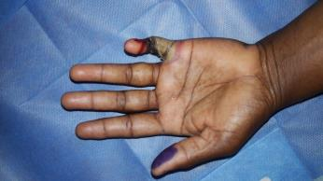
Figure 1:Wound at the time of presentation
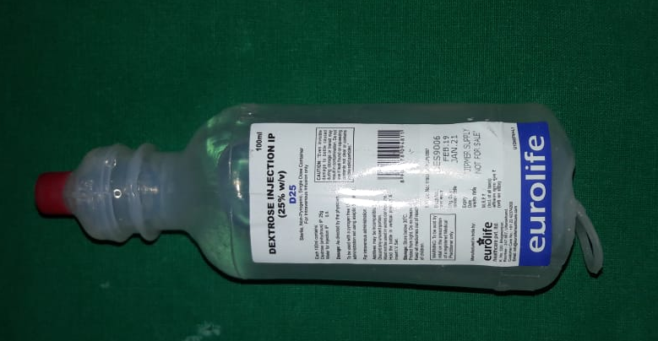
Figure 2:25% dextrose used in prolotherapy
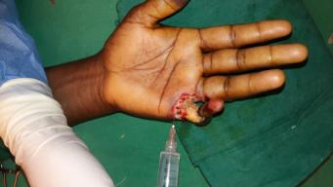
Figure 3:topical prolotherapy for wound bed preparation

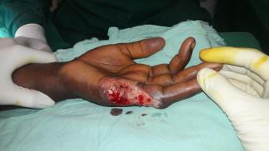
Figure 4:Disarticulation of little finger at MCPJ

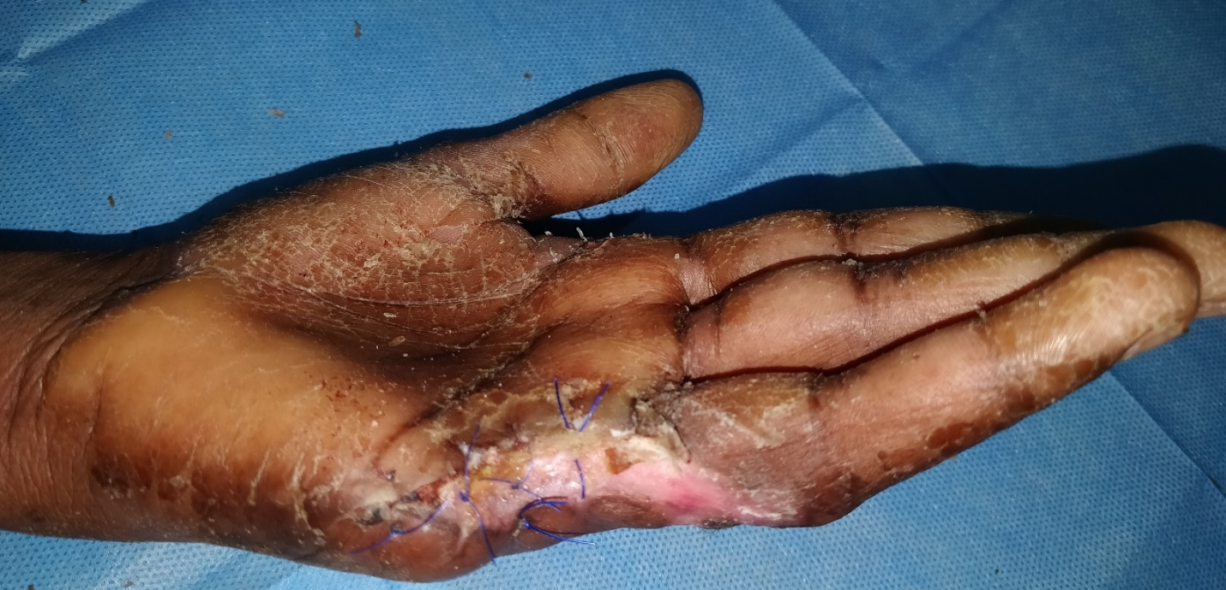
Figure 5: healed wound bed

