Role of Autologuos Platelat Rich Plasma in amputation stump
1. Neljo Thomas
Senior Resident
Department of Plastic Surgery
Jawaharlal Institute of Postgraduate Medical Education and Research (JIPMER)
Pondicherry
India-605006
Email: neljothomas@gmail.com
2. Ravi Kumar Chittoria
Professor
Department of Plastic Surgery
Jawaharlal Institute of Postgraduate Medical Education and Research (JIPMER)
Pondicherry
India-605006
Email: drchittoria@yahoo.com
Phone no- 9442285670

3. Saurabh Gupta
Senior Resident
Department of Plastic Surgery
Jawaharlal Institute of Postgraduate Medical Education and Research (JIPMER)
Pondicherry
India-605006
Email: drsaurabh2007@gmail.com

4. Chirra Likhitha Reddy,
Senior Resident
Department of Plastic Surgery
Jawaharlal Institute of Postgraduate Medical Education and Research (JIPMER)
Pondicherry
India-605006
Email: drlikhithareddy@gmail.com

5. Padmalakshmi Bharathi Mohan
Senior Resident
Department of Plastic Surgery
Jawaharlal Institute of Postgraduate Medical Education and Research (JIPMER)
Pondicherry
India-605006
Email: pebeyem@gmail.com

6. Shijina K
Senior Resident
Department of Plastic Surgery
Jawaharlal Institute of Postgraduate Medical Education and Research (JIPMER)
Pondicherry
India-605006
Email: chinnuvmmc@gmail.com

7. Imran Pathan
Senior Resident
Department of Plastic Surgery
Jawaharlal Institute of Postgraduate Medical Education and Research (JIPMER)
Pondicherry
India-605006
Email: pathan.drimran@gmail.com

8 .Nishad K.
Senior Resident
Department of Plastic Surgery
Jawaharlal Institute of Postgraduate Medical Education and Research (JIPMER)
Pondicherry
India-605006
Email: nishadtmc@gmail.com
9.Daisy Loyola
Observer
Department of Plastic Surgery
Jawaharlal Institute of Postgraduate Medical Education and Research (JIPMER)
Pondicherry
India-605006
Email :daisyloyola@gmail.com

Corresponding author:
Ravi Kumar Chittoria
Professor
Department of Plastic Surgery
Jawaharlal Institute of Postgraduate Medical Education and Research (JIPMER)
Pondicherry
India-605006
Email: drchittoria@yahoo.com
Phone no- 9442285670
Abstract: Wound healing is a complex process with overlapping steps of haemostasis, the inflammatory and proliferative phases, remodelling .Any problem with the edge of the wound can be detrimental to healing and may cause delay in wound healing. In this article, we share our experience of using topical insulin therapy for wound bed preparation in non-healing ulcer over the amputation stump.

Key words topical insulin, amputation stump
Introduction: Wound bed preparation is a novel concept and is done with the T.I.M.E method. The Edge is a component which involves granulation tissue for better healing. Wound bed preparation is needed in difficult to heal wounds. Cost friendly methods in place of commercially available resources are essential in our population which will widen the acceptance of plastic surgery in the society. In this study we have used the patient’s own blood for preparation of platelet rich plasma with materials easily available in the hospital.
Materials and methods: This study was conducted in the department of Plastic Surgery at tertiary care center after obtaining the departmental ethical committee approval. Informed written consent was taken from patient in study .The details of the patient are as follows: 37 year old female with no co morbidities presented with history of road traffic accident 4 months back and underwent right below knee amputation due to vascular injury and degloving injury of the left lower limb and was treated with serial debridement in cardiothoracic and general surgery department. Now, the patient came to plastic surgery department with extensive raw area over left lower limb and non-healing ulcer over right below knee amputation stump. The dressings and antibiotic changes failed to bring healing of the wound. Wound bed preparation was attempted for the patient with platelet rich plasma harvested from the patient blood. Under all aseptic precautions the APRP was prepared by collecting 4.5ml of patient’s own venous blood and mixed with 0.5ml of heparin. This was then centrifuged at 3000rpm for 10minutes and provided three layers of which, the upper most layer was plasma, middle layer was buffy coat and the lower most layer was red blood cells. The upper most layer is then aspirated and then centrifuged in a fresh conical tube at 4000 rpm for 10 minutes. This yields platelet rich plasma at lower one third of the tube. The PRP was injected along the edge of the raw area and sterile dressings were applied (figure 2). The APRP was given twice a week for 2weeks.The wound was reassessed after 2weeks and found to have good granulation tissue.
Discussion
Wound bed preparation was defined kas ‘the global management of the wound to accelerate endogenous healing or to facilitate the effectiveness of other therapeutic measures. Wound bed preparation can be summarized by the acronym T.I.M.E with T for tissue: non-viable or deficient. I for infection/inflammation, M for moisture balance. E for epidermis which was later changed to E for edge. Wound debridement, control of inflammation/infection and moisture are essential components of wound bed preparation that may produce the edge of the wound to get activated, but if they fail, advanced therapies may be required.
Platelet Rich Plasma (PRP) is a portion of the plasma fraction of autologous blood with platelet concentration above the baseline (before centrifugation)¹. PRP contains higher levels of platelets as well as the full complement of clotting factors². It is composed of a range of growth factors (GF), chemokines, cytokines, and other plasma proteins³.PRP is a rich source of signaling molecules, and upon activation of the platelets in PRP, the P-granules degranulate and release GFs and cytokines that will modify the pericellular microenvironment. Some of the most important GFs released by platelets in PRP include vascular endothelial GF(VEGF), fibroblast GF (FGF), platelet-derived GF(PDGF), epidermal GF, hepatocyte GF, insulin-like GF 1, 2 (IGF-1, IGF-2), matrix metalloproteinases (MMP)2, 9, and interleukin 8^{4,5}.

The PRP is prepared from patient’s own blood using materials usually found in a hospital set up. A limitation is the total area to which PRP can be applied as only 10% of the blood collected can be converted to PRP. Hence, only small areas such as hands or neck can be treated, but even small benefits to these areas may represent a drastic improvement in the quality of life of the patient. Cost of commercially available PRP ranges from 13500-35000 INR
Conclusion: Topical insulin therapy was found to be useful in management of non-healing ulcer as it improved the granulation tissue. Long-term clinical observations are needed to determine whether topical insulin can be used for wound bed preparation.

Limitations: This was done on a single patient and needs large population-based study to apply the finding in clinical practice.
Conflict of interest none
Disclosure none
Financial support none
References
- Alves R, Grimalt R: A randomized placebocontrolled, double-blind, half-head study to assess the efficacy of platelet-rich plasma on the treatment of androgenetic alopecia. Dermatol Surg 2016;42:491–497.
- Wroblewski AP, Melia HJ, Wright VJ: Application of platelet-rich plasma to enhance tissue repair. Oper Tech Orthop 2010;20:98– 105.
- Lynch MD, Bashir S: Applications of plateletrich plasma in dermatology: a critical appraisal of the literature. J Dermatolog Treat 2016; 27:285–289.
- Andia I, Abate M: Platelet rich plasma: underlying biology and clinical correlates. Regen Med 2013;8:645–658
- Ferrando J, Fernández-Sartorio C, González de Cossío AC, Navarra E: Tratamiento de la alopecia androgenetica con factores de crecimiento plaquetario. Monografías Dermatología 2016;42:491–497.

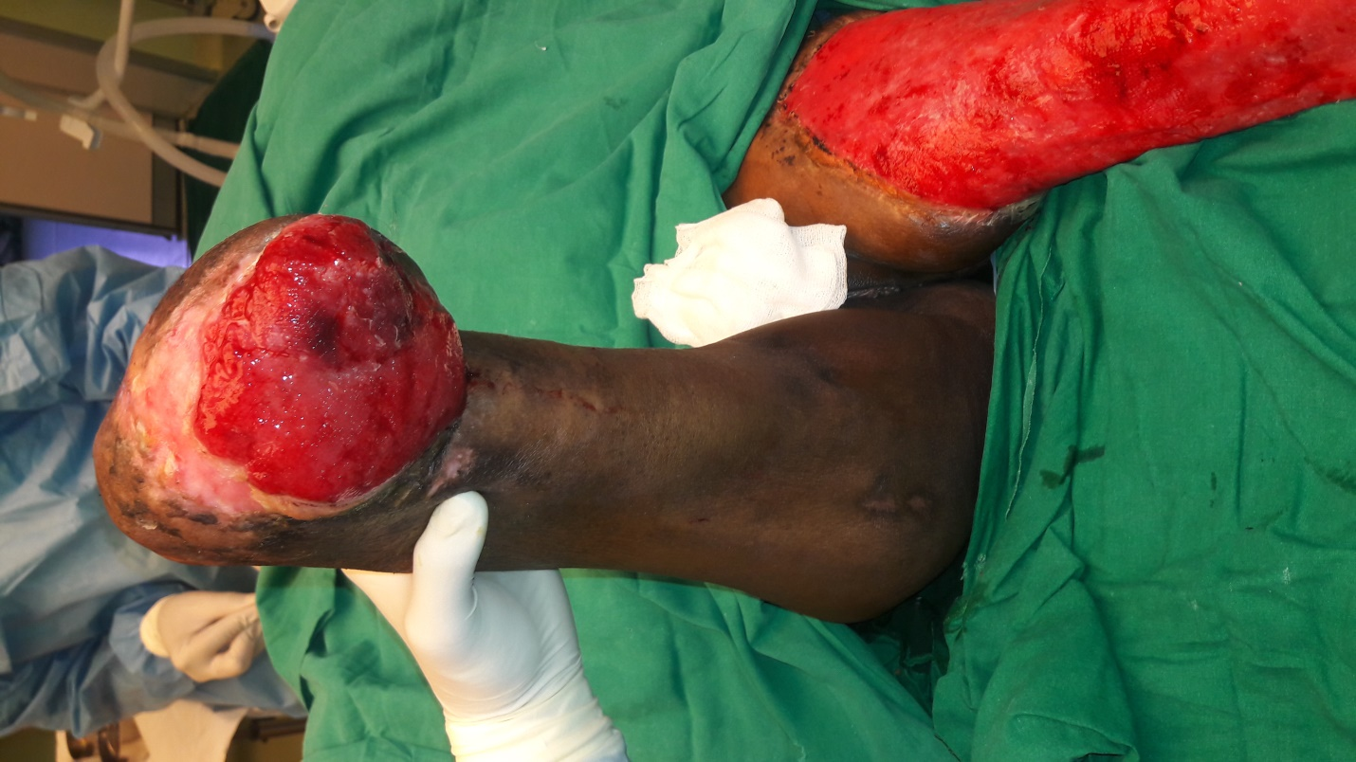
Figure 1: wound over the amputation stump

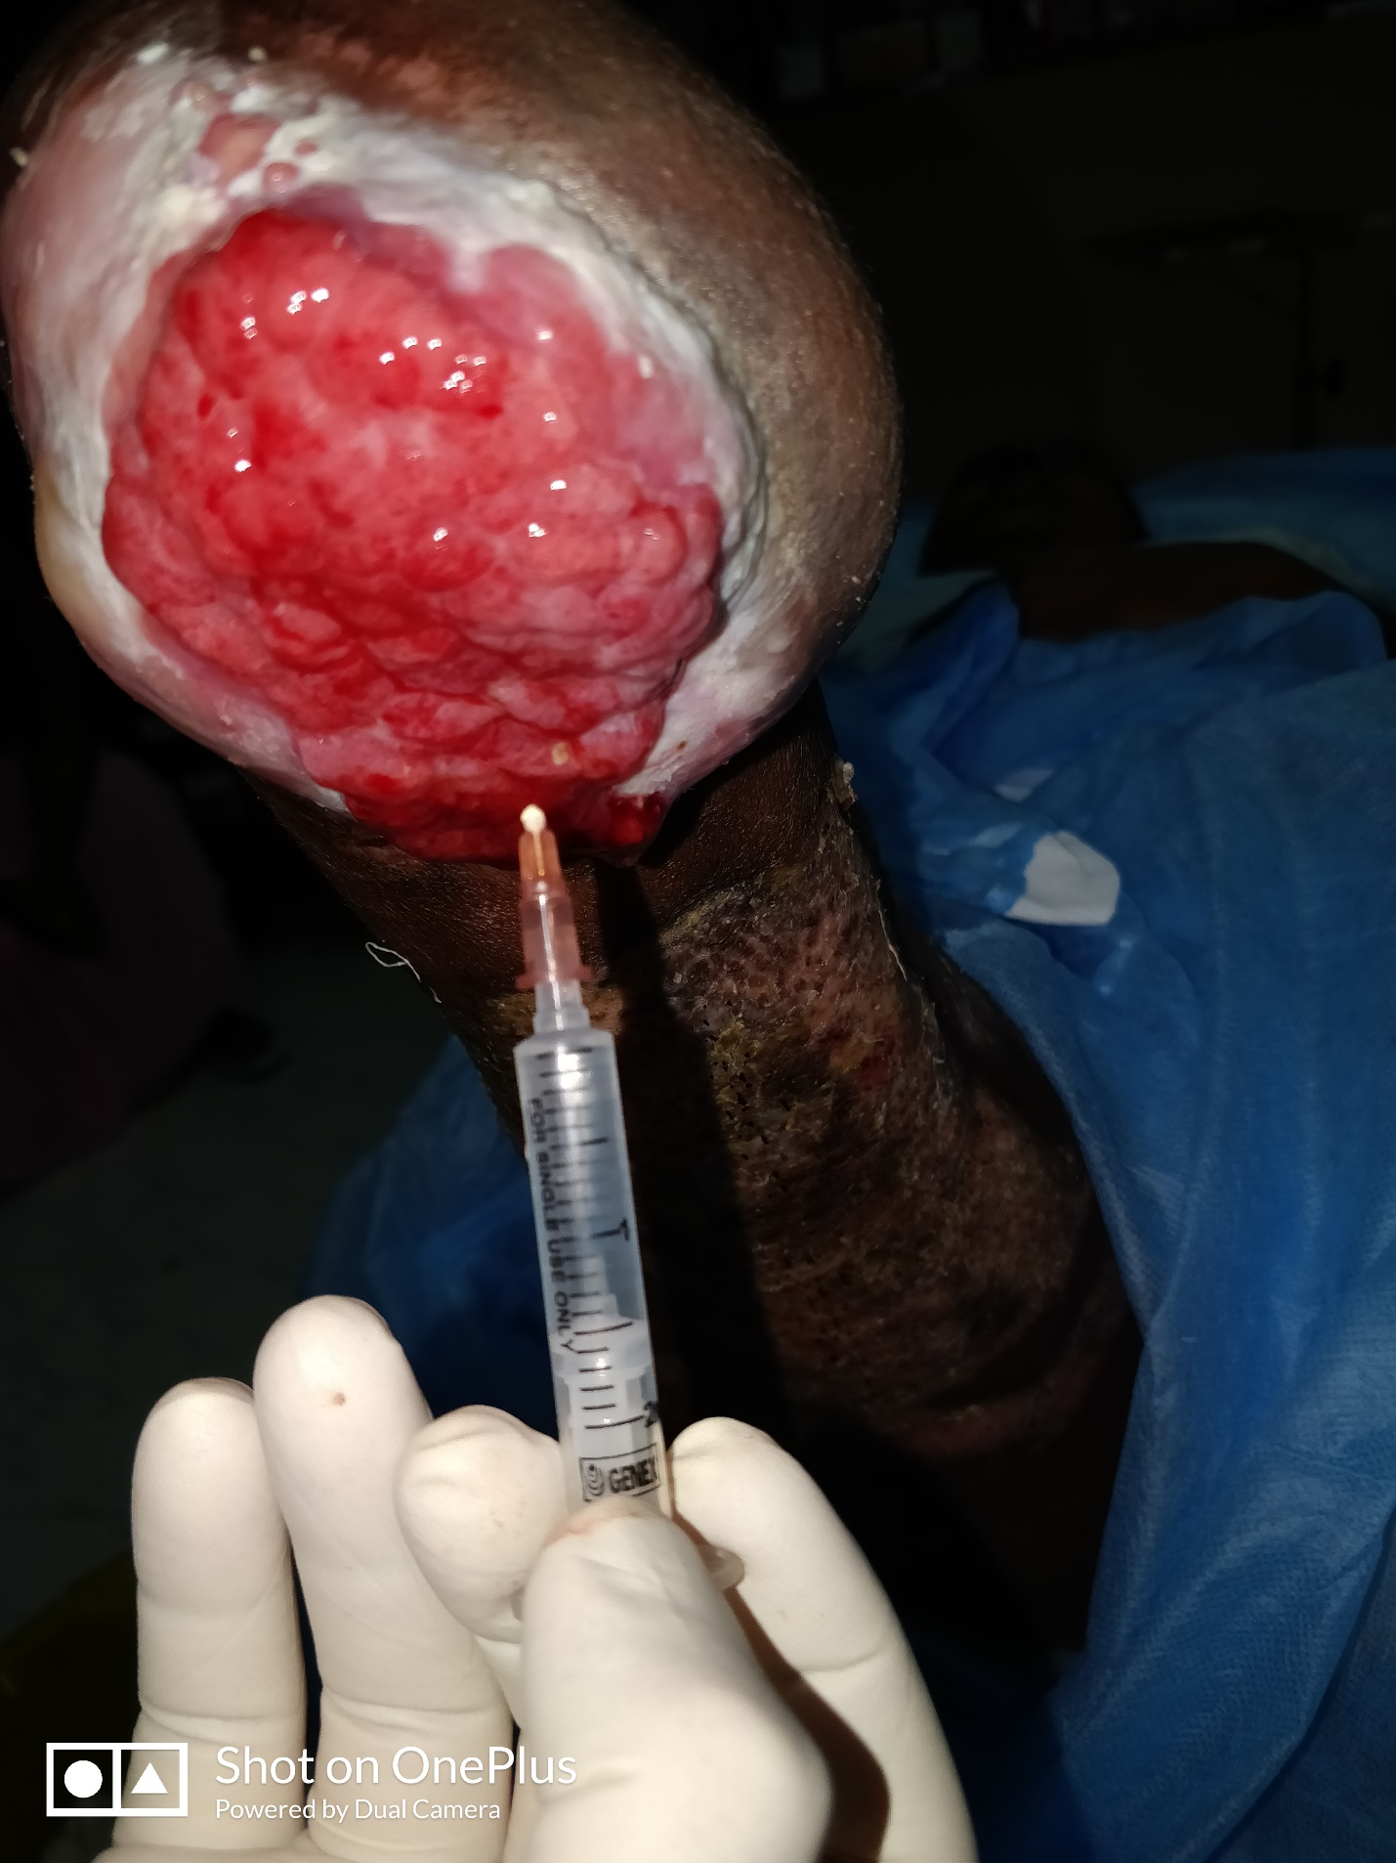
Figure2: topical APRP therapy given to the amputation stump
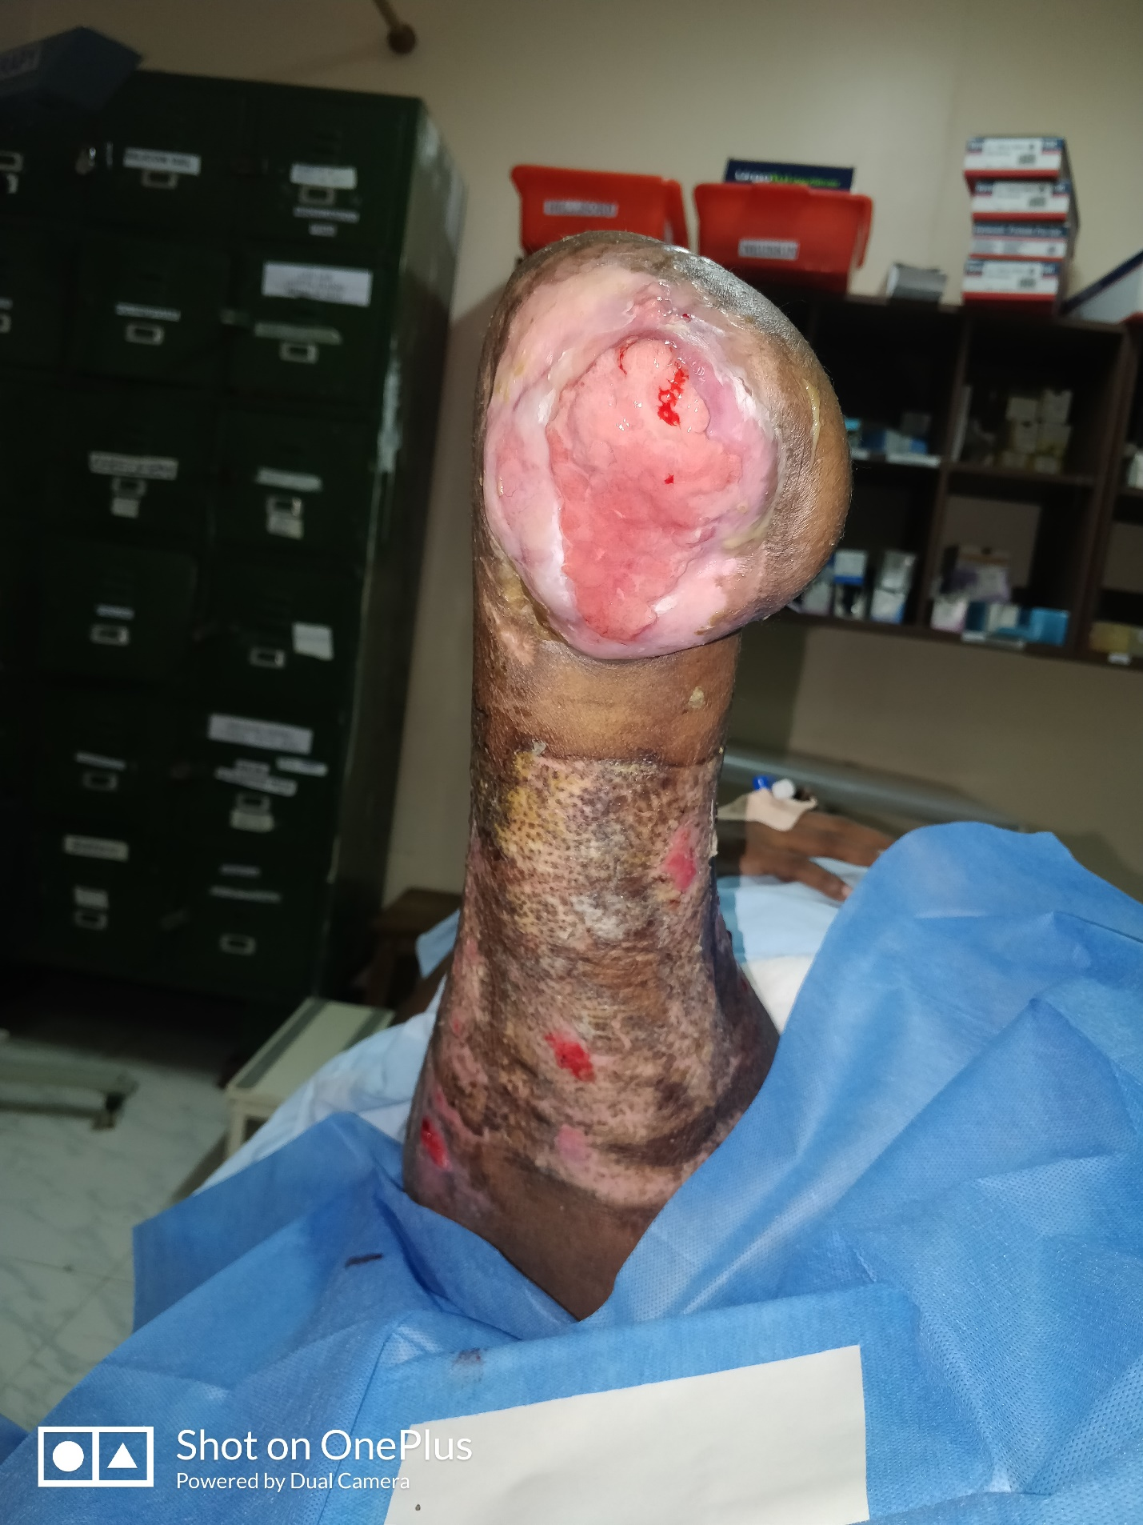
Figure3: healing wound bed

