Title Page –

Caecal tumour presenting with intussusception.
V.B. Pathirana¹, H Sudasinghe².
¹Registrar in surgery General Hospital Matara.
² Consultant Surgeon – General Hospital Matara.

Corresponding author –
V.B. Pathirana.
Email – varunapath@gmail.com.
Address – No 448F, Koswaththa Road, Kalapaluwawa, Rajagiriya – Colombo,
Sri Lanka.

Key words – Adult Intussusception, Caecal tumour, Intestinal obstruction.

Introduction
Intussusception is rare among adults accounting for 5% of cases and only 1% of adult intestinal obstruction is due to intussusception [1]. Intussusception can be difficult to diagnose in adults due to variable nature of presentation and up to 20% can be asymptomatic which are diagnosed incidentally in abdominal imaging [1, 2].

Case presentation
49 year old male patient presented with episodic peri-umbilical pain for nine months duration. It was a gradually worsening non radiating colicky pain of mild to moderate severity occurring 3 -4 times per week. He frequently had nausea associated with pain but only rarely had vomiting. The pain was not related to meals and it partially resolved after bowel motions. He had altered bowel habit with bowel motions occurring 10 -12 times per day with occasional passage of altered blood mix with stools for last five months. There was no fresh rectal bleeding. He did not had anemic symptoms, fever or other constitutional symptoms. He was a diagnosed diabetic with poor glycemic control.
General examination and abdominal examination was unremarkable except mild right iliac fossae tenderness. Per rectal examination was unremarkable.
Ultrasound scan of abdomen revealed long segment of large bowel mass in the right lower quadrant with features suggestive of intussusception [Fig.1] where cause for it was not evident.

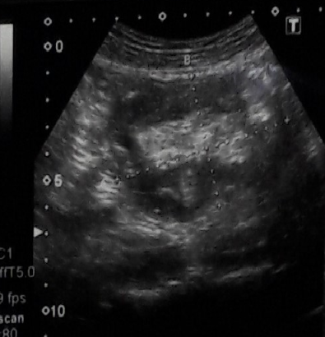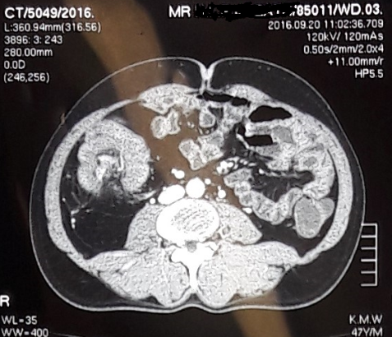
Figure 2 – CT scan confirmed distal ileal intussusception with caecal wall thickening.
Figure 1 – USS suspicious of bowel intussusception

CECT scan revealed ileocaecal intussusception with caecal wall thickening with no regional lymphadenopathy. Exploratory laparotomy revealed caecal tumor and right hemi colectomy was carried out. There was uneventful postoperative recovery.
Histology revealed moderately differentiated adenocarcinoma involving 3/4th of circumference of caecal wall including the ileocaecal valve region with no positive nodal disease.

Discussion –
Cecal tumours usually present with anemia due to chronic blood loss or with abdominal mass [1]. Obstruction and typical bowel symptoms are rare or late if at all owing to larger diameter of right sided colon and semisolid nature of faeces at the early part of colon [1, 2]. Appendicitis or appendicular mass, intussusception are some of rare presentations of cecal tumour.
Cecal tumours presenting with intussusception have being reported in literature and the usual presentation in all these cases is colicky abdominal pain [3, 5, and 6]. There may be long duration of symptoms before the definitive diagnosis is made [3] similar to which is observed in this cases. Other common nonspecific symptoms are nausea and vomiting and in examination abdominal mass may be identified [4, 6].

Key Points
- Intussusception in adults is rare and difficult to diagnose due to nonspecific presentation.

- Majority will have underlying organic cause in contrast to pediatric cases.

- There may be considerable lag period from onset of symptoms to definitive diagnosis due to sub-acute nature of symptoms.

References
- Gordon Carlson, Jonathan Epstein; The small and large intestines (Chapter 69) - Bailey & Love – 26th edition.

- Elliot M. Livstone; Colorectal Cancer [inter net], available form http://www.merckmanuals.com/professional/gastrointestinal-disorders/tumors-of-the-gi-tract/colorectal-cancer.

- Tsutomu Namikawa, Ken Okamoto, Takehiro Okabayashi, Masamitsu Kumon, Michiya Kobayashi, and Kazuhiro Hanazaki; Adult intussusception with cecal adenocarcinoma - Successful treatment by laparoscopy-assisted surgery following preoperative reduction; World Journal of Gastrointestinal Surgery - 2012 May 27; 4(5): 131–134.

- Lindor RA1, Bellolio MF, Sadosty AT, Earnest F, Cabrera D; Adult intussusception - presentation, management, and outcomes of 148 patients; The Journal of Emergency Medicine. 2012 Jul;43(1):1-6.

- Fernando Mendoza Moreno, María del Rocio Diez Gago, Gustavo Zarzosa Hernandez, Benjamin Tallon Iglesias, Manuel Solana Maono and Jesus Manuel Arguello de Andres; Ileocolic Intussusception as a form of Presentation of Cecal Carcinoma - Report of a Case and Review of Literature; JSM Clinical and Medical Imaging: Cases and Reviews 2016.

- Jessica Gonzalez-Hernandez, Fernando Garcia. Cecal adenocarcinoma presenting as colonic intussusception in adulthood; Proc (Bayl Univ Med Cent). 2015 Apr; 28(2): 180–182.

