The use of stereolithographic surgical guides to compare between partial versus complete limiting designs in the posterior mandible. A randomized clinical trial and split mouth study.

Wael Alaaeldin Hussein*, Mohamed Abdel Mageed Katamish**, Mostafa Mohamed Taha***

* B.D.S. Faculty of Dentistry, Misr International University, Teaching Assistant, Oral & Maxillofacial Surgery Department, Misr International University.
** Professor of Oral and Maxillofacial Surgery, Faculty of Dentistry, Ain Shams University, Head of Department Oral and Maxillofacial Surgery, Misr International University
*** Lecturer in Oral and Maxillofacial Surgery Department, Faculty of Dentistry, Ain-Shams University

Abstract

Objective:
The position of the placed dental implants in the edentulous ridge determines its success prosthetically. The implants could be placed in a correct position according to the treatment plan yet have an incorrect angulation. To overcome the discrepancies in angulations and place the dental implants in planned position, surgical stents were introduced. The stent is then used with a sequential drilling, to minimize the possibility of a positional error due to freehand placement of dental implants The aim of this study is to assess the radiographic accuracy of implants inserted by stereolithographic surgical guides using partially versus completely limiting designs in the posterior mandible.

Patients and Methods:
Three patients received 14 implants, each patient had mandibular posterior edentulism and received implants through stereolithographic guide with the right side using partially limiting designs and the left side as completely limiting designs.

Results:
Results of this study in comparison between the test (completely limiting designs) and control (partially limiting designs) groups were statistically insignificant. The angular deviation was slightly lower in the test group.

Conclusion:
The accuracy of completely limiting design is slightly more accurate than partially limiting designs, especially in implant angulation, despite not statistically significant.
Key words: stereolithographic surgical guide, dental implants

Introduction

The position of the placed dental implants in the edentulous ridge determines its success prosthetically. The implants could be placed in a correct position according to the treatment plan yet have an incorrect angulation ¹. To overcome the discrepancies in angulations and place the dental implants in planned position, surgical stents were introduced. The stent is then used with a sequential drilling, to minimize the possibility of a positional error due to freehand placement of dental implants ².

Successful implant treatment is directly related to achieving integration and restoring hard and soft supporting structures for esthetics and function ³. To achieve a predictable and acceptable outcome the clinician should have thorough understanding of the surgical and prosthodontic phases of treatment and be able to visualize the final prosthetic before dental implant placement. The desire for predictable results led to development of prosthetically guided implantology ⁴.

The placement of dental implant in correct position is challenging. Although recent advances in techniques and devices significantly improved the predictability of results, it remains a challenge. Three Dimension (3-D) radiographic information are required for the correct position and orientation of implants, making the diagnostic casts, probing depths and panoramic radiography of less importance due to their unpredictable results ^{3,5-9}.

During dental implant planning, the clinician should plan the position of the implant in accordance with accurate mesiodistal and buccolingual location, angulation with residual bone and correct implant orientation, to achieve a successful prosthesis supported dental implant and avoid anatomical limitations ¹⁰.

The incorrect position of dental implants has consequences on both the short term and long-term run. The malaligned implants complicate the clinical and laboratory procedures needed for the fabrication of the prosthesis. On the long term run the improper load distribution, and the increase in stress concentrations on supporting implants compromises the maintenance of the bone-implant interface ¹⁰.

The use of surgical stents provides optimum implant placement in both the position and orientation. A modified surgical stent will guide to proper mesiodistal position of dental implants ^{10.} Correct positioning of dental implants is largely dependent on the experience and attention of the surgeon since conventional surgical guides include a single-diameter guide channel that allows only the initial drill to pass through ³.

Different types of stents are available and are classified according to their design concept into non-limiting, partial limiting and completely limiting designs. The non-limiting design only indicates the site with no regards to orientation or angulation. The partial limiting designs involve placement of first drill only through the guide, and usually involves fabrication of radiographic templates which are converted into surgical guides. The completely limiting designs restricts the drilling of osteotomy in bucco-lingual and mesiodistal directions. It also includes drill stops that limit the depth of osteotomy. Those surgical guides could either be cast based guided surgical guide, CAD/CAM based Surgical guide and Stereolithography.

Stereolithography is a rapid prototyping technology that permits 3-D implant stimulation and fabrication of computer guided surgical guides. The dental implant is therefore positioned in the accurate position and orientation in bucco-lingual dimension, mesio-distal dimension and even its depth as planned during 3-D computer workup. ¹¹⁻¹⁴.

As in our study we will compare the partially limiting versus completely limiting designs to assess the radiographic accuracy of both surgical guides’ designs in all dimensions.

Aim

The aim of this study is to assess the radiographic accuracy of implants inserted by stereolithographic surgical guides using partially versus completely limiting designs in the posterior mandible.

Patients and Methods

Fourteen implants were placed in three patients, two males and one female. The study design was split mouth where the right side was the control side (partial limiting design) and left side was the study side (completely limiting design). In the control side only the drilling was through the stereolithographic guide sleeves (universal sleeves), where in the study side both the drilling and implant placement was through the specific sleeves in the stereolithographic guide.

Medical history, clinical and radiographic examination by Cone Beam Computed Tomography (CBCT) (Figure 1) to asses bucco-lingual and mesio-distal ridge dimensions, also periodontal treatment was done whenever the condition necessitates it.
For the both groups using CBCT the implants were planned, and the computer guided stents were produced using In2Guide (Figure 2-5).
All subjects were given antibiotic prophylaxis Augmentin 1gm regimen orally 1 hour prior to the surgical procedure, if patients allergic to penicillin Clindamycin 300 mg was given, then the patient was asked to rinse with an antiseptic mouthwash chlorohexidine mouth wash for 5 minutes prior to the surgical procedure.

After reaching the required asepsis by asking the patient to rinse by chlorohexidine mouth wash and swaping the surgical site using Betadine, local anesthesia (Articane 4%) was administered using infiltration technique buccal and lingual, and once the area has been anesthetized, crestal and sulcular incision were done using BP blade #15 and a flap was raised, and the lingual flap was stabilized using 3-0 silk suture. Biohorizon implants with lengths standardized at 10.5 mm and diameters of either 3.8 or 4.6 mm were placed using the guided stereolithographic stent that was fixed by anchoring (positioning) screws (Figure 6). The sequence of drilling was done according to manufacturer protocol.

In the study group, all the drilling and the implant were inserted through the metal sleeve of the stent (Figure 7-8).
In control group, all the drilling was done while the stent is in place while the implant was inserted freehand (after the removal of the stent) (Figure 9-10).

After placement of the implant and delivery of the temporary restorations (partial dentures), antibiotics were prescribed Augmentin 1gm oral tablet twice daily for 5 days postoperatively (or clindamycin 300 mg in patients whom allergic to penicillin 3 times daily for 5 days postoperatively).

Postoperative analgesia (NSAIDs) was prescribed for 3 days, and then whenever it’s needed for pain relief. The patient was instructed to rinse their mouth with antiseptic mouthwash (Chlorohexidine) 3 times a day starting from the second day postoperatively and continued for 2 successive weeks.

CBCT of the implants site were accomplished immediate postoperatively to verify the position of the implant and for comparison between the virtual CBCT and actual postoperative CBCT (Figure 11-12).

All subjects were evaluated based on the following timeline; one-week recall, all subjects were recalled checking for the presence of infection, to evaluate the oral hygiene of the subjects, and to remove the sutures, then one month postoperatively, to evaluate the overall healing process and radiographically by peri-apical radiographs. Also, to prevent any complications that could occur and to control the subjects overall oral hygiene and to evaluate the prosthesis. Finally, at 3 months postoperatively, for stage 2 uncovering surgery and steps for construction of the final prosthesis were accomplished at this stage.

Immediate Postoperative CBCT scans were obtained to compare the implant position with the pre-operative implant planning using a measurement program, in which both the planned implant and the actual implant were superimposed on each other to evaluate the 3-D dimensional deviations in both groups and the following were recorded:
- The superior-inferior dimension
- The bucco-lingual dimension (at the neck and apex of the implant)
- The mesio-distal dimension (at the neck and apex of the implant)
- The angle between the axis of both planned and actual implants

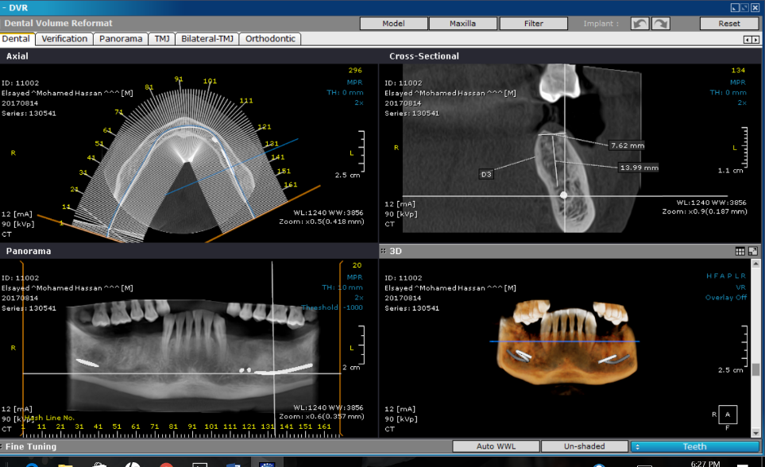

Figure 1: Preoperative CBCT

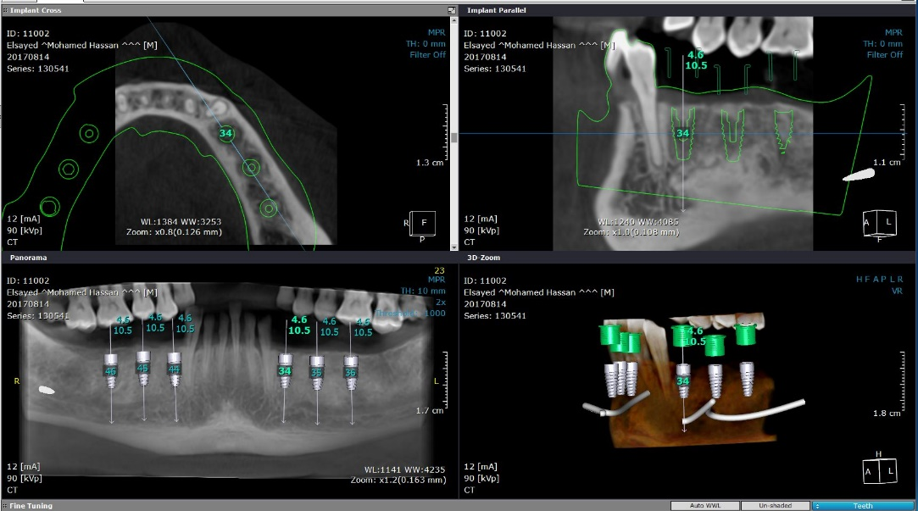

Figure 2: Virtual implant planning on the CBCT

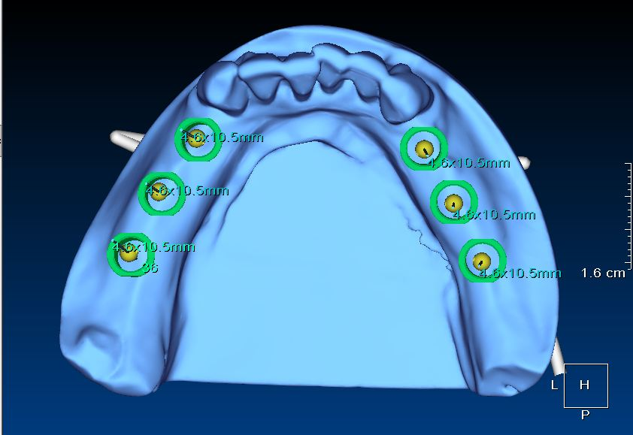

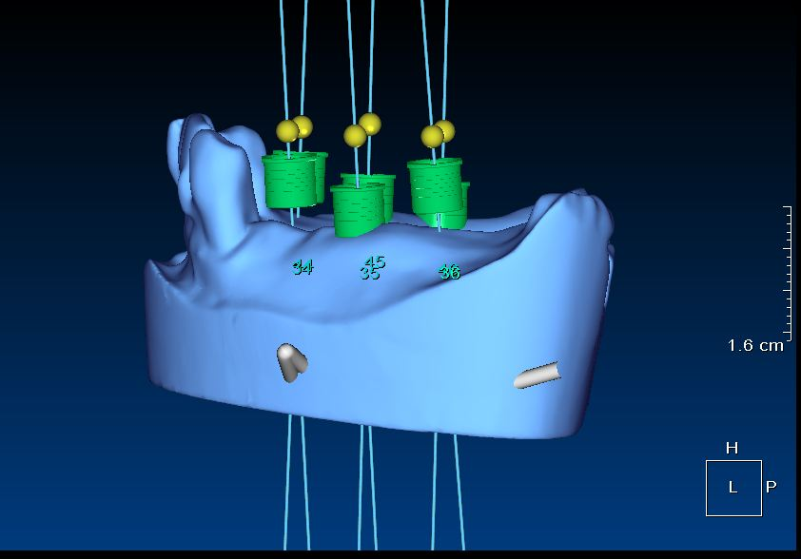
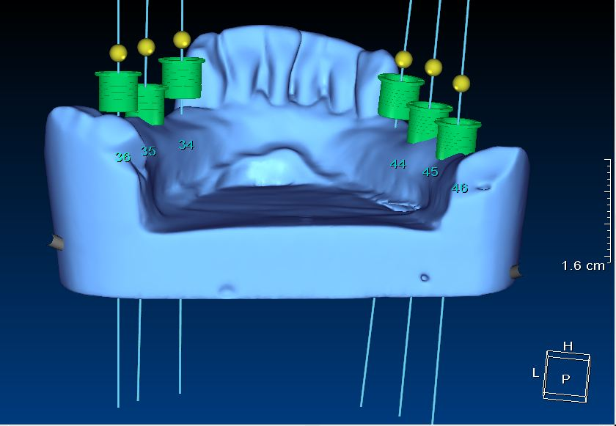
Figure 3: Virtual position of sleeves in relation to optically scanned diagnostic cast: occlusal vie
Figure 4: Virtual position of sleeves in relation to optically scanned diagnostic cast: side view
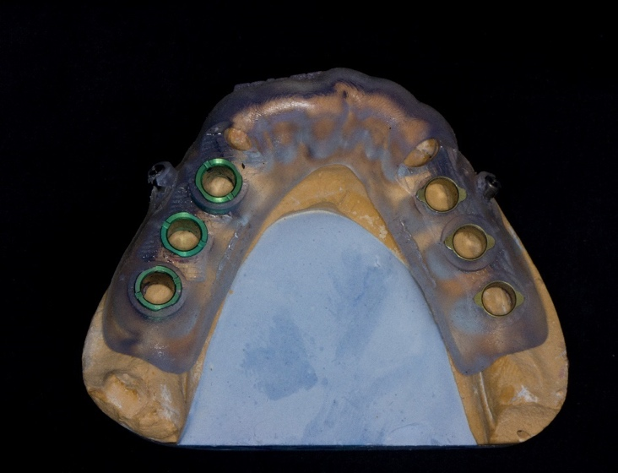

Figure 5: Printed Stereolithographic Guide on the cast with metallic sleeves
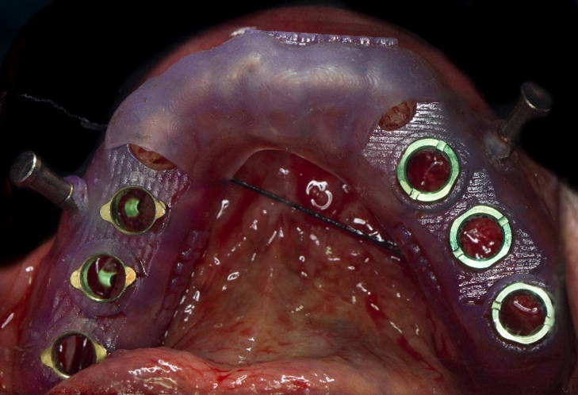

Figure 6: Stereolithographic guide anchored in place using 2 anchor pins
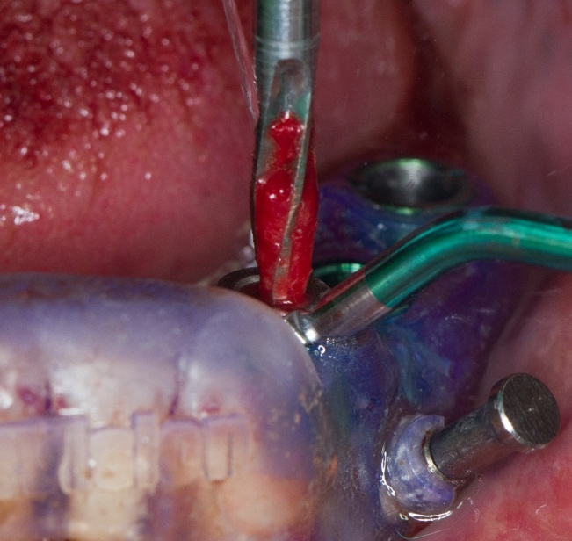

Figure 7: Drilling through the specific metal sleeve and using the drill guides
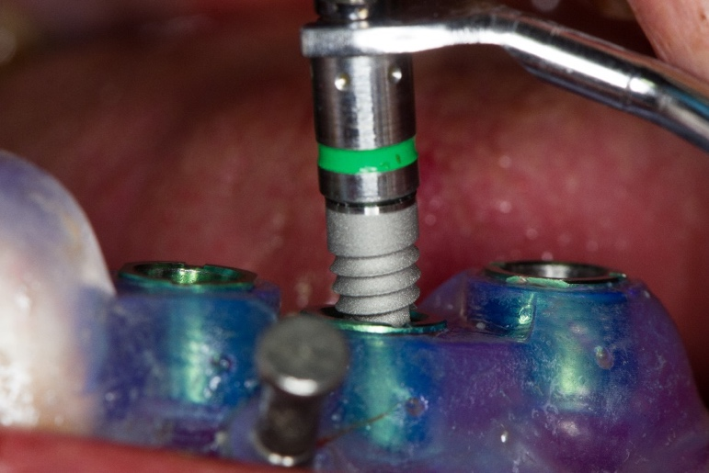
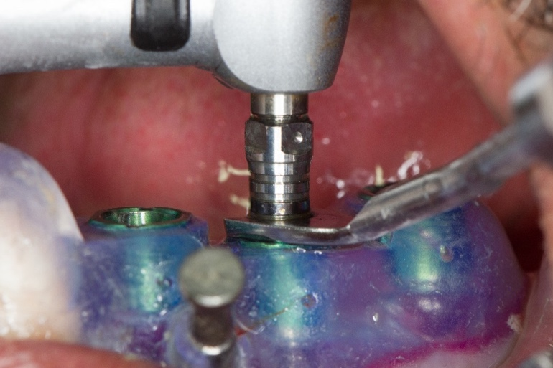

Figure 8: Implant is placed till it is stopped by the depth handle to ensure it is seated in the planned position
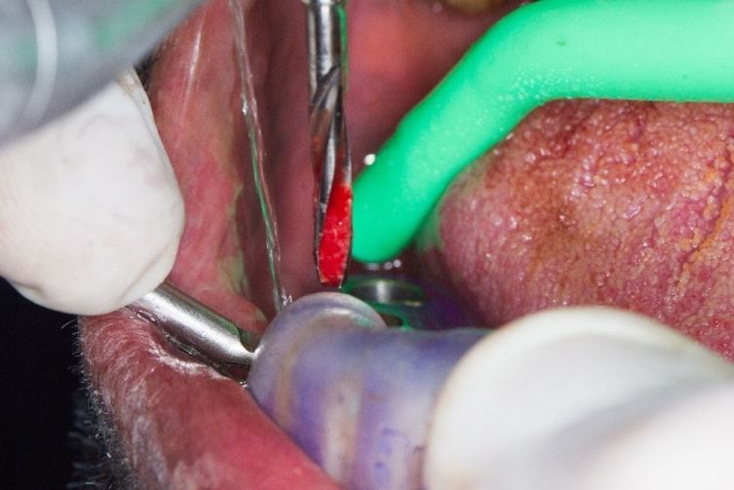

Figure 9: Sequential drilling was continued on the control side through the universal sleeve

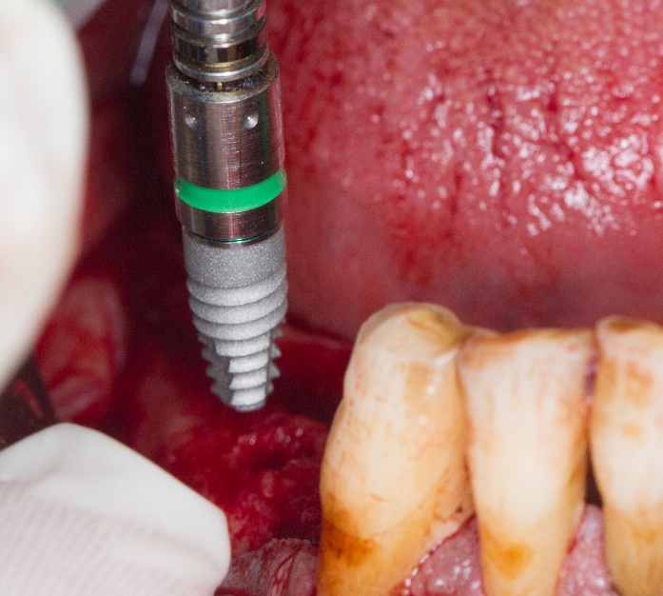

Figure 10: Implants were placed freehand on the control side case number

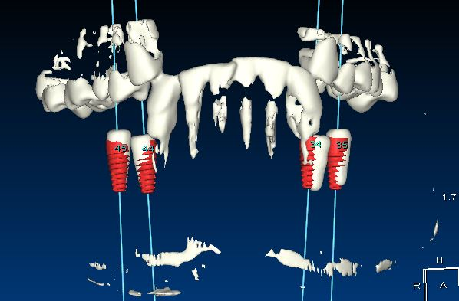

Figure 11: 3-D reconstruction superimposition of both planned (red) and actual (white) positions of implants using the postoperative CBCT
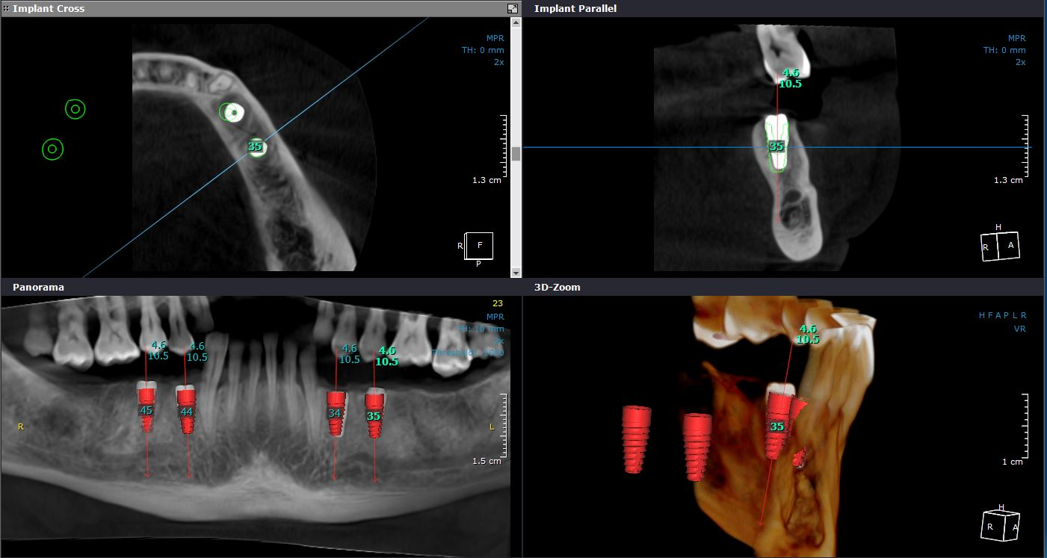

Figure 12: superimposition of both planned (red) and actual (white) positions of implants using the postoperative CBCT

Results

The present study was conducted on 3 patients; 2 males (66.7%) and one female (33.3%). The mean and standard deviation values for age were 47 ⁺₋ 7 years with a minimum of 40 years and a maximum of 53 years.
The mean angular deviation of the completely limiting design was 2.86° while the mean angular deviation for the partially limiting design was 4.26°. 8
There was no statistically significant difference between degree differences of completely and partially guided designs (P-value = 0.463, Effect size = 0.300).

Table 1: Descriptive statistics and results of Wilcoxon signed-rank test for comparison between degree differences of completely and partially guided designs
Degree difference | Completely guided | Partially guided | P-value | Effect size (r)
Mean (SD) | 2.86 (2.1) | 4.26 (2.83) | 0.463 | 0.300
Median (Range) | 2.48 (1 – 6.82) | 4.44 (0 – 7.83)
*: Significant at P ≤ 0.05
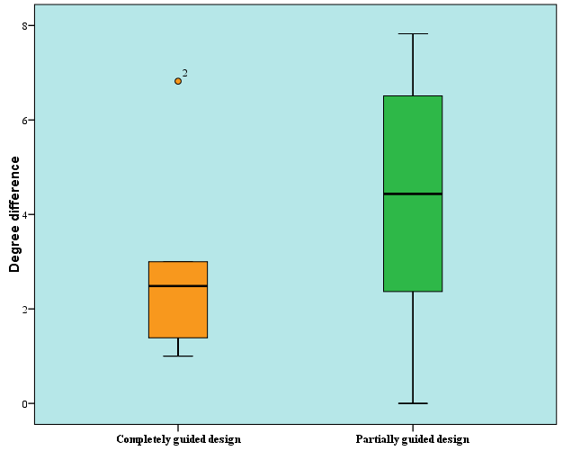

Figure 13: Box plot representing median and range values for degree differences of completely and partially guided designs (Circle represents outlier)
The mean total coronal deviation for the completely limiting design was 1.6mm, with the Dx was 0.64mm, Dy was 0.48mm and Dz 1.25mm. The mean total coronal deviation for the partially limiting design was 1.75mm, with the Dx was 0.61mm, Dy was 0.71mm and Dz 1.42mm.
As regards total coronal difference; there was no statistically significant difference between completely and partially guided designs (P-value = 0.463, Effect size = 0.300).
In Dimension x (Dx); there was no statistically significant difference between completely and partially guided designs (P-value = 0.917, Effect size = 0.043).
In Dimension y (Dy); there was no statistically significant difference between completely and partially guided designs (P-value = 0.249, Effect size = 0.471).
In Dimension z (Dz); there was no statistically significant difference between completely and partially guided designs (P-value = 0.345, Effect size = 0.385).

Table 2: Descriptive statistics and results of Wilcoxon signed-rank test for comparison between coronal differences of completely and partially guided designs
Coronal difference |  | Completely guided | Partially guided | P-value | Effect size (r)
Total | Mean (SD) | 1.6 (0.48) | 1.75 (0.75) | 0.463 | 0.300
 | Median (Range) | 1.62 (0.98 – 2.11) | 1.57 (1.02 – 2.95)
Dx | Mean (SD) | 0.64 (0.41) | 0.61 (0.41) | 0.917 | 0.043
 | Median (Range) | 0.58 (0.21 – 1.3) | 0.51 (0.26 – 1.41)
Dy | Mean (SD) | 0.48 (0.33) | 0.71 (0.61) | 0.249 | 0.471
 | Median (Range) | 0.51 (0.03 – 0.87) | 0.51 (0.12 – 1.74)
Dz | Mean (SD) | 1.25 (0.64) | 1.42 (0.48) | 0.345 | 0.385
 | Median (Range) | 1.37 (0.28 – 1.84) | 1.44 (0.9 – 1.92)
*: Significant at P ≤ 0.05
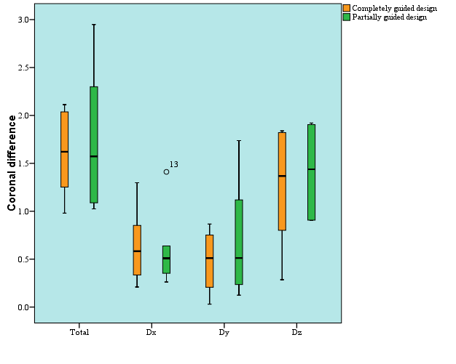

Figure 14: Box plot representing median and range values for coronal differences of completely and partially guided designs (Circle represents outlier)

The mean total apical deviation for the completely limiting design was 1.71mm, with the Dx was 0.73mm, Dy was 0.68mm and Dz 1.25mm. The mean total coronal deviation for the partially limiting design was 1.73mm, with the Dx was 0.36mm, Dy was 0.85mm and Dz 1.38mm.
As regards total apical difference; there was no statistically significant difference between completely and partially guided designs (P-value = 0.917, Effect size = 0.043).
In Dimension x (Dx); there was no statistically significant difference between completely and partially guided designs (P-value = 0.116, Effect size = 0.642).
In Dimension y (Dy); there was no statistically significant difference between completely and partially guided designs (P-value = 0.753, Effect size = 0.128).
In Dimension z (Dz); there was no statistically significant difference between completely and partially guided designs (P-value = 0.463, Effect size = 0.300).

Table 3: Descriptive statistics and results of Wilcoxon signed-rank test for comparison between apical differences of completely and partially guided designs
Apical difference |  | Completely guided | Partially guided | P-value | Effect size (r)
Total | Mean (SD) | 1.71 (0.52) | 1.73 (0.79) | 0.917 | 0.043
 | Median (Range) | 1.72 (1.06 – 2.26) | 1.49 (0.99 – 2.97)
Dx | Mean (SD) | 0.73 (0.23) | 0.36 (0.26) | 0.116 | 0.642
 | Median (Range) | 0.64 (0.52 – 1.03) | 0.37 (0.03 – 0.64)
Dy | Mean (SD) | 0.68 (0.49) | 0.85 (0.74) | 0.753 | 0.128
 | Median (Range) | 0.75 (0.03 – 1.36) | 0.53 (0.34 – 2.24)
Dz | Mean (SD) | 1.25 (0.65) | 1.38 (0.52) | 0.463 | 0.300
 | Median (Range) | 1.38 (0.24 – 1.83) | 1.35 (0.83 – 1.92)
*: Significant at P ≤ 0.05

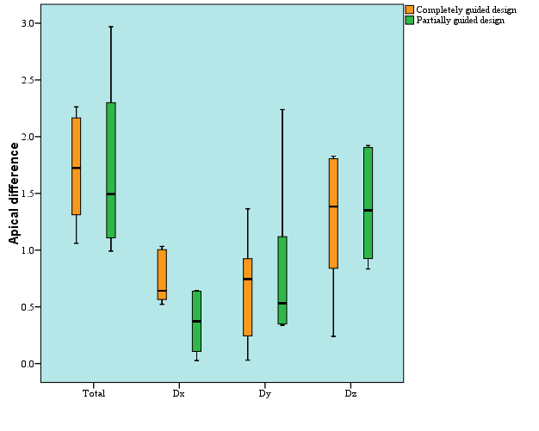

Figure 15: Box plot representing median and range values for apical differences of completely and partially guided designs

Discussion
According to Jacob et al¹⁵ and Siessegger et al¹⁶ the use of Computed tomography is useful for implant planning especially in situations where there are anatomical limitations, insufficient bone dimensions or questionable bone density. Jacob et al¹⁷ concluded that using CT imaging improves for the correlation of both implant planning and placement when compared to other radiographic techniques. In our study, CBCT was used preoperative to measure the bone dimensions, inferior alveolar nerve canal approximation and designing of the stereolithographic surgical guide. CBCT was also used for the comparison between the actual and virtual planned implant position both coronally and apically in 3-D and angular differences.
Verstreken et al¹⁸ explained that the since the introduction of computer aided manufacturing (CAM) of anatomical models and using computer aided design (CAD) to produce surgical guides, the accuracy of transferring the surgical plan intraoperatively has been enhanced. The utilization of the 3D image of the patient’s anatomy allowed for fabrication of both anatomical models and surgical guides. Giacomo et al¹⁹ and Jacob P²⁰ explained that rapid prototyping using stereolithographic modeling, which is fast and accurate computer aided manufacturing (CAM) technique is used to produce prototypes in many fields of manufacturing. Heissler et al²¹, Bianchi et al²² and Marchack CB²³ added that using the stereolithographic modeling is used in the planning of dental implants and their insertion, planning sinus elevation, planning preoperative preparation for reconstruction surgeries and designing soft tissue facial prosthesis. In the present study, the surgical guide was divided into two types partial versus complete limiting designs that were used in the study control and study groups respectively.
Behneke et al²³ emphasized that bone supported surgical guides feature less accuracy errors in comparison to mucosa supported surgical guides primarly due to lack of distance between sleeves and osteotomy but require open flap approach. In the current study flap was opened and surgical guide was bone supported to reduce the potential errors that may result from mucosa supported surgical guides as Behneke emphasized.
Cassetta el al²⁴ explained that completely guided stereolithographic surgical guides show lower accuracy errors when compared to partially limiting designs. The completely guided protocol is more affected by the diameter and length of the sleeves and the distance between the surgical guide and the alveolar crest. Choi et al²⁵ added that the longer the sleeves the less angular deviation and the shorter the implants the less the apical deviation.
Park et al²⁶ concluded that completely guided protocols are more accurate than free hand placement of implants. Kuhl el al²⁷ concluded that both completely and partially limiting designs of stereolithographic surgical guides produce similar accuracy results, but completely guided designs showed less variation. In our study the completely limiting design was slightly more accurate than partially limiting designs but not statistically significant. The mean angular deviation of the completely limiting design was 2.86° while the mean angular deviation for the partially limiting design was 4.26°. 8 The mean total coronal deviation for the completely limiting design was 1.6mm, with the Dx was 0.64mm, Dy was 0.48mm and Dz 1.25mm. The mean total coronal deviation for the partially limiting design was 1.75mm, with the Dx was 0.61mm, Dy was 0.71mm and Dz 1.42mm. The mean total apical deviation for the completely limiting design was 1.71mm, with the Dx was 0.73mm, Dy was 0.68mm and Dz 1.25mm. The mean total coronal deviation for the partially limiting design was 1.73mm, with the Dx was 0.36mm, Dy was 0.85mm and Dz 1.38mm.
Mora et al²⁸ mentioned that the accuracy of guided surgery is reported within 0.4-1.6mm or 3° to 5° and usually measuring the deviation between the proposed and actual implant position in three dimensions. In our study we measured both the angular deviation and the linear deviation both coronally and apically as Dx (buccolingual deviation), Dy (mesiodistal deviation) and Dz (apicocoronal deviation).
Another in vitro study by Sarament et al²⁹ was performed using 50 implants in 5 resin mandibular models. Each model received 5 implants on each side. One side using conventional surgical guide and the other side using stereolithographic surgical guide. The coronal deviation on the conventional side was 1.5+_0.7mm and the apical deviation was 2.1+_0.97mm, whereas in the side of stereolithographic surgical side the coronal deviation was 0.9+_0.5mm and the apical deviation was1.0+_0.6mm. The conclusion was that there was clinical significance that was evident that stereolithographic guides are more accurate than conventional surgical guides. In the current study we used split mouth study with both the completely and partially limiting designs using stereolithographic surgical guide.
Tahmaseb et al³⁰ conducted a systematic review including only clinical studies, excluding any in vitro study or any study done on cadavers. The mean coronal horizontal deviation was 1.2 mm, CI: 95% [1.04–1.44] and the mean coronal vertical (height) deviation was 0.2 mm, CI 95% [−0.25 to 0.57 mm]. The mean apical horizontal deviation was 1.4 mm, CI:95% [1.28–1.58] and the mean apical vertical (height) deviation was 0.5 mm, CI:95% [−0.08 to 1.13 mm]. The angular deviation was 3.5° CI: 95% [3.00°–3.96°]. In our study the results were close to the results obtained in the systematic review by Tahmaseb et al. The mean angular deviation of the completely limiting design was 2.86° while the mean angular deviation for the partially limiting design was 4.26°. 8 The mean total coronal deviation for the completely limiting design was 1.6mm, with the Dx was 0.64mm, Dy was 0.48mm and Dz 1.25mm. The mean total coronal deviation for the partially limiting design was 1.75mm, with the Dx was 0.61mm, Dy was 0.71mm and Dz 1.42mm. The mean total apical deviation for the completely limiting design was 1.71mm, with the Dx was 0.73mm, Dy was 0.68mm and Dz 1.25mm. The mean total coronal deviation for the partially limiting design was 1.73mm, with the Dx was 0.36mm, Dy was 0.85mm and Dz 1.38mm.
Despite the mean deviation is clinically acceptable, some studies reported higher deviations. Verhamme et al³¹ and Verhamme et al³² reported vertical coronal deviation of 7.8mm and vertical apical deviation of 8.7mm. Verhamme et al³³, Verhamme et al³¹ and Verhamme et al¹⁵³ reported vertical coronal deviation of 4.0mm and 4.2 mm and apical deviation of 3.6mm and 4.3mm. The authors mentioned that these implants were placed in edentulous maxilla and implants were placed too superficial. In our study we decided to conduct the whole study on the posterior mandible to avoid discrepancies between both maxilla and mandible in terms on bone quality which may affect the results. The mandible was chosen for conducting this study due to superior bone quality, therefore avoiding an additional parameter affecting accuracy when comparing the partial versus complete limiting designs.

Conclusion

The accuracy of completely limiting design is slightly more accurate than partially limiting designs, especially in implant angulation, despite not statistically significant.
Virtual implant planning and guided surgery is recommended to reproduce the proposed preoperative plan intraoperatively, but a learning curve is required to produce the most accurate results as a number of contributing factors may result in discrepancies between virtual plan and the actual implant position, jeopardizing the final result.

References

[1] Watson RM, Davis DM, Foreman GH, Coward T. “Considerations in design and fabrication of maxillary implant supported prostheses.” Int J Prosthodont 1991; 4: 232-9.
[2] O'Neilly PJ, McGlumphy EA. “New implant surgical guide.” J Prosthet Dent 1993; 70: 506-10.
[3] Engleman MJ, Sorensen JA, Moy P. “Optimum placement of osseointegrated implants.” J Prosthet Dent 1988; 59: 467-73.
[4] Sullivan R. “Avoiding screw access problems.” Nobelpharma News 1992; 6: 6.
[5] Nassef, Tamer M., N. H. Solouma, M. Alkhodary, M. K. Marei, and Yasser M. Kadah. “Extraction of human mandible bones from multi-slice computed tomographic data.” In Biomedical Engineering, 2011 1st Middle East Conference on, pp. 260-263. IEEE, 2011.
[6] Nassef, Tamer M., Reham M. Fliefel, Mona K. Marei, Nahed H. Solouma, and Yasser M. Kadah. “Computer assisted determination of mandibular cystic lesion volume from computed tomographic data.” In Biomedical Engineering (MECBME), 2011 1st Middle East Conference on, pp. 92-95. IEEE, 2011.
[7] Nassef, Tamer M., Mostafa F. Khalil, and Sanaa H. AbdelKader. “Computer assisted to determine the influence of connector design and stress distribution in Incoris TZI (Zirconia) fixed partial denture.” In Biomedical Engineering (MECBME), 2014 Middle East Conference on, pp. 63-66. IEEE, 2014.
[8] Nassef, Tamer M. “New Segmentation Approach to Extract Human Mandible Bones Based on Actual Computed Tomography Data.” American Journal of Biomedical Engineering 2, no. 5 (2012): 197-201.
[9] T.M. Nassef “Computer-Assisted Tissue Engineering for Dental Applications: Multi-Object Reconstruction Technique” LAP Lambert Academic Publishing (2012 February).
[10] Akça K, Iplikçioğlu H, Cehreli MC. “A surgical guide for accurate mesiodistal paralleling of implants in the posterior edentulous mandible.” J Prosthet Dent 2002; 87: 233-5.
[11] Jung RE, Schneider D, Ganeles J, Wismeijer D, Zwahlen M, H€ammerle CH, Tahmaseb A. Computer technology applications in surgical implant dentistry: a systematic review. Int J Oral Maxillofac Implants 2009: 24: 92–109.
[12] LAST, R. J. (1954). Anatomy, Regional and Applied. London: J. and A. Churchill Ltd
[13] HUMPHREY, G. M. (1858). A Treatise of the Human Skeleton. London: Macmillan and Co.
[14] GABRIEL C., SOME ANATOMICAL FEATURES OF THE MANDIBLE. J Anat. 1958 Oct; 92(Pt 4) 580–586.
[15] Siessegger M, Schneider BT, Mischkowski RA, et al: Use of an image-guided navigation system in dental implant surgery in anatomically complex operation sites. J Craniomaxillofac Surg 29:276, 2001
[16] Jacobs R, Adriansens A, Naert I, et al: Predictability of reformatted computed tomography for pre-operative planning of endosseous implants. Dentomaxillofac Radiol 28:37, 1999 [17] Suomalainen, A., Esmaeili, E. P., & Robinson, R. (2015). Dentomaxillofacial imaging with panoramic views and cone beam CT. Insights Imaging, 6, 1–16. https://doi.org/10.1007/s13244-014-0379-4
[18] Verstreken K, van Cleynenbreugel J, Marchal G, et al: Comput- er-assisted planning of oral implant surgery: A 3-dimensional approach. Int J Oral Maxillofac Implants 11:806, 1996
[19] Di Giacomo GA, Cury PR, de Araujo NS, et al: Clinical application of stereolithographic surgical guides for implant place- ment: Preliminary results. J Periodontol 76:503, 2005
[20] Heissler E, Fischer FS, Bolouri S, et al: Custom-made cast titanium implants produced with CAD/CAM for the recon- struction of cranium defects. Int J Oral Maxillofac Surg 27:334, 1998
[21] Bianchi SD, Lojacono A, Nevins M, et al: The use of replicate resin models in the treatment of maxillary sinus augmenta- tion patients. Int J Periodontics Restorative Dent 17:348, 1997
[22] Marchack CB: CAD/CAM-guided implant surgery and fabrica- tion of an immediately loaded prosthesis for a partially eden- tulous patient. J Prosthet Dent 97:389, 2007
[23] Behneke A, Burwinkel M, Knierim K, et al. Accuracy assessment of cone beam computed tomography-derived laboratory-based surgical templates on partially edentulous patients. Clin Oral Implants Res 2012;23(2):137–43.
[24] Cassetta M, Stefanelli LV, Giansanti M, et al. Accuracy of implant placement with a stereolithographic surgical template. Int J Oral Maxillofac Implants 2012;27(3):655–63.
[25] Choi M, Romberg E, Driscoll CF. Effects of varied dimensions of surgical guides on implant angulations. J Prosthet Dent 2004;92(5):463–9.
[26] Park C, Raigrodski AJ, Rosen J, et al. Accuracy of implant placement using precision surgical guides with varying occlusogingival heights: an in vitro study. J Prosthet Dent 2009;101(6):372–81.
[27] Kuhl S, Zurcher S, Mahid T, et al. Accuracy of full guided vs. half-guided implant surgery. Clin Oral Implants Res 2013;24(7):763–9.
[28] Mora MA, Chenin DL, Arce RM. Software Tools and Surgical Guides in Dental-Implant-Guided Surgery. Dental Clinics of North America. 2014;58(3):597–626.
[29] Sarment DP, Sukovic P, Clinthorne N: Accuracy of implant placement with a stereolithographic surgical guide. Int J Oral Maxillofac Implants 18:571, 2003
[30] Tahmaseb A, Wu V, Wismeijer D, Coucke W, Evans C. The accuracy of static computer-aided implant surgery: A systematic review and meta-analysis. Clin Oral Impl Res. 2018;29(Suppl. 16):416–435.
[31] Verhamme, L. M., Meijer, G. J., Bergé, S. J., Soehardi, R. A., Xi, T., de Haan, A. F., ... Maal, T. J. (2015). An accuracy study of computer-planned im- plant placement in the augmented maxilla using mucosa-supported surgical templates. Clinical Implant Dentistry and Related Research, 17(6), 1154–1163. https://doi.org/10.1111/cid.12230
[32] Verhamme, L. M., Meijer, G. J., Boumans, T., de Haan, A. F., Bergé, S. J., & Maal, T. J. (2015). A clinically relevant accuracy study of computer- planned implant placement in the edentulous maxilla using mucosa- supported surgical templates. Clinical Implant Dentistry and Related Research, 17(2), 343–352. https://doi.org/10.1111/cid.12112
[33] Verhamme, L. M., Meijer, G. J., Soehardi, A., Bergé, S. J., Xi, T., & Maal, T. J. (2017). An accuracy study of computer-planned implant placement

