STERNAL CLOSURE METHODS IN HIGH RISK PATIENTS: SHOULD IT BE SPECIFIC TO THE PATIENT?
Original Article
Running Title: ‘PATIENT SPECIFIC STERNAL CLOSURE’

Metin Onur Beyaz¹, Ibrahim Demir², Atalay Karakaya¹, Mustafa Ozer Ulukan¹, Korhan Erkanlı¹

¹Istanbul Medipol University Faculty of Medicine, Department of Cardiovascular Surgery, Istanbul
²Istanbul University, Faculty of Medicine, Department of Cardiovascular Surgery, Istanbul

Address reprint request to:
Op. Dr. Metin Onur Beyaz,
Istanbul Medipol University Faculty of Medicine, Medipol Mega University Hospital, TEM Avrupa Otoyolu Goztepe Cikisi, No:1, 34214 Bagcilar, Istanbul – TURKEY.
Tel: +90 5053599163
Fax: +90 212 521 23 77
e-mail: metinonurbeyaz@gmail.com

ABSTRACT
Aim: We compared steel wire-titanium hooks combination with steel wire-titanium plates and screws combination to investigate the most effective sternum closure method in risky patients undergoing median sternotomy.
Patients and Methods: We examined 67 patients underwent median sternotomy between October 2018 and January 2020. Patients who needed postoperative chemotherapy or radiotherapy due to malignancy were excluded from the study. The patients randomly divided into two groups with similar risk factors. In the first group, a steel wires-titanium hooks combination was used to close the sternum. Steel wires-titanium plates and screws combination was used in the second group of patients.
Results: No dehiscence or mediastinitis were observed in either patient group. Superficial wound infection was seen in 4 patients for each group and was successfully treated with antibiotic therapy. There was no significant difference between the two groups regarding the intensive care stay, the duration of hospitalization, the amount of bleeding and reexploration (p>0.05).
Conclusion: The choice between sternal closure techniques in high-risk patients should be mainly adapted to the characteristics of the patient. The most cost-effective and experienced method should be preferred when making the right decision.

Key Words: Titanium hooks, Titanium plates and screws, Personalized sternal closure methods.

INTRODUCTION
Cardiovascular surgeons have not abandoned cost-effective steel wire choices for sternum closure (1). Sternal dehiscence is the most risky complication that can seen after a median sternotomy (2). Elderly patients, osteoporosis, diabetes mellitus, obesity (BMI> 30) and female gender are risk factors for dehisens (3). Techniques such as Robicsek are available for patients at risk. However, the application of any method involving the use of steel wire is still under discussion in risked patients (4,5). With the advances in technology, classical sternal closure methods have been replaced by new techniques such as titanium plates, titanium hooks (Talon), thermoreactive nitinol clips, flat wire sternal closure systems, plastic materials and titanium cables (6,7). The new sternal closure methods have a high cost compared to steel wire. They also extend the operation time and are difficult to implement. Many surgeons prefer new methods instead of steel wire in patients at risk of dehiscence (8,9).
We compared steel wire-titanium hooks combination with steel wire-titanium plates and screws combination to investigate the most effective sternum closure method in risky patients undergoing median sternotomy.
PATIENTS AND METHODS
Materials and Methods
We examined 67 patients undergoing median sternotomy between October 2018 and January 2020. Patients who needed postoperative chemotherapy or radiotherapy due to malignancy were excluded from the study. The patients randomly divided into two groups with similar risk factors. In the first group, a steel wires-titanium hooks combination was used to close the sternum. Steel wires-titanium plates and screws combination was used in the second group of patients. Some of the patients included in the study underwent heart valve surgery. Others have underwent coronary artery bypass grafting (CABG) surgery. Bilateral internal mammarian artery (IMA) was not used in any of the patients who underwent CABG. , We prepared LIMA or RIMA as classical pedicled graft for patients who needed to use. The cautery dose did not exceed 20 degrees.We closed the skin with prolene suture in all patients.

Statistical Analysis
Statistical analysis was performed with the SPSS version 24.0 program (SPSS Inc. Chicago IL, USA). The normal distribution of the variables was examined by histogram graphs and the Kolmogorov-Smirnov test. Mean ± standard deviation values were used to present descriptive analyzes. Pearson Chi-Square and Fishers Exact Tests were compared with 2x2 tables. While normally distributed (parametric) variables were evaluated among the groups, Student T-test was used. Mann Whitney U Test was used to evaluate nonparametric variables. Logistic regression tests were performed to find odds ratio. P-values below 0.05 were evaluated as statistically significant results.

Results
The patients were divided into two groups. First group’s sternums were closed using steel wires-titanium hooks combination (Yaylamed Inc). The mean age of the patients was 65.5 ±7.8 (min 62-max 73.2). 18 of the patients (52.9%) were women. Diabetes mellitus was present in 14 (41.1%) (HbA1c:7.72±0.9%), hypertension in 9 (26.4%) and chronic obstructive pulmonarydisease (COPD) in 7 (20.58%) (with FEV¹<80% and FEV¹/FVC<70% with spirometry) patients. 19 (55.88%) patients were smoker (more than 10 years/pack), 8 (23.52%) patients were obese (BMI>30 kg/m²). 26 (76.47%) patients had multiple comorbidity included osteoporosis.
Figure 1: Patient who closed sternum using by steel wire and titanium hooks.
Second group’s sternums were closed using steel wires-titanium plates and screws. The average age was recorded as 67 ± 7.1 (min 57-max 74.2). 17 (51.51%) of the patients were women. Diabetes mellitus was present in 7 (21.21%) (HbA1c: 7.1±1.3%), hypertension in 6 (19.8%), COPD in 7 (21.21%) (FEV¹<80% and FEV¹/FVC<70% with spirometry) patients. 24 (36.3%) patients were smoker (more than 10 years/pack), 5 (15.15%) patients were obese (BMI>30 kg/m²). 24 (72.27%) patients had multiple comorbidity included osteoporosis.
Figure 2: Direct graphy of patient who recieved steel wire-titanium plates and screws.
Table 1. Preoperative patient characteristics.
All patients underwent standard median sternotomy and operations were performed under cardiopulmonary bypass (CPB) with aortic cross-clamp. Cephalosporin was used in all patients for surgical prophylaxis. The skin, subcutaneous tissue and sternum were wiped with povidone iodine in all patients while sternotomies were closed. Steel wires-titanium hooks combination was used in the first group, and steel wires-sternal plates and screws combination was used in the second group. In the first group, an appropriate size device was selected by measuring the sternum width from the intercotsal space. In the second group, the appropriate size device was selected by measuring the depth of the sternum. 6 to 8 steel wires were applied in both groups. According to the sternum structure, 2-3 titanium hooks were placed in the first group and 3-4 titanium plates were placed in the second group. Sternums were stabilized. Subcutaneous tissues were closed individually with 2/0 vicryl, skin with 2/0 sharp prolene.
All patients used a sternal corset during post-operative follow-up for 8-week. None of the patients had dehiscence or needed reexploration.
Postoperative drainage was 498±176 (390-830) cc in the first group and 550±182 (400-800) cc in the second group. There was no significant difference between the postoperative bleeding amount between the groups (p>0.05, P=0.285).
Postoperative mechanic ventilation requirement of the patients was seen as 8.2±2.1 (3.9-12.1) hours for the first group and 9.1±2.3 (4.3-11.4) hours for the second group. There was no significant difference between the two groups (p>0.05, P=0.710).
Prolonged inotrope was needed in 9 (26.47%) patients in the first group and in 7 (21.21%) patients in the second group. No significant difference was found between the two groups (p>0.05, P=0.402).
Postoperative intensive care hospitalization time was 25.7±11.2 (22.1-47) hours for the first group and 22.9±9.5 (19-48.5) hours for the second group. No significant difference was found between the two groups (p>0.05, P=0.128).
The average length of hospital stay was 5.4±1.8 (5 -8.8) days for the first group and 5.7±1.7 (5.1-9) days for the second group. There was no significant difference between the two groups (p>0.05, P=0.767).
Superficial tissue infection appeared in 4 (11.76%) patients in the first group and in 4 (12.12%) patients in the second group. There was no significant difference between the two groups (p>0.05, P=0.813). Staphylococcus aureus was considered as the cause of superficial tissue infections, empirical antibiotic therapy was applied and wounds were treated. None active microorganism was grown in the control swab cultures. Sternal dehiscence and mediastinitis were not observed in both groups. Aseptic dehiscence or allergic reaction did not develop against the materials used in both groups.
Table 2. Postoperative follow-up results.

DISCUSSION
The risk of dehiscence, which is 2.5% on average, increases gradually due to increasing human life, deteriorating eating habits, obesity, chronic lung diseases and malignancies (3). New materials and techniques for sternal closure have been developed by using technological advances against these increased risks (10). High-costed, difficult-to-apply but highly durable systems have been developed such as titanium plates, titanium hooks, thermoreactive nitinol clips, flat wire sternal closure systems, kryptonite bone glues, plastic materials, and titanium cables (11).
Cardiovascular surgeons have to fight for different reasons in almost every patient have risk of dehiscence. Sternal dehiscence may develop due to advanced ages, female gender, obesity and having osteoporotic bone structure (12). Sudden cough crises increase intrathoracic pressure in smokers and those with chronic obstructive pulmonary disease. Increased pressure may lead to the breaking of strenal bone structures and the formation of dehiscence in patients closed with traditional steel methods (13). In our study, female sex was dominant in both groups. Smoking and diabetes were common risk factors in the first group as well as gender. In the second group, COPD was seen at a equal rate with diabetes.
The use of titanium plates is still debated in the presence of osteoporosis (14). It has been reported that titanium hooks can be used especially in patients at risk of dehiscence in a study testing the use of titanium hooks. However, the possibility of intercostal arterial injury should be considered (15,16). In our study, there was no complication due to osteoporosis while screwing in the patient group where steel wire and titanium plates were combined. The need for dehiscence and reexploration did not develop in these patients. There was a similar amount of drainage both groups. There was no need for revision due to bleeding, dehisens or mediastnit in any patient in the group where steel wire and titanium hooks were used.
Another reason for strenal dehiscence may be metal susceptibility caused by hypersensitivity and allergic reaction without microbial pathogen. Metal hypersensitivity reactions have been reported to be frequently associated with nickel (17). In our study, our materials in both groups were titanium other than steel, and no allergic reaction was observed.
LIMITATION
Randomized studies are needed in which all risk factors are evaluated in order to choose a routine surgical technique to avoid sternal dehisens.

CONCLUSION
The choice between sternal closure techniques in high-risk patients should be mainly adapted to the characteristics of the patient. The most cost-effective and experienced method should be preferred when making the right decision.

Author Contrıbutıons:
Made substantial contributions to conception and design of the study and performed data analysis and interpretation: Beyaz MO, Demir I, Erkanlı K;
Performed data acquisition, as well as provided administrative, technical, and material support: Karakaya A, Ulukan MO.

Avaılabılıty of Data and Materıals: All data of the patients are stored at Medipol University where the operations are performed.

Fundıngs: None declared.

Conflict of Interest: None declared.

Ethical Disclosure:
We studied in accordance with the ethical guidelines set by the Helsinki Declaration and the International Association of Heart and Lung Transplantation (ISHLT). A retrospective study was made by obtaining signed documents and approvals from all patients for procedures, including the approval of the use of patient data in future retrospective studies. 10840098-604.01.01-E.19387 numbered, 03/07/2020 dated ethics committee permission from Istanbul Medipol University is available for this study.

REFERENCES
- Losanoff JE, Jones JW, Richman BW. Primary closure of median sternotomy: techniques and principles. Cardiovasc Surg. 2002;10(2):102‐110. doi:10.1016/s0967-2109(01)00128-4
- Kamiya H, Al-maisary SS, Akhyari P, et al. The number of wires for sternal closure has a significant influence on sternal complications in high-risk patients. Interact Cardiovasc Thorac Surg. 2012;15(4):665‐670. doi:10.1093/icvts/ivs293
- Molina JE, Lew RS, Hyland KJ. Postoperative sternal dehiscence in obese patients: incidence and prevention. Ann Thorac Surg. 2004;78(3):912‐917. doi:10.1016/j.athoracsur.2004.03.038
- Robicsek F, Daugherty HK, Cook JW. The prevention and treatment of sternum separation following open-heart surgery. J Thorac Cardiovasc Surg. 1977;73(2):267‐268.
- Takazawa K, Ishikawa N, Miyagawa H, Yamamoto T, Hariya A, Dohi S. J Artif Organları . 2003, 6 (1): 71-72. doi: 10.1007 / s100470300011
- Sharma R, Puri D, Panigrahi BP, Virdi IS. A modified parasternal wire technique for prevention and treatment of sternal dehiscence. Ann Thorac Surg. 2004;77(1):210‐213. doi:10.1016/s0003-4975(03)01339-0
- Daniele C Cataneo, Tarcisio A dos Reis, Gilmar Felisberto, Jr, Olavo R Rodrigues, Antônio J M Cataneo, New sternal closure methods versus the standard closure method: systematic review and meta-analysis, Interactive CardioVascular and Thoracic Surgery, Volume 28, Issue 3, March 2019, Pages 432–440, https://doi.org/10.1093/icvts/ivy281
- Pai S, Gunja NJ, Dupak EL, et al. A mechanical study of rigid plate configurations for sternal fixation. Ann Biomed Eng. 2007;35(5):808‐816. doi:10.1007/s10439-007-9272-3
- Snyder CW, Graham LA, Byers RE, Holman WL. Primary sternal plating to prevent sternal wound complications after cardiac surgery: early experience and patterns of failure. Interact Cardiovasc Thorac Surg. 2009;9(5):763‐766. doi:10.1510/icvts.2009.214023
- Raman J, Lehmann S, Zehr K, et al. Sternal closure with rigid plate fixation versus wire closure: a randomized controlled multicenter trial. Ann Thorac Surg. 2012;94(6):1854‐1861. doi:10.1016/j.athoracsur.2012.07.085
- Tewarie LS, Menon AK, Hatam N, et al. Prevention of sternal dehiscence with the sternum external fixation (Stern-E-Fix) corset--randomized trial in 750 patients. J Cardiothorac Surg. 2012;7:85. Published 2012 Sep 9. doi:10.1186/1749-8090-7-85
- Schimmer C, Reents W, Elert O. Primary closure of median sternotomy: a survey of all German surgical heart centers and a review of the literature concerning sternal closure technique. Thorac Cardiovasc Surg. 2006;54(6):408‐413. doi:10.1055/s-2006-924193
- Celik S, Kirbas A, Gurer O, Yildiz Y, Isik O. Sternal dehiscence in patients with moderate and severe chronic obstructive pulmonary disease undergoing cardiac surgery: the value of supportive thorax vests. J Thorac Cardiovasc Surg. 2011;141(6):1398‐1402. doi:10.1016/j.jtcvs.2011.01.042
- Lazar HL, Salm TV, Engelman R, Orgill D, Gordon S. Prevention and management of sternal wound infections. J Thorac Cardiovasc Surg. 2016;152(4):962‐972. doi:10.1016/j.jtcvs.2016.01.060
- Bennett-Guerrero E, Phillips-Bute B, Waweru PM, Gaca JG, Spann JC, Milano CA. Pilot study of sternal plating for primary closure of the sternum in cardiac surgical patients. Innovations (Phila). 2011;6(6):382‐388. doi:10.1097/IMI.0b013e318248fbda
- Savage EB. Is rigid sternal fixation really better? Was the correct control group used?. J Thorac Cardiovasc Surg. 2017;154(6):2003‐2004. doi:10.1016/j.jtcvs.2017.08.011
- Ata EC,Boylu BB , Sternal SteelWire Induced Persistant Intermittan MediastinalWound Drainage After CABG. Turkiye Klinikleri J Case Rep 2018;26(2):98-101 DOI: 10.5336/caserep.2017-57843

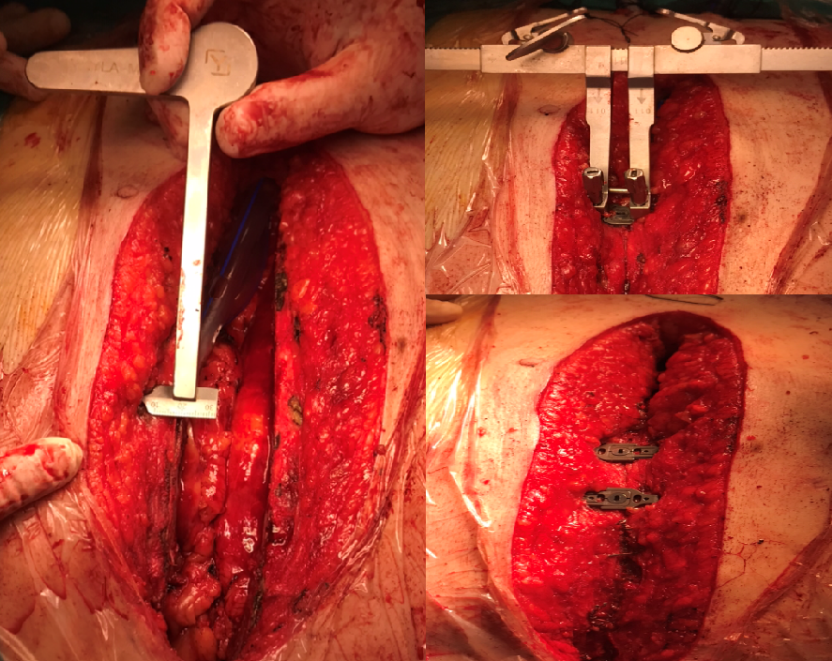
Figure 1. Patient who closed sternum using by steel wire and titanium hooks.

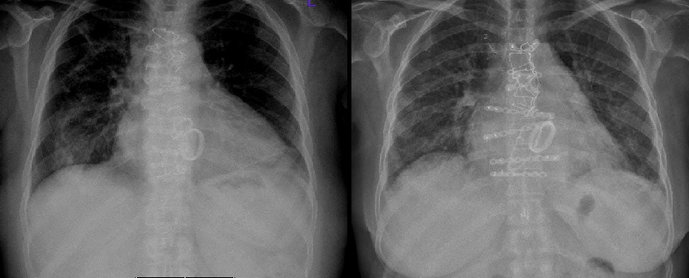
Figure 2. Direct graphy of patient who recieved steel wire-titanium plates and screws.

 | Steel wire and talonN=34 | Steel wire -rigid plade  N=33 | P
Age | 65.5 ±7.8 | 67.0±7.1 | 0.09
Female (%) | 18 (%52.9) | 17 (%51.51) | 0.611
DM (%) | 14 (% 41.1) | 7 (%21.21) | 0.029
HT (%) | 9 (% 26.4) | 6 ( %19.8) | 0.07
COPD (%) | 7 (%20.58) | 7 (%21.21) | 0.889
Smoker (%) | 19 ( % 55.88) | 24 (% 36.3) | 0.061
Obesity (BMI>30kg/m²) | 8 ( %23.52) | 5 (%15.15) | 0.113
Multiple comorbities (%) | 26 (% 76.47) | 24 (%72.27) | 0.892

Table 1. Preoperative patient characteristics.

 | Steel wire and talonN=34 | Steel wire -rigid plade  N=33 | P
Postoperative bleeding (ml) | 498±176 | 550±182 | 0.285
Ventilation (hour) | 8.2±2.1 | 7.1±2.3 | 0.710
Prolonged inotrope | 9 (%26.47) | 7 (%21.21) | 0.402
ICU stay (hour) | 25.7±11.2 | 22.9±9.5 | 0.128
Hospital stay (day) | 5.4±1.8 | 5.7±1.7 | 0.767
Superficial wound infection | 4 (%11.76) | 4(%12.12) | 0.813

Table 2. Postoperative follow-up results.

