**CRITICAL FACTORS LEADING TO WOUND COMPLICATIONS IN AMPUTATED PATIENTS: LOW HEMATOCRIT LEVELS**

**Original Article**

**İbrahim Demir1, Metin Onur Beyaz2**

1Istanbul University, Faculty of Medicine, Department of Cardiovascular Surgery, Istanbul

2Istanbul Medipol University, Faculty of Medicine, Department of Cardiovascular Surgery, Istanbul

**Correspondence:**

İbrahim Demir

Istanbul University, Faculty of Medicine, Department of Cardiovascular Surgery, Topkapı, Turgut Özal Millet Cd, 34093 Fatih/İstanbul

Phone: +90 5444083812

e-mail: [ibrahimd128@gmail.com](mailto:ibrahimd128@gmail.com)

**ABSTRACT**

**Aim:** Patients with diabetes-induced lower extremity infection and gangrene suffer from post-amputation wound complications. The aim of this report is to identify critical factors leading to wound complications in amputated patients.

**Patients and Methods:** 50 patients with ipsilateral transmetatarsal (TMA) or finger amputation treated in Istanbul University Medical Faculty between 2001 and 2013 were retrospectively reviewed. Amputations were caused by diabetic foot infection. None of the patients had peripheral artery disease (ABPI> 1.1).

**Results:** In 9 (18%) patients, revision was required despite appropriate antibiotherapy after amputation. 7 (78%) of these patients were women, 8 (89%) were smokers and hematocrit levels were below 25% in all of them. 4 of the 5 patients (80%) with chronic kidney disease were among the patients in need of revision.

**Conclusion:** The risk of wound complications after amputation is high. These complications increase morbidity and treatment costs. This study showed that low hematocrit value is a risk factor for the development of wound infection after amputation.

**Key Words:** Hematocrit, Diabetic Foot, Amputation, Infected Wound.

**INTRODUCTION**

Diabetic foot is a chronic complication that progresses with necrosis of deep tissues as a result of the development of neuropathy and neuroiscemia in the lower limbs (1). Those who have peripheral artery disease have a higher risk.

Diabetic foot ulcer is a complication that affects 15% of patients with diabetes at any time in their lives. It is associated with diabetic neuropathy and its incidence has increased (2). If the ulceration is not treated properly, it causes a dramatic process that leads to amputations. Neuropathy, neuro-ischemia, and infections play a role in determining the healing or worsening of the ulcers. In diabetic patients, a severe foot ulcer develops before 85% of all amputations (3).

Surgeons often perform total transmetatarsal amputation (TMA) for chronic diabetic infection. The primary goal is to maintain limb function continuity by protecting the ankle joint (4). However, in the literature, cases progressing to more proximal amputations between 30% and 60% have been reported (5-6).

In this article, we examined wound development and the factors that caused it in patients undergoing finger amputation or TMA.

**PATIENTS AND METHODS**

**Material and Methods**

50 patients with ipsilateral transmetatarsal (TMA) or finger amputation treated in Istanbul University Medical Faculty between 2001 and 2013 were retrospectively reviewed. Amputations were caused by diabetic foot infection. None of the patients had peripheral artery disease (ABPI> 1.1). The distal pulse examination was normal.

**Results**

28 of 50 patients (56%) were women. As comorbid risk factors, 11 (22%) patients were obese (BMI>30). 26 (52%) patients were smokers for more than 10 packs/year. 6 (12%) patients had chronic obstructive pulmonary disease (COPD) (with FEV1 <80% and FEV1 / FVC <70% with spirometry).5 patients (10%) were receiving regular dialysis treatment due to chronic kidney disease.

The average age of male patients was 50.6 ± 7.1, and the average age of women was 53.2 ± 5.6. 6 patients (12%) had a history of myocardial infarction. Preoperative hematocrit level was below 25% in 11 patients (22%).

One or more finger amputations were performed in 39 patients (78%), and transmetatarsal amputation was performed in 11 patients (22%). Amoxicillin/clavunate and ciprofloxacin treatment was applied in the preoperative and postoperative period in all patiens. No patients had penicillin allergy.

**Image 1.** Patient had infected distal necrotic wound.

In 9 (18%) patients, revision was required despite appropriate antibiotherapy after amputation. 8 (16%) of the patients who needed further level amputation or debridement due to revision had osteomyelitis. 7 (78%) of these patients were women, 8 (89%) were smokers and hematocrit levels were below 25% in all of them. 4 of the 5 patients (80%) with chronic kidney disease (CKD) were among the patients in need of revision. In addition, all CKD patients had osteomyelitis.

**Image 2.** Patient who needed further amputation.

**DISCUSSION**

Diabetic foot syndrome and related ulcer development is a serious complication and negatively affects life. Although it is worse in those with peripheral arterial disease, it is not necessary for the development of ulcers.

The majority of patients developing ulcers are exposed to amputation. The most common reason for this is infection. The most reproducing microorganism in the infection material is staphylococcus aureus (7). Swab samples should be taken to determine appropriate antibiotherapy in patients who had infections. According to the swab result, the microorganism should be identified, and treatment should be started by evaluating with the antibiogram.

**Image 3.** Patient who had infected wound after amputation.

In our study, methicillin sensitive S. aureus (MSSA) seen in 40 (80%) patients, methicillin resistant S. aureus (MRSA) seen in 5 (10%) patients, vancomycin resistant enterococcus (VRE) seen in 2 (4%) patients, 1 (2%) clostridium difficile was seen in 2 patients and more than one bacterial organism seen in 2 (4%) patients. In addition to the classical amoxicillin/clavunate and ciprofloxacin treatments, antibiotherapies of the patients were arranged according to the antibiogram results. Patients they had MRSA took trimethoprim-sulfamethoxazole, VRE patients took doxycycline, c. difficile patients took vancomycin preparations.

Another important method in controlling the infection is to perform sharp debridements (8). Patients may still need amputation in the presence of debridement and antibiotherapy, but the amputation level shifts more distally since the spread of infection is limited.

**Image 4.** Successful amputation at distal level.

In order to make an amputation decision, the patient should be screened by imaging methods. The sensitivity of X-ray to detect osteomyelitis has been reported to be around 50% (9). Even in the presence of infection, the degree of deep tissue involvement may not be understood. Deep tissue involvement should definitely be considered in the presence of non-healing ulcer. Magnetic resonance imaging (MRI) is 80-90% sensitive for osteomyelitis (10). However, alone it has specificity of 80%. Therefore, X-ray and MRI should be used together to investigate the presence of osteomyelitis. One of the most remarkable result in our patient group was the present of osteomyelitis in all CKD patients requiring revision.

The risk of wound complications after amputation is high. These complications increase morbidity and treatment costs. This study showed that low hematocrit value is a risk factor for the development of wound infection after amputation. More multicenter studies should be done to raise awarness of the low hematocrit level and to define treatment protocols for wound infections seen after amputation.

**CONCLUSION**

Smoking and female gender are important risk factors in patients with diabetic foot. Low hematocrit values play an important role in the development of wound infections in these patients. In patients with diabetic foot infection, finger amputation can be tried in the first place for the purpose of low tissue loss. However, more aggressive treatment can be considered in terms of time and resource consumption in female patients, patients undergoing regular dialysis and patients with low hematocrit. At the same time, studies should be conducted for patients receiving antibiotherapy and treatment to increase hematocrit levels.

**Author Contrıbutıons:**

Made substantial contributions to conception and design of the study and performed data analysis and interpretation: Beyaz MO, Demir I.

Performed data acquisition, as well as provided administrative, technical, and material support: Demir I, Beyaz MO.

**Avaılabılıty of Data and Materıals:** All data of the patients are stored at Istanbul University where the operations are performed.

**Fundıngs:** None declared.

**Conflict of Interest:** None declared.

**Acknowledgments:** None declared.

**Ethical Approval:**

Informed consent was obtained from the relatives of each patient before the procedures after explaining the interventions, risks and benefits as a policy of the health system in the country.

**REFERENCES**

1. Apelqvist J. Diagnostic and treatment of the diabetic foot. Endocrine 2012;41:384-97.
2. Brocco E, Ninkovic S, Marin M, et al. Diabetic foot management: multidisciplinary approach for advanced lesion rescue. J Cardiovasc Surg (Torino). 2018;59(5):670-684. doi:10.23736/S0021-9509.18.10606-9
3. Lepantalo M, Apelqvist J, Setacci C, Ricco JB, De Donato G, Becker F, et al. Chapter V: diabetic foot. Eur J Vasc Endovasc. 2011;42:S60-74.
4. Anthony T, Roberts J, Modrall JG, Huerta S, Asolati M, Neufeld J, Parker B, Yang W, Sarosi G. Transmetatarsal amputation: assessment of current selection criteria. Am J Surg 2006;192:e8–e11.
5. Blume P, Salonga C, Garbalosa J, Pierre-Paul D, Key J, Gahtan V, Sumpio BE. Predictors for the healing of transmetatarsal amputations: retrospective study of 91 amputations. Vascular 2007;15:126–133.
6. Younger AS, Awwad MA, Kalla TP, de Vries G. Risk factors for failure of transmetatarsal amputation in diabetic patients: a cohort study. Foot Ankle Int 2009;30:1177–1182.
7. Sotto A, Richard JL, Messad N, et al. Distinguishing colonization from infection with Staphylococcus aureus in diabetic foot ulcers with miniaturized oligonucleotide arrays: a French multicenter study. Diabetes Care. 2012;35:617‐623.
8. Apelqvist J, Ragnarson‐Tennvall G, Persson U, Larsson J. Diabetic foot ulcers in a multidisciplinary setting. An economic analysis of primary healing and healing with amputation. J Intern Med. 1994;235:463‐471.
9. Dinh MT, Abad CL, Safdar N. Diagnostic accuracy of the physical examination and imaging tests for osteomyelitis underlying diabetic foot ulcers: meta‐analysis. Clin Infect Dis. 2008;47:519‐527.
10. Zavadovskaya VD, Zorkal'tsev MA, Udodov VD, et al. [Possibilities of a software‐based hybrid single photon emission computed tomography/magnetic resonance imaging in the diagnosis of complicated diabetic foot syndrome]. Vestn Rentgenol Radiol. 2015;(6):24‐29.

**Image 1.** Patient had infected distal necrotic wound.

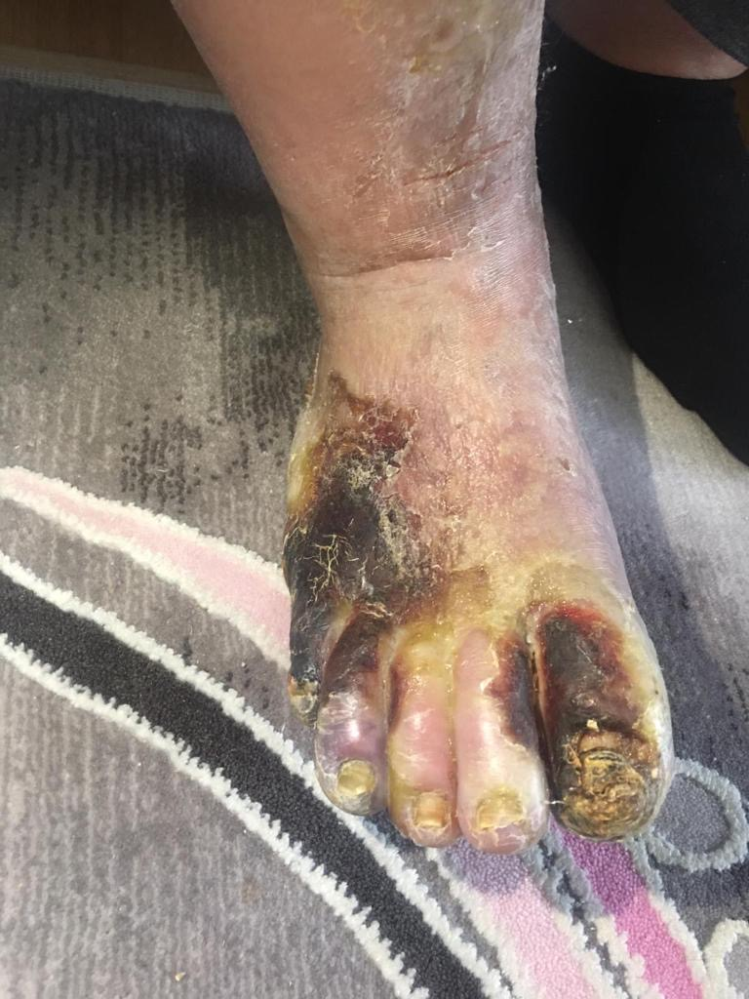

**Image 2.** Patient who needed further amputation.

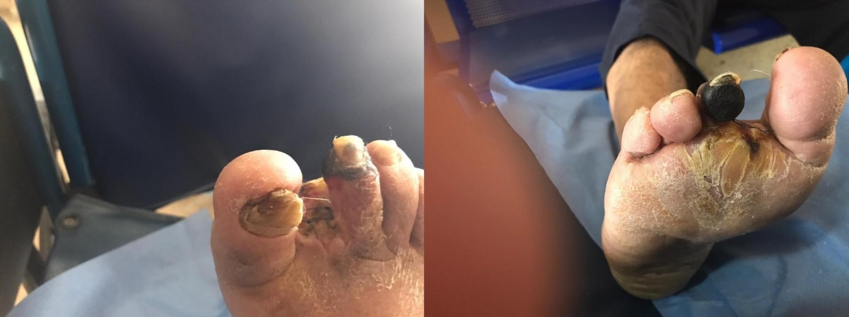

**Image 3.** Patient who had infected wound after amputation.

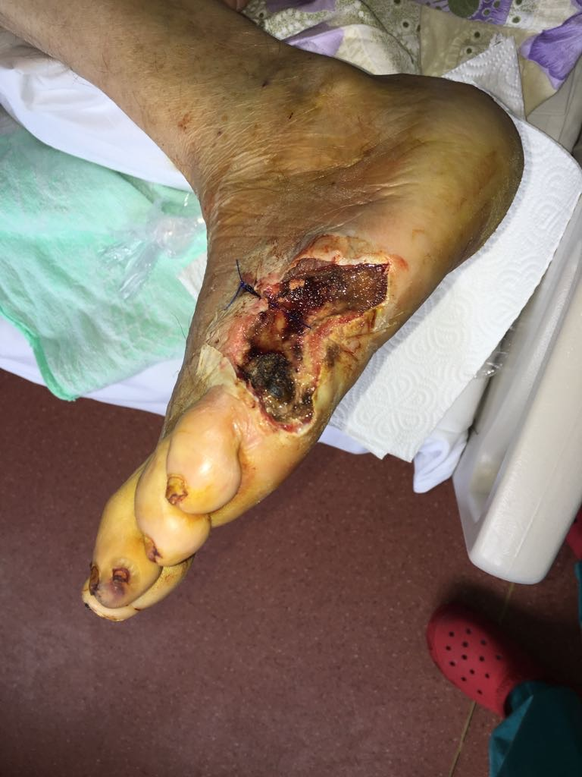

**Image 4.** Successfully amputation at distal level.

