Category : Letter to Editor

Author
- Sajad Ahmad Salati , MBBS, MS , MRCS (Glasgow)
Unaizah College of Medicine, Qassim University, KSA

Address for Correspondence
Dr Sajad Ahmad Salati
Associate Professor of Surgery,
Unaizah College of Medicine, Qassim University, KSA.
Email: docsajad@yahoo.co.in
Mobile: 00966530435652

TITLE

Transjugular Intrahepatic Portosystemic Shunt in Budd-Chiari Syndrome.

A 29 year-old female, known case of primary Budd-Chiari Syndrome (BCS) reported with nonspecific abdominal discomfort. She had previous history of multiple variceal bleeds and had undergone placement of Transjugular Intrahepatic Porto-systemic Shunt (TIPS) three months before this episode. She was on a follow up of regional tertiary care center for hepatic disorders. The patient was managed conservatively as the hemodynamic and laboratory parameters were within acceptable limits. Imaging was done to study the status and patency of shunt . Multiaxial CT scan for abdomen and pelvis with oral and intravenous contrast (Figure 1: A- F) showed heterogeneous liver and patent TIPS stent communicating the porto-venous and systemic system. The portal vein was distended with multiple collaterals. There was no ascites and splenomegaly (dimension - 26 cm). Rest of the study was unremarkable.

Figure 1: CT Scan showing patent TIPS (red arrows ) and dilated collaterals (blue arrow) A- Scout Film , B-Coronal View , C-Saggital view , D- Transverse section(without contrast ) , E-F Transverse section (with contrast ).
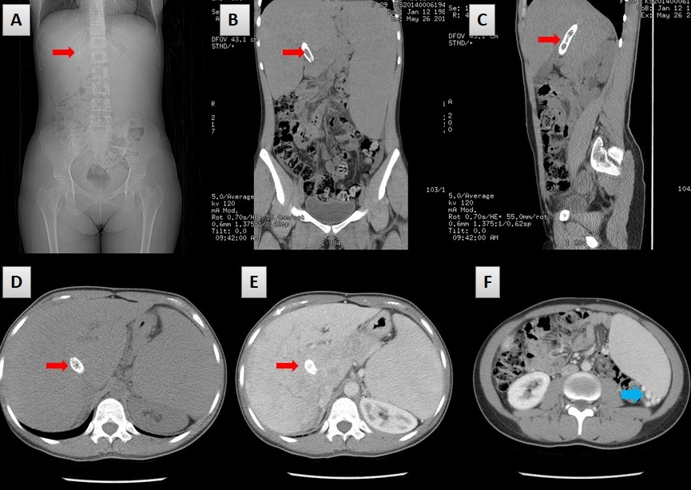

Budd–Chiari syndrome (BCS) is a very rare condition, affecting 1 in a million adults. BCS is named after George Budd, a British internist and Hans Chiari, an Austrian pathologist. BCS affects younger to middle-aged patients with the mean age of 40. The condition is caused by occlusion of the hepatic venous outflow at any level from the small hepatic veins to the atriocaval junction (1). The obstruction may be thrombotic or non-thrombotic. BCS is classified as primary (75%) or secondary (25%) depending on the origin of the obstructive lesion. If the obstruction results from endoluminal venous lesion-like thrombosis, it is termed as primary BCS. If however the cause originates from neighboring structures like extrinsic compression or tumor invasion, it is called as secondary BCS (2).

Two of the hepatic veins must be blocked for clinically evident disease when it presents with the classical triad of abdominal pain, ascites, and liver enlargement. The syndrome can be fulminant, acute, subacute, chronic, or asymptomatic. Acute or sub-acute variants with diffuse occlusion of hepatic veins still have a high mortality rate and remains challenging for clinical treatment. Transjugular intrahepatic porto-systemic shunt (TIPS) has been used in recent times successfully and safely in selected patients of BCS as a definitive treatment or as successful bridge to liver transplant (3, 4). The most common indications for TIPS in BCS patients include progressive liver failure, refractory ascites, recurrent variceal bleeding and diffuse hepatic vein thrombosis and successful TIPS insertion have been found to improve the hemodynamic and clinical parameters (5).

Insertion of TIPS involves a technique that starts with insertion of a 5 F multipurpose catheter into the hepatic vein. Angiography is performed and occlusion is identified. A puncture needle is advanced into the portal vein through the liver parenchyma from inferior vena cava (IVC) and then the guide wire is placed into the portal vein (PV) through the 10 F sheath. Portal vein angiography is performed and the portal vein pressure and right atrium pressure is measured to calculate the porto-systemic pressure gradient (PSG). TIPS shunt is dilated with an angioplasty balloon of 8 or 10 mm diameter, and then a covered stent with a diameter of 8 or 10 mm is deployed (6). Qi X in recent study documented in procedure-related complications in up to 56% after TIPS and shunt dysfunction in 18-100%. Short- and long-term prognosis of BCS-TIPS patients has been found to be excellent with 1-year cumulative survival rate of 80-100% and 5-year cumulative survival rate of 74-78% (5).
Conflict of interest: None

Acknowledgements: The author expresses gratitude to the patient for allowing the usage of images for academic purposes.

References
- Horton JD, San Miguel FL, Membreno F, Wright F, Paima J, Foster P, Ortiz JA. Budd-Chiari syndrome: illustrated review of current management. Liver Int. 2008; 28(4):455-66. doi: 10.1111/j.1478-3231.2008.01684.x.
- Aydinli M, Yusuf Bayraktar Y .Budd-Chiari syndrome: Etiology, pathogenesis and diagnosis. World J Gastroenterol. 2007; 13(19): 2693–2696. doi: 10.3748/wjg.v13.i19.2693
- Fox MA, Fox JA, Davies MH. Budd-Chiari syndrome-a review of the diagnosis and management. Acute Med. 2011; 10(1):5-9. doi: 10.1111/j.1478-3231.2008.01684.x
- Olliff SP. Transjugular intrahepatic portosystemic shunt in the management of Budd Chiari syndrome. Eur J Gastroenterol Hepatol. 2006; 18(11):1151-4. doi: 10.1097/01.meg.0000236874.75601.a1
- Qi X, Yang M, Fan D, Han G. Transjugular intrahepatic portosystemic shunt in the treatment of Budd-Chiari syndrome: a critical review of literatures. Scand J Gastroenterol. 2013; 48(7):771-84. doi: 10.3109/00365521.2013.777775.
- He F , Zhao H, Dai S, Wu Y, Wang L, et al. Transjugular intrahepatic portosystemic shunt for Budd–Chiari syndrome with diffuse occlusion of hepatic veins. Sci Rep. 2016; 6: 36380. ; doi: 10.1038/srep36380

