Double J stent migration in the contralateral ureter during robot-assisted pyeloplasty: an unique complication
Keywords: double J stent dislocation, robotic pyeloplasty, hydronephrosis

Introduction
The placement of double-J (DJ) stent in the urinary tract is an integral part of urologic practice for various indications. However, DJ stent placement may cause many complications ranging from stent-related irritative lower urinary tract symptoms (LUTS) to advanced renal failure in case of a forgotten stent [1]. Although complications such as encrustations, proximal, and distal migrations within the pelvicaliceal system (PCS) are reported frequently in the literature, stent displacement into the contralateral ureter is rare and not previously described at our knowledge. Herein, we present a case of a DJ stent migration into the distal portion of the contralateral ureter, causing hydronephrosis and lumbar pain.
.Case Report
A 25 years-old Caucasian man came to our attention because of a right pielo-ureteral junction stricture with hydronephrosis. His past medical history was negative. Physical examination was within normal limits. We performed a robot-assisted right pieloureteroplasty; during the procedure, a double-J stent was placed in an anterograde way on a hi-wire guide, after the anastomoses posterior plate confection (figure 1). The correct positioning of the stent into the bladder was verified through bladder filling with dye.
During the first post-operative day, patient began complaining of left flank pain and hematuria. An ultrasound scan was performed and left hydronephrosis was found. Thus, we perform a radiograph (KUB) that showed DJ stent with radiopaque coil in the right renal and the distal coil lying into the supposed path of the left ureter (figures 2 and 3). The patient underwent cystoscopy that confirmed the diagnosis (figure 4). The distal coil of the stent was exctracted from the left ureter and replaced into the bladder, under radiological control. The postoperative recovery was uneventful and the patient underwent DJ stent removal after 6 weeks with no complications.
Discussion
Since its inception by Zimskind the placement of DJ stent became an integral part of urologic armamentarium [2]. However, DJ stent placement is not free of complications. The most common complications are irritative LUTS, sovrapubic pain and vesico-ureteral reflux resulting in flank pain [3]. Although proximal and distal migration of ureteral stent is a relatively common occurrence, displacement of the stent into the contralateral ureter is an extremely rare case, never described in literature at our knowledge. In our case, we suggest that the guidewire, inserted into the right ureter at the UPJ, arrived in the bladder through the right ureteral orifice and took the road to the left ureteral orifice, going up to the left pelvic ureter. Consequently, also the DJ stent was placed with its distal coil into the left ureter. As the distal end of the stent was lying into the left ureter lumen, occluding the same, the patient had left flank pain and hydronephrosis. In our case, a cystoscopy with stent replacement guaranteed an optimal management.
References
1. Forgotten Reminders: an Experience with Managing 28 Forgotten Double-J Stents and Management of Related Complications. Sohrab A, Aneesh S, Sureka SK, Varun M, Nitesh P, Manoj K, Rakesh K Indian J Surg. 2015 Dec; 77(Suppl 3):1165-71.
2. Clinical use of long-term indwelling silicone rubber ureteral splints inserted cystoscopically. Zimskind PD, Fetter TR, Wilkerson JL J Urol. 1967 May; 97(5):840-4.
3. Dyer RB, Chen MY, Zagoria RJ, Regan JD, Hood CG, Kavanagh PV. Complications of ureteral stent placement. Radiographics 2002;22:1005–1022

Figures and legends

Figure 1

Figure 2. Rx demonstrating the placement of the distal end of the DJ stent
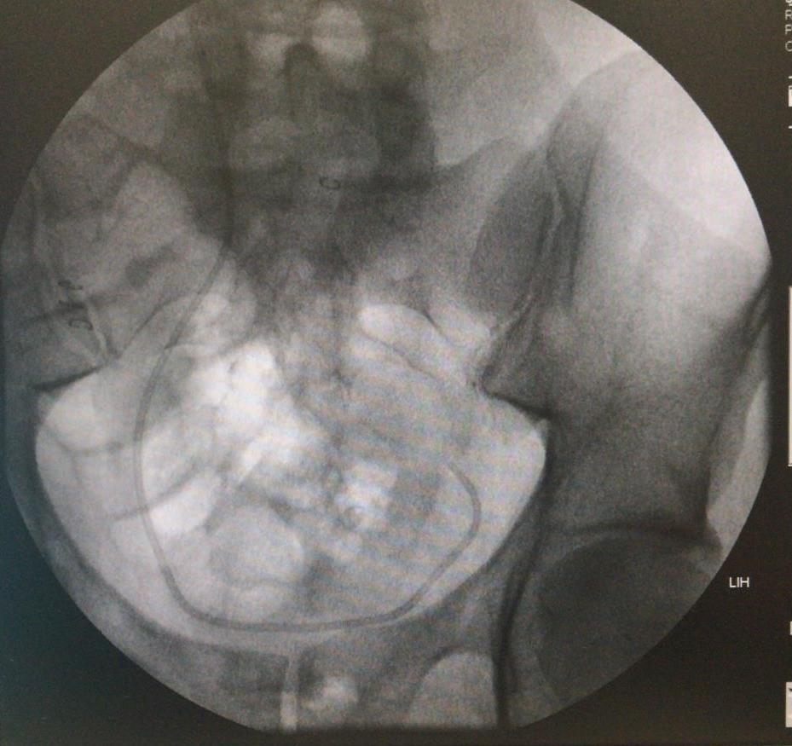
Figure 3. Rx demonstrating the placement of the proximal end of the DJ 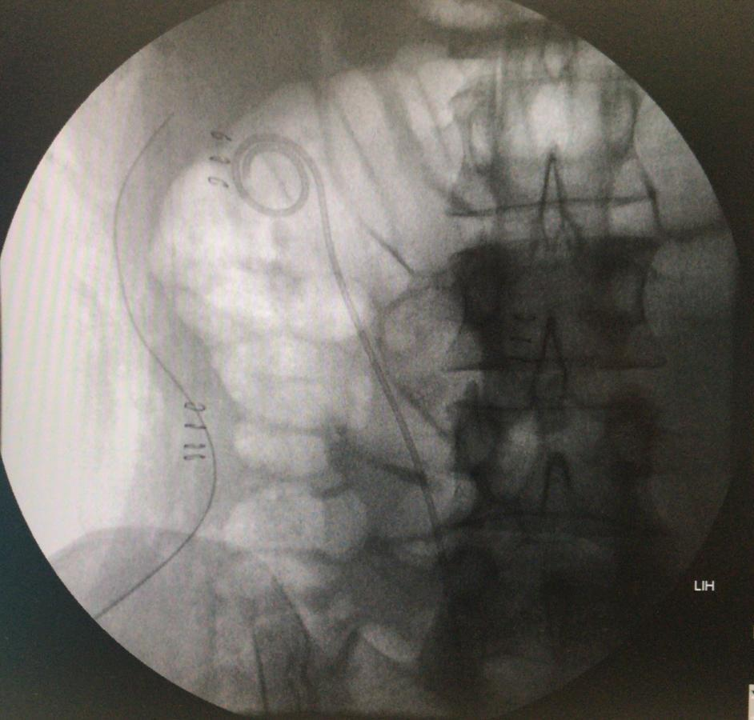

Figure 4. Endoscopic vision of the DJ stent (right and left ureter)


