I have taken note of these changes and agree to the publication.

Dear Reviewers and Editor
We are very grateful for taking time and expertise in reviewing this manuscript. All suggestions have been incorporated and all changes have been underlined. We believe that this has increased the quality of the manuscript and hope that this would be acceptable for publication.

Reviewer#1:
I pointed out the following to the authors:
1- In the abstract, the corrected PSA should be 6.8 x 2 = 13.6 and not 13.4.
Reply: Apologies, this has been corrected.
2- In the 5th paragraph of the discussion, you write : “the primary site
of the suspected cerebral metastasis was investigated extensively with CT
CAP, PET-CT, PSA levels and DRE, all being non-contributory” : This is not
entirely true because PSA levels are suggestive of prostate cancer.
Moreover, it would probably be necessary to define what you think "low PSA"
means. Regardless of the Gleason score and DRE, a PSA level of 13.8 ng/ml is
at least an intermediate-risk prostate cancer according to D'AMICO, which is
in any case an indication to perform a prostate MRI. Can we therefore speak
of "low PSA"? And this, even if the patient is metastatic (he is even
oligo-metastatic).
Reply: Many thanks, we agree with your observation. We have included the normal PSA level for this age group again in this paragraph. As per the newer guidelines, the MRI should have been performed with these PSA levels. But the patient had presented to neurosurgery rather than urology and this aspect was not appreciated till after surgery. We have highlighted this aspect in the manuscript that there is a need to educate non-urologists (all clinicians) about this expansion of scope of mpMRI. The text has been suitably modified.
3- Still in the 5th paragraph of the discussion, you write : “We argue
that mpMRI, if performed pre-operatively, may have led to earlier diagnosis
and SRT to brain metastasis could have been given at the time of initial
treatment, hence avoiding unnecessary craniotomy” : Not sure at all. Even
with a confirmed histological diagnosis of prostate cancer, an isolated
brain metastasis from this cancer remains very rare, and I think that, in
this case, the first hypothesis to be considered is still an occult
pulmonary origin (large cell neuroendocrine carcinomas in particular),
justifying the resection of the cerebral lesion.
Reply: We entirely agree that this aspect is debatable as solitary brain metastasis in prostate cancer is very rare. The text has been modified and both arguments have now been included. However, we intended to emphasise that this patient was not a suitable candidate for brain surgery to begin with, since the lesion was present in an eloquent area and was incompletely resected as a result. Maybe a lesion in a less eloquent area would be resected anyway. The language of the text has been modified to present both views.
4-In the 6th paragraph of the discussion, you write : “mpMRI of prostate
may be included in the protocol for assessment of cerebral metastasis from
unknown primary in select group of males, if CT CAP and/or PET-CT is non
contributory, even when PSA and DRE are negative” : What do you base that
on? It seems unlikely to offer prostate MRI for patients with a normal DRE
or normal PSA (less than 4 ng/ml), especially when looking for metastatic
cancer.
Reply: We agree that it is unlikely that mpMRI would be offered to patients with completely normal PSA levels. Even in this case, PSA was not normal. We have modified the text to accomodate your point of view. The take home message has been modified to acknowledge the expanding role of mpMRI as the first line diagnostic modality with raised PSA levels.
Reviewer#2:
I asked the authors to:
1.Change all the identity references in the introduction and the discussion,
e.g [1] or [1,2].
Reply: Many thanks. These have been modified.
2.-2. Add the title of the article in reference 13.
Reply: Apologies for this oversight. This has been amended.

Solitary cerebral metastasis from undiagnosed prostate cancer. Potential role of multiparametric MRI prostate in pre-treatment diagnostic protocols.

Mustafa El Sheikh, Avinash Kumar Kanodia, William Gietzmann, Ghulam Nabi, Antonia Torgersen, Magdalena Szewczyk-Bieda, Heinke Pulhorn

Corresponding author: Avinash Kumar Kanodia, Consultant Radiologist, Ninewells Hospital & Medical School, Dundee, United Kingdom
avinash.kanodia@nhs.net

1. Mustafa El Sheikh - Neurosurgery Department, Ninewells Hospital & Medical School, Dundee, United Kingdom. m.elsheikh1@nhs.net

2. Avinash Kumar Kanodia - Radiology Department, Ninewells Hospital & Medical School, Dundee, United Kingdom. avinash.kanodia@nhs.net

3. William Gietzmann- Urology Department, Ninewells Hospital & Medical School, Dundee, United Kingdom. w.gietzmann@nhs.net

4. Ghulam Nabi- Urology Department, Ninewells Hospital & Medical School, Dundee, United Kingdom. g.nabi@nhs.net

5. Antonia Torgersen- Department of Neuropathology, Western General Hospital, Edinburgh, United Kingdom. antonia.torgersen@nhs.net

6. Magdalena Szewczyk-Bieda- Radiology Department, Ninewells Hospital & Medical School, Dundee, United Kingdom. m.szewczyk-bieda@nhs.net

7. Heinke Pulhorn- Neurosurgery Department, Ninewells Hospital & Medical School, Dundee, United Kingdom. heinke.pulhorn@nhs.net
Abstract
A 73-year-old man presented with a three-week history of weakness and loss of co-ordination of the left-hand side and weakness of left-hand grip. MRI brain revealed an enhancing lesion in the right parietal lobe, adjacent to the central sulcus, with surrounding oedema and a small satellite lesion in motor cortex. Body CT and FDG-PET CT revealed no obvious primary neoplasm. The patient underwent craniotomy with resection of the lesion, subsequent histopathology confirmed a metastatic carcinoma of likely prostate cancer primary origin. The patient was on 5-ARI (Finasteride) for lower urinary tract symptoms that decrease serum PSA levels to half and had benign feeling prostate on digital rectal examination (DRE). Subsequent MRI prostate confirmed presence of a lesion with very high probability of prostate cancer. The patient’s serum Prostate Specific Antigen (PSA) level was 6.8 (13.6 corrected for Finastride) which is relatively low in the context of metastatic disease. Given the recent NICE guidelines of using pre-biopsy multiparametric MRI (mpMRI) for diagnosis of prostate cancer, we suggest that in patients with cerebral metastases of unknown primary, with negative body CT, FDG PET-CT, low PSA and negative DRE, mpMRI prostate should be included in diagnostic protocol in the selected group of men, to enable early diagnosis and performing more suitable and targeted treatment.
Keywords: Brain metastasis, prostate cancer, multiparametric MRI, metastasis of unknown origin.

Introduction
Prostate cancer (PCa) is the second most common cancer among males worldwide and remains the second largest contributor to cancer-related mortality amongst males in the UK. [1,2] However, it is still considered mostly an indolent disease with overall 5-year survival rate for PCa estimated at 86.6%. [3] Early clinical manifestations of PCa are often non-specific or absent at the time of diagnosis and PCa is known to metastasize widely, preferentially to bone and lymph nodes. [4] Traditionally, the diagnosis is confirmed via prostate biopsy, frequently following a rise in Prostate Specific Antigen (PSA), although its rise depends upon disease burden and is most notable with skeletal metastases. Confirmed cerebral metastases in PCa are considered rare, occurring mostly as single, supratentorial lesion [5], however it is not certain if the low incidence is also partly due to undiagnosed cases with cerebral metastasis of unknown origin, since targeted prostate imaging is not performed unless prostate cancer is clinically suspected, and not all such cases are resected/biopsied. Traditional whole body CT imaging would certainly miss these lesions and would lead to false belief of absence of prostate cancer, in particular in those men on 5-alpha reductase inhibitor (5-ARI) such as Finastride, a drug known to lower PSA levels. However, there is now a new approach to diagnose prostate cancer with principal role of pre-biopsy multiparametric MRI (mpMRI), [6] we believe that it can further alter the diagnostic approach for assessment of brain metastases from unknown primary.

Case Presentation
A 73-year-old man with a past medical history of sarcoidosis and benign prostate enlargement (BPE) presented with three-week history of progressive grip weakness and loss of co-ordination in the left hand. His family reported personality changes and occasional episodes of urinary incontinence. Patient was a non smoker. He had a single previous episode of painless haematuria 9 years ago, which spontaneously resolved. He was investigated by Urology and investigations including, flexible cystoscopy, CT urography and urine cytology were all satisfactory. His digital rectal examination (DRE) showed BPE and the patient was commenced on the 5-ARI, Finasteride, for treatment of BPE to good effect.

CT head revealed a solid-cystic intra-axial enhancing lesion high within the right anterior parietal lobe (adjacent to central sulcus) with surrounding vasogenic oedema. The patient’s cerebral lesion was thought to be suspicious for metastasis and subsequent body CT CAP (chest, abdomen and pelvis) revealed no primary neoplasm but lung appearances and mediastinal lymphadenopathy in keeping with known sarcoidosis. MRI of the brain confirmed presence of a single lesion, just posterior to the right central sulcus (Figure 1.) A small satellite lesion was also noted just anteriorly in the vincinity, in motor cortex (Figure 2). The patient underwent BrainLab guided craniotomy and resection of the main lesion without complications, the smaller satellite lesion was left in situ, due to location in the highly eloquent area.
Histopathological analysis of the lesion reported a metastatic carcinoma with a cribriform pattern (Figure 3). The resected specimen expressed pancytokeratin with occasional cells expressing CK20. PSA showed focal expression, with evidence of prostein and focal PAP expression. There was no expression of CK7, p40, TTF1, CDX2 or PAX8. The specimen’s overall appearances and immunohistochemistry profile were consistent with a PCa primary.
A serum PSA level taken immediately post-op measured 6.8 ng/ml. In light of the past Finasteride use, the patient’s PSA level was corrected to at least 13.6 ng/ml (6.8 x 2) - considered beyond normal limits for a 73-year-old Caucasian male [normal reference range (0 - 6.5 ng/ml) for ages 70 to 79 years].⁷ Whole-body FDG PET scan was negative for bony metastases, repeat DRE denoted a small, smooth feeling prostate. A subsequent multiparametric MR imaging (mpMRI) of the prostate confirmed presence of a solitary 11mm highly likely (PI-RADS 5) peripheral zone cancer with early extracapsular extension (4mm) but again, no evidence of regional metastasis (Figure 4). Following Urology consultation, the patient proceeded to have Degarelix hormone injections repeated every 28 days. Docetaxel chemotherapy was considered, but not commenced due to the patient’s overall poor performance status. Six months post craniotomy, the patient experienced localised seizures. Interval MR imaging demonstrated progression of the satellite (cerebral) lesion (Figure 5). Due to presence in eloquent area, no further surgery was performed but the patient had stereotactic radiotherapy (SRT) delivered to his brain. At the time of writing, the patient remains well with significant improvement in appearances on follow up MR imaging (Figure 6) and undetectable PSA one-year post craniotomy.

Discussion
Cerebral metastases of unknown origin are an important clinical problem. Once detected by either head CT or MRI, a CT CAP is usually performed to try to detect the site of primary cancer, however, it is emphasised that CT is quite insensitive in detecting cancers in certain organs, including prostate, thus there is limited utility of a CT scan for this purpose. A FDG PET-CT may also be performed, which however is not sensitive for small lesions or certain cancer types. In the future, tailored-imaging approach may needed for organs where significant progress has taken place in the detection and characterisation of primary cancers. Prostate cancer is an example where pre-biopsy mpMRI has now an established role in the diagnostic pathway.

There is currently no active screening programme for PCa in the UK. The symptoms of PCa are relatively non specific, mainly related to lower urinary tract, such as urgency, frequency and nocturia, that overlap with presentation of benign prostatic hyperplasia. Clinical suspicion for PCa arises with an increase in serum prostate-specific antigen (PSA) levels or detected abnormality on digital rectal examination (DRE), which can be negative particularly with anterior prostate lesions, notably, repeat DRE following histological diagnosis in this case was also unremarkable, thus, reiterating that a normal examination cannot rule out PCa. If clinical assessment of the prostate using a combination of blood PSA levels and a DRE is negative, no routine imaging for prostate is performed. Thus it is possible, that some of the potential cases of PCa, with isolated cerebral metastases, with relatively low PSA levels, may remain undiagnosed, unless resection or biopsy of the brain lesion is performed.

The spectrum of PCa behaviour is widely variable, ranging from asymptomatic, microscopic tumour to much rarer, symptomatic high-grade cancer that causes distant metastases, significant morbidity and death. A recent Surveillance, Epidemiology and End Results (SEER) program report from the National Cancer Institute (NCI) in the United States found that at the time of diagnosis, 6% of all PCa patients have evidence of distant metastases. [7] A population-based analysis of distribution of metastatic sites in 74,826 patients with PCa recorded that the most common metastatic sites were bone (84%), distant lymph nodes (10.6%), liver (10.2%), thorax (9.1%), brain (3.1%), and digestive system (2.7%). Of all patients with a single metastatic site involved (n= 61,095), bony metastases were the most common (83%). Isolated brain metastases were observed in only 1.0% of patients in this cohort. [8] Specifically, common intracranial sites for PCa spread include the leptomeninges, cerebrum and cerebellum, in order of frequency. [9] It needs to be emphasised that it may still represent a significant number, given the high incidence of PCa. [1,2] Isolated cerebral metastases from undiagnosed PCa are considered very rare, only a few case reports are present. [10,11] It has been highlighted that isolated cerebral metastases may have low or only slightly high PSA levels, since PSA levels are often the highest with increased disease burden, particularly with skeletal metastases. The previous case reports have not specified if any of those patients were also on 5-ARI, which is further expected to reduce PSA levels by about 50%. As in our patient, PSA levels were relatively low and only slightly high even after "adjustment", while this should still have been an indication for MRI as per newer guidelines as discussed below, this is still a message being absorbed by the non- urologists, resulting in inability to diagnose pre-operatively.

Traditional approach to diagnose PCa was, till recently, by using transrectal ultrasound-guided biopsy (TRUSB). However, it is known to miss clinically significant cancers and to overdiagnose non-significant disease leading to overtreatment. More recently, there has been a fundamental change in this approach and the new approach is to use mpMRI as a primary tool in patients clinically suspected or at risk of having prostate cancer. [6] This is also reflected in recent changes in NICE guidelines recommending upfront mpMRI in the PCa diagnosis and management. [12]

As noted from our case, the primary site of the suspected cerebral metastasis was investigated extensively with CT CAP, PET-CT, PSA levels and DRE. Almost all of these were non contributory; however, PSA was slightly raised (adjusted level of 13.6ng/ml), considering a normal level of upto 6.5ng/ml. Given that the patient presented to neurosurgery, it was only after the cerebral lesion was resected that a diagnosis was made, an mpMRI was only performed later, subsequent to urology referral. The resection itself was also suboptimal, since a satellite lesion was left, due to presence in eloquent area, subsequently treated successfully with radiotherapy. We argue that mpMRI, if performed pre-operatively, may have led to earlier diagnosis and SRT to brain metastasis could have been given at the time of initial treatment, hence avoiding unnecessary craniotomy, particularly in a disease where combination of hormones and radiotherapy are known to have significant advantages. However, it could also be argued that an isolated
brain metastasis from this cancer being very rare, the first hypothesis would still have been an occult pulmonary origin lesion such as large cell neuroendocrine carcinomas, justifying the resection of the cerebral lesion, although the resection here was suboptimal due to presence on eloquent area. Nonetheless, this case highlights and reaffirms the importance of performing mpMRI in such patients with potential for an early diagnosis.

We therefore suggest, that given the recent expansion of scope of mpMRI for diagnosis of PCa, and due to its non invasive nature, mpMRI of prostate may be included in the protocol for assessment of cerebral metastasis from unknown primary in select group of males, if CT CAP and/or PET-CT is non contributory, DRE is negative and PSA is slightly raised, since it can make a diagnosis pre-operatively and potentially result in change in treatment and delivering more appropriate treatment, which can otherwise be limited by presence of lesions in eloquent areas and patient's clinical status. As our experience with mpMRI grows due to recent change of practice [13], we may be able to perform larger trials, use a tailored approach, taking patient specific issues into account including risk factors with more specific recommendations. It is also important that the messaging of change in protocols regarding mpMRI as the first line modality for suspected prostate cancer is more widely conveyed, sensitising all clinicians and threshold for requesting it lowered.

Conclusion
We have described a rare case of isolated brain metastases of PCa with negative CT CAP, PET-CT, DRE with slightly raised PSA levels, suppressed by Finasteride use, that was resected, subsequently proven as PCa from histopathology and mpMRI. The lesion recurred due to presence of satellite lesion in eloquent area, subsequently successfully treated by SRT. This case highlights and reaffirms the role of mpMRI in patients with borderline and slightly raised PSA levels and the need to emphasise its increasingly important role in the early diagnosis of prostate cancer.

References
- Cancer Today. (2019). Retrieved 18 April 2020, from http://gco.iarc.fr/today/fact-sheets-cancers

- Cancer Research UK (2017), The 10 Most Common Causes of Cancer Death in Males, UK, 2017, Cancer Research UK, from https://www.cancerresearchuk.org/health-professional/cancer-statistics/mortality/common-cancers-compared#heading-One

- Office for National Statistics, Cancer survival by stage at diagnosis for England, 2019. from https://www.ons.gov.uk/peoplepopulationandcommunity/healthandsocialcare/conditionsanddiseases/bulletins/cancersurvivalinengland/stageatdiagnosisandchildhoodpatientsfollowedupto2018

- Tremont‐Lukats IW, Bobustuc G, Lagos GK, Lolas K, Kyritsis AP, Puduvalli VK. Brain metastasis from prostate carcinoma: The MD Anderson Cancer Center experience. Cancer. 2003;98(2):363-8

- Hatzoglou V, Patel GV, Morris MJ, et al. Brain Metastases from prostate Cancer: An 11‐Year Analysis in the MRI Era with Emphasis on Imaging Characteristics, Incidence, and Prognosis. Journal of Neuroimaging. 2014 ;24(2):161-6.

- Faria R, Soares MO, Spackman E, et al. Optimising the Diagnosis of Prostate Cancer in the Era of Multiparametric Magnetic Resonance Imaging: A Cost-effectiveness Analysis Based on the Prostate MR Imaging Study (PROMIS). Eur Urol. 2018;73(1):23–30. doi:10.1016/j.eururo.2017.08.018

- Cancer of the Prostate - Cancer Stat Facts. (2020). Retrieved 18 April 2020, from https://seer.cancer.gov/statfacts/html/prost.html

- Gandaglia G, Abdollah F, Schiffmann J, et al. Distribution of metastatic sites in patients with prostate cancer: a population‐based analysis. The Prostate. 2014;74(2):210-6.

- Sutton MA, Watkins HL, Green LK, Kadmon D. Intracranial metastases as the first manifestation of prostate cancer. Urology. 1996;48(5):789-93.

- Campagna JP, Feia K. Isolated brain metastasis of prostate carcinoma in the setting of normal prostate specific antigen. Urology case reports. 2018;21:67.

- Hafiz A, Karim MU, Qureshi BM, Jabbar AA, Ahmad Z. Solitary Brain Metastasis: A Rare Initial Presentation of Prostate Carcinoma. Cureus. 2019;11(6):e4804. Published 2019 Jun 2. doi:10.7759/cureus.4804

- Overview | Prostate cancer: diagnosis and management | Guidance | NICE. (2020). Retrieved 21 April 2020, from https://www.nice.org.uk/guidance/ng131
- Szewczyk-Bieda M, Wei C, Coll K, Gandy S, Donnan P, Ragupathy SKA, Singh P, Wilson J, Nabi G. A multicentre parallel-group randomised trial assessing multiparametric MRI characterisation and image-guided biopsy of prostate in men suspected of having prostate cancer: MULTIPROS study protocol. Trials. 2019 Nov 21;20(1):638.

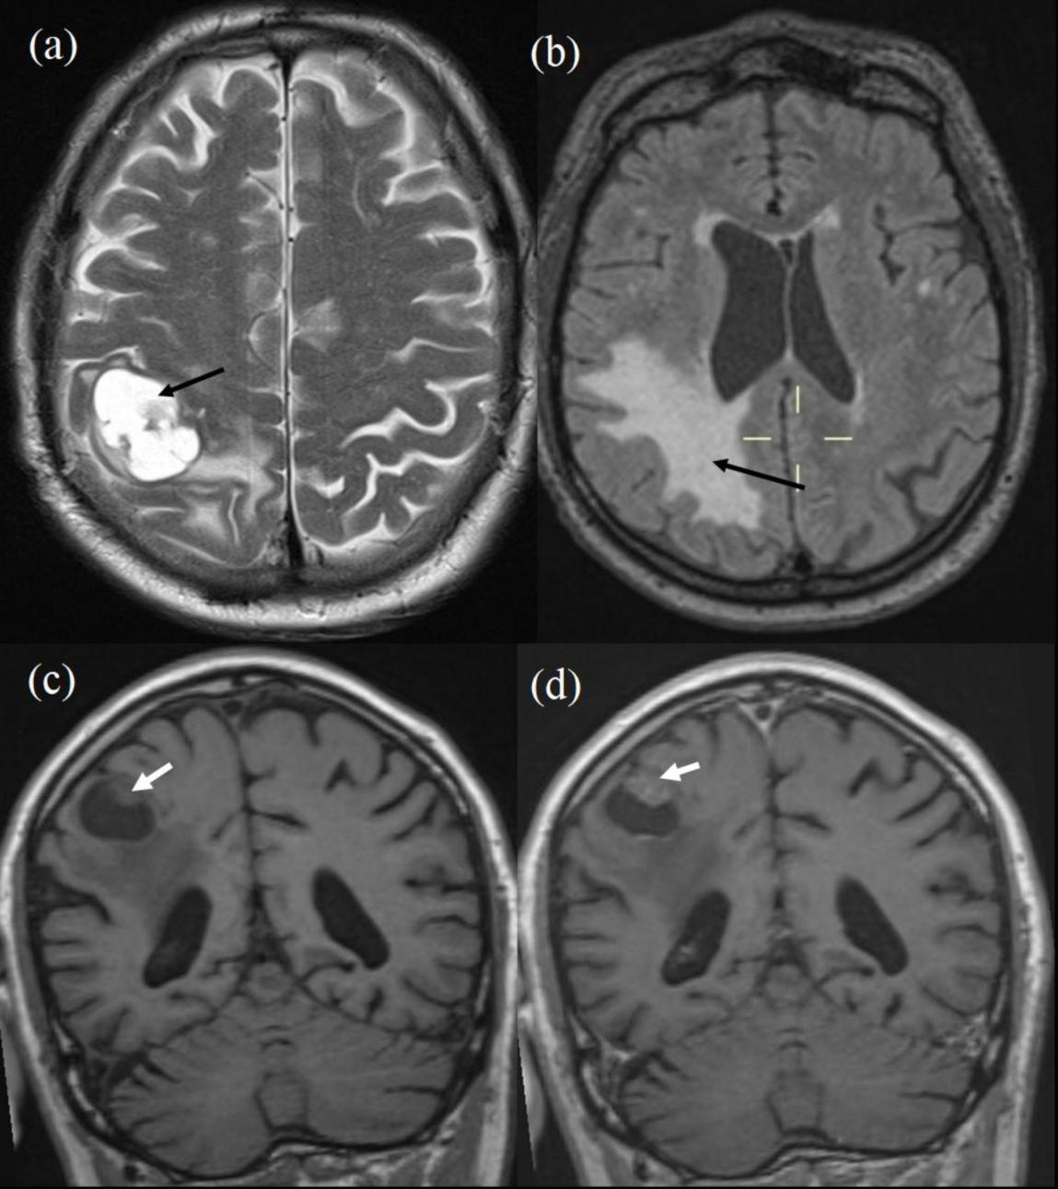
Figure 1: MRI Brain. (a) T2 axial image showing metastatic lesion (black arrow). (b) FLAIR axial image showing perifocal oedema (black arrow). (c) precontrast T1 coronal and (d) post contrast T1 coronal images show enhancing eccentric nodule (white arrow) in (d).

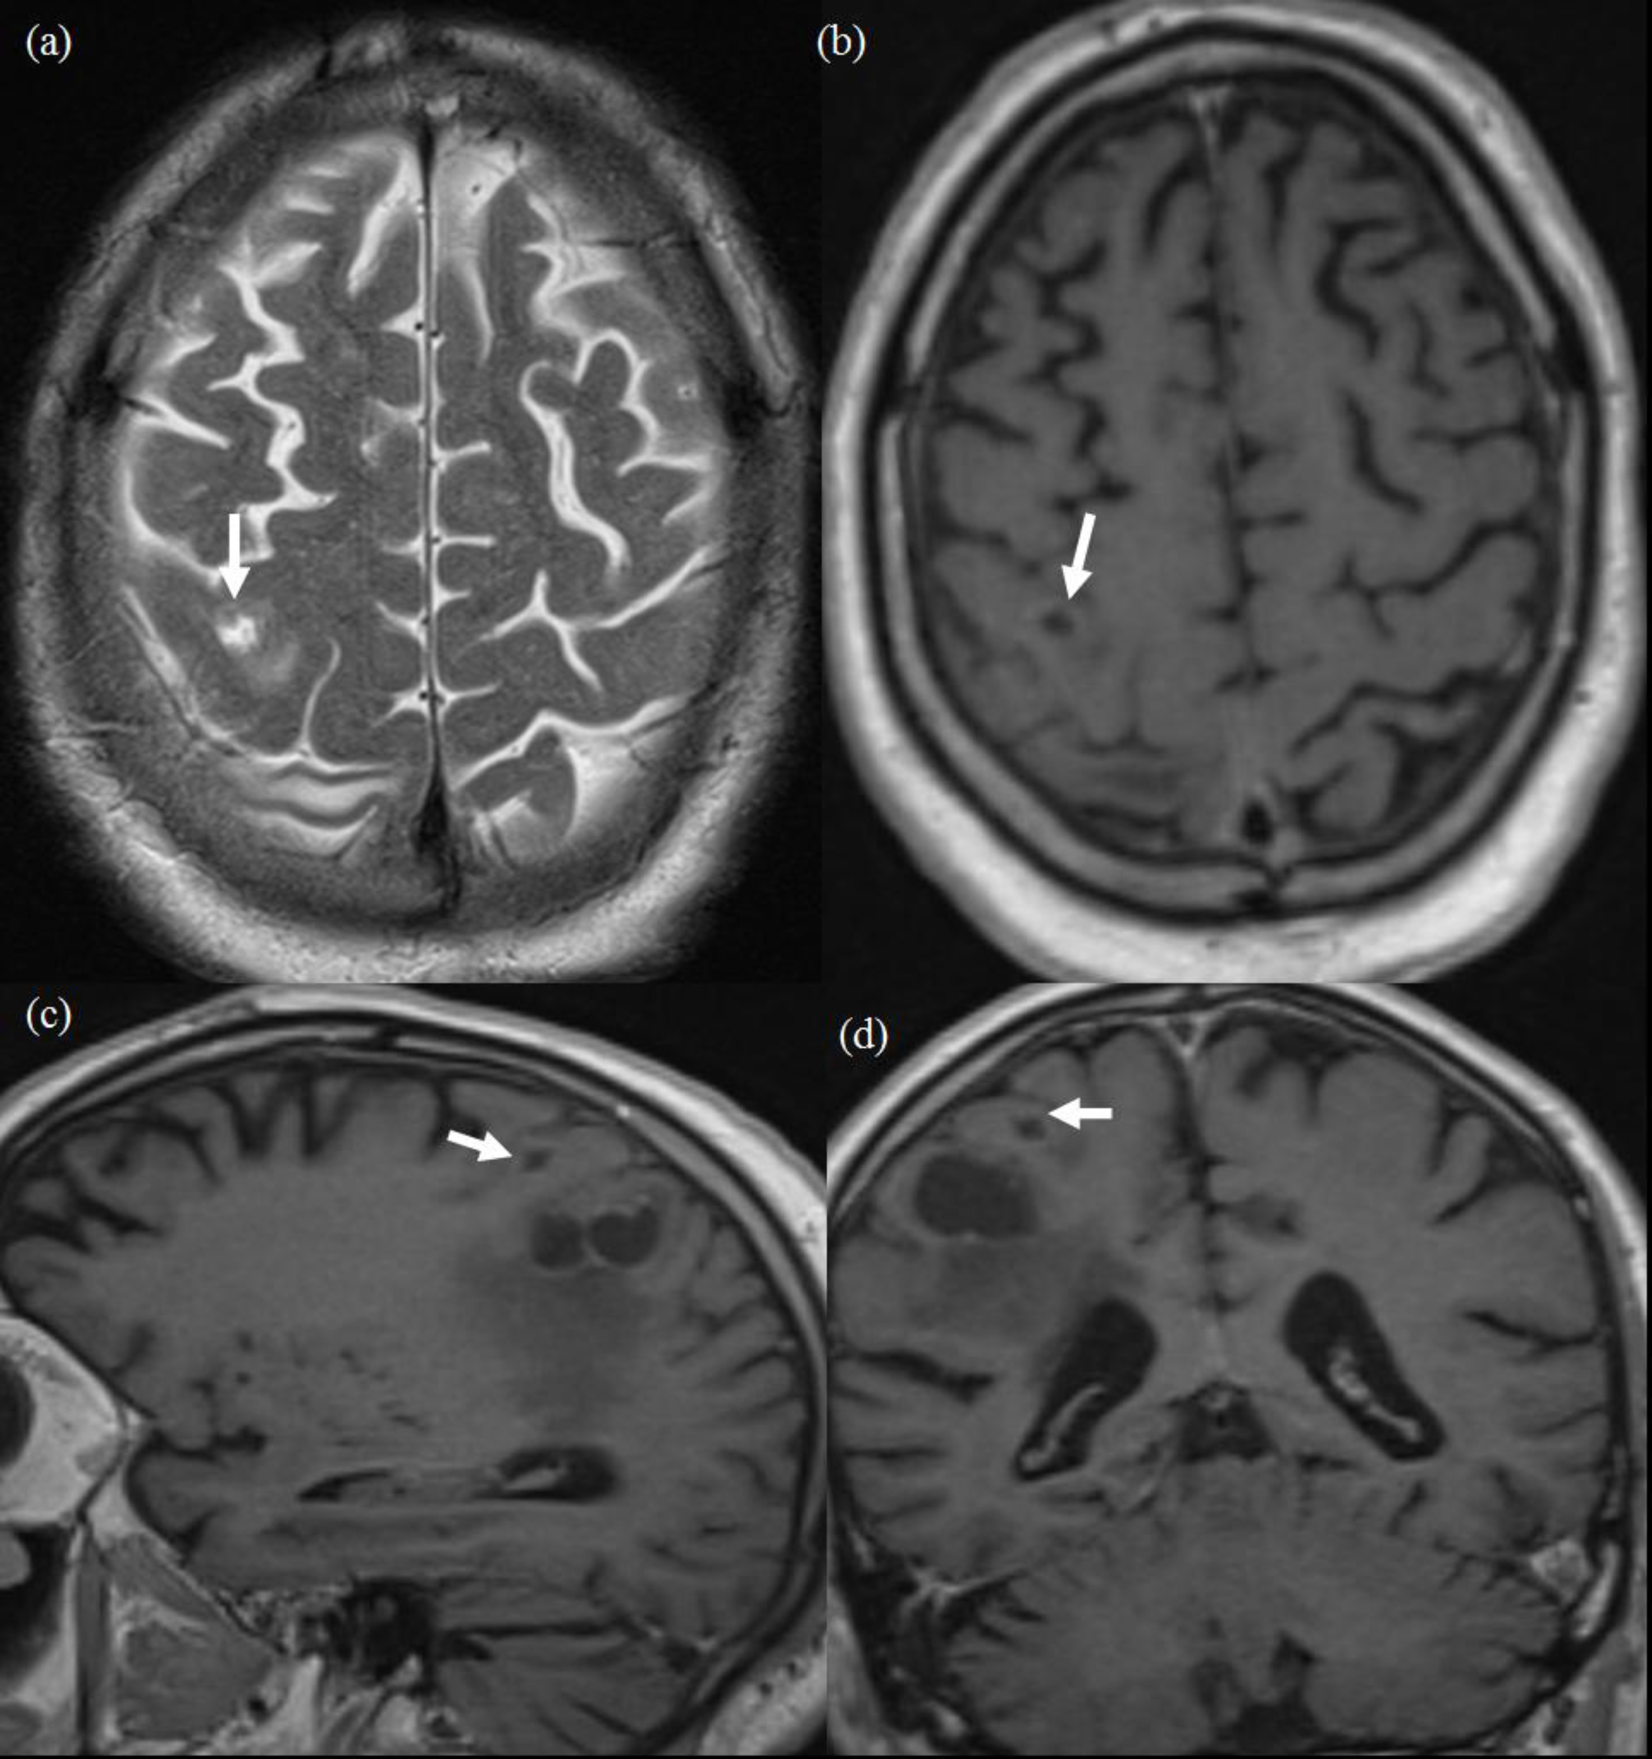

Figure 2: MRI Brain. (a) T2 axials, (b, c, d) Post contrast T1 images in axial, sagittal and coronal planes. White arrow shows the small satellite lesion anterosuperior to the main lesion, in the right motor cortex.

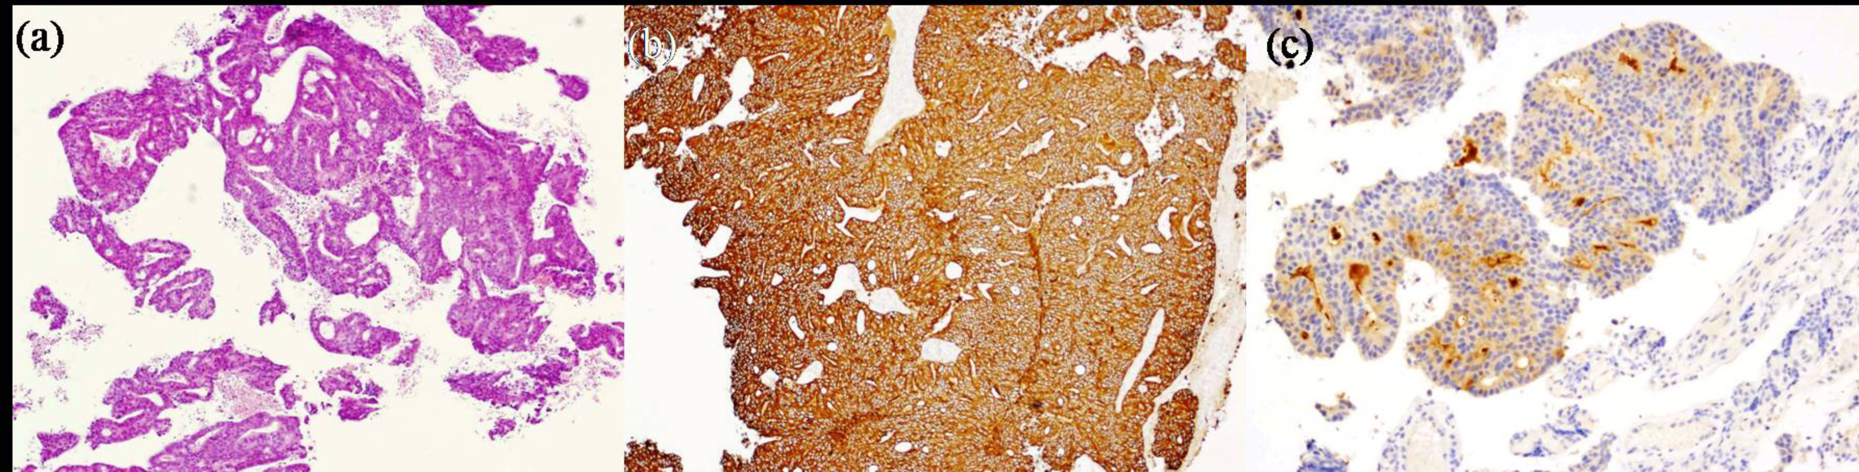

Figure 3: (a) Microscopy shows metastatic carcinoma exhibiting a cribriform pattern (haemotoxylin and eosin, 4x magnification). (b) Immunohistochemistry shows strong expression of cytokeratins (Pancytokeratin, 10x magnification). (c) Immunohistochemistry shows focal expression of PSA (10x magnification)

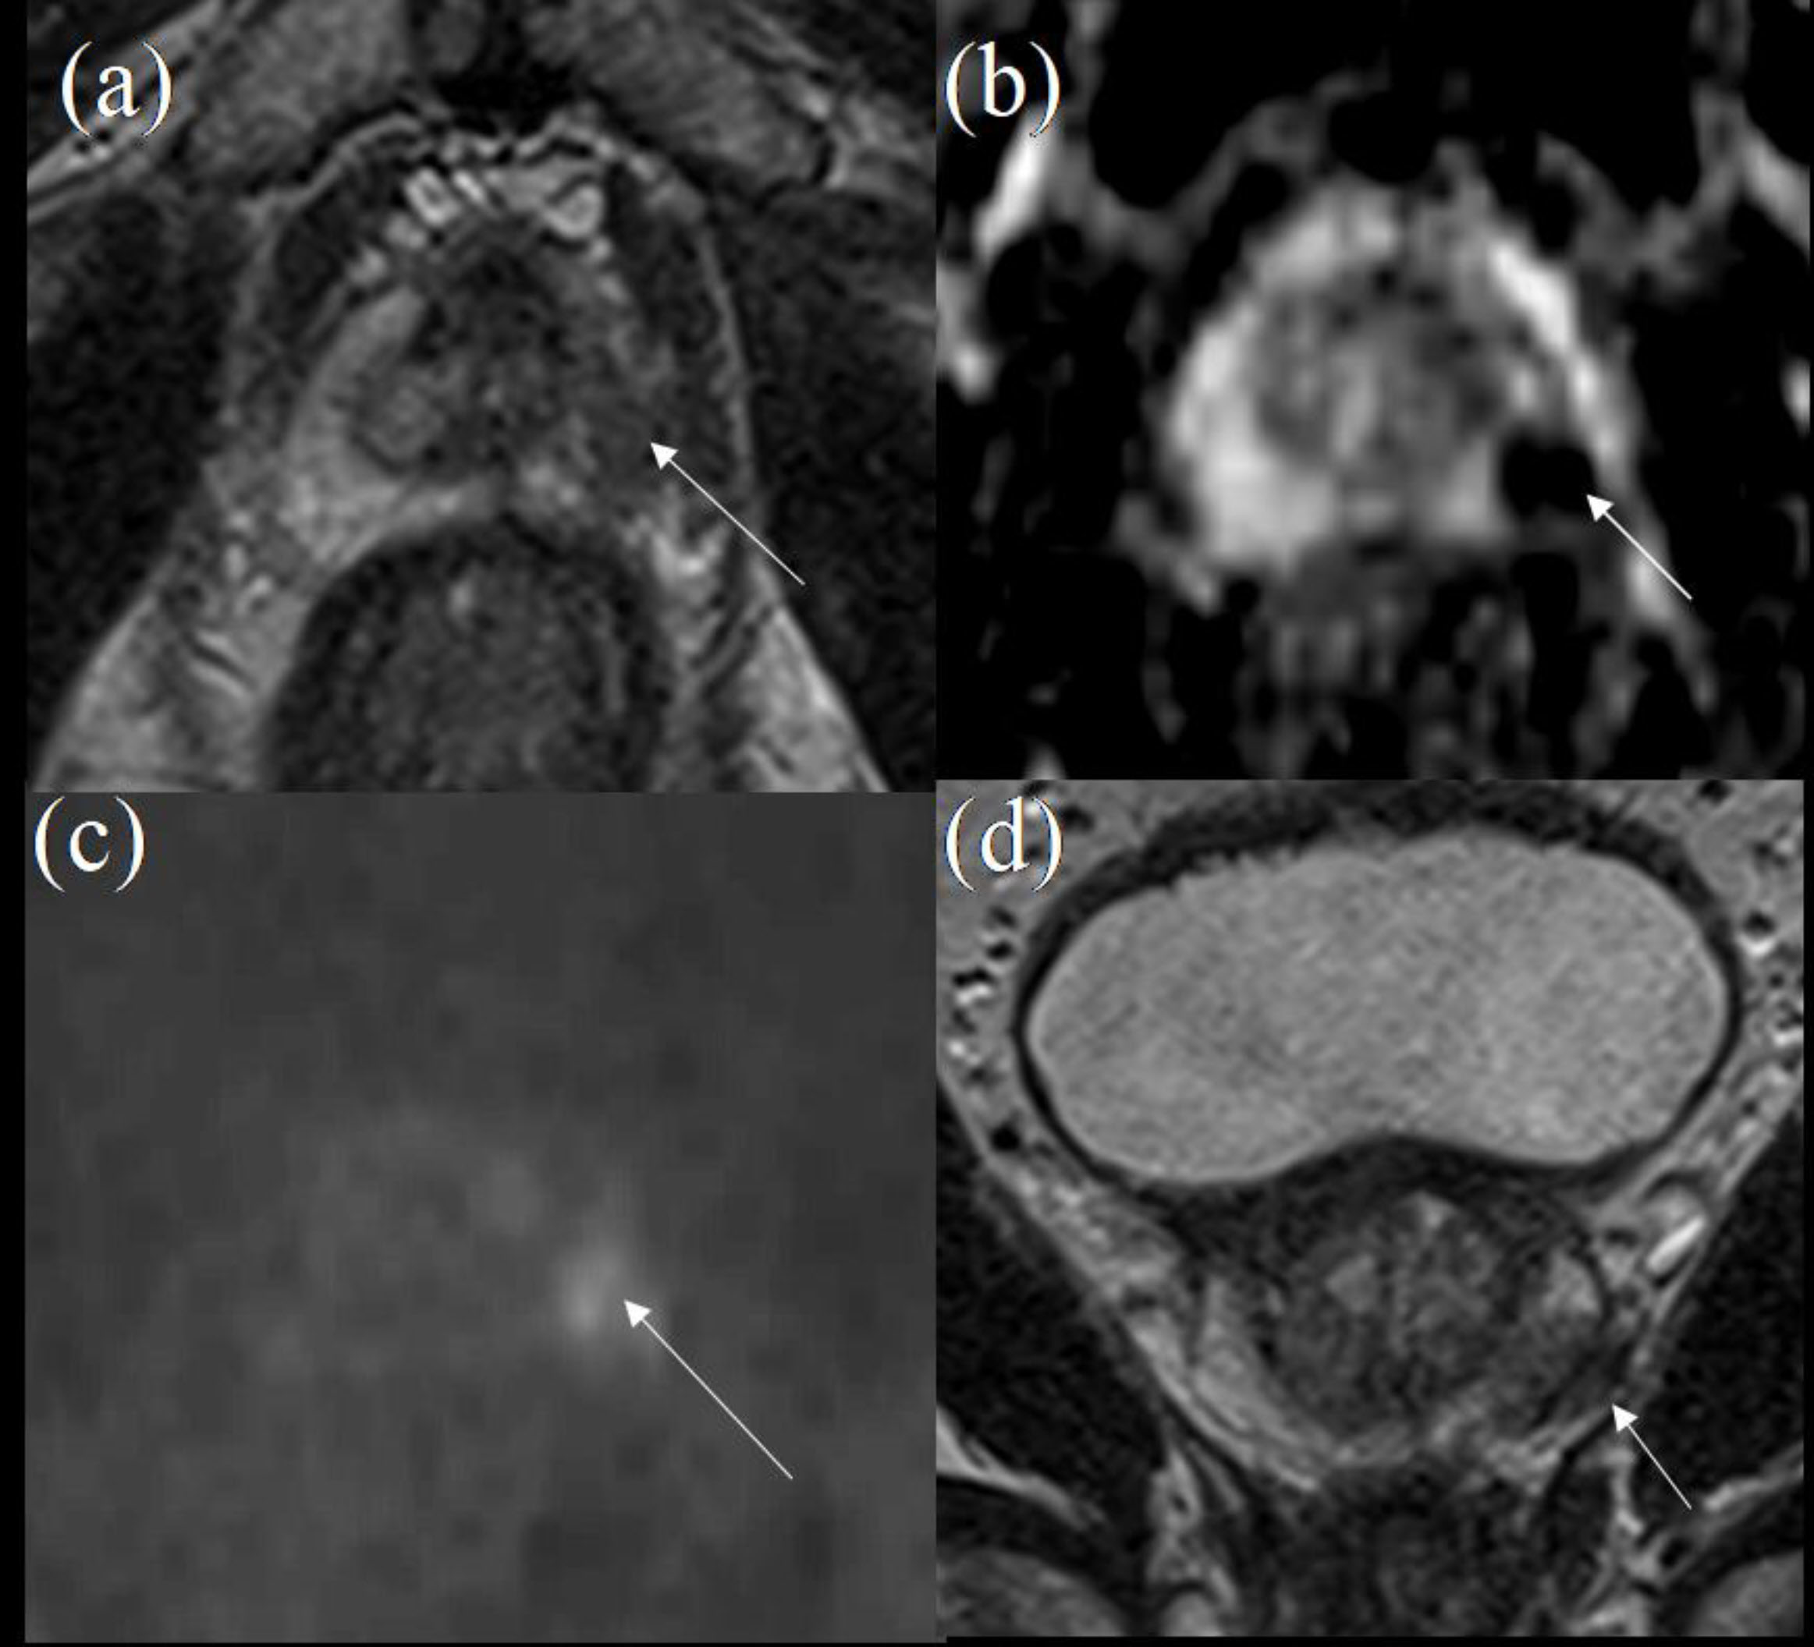

Figure 4: Dual parameteric MRI of the prostate- axial T2 (a), ADC map (b) and high B-value image (c) showing a focal PIRADS 5 lesion (white arrow). Capsular breach and early extracapsular extension depicted on coronal T2 image (d) (white arrow)

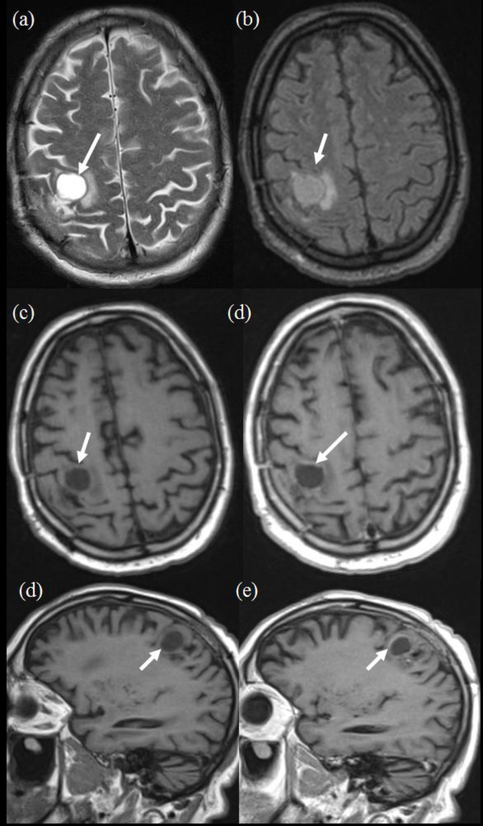

Figure 5: MRI Brain, follow up post surgery. (a) T2 axial, (b) FLAIR axial, (c, d) pre and post contrast T1 axials, (e, f) Pre and post contrast T1 sagittals. White arrow shows the satellite lesion seen in Figure 4 has grown in size, present in the right motor cortex.
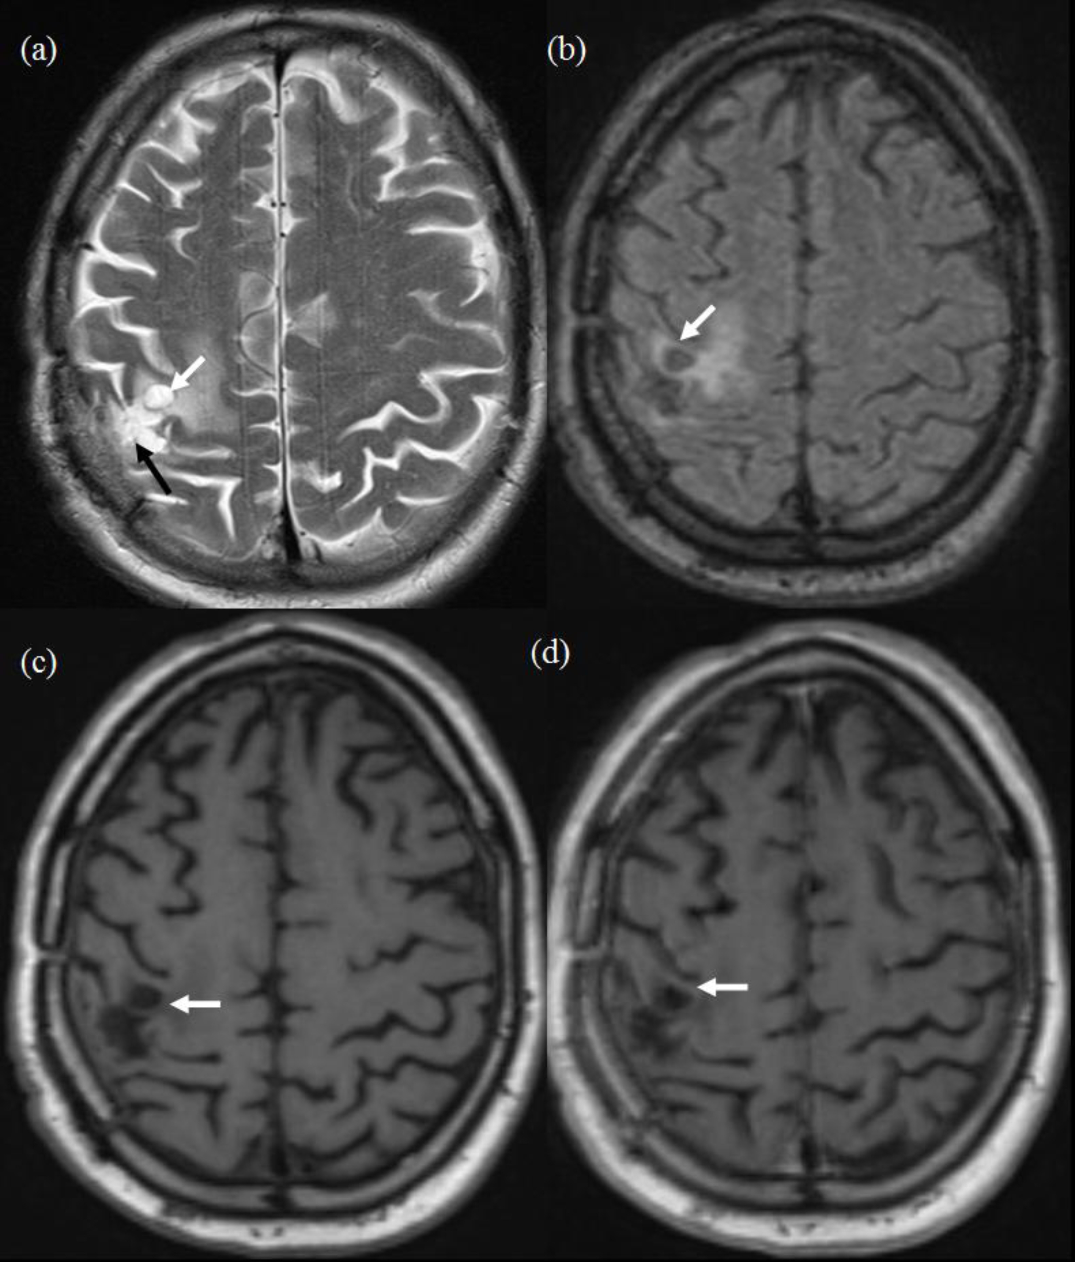
Figure 6: MRI Brain, follow up post SRT. (a) T2 axial, (b) FLAIR axial, (c, d) pre and post contrast T1 axials. White arrow shows the satellite lesion present in the right motor cortex seen in Figure 5 has significantly regressed in size with no enhancement. Black arrow in (a) shows the gliotic change from the previously excised lesion.

