Title

Smartphone photography for smart assessment of post-surgical wounds – an experience.

Abstract
Objective: This study was undertaken with an aim to assess the feasibility of substitution of real-life clinical follow up with a review of smartphone captured digital photographs of post-surgical wounds by a clinician to assess wound healing.
Method:
The postoperative patients who understood the objectives got enrolled in the prospective study and were followed up. They were requested to capture the digital photographs of the wounds with the smartphones and send through WhatsApp on postoperative days 3, 5, 7, 15 and 30 or else whenever they felt need for review due to symptoms like fever, pain, redness or swelling.
Results: 24 abdominal, 2 extremity and 1 neck wounds were followed up in 27 patients. 3 patients developed complications and all were detected with 100% accuracy.
Conclusion: The study shows that, in the follow up of postsurgical wounds, there is good correlation between real life clinical and remote photographic review. Incorporating photographic wound assessment into a postoperative follow-up care pathway may potentially save patients from avoidable hospital visits and decrease burden on healthcare facilities.
Keywords: wound healing; photography; wound assessment; social media.

Introduction
Mobile phones, internet and online applications have revolutionized our lives over the last decades and clinicians are increasingly interested in evaluation of these recent scientific advances to monitor the patients after surgery. Digital photographs captured with smartphones offer great advantage of a possibility of online transfer and then immediate reappraisal for alignment, brightness, positioning, and other photographic settings, which aids in avoiding errors and allows the instant repetition of photographs if necessary ¹.

The use of photographs has a great potential for rapid wound evaluation and they can be shared with the team to evaluate the treatment plan, and be used as an important tool for legal and teaching purposes ². It was against this backdrop that the current study was undertaken as a pilot project to study the utility of photographic follow-up of postsurgical wounds.

Methods
The study was conducted on postoperative patients from Kashmir valley who volunteered to be followed up by photography after the objectives of the study were explained in local language. The participants were explained the objectives of the study as per the ethical guidelines of Helsinki and the consent of the ones who agreed to participate in the study was secured for the usage of history, examination details and/or photographs for academic purposes. They were requested to capture the digital photographs of the wounds with the smartphones and send through WhatsApp on postoperative days 3, 5, 7, 15 and 30 or else whenever they felt need for review due to symptoms like fever, pain, redness or swelling. Real life face-to-face clinical assessment was advised whenever photographs pointed towards the need.
Results

27 patients (23 males, 4 females) ranging in age from 3 years to 54 years (mean – 29.2 years) were enrolled in the prospective study over the period of one year from September 2019 to August 2020. Most of the patients (n-21; 77.7%), however got enrolled during lockdown enforced for containment of Covid-19 pandemic and were derived from self-help social media groups. Complications were detected in 3 (11.1%) patients that were confirmed on real life clinical assessment (as shown in Figures 1-3). There were neither any false positive nor any false negative cases.

Figure 1: A- Erythema and edema above Pfannenstiel incision on 7th postoperative day, collection ruled out by USG and conservative management adopted; B- Resolved cellulitis at 14th postoperative day.

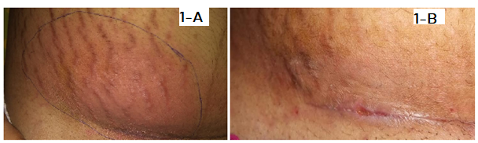

Figure 2: A & B – Multiple erythematous lumps at 30th postoperative day; evaluated by Infection Control Specialists and atypical mycobacterial infection diagnosed.
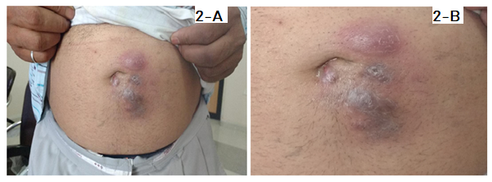

Figure 3: A- Painless infraumbilical swelling with no features of inflammation at 21st postoperative day of open umbilical hernia repair with only polypropylene mesh placement. B – USG Abdomen: Features of infraumbilical parietal wall seroma. The patient was managed conservatively.
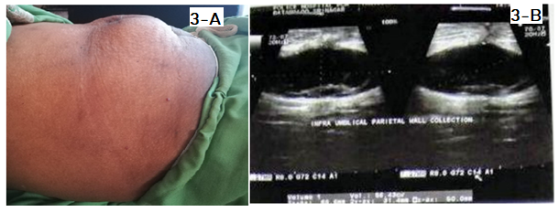

Discussion
There is an increased interest being displayed in recent literature to devise the ways and means by which the ever-expanding technological tools like internet and smartphones can be utilized to decrease the real-life attendance of the patients for postoperative follow-up, thereby saving time and effort of the patient and decreasing burden upon the clinicians and the healthcare system. Digital photographs captured with smartphones and shared via social media is one such area that is being explored and a few studies have been published in last a few years. It is against this backdrop that this study was undertaken at an individual level by a single author.
Totty et al quantitatively analysed 53 postoperative wounds in a total of 37 patients with a mean age of 61.14 years ³. Wounds were scored by a study nurse or a doctor, according to the ASEPSIS scale. Wound photographs were then captured, anonymised and independently reviewed and ASEPSIS scored by two independent investigators. The scores were then blinded to compare with those of the original 'clinical review' ASEPSIS score. There was greater than 85% agreement between the photograph and clinical reviewers in all categories except erythema. The intraclass correlation coefficient for total ASEPSIS score was R=0.806 (95% CI 0.694, 0.881), indicating strong reliability between reviewers. The specificity of photograph review for diagnosis of surgical site infection (SSI) was 90%. The study concluded that in the assessment of SSI, there is a good correlation between face-to-face clinical and remote photographic review and it was recommended that by incorporation of this method of wound assessment into a postoperative follow-up care pathway may save patients and clinicians from unnecessary hospital visits.

Kummerow et al undertook a study to determine how wound photography affects surgeons' abilities to diagnose SSIs in a pragmatic setting ⁴. They intervened by requesting the enrolled 523 surgeons to review online clinical vignettes with or without wound photography. They found that for the diagnosis of SSIs, the addition of wound photography did not change accuracy significantly. Surgeons reported greater confidence when vignettes included a wound photograph compared with vignettes without a wound photograph, regardless of whether they correctly identified an SSI but they were more likely to under-triage the patients when vignettes included a wound photograph. The study concluded that in a practical simulation, wound photography increased specificity and surgeon confidence, but worsened sensitivity for detection of SSIs and it was felt that the remote evaluation of patient-generated wound photographs may not accurately reflect the clinical state of surgical incisions. The study stressed upon additional development of tools, participant training, and mechanisms to verify image quality for effective widespread implementation of remote postoperative assessment with photography. Drake F T also found the smartphone wound photography to be useful but stressed upon caution with regards to proper interpretation ⁵.

In the current study also, the author found the smartphone captured images to be fairly specific and sensitive in the follow-up of postsurgical wounds and all the complications were detected and managed as would be have been otherwise achieved by real-life, face-to-face interactions. The study however has a small number of participants. But this study has initiated two bigger studies, one at the level of tertiary care institution involving multiple surgeons across specialties and another at the level of senior medical students.

Conclusion
Smartphones based photography has a great potential as a toll for follow up of postoperative wounds. This technological tool if used properly, would decrease the hospital visits of postoperative patients and decrease the burden on healthcare system.

Acknowledgements

The author would like to thank all the participants for their contribution to the study and allowing the usage of images for academic purposes . This research received no specific grant from any funding agency in the public, commercial or not-for-profit sector nor is there any conflict of interests.

References

1. Schaaf H, Malik CY, Howaldt HP, Streckbein P. Evolution of photography in maxillofacial surgery: from analog to 3D photography - an overview. Clinical, Cosmetic and Investigational Dentistry. 2009; 1:39-45. DOI: 10.2147/ccide.s6760.

2. Cavalcante BB, Batista KT, de-Araujo HJ, Galvao MIZ. The use of digital photography in the follow-up of surgical neoplastic wound: a case report. Rev. Bras. Cir. Plast.2018;33(4):605-608.

3. Totty JP, Harwood AE, Wallace T, Smith GE, Chetter IC. Use of photograph-based telemedicine in postoperative wound assessment to diagnose or exclude surgical site infection. J Wound Care. 2018;27(3):128-135. doi:10.12968/jowc.2018.27.3.128

4. Kummerow B K, Gaskill CE, Faqih A, Feng M, Phillips S E, Lober W B, Pierce R A, Holzman M D , Evans H L, Poulose B K . Evaluation of Wound Photography for Remote Postoperative Assessment of Surgical Site Infections. JAMA Surg. 2019;154(2):117-124. doi:10.1001/jamasurg.2018.3861

5. Drake FT. Smartphone Photographs-Proceed, but With Caution. JAMA Surg. 2019;154(2):125. doi:10.1001/jamasurg.2018.3862

