An uncommon source of sciatic pain: an acetabular cup loosening.

Dr Mohamed BEN SALAH, Orthopedic Surgery, Charles Nicolle Hospital-Tunis-Tunisia.
Corresponding author
e-mail: mbensalah9494@gmail.com

Dr Ferid HARRAR, Orthopedic Surgery, Charles Nicolle Hospital -Tunis-Tunisia.
Dr Walid BALTI, Orthopedic Surgery, Charles Nicolle Hospital- Tunis-Tunisia.
Dr Khalil AMRI, Orthopaedics and Trauma Surgery Military Hospital-Tunis-Tunisia.
Dr Yacine BEN SAFTA, General Surgery, Charles Nicolle Hospital-Tunis-Tunisia.
Dr Zeineb TEYEB, Internal Medicine, Internal Security Forces Hospital-La marsa-Tunisia
Dr Mondher KOOLI, Orthopedic Surgery, Charles Nicolle Hospital-Tunis-Tunisia.
Dr Khaled HADHRI, Orthopedic Surgery, Charles Nicolle Hospital-Tunis-Tunisia.

Conflict of interest: All the authors declare that they have no conflict of interest.

Fundings: No funding was received for this study.

Abstract:
Late sciatic palsy after a total hip arthroplasty are uncommon, especially hardware induced palsy. We report here a case of a patient who presented , 9 years postoperative, after a total hip arthroplasty with an acetabular cup loosening, a sciatic pain due to a conflict between the sciatic nerve and a trans-acetabular screw.
Introduction:
Late hardware induced sciatic nerve palsy after a total hip replacement are a disabling complication reported in 0.22%-1.7% of Total hip arthroplasty (THA) [1.2]. Most of them are related to the surgery, appear rapidly and are attributable to an intraoperative lesion or compression, an important lengthening or a compressive hematoma. Thus, late sciatic palsy is not frequent and most of the reported cases are related to THA revisions.[3] At a certain age, the sciatica is most often related to a degenerative spinal pathology, hence the risk of missing the diagnosis of an acetabular cup loosing.

Case report:
In july 2019, a 50-Years old female patient who underwent a left total hip arthroplasty by a postero-lateral approach in 2010, with a good functional and radiological result (Figure1), presented 9 years post-operative with a left sciatic pain , a foot drop and an hypoaesthesia in the territory of the fibular and tibial branch of the sciatic nerve.The radiography showed a loosening of the acetabular cup (Figure 2).
A computed tomography showed a degenerative lumbar stenosis not explaining the symptoms and two protrusive trans-acetabular screws in the great sciatic notch (Figure 3).
The electroneuromyography showed a severe lesion of the fibular and the tibial branch of the sciatic nerve which confirmed the extra-spinal origin of the palsy.
The patient underwent surgery by two approaches: first by a stoppa approach the exploration showed an impingement of a devitalised sciatic nerve with the trans-acetabular screws (Figure 4) which we released (Figure 5).
After that we completed the revision by a potero-lateral approach (Figure 6).
Postoperative the patent presented a relief of the sciatic pain but no improvement of the motor deficit.
At one year post surgery, there was no radiating pain and numbness in the lower limb but no recovery of the tibialis anterior and the extensor hallucis longus.

Discussion:
Sciatic palsy after a total hip replacement is a disabling complication reported in 0.22%-1.7% of THA with an early onset.[1,2]
Late hardware induced palsy are uncommon 6 cases were reported by Vastamäki and were related to an impingement of the acetabular reinforcement ring [3], for the primary THA. Two cases of protrusive trans-acetabular screws which were initially misplaced were reported [6,7].
It is difficult to identify the spinal or extra-spinal origin of the sciatic deficit after a total hip arthroplasty, Pritchett reported 21 foot drop cases after a THA due to a severe lumbar stenosis[4], showing the importance of a meticulous physical examination, a complete spinal exploration( CT or MRI) and electroneuromyography.
The good placement of the trans-acetabular was shown by Wasielewski [8] and permits to reduce the incidence of this type of incident. It is important to think of a hardware impingement ahead of late sciatic palsy after a total hip arthroplasty.
It is fundamental to proceed to all the explorations especially the electroneuromyography.
It is important to not delay the surgical exploration before the onset of a complete deficit in order to ensure a better outcome. The acetabular protrusion associated to the protrusion of the screw in the retroperitoneum, in front of the greater sciatic notch requires a double surgical approach. The anterior approach will allow a neurolysis of the nerve and will limit the nerve’s damage that could be caused by tearing the screw posteriorly.

Conclusion:
Dealing with late sciatic palsy after a total hip arthroplasty is very challenging and requires meticulous radiological and electrophysiological examinations.
An early surgical exploration is recommended to obtain better results. A double surgical approach is necessary in order to preserve the sciatic nerve as much as possible.
Declarations:

- Ethics approval and consent to participate yes
- Data avalable
- Consent for publication of all the authors
- Availability of data and materials yes
- Competing interests no conflict of interest
- Funding no fundings waw received for the study
- Authors' contributions
Dr Mohamed BEN SALAH: Conception and acquisition of data, revising the article.
Dr Ferid HARRAR: Conception and acquisition of data
Dr Walid BALTI: Drafting the article
Dr Khalil AMRI: Drafting the article
Dr Yacine BEN SAFTA: Drafting the article

Dr Zeineb TEYEB: acquisition of data

Dr Mondher KOOLI: Revising the article

Dr Khaled HADHRI: Revising the article

- Acknowledgements not apllicable

References:
1. S Kawan, M Sonohata, M Kitajima, M Mawatari. Risk Factors for the Development of Nerve Palsy Following Primary Total Hip Arthroplasty. Open Orthop J. 2018;12:164-172.
2.TP Schmalzried, HC Amstutz, FJ Dorey. Nerve palsy associated
with total hip replacement: risk factors and prognosis. J Bone Joint Surg Am. 1991;73:1074–1080.
3. M Vastamäki, P Ylinen, A Puusa, T Paavilainen. Late hardware induced.
sciatic nerve lesions after acetabular revision. Clin Orthop Relat Res. 2008;466:1193-1197.
4.Pritchett JW. Lumbar decompression to treat foot drop after hip arthroplasty. Clin Orthop Relat Res. 1994;(303):173-177.
5. JH Park , B Hozack, P Kim, R Norton, S Mandel, C Restrepo, J Parvizi. Common peroneal nerve palsy following total hip arthroplasty: prognostic factors for recovery. J Bone Joint Surg Am. 2013;1;95(9):e55.
6.S Yoon, M Park, DK Matsuda, YH Choi. Endoscopic resection of acetabular screw tip to decompress sciatic nerve following total hip arthroplasty. BMC Musculoskelet Disord. 2018;4;19(1):184.

7.Wasielewski RC, Cooperstein LA, Kruger MP, Rubash HE. Acetabular anatomy and the transacetabular fixation of screws in total hip arthroplasty. J Bone Joint Surg Am. 1990;72(4):501-508.

Figures

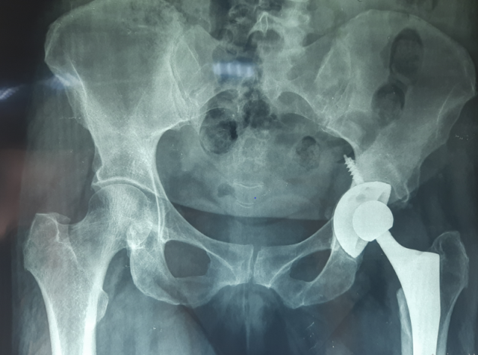
Figure 1: Normal radiography.

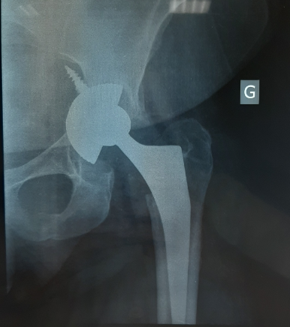
Figure 2: Acetabular cup loosening on radiography.
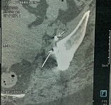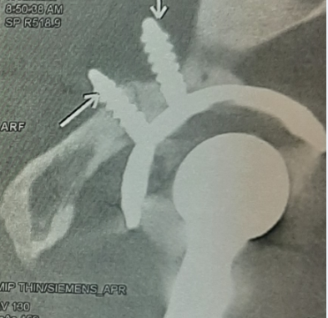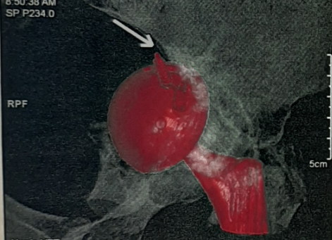
Figure 3: Protrusive trans-acetabular screw on hip tomography.

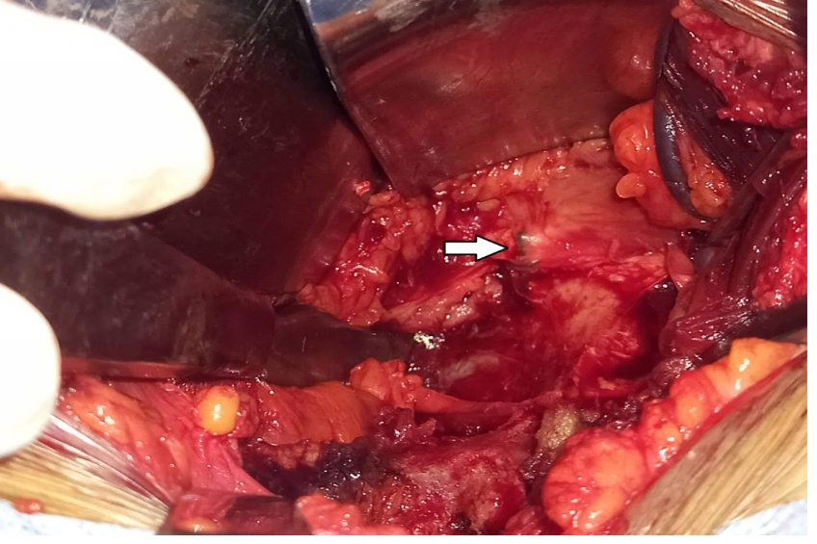
Figure 4: Impingement of the nerve with the trans-acetabular screws (wight arrow).

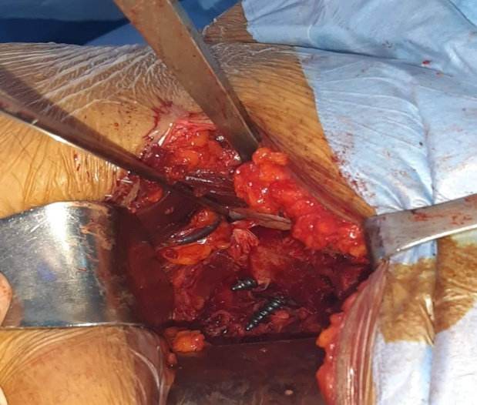
Figure 5: A photograph shows the aspect after the release.

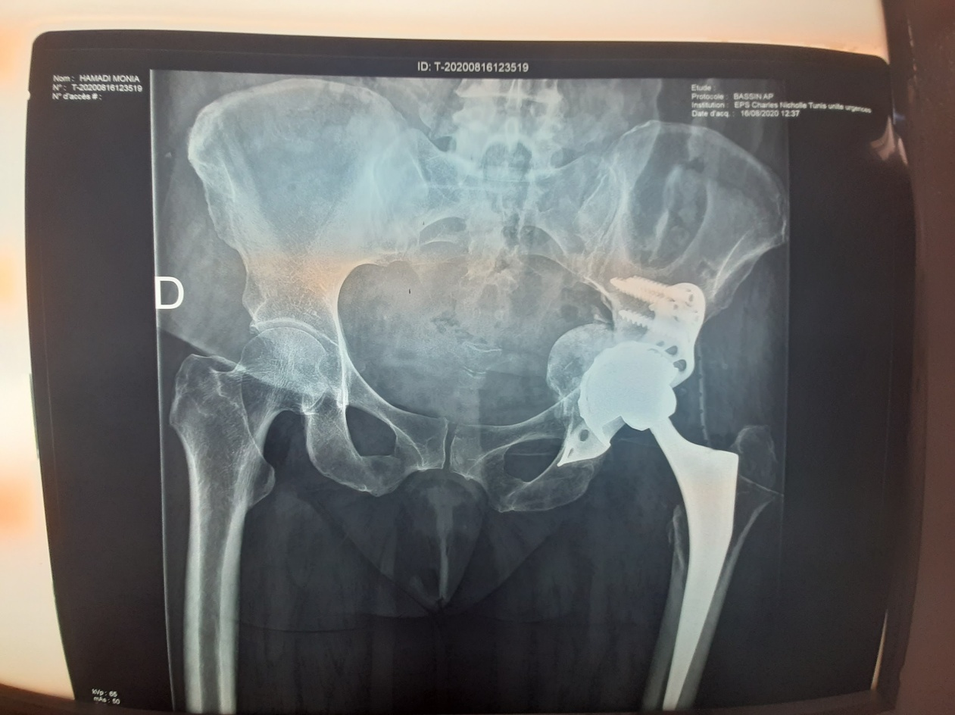

Figure 6: Post-operative radiography.

