Title Page
Case report
Ulnar Dimelia – A Rare and Neglected Anomaly of Upper Extremity

Yasir Salam Siddiqui¹, Mazhar Abbas¹, Nusra Rahman², Julfiqar¹
1 Dept. of Orthopaedic Surgery, J. N. Medical College, Faculty of Medicine, A.M.U., Aligarh 202002 India.
2 Dept. of Anatomy, J. N. Medical College, Faculty of Medicine, A.M.U., Aligarh 202002 India.

Corresponding to:
Dr. Yasir Salam Siddiqui (MS Orth.), Assistant professor,
Dept. of Orthopaedic Surgery, J. N. Medical College, Faculty of Medicine,
A.M.U., Aligarh, Uttar Pradesh,202002 India.
E-mail: yassu98@gmail.com
Mobile Ph: +919837343400

Abstract
Ulnar dimelia is a rare congenital anomaly of the upper extremity. The condition presents with double ulnae forearm and polydactyly with complete absence of radius bone and thumb. Clinically it presents not only as functional deformity, but also as cosmetic deformity. The case presented here is of a 1 and ½ year old male baby, born with right side ulnar dimelia with no other musculoskeletal defect. We believe that the case presented here deserves reporting not only because of rarity of the disease but also due to its difficult management requiring multiple staged operations and henceforth consequent neglect on the part of parents. An attempt is also made to do brief literature review.
Keywords: Ulnar dimelia, polydactyly, ulna, radius, thumb.

Introduction
Ulnar dimelia also referred as mirror hand syndrome is a rare congenital anomaly of the upper extremity. The condition presents with double ulnae forearm with complete absence of radius bone. There is also polydactyly with absence of thumb.^{[1,2]} Along with musculoskeletal deformity, malformation of the neuro-vascular structures in the form of doubling of the ulnar nerve and artery with absence of the radial artery has also been reported in the literature.^{[1-3]} Clinically it presents not only as functional deformity, but also as cosmetic deformity. The broadened elbow, short forearm, radially deviated wrist, polydactyly and absent thumb gives a poor unacceptable cosmetic appearance. The functional deficit with ulnar dimelia is restricted elbow range of motion, forearm rotations and oppositional grasp.^{[4]}
Most cases of mirror hand syndrome are sporadic, while few case studies designated associated genetic syndromes.^{[5,6]} Ulnar dimelia results from the imbalance of the inductive signals across the radio-ulnar plane during embryonic development.^{[3,7]} Failure of the morphogenesis signals on the radial side, while concentration of such signals on the ulnar side produces ulnar dimelia. Diverse variants of the disease depends upon the severity of disproportion of the signals across the radio ulnar plane.^{[2,8]} In literature case studies are reported, highlighting the various aspects of deformity including anatomical variations, clinical presentation and management.^{[1-4]} We believe that the case presented here deserves reporting not only because of rarity of the disease but also due to its difficult and prolonged management requiring multiple staged operations and henceforth consequent neglect on the part of parents. An attempt is also made to do brief literature review.
Case Report
One and half year old male baby was brought to us by his parents with complaints of restriction of movements of the right elbow with polydactyly, giving an unacceptable cosmetic appearance of the forearm and hand. They further added that the child is also having difficulty in holding the objects. The patient was their third child with two female siblings without any such complaints. There was no history of consanguinity. The baby was full term, delivered through vaginal route. There was no history suggestive of any maternal infection or any exposure to teratogenic agents throughout the antenatal period. There was no family history of congenital elbow and hand anomalies in first degree lineages. There was no developmental delay. No history of any other joint involvement or other systemic illness. Clinical examination revealed shortening of right forearm with fixed flexion deformity of 20 degrees at elbow, with further 50 degrees of free flexion possible (range of motion = 20 – 70 degrees). Forearm rotations were grossly restricted. The wrist was deviated radially with the hand having six well-formed fingers in single plane (Figure-1). Contour and the movements of right shoulder were comparable to left shoulder. The child was able to hold the objects in between fingers (crude grasp). However fine grasp requiring opposition function was not conceivable. Left upper extremity was absolutely normal. There were no other skeletal abnormalities. Furthermore, no definite syndromic features were noted. Systemic examination was unremarkable. Ultrasonography of abdomen and echocardiography were normal. Radiograph of the right upper extremity including elbow revealed double ulnae facing each other with absence of radius and thumb (Figure-2). The laterally placed ulna was shorter than normal medially placed ulna. The wrist and hand showed two carpal bones and six metacarpals all lying in same plane. The two carpal bones were centered over the medially placed ulna. In the present circumstance, we planned for staged surgeries, with an objective to provide functional range of motion at elbow, forearm rotations and reconstruction of thumb for oppositional grasp. Meanwhile the patient was put on stretching exercises of elbow, wrist and fingers, especially to correct radial deviation of wrist along with night splinting of the wrist in neutral position. Parents were communicated about the need of regular follow-up for proper treatment and rehabilitation of child, least as the child would grow there will be limitations of activities which require coordinated movement of elbow, forearm and hand like writing, buttoning, unbuttoning, tying shoe laces and others. However the parents never turned up again after their first visit, highlighting the neglect of the deformity.
Discussion
Our patient had double ulnae in the right forearm with six digits with six corresponding metacarpals in single plane with two carpal bones supported by medially placed ulna. Laterally placed hypoplastic ulna was not supporting any of the carpal bones. This might be due a delay in the development of the ossification centres on the lateral side. Both thumb and radius were absent. Although the laterally placed ulna was hypoplastic in comparison to medial one, but the both ulnae were well molded. Our case was classified as type I ulnar dimelia, according to Al‑Qattan et al classification.^{[2]}
A classical ulnar dimelia has symmetrical distribution around the midline axis. However, the non-classical one lacks symmetrical distribution in morphogenesis of the forearm bones and the fingers.^{[8]} In the non-classical one, the forearm may contain an ulna and a radius, or even three bones in different combinations.^{[9-11]} Even though seven^{[9,10]} or eight^{[2,10-14]} digits are typical, patients with six^{[15,16]} or even five digits^{[17]} have been described in the literature. Taking into account the bony morphology of the forearm, Al-Qattan et al published a descriptive classification for the ulnar dimelia.^{[2]} The goal of the management of such a condition is to improve upper extremity function by executing single stage or more often multiple stage operations. The literature designates, depending upon the severity of functional and cosmetic deformity, the management of this condition varies from physiotherapy alone to multiple stage operations.^{[1, 2, 7, 8, 11,18]} In present case study we discussed with the parents about the future prospects and limitations of activities due to deformity and planned for staged surgeries with an objective to provide functional and cosmetically acceptable upper extremity. However the parents never turned up again with the patient for taking treatment, highlighting the neglect of the deformity. The neglect was probably due to the low socio-economic status and ignorance of parents. We believe that in the patient described above, excision of proximal end of the laterally placed ulna with soft tissue reconstruction along the medially placed ulna and pollicization would have given a reasonable functional and cosmetic enhancement of the upper extremity.
Conclusion
Ulnar dimelia is a rare congenital anomaly presenting as functional as well as cosmetic deformity. If untreated, renders the patient with poor function and cosmetic appearance of the extremity. Not only has the difficult management requiring multiple staged operations is a therapeutic challenge for treating orthopaedic surgeon but also neglect on the part of care givers. Hence, awareness among the masses is to be developed regarding the condition and educating them that acceptable outcome can be achieved with proper treatment.
Authors’ contributions: Siddiqui YS and Abbas M: substantial contribution to conception and designing and supervision of the study. Nusra Rahman and Julfiqar: provided material & technical support for the study.
Financial support and sponsorship: none
Conflict of interest: all authors declare that there are no conflicts of interest.
Ethics approval and consent to participate: an informed consent was obtained from the parents of the patient to participate in the study.
Consent for publication: a written informed consent for publication was obtained.
References
- Alosaimi MN, Samman AT, Alswat MM, Alsaggaf KW. A rare developmental anomaly of the upper limb: Case of ulnar dimelia. J Musculoskelet Sur g Res 2020;4:160-2.
- Al‑Qattan MM, Al‑Thunayan A, de Cordier M, Nandagopal N, Pitkanen J. Classification of the mirror hand‑multiple hand spectrum. J Hand Surg Br 1998;23:534‑6.
- Tomaszewski R, Bulandra A. Ulnar dimelia‑diagnosis and management of a rare congenital anomaly of the upper limb. J Orthop 2015;12:S121‑4.
- Cohen MH, Kozin S, Pederson W, Wolfe S, Green D. Deformities of the hand and fingers. In: Scott W, editors. Green’s Operative Hand Surgery. 7th ed. Philadelphia: Elsevier, Inc.; 2017. p. 1237‑8.
- Sandrow RE, Sullivan PD, Steel HH. Hereditary ulnar and fibular dimelia with peculiar facies: a case report. J Bone Joint Surg [Am] 1970;52-A:367-70.
- Martin RA, Jones MC, Jones KL. Mirror hands and feet with a distinct nasal defect: an autosomal dominant condition. Am J Med Genet 1993;46:129-31.
- Gaba S, John N, Bhogesha S, Singh O, Vemula GK. Mirror hand: An uncommon neglected case managed with pollicisation. World J PlastSurg 2017;6:263‑5.
- Afshar A. Ulnar dimelia without duplicated arterial anatomy. J Bone Joint Surg Br 2010;92:29‑6.
- Barton NJ, Buck-Gramcko D, Evans DM. Soft tissue anatomy of mirror hand. JHand Surg [Br] 1986;11:307-19.
- Bhaskaranand K, Bhaskaranand N, Bhat AK. A variant of mirror hand: a case report. J Hand Surg [Am] 2003;28:678-80.
- Jafari D, Sharifi B. A variant of mirror hand: a case report. J Bone Joint Surg [Br] 2005;87B:108-10.
- King RJ, Hoyes AD. The mirror hand abnormality. Hand 1982;14:188-93.
- Pintilie D, Hatmanu D, Olaru I, Panzoa GH. Double ulna with symmetrical polydactyl: a case report. J Bone Joint Surg [Br] 1964;46-B:89-93.
- Yang SS, Jackson L, Green DW, Weiland AJ. A rare variant of mirror hand: a case report. J Hand Surg [Am] 1996;21:1048-51.
- De Smet L. Ulnar dimelia. ActaOrthopBelg1999;65:382-4.
- Gorriz G. Ulnar dimelia: a limb without anteroposterior differentiation. J Hand Surg [Am] 1982;7:466-9.
- Chinegwundoh JOH, Gupta M, Scott WA. Ulnar dimelia: is it true duplication of the ulna? J Hand Surg [Br] 1997;22:77-9.
- Avadis AM, Haider AA,, (2007) Ulnar dimelia, a case report. Bas J Surg 2:73–74.

Figure Legend
Figure-1: Clinical photograph of patient showing radial deviation of the right wrist (arrow) with the hand having six well-formed fingers in single plane. Also note the absence of thumb.
Figure-2: Radiograph of the right upper extremity including elbow revealed double ulnae facing each other with complete absence of radius and thumb. The laterally placed ulna is hypoplastic with broad distal end (thin arrow). The wrist and hand showed two carpal bones and six metacarpals all lying in same plane. The two carpal bones were centered over the medially placed ulna (thick arrow).
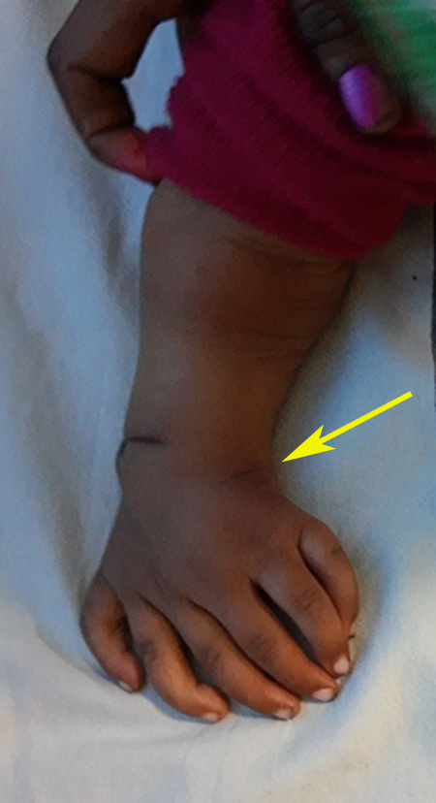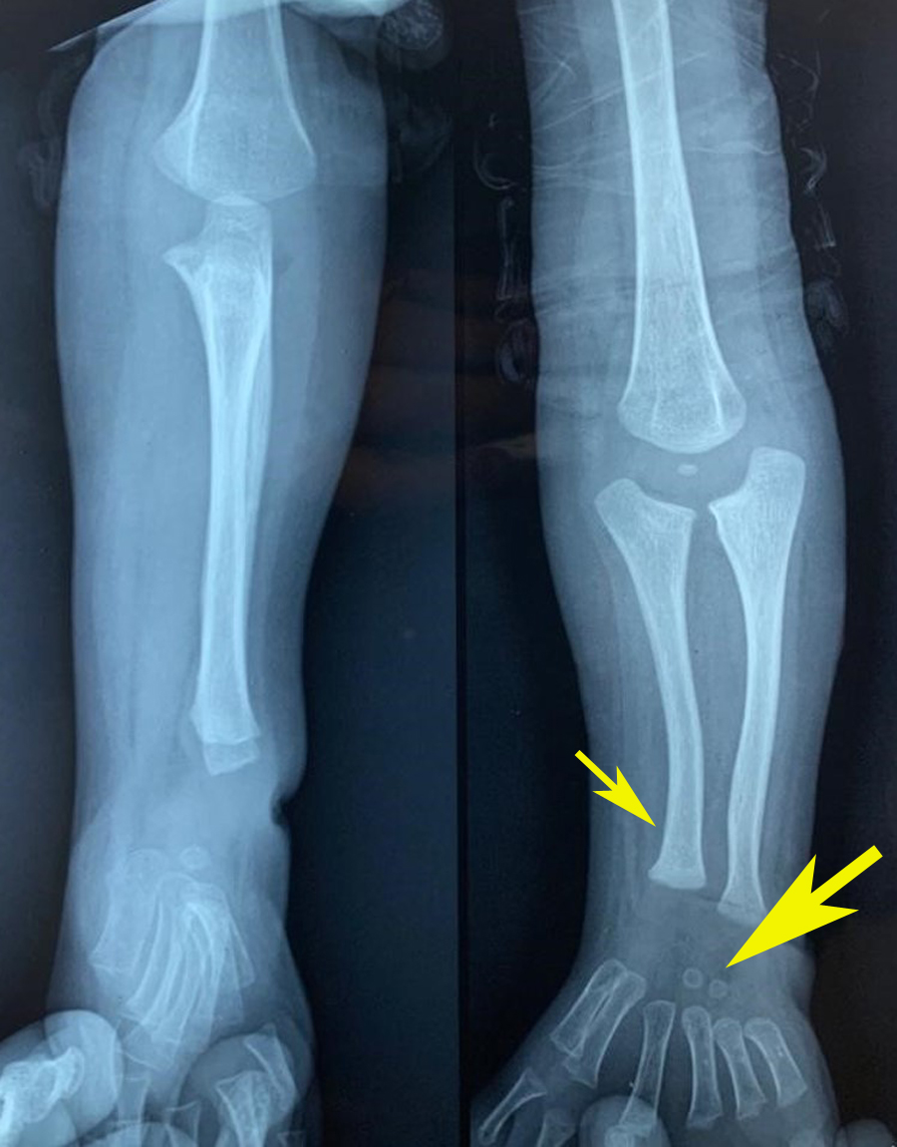
Figure-1 Figure-2

