Case report
Isolated tubercular orchi epididymitis with painful hydrocoele: case report

NEDJIM Abdelkerim Saleh¹, EL IDRISSI ALAMI Oussama¹, GHANNAM Youssef¹, ABDI Moustapha¹, DAKIR Mohamed¹, DEBBAGH Adil¹, ABOUTAIEB Rachid¹
¹Service d’urologie, CHU Ibn Rochd et Faculté de Médecine et Pharmacie, Casablanca/Maroc

Correspondence to: Dr. NEDJIM Abdelkerim Saleh, Service d’urologie, CHU Ibn Rochd et Faculté de Médecine et Pharmacie, Casablanca/Maroc, nedjimsaleh@gmail.com

Abstract
Testicular tuberculosis is a rare and represent only 3% of genitourinary tuberculosis cases. We are reporting a case of tuberculous orchiepididymitis which was manifesting as a painful hydrocoele knowing that the condition has become favourable with a good evolution after conservative surgical intervention and anti-bacillary treatment.
Key words: hydrocoele, orchiepididymitis, surgery, tuberculosis
Introduction
Testicular tuberculosis is a rare about genitourinary tuberculosis and represent only 3% of genitourinary tuberculosis cases (1). It’s clinical symptomatology is non-specific and the available microbiological tests are of low sensitivity. Treatment can be medical at an early stade, but the delay in diagnosis can lead to orchiectomy (2). We are reporting a case of tuberculous orchiepididymitis that has manifested as a painful hydrocoele and the condition has become favourable with a good evolution after conservative surgical intervention and anti bacillary treatment.
Clinical case
Mr A.A., 43 years old, a chronic smoker, with no notable past medical history, come to the emergency departement for a pain with fever on scrotal swelling that had been evolving for about one year. Clinical examination found a conscious and stable patient with a body temperature of 37.8 *C and painful right scrotal swelling extending to the inguinal region. This swelling was transluminal (picture 1).
The ultrasound scan (image 2) carried out as a matter of emergency revealed the presence of a scrotal swelling which was poorly limited with a thick and mobile echogenic content. This thick formation extends toward the right spermatic cord which is swollen and oedematous. It is associated with a right testicle of normal volume, regular contours, heterogeneous echo-structure with a poorly limited hypoechoic range and hypovascularisation.
A surgical exploration revealed a hydrocele with a cloudy content and significant swelling of the cord with the presence of fibrous tissue at the expense of the right testicle (image 3). The epididymis was individualised. Fluid sampling and biopsies were taken and a hydrocoele cure was performed. The Ziehl stain was positive, and the cytology has isolated tuberculoid granulomas.
The post-operative follow-up was simple. Bacteriological and cytological studies supported the diagnosis of tuberculosis. The patient was put under anti-bacillary traitement.
Discussion
Genitourinary tuberculosis involving the epididymis is caused by retrogade extension from the prostate and/or seminal vesicles, or by blood. The epididymal tail is most often affected, and the involvement may be unilateral or bilateral. Untreated epididymal infection can progress to orchi- epididymitis. Tuberculous involvement may be manifested by the thickening of the scrotal skin, hydrocoele or scrotal abscess (3). Testicular involvement is rare and represent only 3% of genitourinary tuberculosis cases (1). We are reporting one case of isolated tuberculous orchiepididymitis with a painful hydrocoele as a presentation.
In 80% of the cases, patients with tuberculous orchi- epididymitis have a scrotal mass, which can be painful in 40-44%. Bilateral tuberculous involvement is observed in 34% of cases, 4-50% may present late with an abscess or fistula and 5-10% may have an associated hydrocoele (4). It has been described that the presentation appears as a painful, rapidly progressing hydrocoele that’s due to the isolated involvement of the albuginea and tunica vaginalis (5).
Ultrasonography is currently the best imaging technique to study the scrotum and its contents. It can be used to reliably differentiate between intratesticular lesions (6). Ultrasound can reveal a heterogeneous epidydimitis with hypoechoic areas (7). The ultrasound carried out in our patient's emergency revealed the presence of a poorly limited scrotal swelling with a thick and mobile echo genic content. In addition to the aspects described in the literature, the right spermatic cord was swollen and oedematous with the contralateral testis which is heterogeneous and has a poorly limited hypoechoic areas with hypo-vascularisation.
The diagnosis can be confirmed by culture, Ziehl-Neelson staining and/or histological examination (8). The cytological study allowed the diagnosis to be made by isolating a tuberculoid granuloma with a positive Ziehl stain.
The treatment of tuberculous orchi-epididymitis is essentially conservative. The classic scheme in practice is the combination of four molecules (rifampicin, isoniazid, pyrazinamide and ethambutol) for 6 months in two phases. The cure rate is over 95% (9). Surgery is recommended for patients who do not respond to medical treatment within the first 2 months or those who present an intrascrotal abscess (10). Our attitude was conservative. The evolution was favourable after six months of anti-bacillary treatment.
Conclusion
Genital tuberculosis is rare and not often mentioned in practice. In front of a painful and feverish hydrocoele, the hypothesis deserves to be evoked. The prognosis depends on the diagnosis and treatment.
Reference
- Das A, Batabyal S, Bhattacharjee S, Sengupta A. A rare case of isolated testicular tuberculosis and review of literature. J Family Med Prim Care 2016;5:468-70.
- Yadav S, Singh P, Hemal A, Kumar R. Genital tuberculosis: current status of diagnosis and management. Transl Androl Urol 2017;6(2):222-233. doi: 10.21037/ tau.2016.12.04
- Muttarak M, Peh WC, Lojanapiwat B, et al. Tuberculous epididymitis and epididymo-orchitis: sonographic appearances. AJR Am J Roentgenol. 2001;176(6):1459Y1466.
- Suankwan U, Larbcharoensub N, Viseshsindh W, et al. A clinicopathologic study of tuberculous epididymo-orchitis in Thailand. Southeast Asian J Trop Med Public Health2012;43:951-58.
- Khan S, Haroon N, Azami R, et al. Isolated tuberculosis of tunica albuginea and tunica vaginalis presenting as acute hydrocoele: a diagnostic dilemma. BMJ Case Rep 2015;2015. pii: bcr2014207744.
- Dell’Atti L. Ultrasound diagnosis of unusual extratesticular mass: case report and review of the literature. Arch Ital Urol. 2013;85(1):41-43.
- Chung J, Kim M, Lee T, et al. Sonographic findings in tuberculosis epididymitis and epididymo-orchitis. J Clin Ultrasound. 1997;25:390-394.
- Lenk S, Schroeder J. Genitourinary tuberculosis. Curr Opin Urol. 2001;11:93-98.
- Chan ED, Iseman MD. Current medical treatment for tuberculosis. BMJ. 2002;325:1282-1286.
- Gow JG, Barbosa S. Genitourinary tuberculosis. A study of 1117 cases over a period of 34 years. Br J Urol 1984;56:449-455.

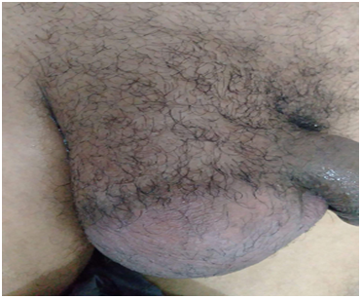
Image 1: Scrotal swelling, painful, transluminal

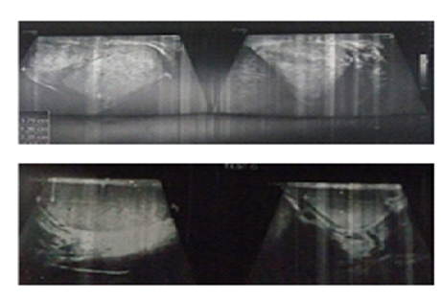
Image 2: testis and scrotum swollen with echoes heterogeneous structure and hypo echogenic areas

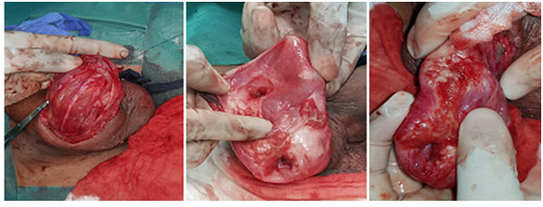
Image 3: Significant swelling of the cord and fibrous reshaping of the testis and adnexae.

