KONNO-RASTAN PROCEDURE COMBINED WITH MANOUGUIAN ROOT ENLARGEMENT FOR SMALL AORTIC ROOT
Case Report
Runnign Title: ‘ENLARGEMENT FOR SMALL AORTIC ROOT’

Metin Onur Beyaz¹, Nur Gizem Elipek², Mustafa Ozer Ulukan¹, Murat Ugurlucan¹, Halil Türkoğlu¹

¹Istanbul Medipol University Faculty of Medicine, Department of Cardiovascular Surgery, Istanbul
²Istanbul Medipol University Faculty of Medicine, Istanbul

Corresponding Author:
Op. Dr. Metin Onur Beyaz
Istanbul Medipol University Faculty of Medicine, Medipol Mega University Hospital, TEM Avrupa Otoyolu Goztepe Cikisi, No:1, 34214 Bagcilar, Istanbul – TURKEY.
Tel: +90 5053599163
Fax: +90 212 521 23 77
e-mail: metinonurbeyaz@gmail.com

ABSTRACT
Aortic stenosis is a rarely seen condition in pediatric population. Valve replacement is another treatment option for patients who do not benefit from medical or interventional procedures. In this report, we described the surgical treatment we performed on a 17-year-old patient who developed patient-prosthesis mismatch (PPM) due to aortic valve replacement (AVR) history.
Keywords: Konno-Rastan Procedure, Manouguian Technique, Root enlargement

INTRODUCTION
Aortic stenosis is a rarely seen condition in pediatric population. The known incidince is 3.8/10.000 in live births (1). Balloon angioplasty is one treatment method in neonatal period for aortic stenosis (2). Valve replacement another treatment option for patients who do not benefit from medical and interventional procedures (3). Valve replacement options include Ross technique, Konno technique and biological or mechanical valve replacement. As the patients grow older, patient prosthesis mismatch still appears as an important factor who underwent valve replacement surgery (4).
In this report, we described the surgical treatment we performed on a 17-year-old patient who developed patient-prosthesis mismatch due to aortic valve replacement history.

CASE
17-year-old male patient who underwent aortic valve surgery used by Manouguian technique due to diagnosis of aortic stenosis 10 years ago was admitted to our clinic with complaints of increased chest pain and shortness of breath after exercise.
There was no family history. All blood parameters were normal. Cardiothoracic index was increased in his chest x-ray. The patient had increased bodyweight (BMI: 27.19 kg/m2). Echocardiography shown intact bioprosthesis valve with low effective orifice area (Indexed EoA:0.70), ventricular hypertrophy and ejection fraction measured 55%.
After the patient and his family were informed about the operation and the necessary operation consent was obtained, aortic valve replacement surgery was planned.
Surgıcal Tehcnıque
Sternotomy incision was made along the old sternotomy incision line. Adhesions were removed. The pericardium was opened and suspended. Aortic cannulation and two stage venous cannulation were performed systemic heparinization. Cardiopulmonary bypass was initiated under normothermia (23 °C). A vent catheter was inserted into the left atrium from the right upper pulmonary vein. Myocardial protection was provided with direct cold blood cardioplegia after aortic clamp and aortotomy. The old aortic valve was excised. The pericardial band used for the old Manougian procedure was found to be calcified and resected. Right ventricle outflow tract (RVOT) was opened and an incision was made extending to the interventricular septum. Conno-Rastan procedure performed using by Dacron patch. The Manougian posterior expansion performed using by Dacron patch (Figure 1). No:27 St. Jude mechanical valve was placed with the help of Teflon reinforced 2/0 ti-cron sutures (Figure 2). A autologous pericardial patch that held gluteraldehyde was applied from over the coronary arteries. The aortotomy was closed using by a dacron patch. RVOT constructed using by dacron graft piece (Figüre 3). The cross clamp was removed. Separation from CPB was obtained at appropriate hemodynamics and temperature. Bleeding control and decanulation were performed. The drainage tube was placed in the right pleura and mediastinum. Temporary pacing wires were placed. The sternum was closed in the anatomical plan. The patient was taken to the intensive care unit in stable conditions. There were no complications.
DISCUSSION
Aortic stenosis causes can vary from congenital bicuspid aortic valve, calcification to rheumatic fever (5). When aortic stenosis that starts asymptomatically is not treated has a classical tria with dyspnea, syncope and angina. Heart failure and rhythm disturbances may be added to these symptoms in later stages (6). PPM should always be avoided as it has been associated with perioperative mortality, reduced long-term survival, consistent symptoms, and slow regression of LV mass. Meta-analysis has reported that severe PPM is associated with reduced long-term survival (7) Patient-prosthesis incompatibility (PPM) is one of the problems affecting patient quality of life after aortic valve replacement surgery and this situation may be more prominent especially in child population as their growth continues (8). It has been shown that aortic root augmentation operations can be performed to correct PPM, and the incidence of PPM is reduced by root expansion surgeries. Konno-Rastan and Manouguian procedures are the most preferred root augmentation operations for patients. In operations performed Konno and Manouguian, it is possible to implant larger aortic valves to patients have growth potential (9). The Ross procedure is another technique used for therapeutic purposes in aortic valve pathologies, and by its nature, the patient's pulmonary autograft is used to replace the aortic valve (10). Because of our patient had bicuspid pulmonary valve he was not found suitable for Ross procedure ten years ago. No:17 mechanical valve was suitable for the patient. But since the child grew up in time, this mechanical valve remained small as expected. What needs to be done in the meantime is to replace the valve.

CONCLUSION
A cardiac surgeon should be well skilled with the root enlargement procedures which may be helpful at the time of AVR for young obese man and women with small aortic root. Combined aortic root enlargement techniques should be considered in the presence of bodily growth potential.
DECLARATIONS
Acknowledgments: None.
Authors’ contributions: Made substantial contributions to conception and design of the study and performed data analysis and interpretation: Beyaz MO, Elipek NG;
Performed data acquisition, as well as provided administrative, technical, and material support: Uğurlucan M, Türkoğlu H, Ulukan MO.
Availability of Data and Materials: All data of the patients are stored at Medipol University where the operations are performed.
Fundings: None.
Conflicts of interest: All authors declared that there are no conflicts of interest.
Ethical approval and consent to participate: We studied in accordance with the ethical guidelines set by the Helsinki Declaration and the International Association of Heart and Lung Transplantation (ISHLT). A case report was made by obtaining signed document and approval from patient and his familiy for procedures.
Consent for publication: Not applicable.

REFERANCES:
- Kjellberg Olofsson C, Hanseus K, Johansson Ramgren J, Johansson Synnergren M, Sunnegårdh J. A national study of the outcome after treatment of critical aortic stenosis in the neonate [published online ahead of print, 2020 Jul 30]. Cardiol Young. 2020;1-7. doi:10.1017/S1047951120002036
- Nişli K, Karaca S, Dindar A. Yenidoğanda umblikal ven yoluyla aort balon valvüloplastisi: Ülkemizdeki ilk tecrübe [Balloon valvuloplasty for aortic stenosis using umbilical vein access in a newborn: First experience in Turkey]. Turk Kardiyol Dern Ars. 2016;44(6):521-523. doi:10.5543/tkda.2016.39969
- San Román JA, Vilacosta I, Antunes MJ, Iung B, Lopez J, Schäfers HJ. The 'wait for symptoms' strategy in asymptomatic severe aortic stenosis [published online ahead of print, 2020 Aug 3]. Heart. 2020;heartjnl-2020-317323. doi:10.1136/heartjnl-2020-317323
- Kim HJ, Kim HJ, Kim JB, et al. Prosthesis-patient mismatch after surgical aortic valve replacement in patients with aortic stenosis. Interact Cardiovasc Thorac Surg. 2020;31(2):152-157. doi:10.1093/icvts/ivaa085
- Maganti K, Rigolin VH, Sarano ME, Bonow RO. Valvular heart disease: diagnosis and management. Mayo Clin Proc. 2010;85(5):483-500. doi:10.4065/mcp.2009.0706
- Minners J, Rossebo A, Chambers JB, et al. Sudden cardiac death in asymptomatic patients with aortic stenosis [published online ahead of print, 2020 Jul 31]. Heart. 2020;heartjnl-2019-316493. doi:10.1136/heartjnl-2019-316493
- Head SJ, Mokhles MM, Osnabrugge RL, et al. The impact of prosthesis-patient mismatch on long-term survival after aortic valve replacement: a systematic review and meta-analysis of 34 observational studies comprising 27 186 patients with 133 141 patient-years. Eur Heart J. 2012;33(12):1518-1529. doi:10.1093/eurheartj/ehs003
- Nardi P, Russo M, Saitto G, Ruvolo G. The Prognostic Significance of Patient-Prosthesis Mismatch after Aortic Valve Replacement. Korean J Thorac Cardiovasc Surg. 2018;51(3):161-166. doi:10.5090/kjtcs.2018.51.3.161
- Khan FW, Said SM. Konno-Rastan Combined with Manougiaun Root Enlargement for Small Aortic Root with Coronary Anomaly in a Young Woman. heartviews.2019;20(4):172-174.doi:10.4103/heartvıews.heartvıews10818
- Erek E, Kenan Yalcinbas Y, Sarioglu A, Sarioglu T. Double root re-replacement after Ross-Konno operation in a patient with straight back syndrome: clamshell approach. Interact Cardiovasc Thorac Surg. 2004;3(4):575-577. doi:10.1016/j.icvts.2004.06.009

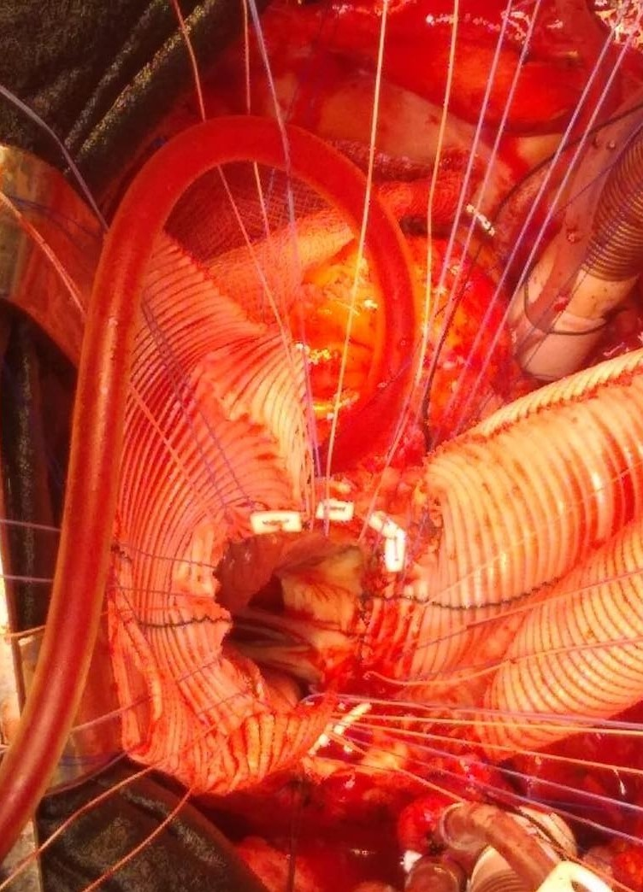
Figure 1: The Manougian posterior expansion was performed using by Dacron patch.
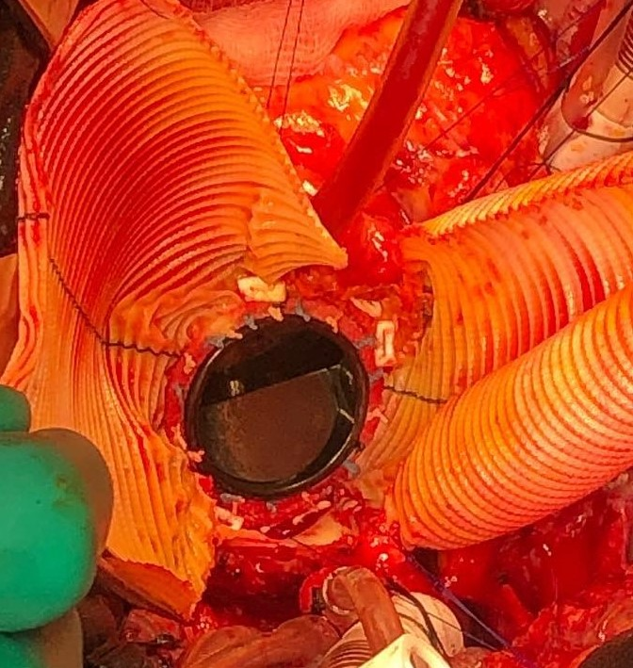
Figure 2: No:27 St. Jude mechanical valve was placed with the help of Teflon reinforced 2/0 ti-cron sutures.

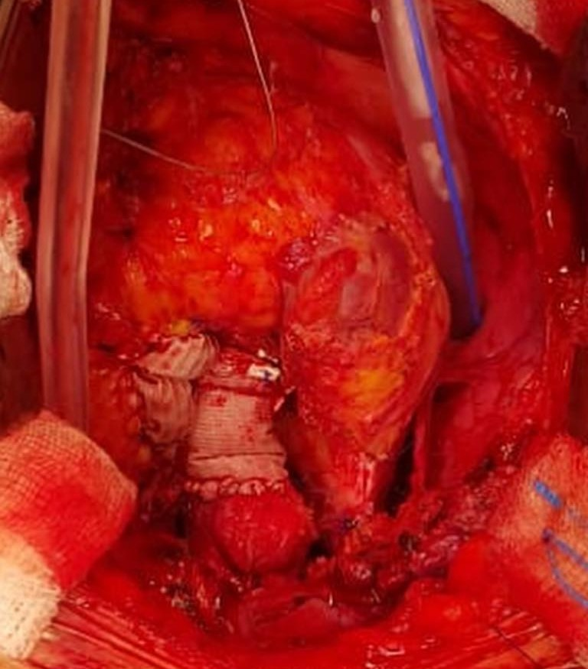
Figure 3: Dacron graft pieces used for expansion of RVOT and Aort.

