Spina Bifida: alternative approaches and treatment, based on evidence through gait analysis

Marcel Rupcich G¹, Ricardo J Bravo^{2,3}
¹Head of Pediatric Orthopaedic Service, Centro Médico Docente La Trinidad, Venezuela.
²Center for Assistive Technology, Universidad Simón Bolívar, Venezuela.
³Neurodevelopment Unit, Residencia Humana, Venezuela.
Correspondence: Marcel Rupcich G, MD. Pediatrics Department, Centro Médico Docente La Trinidad, Caracas, Venezuela. Tel +58-412-3327825, Email: marcelrupcich@gmail.com

Abstract

Myelomeningocele results from failure of the neural tube to close in the developing fetus and is associated with neurological impairment (Incidence 1:1000 births). The level of the anatomic lesion generally correlates with the neurological deficit and ranges from complete paralysis to minimal or in some cases no motor involvement. Myelomeningocele or Spina bifida can lead to health problems, physical disabilities, and learning problems. Most commonly, associated paralysis of the lower extremities and neurogenic bladder. Treatment requires multidisciplinary participation. The functional classification that concerns us in this review includes three types and were obtained through gait analysis.

Keywords

Spina Bifida, instrumental gait analysis, kinematics and kinetics, orthotics.

Introduction
The term spinal dysraphism¹ refers to those conditions that result from a defective development in the midline of the dorsal aspect of the embryo, resulting in bone or nervous system deformities. Cutaneous manifestations can be accompanied, but they are not always present.
Spina bifida belongs to a group of developmental disorders of the vertebral arches or the cranial vault. They are often associated with disorders of the formation of structures derived from the neural tube and meninges, and can lead to cystic formations. the causes of spina bifida appear multifactorial. Folic acid deficiency is a significant factor and there appears to be a genetic component.

Three types of spina bifida can be described: The severity ranges from occult, in which no obvious abnormalities are seen, to protruding sacs (cystic spina bifida), and to a completely open spine with severe neurological disability and death.
Occult Spina bifida is a defect located in one or more vertebral arches. It develops as a failure of the vertebral arches, remaining unfused in the third month. The spinal cord and meninges remain within the vertebral canal.
The meningocele is a cystic mass of the dura and arachnoid that protrudes through a defect in the vertebral arches under the skin. The spinal cord is completely confined to the vertebral canal, but abnormalities can occur.
Myelomeningocele (MMC), or open spina bifida, where the exposed elements of the spine are fully exposed.
The spectrum of clinical presentation is huge, from lethal rachischisis to asymptomatic occult spina bifida with a small lipoma. The diversity of presentations suggests that causal factors exert their effects in different periods of development, in addition to genetics and the environment that must be considered. Other associated abnormalities found in spina bifida are congenital spinal deformity, Sprengel deformity, tethered cord, neurogenic bladder, and clubfoot. A high incidence of allergy to latex has also been observed.
Progressive neurological deterioration can occur because hydrocephalus in association with an Arnold-Chiari type II defect is common and develops in 80% of children with thoracolumbar myelomeningocele ^{2,3,4,5}.

Instrumental Gait Analysis
The instrumental gait analysis (IGA) is the record of the biomechanical variables of human movement related to the way we walk. Allowing to know the principles that govern the human movement, making its analysis more objective and able to be measurable.
Nowadays it is compound by:
- The clinical exam using muscular force measurement through dynamometry
- Observational Analysis (three-dimensional video)
- Kinematics and muscle length
- Kinetics
- Muscle activity (dynamic EMG)
- Energy consumption
- Baropodography

This type of analysis has made it possible to identify the prerequisites for normal gait, making it easier to recognize deviations that occur in pathological gait.

Functional impact
Regarding independence in daily life, at present, the most accepted classification is the one that arises from the available motor function^{6,7,8,} so it should be clear what the patient's motor resources are, mainly the antigravity muscles, which are also related to the prognosis of gait and its maintenance over time.
Ambulation is also affected by age, obesity, spasticity, orthopedic deformities, etc.^{9.} The greater the commitment, the greater the disability and implications such as survival, associated deformities, and the ability to walk.
Motor level and balance are two main factors that compromise the ability to walk and subsequently the degree of support required.

Motor level

Classification and motor implications:

The level of neurological involvement is one of the key determinants of a child's ambulation.

The most accepted classification of spina bifida is based on the neurological level of the lesion^{6,7,8} (see Table 1). Patients are divided into three groups according to the level of injury, functional ability, and ambulation.
As reference, we used the classification proposed by Swank & Dias⁶ to make communication easier and simpler, based on the motor function level (FML) and the functional mobility scale (FMS), which should always be used together.
FML is based on what type of assisted device the patient is using and what type of brace they are wearing, while FMS is based on the ability to walk in three different distances (5/50/500 meters).

Table I. Functional classification for outpatients with myelomeningocele

Group | Level | Comments
1 | Thoracic /High Lumbar Level- MM1 | - Minimum lower limb motor resource, short-term ambulation  - The highest risk of associated deformities.  - Approximately 7% become sedentary between 7 and 10 years of age.  - No Quadriceps.  - Requires reciprocal Gait-Orthosis (RGO), Hip Knee Ankle Foot Orthosis (HKAFO), or Parapodium  - FMS 2 2.1  - Most will stop walking by 11 to 13 years of age.  - Obesity is common.  - Adult: 99% require a wheelchair to mobility (FMS 1.1.1)
2 | Low Lumbar Level-MM2 | - Quadriceps and hamstrings function mainly internal: 70% to 80% maintain walking capacity in adulthood.  - Hip flexor; knee extensor, and medial Hamstring  - Young patients FMS: 3.3.3, 3.3.1, 3.3.2, 2.2.1  - Requires AFO, crutches, walker.  - Gluteus maximus and medius: 2 or less, Gastrocnemius: 0.  - As they get old, gain weight, and walking decrease.FMS: 3.3.1, 3.2.1, 2.2.1, 2.1.1/1.1.1
3 | Sacral Level:  - Group I  High Sacral-MM3  - Group II  Low Sacral-MM4 | - They practically have a normal gait. 98% maintain walking capacity in adulthood. This group has been subdivided into two subgroups:  - High Sacrum:  - Defined by the absence of plantar flexors,  - Weak Gluteus Medius and Maximus  - Gastrocsoleus strength 2 or less  - Requires solid AFO  - Gluteus lurch.  - FMS 5.5.5 or 5.5.3 or 6.6.6  - Most will retain walking ability as adults.  - Low Sacrum  - Usual presence of weak plantar flexors.  - Strong gluteus medius and maximus.  - Strong gastrocsoleus.  - May need SMO/UCBL or no braces.  - No Gluteus lurch.  - FMS 6.6.6
Source: Adapted from Swank and Dias, 1994.

The classification criteria for patients, based on the muscle resource present in the lower limbs, are summarized in Table II:

Table II. Muscle resources versus motor level in myelomeningocele.
Muscle group | Thoracic / High Lumbar-MM1 | Low Lumbar -MM2 | High Sacral- MM3 | Low Sacral-MM4
Hip flexors | May or may not be present | present | present | present
Hip adductors | May or may not be present | present | present | present
Hip extensors | absent | absent | present | present
Hip abductors | Absent | absent | present | present
Knee extensors | Absent | present | present | present
Knee flexors | Absent | Medial present &  Lateral may or may not | present | present
Ankle plantar flexor | Absent | absent | absent | Present (weak)
Ankle dorsal flexors | absent | absent | May or may not be present | Present (weak)
Source: authors.

It is important to note that the lesion tends to be asymmetric in most cases, therefore the classification leans towards the more involved side.

Balance

Balance also affects the ability to walk and the degree of support required and is related to the presence or absence of shunt¹⁰, the function of the shunt, the number of shunt reviews.

Statistical reports from the literature of specialized centers⁸ show that of 70 - 80% of the lower lumbar level and 98% of the sacral level retain their ability to walk independently in adult life, whereas thoracic or upper lumbar levels, 7 % lose the ability to walk between 7 and 10 years ^{6,7,8.}

Quality of ambulation and Gait Analysis

Factors affecting gait quality include¹¹: muscle weakness, severe scoliosis, flexion contracture of the hip, abduction contracture of the hip, subluxation or dislocation of the hip (with or without soft tissue contracture), rotational deformities of the hip (internal or external)¹², flexion contracture of the knee^{13,14,15} and tibial torsion (internal or external) ^{16,17.}

Since a large percentage of outpatients maintain their ability to walk, its quality must be considered. Gait analysis can be used to access and help quantify its quality during ambulation ^{9.}

Generally, a clinical assessment of strength alone rarely reflects the asymmetry noted during gait. An instrumental gait analysis should be the standard of expert care for children with movement abnormalities secondary to spina bifida.

The IGA has made it possible to measure the impact of the orthoses with the use of kinematics²⁰ and kinetics on the loads applied to the joints of the lower limbs during movement ^{8 17 21 22.} With which the benefit or not, of walking aid options is documented, and their impact on biomechanics ^{23.}

It allows observing the knee moments in the coronal plane to define if there are valgus forces²⁴, as well as documenting the rotation patterns of the trunk and pelvis in the transverse plane²⁵ due to the combination of bone deformities and muscle weakness.

IGA also shows muscle function, especially in the ankle, due to muscle hyperactivity, muscle shortening, or weakness²² ²⁶ ²⁷ resulting from growth, puberty, or cord retention, when a given treatment is considered.

It documents postoperative changes that are used for subsequent decision making. All this information allows the specialist to formulate treatment plans and protocols in order to develop the maximum potential and independence of the patient ^{8 17 21 22.}

Evidence from Instrumental Gait Analysis

This section shows more in-depth the IGA evidence applied to the management of patients with MMC²⁸, with examples based on gait kinematics and kinetics.

Kinematics and kinetics derived from functional modeling in 3-dimensional instrumental gait analysis provide subject-specific data and can detect not only static but also functional alignment.

Gluteus weakness is the cause of compensation with the lateralization of the trunk during ipsilateral support (fig 1), also affecting the movements of the pelvis and trunk in the coronal and transverse planes (excessive pelvic obliquity and rotation (figure 2), and excessive trunk rotation (fig 3), in kinematics) and at the knee (increased valgus stress, figure 4).

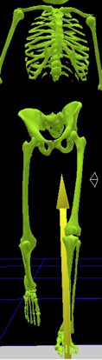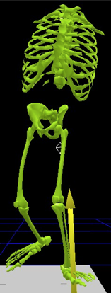
a) normal b) valgus trust

Figure 1: trunk movement increases knee varus moment (Figure 1 b) compared with a normal gait (fig 1 a). (Courtesy of Luciano Dias, M.D., A&R Lurie Children’s Hospital of Chicago)

The primary factor of the pelvic obliquity (fig 2, top and right) is the hip abductor weakness which induces a lateral trunk movement over the stance limb. Generally higher levels will show a greater pelvic oblique pattern.

The deviation in the pelvic rotation (fig 2, bottom left) is a compensatory motion in the presence of decreased strength of the ankle plantar flexor (primary power generator of walking) and weak hip extensor.

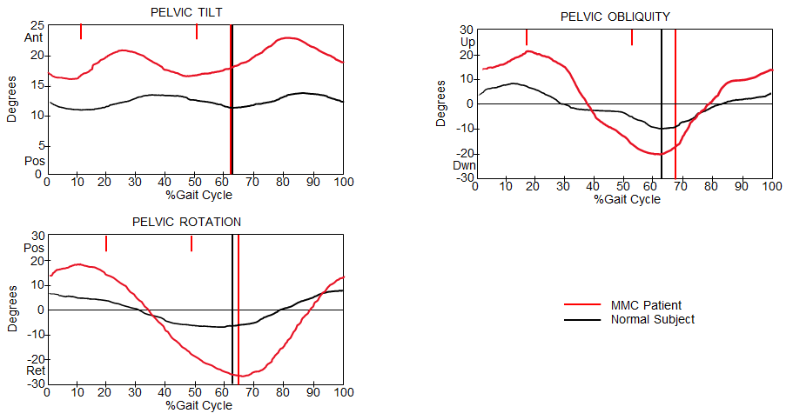

Figure 2. An example of kinematics pelvic obliquity pelvic rotation and pelvic tilt of an MMC patient vs. normal subject, showing: increased elevation of hemipelvis during the loading response and associate depression of the hemipelvis at toe off. Excessive transverse plane pelvic rotation, increased anterior excursion.
(Adapted from Dias et al.²⁸).

MMC patients show greater than a normal excursion of anterior pelvic tilt progression during single-limb stance (figure 2 top left). Its primary factor obeys a decreased hip extensor strength (Gluteus Maximus).

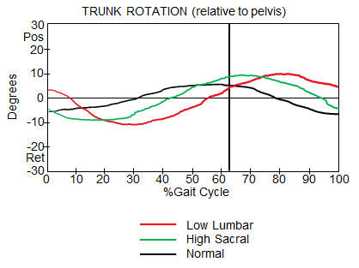
Figure 3. Trunk rotation is relative to the pelvis for different levels of MMC. (Adapted from Dias et al.²⁸).
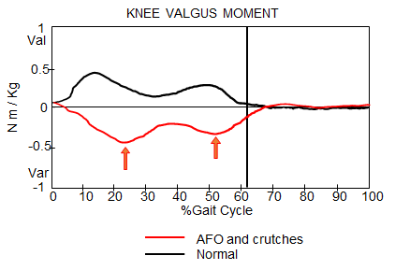
Figure 4. Increased knee valgus stress in MMC patients.
(Adapted from Dias et al.²⁸).

Also, an increased knee flexion throughout the gait cycle is verified (see figure 5).

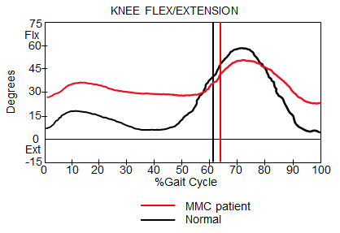
Figure 5. Increased knee flexion in MMC patients. (Adapted from Dias et al.²⁸)

Its primary cause is a weak plantar flexor, and or hip extensor, or quadriceps. Prolonged muscular activity recorded on EMG of the hamstring during the stance phase is needed to control pelvic tilt.

Swing phase pelvic rotation and hip abduction can interrupt the pendulum action of the swing limb. Hip and knee flexor contractures are generally more associated with high levels, affecting the pattern and magnitude of movement.

As can be seen in the graphs of figure 6, the pelvic tilt and pelvic rotations increase with the level of the lesion.

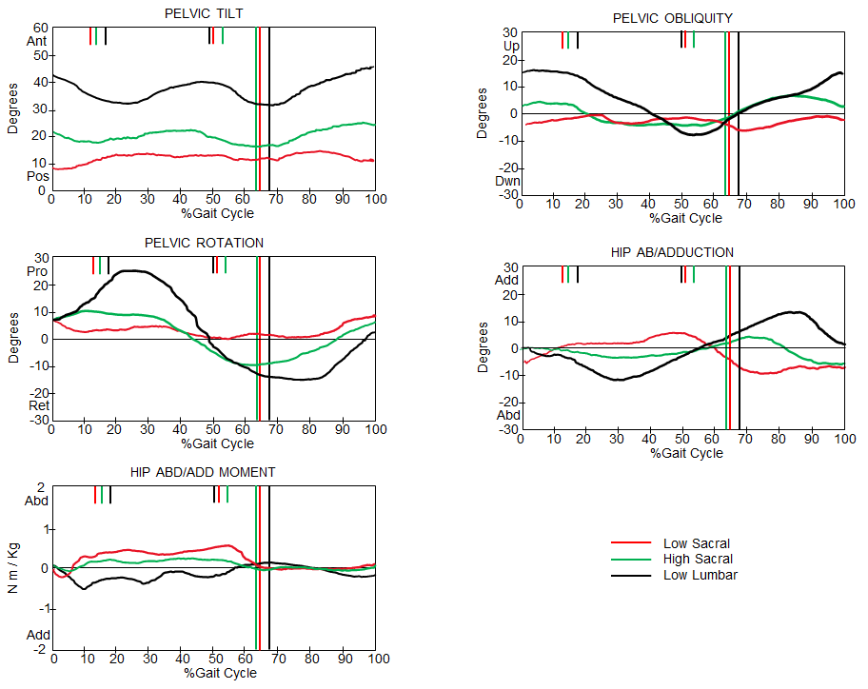

Figure 6. A comparison of gait deviations between MMC levels.
(Adapted from Dias et al.²⁸)

IGA also shows the impact of the use of orthosis and additaments (figure 7). Solid AFOs stabilize the ankle and hindfoot, preventing foot and knee valgus. Crutches decrease trunk movement, therefore, decreasing internal knee varus moment. AFOs also reduce excessive knee flexion in the stance phase as shown in figure 8.

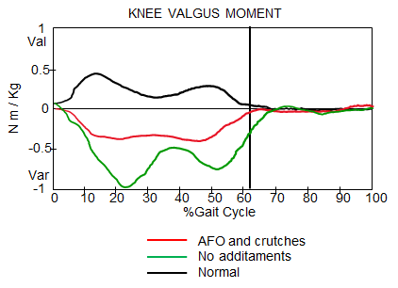

Figure 7. A comparison of knee valgus/varus moment using solid AFO and crutches (red) and without its (green). (Adapted from Dias et al.²⁸)

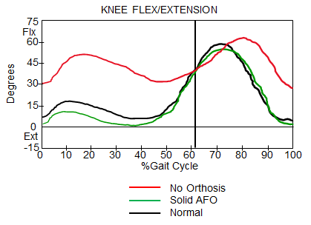

Figure 8. Improvement of knee flexion on a MM3 patient due to the use of AFOs. (Adapted from Dias et al.²⁸)

Due to the increase of the pelvic tilt and pelvic rotations with the level of the lesion shown by kinematics (figure 6), a surgery that affects pelvic motion will make the gait more difficult.

Besides, IGA kinetics have demonstrated that Any surgery that decreases the strength of power generation muscles (i.e. Ileopsoas, Gluteus, Hamstrings), will affect gait. Transfers of the Iliopsoas muscle (Sherrard procedure) should not be performed as it decreases the flexor power of the hip. Spinal fusion to the Sacrum in low lumbar and sacral level patients must not be performed.

An Overview of Current Treatments

In this review, we want to show the current state of disease management, its approach with “in utero” interventions, and current treatments based on the knowledge obtained through gait analysis. Existing treatment protocols depend on the anatomical level (muscle resources), balance, and bilaterality or not, present.

Spina bifida is the most common congenital defect, presenting in a wide range of severity and with poor postnatal treatment options. The resolution "in utero" ²⁹ ³⁰ ³¹ has shown beneficial results such as the absence of a sac over the lesion, an improvement in the functional level, per example: an L3 lesion is significantly associated with independent ambulation ³² ³³. The decrease in the need for ventriculoperitoneal shunts remains controversial, as the incidence or not of Chiari malformation as well³¹. Improved surgical techniques have controlled a large percentage of obstetric risks such as premature births and maternal complications derived from the procedure.

Due to the variety of medical comorbidities involved, for the evaluation and management of these patients, the competence of a multidisciplinary team³⁴, such as neurosurgery, pediatrics, physiatry, urology, orthopedic surgery, orthotics, physiotherapy, and social work is necessary for appropriate handling.

The goal of the orthopedic surgeon is to correct deformities and improve function and mobility. This is where IGA plays an increasingly important role in behaviors, decision-making, and treatment ³⁵. Decision-making about treatment has been made more precise and with better results based on the scientific method, so the inclusion of Instrumental Gait Analysis is essential in the patient care process.³⁶

***ADDED CONTENT BEGINS HERE, containing more details in MMC treatment based on Gait Analysis evidence. Also the last paragraph of the original section, that would be placed here was deleted – reviewer #1***

Gait analysis enabled to have a better understanding of the gait patterns of each level, allowing to know, which is the best orthosis or additament, and what deformity affects gait and currently has a greater influence on the selection of functional surgical procedures. The results of the instrumental gait analysis often change the identification of pathologies and surgical recommendations, e.g. femoral derotation osteotomy, first metatarsal osteotomy, the release of the plantar fascia, tibial derotation osteotomy, etc³⁶.

The magnitude of muscle weakness associated with the lesion level is the predominant factor that induces the adapted walking patterns. patients with a low lever lesion typically walk with AFOs and without external support. Higher-level typically walks with AFOs and external support.

The indication of splints on the feet, ankles, and knees is accepted, as long as an improvement in function is demonstrated.

In MM3, the use of the AFO stabilizes the ankle and foot, and its use protects valgus feet and valgus knee. The AFO substitutes for weak ankle plantar flexor in stance phase (improves the abnormal plantar flexion-knee extension couple) and weak ankle dorsiflexors in the swing phase. The stabilization of the ankle due to AFOs, enhances the knee extension in stance (as shown in figure 8).

AFOs provide (figure 9) support to prevent foot drop in swing, improves the valgus position of the foot in stance and lever arm of the ankle/foot (resulting in an improvement of ankle plantar-flexor moment and power generation in terminal stance/pre-swing).

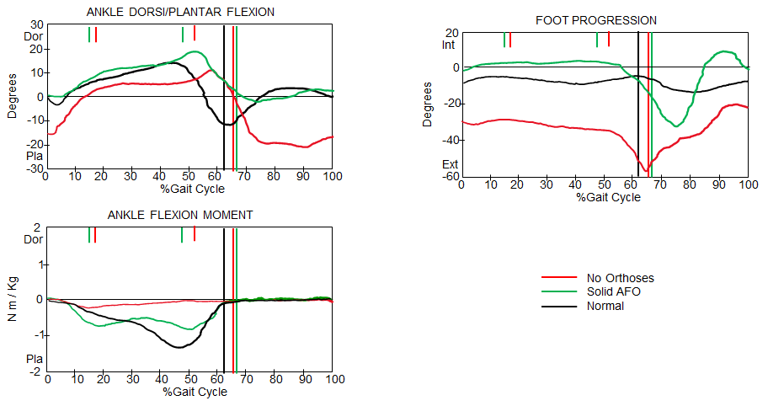

Figure 9. Effect of AFOs in the treatment of an MM3 patient.
(Adapted from Dias et al.²⁸)

The following paragraphs show the deformities that can affect the function and how they are treated, such as: hip contractures and/or dislocation, knee contractures, rotational deformities of the femur or tibia, and foot deformities.

Hip pathologies

It is a consensus to treat hip dislocation in patients with L5 level or lower and the release of contractures is limited to being functionally significant.

Hip flexion contracture that produces anterior pelvic tilt from 20⁰- 60⁰, or increased hip flexion in stance which may or may not be associated with increased knee flexion and decreased hip extension. Could be treated with the following procedures: hip flexor lengthening, fascia-lata tensor release, transfer sartorius origin to the anterior inferior iliac spine or free tendon graft, the proximal release of rectus femoris, iIiopsoas lengthening above the brim, anterior hip capsulotomy (if necessary). In severe cases after hip flexor lengthening, proximal femur extension osteotomy.

The final procedure to be applied to the patient will depend on the surgeon’s criteria

Low lumbar level with unilateral hip subluxation (with hip flexion and adduction contractures):

Those patients walks with AFOs and crutches with any of these characteristics: asymmetrical hip flexion contractures result in asymmetrical pelvic tilt and/or pelvic rotation, asymmetrical hip adduction contracture results in asymmetrical in pelvic obliquity and/or hip ab/adduction, leg length discrepancy (may also contribute to the gait asymmetry).

The treatment may need hip flexor lengthening, adductor myotomy, valgus osteotomy (Shanz) if necessary. Femoral shortening or epiphysiodesis for leg length discrepancy (see figure 10).

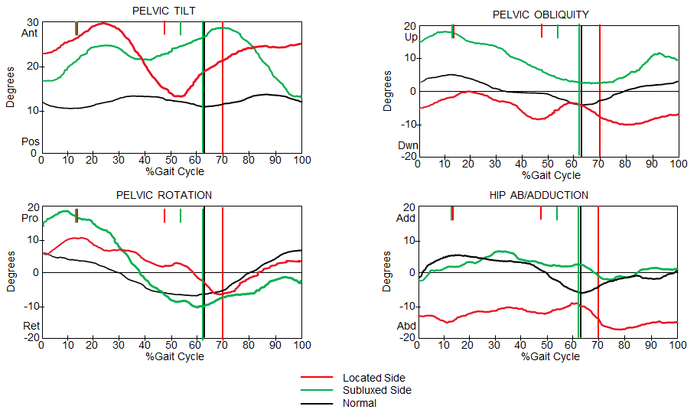
Figure 10. Pelvic kinematics and hip ab/adduction of a located and subluxated hip of an asymmetrical gait MMC patient. (Adapted from Dias et al.²⁸)

Low lumbar level with unilateral hip subluxation (with symmetrical or no contractures):

These patients walk with AFOs and crutches (some without it) and with symmetrical anterior pelvic tilt, due to symmetrical hip flexion contractures or absence of contractures. See figure 11.

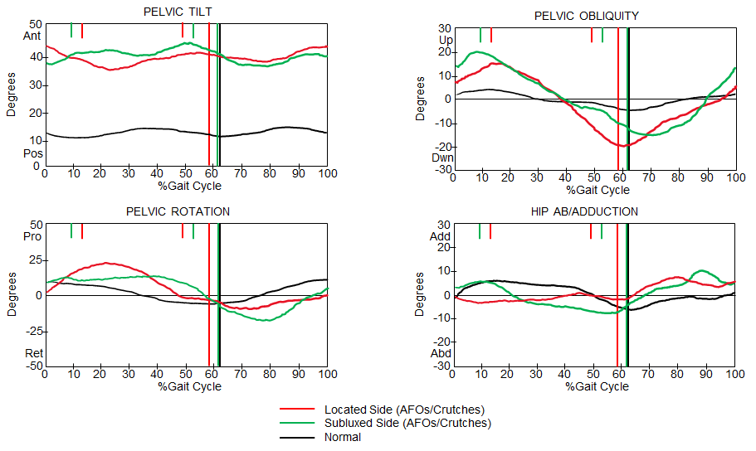

Figure 11. Pelvic kinematics and hip ab/adduction of a located and subluxated hip of symmetrical gait MMC patient. (Adapted from Dias et al.²⁸)

These patients do not need surgical relocation, treat hip flexion contracture if it is above 20⁰.

Sacral level

If unilateral hip subluxation and/or dislocation is present, it is important for these patients to rule out a tethered cord. Those patients walk with AFOs and without crutches and asymmetric gait patterns in terms of the pelvic obliquity, pelvic rotation, and hip ab/adduction as shown in the following plots (figure 12).

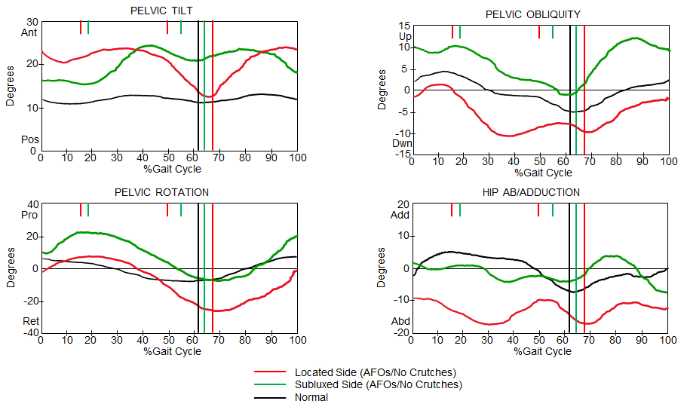

Fig 12. A comparison of a normal pattern vs located and subluxated hips of a MMC sacral level patient using AFOs and no crutches. (Adapted from Dias et al.²⁸)

Depending on the alteration, treatment must include the relocation of the hip, open reduction, pelvic osteotomy (Shelf, Pemberton, Dega, based on surgeon criteria), varus derotation osteotomy (VDO), external oblique transfer or Mustard procedure and treat any of soft tissue contractures.

Knee pathologies

Knee flexion contracture, will augment the tendency for increased knee flexion which results from weak ankle plantar flexor and hip extensor. The IGA graphs show increased stance phase knee flexion (figure 13). In consequently the corresponding sagittal plane graphs of hip and knee (not displayed in this document), will show hip flexion and ankle dorsiflexion.

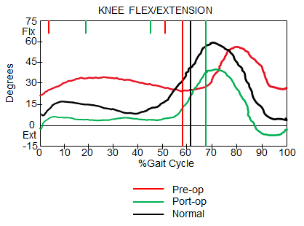

Figure 13. Knee flex/extension of a MMC patient pre and post-surgery vs. a normal pattern. (Adapted from Dias et al.²⁸)

Treatment: orthoses are of limited benefit when knee flexion is equal to or less than 30⁰ degrees. The surgery will be the lengthening of the hamstrings and in extreme cases distal femoral extension osteotomy.

Rotational deformities of the femur and tibia:

Femur:

Internal hip rotation may be present, then foot progression angle varies depending upon the degree of external tibial torsion, and kinetics will show internal varus moment at the knee with external tibial torsion. See figure 14.

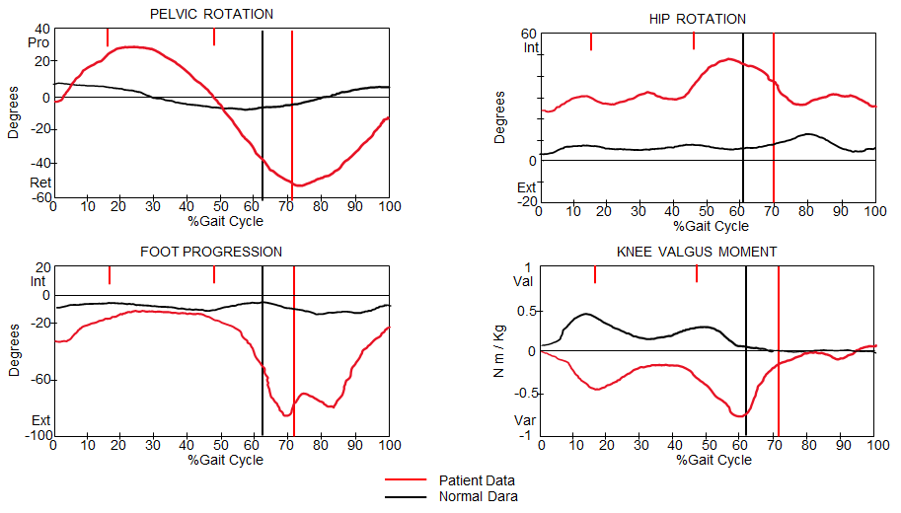
Figure 14. Effects of internal hip rotation and external tibial torsion in knee valgus/varus moment. (Adapted from Dias et al.²⁸)

Treatment of such deformities is femoral derotation osteotomy. If there is external tibial torsion, tibia/fibular derotation osteotomy must also be considered.

Tibia:

Internal tibial torsion is uncommon in MMC patients. where you can see, Internal foot progression angle during the swing phase, decreases ankle plantar-flexor moment wave at the terminal stance, as shown in figure 15.

The treatment for such cases is the use of orthosis: AFOs, KAFOs depending on level.

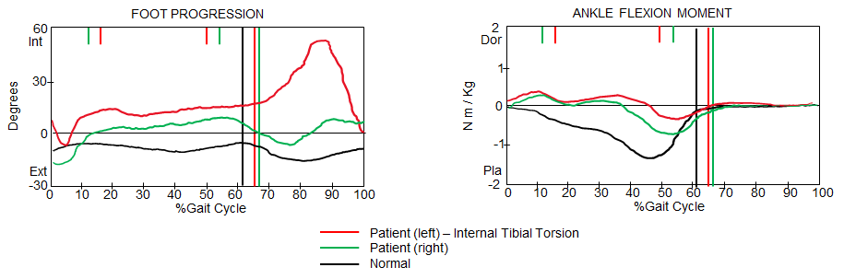

Figure 15. A comparison of the decrease of ankle dorsi/plantar flexion moment due to an internal tibial torsion in a MMC patient. (Adapted from Dias et al.²⁸)

External tibial torsions are common in MMC. The magnitude of the external tibial torsion affects the kinetics of the coronal plane (figure 16), which has been evaluated by several authors³⁷ ³⁸. Other factors must be considered because they are consequences of an external tibial torsion, such as: trunk lean toward in stance phase, dynamic pelvic rotation internal hip rotation, stance phase knee flexion, and ankle and hindfoot valgus

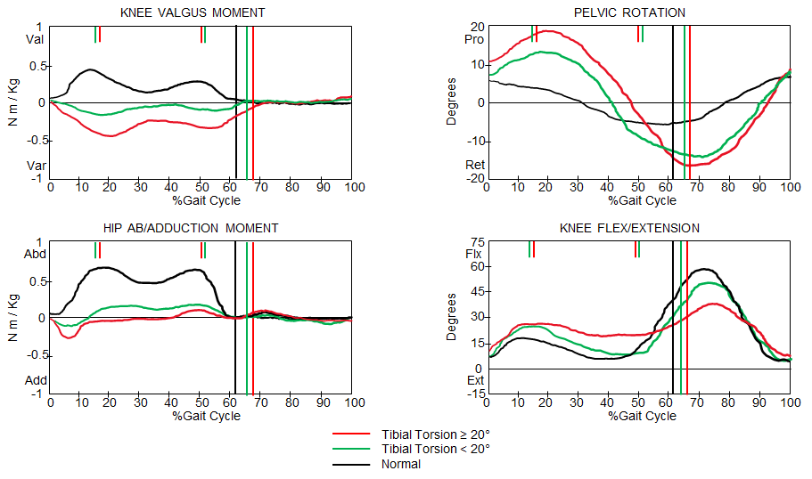

Figure 16. Coronal plane kinetics, pelvic rotation and knee kinematics as a function of external tibial torsion in MMC. (Adapted from Dias et al.²⁸)

Treatment of external tibial torsion may be either orthotic or surgical. If it is less than 20⁰ degrees then an AFO/KAFO is recommended. Surgery tIbial/fibular supramalleolar derotation osteotomy should not be done until 5 or 6 years old. (see figure 17).
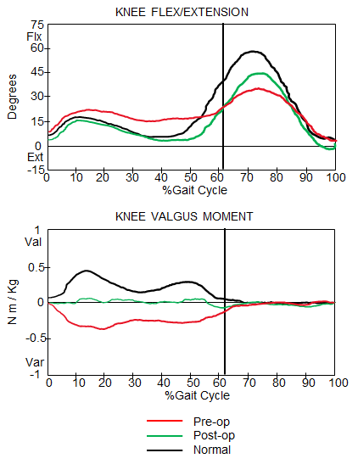

Figure 17. Pre/post op effects at the knee of a tibial derotation osteotomy.
(Adapted from Dias et al.²⁸)

Foot Deformities:

Pes valgus is the most common foot deformity, and consists of hindfoot pronation with supination and abduction of the forefoot, producing the same effect in the lower limbs upper segments as the external tibial torsion (knee varus moment). In addition, abnormal ankle plantar flexion-knee extension couple due to loss of lever arm rigidity.

The treatment suggested is anterolateral release secondary to muscle imbalance and progressive deformity, otherwise maintained with UCBL type orthosis until 8 years. After 10 years, an osteotomy of the calcaneus should be considered and maintenance of UCBL.

Talipes equinovarus present at birth is also frequent. Initially treated with serial casting and continuous splinting until the child is 12 month old, then surgery if needed. Surgery consists of postero medial lateral release with tendon excision.

Conclusion

In general, a clinical evaluation alone rarely provides an approach to compromise in detail what the asymmetries and compensatory responses are used during gait. Instrumental gait analysis should be the standard of care for children with walking abnormalities secondary to spina bifida or any other pathology that alters movement. The main objective of the gait analysis is to define the consequences derived from the neural tube injury in relation to functional activity and future independence of the patient.

Instrumented gait analysis can also provide clinicians with a better understanding of how neurological impairment affects walking, the compensations or compensatory responses used, and further define the functional level of the patient. The current trend is to minimize dependence on orthosis for ambulation during childhood and optimizing mobility and independence within the expectations and functional level of the patient.

Decision-making about treatment has been made more precise and with better results based on the scientific method, so the inclusion of Instrumental Gait Analysis is essential in the patient care process.

Authors' Contributions

Both authors contributed equally in the development, writing, translation and formatting of this work.

Availability of Data and Materials

None.

Conflicts of Interest
All authors declared that there are no conflicts of interest.

Ethical Approval and Informed consent
Not applicable

Consent for Publication
Not applicable

Copyright
Authors retain the copyright of their works through a Creative Commons Attribution 4.0 International License that clearly states how readers can copy, distribute, and use their attributed research, free of charge. Authors are required to sign a License to Publish before formal publication.

References
1. Menelaus M. The orthopedic Management of Spina Bifida Cystica. Churchill Livingstone. 2nd Ed. 1980.

2. Stein SC, Schut L. Hydrocephalus in myelomeningocele. Childs Brain. 1979: 5(4):413-9.

3. Mazur JM, Stillwell A, Menelaus M. The significance of spasticity in the upper and lower limbs in myelomeningocele. J Bone Joint Surg Br. 1986: 68(2):213-7.

4. Mazur JM, Menelaus MB, Hudson I, Stillwell A. Hand function in patients with spina bifida cystica. J Pediatr Orthop. 1986: 6(4):442-7.

5. Roach JW, Short BF, Saltzman HM. Adult consequences of spina bifida: a cohort study. Clin Orthop Relat Res. 2011: 469(5):1246-52.

6. Swank M, Dias LS. Walking ability in spina bifida patients: a model for predicting future ambulatory status based on sitting balance and motor level. J Pediatr Orthop. 1994: 14:715–718.

7. Dias LS. Myelomeningocele and intraspinal lipoma. In: Sponseller PD (ed) Orthopaedic knowledge update: pediatrics 2nd eds. American Academy of Orthopaedic Surgeons. 2002: pp 249–259.

8. Swaroop VT, Dias LS. Orthopedic management of spina bifida. Part I: hip, knee, and rotational deformities. J Child Orthop. 2009: 3:441–449.

9. Baghdadi T, Abdi R, Bashi RZ, Aslani F. Surgical Management of Hip Problems in Myelomeningocele: A review article. Arch Bone Jt Surg. 2016: 4(3): 197-203.

10. Swank M, Dias L. Walking ability in spina bifida patients: a model for predicting future ambulatory status based on sitting balance and motor level. J Pediatr Orthop 1994:14(6):715-8.

11. Battibugli S, Gryfakis N, Dias LS, Kelp-Lenane C, Figlioli S, et al. Functional gait comparison between children with myelomeningocele: shunt versus no shunt. Developmental Medicine & Child Neurology. 2007: 49: 764–769.
12. Asher M, Olson J. Factors affecting the ambulatory status of patients with spina bifida cystica. J Bone Joint Surg Am. 1983: 65:350–356.

13. Dunteman RC, Vankoski SJ, Dias LS. Internal derotation osteotomy of the tibia: pre- and postoperative gait analysis in persons with high sacral myelomeningocele. J Pediatr Orthop. 2000: 20:623–628.

14. Westcott MA, Dynes MC, Remer EM, Donaldson JS, Dias LS. Congenital and acquired orthopedic abnormalities in patients with myelomeningocele. Radiographics. 1992:12:1155–1173.

15. Moen T, Gryfakis N, Dias L, Lemke L. Crouched gait in myelomeningocele: a comparison between the degree of knee flexion contracture in the clinical examination and during gait. J Pediatr Orthop. 2005: 25(5):657–660.

16. Dias LS. Surgical management of knee contractures in myelomeningocele. J Pediatr Orthop. 1982: 2:127–131.

17. Duffy CM, Hill AE, Cosgrove AP, Corry IS, Mollan RA, Graham HK. Three-dimensional gait analysis in spina bifida. J Pediatr Orthop. 1996: 16:786–791.

18. Dodgin DA, De Swart RJ, Stefko RM, Wenger DR, Ko JY. Distal tibial/fibular derotation osteotomy for correction of tibial torsion: review of technique and results in 63 cases. J Pediatr Orthop. 1998: 18:95–101.

19. Farmer DL, Thom EA, Brock JW, et al. The Management of Myelomeningocele Study: full cohort 30-month pediatric outcomes. Am J Obstet Gynecol. 2018: 218-256.e1-13.

20. Vankoski S, Sarwark J, Moore C, Dias L. Characteristic pelvic, hip, and knee kinematic patterns in children with lumbosacral myelomeningocele. Gait & Posture 1995: Vol. 3: 51-57

21. Dias L. Orthopaedic care in spina bifida: past, present, and future. Dev Med Child Neurol. 2004: Vol 46 (9):579.

22. Fabry G, Molenaers G, Desloovere K, Eyssen M. Title: Gait analysis in myelomeningocele: possibilities and applications. J Pediatr Orthop. 2000: Vol. 9(3): 170-9.

23. Thomson JD, Segal LS. Orthopedic management of spina bifida. Dev Disabil Res Rev. 2010: 16(1):96-103.

24. Ounpuu S, Thomson J, Davis R, DeLuca P. An examination of the knee function during gait in children with myelomeningocele. J Pediatr Orthop. 2000: Vol 20 (5):629-35.

25. Bartonek A, Saraste H, Eriksson M, Knutson L, Cresswell A. Upper body movement during walking in children with lumbo–sacral myelomeningocele. Gait and Posture. 2002: Vol 15: 120–129.

26. Gabrieli A, Vankoski S, Dias L, et al. Gait analysis in low lumbar myelomeningocele patients with unilateral hip dislocation or subluxation. J Pediatr Orthop. 2003: Vol. 23(3): 330-4.

27. Gutierrez E, Bartonek Å, Haglund-Åkerlind Y, Saraste H. Kinetics of compensatory gait in persons with myelomeningocele. Gait and Posture. 2005: Vol. 21: 12–23.

28. Dias L, Kelp-Lenane C, Novak R, Vankoski S. Myelomeningocele: Orthopedic Management and Gait Analysis. Course 9. Annual meeting of the American Academy of Cerebral palsy and Developmental Medicine: 2000.

29. Adzick NS, Thom EA, Spong CY, et al. A randomized trial of prenatal versus postnatal repair of myelomeningocele. N Engl J Med. 2011: 364(11):993-1004.

30. Tulipan N, Wellons JC, Thom EA, et al. Prenatal surgery for myelomeningocele and the need for cerebrospinal fluid shunt placement. J Neurosurg Pediatr. 2015:16(6):613-620.

31. Johnson P, Sutton L, Rintoul N et al. Fetal myelomeningocele repair: short-term clinical outcomes. American Journal of Obstetrics and Gynecology. 2003: Vol. 189 (2):482-487.

32. Danzer E, Joyeux L, Flake AW, Deprest J. Fetal surgical intervention for myelomeningocele: lessons learned, outcomes, and future implications. Dev Med Child Neurol. 2020: 62(4):417-425.

33. Houtrow A, Thom E, Gletcher J, et al. Prenatal Repair of Myelomeningocele and School-age Functional Outcomes. Pediatrics. 2020: Vol. 145(2) e20191544.

34. Ntimbani J, Kelly A, Lekgwara P. Myelomeningocele - A literature review. Interdisciplinary Neurosurgery. 2020: Vol. 19(3), e100502.

35. Wren T, Tucker C, Rethlefsen S et al. Clinical efficacy of instrumented gait analysis: Systematic review 2020 update. Gait & Posture. 2020: Vol. 80: 274-279.

36. Mueske N, Õunpuu S, Ryan D, Healy B et al. Impact of gait analysis on pathology identification and surgical recommendations in children with spina bifida. Gait & Posture. 2019: Vol. 67: 128-132.

37. Shih Y, Chau M, Arendt E, Novacheck T. Measuring Lower Extremity Rotational Alignment
A Review of Methods and Case Studies of Clinical Applications. The Journal of Bone and Joint Surgery. 2020: Vol. 102(4): 343-356.

38. Lim R, Dias L, Vankoski S, Moore C, Marinello M, Sarwark J. Valgus knee stress in lumbosacral myelomeningocele: a gait analysis evaluation. J Pediatr. 1998: Vol 18: 428–433.

