New surgical technique for peritoneal dialysis catheter placement: Early peritoneal dialysis and catheter migration prevention
Charbel Aoun^{1⁎}, Saleem Abdelbacki¹, Toufic Saber¹, Alexandre Malek¹, Marilyn Khoury¹, and Mansour El Khoury¹
¹ Department of General Surgery, Saint Georges Hospital University Medical Center, University of Balamand, Lebanon
*Correspondence: Charbel Aoun, Department of General Surgery, Saint Georges Hospital University Medical Center, University of Balamand, Beirut, Lebanon. E-mail: charbelaoun28@gmail.com

Abstract
Introduction: The technique for peritoneal dialysis (PD) catheter placement is essential to the success of the renal replacement therapy through peritoneal dialysis. Our technique can reduce dialysis failure by decreasing the risk of catheter complications.
Catheter type and design: There are several shapes of PD catheters including pigtail curled, straight, and swan neck. In our technique, we used the pigtail-curled catheter.
Technique of implantation and surgical technique: The preferred techniques are open surgical and laparoscopic due to their good initial results and safety. Our new open surgical technique provides the advantages of being done under local anesthesia, fast, small sized incision, and the early use of the catheter for dialysis with low risk of fluid leakage.
Complications: After the procedure, complications are defined as early if less than 30 days or late if more than 30 days. Early complications include bowel perforation, bleeding, wound infection, outflow failure, or leakage of the dialysate. Late complications involve outflow failure, cuff protrusion, tunnel or exit-site infection, and hernia or dialysate leaks.
Conclusion: The advantage of our open surgical technique is its simplicity and its ability to be operated under local anesthesia. It requires fewer skills, so it is easier for surgical residents. Postoperatively less dialysate leakage due to the closure of the peritoneum and the rectus sheaths. In addition, the suture fixation of the catheter to the retropubic peritoneum prevents kinking, catheter displacement, or occlusion of the catheter by the omentum.

Introduction
The procedure for peritoneal dialysis (PD) catheter placement is vital to the accomplishment of the renal replacement therapy through PD. The first effective peritoneal dialysis was done by Richard Ruben in 1959 and his patient lived for 6 months. Fred Boen in the year 1963 used a device for the treatment of two patients with end-stage renal disease (ESRD) ^{1,2}. Many techniques were used and modified over the years for catheter placement due to the early successes with the peritoneal dialysis³. Peritoneal dialysis has several benefits over hemodialysis including lower mortality and preservation of residual renal function. It is also simple and provides excellent quality of life due to patient independence and mobility. PD has a drawback of fluid overload that could lead to poor blood pressure ⁴.
Our technique can reduce dialysis failure by decreasing the risk of catheter complications.

Catheter type and design
There are several shapes of PD catheters including pigtail curled, straight, and swan neck. They also differ in number and length of Dacron cuffs for the ultimate fixation and ingrowth. A flexible silicone tube was implicated with open end port and several side holes for improved drainage and absorption of the dialysate ^{1,5}. In the extraperitoneal segment of the PD catheter, there are one or two Dacron cuffs. In the adult population, a double cuff is usually used with the proximal cuff placed in the preperitoneal space responsible for keeping the catheter in place and the distal one implanted in the subcutaneous tissue that acts as a barrier to infection^{1,5}. The ideal location for the catheter tip is the pubic symphysis which is a reliable marker in the pelvis ¹. The type of catheter chosen is generally based on the surgeon’s preference. An ideal PD catheter should have no effect on the physiology of the abdominal tissues and allow an optimal inflow and outflow. It also should be resistant to infection and kinking, and lastly affordable ⁵. Straight and curled catheters have comparable performance, and the procedure of implantation is plain and minimally differs ⁵. However, the curled catheters have several advantages with little catheter tip dislocation and less pain while fluid inflow into the abdomen^{1,5}. In our technique, we used the pigtail-curled catheter.

Technique of implantation
There are multiple techniques for the introduction of the peritoneal dialysis catheter into the abdomen. The preferred techniques are open surgical and laparoscopic due to their good initial results and safety ¹. The advantage of laparoscopic technique is performing partial omentectomy if needed or adhesiolysis during the initial catheter implantation. The least invasive is the percutaneous catheter insertion, but it increases the risk of bowel perforation and unsatisfactory catheter placement ^{1,6}. Randomized prospective studies indicate similar results of open surgically and laparoscopically placed PD catheters ⁷. The traditional procedure is quicker than the laparoscopic one (14.3 versus 21.9 min, P < 0.0001), but there is no variation in the early complication rate ⁷. Immediate start of dialysis with decreased risk of fluid leakage is seen in laparoscopic technique and other procedures can be done concurrently ^{8,9,10}.
Laparoscopic techniques need general anesthesia which is usually contraindicated in patients needing peritoneal catheter for dialysis since they are mostly critically ill. Our new open surgical technique provides the advantages of being done under local anesthesia, fast, small sized incision, and the early use of the catheter for dialysis with low risk of fluid leakage.

Surgical Technique
The patient is placed in the supine position. Local anesthesia is initiated, and the intravenous antibiotics are given. A vertical incision of ∼4 cm is made in the midline (suprapubic). Then dissection till we reach the sheath of the rectus abdominus muscle. Then the muscle fibers are bluntly dissected, and the anterior rectus sheath opened. Afterward, 3cm of the posterior sheath is opened followed by the peritoneum. The abdominal wall is evaluated for any adhesions. Subsequently, a retractor is used to elevate the anterior abdominal wall. Adhesiolysis near the abdominal wall is done if adhesions were present. A tunnel is established to the preferred exit site and attention should be retained to make sure that the exit site is facing downward. 2cm away from the exit site, the distal cuff is positioned subcutaneously. The exit site of the catheter is situated on the left lateral abdominal wall (Figure 1). Trendelenburg position is applied, and the catheter is advanced deep into the pelvis (Figure 2). Tunneling of the retropubic peritoneal lining on top of the catheter using 2 interrupted non-absorbable prolene sutures (Figure 3). The cuff is advanced to the preperitoneal space and the peritoneum is closed around it. The operation of the catheter is examined by loading the abdomen with 200 cc saline and the entrance site is tested for leakage. Rectus sheaths are closed with resorbable sutures, making sure not to impede the catheter and to avoid dialysate leak. Another test done with saline and the site is checked for leakage. Drainage of the saline done and we check for any fecal contamination or hemoperitoneum. After hemostasis, closure of the incision and no fixation needed for the catheter.

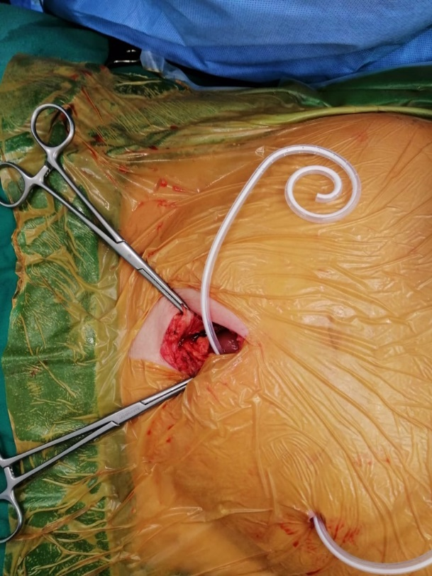
Figure 1: Insertion of the PD catheter through a small midline suprapubic incision (4cm) with the exit site of the catheter on the left lateral abdominal wall.

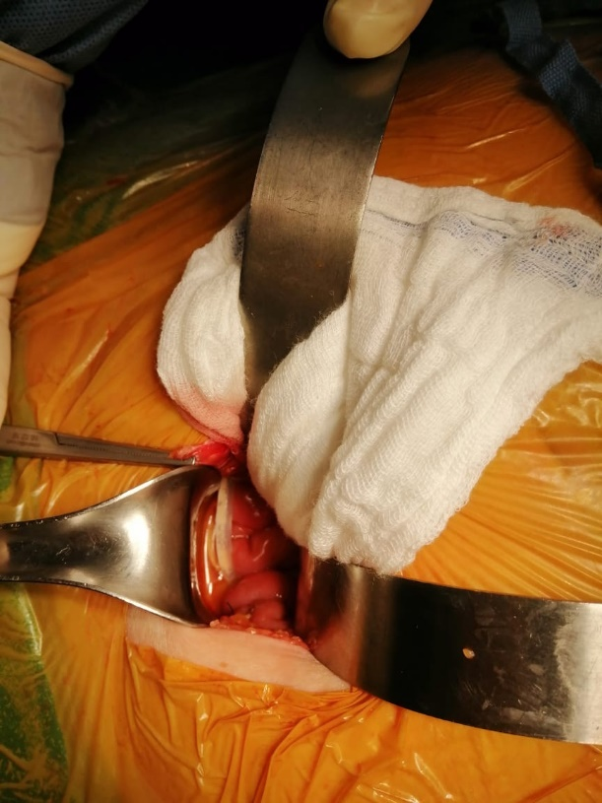
Figure 2: Placement of the tip of the catheter deep in the pelvis.

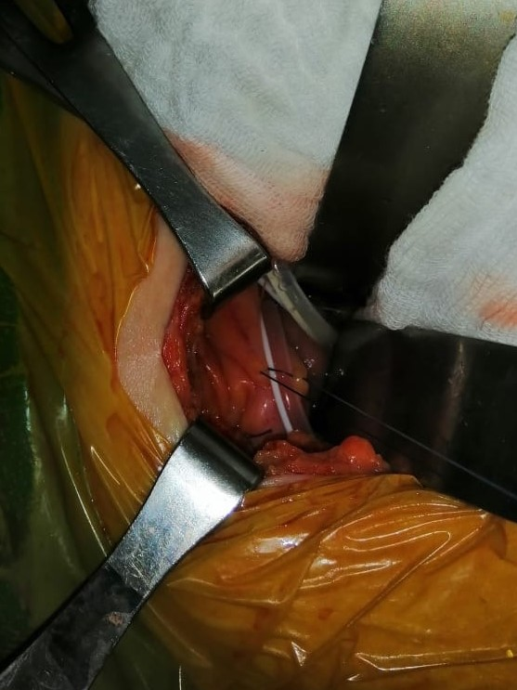
Figure 3: Tunneling of the retropubic peritoneal lining on top of the catheter using two interrupted non-absorbable prolene sutures.

Complications
After the procedure, complications are defined as early if less than 30 days or late if more than 30 days. Early complications include bowel perforation, bleeding, wound infection, outflow failure, or leakage of the dialysate ¹. Outflow failure may be expected to be due to malpositioning of the peritoneal dialysis catheter in the omentum or into the upper abdomen. Other reasons involve a kink in the tunnel that is located subcutaneously or the movement of clots or fibrin in the catheter. Identification of dialysate leakage is through a bulge below the entrance site or drainage at the exit site. This may arise owing to the positioning of the proximal cuff on the rectus muscle, or the presence of hernia at the entrance site, or trauma ^{11,12}.
Late complications involve outflow failure, cuff protrusion, tunnel or exit-site infection, and hernia or dialysate leaks ^{1,11}. Constipation is the usual cause of outflow failure that is beyond 30 days after the surgery. This is usually resolved by using laxatives. Peritonitis is generally the consequence of infection from skin flora or gram-negative bacteria associated with diverticulitis or diarrhea. Intraperitoneal or systemic antibiotics are administered, and the exchange volumes decrease. Generally, peritonitis will resolve with proper antibiotic treatment. If the infection perseveres, catheter elimination and usage of hemodialysis for approximately 4 to 6 weeks is adequate for resolving the peritonitis ^{11,12}.
Conclusion
The success of PD catheter for dialysis is dependent on the proper positioning and a better knowledge of the implantation techniques and complications. Usually, the catheter type does not modify the outcome. The advantage of our open surgical technique is its simplicity and its ability to be operated under local anesthesia. Surgical residents who are acquainted with opening the abdomen can carry out the surgery. Adhesions near the incision site can be evidently dissected close to the abdominal wall and need less skills than those in the laparoscopic setting. Postoperatively less dialysate leakage is seen due to the closure of the peritoneum and the rectus sheaths. In addition, the suture fixation of the catheter to the retropubic peritoneum prevents kinking, catheter displacement, or occlusion of the catheter by the omentum.

References
- Peppelenbosch A, Van Kuijk WHM, Bouvy ND, Van der Sande FM, Tordoir JHM. Peritoneal dialysis catheter placement technique and complications. NDT Plus. 2008;1(1): 23-28
- Blagg CR. The early history of dialysis for chronic renal failure in the United States: A view from Seattle. American Journal of Kidney Diseases. 2007;3:482-496
- Popovich RP, Moncrief JW, Nolph KD, et al. Continuous ambulatory peritoneal dialysis. Annals of Internal Medicine. 1978;88:449-456
- Konings CJ, Kooman JP, Schonck M, Dammers R, Cheriex E, Palmans Meulemans AP, Hoeks AP, van Kreel B, Gladziwa U, van der Sande FM, Leunissen KM. Fluid status, blood pressure, and cardiovascular abnormalities in patients on peritoneal dialysis. Peritoneal Dialysis International. 2002;22(4):477-487
- Gallieni M, Giordano A, Pinerolo C, Cariati M. Type of peritoneal dialysis catheter and outcomes. The Journal of Vascular Access. 2015;16(Suppl 9):S68-S72
- Haggerty S, Roth S, Walsh D, et al. Guidelines for laparoscopic peritoneal dialysis access surgery. Surgical Endoscopy. 2014;28:3016-3045
- Wright MJ, Bel’eed K, Johnson BF et al. Randomized prospective comparison of laparoscopic and open peritoneal dialysis catheter insertion. Perit Dial Int 1999; 19: 372–375
- Tsimoyiannis EC, Siakas P, Glantzounis G et al. Laparoscopic placement of the Tenckhoff catheter for peritoneal dialysis. Surg Laparosc Endosc Percutan Tech 2000; 10: 218–221
- ¨O˘g˝unc G, Tuncer M, ¨O˘g˝unc D et al. Laparoscopic omental fixation technique vs open surgical placement of peritoneal dialysis catheters. Surg Endosc 2003; 17: 1749–1755
- 15. Lund L, Jonler M. Peritoneal dialysis catheter placement—is laparoscopy an option? Int Urol Nephrol 2007; 39: 625–628
- Ellsworth PI. Peritoneal dialysis catheter insertion. In: Kim ED, editor. 2016. https:// emedicine.medscape.com/article/1829737 [Accessed: 10th January, 2018]
- Piraino B, Bailie GR, Bernardini J, et al. Peritoneal dialysis-related infections recommendations: 2005 update. Peritoneal Dialysis International. 2005;25(2):107-131

