Case report: Giant pyonephrosis due to atypical germ

Summary : a patient of 49 years old, diabetic on insulinotherapy was admitted for a massive pyonephrosis of the left kidney on a subocclusive syndrome chart, the pus was drained by percutaneous nephrostomy that has brought up 5L and 500ml purely pus. a left nephrectomy was performed in front of a non-functioning kidney on renal scintigraphy.

Key words: Pyonephrosis, diabetes, candida albicans, nephrectomy.

Introduction:
Pyonephrosis is a rare pathology causing suppressed destruction of the renal parenchyma. It can also appear as a complication oncertain urological condtions like (urolithiasis, obstructive pyelonephritis…). The diagnosis is usually evoked in front of a febrile loin pain with characteristic CT images and rarely an abdominal distention with massive pyonephrosis. Delayed management can lead to death by septic shock. We will report a case of massive pyonephrosis with an atypical germ discovered accidentlty in front of a subocclusive syndrome picture. We will discuss the causing agents and therapeutic management based on literature reviews.

Observation:
A patient of 49 years old B.F. with a history of type 2 diabetes followed for 10 years under insulintherapy. The patient was presented with a diffuse abdominal pain with absence of gas passage (flatulence) for 5 days. The clinical examination found a conscious patient, febrile at 38°C, a left hypochondrial distention with a more pronounced left hypochondrial tenderness as well as the left lumbar region. Biologically, the patient had a hyperleukocytosis at 14000/mm3, CRP 25, HbA1c 8%, the renal function was normal and the cytobacteriological examination of urine had isolated a candida albican. We have requested a plain abdominal x-ray for transit disorders which was normal (no signes of air –fluid level) and then an abdominal ultrasound was performed which revealed a left pyelocaliceal dilatation laminating the renal cortex with an echogenic content, which could be related to the purulent retention. The patient had also benefited an uroscanneras an emergency request which has confirmed a massive pyonephrosis. After restoring the patient's condition, a urinary diversion by percutaneous nephrostomy was performed under ultrasound guiding. The evolution was marked by apyrexia, improvement of white blood cell counts and CRP. In addition to this, a renal scintigraphy was performed showing a normally functioning right kidney and a non-functional left kidney.nephrectomy which was performed after 3 weeks.

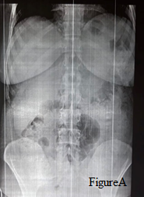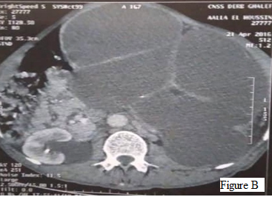

Figure A: a normal plain abdominal x-ray Figure B: Uroscanner showing enlarged left kidney measuring 20*14*8 cm, site of a major pyelocaliceal dilatation laminating the cortex, repressing the digestive structures and coming into contact with the abdominal wall.

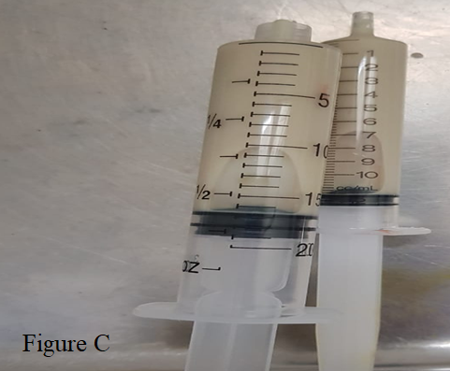
Figure C: pus sample taken during the PNC nephrostomy

Discussion:
Pyonephrosis is a suppurative upper urinary tract infection that differs from hydronephrosis by the presence of pus. It is usually associated with parenchymal lesions and subsequent loss of renal function [1].The main anatomical factor in pyonephrosis is ureteral obstruction. Urolithiasis is the most common obstructive cause in at least 70% of patients [2]. The obstruction may be intrinsic (calculus, pyelo-ureteral junction syndrome, blood clots, fungal ball, papillary necrosis, tumors of the upper urinary tract) or extrinsic (e.g prostatic cancer, bladder tumors, retroperitoneal tumors, or lymph nodes) [3]. The usual organisms responsible for pyonephrosis are E. coli, Klebsiella Enterococcus, Proteus m and Pseudomonas a [1]. The clinical presentation is most often in the form of flank pain associated with fever or chills, rarely hematuria or abdominal arching [2]. 15% of patients may remain asymptomatic. Infection in the obstructed upper urinary tract can lead to urosepsis especially in immunocompromised patients [3]. Our patient presented with diffuse abdominal pain in a febrile context without hematuria with a subocclusive syndrome. The diagnosis of pyo nephrosis was made on the basis of radiological images and cytobacteriological examination of the urine. The uroscanner is very sensitive for the diagnosis of pyonephrosis as well as the causing agents like urolithiasis and tumor pathology. Fultz and Al. found that computed tomography was a very sensitive radiological diagnosis in their study of 17 pyonephroses [4]. Treatment options for pyonephrosis include percutaneous drainage of pus, retrograde ureteral stenting and nephrectomy. Antibiotic treatment is not effective in pyonephrosis, interventional surgery is usually required. Percutaneous Nephrostomy (PCN) is usually the first-line treatment to drain the retained in the upper urinay tract. It is an effective and minimally invasive method of draining the pyelocaliciel system [1]. The ureteral stent is also an alternative to percutaneous nephrostomy for drainage in selective patients. Nephrectomy is generally indicated in front of a non-functioning dumb kidney in long-term pyonephrosis [1]. Hasigov A et al. recently reported a case of massive pyonephrosis measuring 23 cm x 30 cm x 27.9 cm upstream of a diabetic-associated urinary urolithiasis that was treated by an open nephrectomy [5]. In our case, the patient underwent percutaneous nephrostomy draining 5 Land 500 ml of pus, and a kidney scan performed showing a non-functioning left kidney an indication of nephrectomy.

Conclusion:
pyonephrosis is a parenchymal destruction of the kidney by a suppurative process due to ureteral obstruction. The clinical presentation and the germ can be unusual in diabetic patients and only a radiological imaging allows an early diagnosis including uroscanning.
It is a serious pathology that can progress to a septic shock and therefore it requires an urgent management in order to avoid the risk of life-threatening complications. Percutaneous nephrostomy remains the treatment of choice and a subsequent renal scintigraphy must be performed to evaluate the percentage of renal function.

Reference :
[1] Scarneciu I, Constantina A, Grigorescu D, Maxim L. Pyonephrosis: diagnosis and treatment: report of 65 cases. Journal of Molecular Biology. 2015;2:122-25.
[2] Rabii R, Joual A, Rais H. Pyonephrosis: diagnosis and treatment: a review of 14 cases. Annales d’Urologie. 2000;34(3):161–64.
[3] Schaeffer AJ, Schaeffer EM. Infections of the Urinary Tract. In: Wein, A.J. and Kavoussi, L.R., Eds., Campbell-Walsh Urology, 9th ed, Saunders Elsevier, Philadelphia, 2007;pp.223-96
[4] P. J. Fultz, W. R. Hampton, and S. M. S. Totterman, “Computed tomography of pyonephrosis,” Abdominal Imaging, vol. 18, no. 1, pp. 82–87, 1993.
[5] Hasigov A, Engbang JPN, Fidarov F. Giant pyonephrosis due to urolithiasis and diabetes: a case report. Open Journal of Urology. 2016;6:122-25.

