TRUE ANEURYSMAL DILATATION OF A CONTEGRA CONDUIT AFTER RIGHT VENTRICULAR OUTFLOW TRACT RECONSTRUCTION: A UNIQUE COMPLICATION
Metin Onur Beyaz¹, İbrahim Demir², Emin Tireli²

¹Istanbul Medipol University, Faculty of Medicine, Department of Cardiovascular Surgery, Istanbul
²Istanbul University, Istanbul Medical Faculty, Department of Cardiovascular Surgery, Istanbul

Address reprint request to:
İbrahim Demir
Topkapı Mah, Turgut Özal Millet Cd, 34093 Fatih/İstanbul
Tel: +90 544 4083812
e-mail: ibrahimd128@gmail.com

ABSTRACT
Contegra® is an integrated valved conduit using for reconstruction or replacement of the neutral right ventricular outflow tract (RVOT) or replacement of a failed homograft or composite pulmonary conduit in patients. However, complications frequently occur like stenosis, thrombosis, and valve failure of conduit. Here we present a case of true aneurysmal dilatation of a Contegra® conduit after RVOT reconstruction.
Keywords: True Aneurysmal Dilatation, Contegra Conduit.
INTRODUCTION
The incidence of anatomic complications after treatment has increased due to the rates of intervention in congenital heart diseases. Contegra® (Medtronic Inc, Minneapolis, MN) is often used to maintain continuity between the right ventricle and pulmonary arteries. This conduit is a ready-to-use graft with a three-leaflet valve has excellent hemodynamic properties. Dilatation, occlusion, and valve insufficiency may develop in the graft due to deformation, and therefore re-operation may be required in the postoperative period [1].
When the first aortic homoggraft was used in 1960, many bioprostheses like bovine or pig xenografts, bioprostheses placed in aortic or pulmonary roots, valvular aortic and pulmonary homografts fixed with glutaraldehyde have been used in cardiac surgery. Contegra® conduit which is manifactured from bovine jugular vein in 1999 (Medtronic Inc, Minneapolis, MN) has been preferred among pediatric cardiovascular surgeons for reconstruction of RVOT. Conduit dilation has been reported as a very unique complication and reported cases usually represent pseudoaneurysm formation [2].
In this report, we present a case of true aneurysmal dilatation of a Contegra® conduit that have been applied as a 4th operation in a 17 year-old woman with a basic diagnosis of fallot tetrology.
CASE REPORT
A 17 year-old female patient applied to our clinic with the complaints of increasing shortness of breath, chest pain and palpitations for five months.
Our patient who was born with the diagnosis of tetralogy of Fallot had a modified Blalock-Taussig (mBT) shunt operation in the newborn period. A central shunt operation was performed when she was 5 months old, and a full correction operation was performed when she was 23 months old. A 16 mm Contegra® conduit was applied as the fourth operation to the patient who developed pulmonary stenosis at the age of 5. The patient was followed up by pediatric cardiologists every six months. Echocardiography was performed at the age of 16, and pulmonary hypertension (66/34 mmHg) was detected. No anatomical abnormality was found in the conduit. Complaints of shortness of breath, chest pain, and palpitations gradually increased in the last 5 months which emerged 12 years after the last surgery.
On physical examination, heart rate was 88 bpm and arterial blood pressure was 110/65 mm/Hg. A systolic insufficiency murmur was heard on the right side of the sternum. Conduit aneurysm was detected in the control echocardiography. Cardiac CT angiography (Figure A) and cardiac MR angiography (Figure B) revealed an appearance consistent with the giant aneurysm sac extending from the right ventricular anostomosis line to the intact area in the pulmonary conduit (Figure C). Operation decision was made for the patient.
Following femoral and jugular cannulation, a re-do median sternotomy was performed under cardiopulmonary bypass. While performing sternotomy, aneurysm ruptured. The old conduit was replaced with a 22 mm Contegra® pulmonary valve conduit. In the evaluation of six months after the operation, the patient lives asymptomatically without stenosis or pulmonary insufficiency.
Figures : (A) Cardiac CT angiography, (B) Cardiac MR angiography, (C) The giant aneurysm sac.

DISCUSSION
Contegra is biologically stable and available in many different diameters, so no size mismatch issues are observed. There are studies showing that the deformation incidence of the Contegra conduit exceeds 50% in five years [3]. Aneurysmal dilatation of the Contegra has been rarely reported, and diagnosed aneurysmatic dilatations are usually pseudoaneurysms. It has been associated with distal anastomotic stenosis caused by surgery [4].
In our case, true aneurysmal dilatation was observed at 16 mm Contegra, but no obstruction was found in the distal anastomosis line. We explained that two different complications occurred after using contegra. Failure mechanisms are still unknown, but there may be mechanical stress and/or immunological factors [5]. Whatever the cause, Contegra's true aneurysm is rarely observed and can be considered a new condition for the close follow-up of patients using Contegra graft.

Ethical Approval: After explaining the interventions, risks, and benefits as a policy of the health system in the country, informed consent was obtained from the relatives of each patient before the procedures.
Conflict of Interest: None declared.
Acknowledgement: None declared.

REFERENCES
- Mohammadi S, Belli E, Martinovic I, et al. Surgery for right ventricle to pulmonary artery conduit obstruction: risk factors for further reoperation. Eur J Cardiothorac Surg. 2005;28(2):217‐222. doi:10.1016/j.ejcts.2005.04.014
- Delmo-Walter EM, Alexi-Meskishvili V, Abdul-Khaliq H, Meyer R, Hetzer R. Aneurysmal dilatation of the Contegra bovine jugular vein conduit after reconstruction of the right ventricular outflow tract. Ann Thorac Surg. 2007;83(2):682‐684. doi:10.1016/j.athoracsur.2006.06.050
- Niemantsverdriet MB, Ottenkamp J, Gauvreau K, Del Nido PJ, Hazenkamp MG, Jenkins KJ. Determinants of right ventricular outflow tract conduit longevity: a multinational analysis. Congenit Heart Dis. 2008;3(3):176‐184. doi:10.1111/j.1747-0803.2008.00190.x
- Yoldaş T, Örün UA, Kutsal A, Tak S. True aneurysmal dilatation of a valved bovine jugular vein conduit after right ventricular outflow tract reconstruction: a rare complication-CORRIGENDUM. Cardiol Young. 2019;29(12):1569. doi:10.1017/S1047951119002695
- Tomar M, Bhan A. Rapidly progressing giant aneurysm of right ventricular outflow tract with severe conduit obstruction: Report of two cases. Images Paediatr Cardiol. 2018;20(1):1‐7.

FIGURES
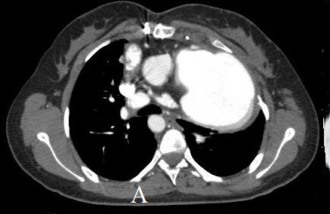
Figure A: Cardiac CT angiography of Contegra Aneurysm image.
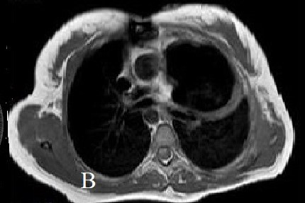
Figure B: Cardiac MR angiography of Contegra Aneurysm transvers image.
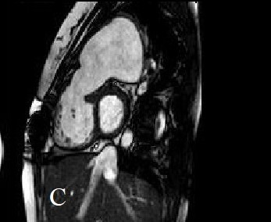
Figure C: Cardiac MR angiography of Contegra Aneurysm lateral vertical image.

