Solitary primary subcutaneous hydatid cyst of the buttock
-Case report and literature review-

MONSEF ELABDI * (1), HASSANE ZEJJARI (2), ABDERRAHMANE ELWALI (3), REDOUANE ROUKHSI (4), JAMAL LOUASTE (2), LAARBI AMHAJJI (2)

1 Orthopaedic Surgeon, Department of Orthopaedic Surgery, Military Hospital of Laayoun, Morocco

2 Professor, Department of Orthopaedic Surgery, Military Hospital of Meknes, Morocco

3 Professor, Department of Anesthesiology and Intensive Care, Military Hospital of Laayoun, Morocco

4 Professor, Department of Radiology, Military Hospital of Laayoun, Morocco

Email address:
elabdimonsef@gmail.com (M. Elabdi), hassane.zejjari@usmba.ac.ma (H. Zejjari), elwaliima@gmail.com (A. ELWALI), redouan9990@hotmail.com (R. Roukhsi), louasteaya@yahoo.fr (J. Louaste). amhajjilarbi@yahoo.fr (L. Amhajji)

* Address correspondence to: Monsef Elabdi, MD, Department of Orthopaedic Surgery, Military Hospital, 70000, Laayoun, Morocco.
E-mail address: elabdimonsef@gmail.com (M. Elabdi).

ABSTRACT
Hydatidosis is an endemic parasitic disease affecting in most cases the parenchymal organs. The involvement of the soft tissue is a rare pathology that, left untreated, can lead to rupture and potentially catastrophic anaphylaxis. In this article, we describe the case of a 42-year-old male who developed subcutaneous hydatid cyst in the buttock as a solitary primary localization. Consequently, the patient underwent successfully surgical excision with uneventful post-operative recovery.

KEYWORDS

Hydatid Cyst, Echinococcus granulosis, Subcutaneous, Soft tissue, Buttock

INTRODUCTION

Hydatid cyst [HC] is an endemic disease in Mediterranean Basin, Middle East, South America, East Africa, Central Asia, and Australia [1-2]. This happens principally in areas where dogs are used to herd grazing animals, particularly sheep [3].
Infection is caused by Echinococcus granulosus [4]. Involvement of one or multiple organs is a known event. The liver and lung are the most common organs involved (>85%) and represent generally primary foci [2, 5-6]. However, primary subcutaneous soft tissue hydatitosis is very rare [1, 7-8]. To our knowledge, few cases have been reported in the literature. We present the case of a subcutaneous hydatid cyst in the buttock region as a primary site without involving other rentals.
CASE REPORT
A 42-year-old soldier presenting with a two-year history of gradual development of a voluminous painless mass on his right hip, without any history of trauma or infection. Since his childhood, the patient was living in an urban area, which is not endemic for hydatid cyst. He weighs 72 kg with a height of 1.73 m and who’s the BMI of 24.05, with good general conditions. Clinical examination revealed a painless right buttock mass, renitent on palpation, poorly limited, measured approximately 20 cm in greatest dimension (Figure 1). The overlying skin was distended without associated inflammatory signs. Hip X-ray showed no abnormalities. Ultrasound examination (UE) and magnetic resonance imagining (MRI) depicted a superficial multilobed formation, adjacent to the buttock muscles, with multiple cystic lesions (Figure 2 and 3). This was considered as a hydatid cyst. Hydatid serology for antibodies to Echinococcus granulosus antigens was negative. Complete blood count (CBC) did not reveal eosinophilia and biochemistry findings were normal. In the extended assessment, a computed tomography (CT) scan of the chest and abdomen was within the normal range, and excluded pulmonary or hepatic involvement.
The patient underwent surgical excision by pericystectomy (Figure 4). The subcutaneous cystic lesions were removed completely without damaging the cyst wall (Figure 5 and 6), and that extensive irrigation with hypertonic saline solution was performed. Histopathological examination confirmed the diagnosis of hydatidosis. Antihelminthic treatment with 2 x 400 mg of albendazole was administrated for two months to reduce the risk of relapse. One year postoperatively, the evolution was favorable. Clinical follow-up and repeated ultrasound controls were confirmed the absence recurrence of the hydatid cyst.

DISCUSSION
Cystic hydatidosis is a cosmopolitan anthropozoonosis caused by Echinococcus granulosus. Parasitic infection is endemic in areas where sheep are raised in large quantities. Close contact with dogs is the main risk factor [3]. Mediterranean region has been reporting cases regularly.
Liver and lungs are known as the most often sites involved (85%) [2, 5-6]. After ingestion, the ova of the parasite, which penetrate the mucosa of the small intestine, join the portal system and meet the liver and lungs. These organs filter out most ova. However, parasitic eggs can pass to systemic circulation and reach other places in the body [7-9]. Mechanism of primary subcutaneous hydatidosis is not clear. Although larval subcutaneous colonization is a reliable mechanism, we believe that systemic dissemination through lymphatic channels should be considered [10].
Primary subcutaneous HC is an uncommon condition, its gluteal localization makes only 1% of all the localizations of the cyst, with cold abscess, calcified hematoma, or lipoma as main differential diagnoses [8-9, 11]. This involvement causes a diagnosis problem because of the insidious symptomatology; however, it's should be considered when slowly growing soft tissue mass in patients living in the endemic areas [12-13]. Because hydatid disease [HD] may develop complications such as rupture and anaphylactic reaction [14-15], diagnosis of echinococcosis is required before any biopsy or surgical excision.
Ultrasonography is useful key method for detecting hydatid cyst [8-10]. MRI is the better examination, which provides local and locoregional meticulous analysis [16]. Serological techniques are less sensitive for muscular involvements and can yield false-negatives [9, 17]. In our case, the negative serological test does not exclude the diagnosis, and the imaging investigations were revealed a presentation of solitary primary subcutaneous hydatid cyst of the buttock.
Echinococcosis of the soft tissue is treated by surgery. Pericystectomy without perforing the cyst is the recommended option [7-8, 11, 18]. If this method is impossible to done without breaking the wall of the HC, the cyctic fluid has to be aspired, and the laminated membrane should be totally excised. Sterilization of the cystic pouch is performed by protoscolicidal solutions [7-9, 14]. In some cases, an additional perioperative antihelmenthic therapy is preferred to reduce the risk of recurrence. Given our department guidelines, our patient underwent an antiparasitic medical treatment for 2 months after the surgical excision. We recommended 2 courses of oral Albendazole (400 mg twice per day) or (12 mg/Kg/day) for two months. Clinical and ultrasound periodic follow up of our patient did not reveal any postoperative recurrence manifestations during 1 year.
Author | Year | Sex of the patient | age of the patient | Localization | size of the cyst (cm) | Serologic test of Echinococcus | results after surgery
Sreeramulu P. N. | 2010 | M | 34 | Left gluteal | 12/10 | Negative | No evidence of recurrence for 6 months
Tarun Kumar Pathak | 2011 | F | 30 | Right thigh | 12/8 | ----------- | No local recurrence after one year
Nicolas Argy | 2013 | F | 60 | Right thigh | 10 | Positive | Relapse (three weeks later)
Samer Makki | 2018 | M | 37 | Right thigh | 10/6.5 | Positive | ----------
Abdulwahid M. Salih | 2018 | F | 34 | Left thigh | 10/17 | Negative | ----------
Samiee-Rad | 2020 | M | 86 | Right thigh | 9/8/6.5 | ------------- | No evidence of recurrence (23 months follow-up)
Rama Zazo | 2020 | F | 36 | Right thigh | 12.4/8/11 | Negative | 1 month without any recurrence manifestations
Meltem Özdemir | 2020 | M | 72 | Left gluteal | 4.4/3.4/4.6 | Negative | No recurrence for 6 months
Majid Samsami | 2021 | F | 32 | Left thigh | 15/5 | Negative | No recurrence during 8 months follow-up
Table: Patients with isolated and primary subcutaneous hydatid cysts of the gluteal region and thigh [19-27].
REFERENCES

- Kayaalp C. Hydatid cyst of the liver. In: Blumgart LH, Belghiti RJ, DeMatteo RP, Chapman WC, Büchler MW, Hann LE, D'Angleca M, editors. Surgery of the Liver, Biliary Tract, and Pancreas. ed 4. Philadelphia: Saunders Elsevier; 2007. pp. 952–970
- Saidi F. Surgery of hydatid disease. Philadelphia: Saunders; 1976.
- Eckert J, Deplazes P. Biological, epidemiological, and clinical aspects of echinococcosis, a zoonosis of increasing concern. Clin Microbiol Rev. 2004;17:107–35. [PMC free article] [PubMed]
- Kern P, Bardonnet K, Renner E, Auer H, Pawlowski Z, Ammann RW. European echinococcosis registry: human alveolar echinococcosis, Europe, 1982–2000. Emerg Infect Dis. 2003;9(3):343-9
- Bal N, Kocer NE, Arpaci R, Ezer A, Kayaselcuk F. Uncommon locations of hydatid cyst. Saudi Med J 2008;29:1004e8.
- Yildirim M, Erkan N, Vardar E. Hydatid cysts with unusual localizations: diagnostic and treatment dilemmas for surgeons. Ann Trop Med Parasitol 2006;100:137e42.
- Dirican A, Unal B, Kayaalp C, Kirimlioglu V. Subcutaneous hydatid cysts occurring in the palm and the thigh: two case reports. J Med Case Reports. 2008;2:273.
- Ousadden A, Elbouhaddouti H, Ibnmajdoub KH, Mazaz K, AitTaleb K. A solitary primary subcutaneous hydatid cyst in the abdominal wall of a 70-year-old woman: a case report. Journal of Medical Case Reports. 2011;5:270.
- Orhan Z, Kara H, Tuzuner T, Sencan I, Alper M. Primary subcutaneous cyst hydatic disease in proximal thigh: an unusual localisation: a case report. BMC Musculoskelet Disord. 2003;4:25.
- Ok E, Sözüer EM. Solitary subcutaneous hydatid cyst: a case report. Am J Trop Med Hyg. 2000;62:583-4.
- Rezakhaniha B, Sirosbakht S. Coincidental hydatid cyst of skin and kidney: a very rare case report. Iran J Pathol. 2010;5:47-50
- Marwah S, Shubramainan P, Marwah N, Rattan KN, Krwasra RK. Infested primary intramuscular echinococcosis of thigh. Indian J Pediatr 2005; 72: 799-800.
- Erol B, Tetik C, Altun E, Soyal A, Bakir M. Hydatid cyst presenting as a soft tissue calf mass in a child. Eur J Pediatr Surg 2007; 17: 55-8.
- Duncan GJ and Tooke SMT: Echinococcus infestation of the biceps brachii. Clin Otrhop 1990, 261:247-250
- Rao S, Parikh S and Kerr R: Echinococal infestation of the spine in North America. Clin Orthop 1991, 52:582-584
- Diez G, Mendoza LHR, Villacampa VM, Cózar M, Fuertes MI. MRI evaluation of soft tissue hydatid disease. EurRadiol. 2000;10:462-6.
- Gonzalez AN, Muro A, Barrera I. Usefulness of four different echinococcus granulosus recombinant antigens for serodiagnosis of unilocularhydatid disease (UHD) and postsurgical follow-up of patients treated for UHD. Clin Vaccine Immunol. 2008;15:147-53.
- Ates M, Karakapalam M. Hydatid cyst in the biceps and gluteal muscles: case report. Surg Infect (Larchmt) 2007; 8: 475-8.
- Sreeramulu P. N. and al. Gluteal region musculoskeletal hydatid cyst: Case report and review of literature. Indian J Surg 72(Suppl 1): 302–305 DOI: 10.1007/s12262-010-0096-2
- Tarun Kumar Pathak, and al. Solitary hydatid cyst in thigh without any detectable primary site. J Pak Med Assoc. Vol. 61, No. 12, December 2011
- Nicolas Argy and Al. Primary musculoskeletal hydatid cyst of the thigh: Diagnostic and curative challenge for an unusual localization. Can J Infect Dis Med Microbiol Vol 24 No 3 Autumn 2013
- Samer Makki Mohamed Al-Hakkak. Adductor magnus muscle primary hydatid cyst rare unusual site: A case report. Int J Surg Case Rep. 2018; 51: 379-384. Published online 2018 Sep doi: 10.1016/j.ijscr.2018.09.026
- A.M. Salih et al. / International Journal of Surgery Case Reports 51 (2018) 8–10. Hydatid cyst of the thigh: A case report with literature review
- Fatemeh Samiee-Rad. Ali Emami. An Iranian man with increased thigh mass due to a hydatid cyst. GMS Hygiene and Infection Control 2020, Vol. 15, ISSN 2196-5226
- Aya Zazoa, Rama Zazoa,∗ and al. Uncommon musculoskeletal femoral hydatid cyst disturbs a female for a year: Case report. Annals of Medicine and Surgery 55 (2020) 30–32 . doi.org/10.1016/j.amsu.2020.04.025
- M. Özdemir and al. Primary gluteal subcutaneous hydatid cyst. IDCases 19 (2020) e00719
- Majid Samsami, and al. A case report of primary isolated extrahepatic hydatid cyst of the soft tissues of the breast and thigh. Int J Surg Case Rep. 2021 Feb; 79: 475–478. Published online 2021 Jan 29. doi: 10.1016/j.ijscr.2021.01.087

LEGEND OF FIGURES:
Figure. 1. Preoperative clinical photograph showing the lump in the right buttock.
Figure. 2. Ultrasonography shows a superficial mass with multiple extramusculo-aponeurotic cysts.
Figure. 3. (A) Axial T1-weighted and (B) axial fat saturated T2-weighted magnetic resonance images showing subcutaneous multilocular cystic formation in the right buttock with daughter cysts.
Figure. 4. (A and B) Per-operative view of hydatid cyst operation.
Figure. 5. Macroscopic aspect of the totally excised hydatid cyst without destroying the cyst wall.
Figure. 6. Image of several daughter cysts after opening of the main hydatid cyst.

Financial Disclosure: None reported.

Conflict of Interest: None reported.

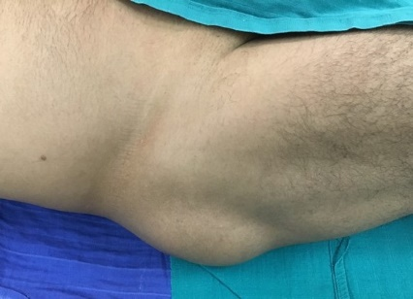
Figure. 1. Preoperative clinical photograph showing the lump in the right buttock.
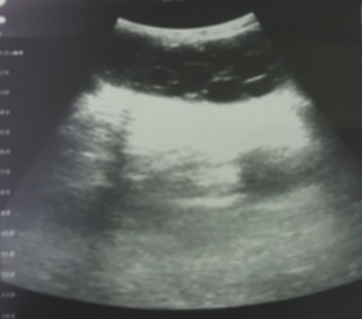
Figure. 2. Ultrasonography shows a superficial mass with multiple extramusculo-aponeurotic cysts.
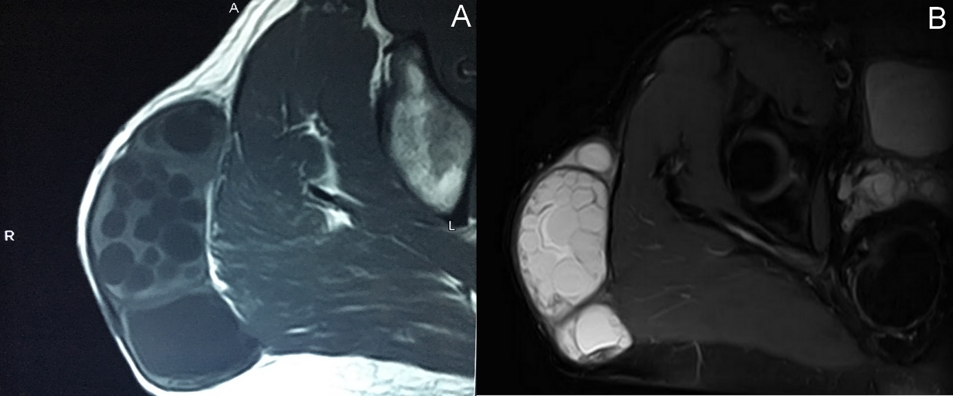
Figure. 3. (A) Axial T1-weighted and (B) axial fat saturated T2-weighted magnetic resonance images showing subcutaneous multilocular cystic formation in the right buttock with daughter cysts.
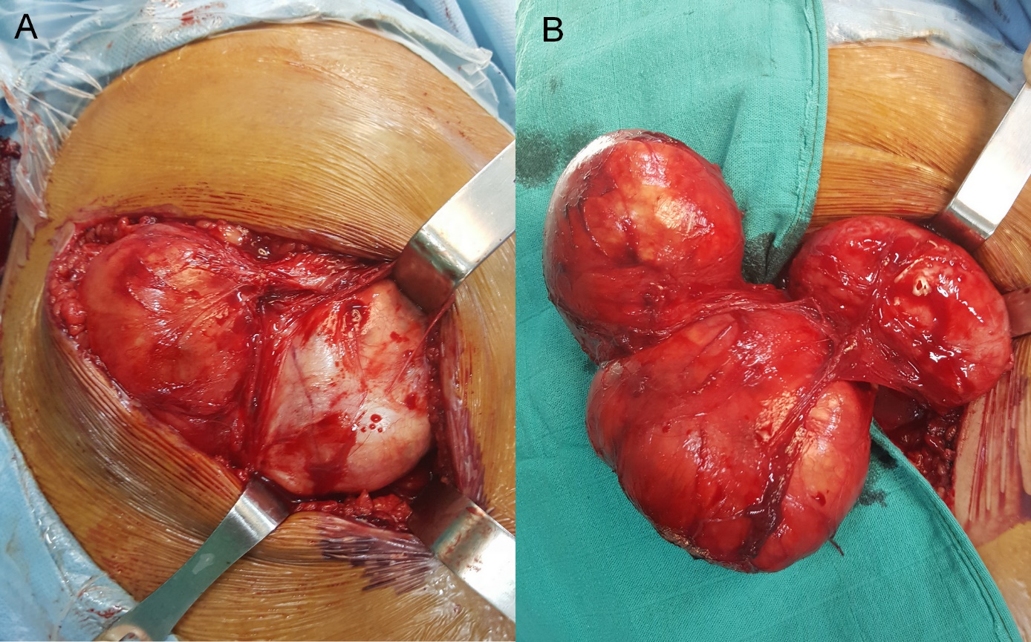
Figure. 4. (A and B) Per-operative view of hydatid cyst operation.
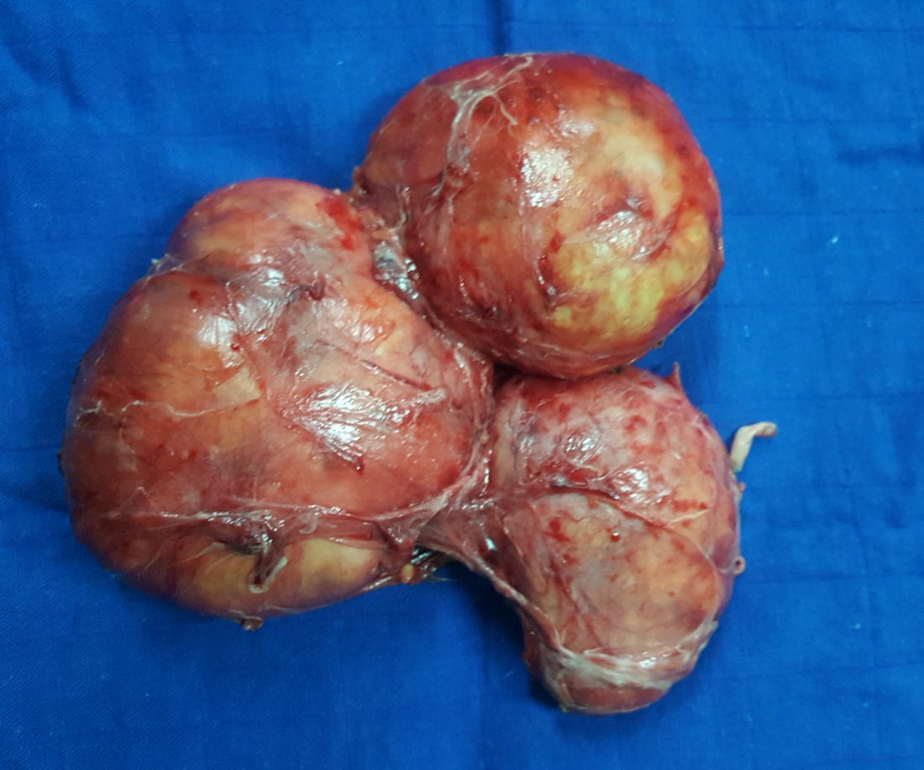
Figure. 5. Macroscopic aspect of the totally excised hydatid cyst without destroying the cyst wall.
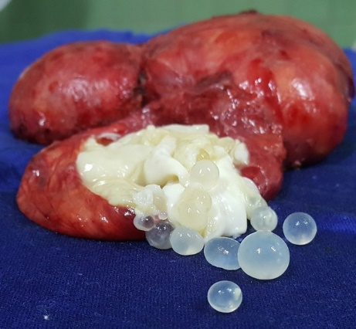
Figure. 6. Image of several daughter cysts after opening of the main hydatid cyst.

