Solitary primary subcutaneous hydatid cyst of the buttock

M. ELABDI * (1), H. ZEJJARI (2), A. ELWALI (3), R. ROUKHSI (4), J. LOUASTE (2), L. AMHAJJI (2)

1 Orthopaedic Surgeon, Department of Orthopaedic Surgery, Military Hospital of Laayoun, Morocco

2 Professor, Department of Orthopaedic Surgery, Military Hospital of Meknes, Morocco

3 Professor, Department of Anesthesiology and Intensive Care, Military Hospital of Laayoun, Morocco

4 Professor, Department of Radiology, Military Hospital of Laayoun, Morocco

Email address:
elabdimonsef@gmail.com (M. Elabdi), hassane.zejjari@usmba.ac.ma (H. Zejjari), elwaliima@gmail.com (A. ELWALI), redouan9990@hotmail.com (R. Roukhsi), louasteaya@yahoo.fr (J. Louaste). amhajjilarbi@yahoo.fr (L. Amhajji)

* Address correspondence to: Monsef Elabdi, MD, Department of Orthopaedic Surgery, Military Hospital, 70000, Laayoun, Morocco.
E-mail address: elabdimonsef@gmail.com (M. Elabdi).

ABSTRACT
Hydatidosis is an endemic parasitic disease affecting in most cases the parenchymal organs. The involvement of the soft tissue is a rare pathology that, left untreated, can lead to rupture and potentially catastrophic anaphylaxis. In this article, we describe the case of a 42-year-old male who developed subcutaneous hydatid cyst in the buttock as a solitary primary localization. Consequently, the patient underwent successfully surgical excision with uneventful post-operative recovery.

KEYWORDS

Hydatid Cyst, Echinococcus granulosis, Subcutaneous, Soft tissue, Buttock

INTRODUCTION

Hydatid cyst is an endemic disease in Mediterranean Basin, Middle East, South America, East Africa, Central Asia, and Australia [1-2]. This happens principally in areas where dogs are used to herd grazing animals, particularly sheep [3].
Infection is caused by Echinococcus granulosus [4]. Involvement of one or multiple organs is a known event. The liver and lung are the most common organs involved (>85%) and represent generally primary foci [2, 5-6]. However, primary subcutaneous soft tissue hydatitosis is very rare [1, 7-8]. To our knowledge, few cases have been reported in the literature. We present the case of a subcutaneous hydatid cyst in the buttock region as a primary site without involving other rentals.
CASE REPORT

A 42-year-old man with a two-year history of gradual development of a voluminous painless mass on his right hip, without any history of trauma or infection. Clinical examination revealed a mass of the right buttock, poorly limited, approximately 20 cm in greatest dimension, painless and renitent on palpation (Figure 1). The overlying skin was normal. X-ray of the hip was no abnormalities. Echography and magnetic resonance imagining (MRI) showed a superficial multilobed formation with multiple cystic lesions (Figure 2 and 3). This was considered as a hydatid cyst. Hydatid serology for antibodies to Echinococcus granulosus antigens was negative. Complete blood count (CBC) did not revealed eosinophilia and blood biochemical tests were normal. Computed tomography (CT) scan of the chest and abdomen was within the normal range. The patient underwent surgical excision (Figure 4). The cystic lesions located subcutaneously were removed completely (Figure 5 and 6), and that irrigation with hypertonic saline solution was performed. Histopathological examination confirmed the diagnosis of hydatidosis. Treatment with albendazole was administrated. One year postoperatively, the patient had no recurrence of the hydatid cyst.

DISCUSSION

Cystic hydatidosis is a cosmopolitan parasitic infection caused by Echinococcus granulosus. The disease is endemic in areas where sheep are raised in large quantities. Close contact with dogs is the main risk factor [3].
The liver and lungs are the sites most often involved (85%) [2, 5-6]. After ingestion, the ova of the parasite, which penetrate the mucosa of the small intestine, join the portal system and meet the liver and lungs. These organs filter out most ova. However, parasitic eggs can pass to systemic circulation and reach other places in the body [7-9].
The mechanism of primary subcutaneous hydatidosis is not clear. Although subcutaneous colonization of the parasite in the circulation after ingestion is a reliable mechanism, we believe that systemic dissemination through lymphatic channels should be considered [10].
Primary subcutaneous hydatid cyst is a very uncommon condition, with abscess and lipoma as main differential diagnoses [8-9, 11]. This involvement causes a diagnosis problem because of the insidious symptomatology; however, it's should be considered when slowly growing soft tissue mass in patients living in the endemic regions [12-13]. Because hydatid disease may develop complications such as rupture and anaphylactic reaction [14-15], diagnosis of echinococcosis is required before any biopsy or surgical excision. Ultrasonography is useful key method for detecting hydatid cyst [8-10]. MRI is the better examination; it provides a local and locoregional meticulous analysis [16]. Blood tests can yield false-negatives [9, 17].
Primary echinococcosis of the soft tissue is treated by surgery. Subcutaneous total excision without perforation through the cyst is the recommended option [7-8, 11, 18]. If this method is impossible to done without opening, the cyctic fluid has to be aspired, and the laminated membrane should be totally excised. Sterilization of the cyst pouch is performed by protoscolicidal solutions [7-9, 14]. Postoperative medical treatment with an antihelmenthic agent reduces the risk of recurrence.

REFERENCES

- Kayaalp C. Hydatid cyst of the liver. In: Blumgart LH, Belghiti RJ, DeMatteo RP, Chapman WC, Büchler MW, Hann LE, D'Angleca M, editors. Surgery of the Liver, Biliary Tract, and Pancreas. ed 4. Philadelphia: Saunders Elsevier; 2007. pp. 952–970
- Saidi F. Surgery of hydatid disease. Philadelphia: Saunders; 1976.
- Eckert J, Deplazes P. Biological, epidemiological, and clinical aspects of echinococcosis, a zoonosis of increasing concern. Clin Microbiol Rev. 2004;17:107–35. [PMC free article] [PubMed]
- Kern P, Bardonnet K, Renner E, Auer H, Pawlowski Z, Ammann RW. European echinococcosis registry: human alveolar echinococcosis, Europe, 1982–2000. Emerg Infect Dis. 2003;9(3):343-9
- Bal N, Kocer NE, Arpaci R, Ezer A, Kayaselcuk F. Uncommon locations of hydatid cyst. Saudi Med J 2008;29:1004e8.
- Yildirim M, Erkan N, Vardar E. Hydatid cysts with unusual localizations: diagnostic and treatment dilemmas for surgeons. Ann Trop Med Parasitol 2006;100:137e42.
- Dirican A, Unal B, Kayaalp C, Kirimlioglu V. Subcutaneous hydatid cysts occurring in the palm and the thigh: two case reports. J Med Case Reports. 2008;2:273.
- Ousadden A, Elbouhaddouti H, Ibnmajdoub KH, Mazaz K, AitTaleb K. A solitary primary subcutaneous hydatid cyst in the abdominal wall of a 70-year-old woman: a case report. Journal of Medical Case Reports. 2011;5:270.
- Orhan Z, Kara H, Tuzuner T, Sencan I, Alper M. Primary subcutaneous cyst hydatic disease in proximal thigh: an unusual localisation: a case report. BMC Musculoskelet Disord. 2003;4:25.
- Ok E, Sözüer EM. Solitary subcutaneous hydatid cyst: a case report. Am J Trop Med Hyg. 2000;62:583-4.
- Rezakhaniha B, Sirosbakht S. Coincidental hydatid cyst of skin and kidney: a very rare case report. Iran J Pathol. 2010;5:47-50
- Marwah S, Shubramainan P, Marwah N, Rattan KN, Krwasra RK. Infested primary intramuscular echinococcosis of thigh. Indian J Pediatr 2005; 72: 799-800.
- Erol B, Tetik C, Altun E, Soyal A, Bakir M. Hydatid cyst presenting as a soft tissue calf mass in a child. Eur J Pediatr Surg 2007; 17: 55-8.
- Duncan GJ and Tooke SMT: Echinococcus infestation of the biceps brachii. Clin Otrhop 1990, 261:247-250
- Rao S, Parikh S and Kerr R: Echinococal infestation of the spine in North America. Clin Orthop 1991, 52:582-584
- Diez G, Mendoza LHR, Villacampa VM, Cózar M, Fuertes MI. MRI evaluation of soft tissue hydatid disease. EurRadiol. 2000;10:462-6.
- Gonzalez AN, Muro A, Barrera I. Usefulness of four different echinococcus granulosus recombinant antigens for serodiagnosis of unilocularhydatid disease (UHD) and postsurgical follow-up of patients treated for UHD. Clin Vaccine Immunol. 2008;15:147-53.
- Ates M, Karakapalam M. Hydatid cyst in the biceps and gluteal muscles: case report. Surg Infect (Larchmt) 2007; 8: 475-8.

LEGEND OF FIGURES:
Figure. 1. Preoperative clinical photograph showing the lump in the right buttock.
Figure. 2. Ultrasonography shows a superficial mass with multiple extramusculo-aponeurotic cysts.
Figure. 3. (A) Axial T1-weighted and (B) axial fat saturated T2-weighted magnetic resonance images showing subcutaneous multilocular cystic formation in the right buttock with daughter cysts.
Figure. 4. (A and B) Per-operative view of hydatid cyst operation.
Figure. 5. Macroscopic aspect of the totally excised hydatid cyst without destroying the cyst wall.
Figure. 6. Image of several daughter cysts after opening of the main hydatid cyst.

Financial Disclosure: None reported.

Conflict of Interest: None reported.

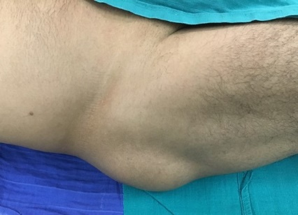
Figure. 1. Preoperative clinical photograph showing the lump in the right buttock.
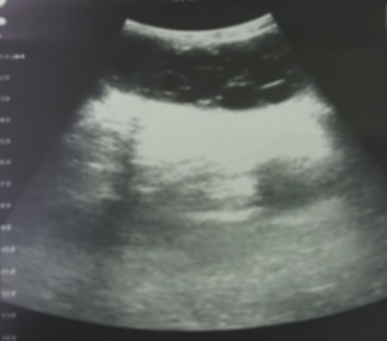
Figure. 2. Ultrasonography shows a superficial mass with multiple extramusculo-aponeurotic cysts.
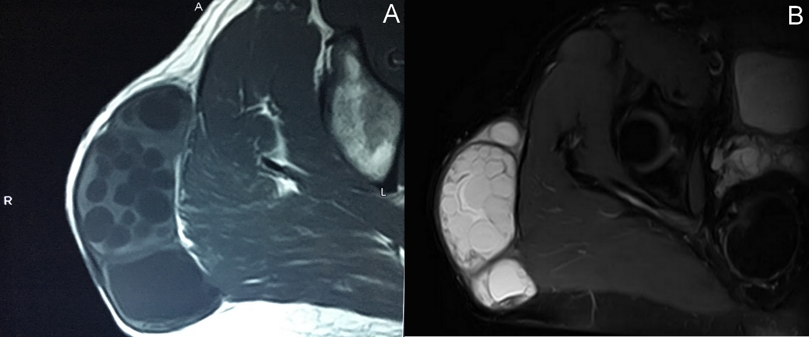
Figure. 3. (A) Axial T1-weighted and (B) axial fat saturated T2-weighted magnetic resonance images showing subcutaneous multilocular cystic formation in the right buttock with daughter cysts.
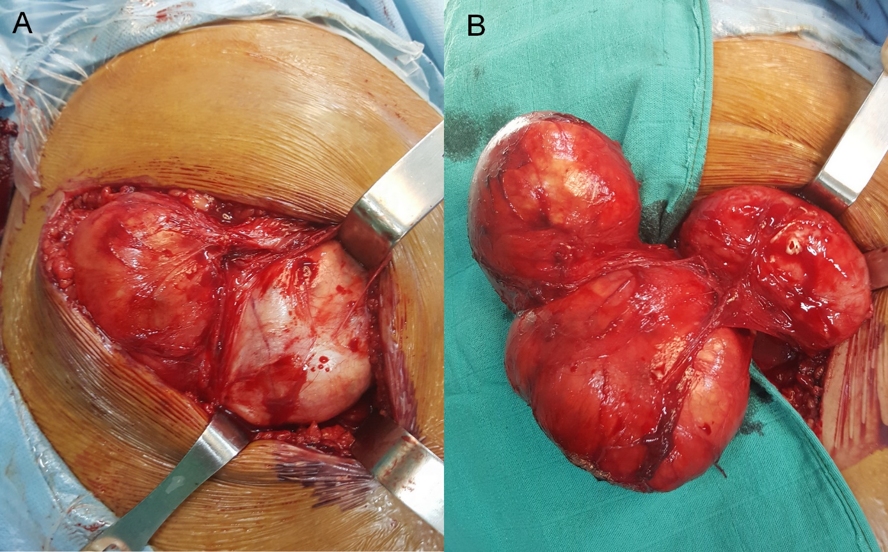
Figure. 4. (A and B) Per-operative view of hydatid cyst operation.
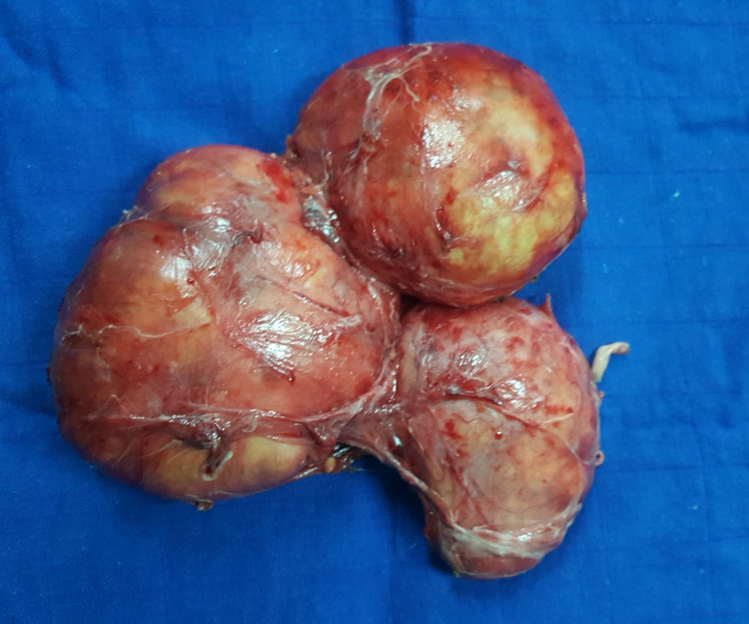
Figure. 5. Macroscopic aspect of the totally excised hydatid cyst without destroying the cyst wall.
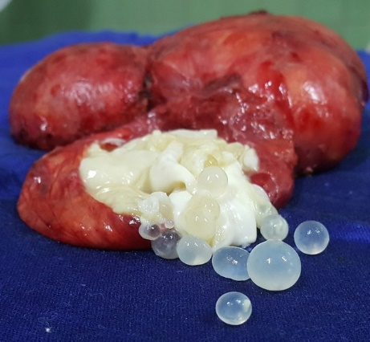
Figure. 6. Image of several daughter cysts after opening of the main hydatid cyst.

